Journal: Plant and soil

Article title:
Effects of drought and nutrient deficit on the allocation of recently fixed carbon in plant-soil-microbe system
Authors:
Huijuan Xia^{a, #}, Tiantian Zhang^{b, #}, Xinshuai Liª, Tiehu Heª, Xia Wangª, Jiehao Zhangª, Kerong Zhang^{a, c, *}
ª Key Laboratory of Aquatic Botany and Watershed Ecology, Wuhan Botanical Garden, Chinese Academy of Sciences, Wuhan 430074, P.R. China
^{b} Colledge of Science, Tibet University, Lhasa 850000, P.R. China
^{c} Danjiangkou Wetland Ecosystem Field Scientific Observation and Research Station, the Chinese Academy of Sciences & Hubei Province, Wuhan 430074, P.R. China

# These authors contributed equally to this work.
*Corresponding author:
Kerong Zhang, Email: kerongzhang@wbgcas.cn
Key Laboratory of Aquatic Botany and Watershed Ecology, Wuhan Botanical Garden,
Chinese Academy of Sciences, Wuhan 430074, P.R. China
Phone: +86 27 87700866 Fax: +86 27 87700877
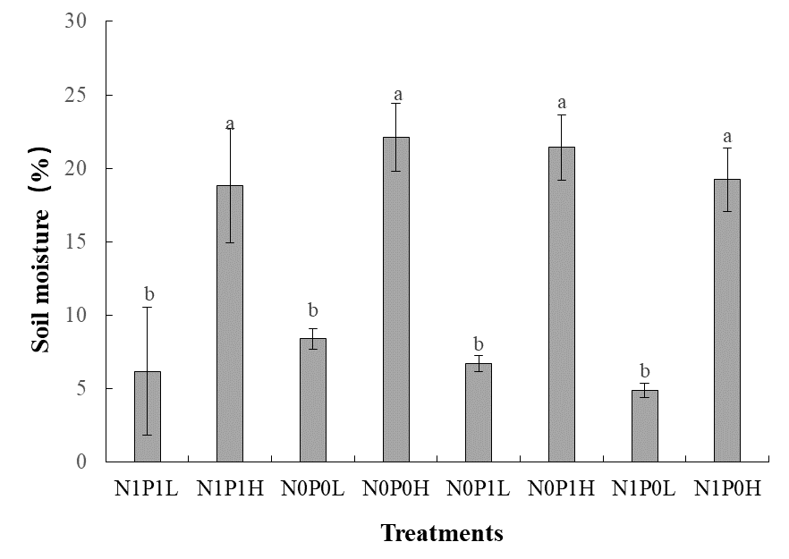
Fig. S1 Soil moisture at different treatments. Different letters were labeled above boxes to show significant differences among treatments. N: nitrogen; P: phosphorus; L: drought; H: non-drought; N0: N deficit; N1: N addition; P0: P deficit; P1: P addition.

