Supplementary Information
Figure S1
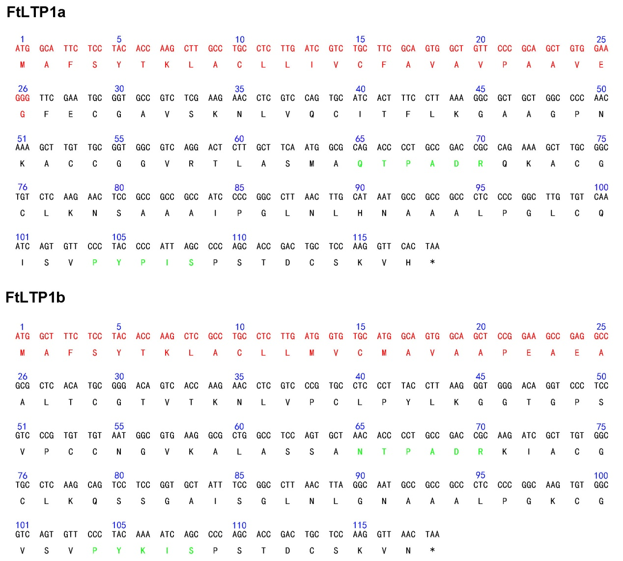

Figure S1. cDNA sequences and amino acid sequences of FtLTP1a and FtLTP1b. Red font is predicted signal peptide sequence, and the green font is conserved regions for lipid binding.

Figure S2
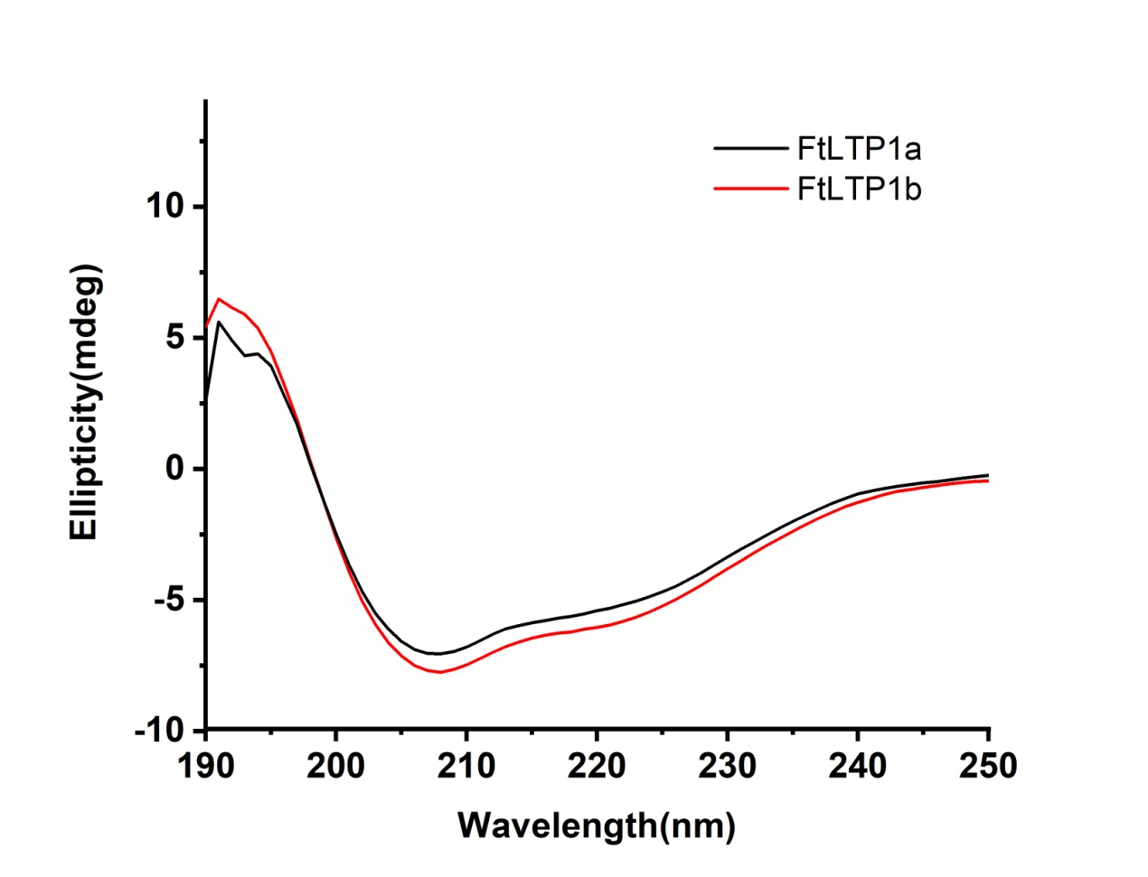

Figure S2. Circular dichroism spectra of FtLTP1a and FtLTP1b.

Table

Table S1. Data on serum of specific buckwheat allergen
Serum No. | Sex | Ages | IgE specific for buckwheat (kU/L) | Other known allergens*
1 | M | 19 | 0.261 | D1, H1, HX2
2 | M | 21 | 0.140 | H1, HX2, MX2, TX4, W6, WX7
3 | M | 32 | 0.321 | W6
4 | M | 27 | 0.790 | W6
5 | M | 46 | 0.650 | W6
6 | F | 15 | 0.173 | T8, T12, TX4,W6, W22, WX7
7 | F | 23 | 0.151 | TX4, W22, W6, WX7
8 | M | 14 | 0.216 | W22, W6
9 | M | 27 | 0.133 | TX4, W22, W6, WX7
*D1, house dust mite; D2, dermatophagoides farina; T8, elm pollen; T12, willow pollen; TX4, polyvalent tree pollen; H1, house dust; HX2, polyvalent mite; W6, artemisia pollen; W22, humulus; WX7, polyvalent grass pollen; MX2, polyvalent mold.

Table S2. Data on serum of pollen allergen
Serum No. | Sex | Ages | IgE specific for W6*  (kU/L) | IgE specific for WX7*  (kU/L)
1 | F | 23 | 3.169 | 2.053
2 | M | 37 | 3.341 | 2.477
3 | F | 14 | 8.919 | 6.523
*W6, artemisia pollen; WX7, polyvalent grass pollen;

Table S3.The purification process of FtLTP1a and FtLTP1b from per liter of culture

Steps | FtLTP1a | FtLTP1b
Wet cell mass(g) | 17.12 | 19.29
Crude proteins(mg) | 35.79 | 45.09
Target proteins(mg) | 2.14 | 2.46
*Crude proteins were supernatant of E.coli after ultrasonic.

Table S4. MICs of the FtLTP1a and FtLTP1b
Microorganisms. | FtLTP1a (μmol/L) | FtLTP1b (μmol/L)
Aspergillus niger | 8 | 16
Aspergillus flavus | 8 | 16
Fusarium oxysporum | 64 | 64

