Supplementary Information
Table of contents:
Supplementary Notes
- Implementation of PSRelIP
- Commands and parameters used to prepare genetic variant data
- Details of selecting BioSample accessions and reference genomes, downloading nucleotide sequence data, and preparing genetic variant data
- Calculating the percentage of variance explained by each principal component
Supplementary Figures
Supplementary Tables
Additional References
Supplementary Notes
Supplementary Note 1 Implementation of PSRelIP
Note that ($) denotes variables with values defined in the configuration file (Supplementary Table 1) and corresponding shell script.
In the PSRelIP pipeline, in all PLINK command lines, the --memory $MAX_MEM_USAGE flag is used.
First shell script:
The PLINK command lines to convert VCF/BCF to PLINK format (PLINK 2 binary fileset will be created):
plink2 --vcf $VCF_FILE_NAME --allow-extra-chr --max-alleles 2 --make-pgen --out binary_fileset
plink2 --bcf $VCF_FILE_NAME --allow-extra-chr --max-alleles 2 --make-pgen –out binary_fileset
The PLINK command line to generate an allele count report, which is a valid input for --read-freq:
plink2 --pfile binary_fileset --allow-extra-chr --freq counts --out plink2.acount
In addition to the PLINK commands, an in-house Perl program was used to create identifiers for all the variants in the binary_fileset.pvar file.
Second shell script:
The PLINK command lines for input filtering:
of samples:
--keep samples.list
--mind $MIND_VAL
of variants:
--chr $RANGE_OF_CHROMOSOMES
--snps-only
--geno $GENO_VAL
--maf $MAF_VAL
The PLINK command lines for basic statistics calculation:
of original dataset and filtered and LD pruned dataset:
--sample-counts
--missing sample-only
of filtered and LD pruned dataset:
--het 'cols=+het,+het'
--ibc
The PLINK command lines for LD-based variant pruning (a pruned subset of variants will be written to plink2.prune.in, which is a valid input for --extract):
window size in kilobase:
--indep-pairwise $LD_WINDOW_SIZE $LD_WINDOW_SIZE_UNITS 1 $LD_THRESHOLD
window size in variant count:
--indep-pairwise $LD_WINDOW_SIZE $LD_STEP_SIZE $LD_THRESHOLD
for excluding all unlisted variants from the current analysis:
--extract plink2.prune.in
The PLINK command line for clustering calculations and multidimensional scaling (MDS) report generation (PLINK 1.9)
--cluster --K $GROUPS_NO --mds-plot 10
The PLINK command line for top 10 principal components (PCs) extraction:
--read-freq plink2.acount --pca
with the 'meanimpute' modifier to request mean-imputes missing genotype calls:
--read-freq plink2.acount --pca meanimpute
The PLINK command line for FST (Pairwise fixation index) estimation between pairs of subpopulations is defined as a categorical phenotype:
--fst CATEGORY --pheno groups.list
with the 'report-variants' modifier to request per-variant FST estimates:
--fst CATEGORY 'report-variants' --pheno groups.list
The PLINK command line for the IBS (identity-by-state) matrix calculation (PLINK 1.9):
--distance square ibs
The PLINK command line for relationship matrix computation:
--read-freq plink2.acount --make-rel square
with the 'meanimpute' modifier to request mean-imputes missing genotype calls:
--read-freq plink2.acount --make-rel meanimpute square
The PLINK command line for KING kinship coefficients computation:
--make-king square
In addition to the PLINK commands, in-house Perl programs were used to reorder samples and their corresponding values in matrices of various types, to edit various values (such as replacing negative values with 0) for visualization purposes, pipelining, and other purposes.

Supplementary Note 2 Commands and parameters used to prepare genetic variant data
Analysis tools
Java (JDK 1.8.0_111)
BWA (bwa-0.7.17)
SamTools (v1.12)
GATK (v4.2.0.0)
Trimmomatic (v0.39)
Picard (v2.25.5)
Creating index of the genome
samtools faidx genome.fa
java -jar picard.jar CreateSequenceDictionary REFERENCE= genome.fa OUTPUT= genome.dict
bwa index genome.fa
Preprocessing of Illumina paired-end reads (per sample)
TRIMMOMATIC_OPT=”ILLUMINACLIP:adapters.fa:2:30:10 LEADING:20 TRAILING:20 SLIDINGWINDOW:4:20 MINLEN:36”
java -jar trimmomatic-0.39.jar PE -phred33 read.r1.fastq.gz read.r2.fastq.gz read.pe.r1.fastq.gz read.se.r1.fastq.gz read.pe.r2.fastq.gz read.se.r2.fastq.gz $TRIMMOMATIC_OPT
Alignment of Illumina reads to the reference genome (per sample)
$ bwa mem -M genome.fa read.pe.r1.fastq.gz read.pe.r2.fastq.gz | samtools sort -o pe_masterPsrt.bam -
$ samtools view -u -q 20 pe_masterPsrt.bam | samtools sort -n -T pe -O bam - | samtools fixmate -O bam - pe_fixmate.bam
$ samtools view -u -f 0x2 pe_fixmate.bam | samtools sort -T pe -O bam -o pe_pSrt.bam -
$ samtools index pe_pSrt.bam
Removal of PCR duplicates (per sample)
$ java -jar picard.jar MarkDuplicates INPUT=pe_pSrt.bam OUTPUT=pe_rmdup.bam METRICS_FILE=mark_duplicates.metrics MAX_RECORDS_IN_RAM=1000000 REMOVE_DUPLICATES=true
$ samtools index pe_rmdup.bam
Variant detection by GATK HaplotypeCaller (per sample)
$ gatk HaplotypeCaller --input pe_rmdup.bam --output sample_n.g.vcf.gz --reference genome.fa --emit-ref-confidence GVCF
Combining per-sample files into a multi-sample VCF file by GATK CombineGVCFs
IN_GVCFs='--variant sample_1.g.vcf.gz --variant sample_2.g.vcf.gz --variant sample_n.g.vcf.gz …’
$ gatk CombineGVCFs -R genome.fa -O multi_sample.g.vcf.gz $IN_GVCFs
Genotyping and filtering variants by GATK
$ gatk GenotypeGVCFs --include-non-variant-sites -R genome.fa -V multi_sample.g.vcf.gz -O multi_sample.genotyped.vcf.gz
VAR_FILTER_OPT='QD < 2.0 || FS > 60.0 || MQ < 40.0 || MQRankSum < -12.5 || ReadPosRankSum < -8.0'
$ gatk VariantFiltration --reference genome.fa --variant multi_sample.genotyped.vcf.gz --output multi_sample.filtered.vcf.gz --filter-expression "${VAR_FILTER_OPT}" --filter-name "FILTER"
gatk SelectVariants --reference genome.fa --variant multi_sample.filtered.vcf.gz --output multi_sample.varonly.vcf.gz --exclude-filtered --select-type-to-include SNP --select-type-to-include INDEL

Supplementary Note 3 Details on selecting BioSample accessions and reference genomes, downloading nucleotide sequence data and preparing genetic variant data
To divide samples into groups and obtain SRA accessions of each sample, we downloaded the metadata from the NCBI BioSample database (https://www.ncbi.nlm.nih.gov/biosample/) using the BioSample accessions selected as described in the ‘Preparing data for case studies’ subsection of the main text of this paper and listed them in Supplementary Tables 2 and 3. Using the obtained SRA Run accessions (Supplementary Tables 2 and 3), we downloaded nucleotide sequence data as fastq files from the European Nucleotide Archive (ENA) (https://www.ebi.ac.uk/ena/browser/home) and used them to generate genetic variant data. The chromosome-level genome assemblies, such as IRGSP-1.0 (RefSeq assembly accession: GCF_001433935.1; BioProject: PRJDB1747) (Kawahara et al. [38]) and M_zebra_UMD2a (RefSeq assembly accession: GCF_000238955.4; BioProject: PRJNA60369) (Conte and Kocher [39]), were used as reference genomes for variant calling for rice and Malawi cichlids data, respectively. For reference genome selection for the analysis of Malawi cichlids, our method differs from the method described by Malinsky et al. [37], in which Illumina short reads were aligned to the M. zebra reference assembly version 1.1 (MetZeb1.1_prescreen) (Brawand et al. [45]), which is a scaffold-level genome assembly. There was also a difference in the set of accessions used in the analysis and in the programs used to perform the PCA analysis and genome-wide FST calculations, which was the PLINK software in our pipeline and the smartpca program from the eigensoft v5.0.2 software package. However, the PCs calculated using the PLINK –pca command were very similar to the PCs calculated by eigensoft's smartpca program, and both programs used the same Hudson method to estimate FST values. Despite the described differences, the results obtained by us for the assessment of PS, which are described in the ‘Results obtained in case studies’ subsection of the main text of this paper, are comparable to those published in the article by Malinsky et al. [37].

Supplementary Note 4 Calculating the percentage of variance explained by each principal component
The proportion of variance explained by each principal component (PC) was calculated by dividing the PC’s corresponding eigenvalue by the sum of all eigenvalues.
The PLINK --pca command extracts the top principal components from the variance-standardized relationship matrix computed by --make-rel/--make-grm (https://www.cog-genomics.org/plink/2.0/strat#pca).
To calculate the proportion of variance explained by each principal component, we relied on the following reference sources.
Butler [46] described as follows:
Let A be an n×n matrix.
• Matrix A has n eigenvalues (including each according to its multiplicity).
• The sum of n eigenvalues of A is the same as the trace of A (i.e., the sum of the diagonal elements of A).
Parellada [47] described as follows:
- PCA relies on the singular value decomposition of the covariance matrix (Cov(Data)).
- The trace is the sum of variance values in the diagonal of Cov(data).
- The trace is the sum of eigenvalues.
Thus, it follows that the sum of the eigenvalues is the same as the sum of the diagonal in the covariance matrix. We calculated the principal components from the variance-standardized relationship matrix computed by --make-rel (to calculate a straight covariance matrix, ‘cov’ modifier and --make-rel ‘cov’ command should be used); additionally, we calculated the percentage of the variance explained by each principal component as follows:
Percentage of the variance explained by n-th eigenvector (n-th PC) = (n-th eigenvalue / the sum of diagonal entries of the relationship matrix) * 100
Supplementary Figures
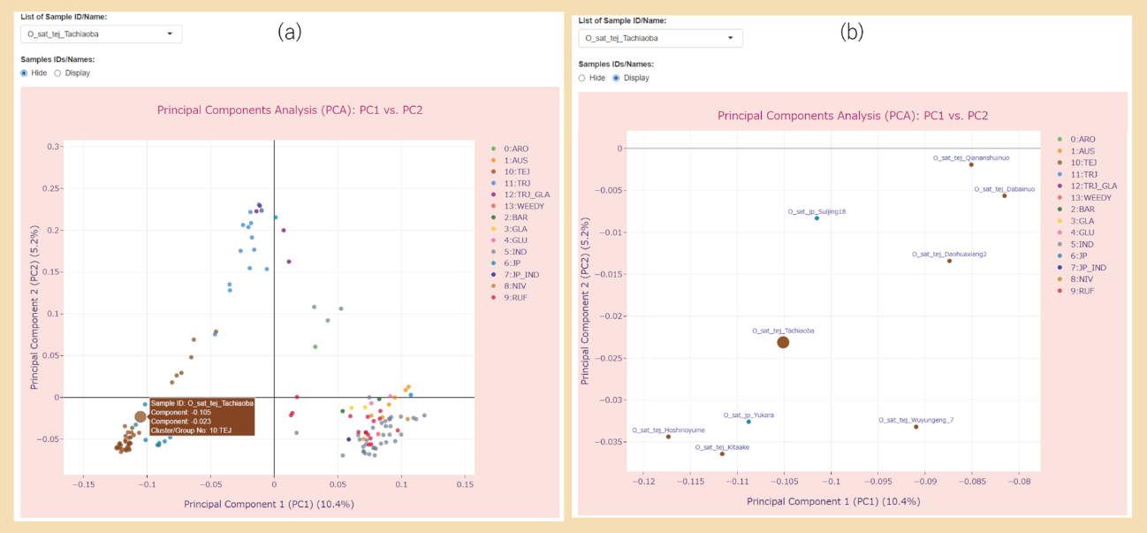
Fig. S1 An illustration of the main features of the PCA plots created in PSReIP
(a, b) The interactive 2-component PCA plot displays the first and second principal components (PC1/PC2) for 141 accessions of rice varieties, with data point colors corresponding to 14 rice type groups. The parameters used are shown in Table 2 (Run A). (a) The sample selected from the drop-down list titled ‘List of Sample ID/Name’ is displayed is a larger font size. Hovering the mouse pointer over the marker (sample) in the scatter plot will display annotation information related to that sample. (b) IDs or names of the samples are displayed by checking the ‘Display’ value in the radio button titled ‘Samples IDs/Names’. In Fig. S1b, we have zoomed in on the bottom left corner of the plot shown in Fig. S1a and illustrated the Plotly's zoom functionality. Users can zoom in and out of Plotly graphs by clicking the ‘Zoom in’ button (+ icon) and ‘Zoom out’ button (- icon) on the Modebar.

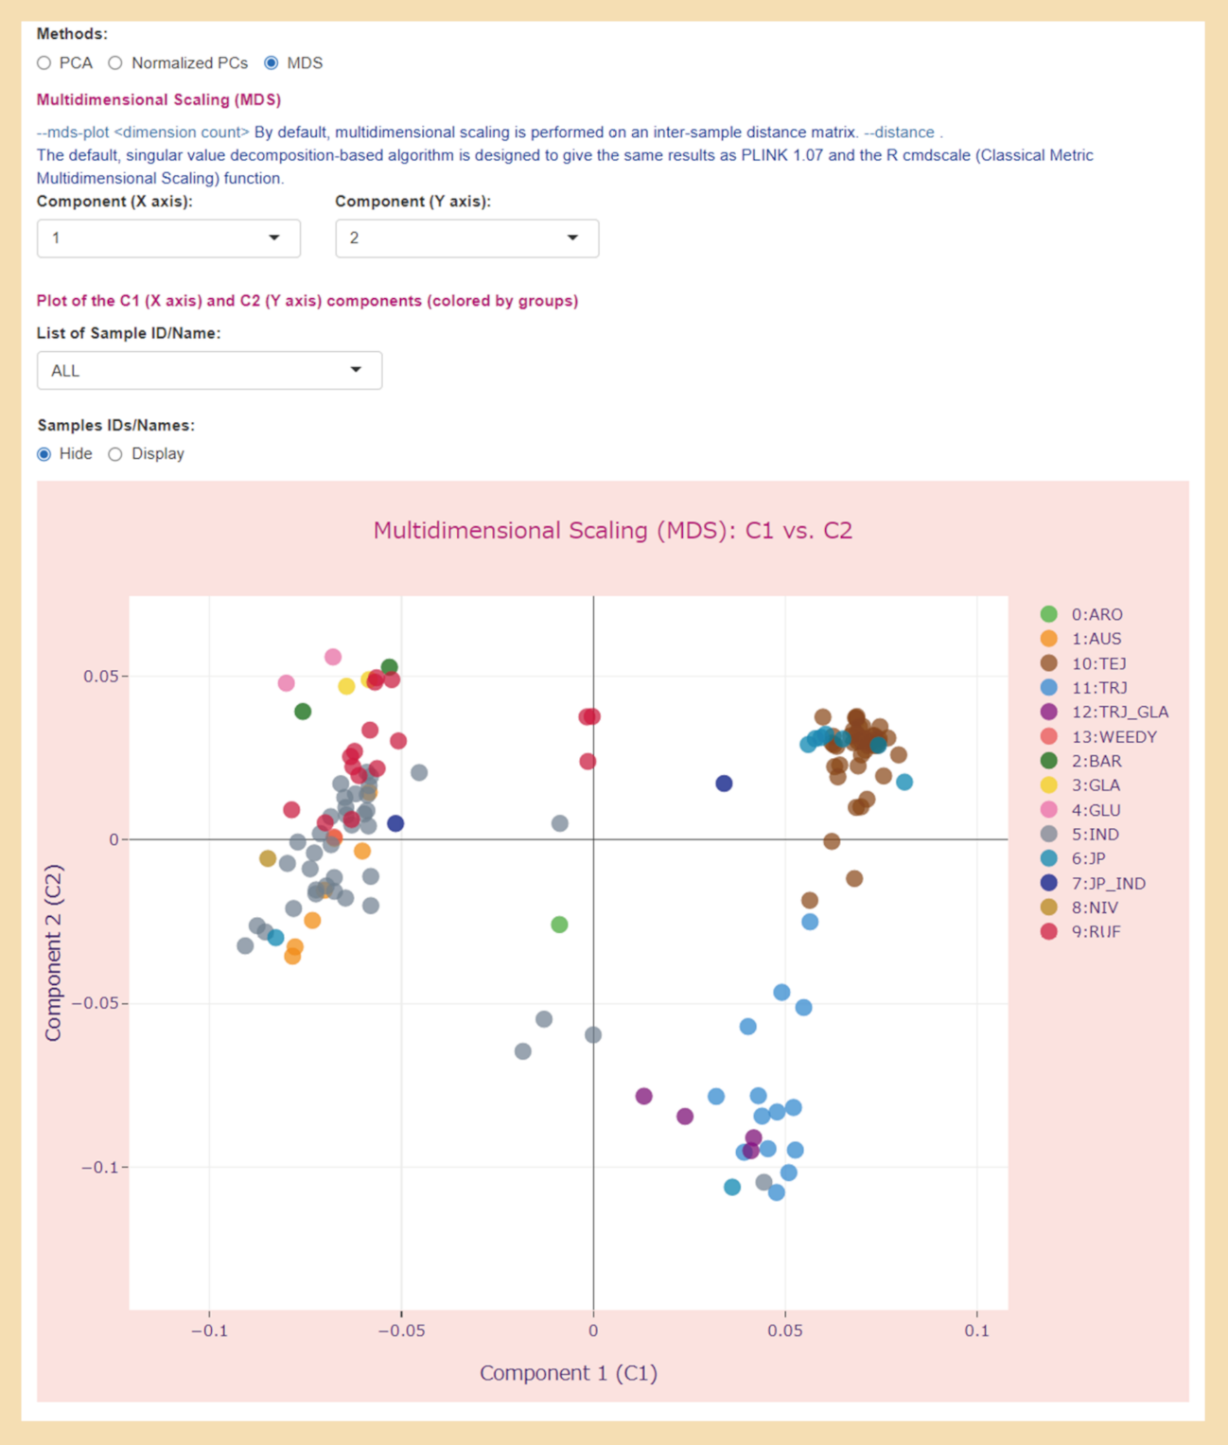
Fig. S2 User interface for results of Population Stratification analysis with the two-dimensional MDS plot
The parameters used are listed in Table 2 (Run A). The interactive two-dimensional MDS plot displays the first (Component 1, C1) and second dimension of MDS (Component 2, C2) for 141 accessions of rice varieties, with data point colors corresponding to 14 rice type groups. A PCA plot of the first two principal components of the same dataset is shown in Fig. 5.

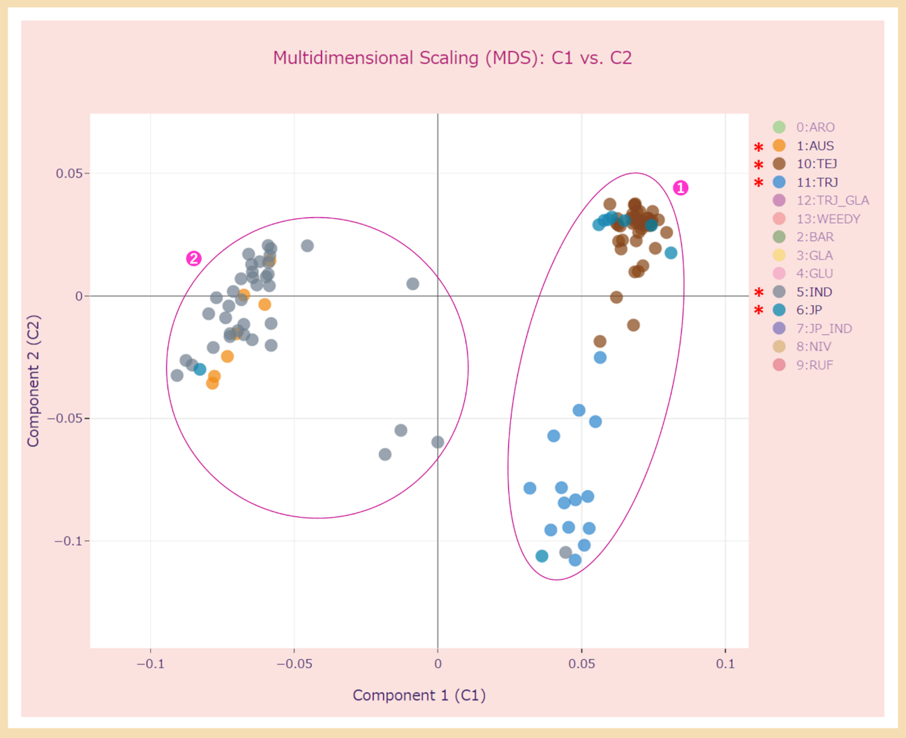
Fig. S3 An illustration of Plotly's ability to toggle the visibility of the data series. Plotly legends are interactive
Trace parts of the same legend group can be hidden or shown at the same time by clicking the corresponding legend item. This two-dimensional MDS plot shows samples from only five groups, JP, TEJ, and TRJ (indicated by ①) and IND with AUS (indicated by ②), since only these groups are selected in the legend (in this figure, we marked them by an asterisk). The parameters used are listed in Table 2 (Run A).

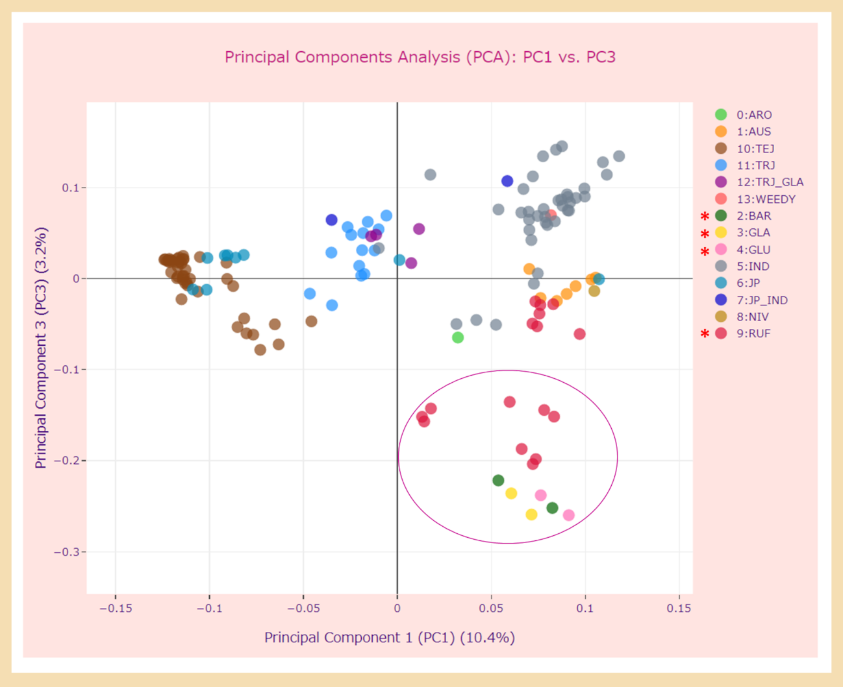
Fig. S4 The interactive 2-component PCA plot of the first and third principal components (PC1/PC3)
The parameters used are listed in Table 2 (Run A). PC1 explained 10.4% of the variance, while PC3 explained 3.2%. Samples from groups such as BAR (Oryza barthii), GLA (Oryza glaberrima), and GLU (Oryza glumaepatula) as well as some samples from the RUF (Oryza rufipogon) group, which are indicated in the figure by an oval, were separated along the third principal component from samples from other groups, including the groups of Oryza sativa. A PCA plot of the first two principal components of the same dataset is shown in Fig. 5.

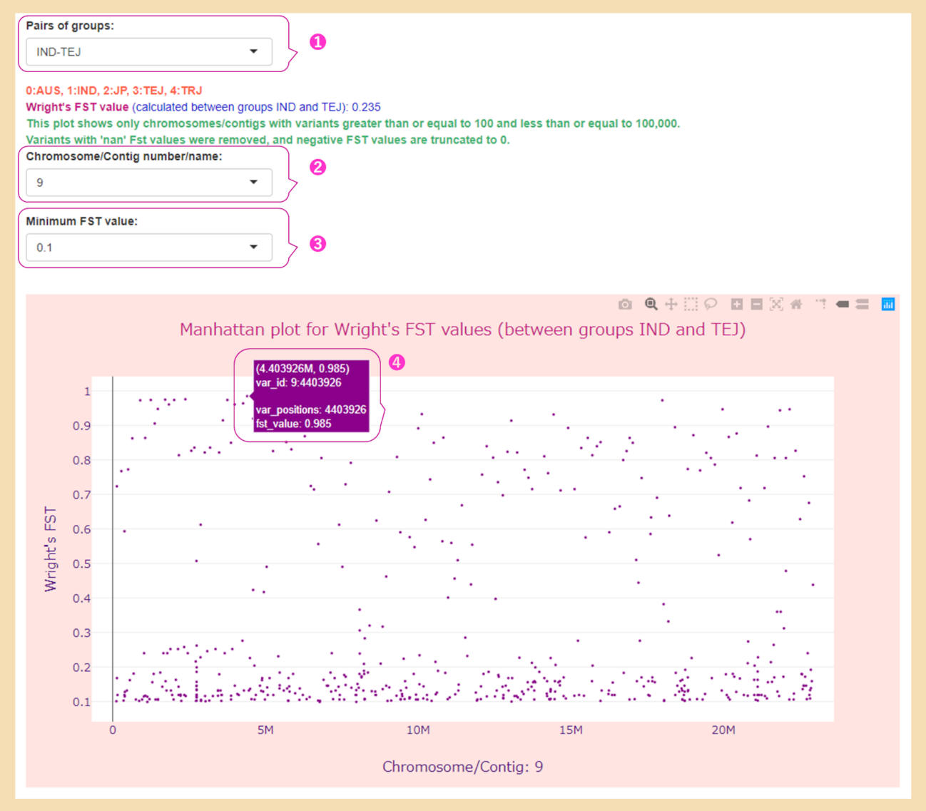
Fig. S5 User interface for FST estimation with the Manhattan plot of FST values for a single chromosome
The parameters used are listed in Table 2 (Run C). ① The drop-down list with values of all pairs of subpopulations (groups or clusters of samples) for which the FST values are shown on the Manhattan plot, with the selected value ‘IND-TEJ’; ② the drop-down list with the value ‘ALL’ or the name of the chromosome/contig (in this case, chromosome 9), which contains variants whose number is ≥100 and ≤100,000; ③ the drop-down list with a range of FST values (0–0.9) to filter the data displayed in the Manhattan plot, with a selected value of 0.1; ④ annotation information related to the variant, such as identifier, position on the chromosome, and FST value, which will be displayed on hovering the mouse over the variant. The interactive Manhattan plot shows Wright's FST values for variants on chromosome 9 calculated between the IND and TEJ rice groups.

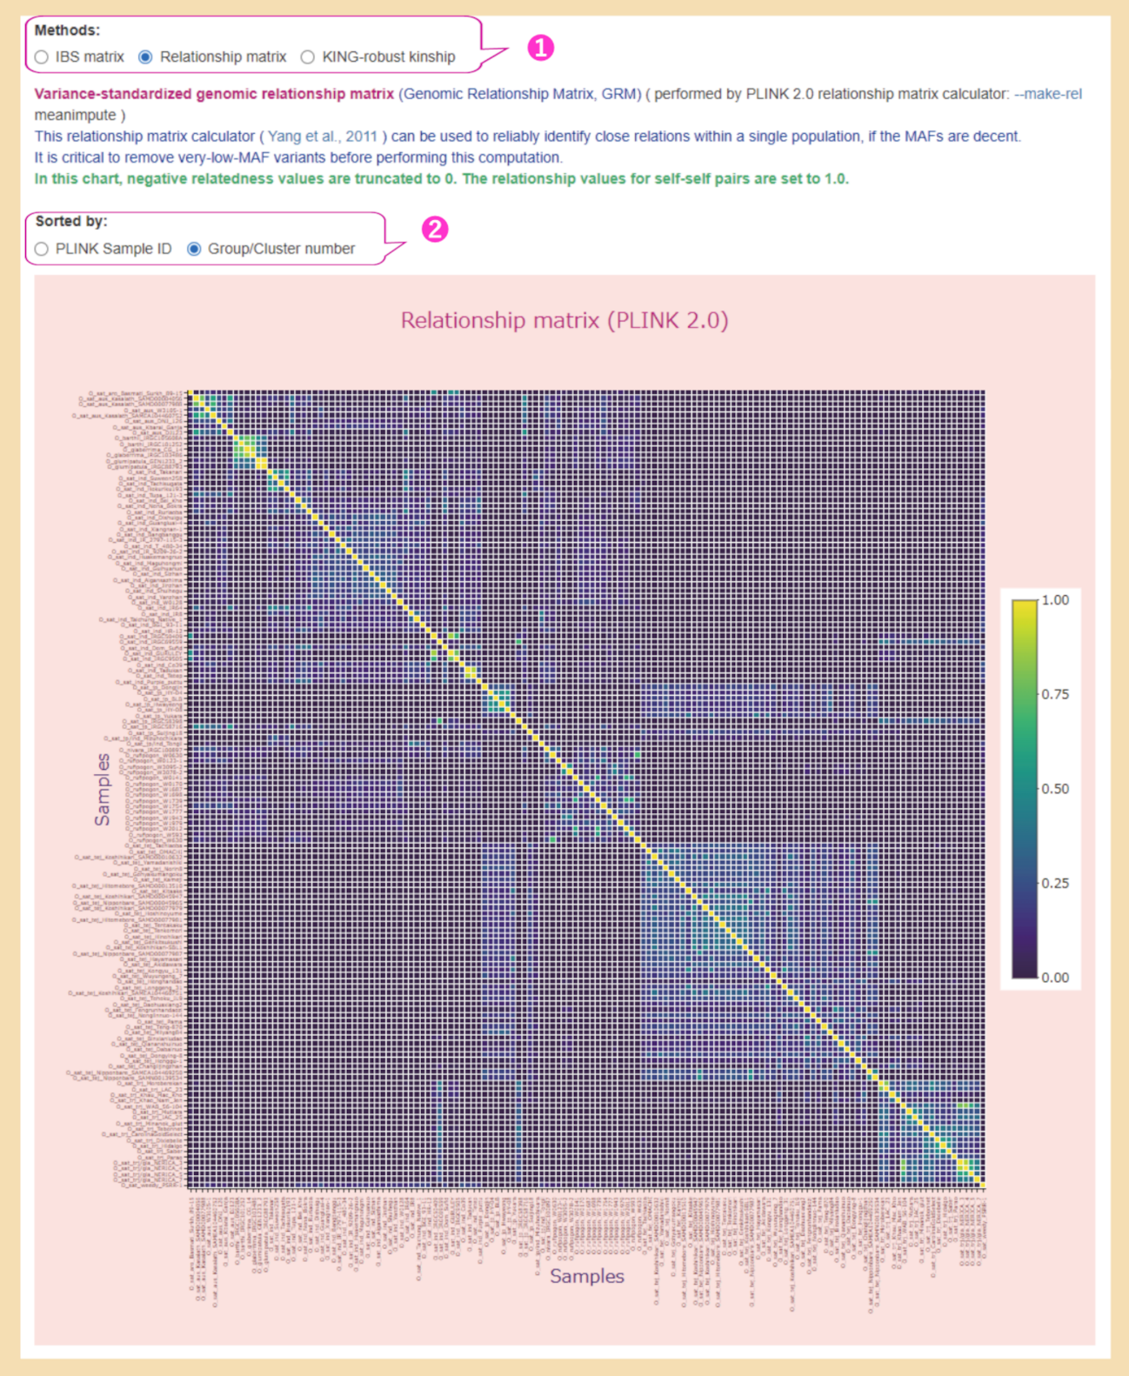
Fig. S6 User interface for results of IBS, GRM, and Kinship coefficient calculation with the heatmap of GRM
The parameters used are listed in Table 2 (Run A). ① A radio button for choosing any of the three methods for this type of analysis, of which the ‘Relationship matrix’ value is selected; ② a radio button to select the sort order of the samples for the heatmap with the value ’Group/Cluster number’ selected, meaning that the order is according to the groups/clusters to which the samples are assigned. The interactive heatmap represents the Relationship matrix for 141 accessions of rice varieties, in which the samples are ordered by ‘Group/Cluster number’.

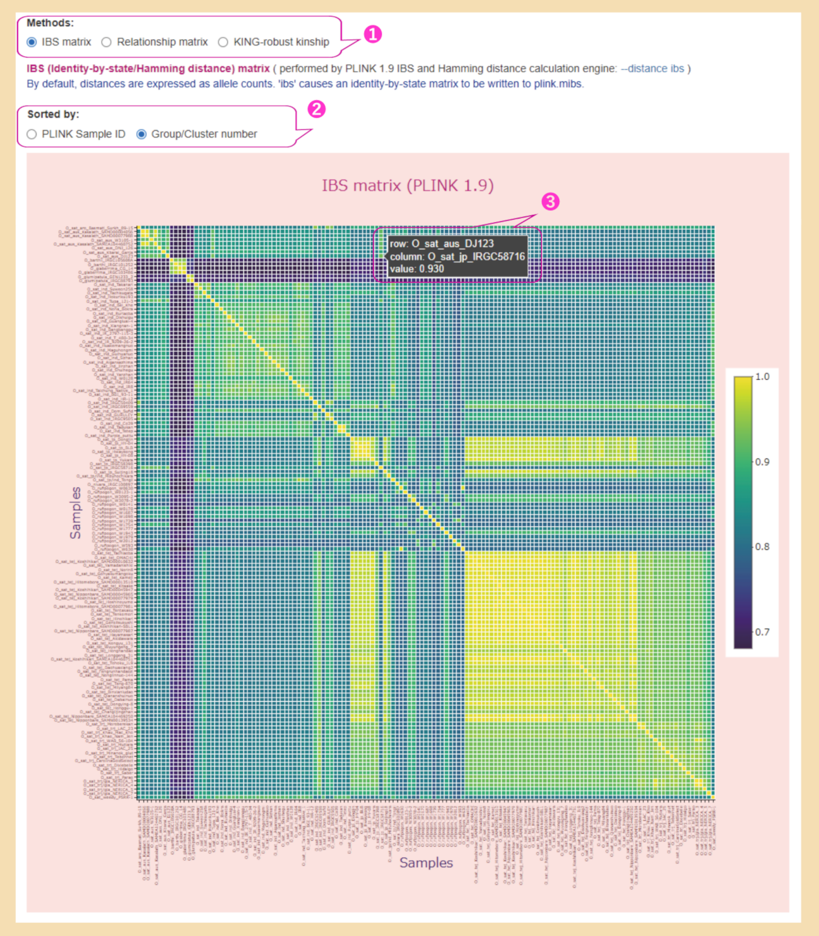
Fig. S7 User interface with the heatmap of IBS calculated for the dataset not pruned for LD
The parameters used are listed in Table 2 (Run B). ① A radio button for choosing any of the three methods for this type of analysis, of which the ‘IBS matrix’ value is selected; ② a radio button to select the sort order of the samples for the heatmap with the value ’Group/Cluster number’ selected; ③ the IBS value for the pair of samples and their ID/name displayed by hovering the mouse over the colored square. The interactive heatmap represents the IBS matrix for 141 accessions of rice varieties, in which the samples are ordered by ‘Group/Cluster number’. Compared with the heatmap of IBS shown in Fig. 8, in which the IBS matrix was calculated for the dataset pruned for LD, the values of the IBS matrix in this map are higher, as in the example of the same pair of samples, indicated by ⑤ in Fig. 8 (IBS value is 0.859) and ③ in Fig. S7 (IBS = 0.930), respectively.

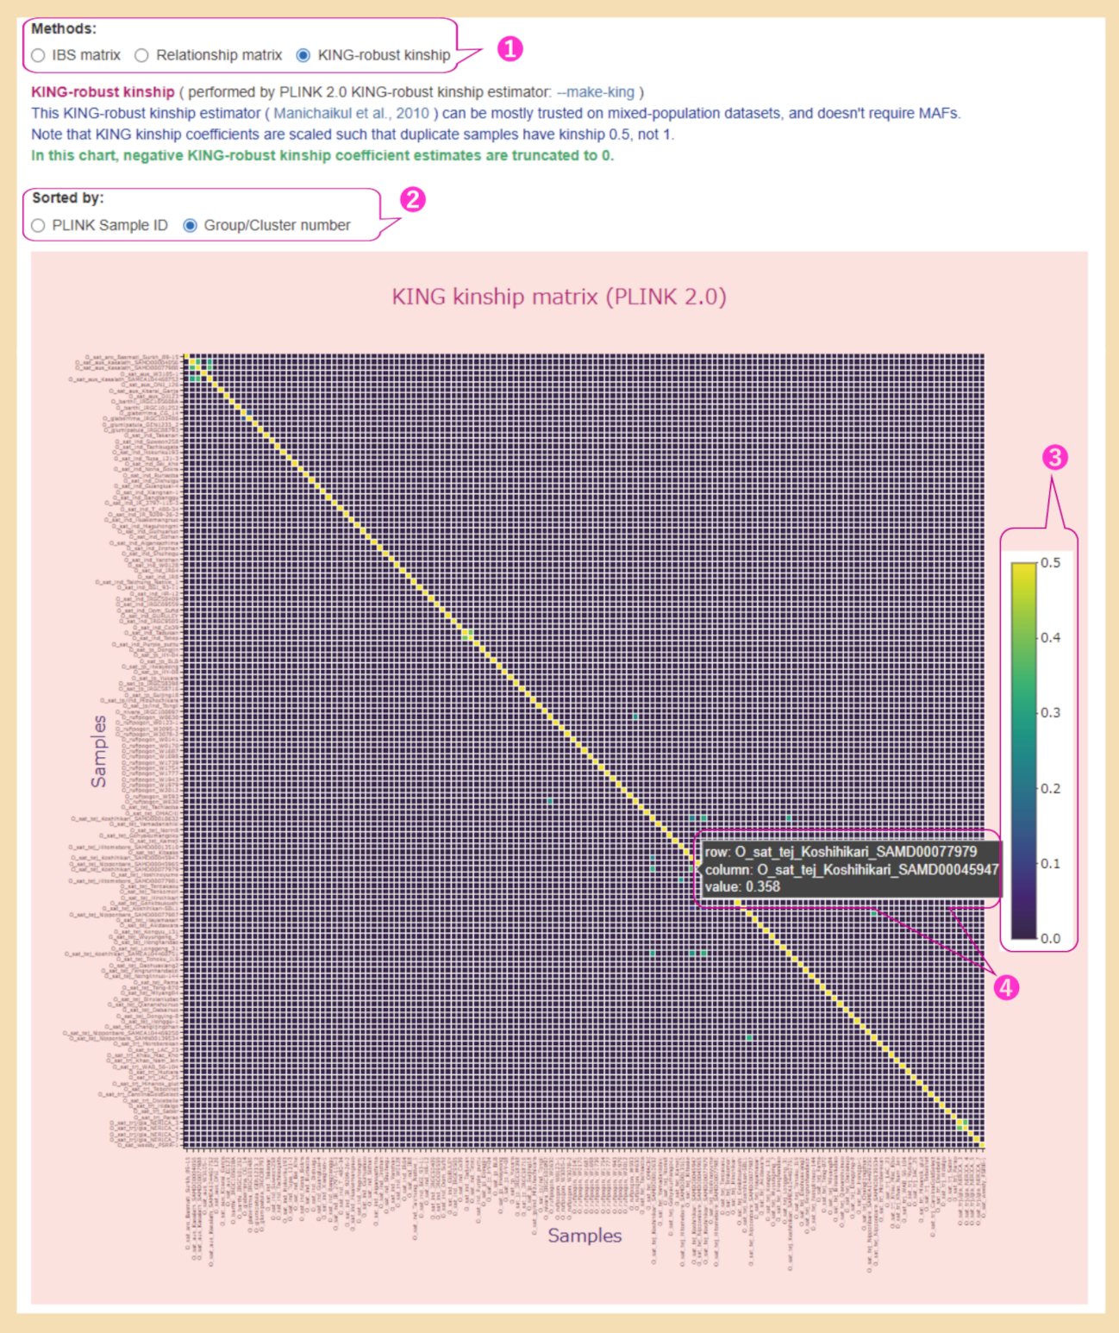
Fig. S8 User interface with the heatmap of KING-robust kinship coefficients
KING-robust kinship coefficients were estimated for data that were not pruned for LD, and the --maf value was set to 0.01 (Run B in Table 2). ① A radio button for choosing any of the three methods used for this type of analysis, of which the ‘KING-robust kinship’ value is selected; ② a radio button to select the sort order of the samples for the heatmap with the value ’Group/Cluster number’ selected; ③ the gradient color bar mapping colors to their corresponding values (note that the duplicate samples have a kinship 0.5, not 1); ④ the KING-robust kinship coefficient for pairs of samples and their IDs/names displayed by hovering the mouse over the colored square. The interactive heatmap represents the KING-robust kinship matrix for 141 accessions of rice varieties, in which the samples are ordered by ‘Group/Cluster number’.

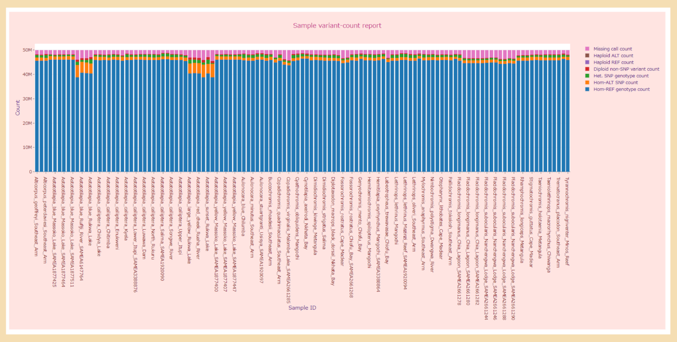
Fig. S9 The interactive stacked bar chart for the ‘Sample variant-count report’ from the ‘Basic statistics’ tab
The interactive stacked bar chart displays the ‘Sample variant-count report’ for the original dataset of 119 accessions of Malawi cichlids, reporting the number of observed variants subdivided into various classes. The parameters used are listed in Table 2 (Run F). The classes of observed variants are shown in the legend of the stacked bar chart. Most of the observed variants belonged to the ‘Hom-REF genotype’ class when the reads were mapped to the M_zebra_UMD2a reference genome (RefSeq assembly accession: GCF_000238955.4; BioProject: PRJNA60369).

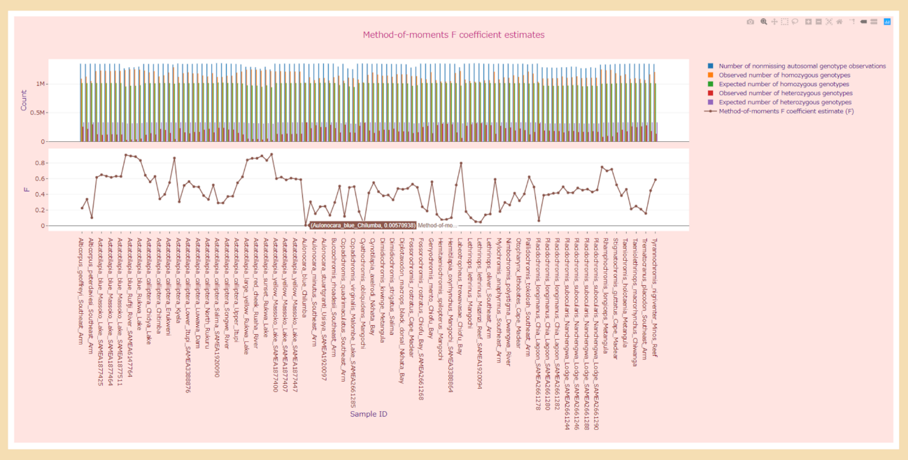
Fig. S10 Multiple subplots for the ‘Method-of-moments F coefficient estimates’ report from the ‘Basic statistics’ tab
Interactive multiple subplots, namely the grouped bar chart and line plot, display the ‘Method-of-moments F coefficient estimates’ report for the ‘After filtering’ dataset of 119 accessions of Malawi cichlids (Run F in Table 2). Each column of the report is listed in the legend and is shared across multiple subplots. The low expected heterozygosity seen in this figure indicates high homozygosity and low genetic diversity in Malawi cichlids.

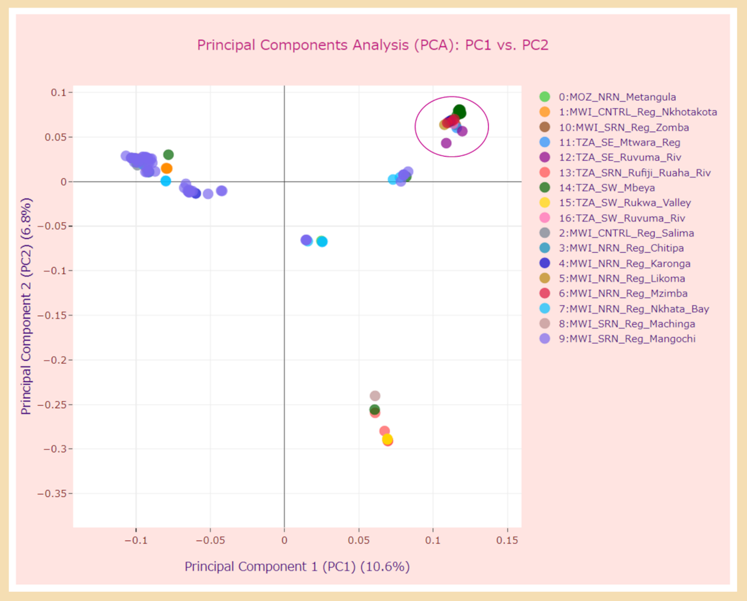
Fig. S11 PCA plot with data points colored according to sampling locations.
The interactive 2-component PCA plot displays the first and second principal components (PC1/PC2) for the 119 accessions of Malawi cichlids. The parameters used are listed in Table 2 (Run F). The colors of the data points correspond to the 17 groups (we divided the samples depending on the geographic location of the places where they were taken; see the Supplementary Notes for details). The groups that were separated from each other by the first and second principal components correlated well with the eco-morphological groups. The group of the Astatotilapia calliptera species is indicated in the figure by an oval.

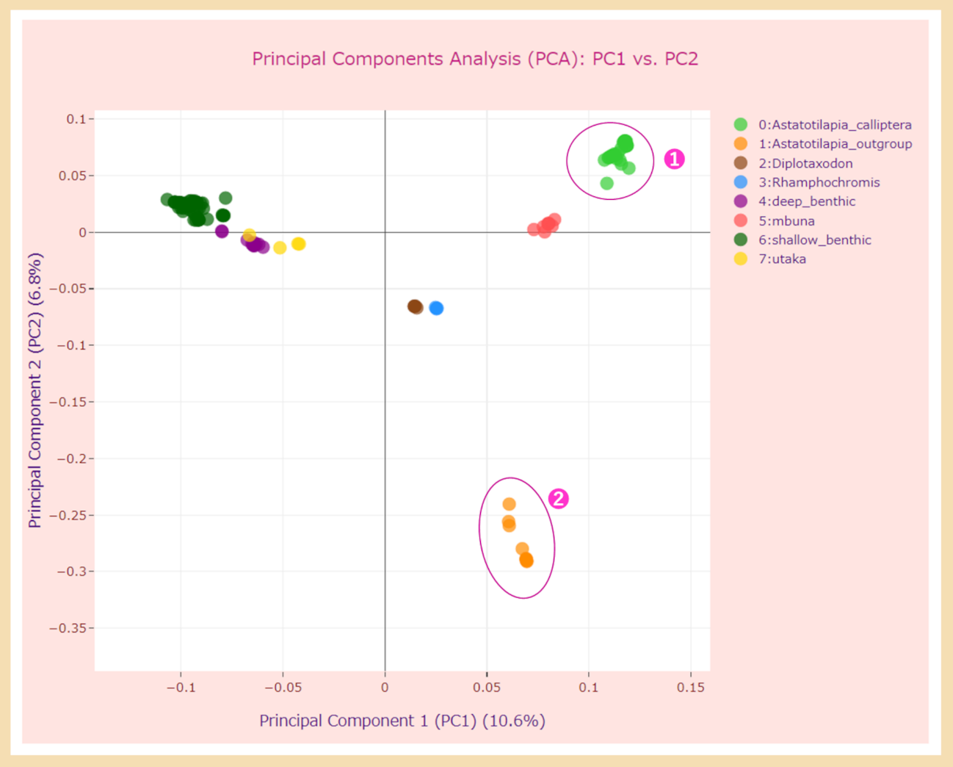
Fig. S12 PCA plot with data points colored according to eco-morphological groups.
The interactive 2-component PCA plot displays the first and second principal components (PC1/PC2) for the 119 accessions of Malawi cichlids. The parameters used are listed in Table 2 (Run G). ① The group of samples of Astatotilapia calliptera species; ② the samples from the ‘outgroup Astatotilapia’. The colors of the data points correspond to the seven eco-morphological groups of Malawi cichlids and the ‘outgroup Astatotilapia’, which consists of the individuals of the Astatotilapia calliptera species, but lives in an area outside the Lake Malawi catchment. The groups that were separated from each other by the first and second principal components correlated well with the eco-morphological groups indicated by corresponding colors.

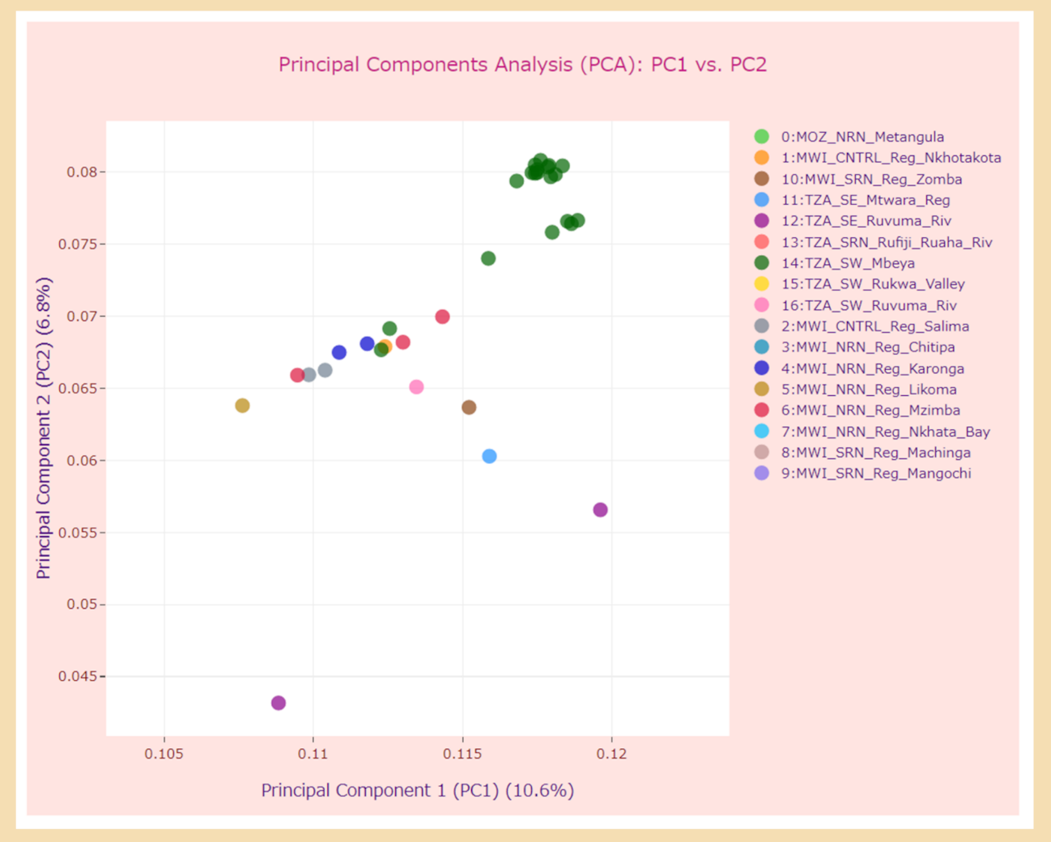
Fig. S13 PCA plot for the Astatotilapia calliptera species with data points colored according to sampling locations
The interactive 2-component PCA plot for the first and second principal components (PC1/PC2) for 119 accessions of Malawi cichlids displayed the same dataset as that in Fig. S11 but is zoomed in on the group of Astatotilapia calliptera species, indicated by an oval in Fig. S11. The parameters used are listed in Table 2 (Run F). For some individuals, an association between genetic similarity and sampling locations can be seen in this plot.

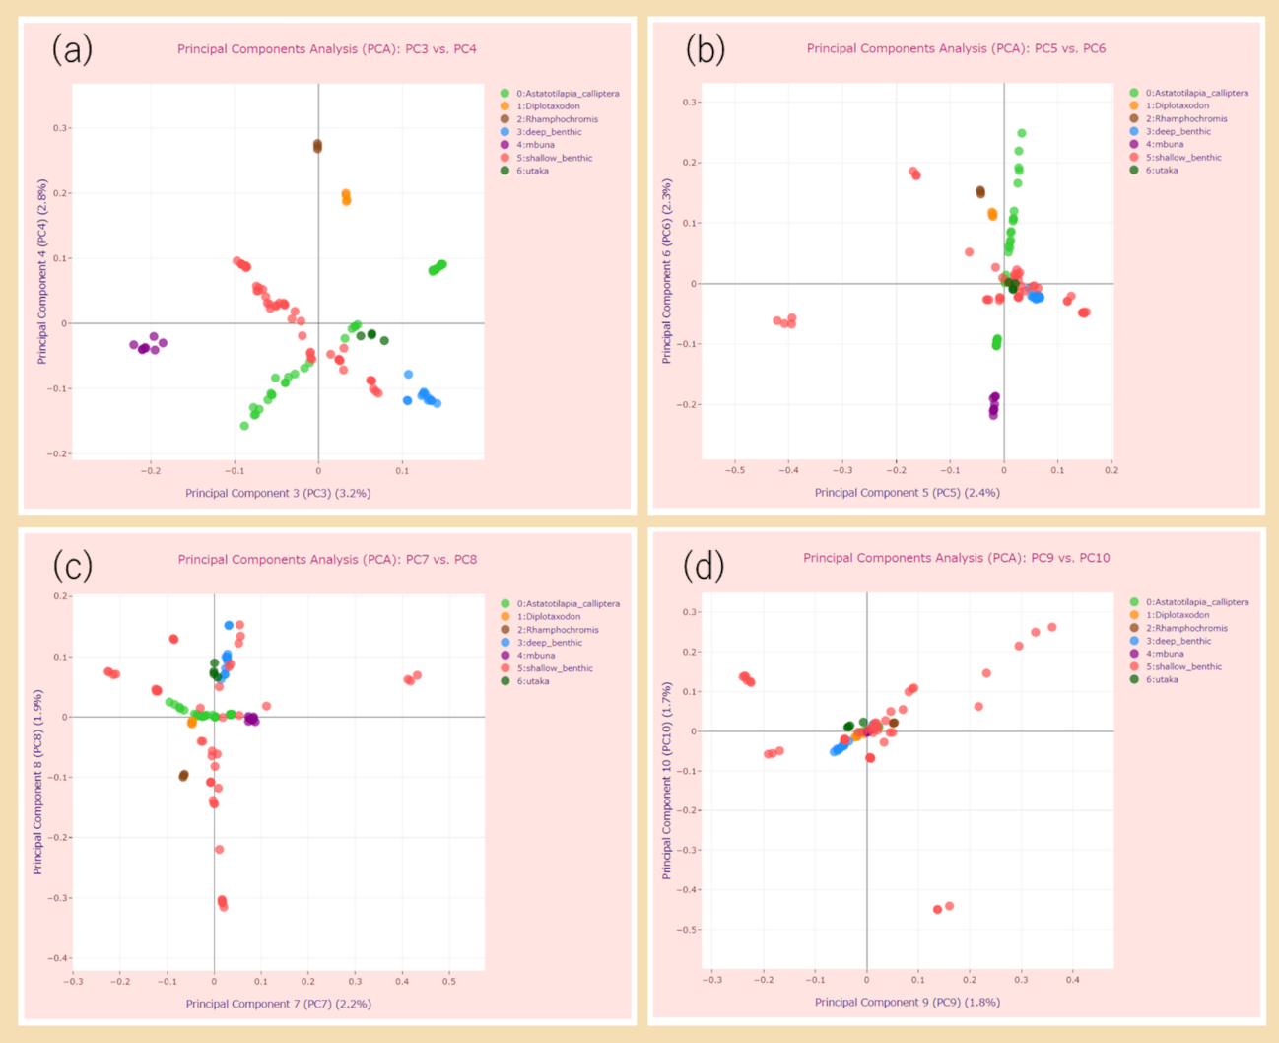
Fig. S14 The 2-component PCA plots of top 3-10 principal components for 109 accessions of Malawi cichlids
The parameters used are listed in Table 2 (Run H). The data point colors correspond to seven eco-morphological groups. The 2-component PCA plot for the first and second principal components (PC1/PC2) for the same dataset are shown in Fig. 9.

Supplementary Tables
Supplementary Table 1 List of parameters used in the pipeline configuration file
Note: ª represents the version of the PLINK executable used in our pipeline; ^{b} denotes a quotation from the PLINK 2.0 User Manual (https://www.cog-genomics.org/plink/2.0/); ^{c} denotes a quotation from the PLINK 2.0 Command-line help; and ^{d} denotes a quotation from the PLINK 1.9 User Manual (https://www.cog-genomics.org/plink/1.9/).

Supplementary Table 2 BioSample, BioProject, and SRA accessions of the rice varieties used in the case study
Note: ª represents the BioSample accession numbers from the BioSample database (https://www.ncbi.nlm.nih.gov/biosample/); ^{b} represents the BioProject accession numbers from BioProject (https://www.ncbi.nlm.nih.gov/bioproject/); and ^{c} represents the SRA accession numbers from the Sequence Read Archive (SRA) based on the source database (SRA, European Bioinformatics Institute (EBI), or DNA Data Bank of Japan (DDBJ)).

Supplementary Table 3 BioSample, BioProject, and SRA accessions of Malawi cichlids used in the case study
Note: ª represents the BioSample accession numbers from the BioSample database (https://www.ncbi.nlm.nih.gov/biosample/); ^{b} represents the BioProject accession numbers from BioProject (https://www.ncbi.nlm.nih.gov/bioproject/); and ^{c} represents the SRA accession numbers from the Sequence Read Archive (SRA) based on the source database (European Bioinformatics Institute (EBI)).

Supplementary Table 4 List of rice samples with their names and BioSample accession numbers and groups
Note: The asterisk (*) represents the data used in the PSRelIP pipeline.

Supplementary Table 5 List of Malawi cichlid samples with their names, BioSample accession numbers, and groups.
Note. Eco-morphological group: We grouped the samples into seven eco-morphological groups based primarily on Malinsky et al. (2018) [37] and additional information from Duncan and Martin (2019) [48]. Additionally, we added one more group such as the ‘outgroup Astatotilapia’. Geographic location of the sampling site and Group abbreviation (sampling location): Using the information on sampling locations recorded in the NCBI BioSample database as the value of the description field, we divided the samples into 17 groups according to the geographic location of the locations where they were taken. We grouped sampling locations by country, geographic regions within those countries, and administrative divisions within them. The asterisk (*) represents the data used in the PSRelIP pipeline.

Additional References:
- Brawand D, Wagner CE, Li YI, Malinsky M, Keller I, Fan S, et al. The genomic substrate for adaptive radiation in African cichlid fish. Nature. 2014;513(7518):375-81. doi:10.1038/nature13726.
- Butler D. Facts About Eigenvalues By Dr David Butler. https://www.adelaide.edu.au/mathslearning/ua/media/120/evalue-magic-tricks-handout.pdf. Accessed 14 Mar 2022.
- Parellada A. Why is the sum of eigenvalues of a PCA equal to the original variance of the data? CrossValidated, StackExchange. https://stats.stackexchange.com/questions/266864/why-is-the-sum-of-eigenvalues-of-a-pca-equal-to-the-original-variance-of-the-dat (2019). Accessed 14 Mar 2022.
- Duncan EE, Martin JG. Adaptive diversification of the lateral line system during cichlid fish radiation. iScience. 2019;16:( )1-11. doi:10.1016/j.isci.2019.05.016.

