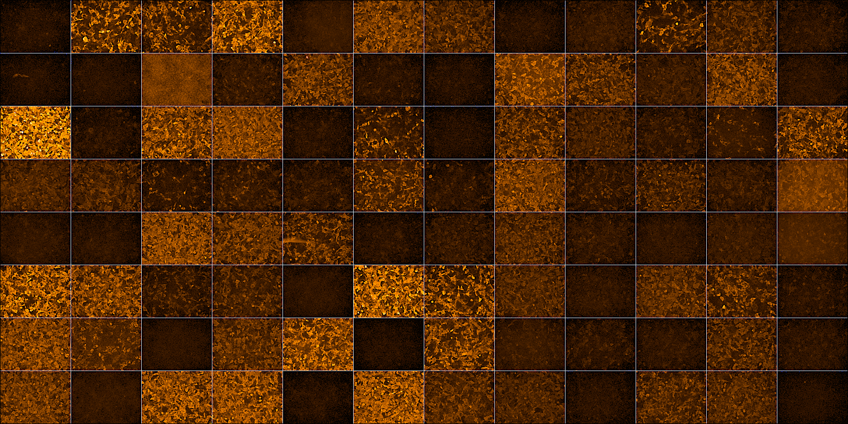

Cell-ELISA screening of mAbs raised from immunized guinea pigs. Each HEK293 cell culture medium containing a mAb was used to assess its reactivity with CoV-2-NP expressed in HEK293 cells. Representative immunofluorescent images taken by the Operetta High Content Imaging System are shown.

