Supporting Information

Photoelectrocatalytic Treatment and Resource Utilization of Industrial Waste Salt for Chlor-Alkali Electrolysis

Huan Zhou¹, He Zhou², Langlang Tang², Xinlin Hong¹

¹ Department of Physical Chemistry, College of Chemistry and Molecular Science, Wuhan University, Luojiashan 16#, 430072, Wuhan, China.

² Chibi Research Institute for High-Quality Development, Xianning, China.

E-mail:
Xinlin Hong: hongxl@whu.edu.cn;
He Zhou: zhouhe2017@hust.edu.cn;

1 HPLC analysis on waste salt
Mobile phase: 0.27 g potassium dihydrogen phosphate was dissolved in a mixture of 970 ml water and 30 ml methanol, and then the pH of the solution was adjusted between 2 and 3 with phosphoric acid solution（φ=50%, φ refers to mass percentage).
HPLC conditions: The chromatographic column used is a 4.6×250 mm ZORBAX ion exchange column (SAX, Agilent, USA) with the flow rate of mobile phase of 1.5 ml min⁻¹, its temperature kept at 25±2 ℃, and the wavelength of the UV detector of 195 or 215 nm. In case of no special mark in the figure, the detection wavelength should be 215 nm, the volume of the injected sample be 20 μL, and the NaCl concentration of the waste salt sample (noted as “salt” in the figure legends), prepared with the mobile phase, be 10 mg ml⁻¹ by default. For example, the “salt + 0.01 mg mL⁻¹ KNO₃” in Fig. 1c means that the sample contains 10 mg mL⁻¹ waste salt and 0.01 mg mL⁻¹ KNO_{3.}

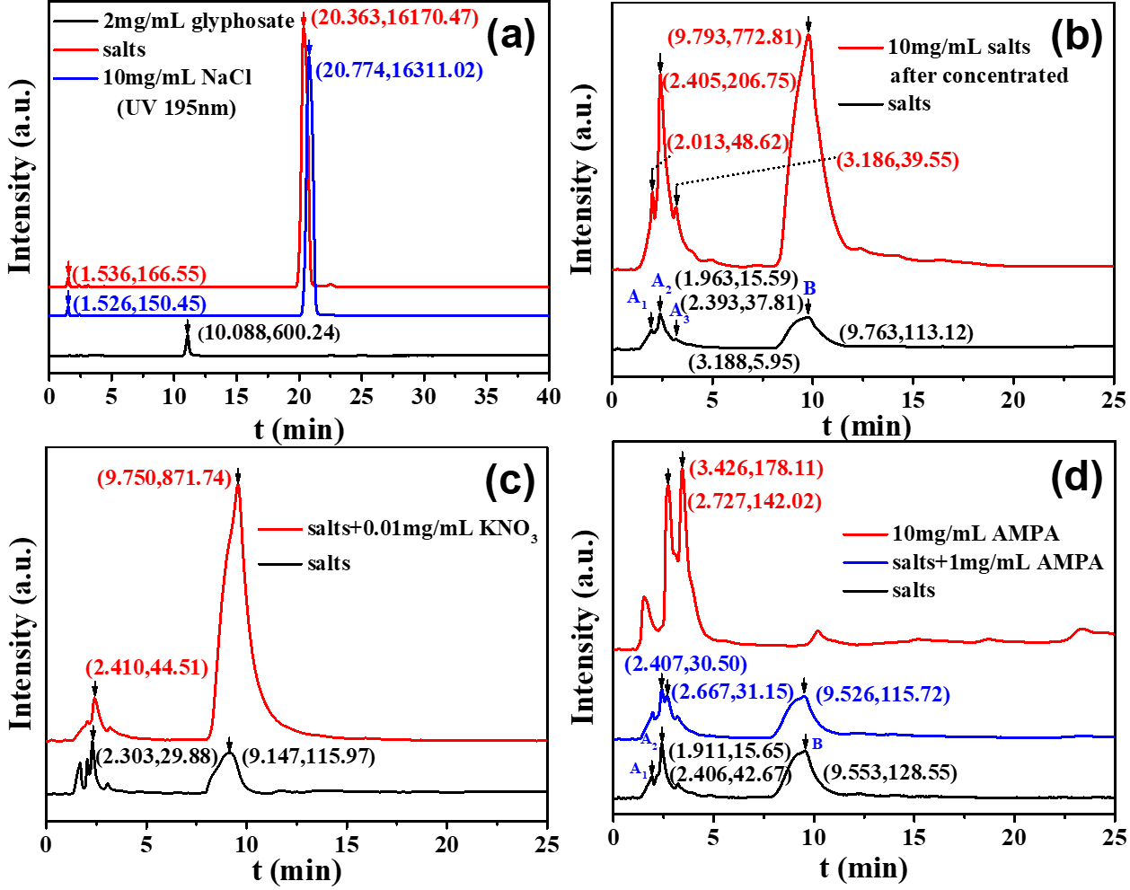
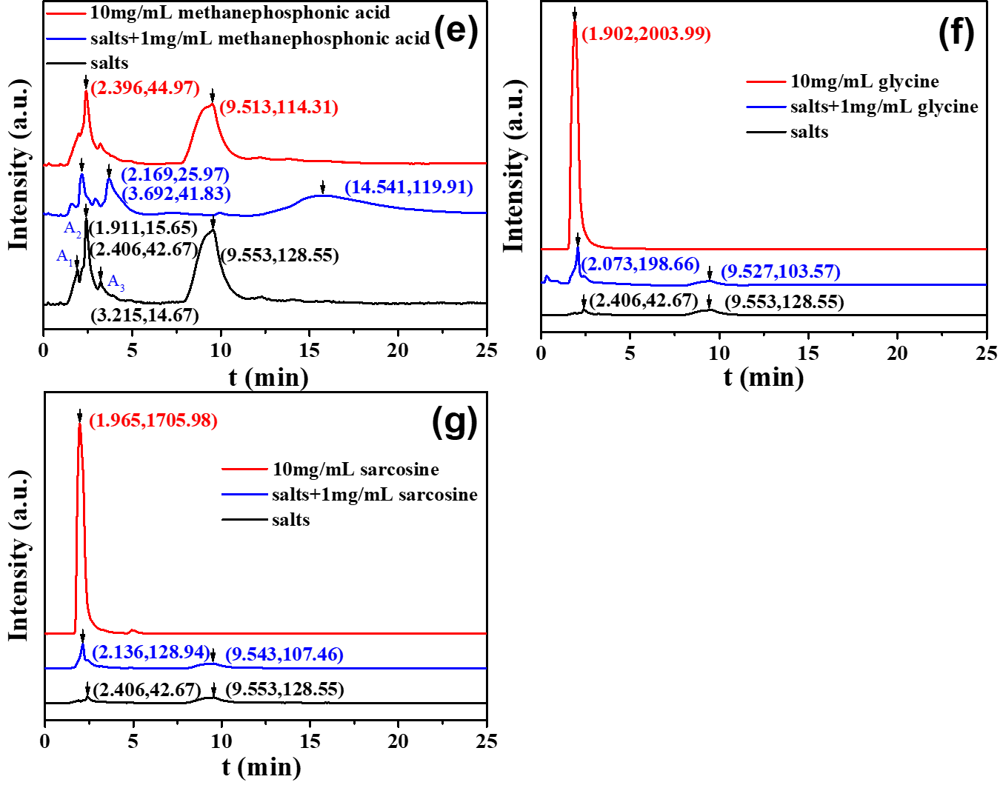
Fig. S1 HPLC patterns of different samples

The results of HPLC analysis on various samples are shown in Fig. S1 The retention time and integral area of the peaks are marked in brackets. As shown in Fig. S1a and Fig. S1b, no glyphosate signal was detected in the waste salt at the detection wavelength of 195 nm, while the Cl⁻ signal is very strong, which interferes the detection of other components; at 215 nm, the Cl⁻ signal disappears, four peaks contributed from other components in the waste salt are obvious, and the peak area increases proportionally after concentration. They are successively recorded as A₁, A₂, A₃ and B according to the retention time. It can be deduced from Fig. S1c that the peak B is a sign of NO₃⁻, and according to Fig. S1d-g, the waste salt does not contain AMPA and methanephosphonic acid, and the retention time of peak A₁ is close to that of glycine and sarcosine, indicating that A₁ may be assigned to glycine or sarcosine or others with similar molecular structures. A₂ and A₃ components need to be further studied.

2 Photoelectrocatalysis (PEC)

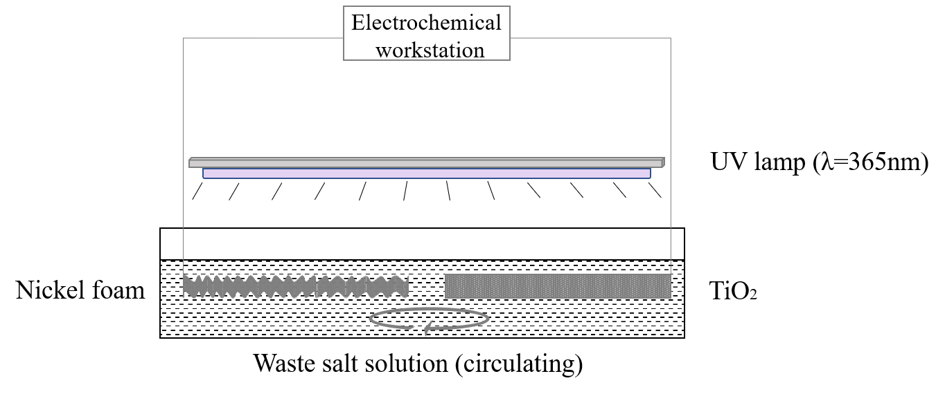
Fig. S2 Schematic diagram of the photoelectrocatalytic oxidation device

3 Chlor-alkali electrolysis device

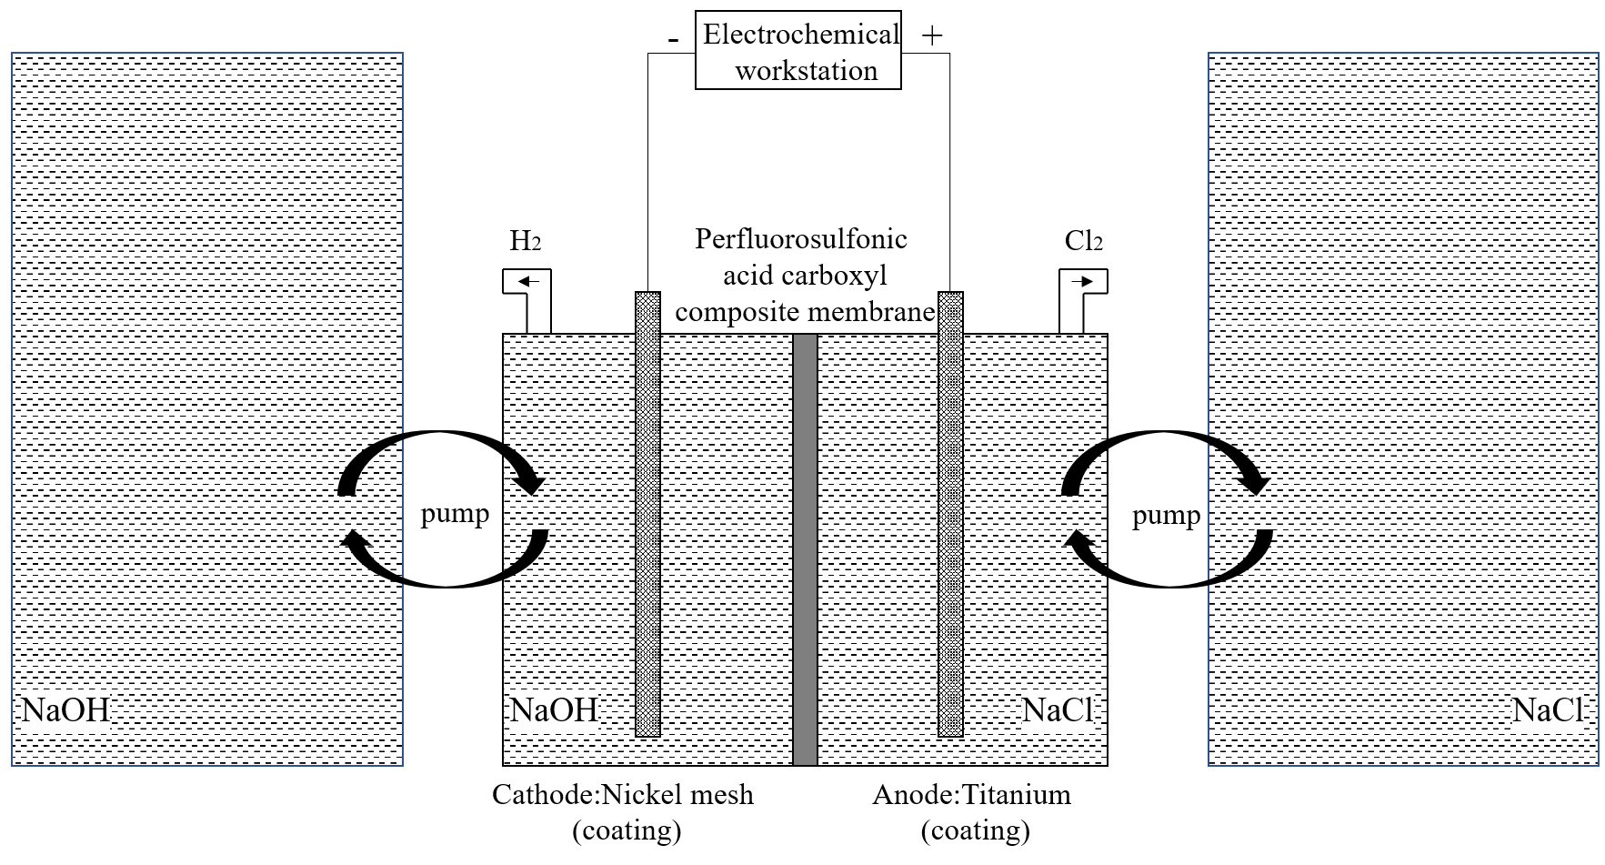
Fig. S3 Schematic diagram of the chlor-alkali electrolysis device

4 Characterization of waste salt

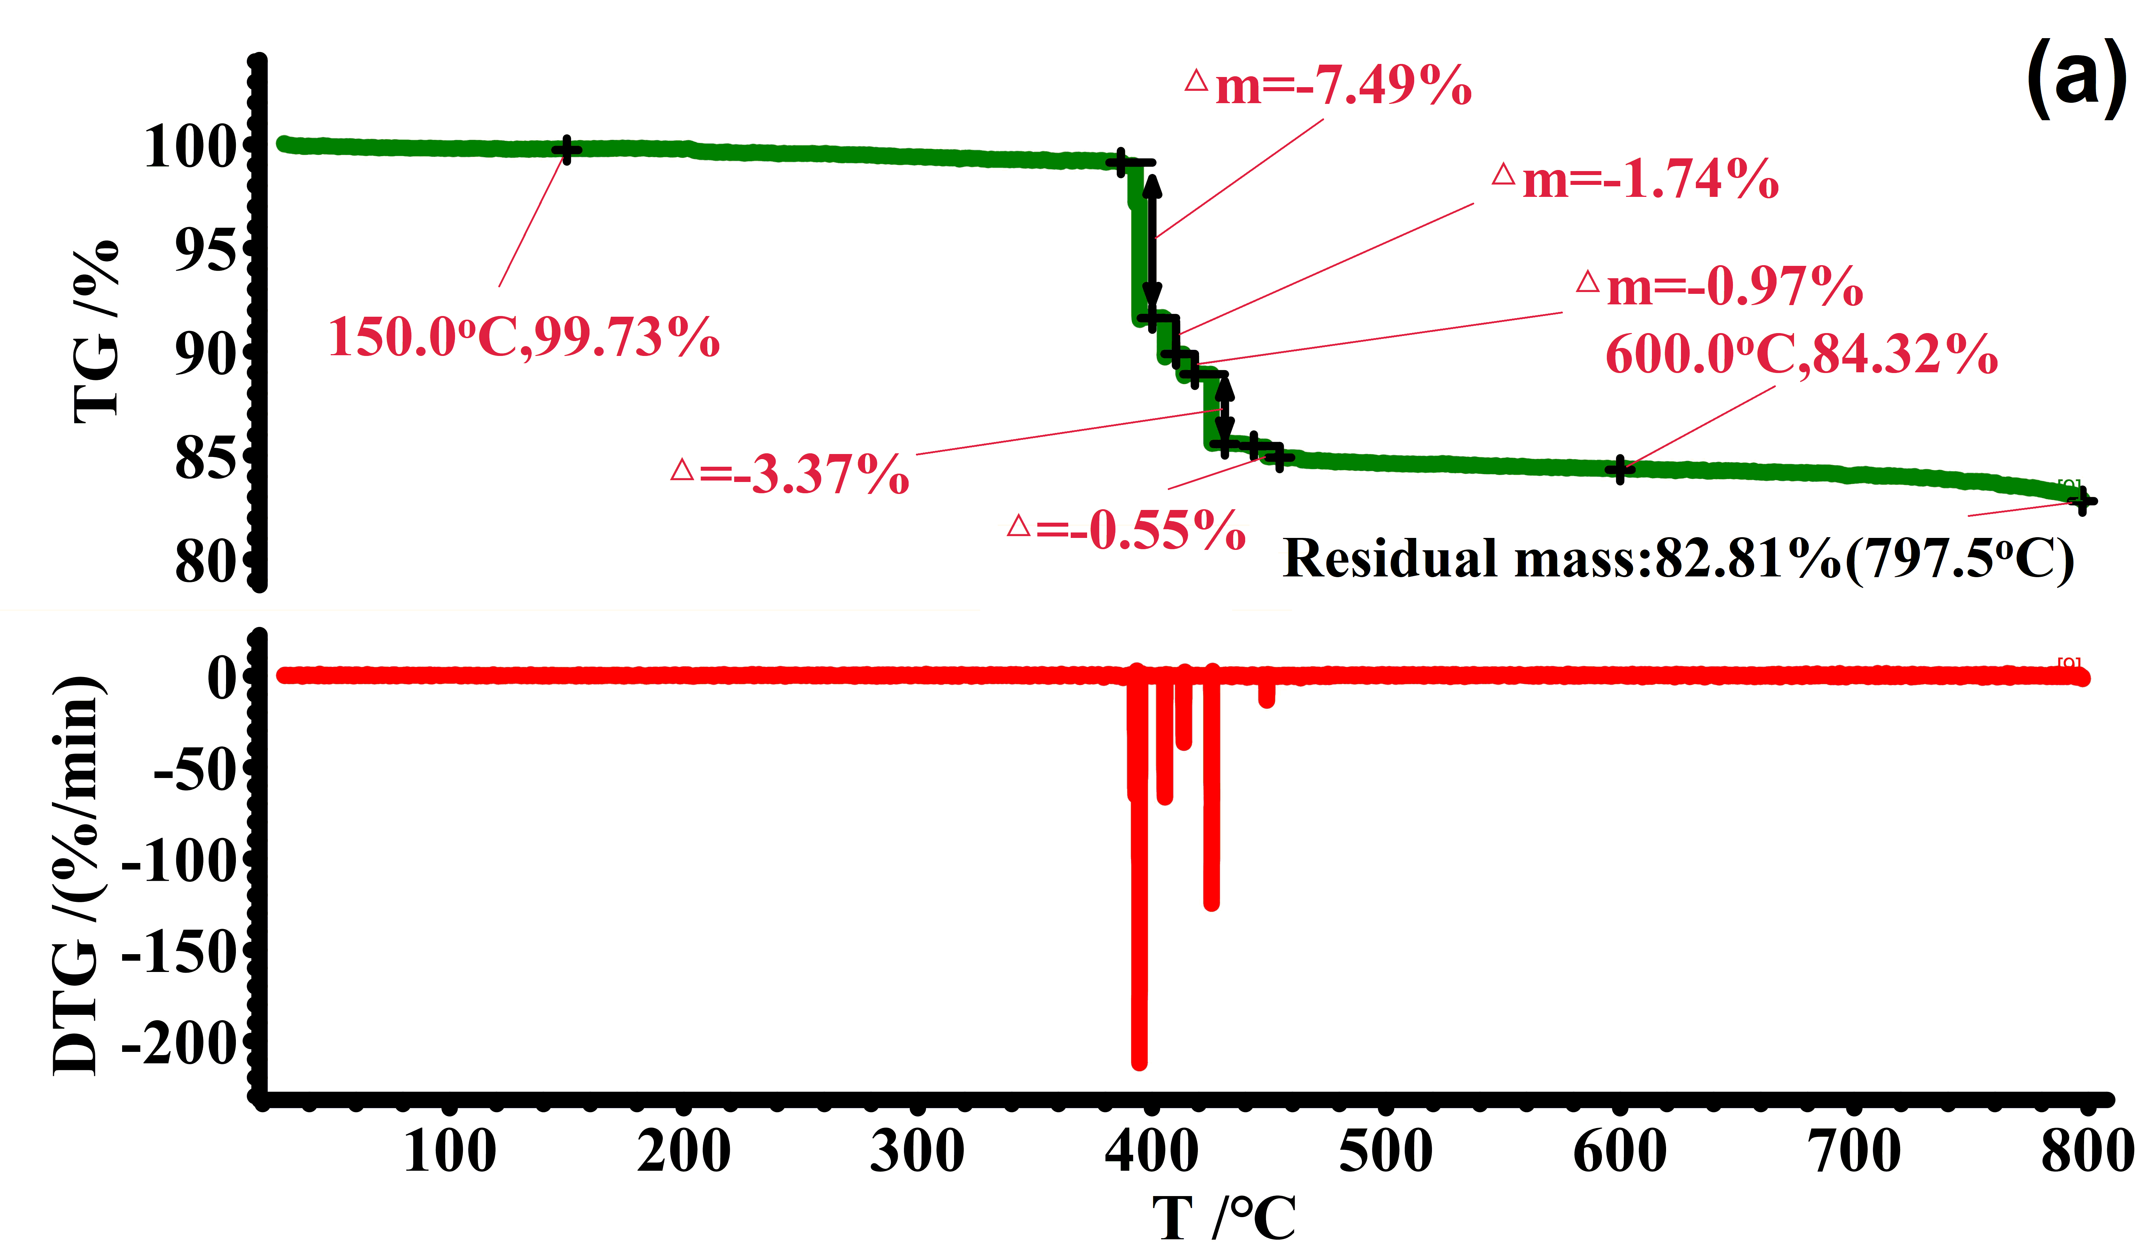
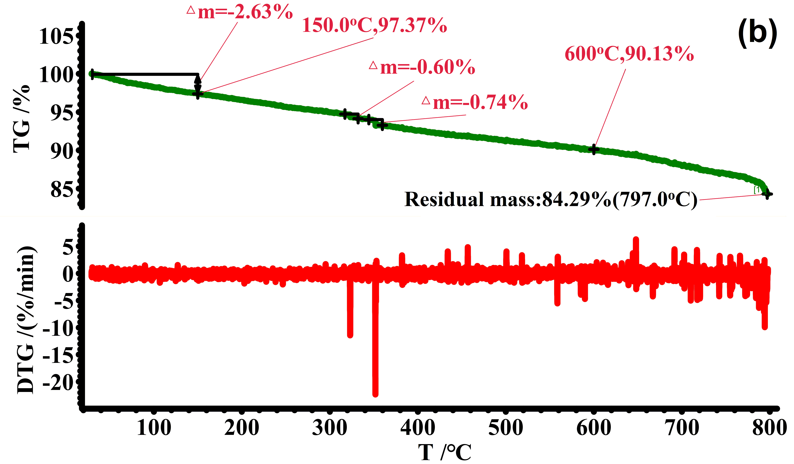
Fig. S4 TG and DTG curves of a analytical reagent NaCl salt and b waste salt.

5 Comparison between PEC and photocatalysis (PC)

Fig. S5 Variation of the TOC degradation ratio as a function of reaction time in 100-h photoelectrocatalytic process

6 Verification of oxidation mechanism
6.1 Chlorine radical (Cl∙) capture

Fig. S6 EPR spectra for the detection of radicals trapped by the DMPO added into the electrolyte, which was treated through PEC of different duration.
6.2 Holes (h⁺) detection
Sodium oxalate was used as a hole scavenger, and methyl orange (MO) was chosen as the target pollutant so that the variation of their concentrations could be separately analyzed by HPLC and UV-vis absorption technique. Analytical regent NaCl was adopted for the preparation of salty wastewater. The composition of the salty wastewater (brine A) was 270 g L⁻¹ NaCl, 30 g L⁻¹ sodium oxalate, and 1 g L⁻¹ MO. And a solution (brine B) consisting of 270 g L⁻¹ NaCl and 1 g L⁻¹ MO was also prepared for comparison.
The self-made brine A and brine B were subjected to photoelectrocatalytic treatment at the constant voltage of 2.5 V for 1 h. The light source used was a UV lamp (20 W, 365 nm). At desired intervals, the solutions were sampled for the detection of sodium oxalate and MB concentrations.
To verify the non-selective oxidation of sodium oxalate and MB by active chorine species, NaClO was used to directly react with sodium oxalate and MB. An aqueous NaClO solution with the active chlorine content of 1% was prepared as oxidant. Different oxidant dosages of 0.1, 0.2, 0.4, 1 and 2 ml were added into 20 ml self-made brine A in parallel experiments, which reacted for 1 h under stirring. After reaction, the solutions were sampled for the detection of sodium oxalate and MB concentrations.
UV-vis absorption test: Before the tests, samples were diluted to an appropriate concentration with deionized water. The absorbance of brine A and brine B in the range from 190 to 900 nm was scanned to obtain the characteristic absorbance wavelength of MB at 463 nm. Then the absorbance of the samples at 463 nm was tested and accordingly the concentration of MB was calculated by using the value of blank saline as the background.
HPLC conditions: the mobile phase is 0.02 mol L⁻¹ KH₂PO₄ aqueous solution with its pH adjusted between 2 and 3 using phosphoric acid; the chromatographic column is a 4.6 mm×250 mm Zar Sax strong anion exchange column (SAX, Agilent, USA); the wavelength of the UV detector is 215 nm and the injection volume is 20 μL. The flow rate of mobile phase is 1.5 ml min⁻¹.

Fig. S7 The concentration changes of MO and sodium oxalate (Na₂C₂O₄) during a photoelectrocatalytic treatment and b NaClO oxidation

As revealed in Fig. S7, the oxidation of MO is inhibited in the presence of Na₂C₂O₄ during photoelectrocatalytic treatment, when directly oxidized by NaClO, the degradation efficiency of MB showed no obvious difference with or without the addition of Na₂C₂O₄, which corroborated that the holes played an important role in the photoelectrocatalytic process.

7 Chlor-alkali electrolysis
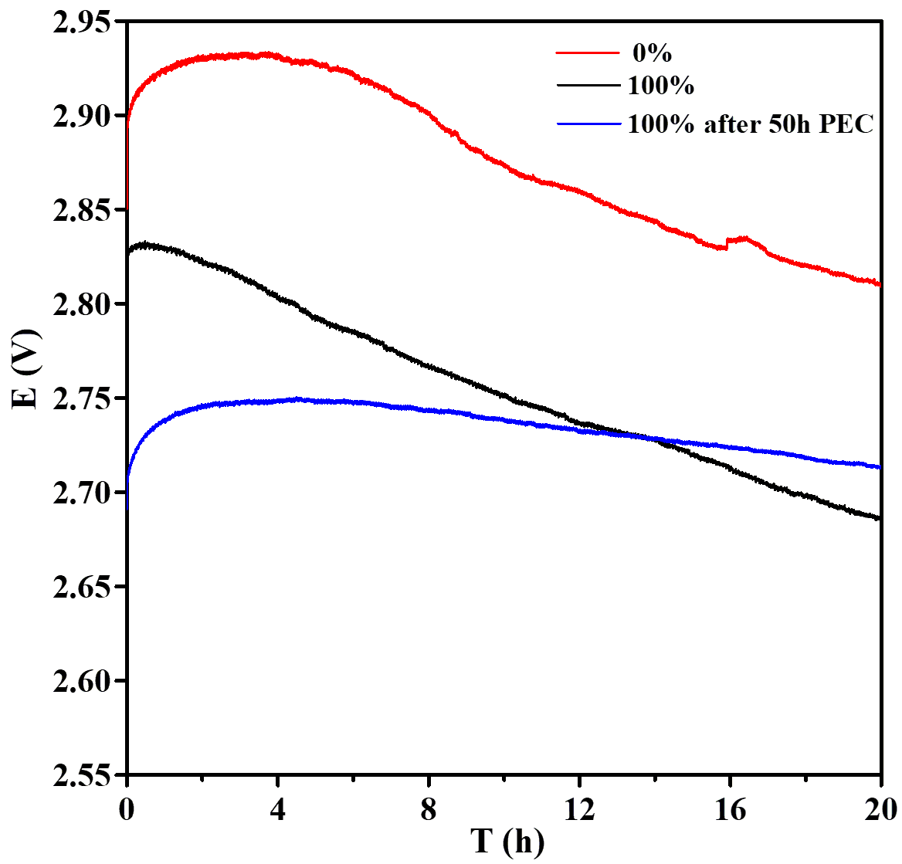
Fig. S8 E-t curves of chlor-alkali constant current electrolysis of waste salt before and after photoelectrocatalytic treatment.

