Supplemental Figure 1

a)
b)

Characterization of senescence. s) Percentage of S phase cells during senescence. BrdU labelled cells were stained and analysed by flow cytometry. Percentage of cells gated in S phase of cell cycle was determined in serially passaged and in cells treated with TNF-α. b) Growth cure of HUVECs either serially passaged until replicative exhaust or proliferative arrest or chronically treated with inflammatory cytokine TNF-α as indicated

Supplemental Figure 2

Downregulation of cell cycle regulatory genes during senescence. Canonical pathway generated by IPA illustrates expression of cyclins and cdks which are essential for transition and regulation of G1/S and G2/M phase of cell cycle were down regulated during senescence. Green color represents decreased expression of the genes.

Supplemental Figure 3
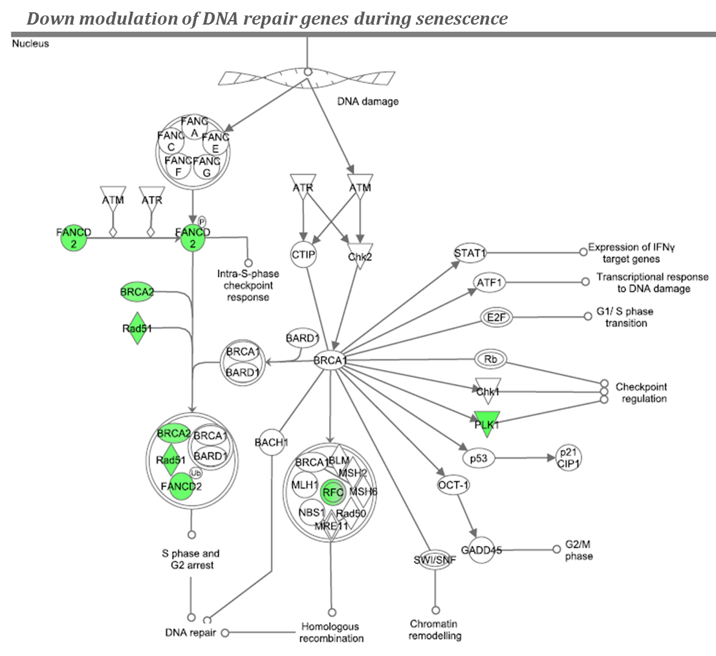

Defective DNA repair and replication regulates senescence. IPA generated pathway shows decreased expression of gene involved in DNA repair (RAD51, FANCD2, and BRAC2) and replication (RFC) during senescence. Green color denotes decreased expression of the genes

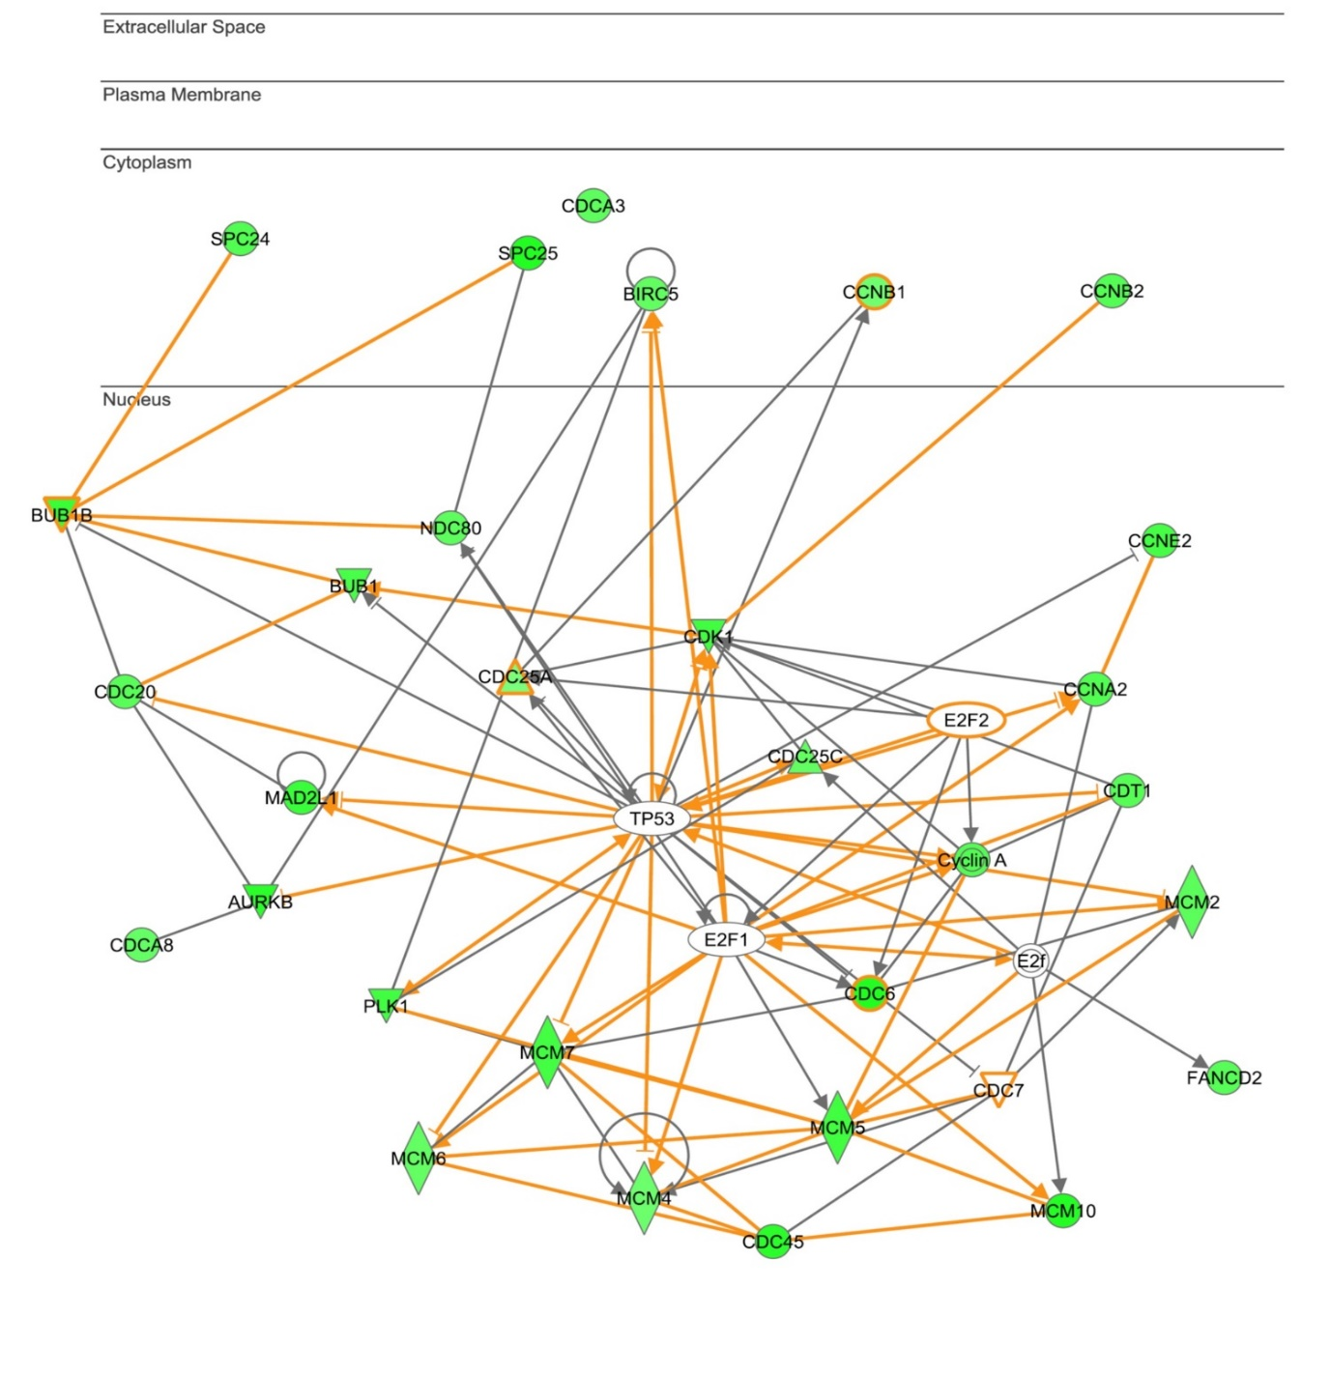
Supplemental Figure 4

Graphic representation of the network generated by IPA. Multiple genes down regulated during senescence are associated to transcriptional network connected to p53-E2F. Nodes represent genes and lines show the relationship between genes. Green color represents decreased expression of the genes.

