Supplementary Material

Changes in the South American Monsoon System since the Last Glacial Maximum

Igor Stivanelli Custódio¹, Pedro L. da Silva Dias¹, Ilana C. Wainer², Luciana F. Prado².
¹Instituto de Astronomia, Geofísica e Ciências Atmosféricas, Universidade de São Paulo, São Paulo, Brasil.
²Instituto Oceanográfico, Universidade de São Paulo, São Paulo, Brasil.
*igor.custodio@iag.usp.br

a 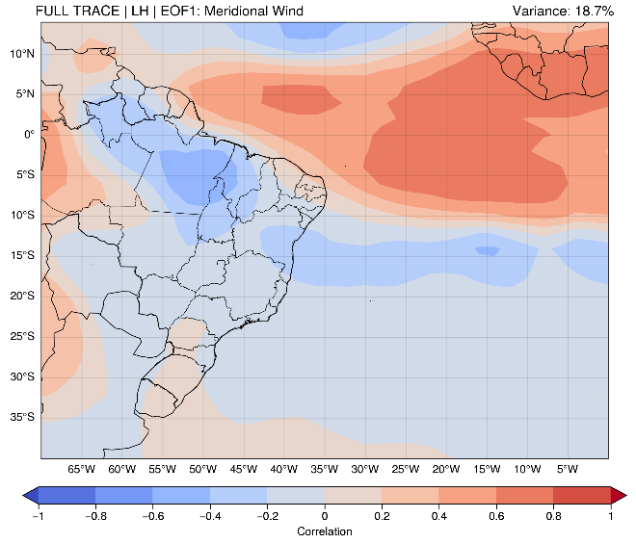 | b 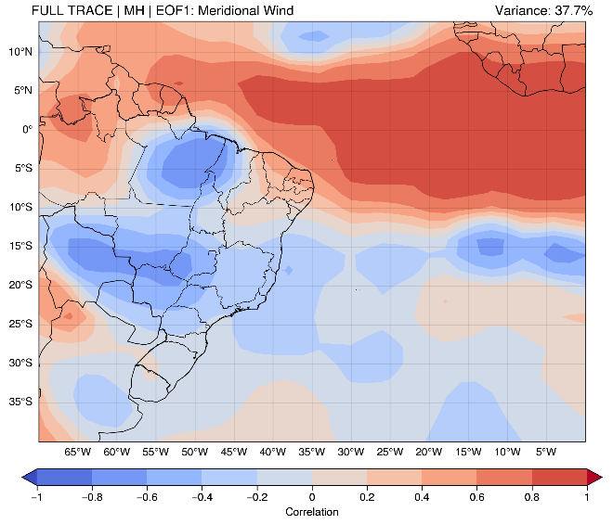
c 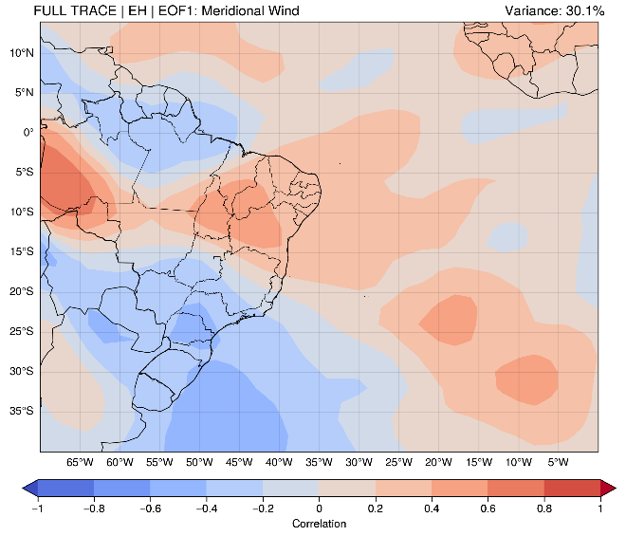 | d 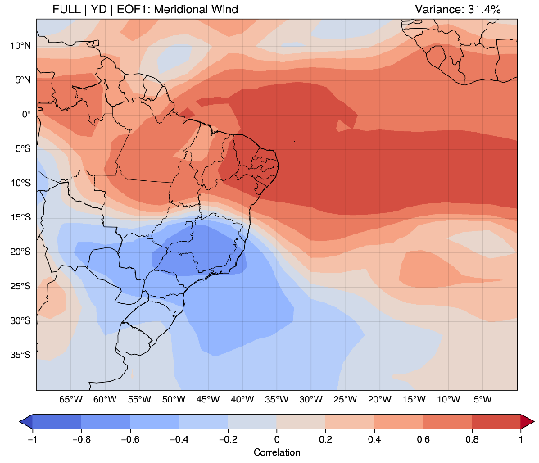
e 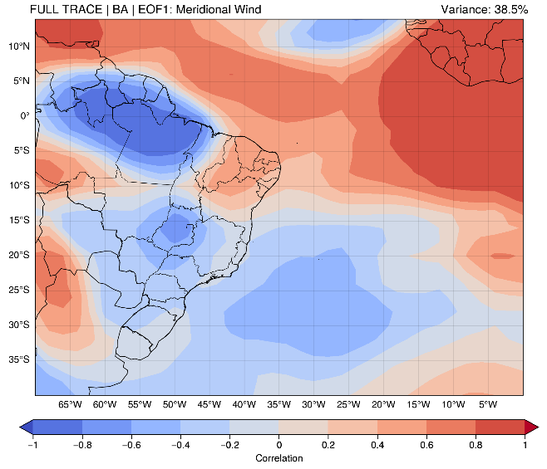 | f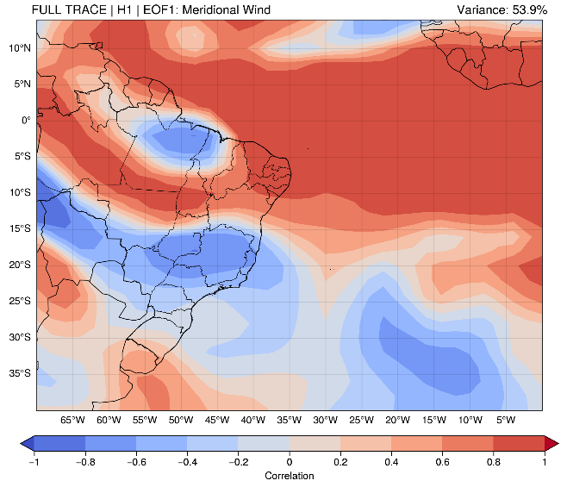
Fig. S1. Spatial patterns and time series of the expansion coefficients of the first variability mode of LISAM applied in TraCE-21k Full Forcing in the meridional wind variable, subdivided into the periods: a) Late Holocene (LH); b) Middle Holocene (MH); c) Early Holocene (EH); d) Younger Dryas (YD); e) Bølling–Allerød (BA); f) Heinrich Stadial 1 (H1). It also shows the location of the climatic proxies of the caves of: BOT: Botuverá; JAR: Jaraguá; LSF: Lapa Sem Fim; LG: Lapa Grande; PAI: Paixão; RAI: Rainha; PAR: Paraíso.

a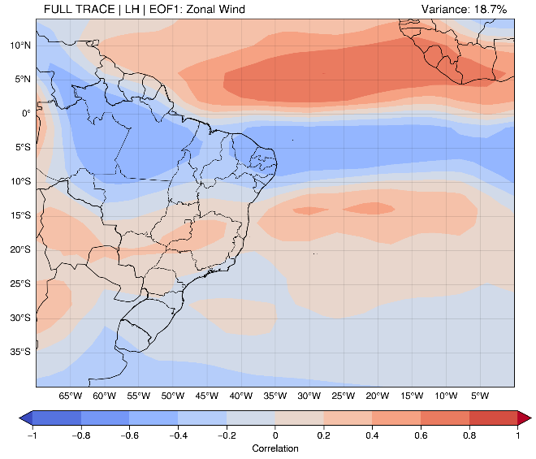 | b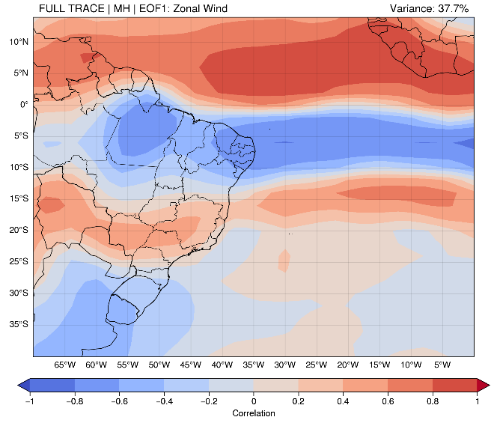
c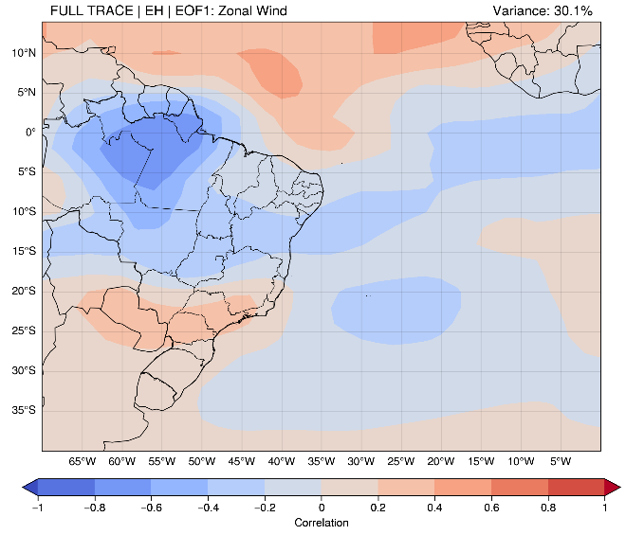 | d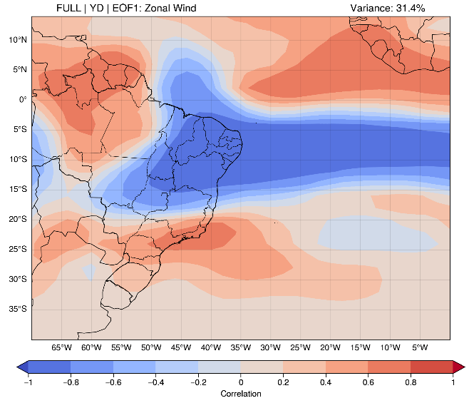
e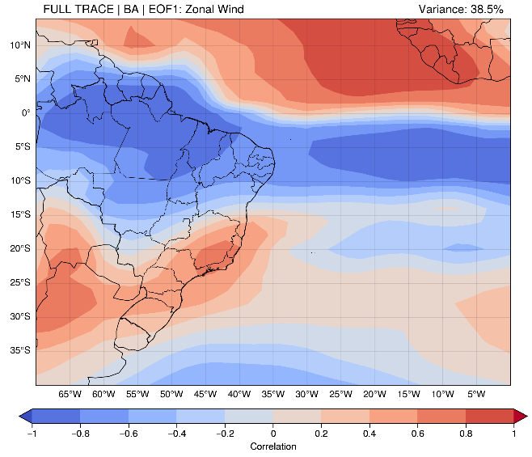 | f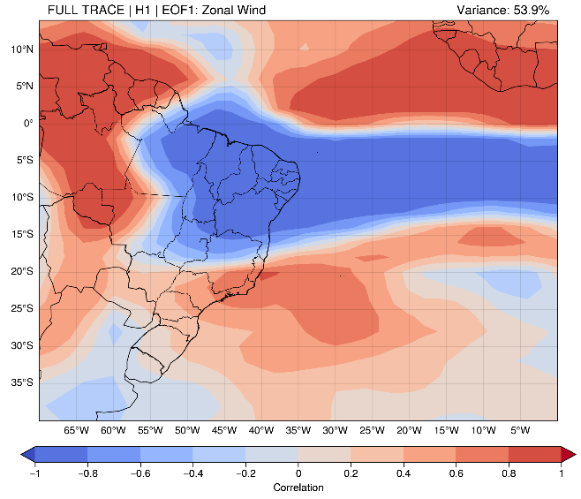
Fig. S2. Spatial patterns and time series of the expansion coefficients of the first variability mode of LISAM applied in TraCE-21k Full Forcing in the zonal wind variable, subdivided into the periods: a) Late Holocene (LH); b) Middle Holocene (MH); c) Early Holocene (EH); d) Younger Dryas (YD); e) Bølling–Allerød (BA); f) Heinrich Stadial 1 (H1). It also shows the location of the climatic proxies of the caves of: BOT: Botuverá; JAR: Jaraguá; LSF: Lapa Sem Fim; LG: Lapa Grande; PAI: Paixão; RAI: Rainha; PAR: Paraíso.
a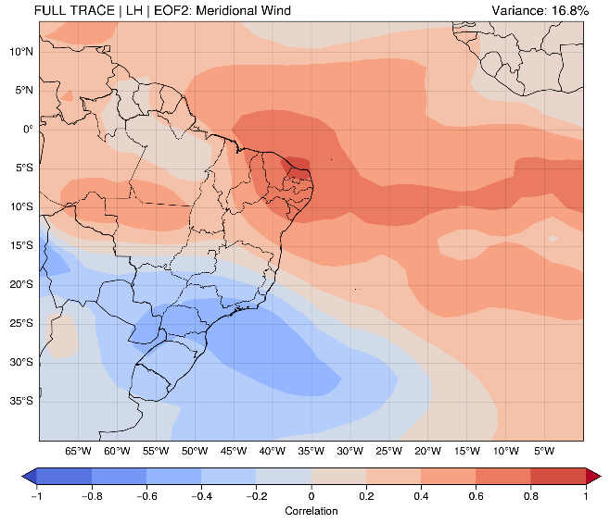 | b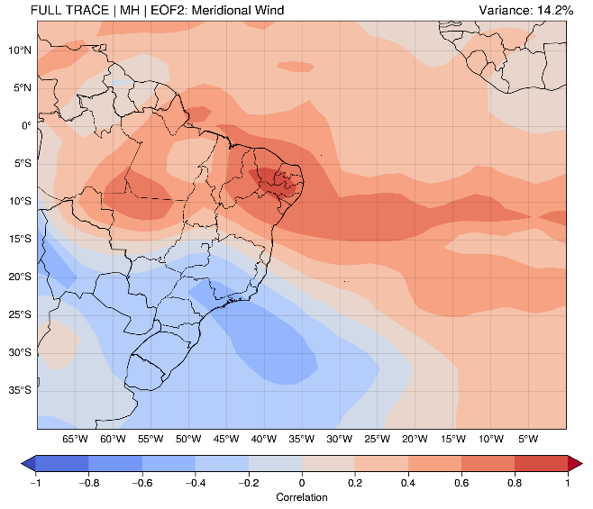
c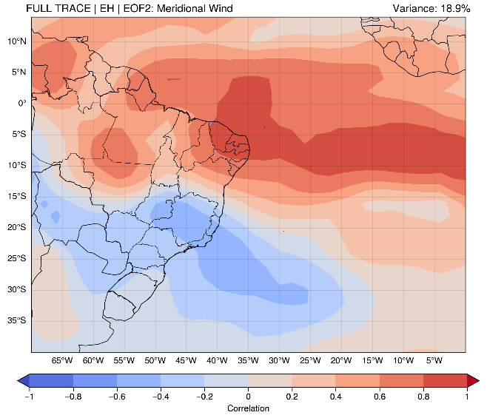 | d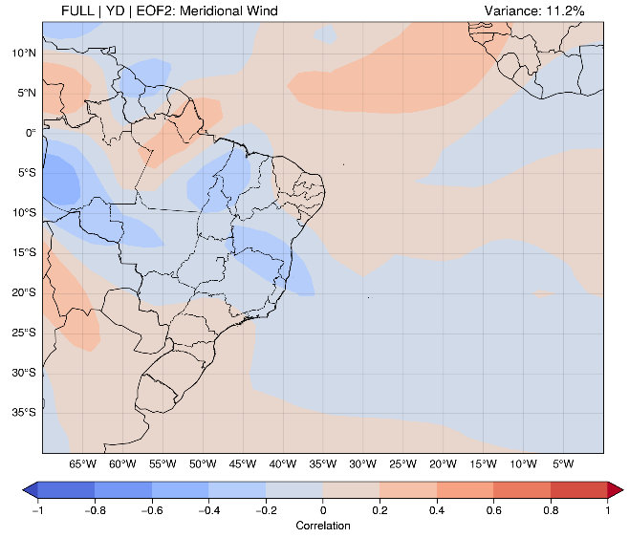
e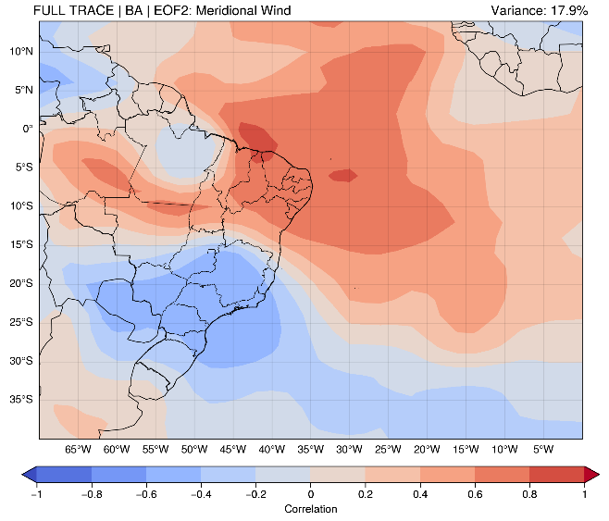 | f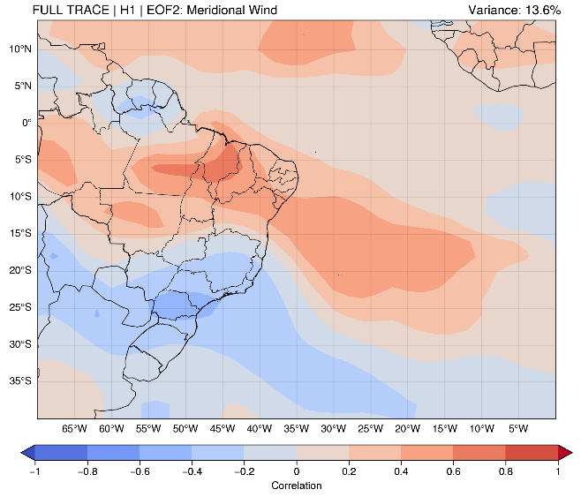
Fig. S3. Spatial patterns and time series of the expansion coefficients of the second variability mode of LISAM applied in TraCE-21k Full Forcing in the meridional wind variable, subdivided into the periods: a) Late Holocene (LH); b) Middle Holocene (MH); c) Early Holocene (EH); d) Younger Dryas (YD); e) Bølling–Allerød (BA); f) Heinrich Stadial 1 (H1). It also shows the location of the climatic proxies of the caves of: BOT: Botuverá; JAR: Jaraguá; LSF: Lapa Sem Fim; LG: Lapa Grande; PAI: Paixão; RAI: Rainha; PAR: Paraíso.

a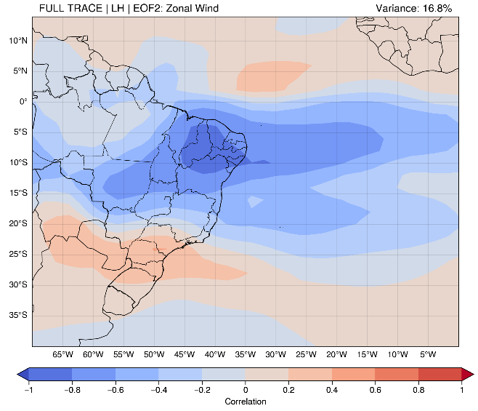 | b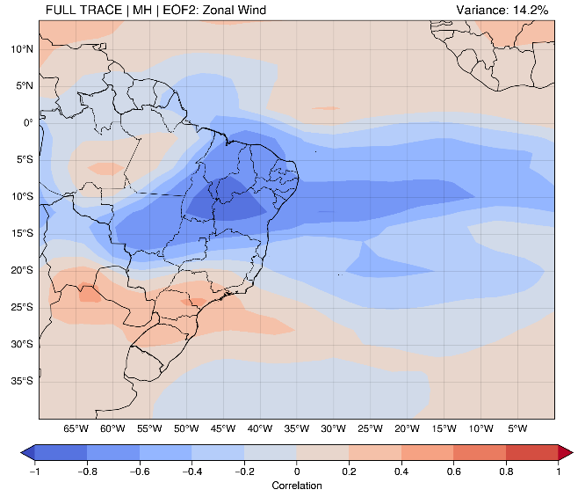
c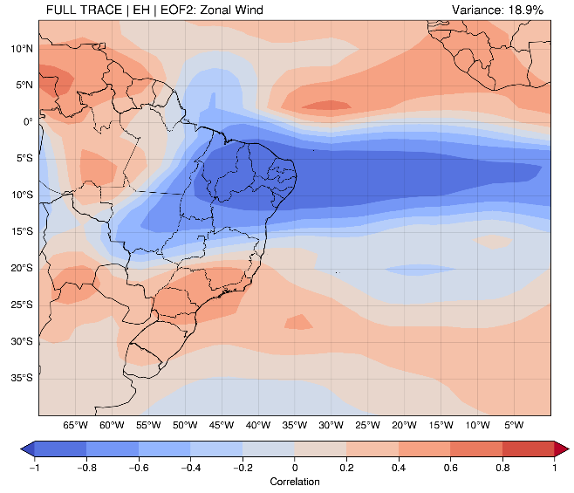 | d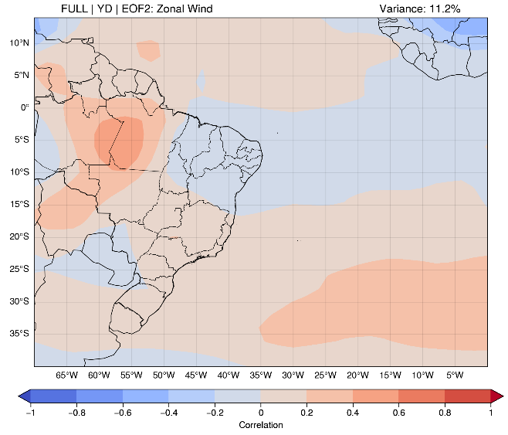
e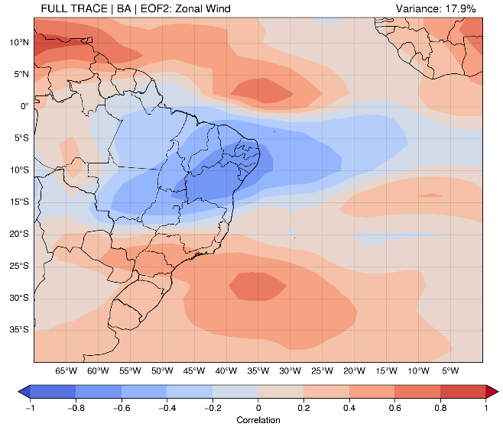 | f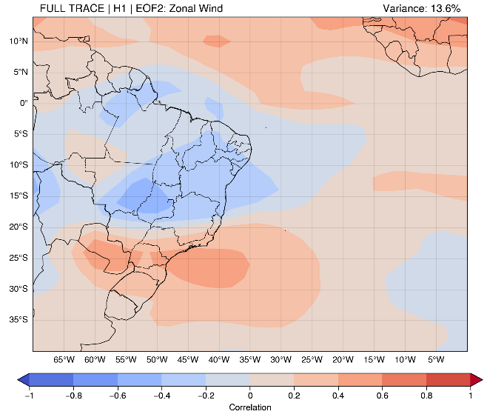
Fig. S4. Spatial patterns and time series of the expansion coefficients of the second variability mode of LISAM applied in TraCE-21k Full Forcing in the zonal wind variable, subdivided into the periods: a) Late Holocene (LH); b) Middle Holocene (MH); c) Early Holocene (EH); d) Younger Dryas (YD); e) Bølling–Allerød (BA); f) Heinrich Stadial 1 (H1). It also shows the location of the climatic proxies of the caves of: BOT: Botuverá; JAR: Jaraguá; LSF: Lapa Sem Fim; LG: Lapa Grande; PAI: Paixão; RAI: Rainha; PAR: Paraíso.

