Dimensionally Reduced Machine Learning Model for Predicting Single Component
Octanol-Water Partition Coefficients
David Kenney ª, Randy C. Paffenroth^{b}, Michael Timkoª, Andrew R. Teixeira ^{a,*}
- Department of Chemical Engineering, Worcester Polytechnic Institute, Worcester, Massachusetts 01609, United States
- Department of Mathematical Sciences, Worcester Polytechnic Institute, Worcester, Massachusetts 01609, United States
* Correspondence should be addressed to arteixeira@wpi.edu
Keywords: Molecular Formula, Feature Engineering, Model Optimization
Table of Contents
S2.2. Feature Engineering 3
Figure S1. Functional group occurance within overall dataset 3
S2.4. Hyperparameter Tuning 3
Table S1. Model parameters for pre-defined and tuned models 3
S2.6. Data Split and Training 3
Table S2. 2x3 Factorial design options 3
Table S3. 2x3 Factorial design matrix 4
Figure S2. $RMSE$ results for each model in the DoE matrix 4
Figure S3. $MAE$ results for each model in the DoE matrix 5
Figure S4. $R^{2}$ results for each model in the DoE matrix 5
S3.1. Dataset Discovery 6
Figure S5. Carbon number occurances 6
Figure S6. Hydrogen number occurances 6
Figure S7. Nitrogen number occurances 7
Figure S8. Oxygen number occurances 7
Figure S9. Sulfur number occurances 8
Figure S10. Phosphorous number occurances 8
Figure S11. Fluorine number occurances 9
Figure S12. Chlorine number occurances 9
Figure S13. Bromine number occurances 10
Figure S14. Iodine number occurances 10
Figure S15. $LogP$ number occurances 11
Figure S16. F-test anaysis for feature importances 11
Figure S17. Feature-feature and feature-response parity plot matrix 12
S3.2. Model Performances 12
Table S4. Averaged base perfomance parameters with standard deviation 12
Figure 18. Parity plots for model performances with feature engineering 13
Table S5. Averaged feature-engineered perfomance parameters with standard deviation 13
S3.3. Comparing Predictions by Compound Class 14
Figure S20. Top ten compounds with the largest and smallest absolute errors 14
Table S6. Comparison of predicted and experimental partition coefficients for the 10 worst predictions IUPAC Structure 15

S2.2. Feature Engineering
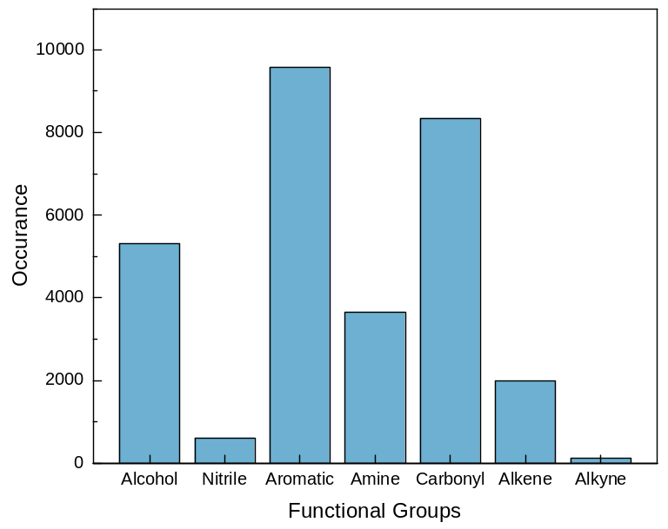
Figure S1. Bar plots of functional group occurrences within the dataset used for the training of the MF-LOGP algorithm. Each functional group presence was determined using each compounds unique SMILES string. It is readily apparent that nitrile, alkene, and alkyne functional groups are not readily present within the dataset.

S2.4. Hyperparameter Tuning
Table S1. Pre-defined and tuned model parameters for each of the six models
Model | Base Hyperparameters | Tuned Hyperparameters
Linear | N/A | N/A
Ridge | ‘alpha’ = 1 | ‘alpha’ = 10
Lasso | ‘alpha’ = 1 | ‘alpha’ = 0.0001
Random Forest | ‘n_estimators’ = 100  ‘min_samples_split’ = 2  ‘min_samples_leaf’ = 1  ‘max_features’ = 10 | ‘n_estimators’ = 1000  ‘min_samples_split’ = 4  ‘min_samples_leaf’ = 2  ‘max_features’ = 6
Gradient Boosted | ‘n_estimators’ = 100  ‘min_samples_split’ = 2 | ‘n_estimators’ = 500  ‘min_samples_split’ = 3
k-Nearest Neighbor | ‘n_neighbors’ = 5  ‘leaf_size’ = 30 | ‘n_neighbors’ = 7  ‘leaf_size’ = 4

S2.6. Data Split and Training
Table S2. Factorial design options for cross validation, feature engineering, and hyperparameter tuning
 | k-Fold Cross Validation | Feature Engineering | Hyperparameters
$$+$$ | k = 8 | Additional features added | Tuned hyperparameters
$$-$$ | Randomized train/test split | No additional features | Base model parameters

Table S3. 2x3 Factorial design of experiments. For each of the eight options the plus ($+$) and minus ($-$) symbols correlate to the options outlined above in Table S2
Experiment | k-Fold Cross Validation | Feature Engineering | Hyperparameters
1 | $$-$$ | $$-$$ | $$-$$
2 | $$+$$ | $$-$$ | $$-$$
3 | $$-$$ | $$+$$ | $$-$$
4 | $$-$$ | $$-$$ | $$+$$
5 | $$+$$ | $$+$$ | $$-$$
6 | $$+$$ | $$-$$ | $$+$$
7 | $$-$$ | $$+$$ | $$+$$
8 | $$+$$ | $$+$$ | $$+$$

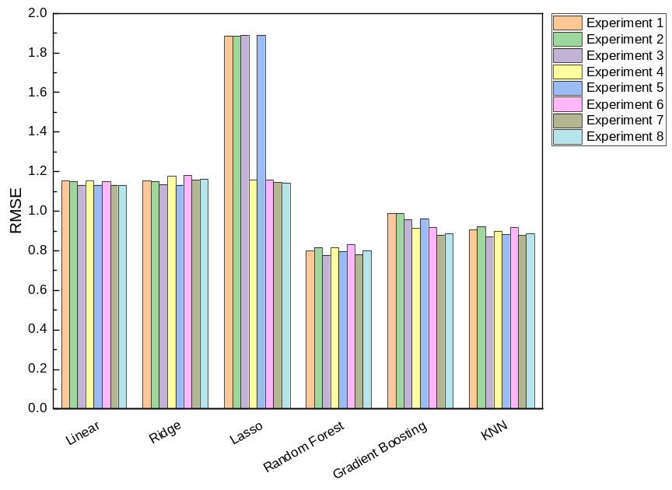
Figure S2. Averaged root mean square error for each iteration of the 2x3 design of experiments matrix outlined in Table S3 for 100 iterations. The gradient boosting and lasso regressions are both largely impacted by the use feature engineering and hyperparameter tuning (experiments 4, 7, and 8). The random forest regression observes some fluctuation in performance but not outside of significance of the base performance ($RMSE$ = 0.797).

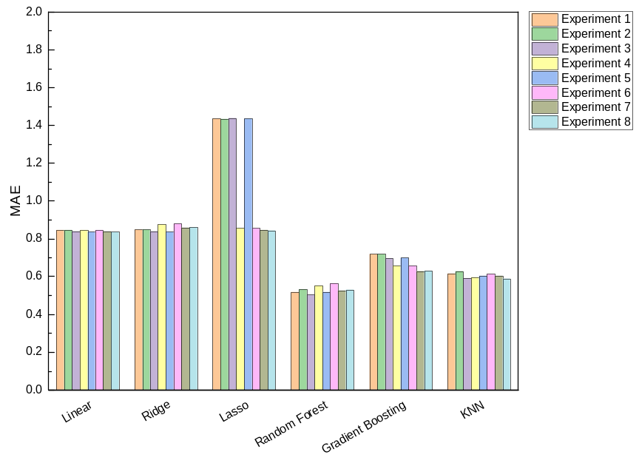
Figure S3. Averaged mean absolute error for each iteration of the 2x3 design of experiments matrix outlined in Table S3 for 100 iterations. The gradient boosting and lasso regressions are both largely impacted by the use feature engineering and hyperparameter tuning (experiments 4, 7, and 8). The random forest regression observes some fluctuation in performance but not outside of significance of the base performance ($MAE$ = 0.518).

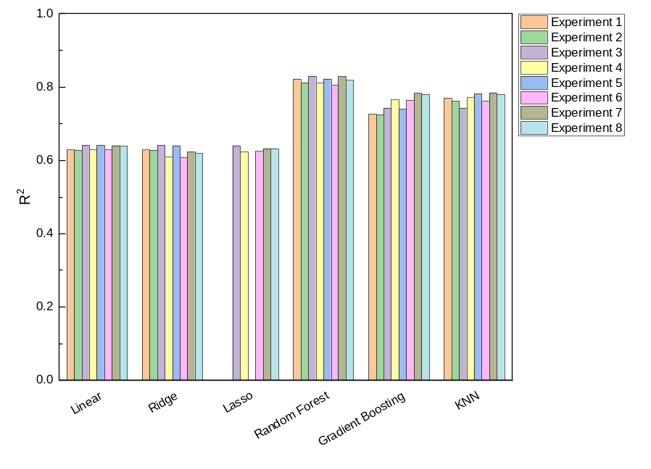.

Figure S4. Averaged mean absolute error for each iteration of the 2x3 design of experiments matrix outlined in Table S3 for 100 iterations. The gradient boosting and lasso regressions are both largely impacted by the use feature engineering and hyperparameter tuning (experiments 4, 7, and 8). The random forest regression observes some fluctuation in performance but not outside of significance of the base performance ($R^{2}$ = 0.822).

S3.1. Dataset Discovery
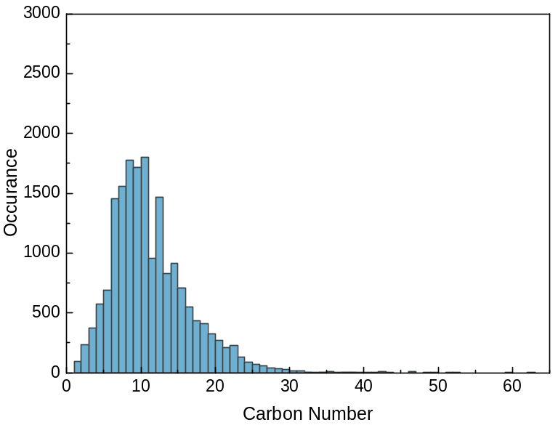
Figure S5. Histogram of carbon number occurrences within the dataset

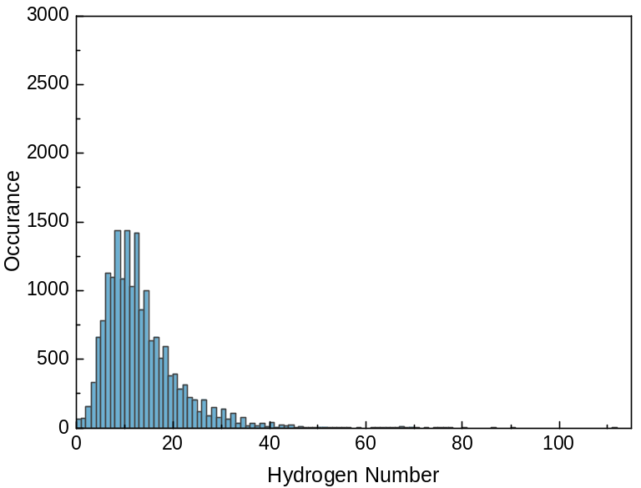
Figure S6. Histogram of hydrogen number occurrences within the dataset
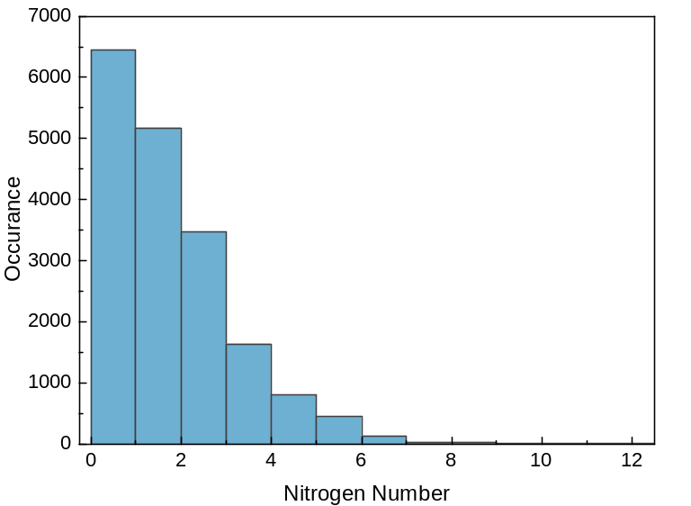
Figure S7. Histogram of nitrogen number occurrences within the dataset

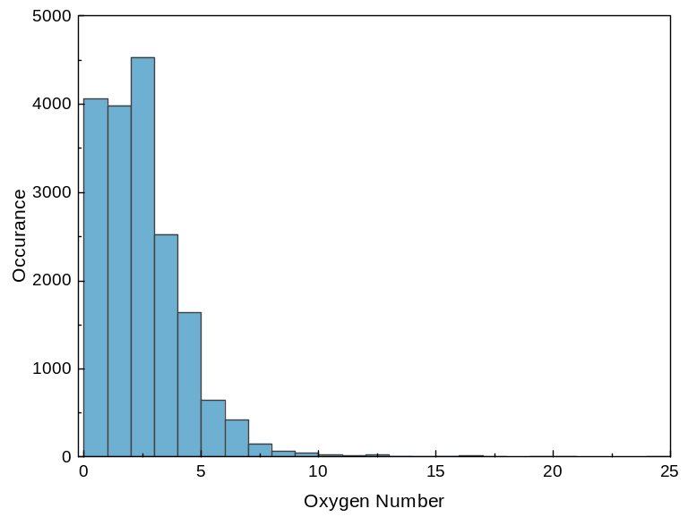
Figure S8. Histogram of oxygen number occurrences within the dataset
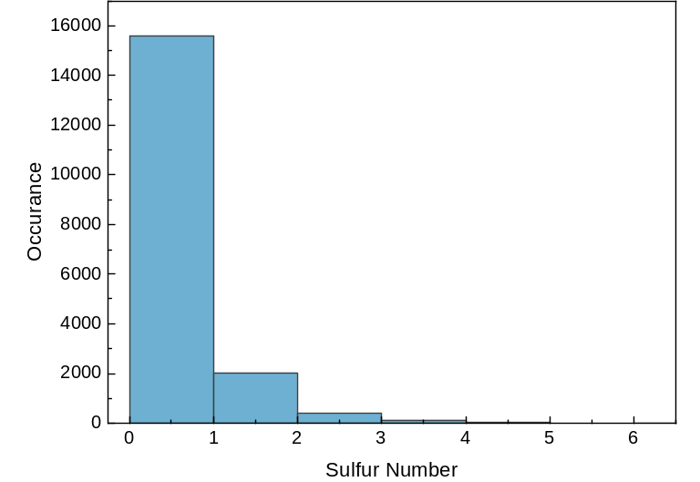
Figure S9. Histogram of sulfur number occurrences within the dataset

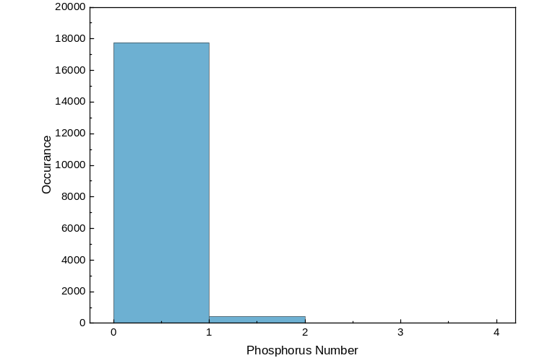
Figure S10. Histogram of phosphorus number occurrences within the dataset
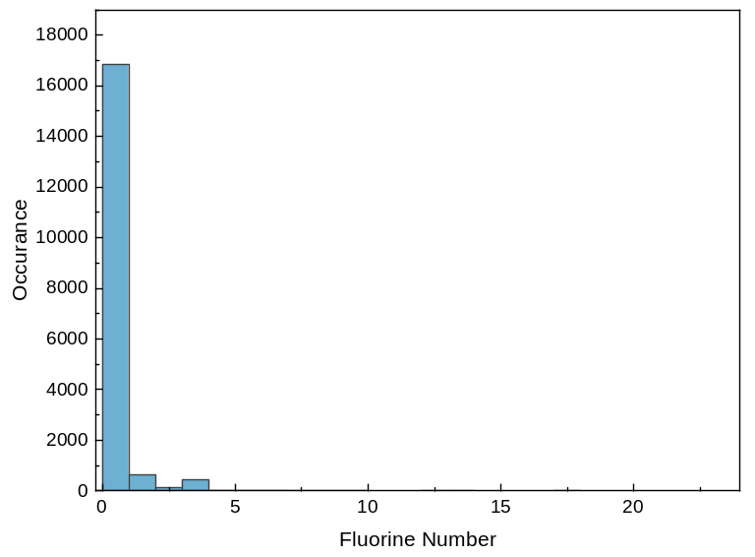
Figure S11. Histogram of fluorine number occurrences within the dataset

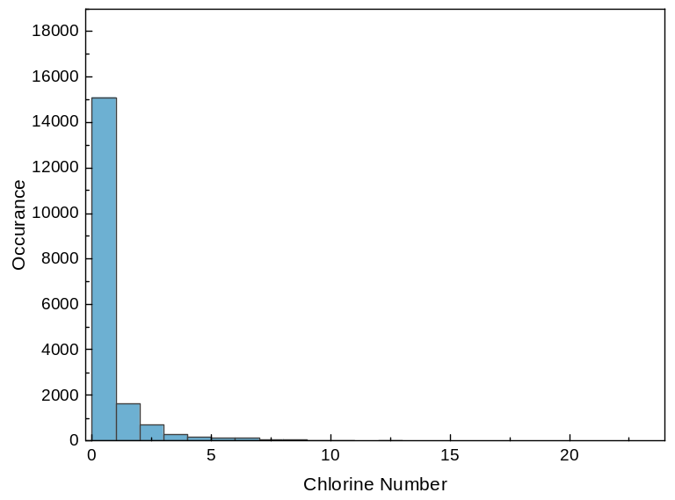
Figure S12. Histogram of chlorine number occurrences within the dataset
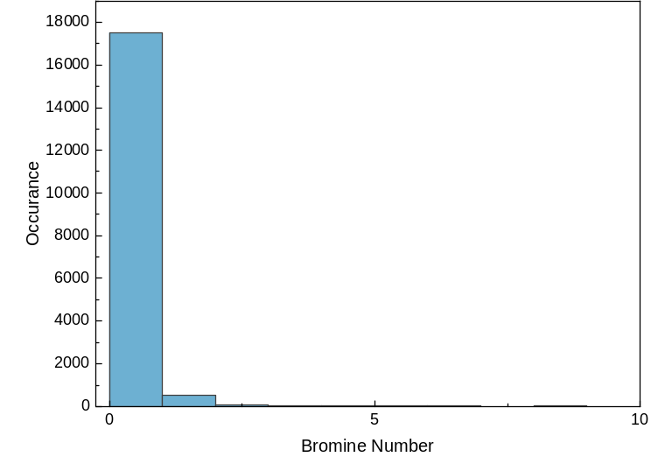
Figure S13. Histogram of bromine number occurrences within the dataset

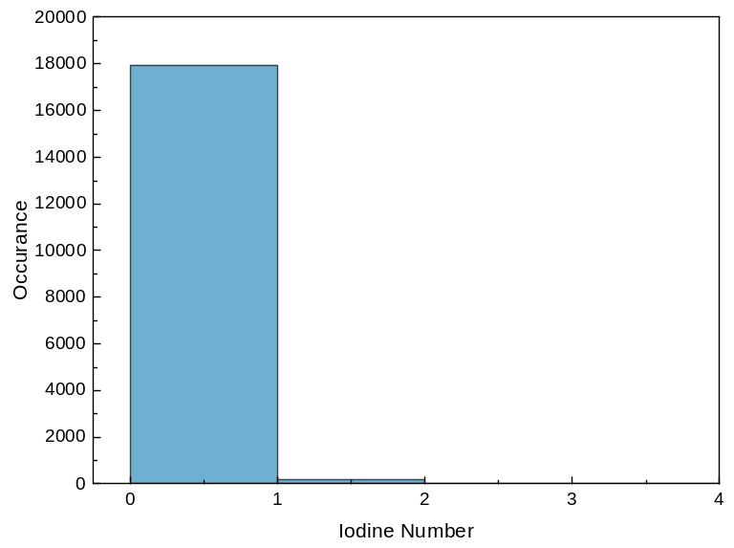
Figure S14. Histogram of iodine number occurrences within the dataset
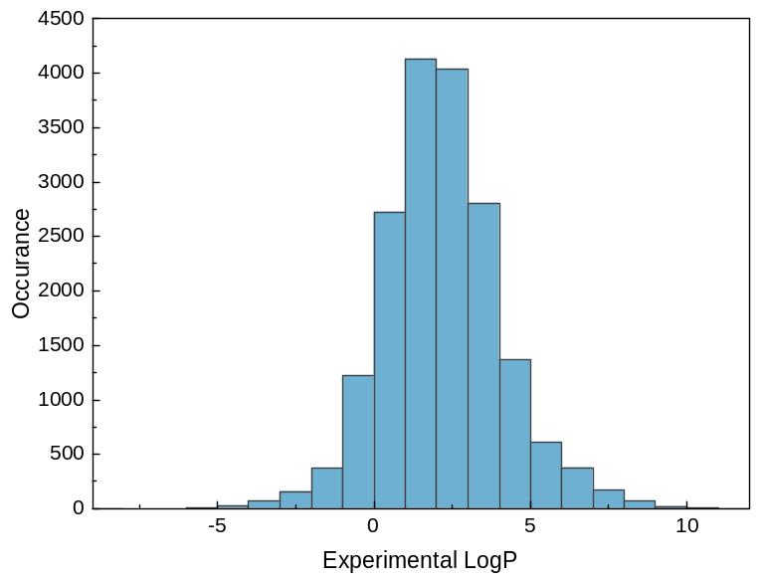
Figure S15. Histogram of experimental $LogP$ number occurrences within the dataset

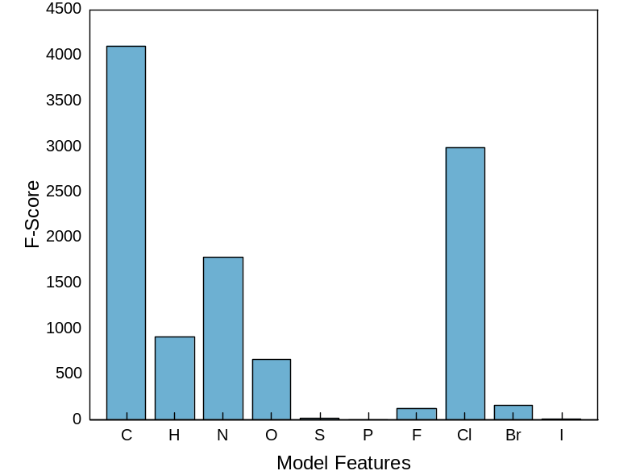
Figure S16. F-test statistical analysis indicating the importance of each feature in the prediction of partition coefficients

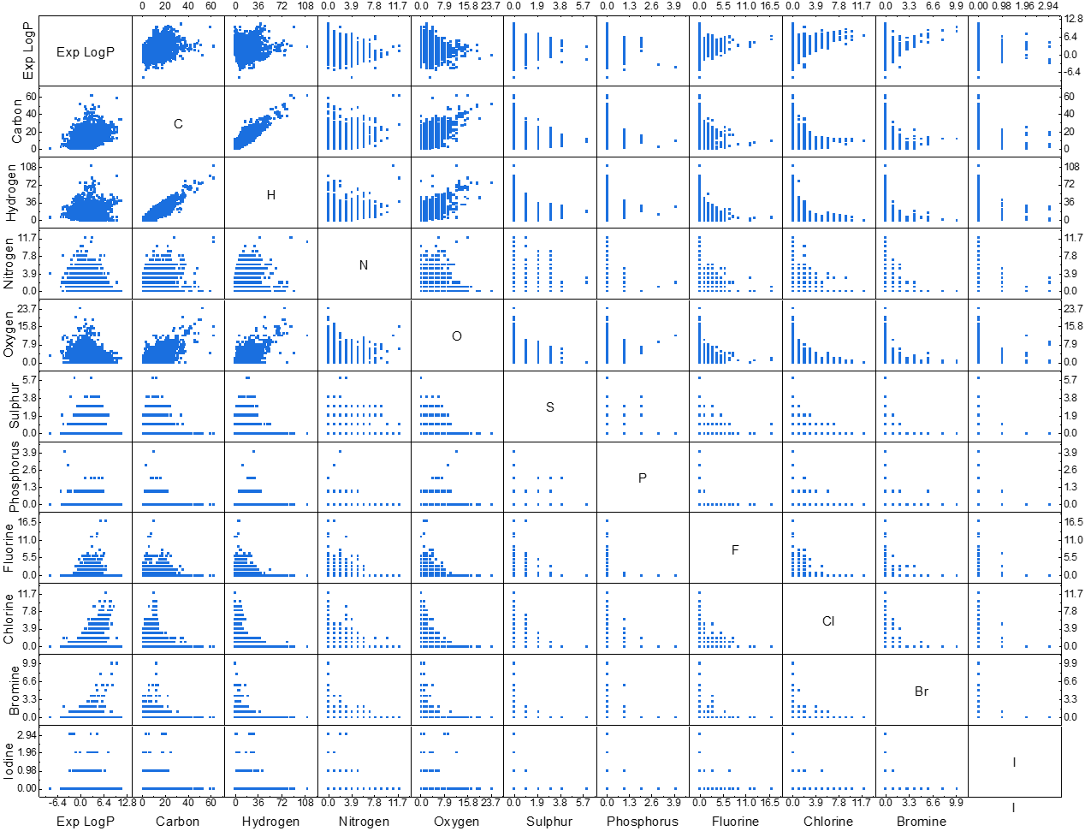
Figure S17. Scatter parity plots between model features and responses. These results model the correlation coefficients depicted in Figure 1. Between the features, there is a clear positive trend between carbon and hydrogen, carbon and nitrogen, and carbon and oxygen. For the features impact on the response predictions, there is a positive trend between with carbon, chlorine, and bromine. Nitrogen and oxygen have a slightly negative relationship with the response. The remaining features have seemingly little predictive capabilities.

S3.2. Model Performances
Table S4. Averaged values for $RMSE$, $MAE$, and $R^{2}$ for each base model over 100 iterations of different training and validation data assignments
 | $$RMSE$$ |  |  |  | $$MAE$$ |  |  |  | $$R^{2}$$
 | Training | STD | Testing | STD | Training | STD | Testing | STD | Training | STD | Testing | STD
MLR | 1.149 | 0.005 | 1.151 | 0.019 | 0.845 | 0.003 | 0.846 | 0.012 | 0.629 | 0.003 | 0.628 | 0.010
RR | 1.149 | 0.005 | 1.151 | 0.019 | 0.846 | 0.003 | 0.847 | 0.012 | 0.629 | 0.003 | 0.628 | 0.010
LR | 1.887 | 0.007 | 1.887 | 0.027 | 1.436 | 0.005 | 1.435 | 0.020 | 0.000 | 0.000 | 0.000 | 0.001
RFR | 0.497 | 0.004 | 0.797 | 0.021 | 0.322 | 0.002 | 0.518 | 0.009 | 0.931 | 0.001 | 0.822 | 0.010
GBR | 0.961 | 0.005 | 0.988 | 0.018 | 0.702 | 0.004 | 0.718 | 0.011 | 0.741 | 0.003 | 0.726 | 0.009
KNNR | 0.743 | 0.005 | 0.905 | 0.020 | 0.502 | 0.003 | 0.616 | 0.010 | 0.845 | 0.002 | 0.770 | 0.010
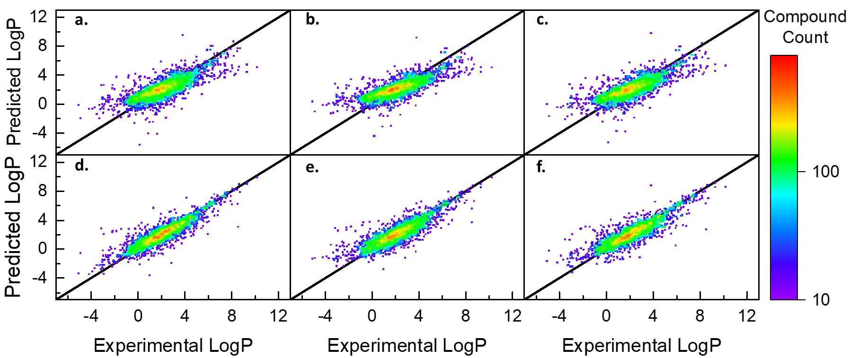
Figure 18. Parity density plots for experimentally determined and predicted values of the validation data (N = 3,084) for each of the six regression models with feature engineering and tuned hyperparameters. The linear models, except for Lasso, appear to have a similar performance while the RFR shows a better visual fit and higher density of points along y = x baseline. (a) Linear, (b) Ridge, (c) Lasso, (d) Random Forest, (e) Gradient Boosted, (f) k-Nearest Neighbors

Table S5. Averaged values for $RMSE$, $MAE$, and $R^{2}$ for each model with feature engineering and tuned hyperparameters over 100 iterations of different training and validation data assignments
 | $$RMSE$$ |  |  |  | $$MAE$$ |  |  |  | $$R^{2}$$
 | Training | STD | Testing | STD | Training | STD | Testing | STD | Training | STD | Testing | STD
MLR | 1.129 | 0.004 | 1.131 | 0.018 | 0.835 | 0.003 | 0.837 | 0.010 | 0.643 | 0.003 | 0.640 | 0.012
RR | 1.157 | 0.004 | 1.157 | 0.019 | 0.856 | 0.003 | 0.857 | 0.011 | 0.625 | 0.003 | 0.623 | 0.011
LR | 1.142 | 0.004 | 1.143 | 0.018 | 0.843 | 0.003 | 0.845 | 0.010 | 0.634 | 0.003 | 0.632 | 0.012
RFR | 0.561 | 0.003 | 0.780 | 0.018 | 0.377 | 0.002 | 0.524 | 0.009 | 0.912 | 0.001 | 0.829 | 0.008
GBR | 0.789 | 0.004 | 0.879 | 0.019 | 0.574 | 0.003 | 0.628 | 0.010 | 0.825 | 0.002 | 0.782 | 0.011
KNNR | 0.758 | 0.005 | 0.876 | 0.018 | 0.520 | 0.003 | 0.604 | 0.009 | 0.839 | 0.002 | 0.784 | 0.009

S3.3. Comparing Predictions by Compound Class
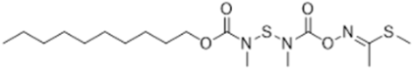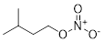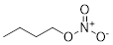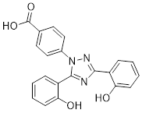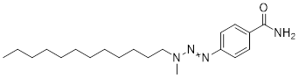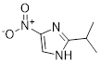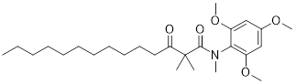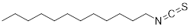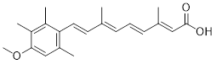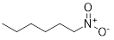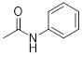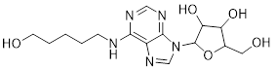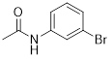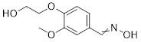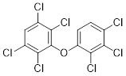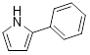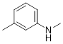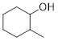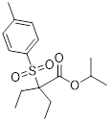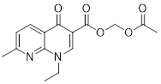
(a)
(b)
(c)
(d)
(e)
(h)
(n)
(i)
(o)
(j)
(p)
(k)
(q)
(r)
(l)
(m)
(f)
(g)
(s)
(t)
Figure S20. Twenty compounds identified as having the (RED) top ten largest absolute errors and (GREEN) top ten smallest absolute errors between the experimental partition coefficients and the MF-LOGP predicted values

Table S6. Experimental and predicted partition coefficients for the compounds identified to have the ten largest and smallest absolute error between experimental and predicted partition coefficients
Index | IUPAC name | Exp $LogP$ | Pred $LogP$ | Difference
(a) | methyl (1E)-N-[[decoxycarbonyl(methyl)amino]sulfanyl-methylcarbamoyl]oxyethanimidothioate | 6.20 | 0.19 | 6.01
(b) | 3-Methylbutyl nitrate | 2.84 | -3.05 | 5.89
(c) | Butyl nitrate | 2.15 | -2.87 | 5.02
(d) | 4-[3,5-bis(2-hydroxyphenyl)-1,2,4-triazol-1-yl]benzoic acid | 6.30 | 1.97 | 4.33
(e) | 4-(dodecyl-methylamino)diazenylbenzamide | 6.58 | 2.78 | 3.80
(f) | 2-Isopropyl-4-nitro-1H-imidazole | 0.90 | -2.75 | 3.65
(g) | N,2,2-trimethyl-3-oxo-N-(2,4,6-trimethoxyphenyl)tetradecanamide | 6.67 | 3.02 | 3.65
(h) | 1-Isothiocyanatododecane | 7.13 | 3.77 | 3.36
(i) | (2E,4E,6E,8E)-9-(4-methoxy-2,3,6-trimethylphenyl)-3,7-dimethylnona-2,4,6,8-tetraenoic acid | 6.40 | 3.13 | 3.27
(j) | 1-Nitrohexane | 2.70 | -0.53 | 3.23
(k) | N-phenylacetamide | 4.94 | 4.94 | 2.68E-4
(l) | 2-(hydroxymethyl)-5-[6-(5-hydroxypentylamino)purin-9-yl]oxolane-3,4-diol | -0.24 | -0.24 | 3.33E-4
(m) | N-(3-bromophenyl)acetamide | 2.31 | 2.31 | 3.58E-4
(n) | 2-[4-(hydroxyiminomethyl)-2-methoxyphenoxy]ethanol | 0.82 | 0.82 | 5.17E-4
(o) | 2,2',3,3',4,5',6'-Heptachlorodiphenyl ether | 7.14 | 7.14 | 8.38E-4
(p) | 2-Phenyl-1H-pyrrole | 2.76 | 2.76 | 2.37E-3
(q) | N,3-Dimethylaniline | 2.19 | 2.19 | 2.36E-3
(r) | 2-Methylcyclohexanol | 1.84 | 1.84 | 3.60E-3
(s) | propan-2-yl 1-(4-methylphenyl)sulfonylcyclohexane-1-carboxylate | 3.21 | 3.21 | 3.91E-3
(t) | acetyloxymethyl 1-ethyl-7-methyl-4-oxo-1,8-naphthyridine-3-carboxylate | 1.21 | 1.21 | 4.44E-3

