SUPPORTING INFORMATION

Synthesis and cytotoxic/antimicrobial screening of 3-alkenylimidazo[1,2-a]pyrimidines
Ángel Ramírez-Trinidad, Karol Carrillo-Jaimes, José A. Rivera Chávez, Eduardo Hernández Vázquez*.

Table of content:

NMR spectra of butenones 9a–p………………………………….……. | S2
NMR spectra of imidazo[1,2-a]pyrimidines 4a–p……………….. | S39
Table S1…………………………………………………………………………….. | S74

NMR of
butenones 9a-9p

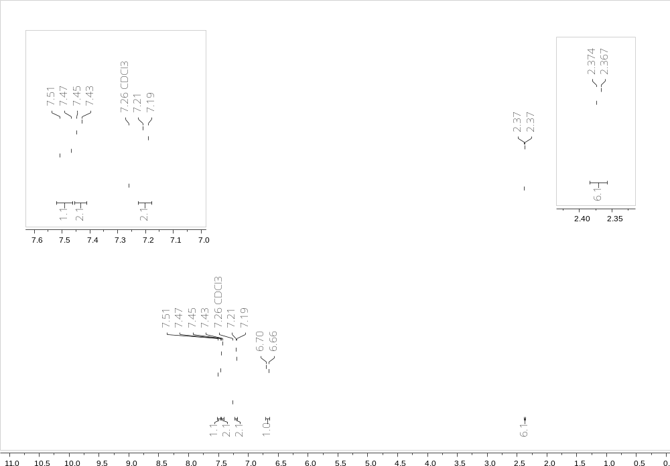

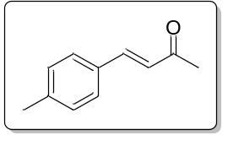

Figure S1. ¹H-NMR of (E)-4-(4-methylphenyl)but-3-en-2-one (9b)

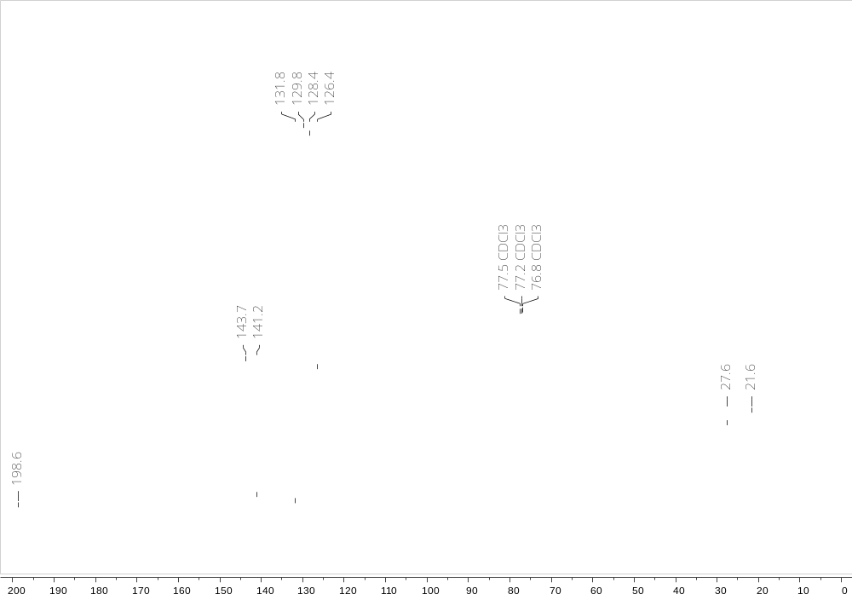

Figure S2. ¹³C-NMR of (E)-4-(4-methylphenyl)but-3-en-2-one (9b)

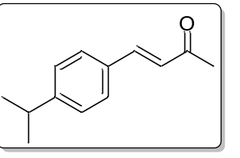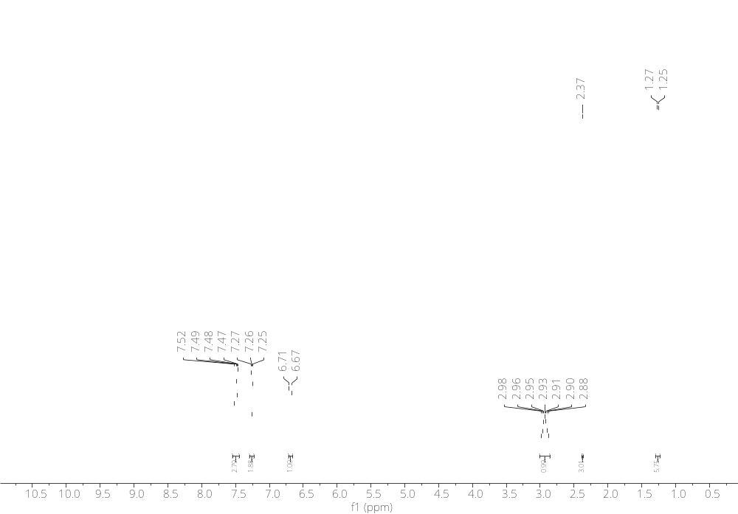
Figure S3. ¹H-NMR of (E)-4-(4-isopropylphenyl)but-3-en-2-one (9c)

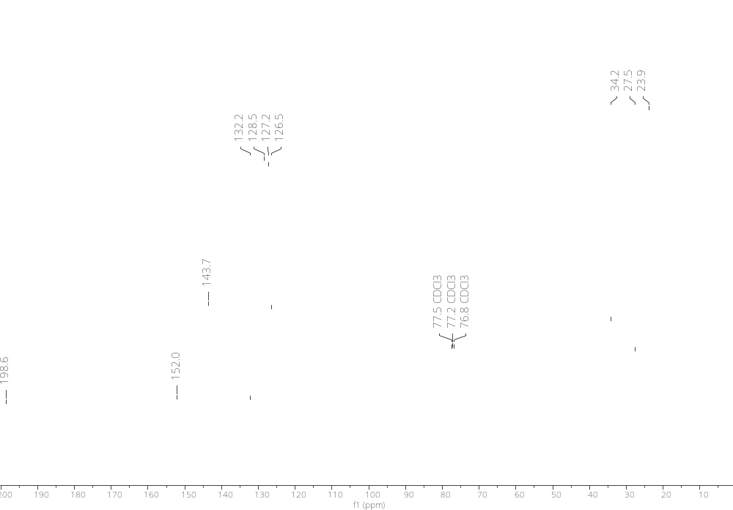
Figure S4. ¹³C-NMR of (E)-4-(4-isopropylphenyl)but-3-en-2-one (9c)

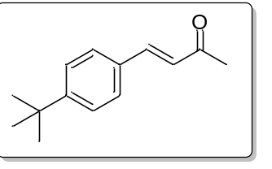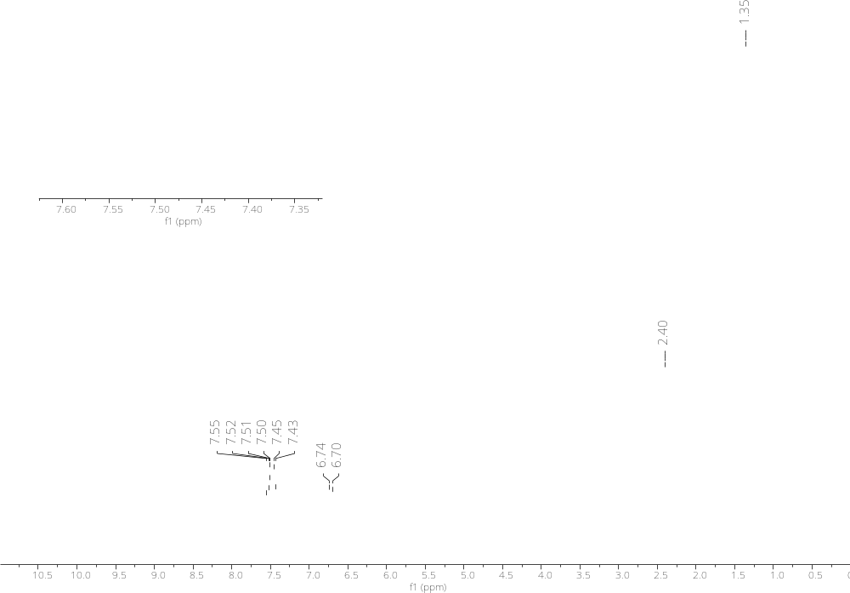
Figure S5. ¹H-NMR of (E)-4-(4-(tert-butyl)phenyl)but-3-en-2-one (9d)

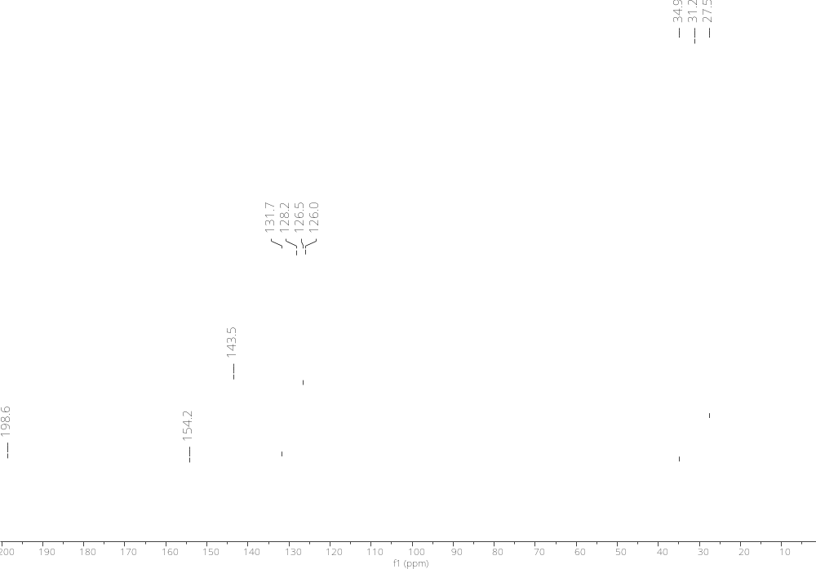
Figure S6. ¹³C-NMR of (E)-4-(4-(tert-butyl)phenyl)but-3-en-2-one (9d)

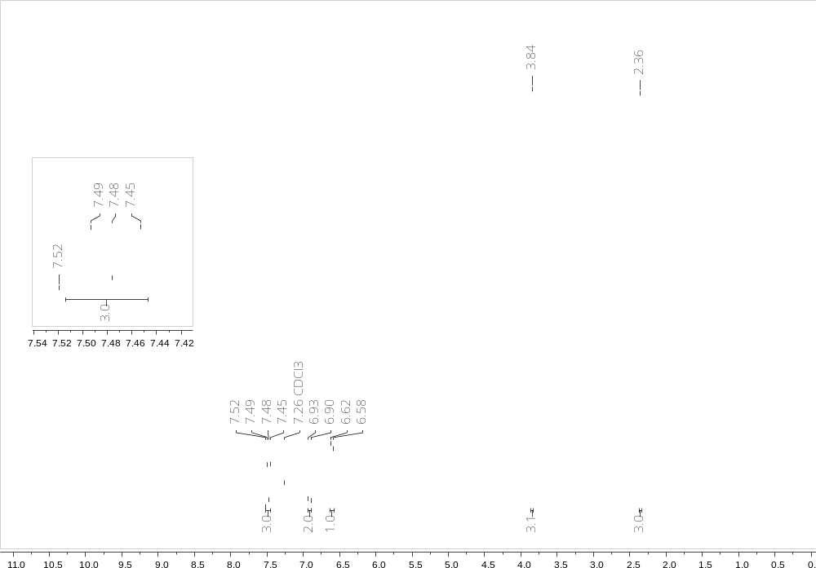

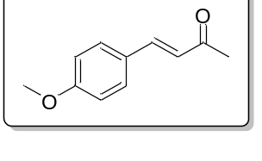

Figure S7. ¹H-NMR of (E)-4-(4-methoxyphenyl)but-3-en-2-one (9e)
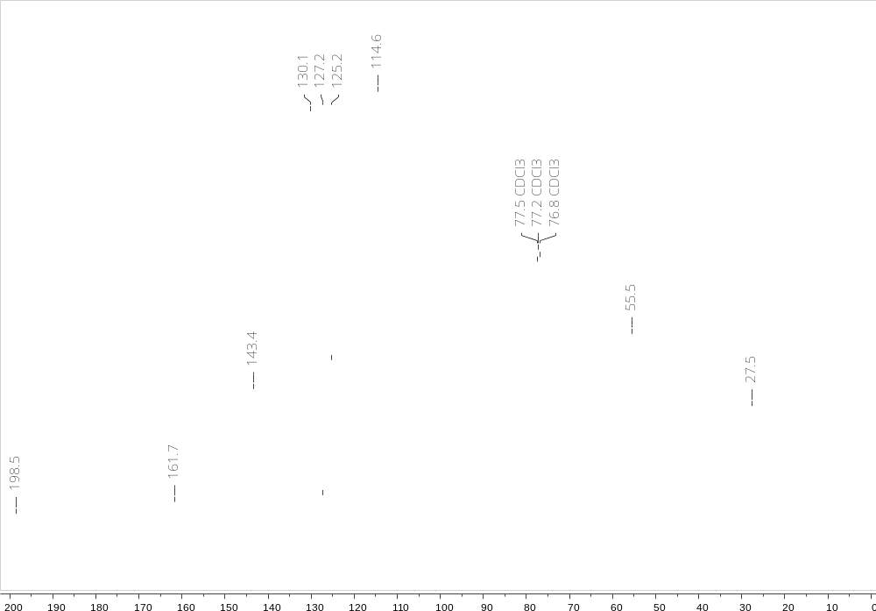

Figure S8. ¹³C-NMR of (E)-4-(4-methoxyphenyl)but-3-en-2-one (9e)

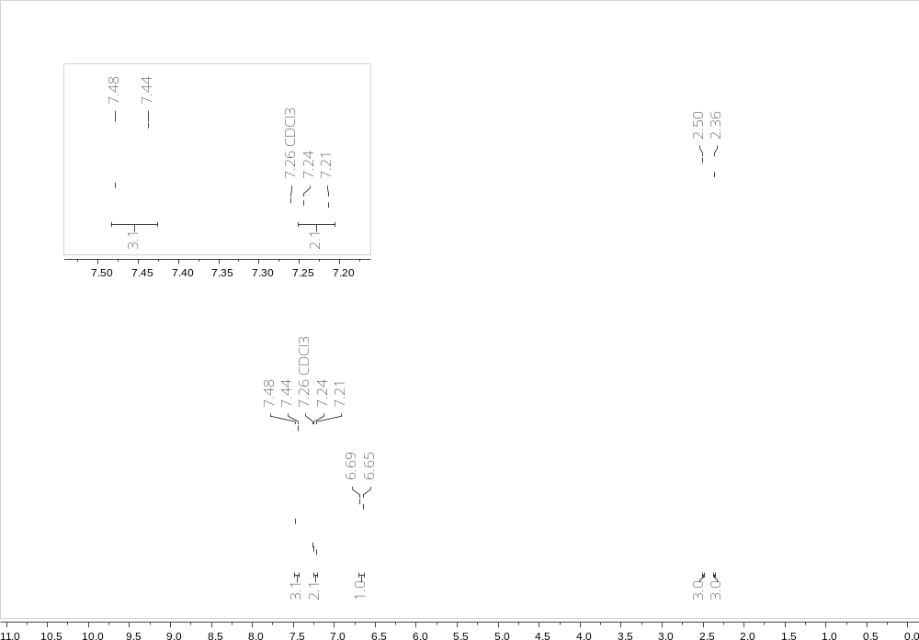

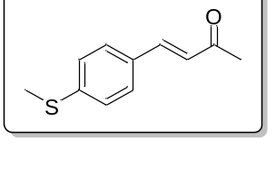

Figure S9. ¹H-NMR of (E)-4-(4-(methylthio)phenyl)but-3-en-2-one (9f)
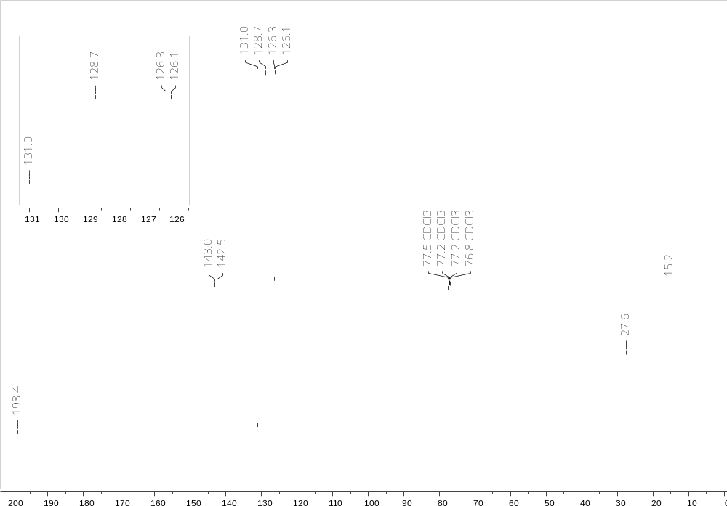

Figure S10. ¹³C-NMR of (E)-4-(4-(methylthio)phenyl)but-3-en-2-one (9f)

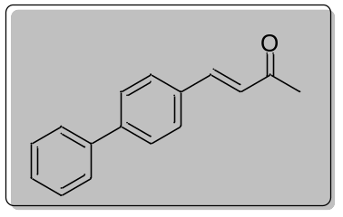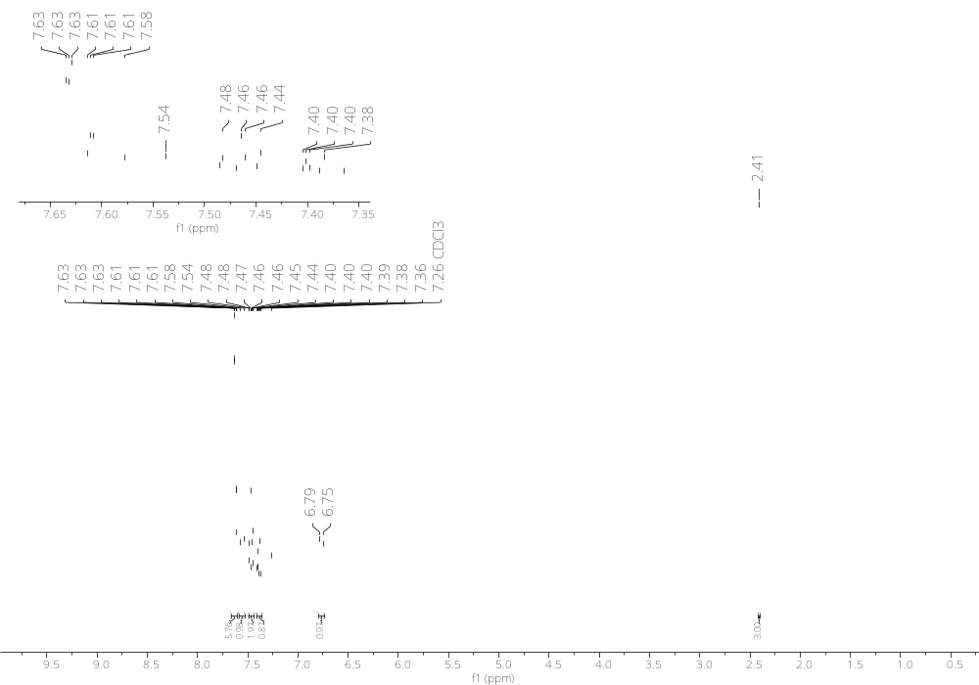
Figure S11. ¹H-NMR of (E)-4-([1,1'-biphenyl]-4-yl)but-3-en-2-one (9g)
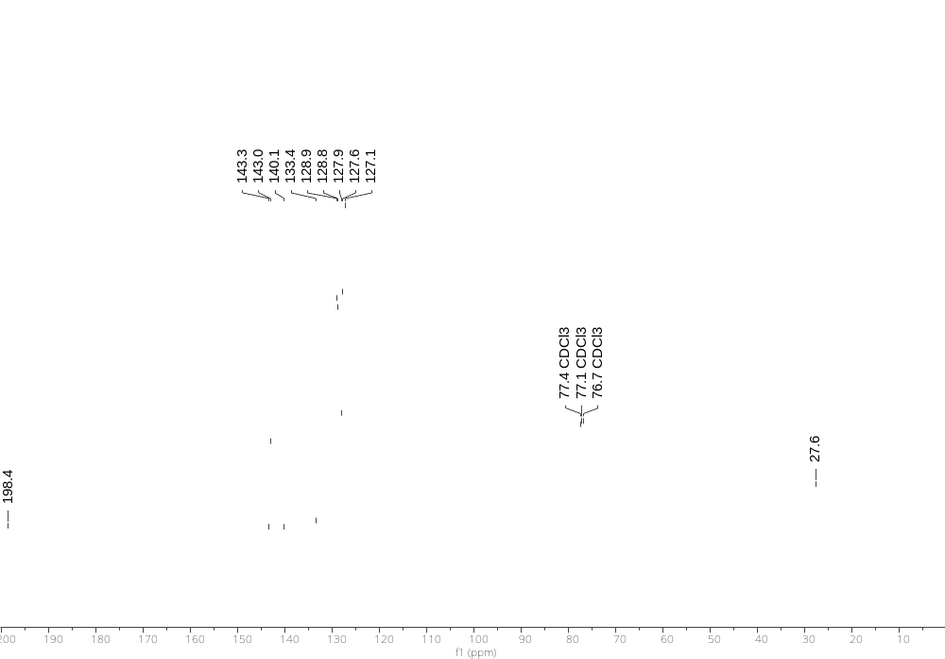
Figure S12. ¹³C-NMR of (E)-4-([1,1'-biphenyl]-4-yl)but-3-en-2-one (9g)
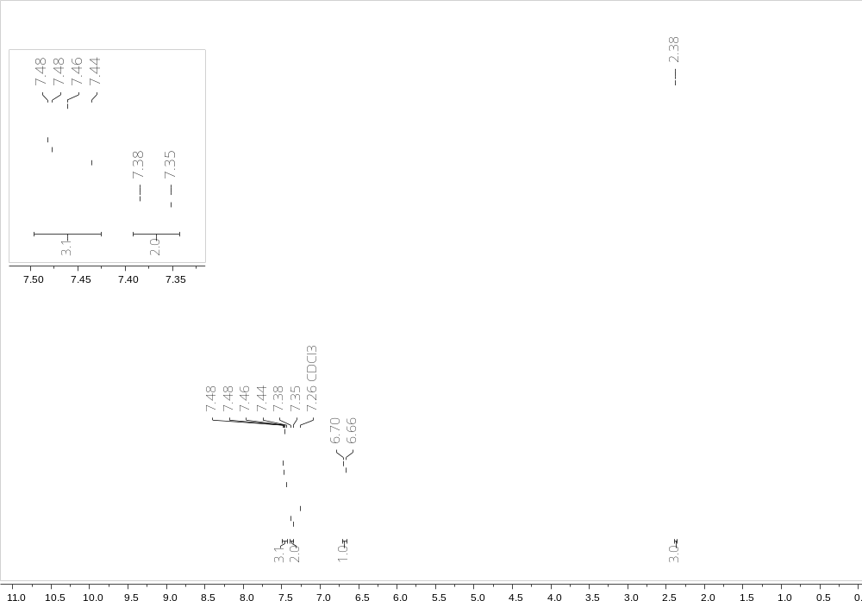

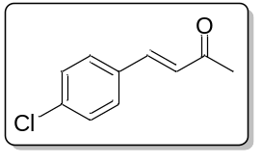

Figure S13. ¹H-NMR of (E)-4-(4-chlorophenyl)but-3-en-2-one (9h)
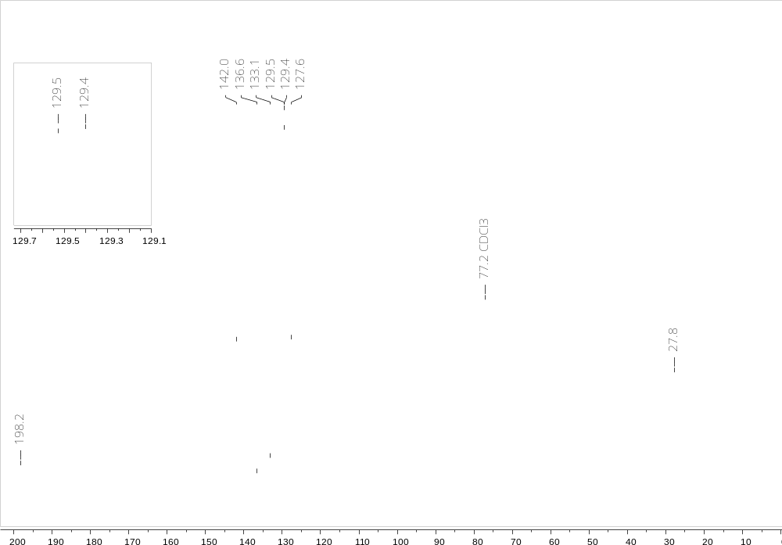

Figure S14. ¹³C-NMR of (E)-4-(4-chlorophenyl)but-3-en-2-one (9h)
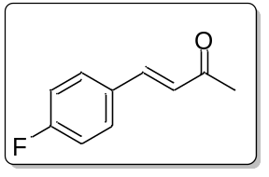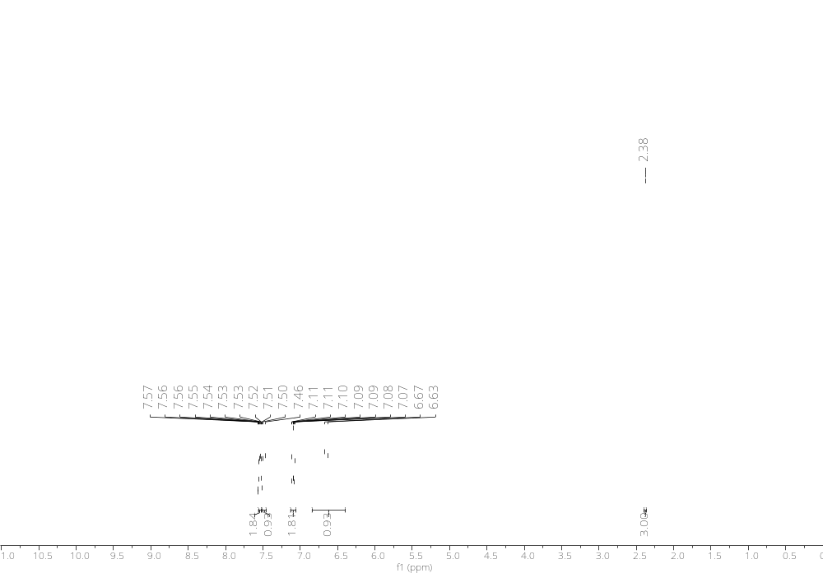
Figure S15. ¹H-NMR of (E)-4-(4-fluorophenyl)but-3-en-2-one (9i)
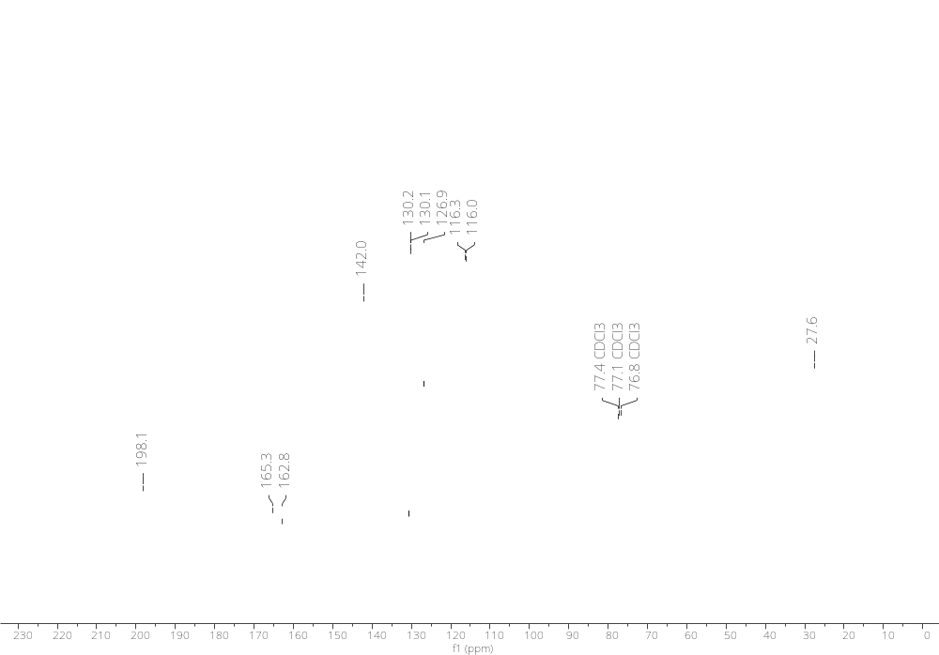
Figure S16. ¹³C-NMR of (E)-4-(4-fluorophenyl)but-3-en-2-one (9i)
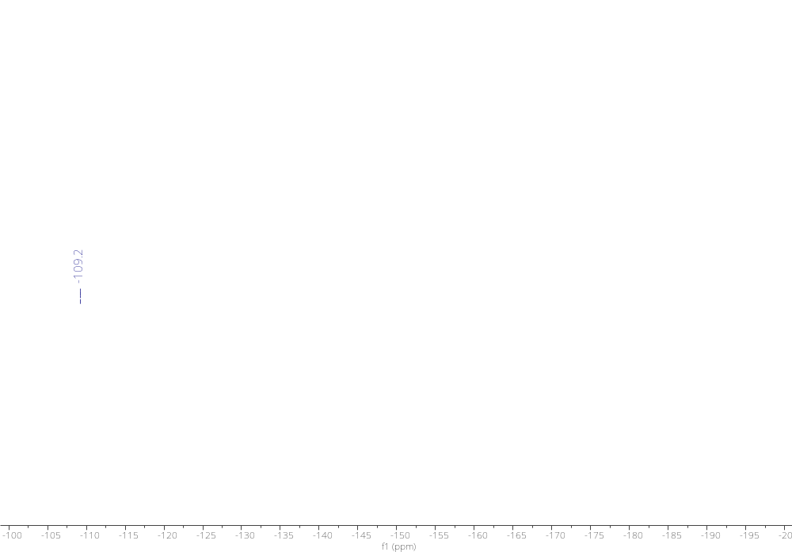
Figure S17. ¹⁹F-NMR of (E)-4-(4-fluorophenyl)but-3-en-2-one (9i)
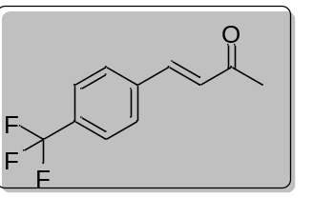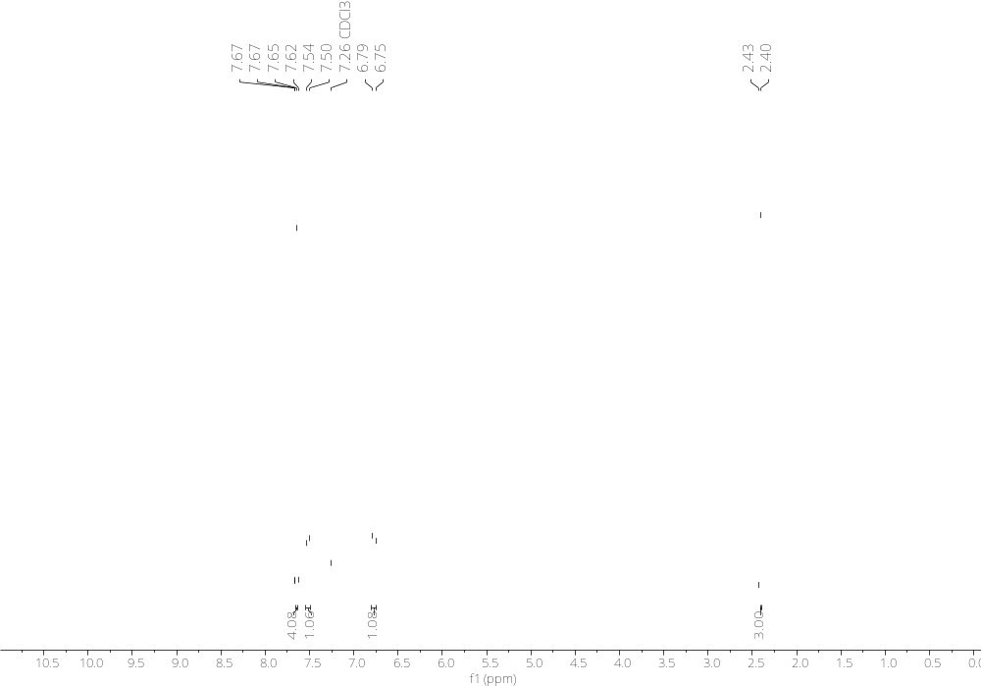
Figure S18. ¹H-NMR of (E)-4-(4-(trifluoromethyl)phenyl)but-3-en-2-one (9j)
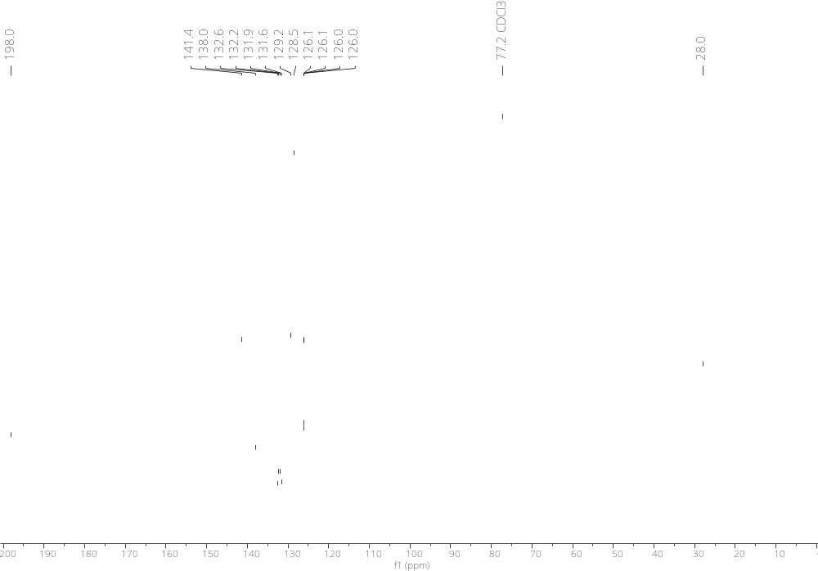
Figure S19. ¹³C-NMR of (E)-4-(4-(trifluoromethyl)phenyl)but-3-en-2-one (9j)
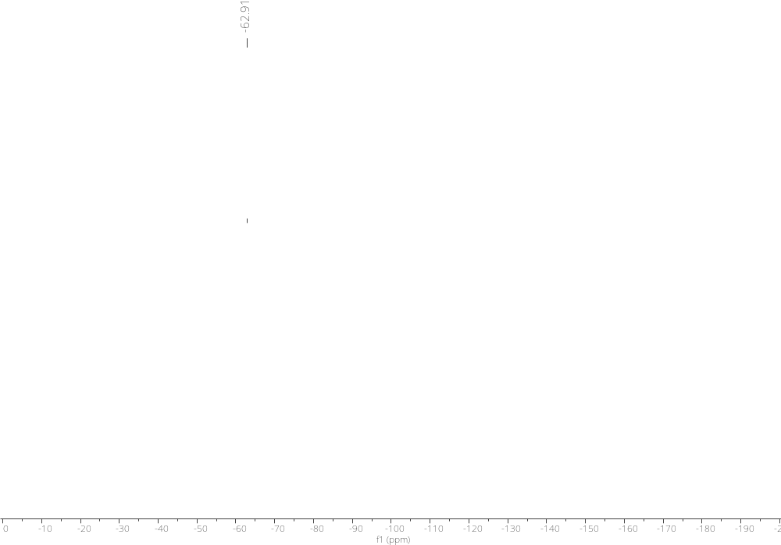
Figure S20. ¹⁹F-NMR of (E)-4-(4-(trifluoromethyl)phenyl)but-3-en-2-one (9j)
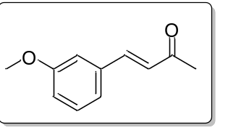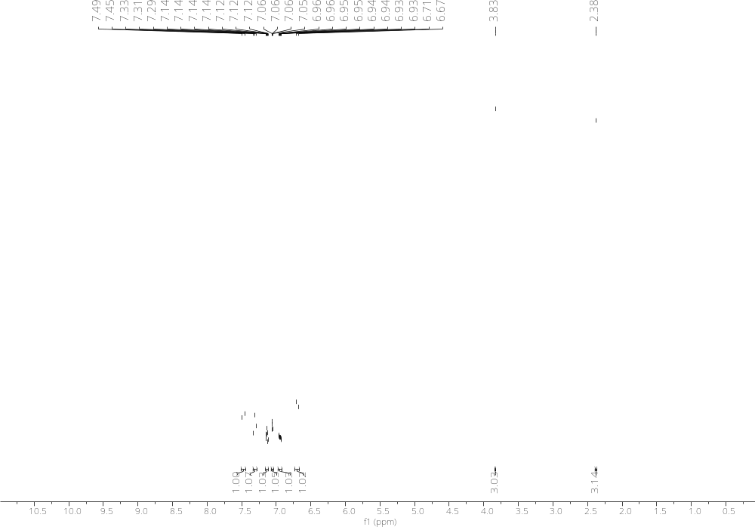
Figure S21. ¹H-NMR of (E)-4-(3-methoxyphenyl)but-3-en-2-one (9k)
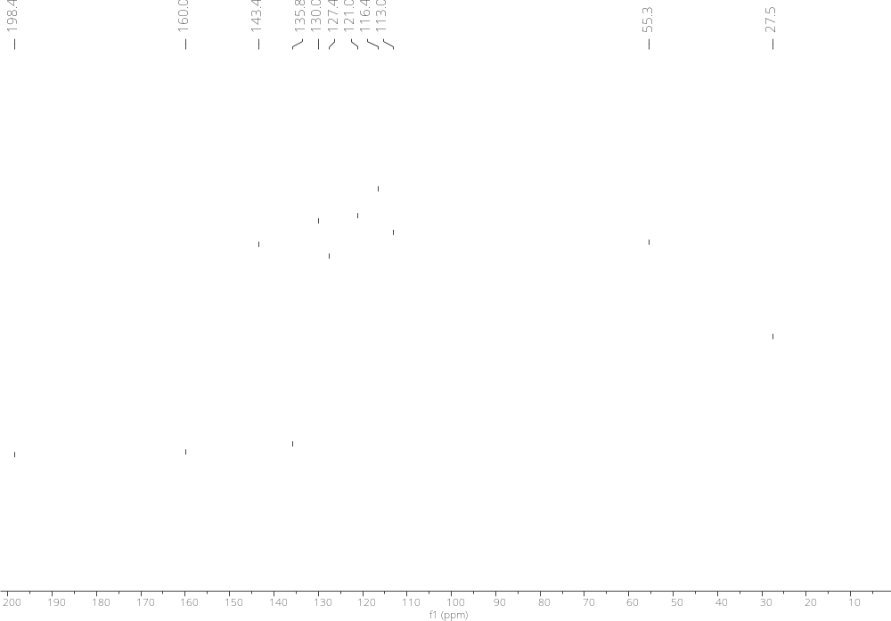
Figure S22. ¹³C-NMR of (E)-4-(3-methoxyphenyl)but-3-en-2-one (9k)
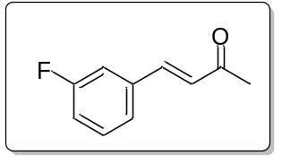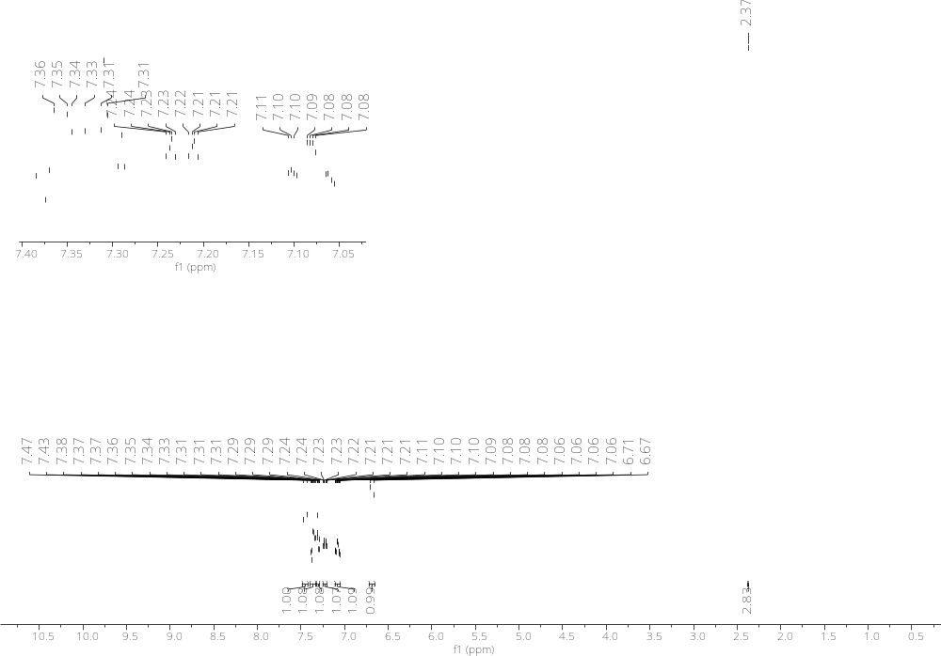
Figure S23. ¹H-NMR of (E)-4-(3-fluorophenyl)but-3-en-2-one (9l)
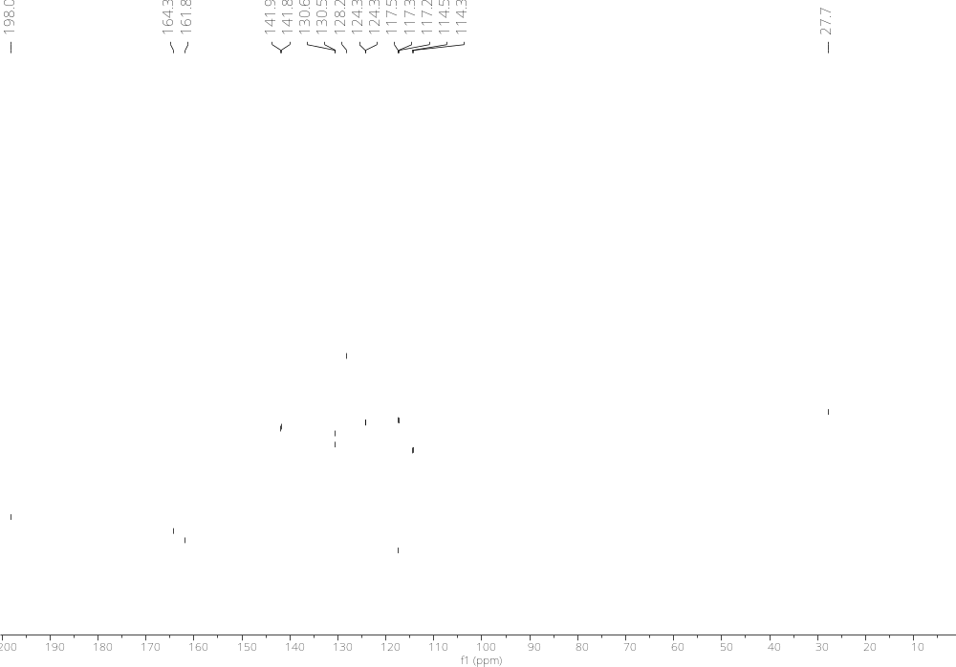
Figure S24. ¹³C-NMR of (E)-4-(3-fluorophenyl)but-3-en-2-one (9l)
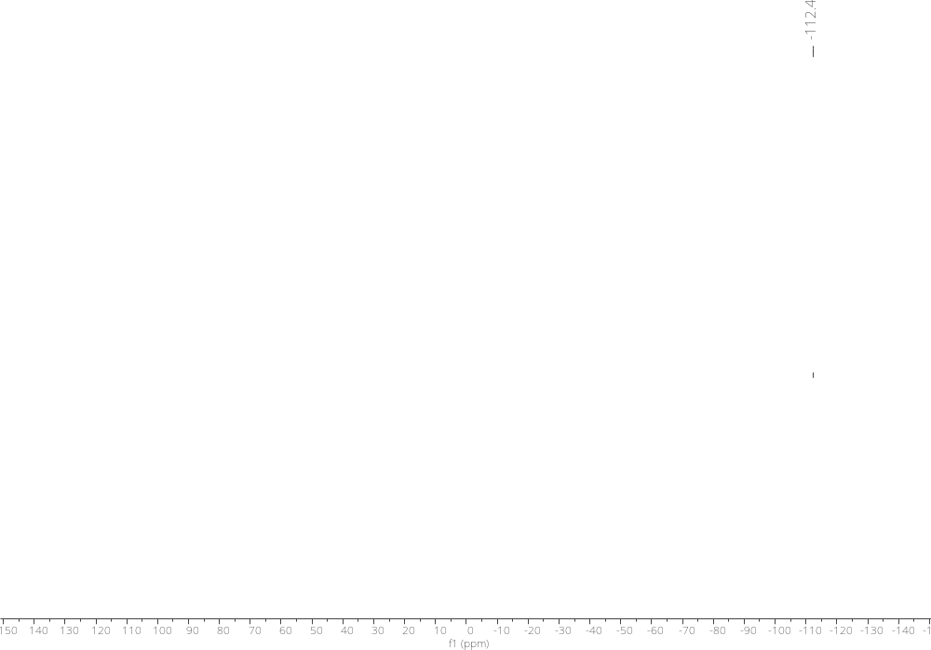
Figure S25. ¹⁹F-NMR of (E)-4-(3-fluorophenyl)but-3-en-2-one (9l)

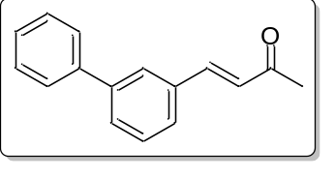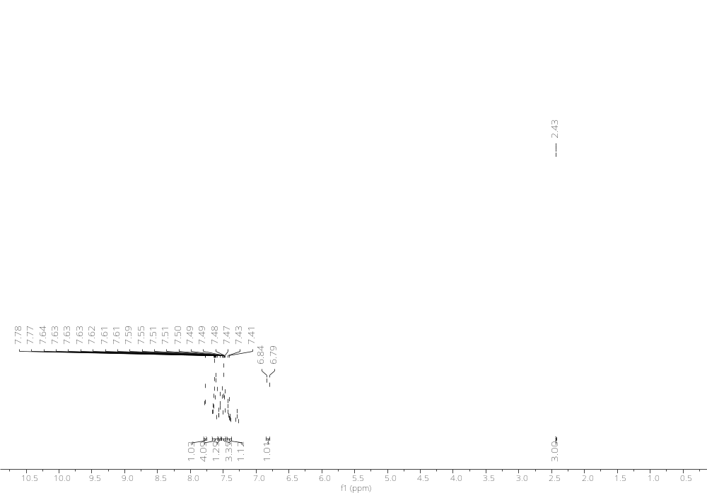
Figure S26. ¹H-NMR of (E)-4-([1,1'-biphenyl]-3-yl)but-3-en-2-one (9m)

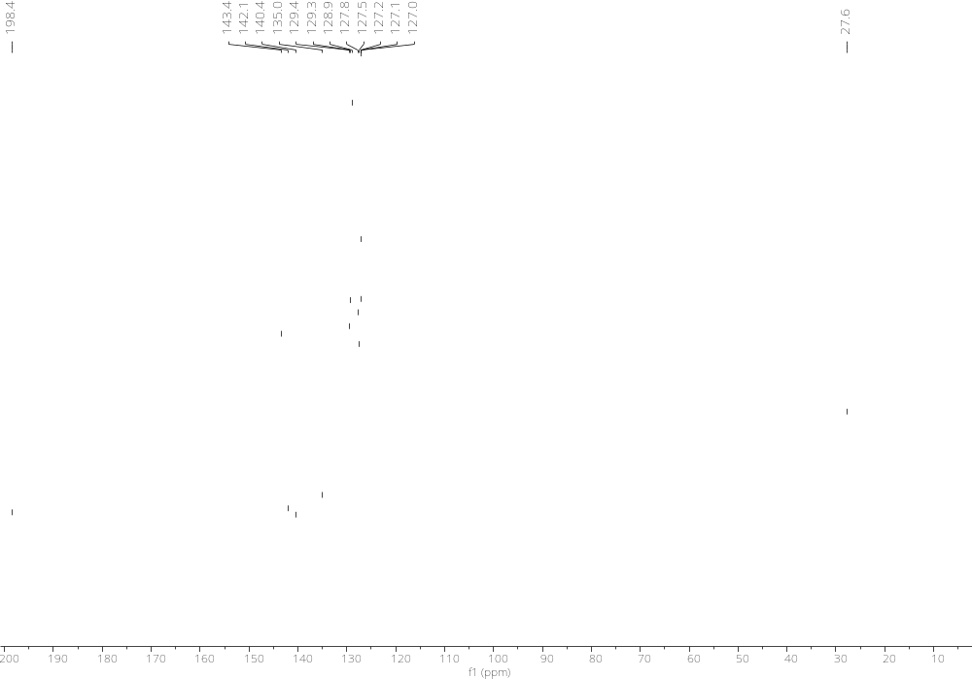
Figure S27. ¹³C-NMR of (E)-4-([1,1'-biphenyl]-3-yl)but-3-en-2-one (9m)
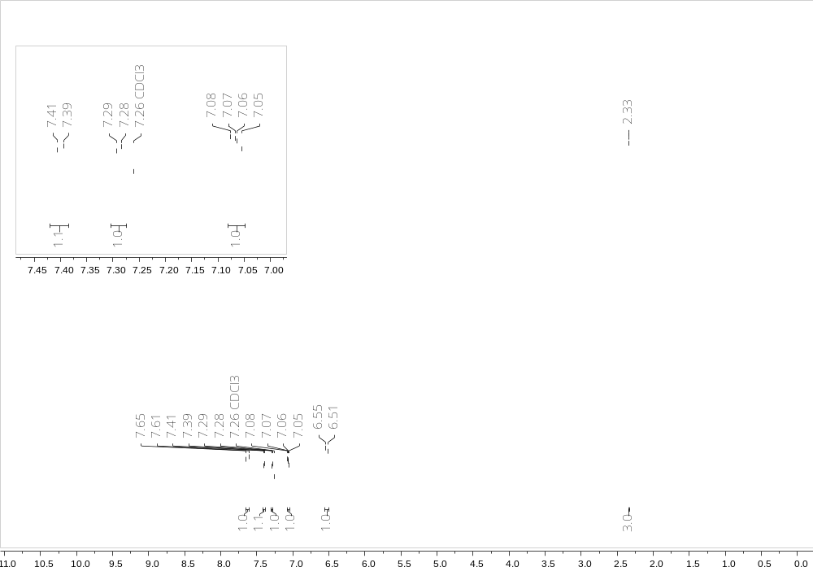

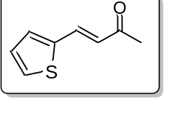

Figure S28. ¹H-NMR of (E)-4-(thiophen-2-yl)but-3-en-2-one (9n)

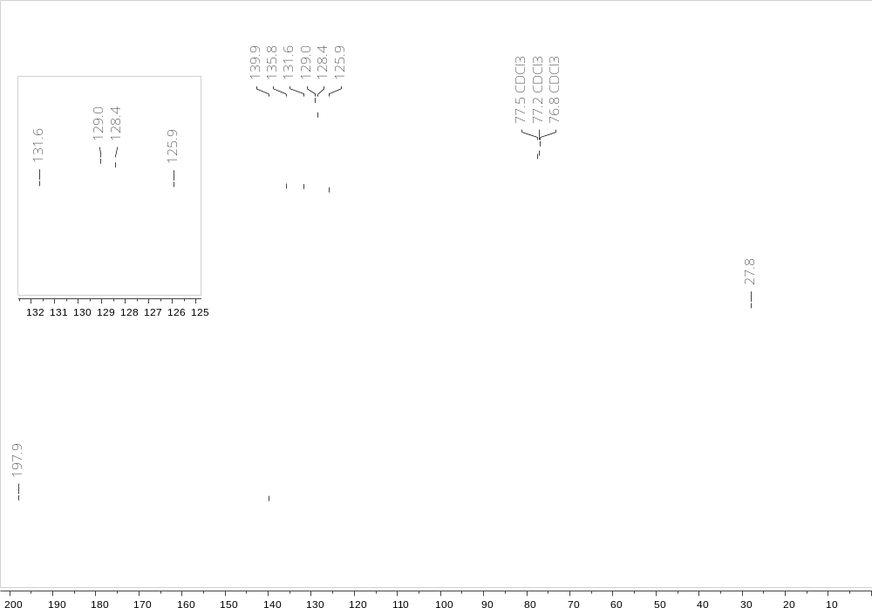

Figure S29. ¹³C-NMR of (E)-4-(thiophen-2-yl)but-3-en-2-one (9n)

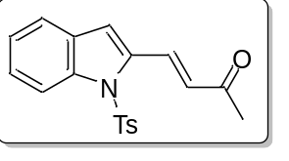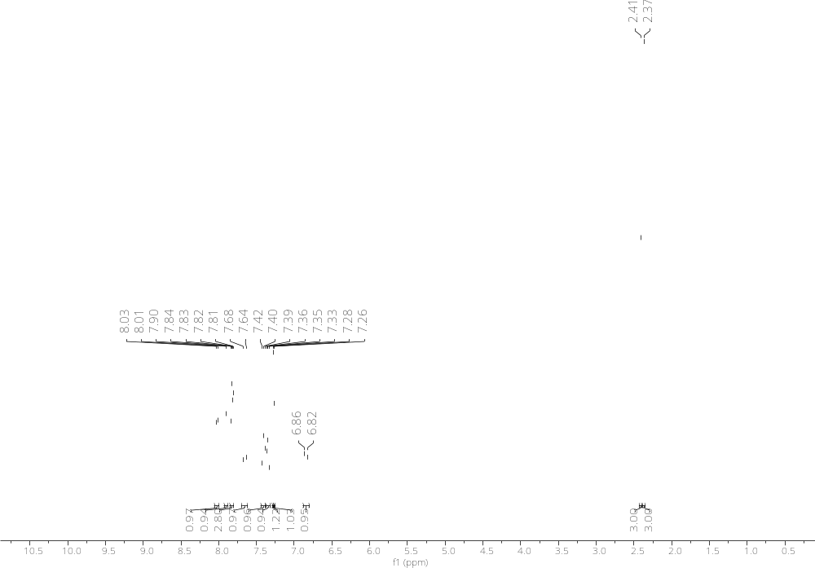
Figure S30. ¹H-NMR of (E)-4-(1-tosyl-1H-indol-2-yl)but-3-en-2-one (9o)

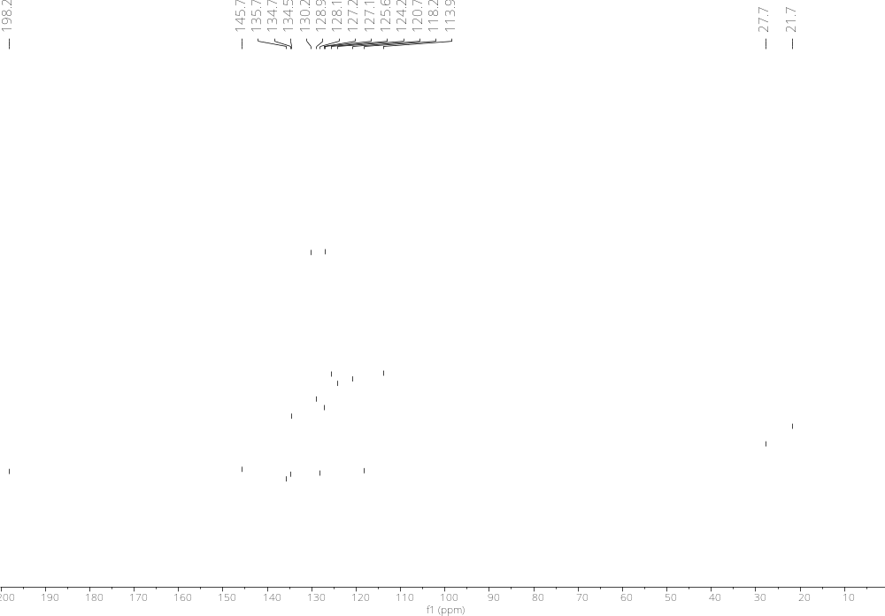
Figure S31. ¹³C-NMR of (E)-4-(1-tosyl-1H-indol-2-yl)but-3-en-2-one (9o)
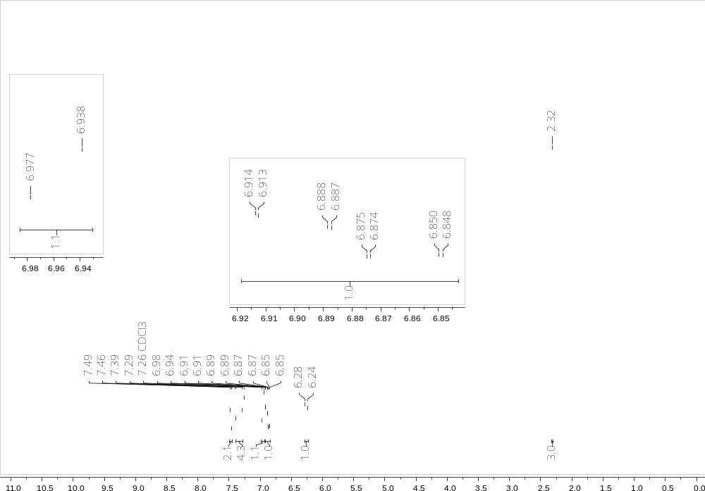
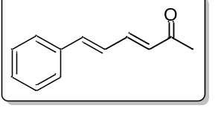

Figure S32. ¹H-NMR of (3E,5E)-6-phenylhexa-3,5-dien-2-one (9p)
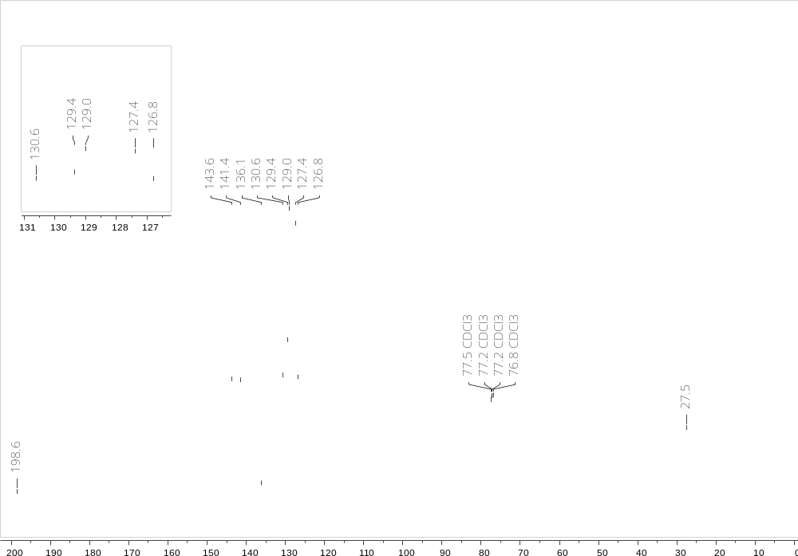

Figure S33. ¹³C-NMR of (3E,5E)-6-phenylhexa-3,5-dien-2-one (9p)
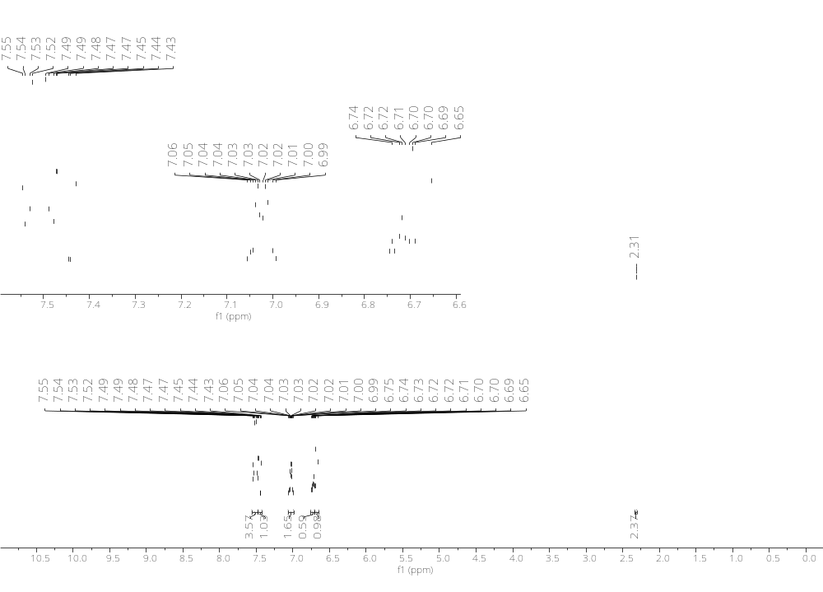
Figure S34. ¹H-NMR of (E)-4-(3',5'-difluoro-[1,1'-biphenyl]-4-yl)but-3-en-2-one (9r).
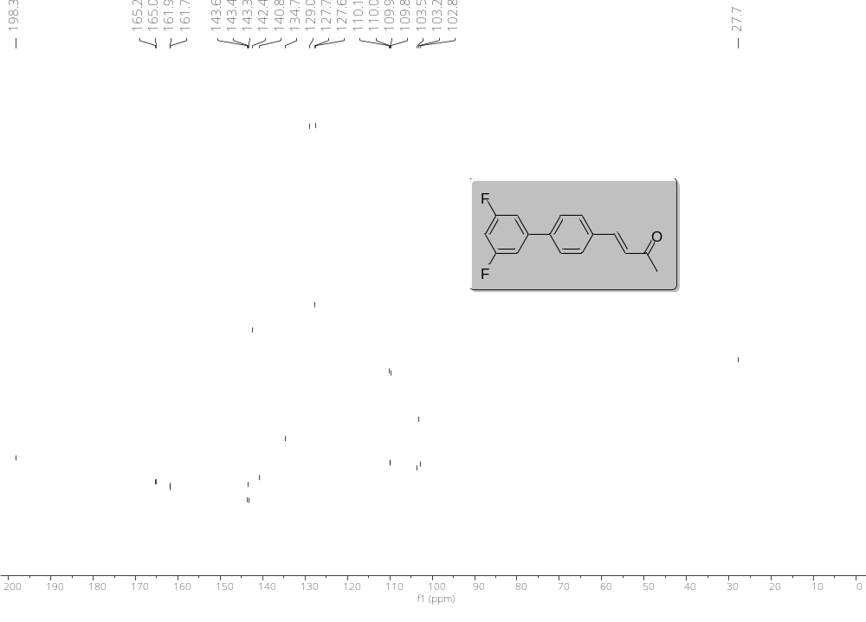
Figure S35. ¹³C-NMR of (E)-4-(3',5'-difluoro-[1,1'-biphenyl]-4-yl)but-3-en-2-one (9r).
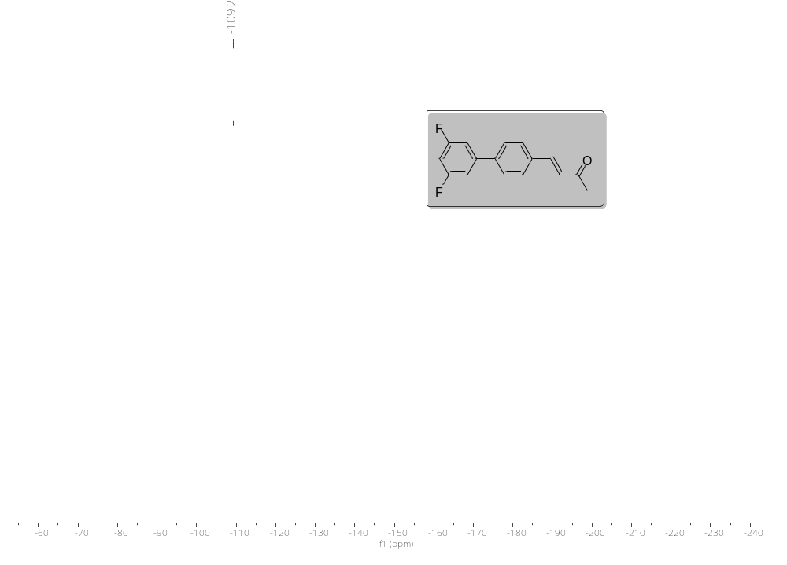
Figure S36. ¹³C-NMR of (E)-4-(3',5'-difluoro-[1,1'-biphenyl]-4-yl)but-3-en-2-one (9r).

NMR of
Imidazo[1,2-a]pyrimidines 4a-4p

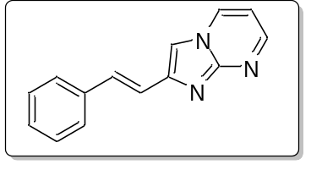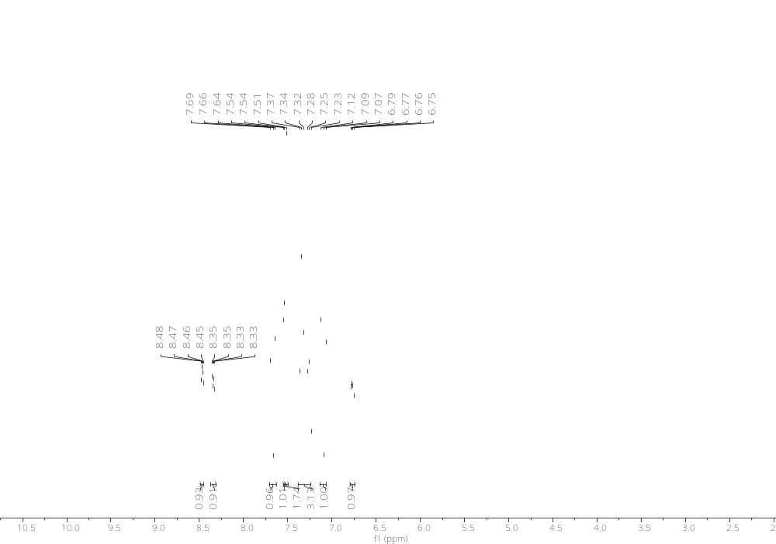
Figure S37. ¹H-NMR of (E)-2-styrylimidazo[1,2-a]pyrimidine (4a)
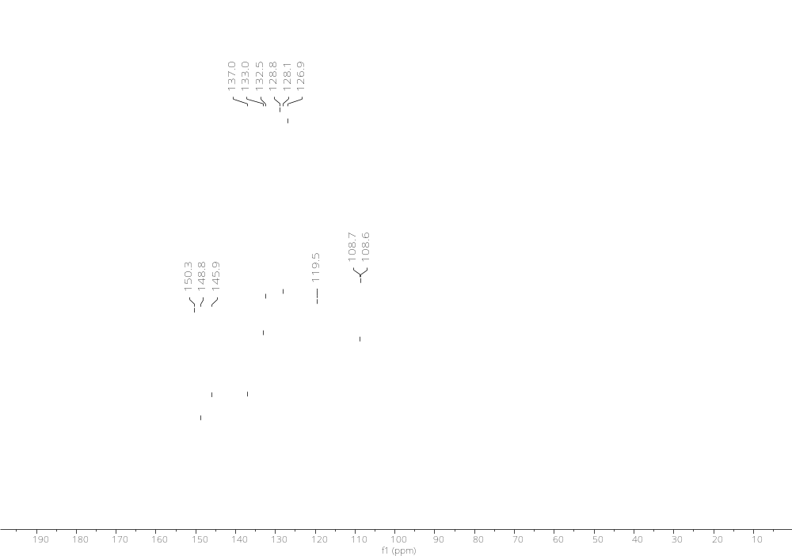
Figure S38. ¹³C-NMR of (E)-2-styrylimidazo[1,2-a]pyrimidine (4a)
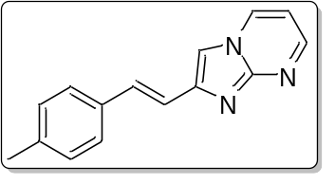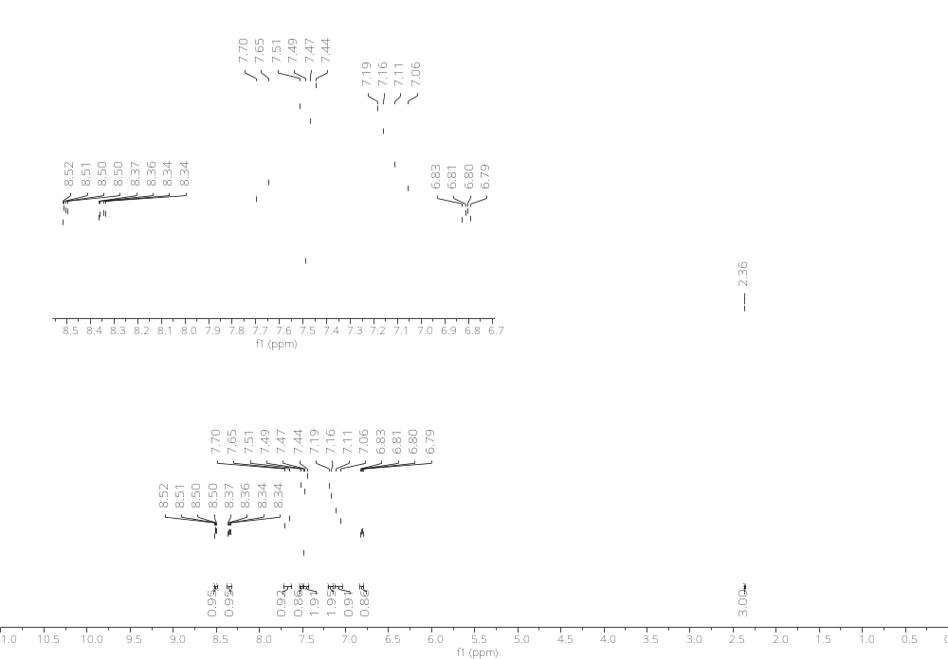
Figure S39. ¹H-NMR of (E)-2-(4-methylstyryl)imidazo[1,2-a]pyrimidine (4b)
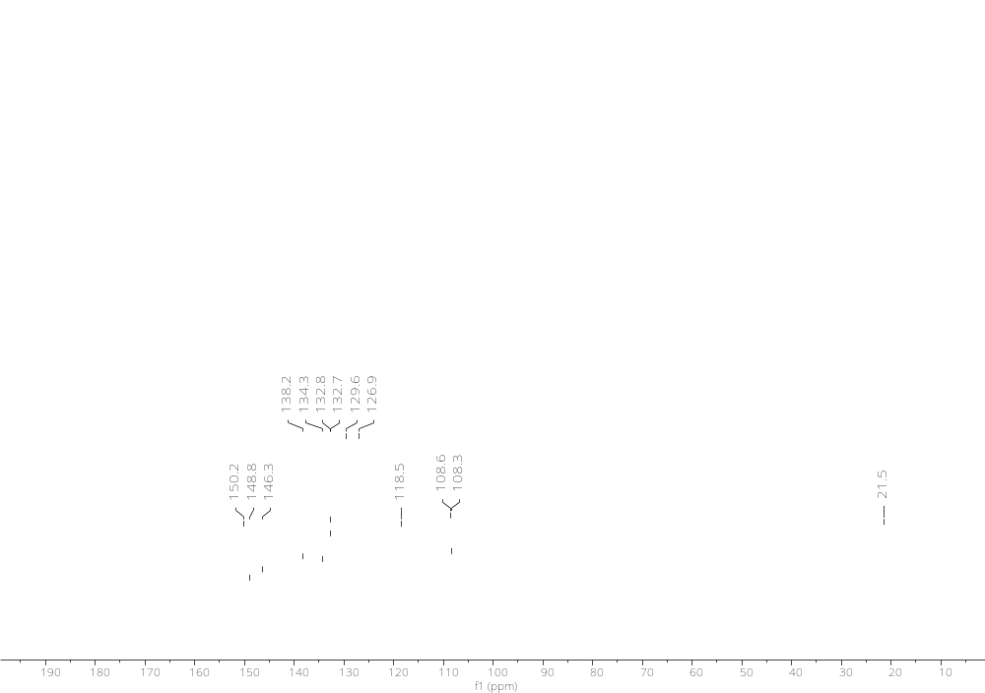
Figure S40. ¹³C-NMR of (E)-2-(4-methylstyryl)imidazo[1,2-a]pyrimidine (4b)
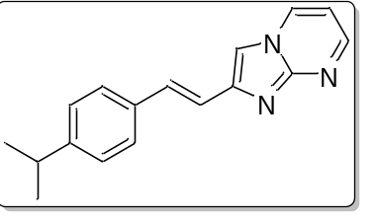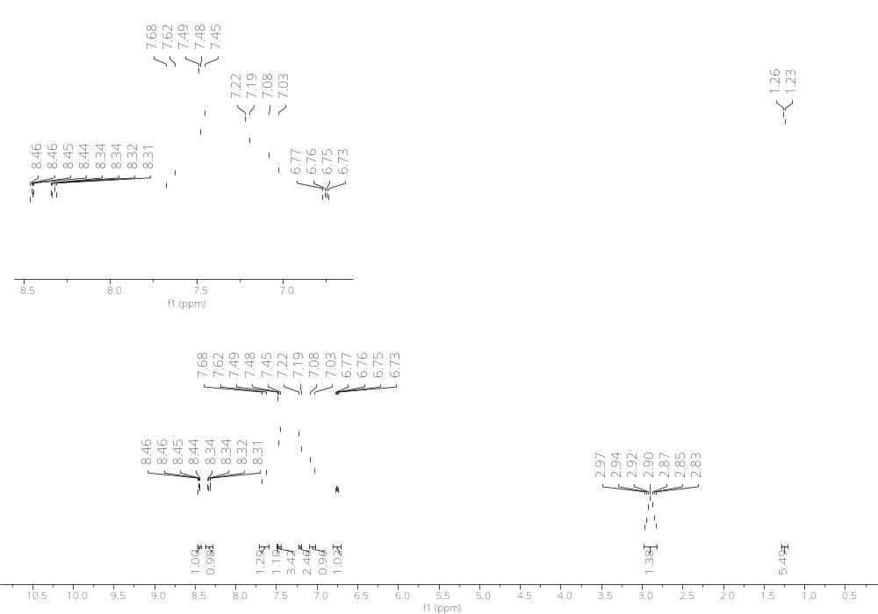
Figure S41. ¹H-NMR of (E)-2-(4-isopropylstyryl)imidazo[1,2-a]pyrimidine (4c)
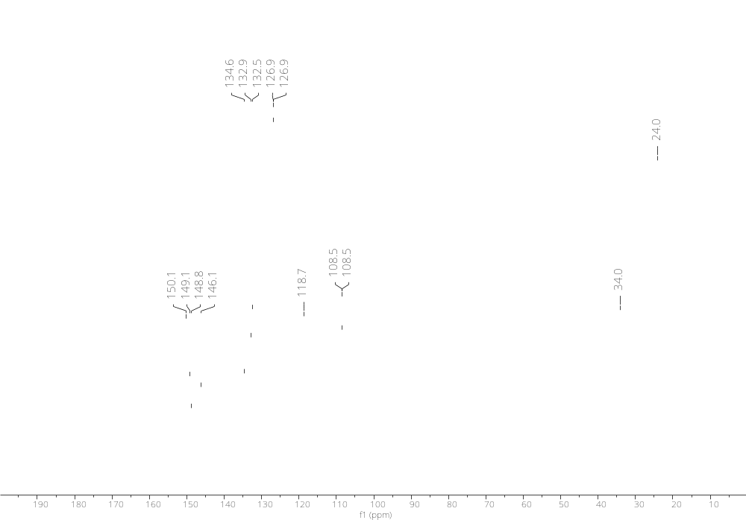
Figure S42¹³C-NMR of (E)-2-(4-isopropylstyryl)imidazo[1,2-a]pyrimidine (4c)
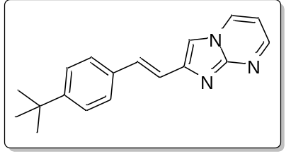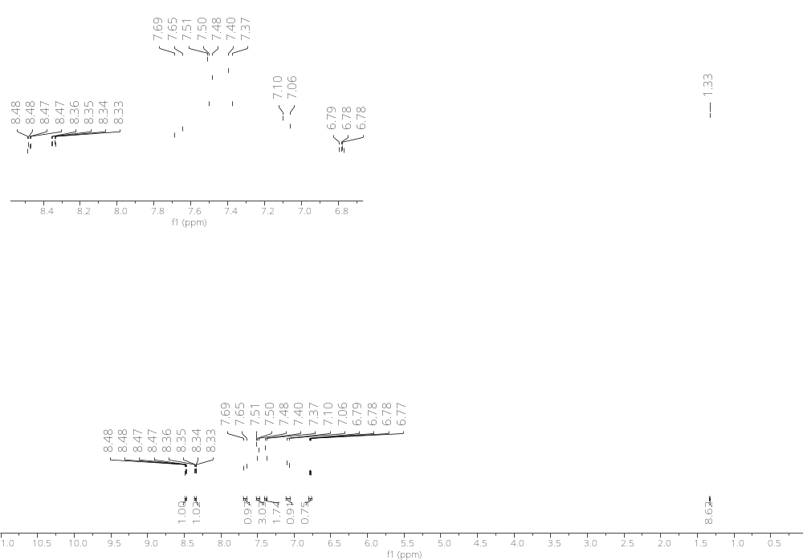
Figure S43. ¹H-NMR of (E)-2-(4-(tert-butyl)styryl)imidazo[1,2-a]pyrimidine (4d)
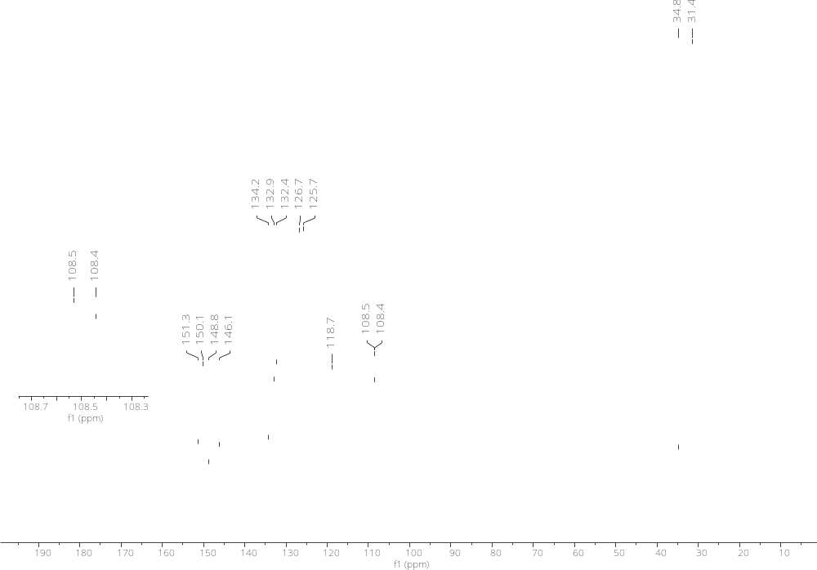
Figure S44. ¹³C-NMR of (E)-2-(4-(tert-butyl)styryl)imidazo[1,2-a]pyrimidine (4d)
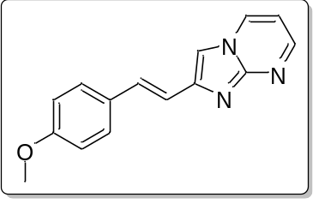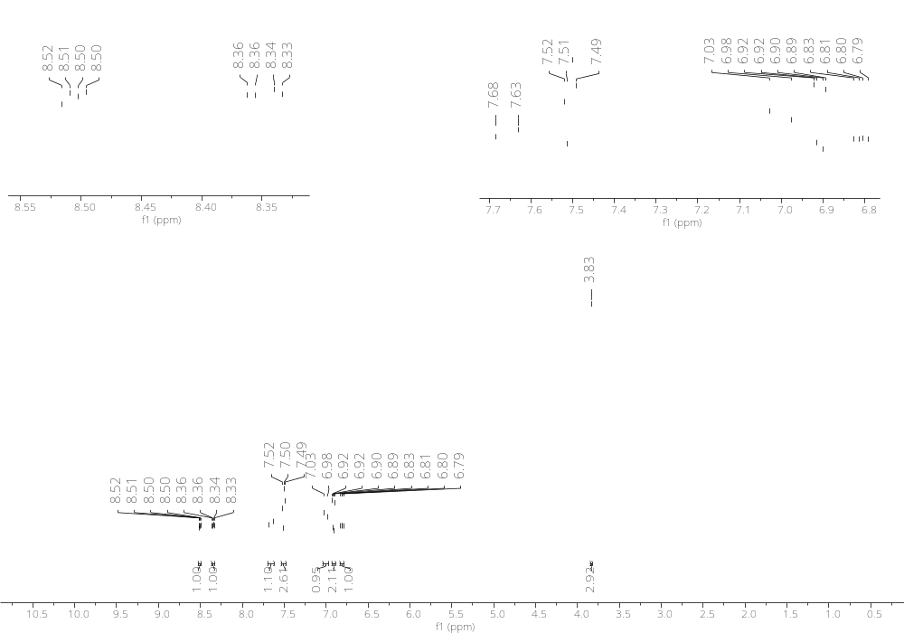
Figure S45. ¹H-NMR of (E)-2-(4-methoxystyryl)imidazo[1,2-a]pyrimidine (4e)
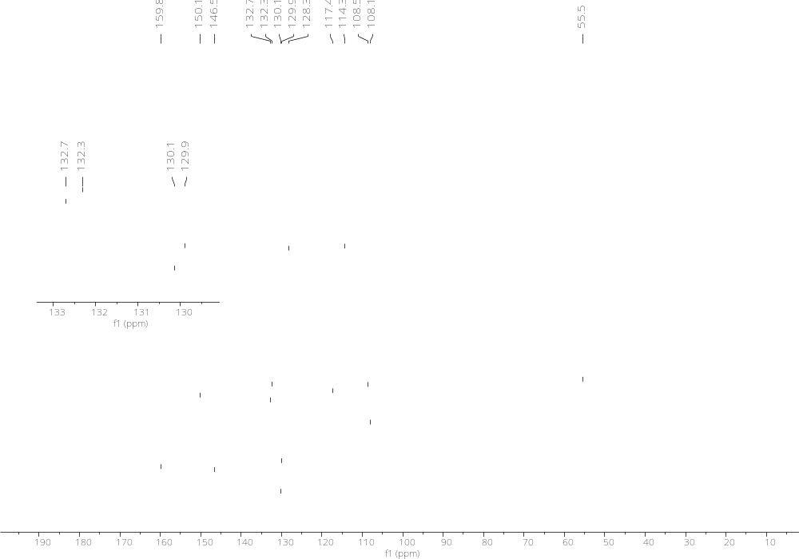
Figure S46. ¹³C-NMR of (E)-2-(4-methoxystyryl)imidazo[1,2-a]pyrimidine (4e)
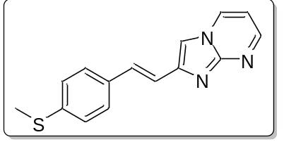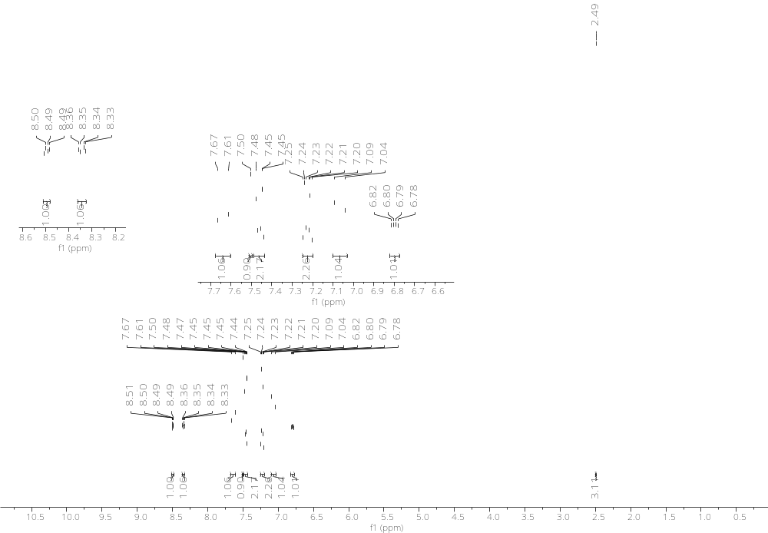
Figure S47. ¹H-NMR of (E)-2-(4-(methylthio)styryl)imidazo[1,2-a]pyrimidine (4f)
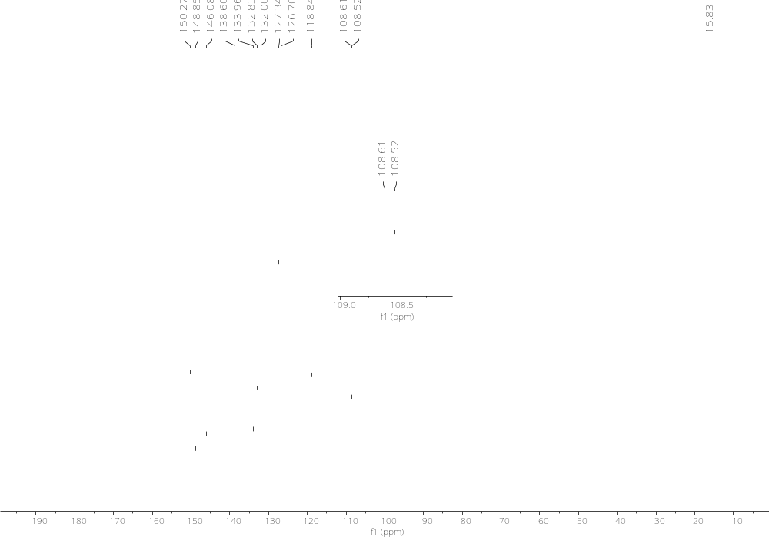
Figure S48. ¹³C-NMR of (E)-2-(4-(methylthio)styryl)imidazo[1,2-a]pyrimidine (4f)
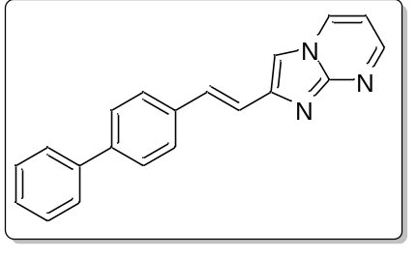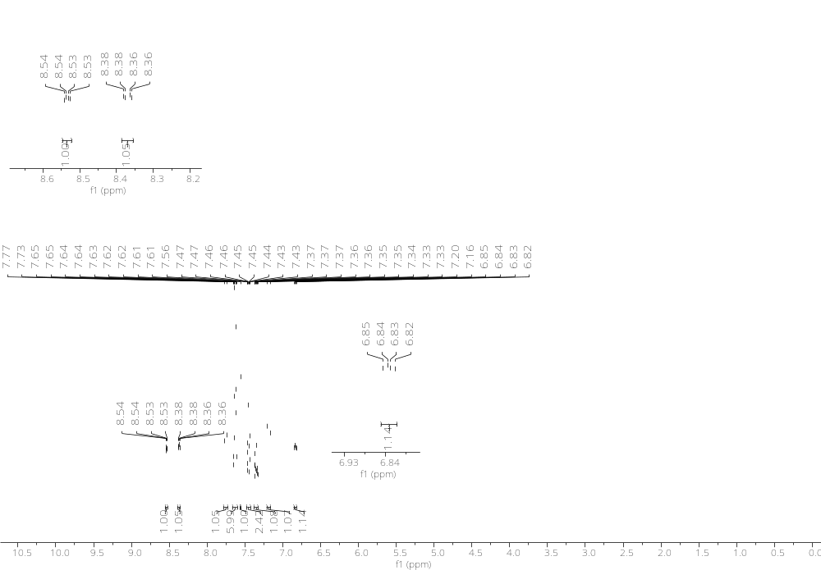
Figure S49. ¹H-NMR of (E)-2-(2-([1,1'-biphenyl]-4-yl)vinyl)imidazo[1,2-a]pyrimidine (4g)

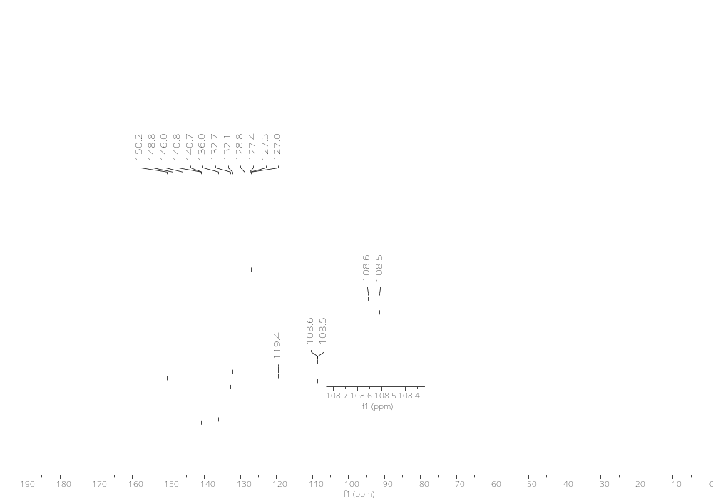
Figure S50. ¹³C-NMR of (E)-2-(2-([1,1'-biphenyl]-4-yl)vinyl)imidazo[1,2-a]pyrimidine (4g)

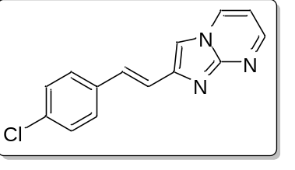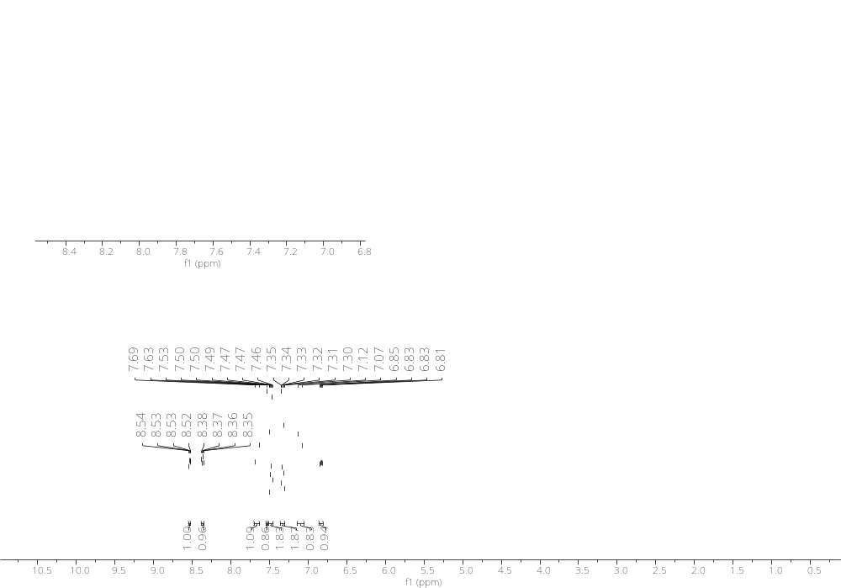
Figure S51. ¹H-NMR of (E)-2-(4-chlorostyryl)imidazo[1,2-a]pyrimidine (4h)

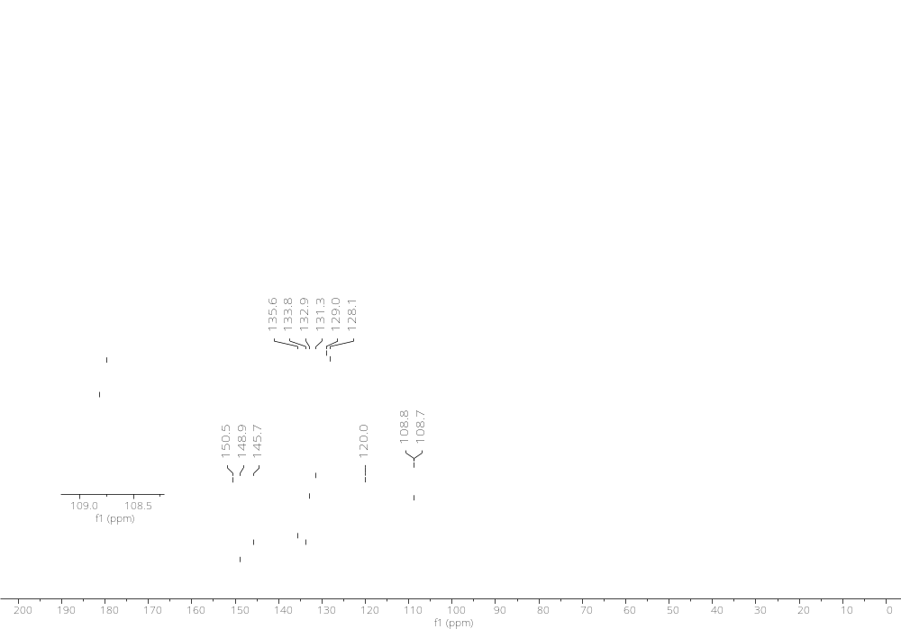
Figure S52. ¹³C-NMR of (E)-2-(4-chlorostyryl)imidazo[1,2-a]pyrimidine (4h)
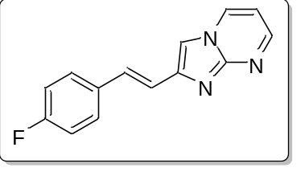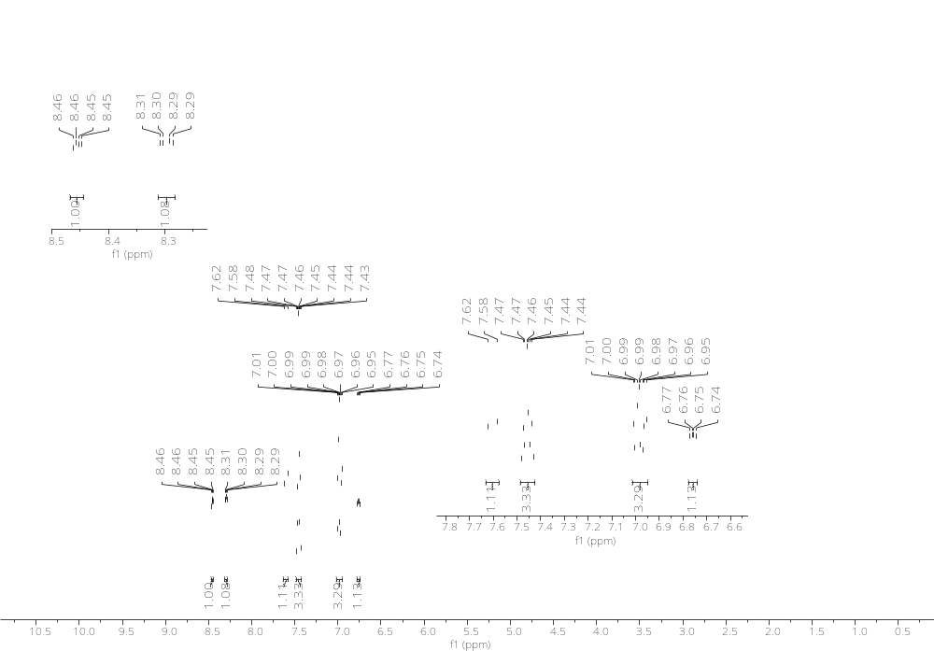
Figure S53. ¹H-NMR of (E)-2-(4-fluorostyryl)imidazo[1,2-a]pyrimidine (4i)

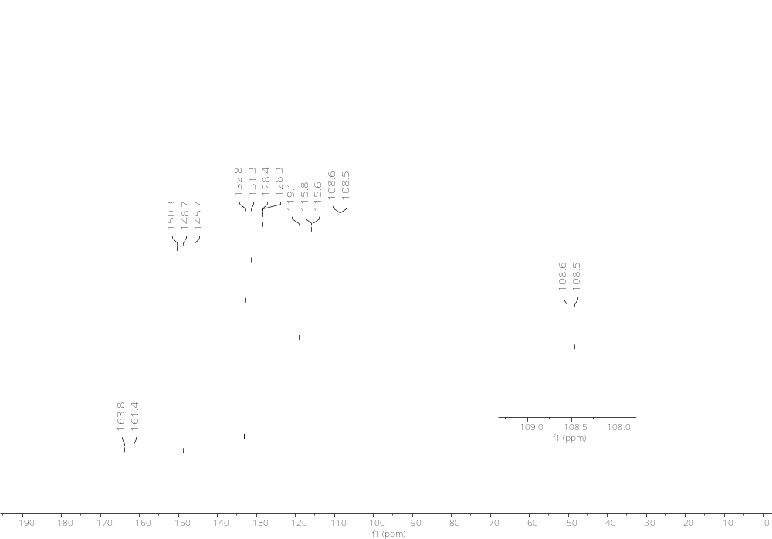
Figure S54. ¹³C-NMR of (E)-2-(4-fluorostyryl)imidazo[1,2-a]pyrimidine (4i)

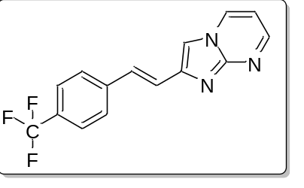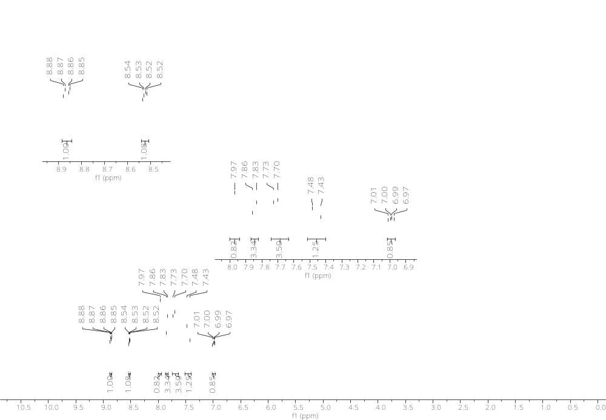
Figure S55. ¹H-NMR of (E)-2-(4-(trifluoromethyl)styryl)imidazo[1,2-a]pyrimidine (4j)

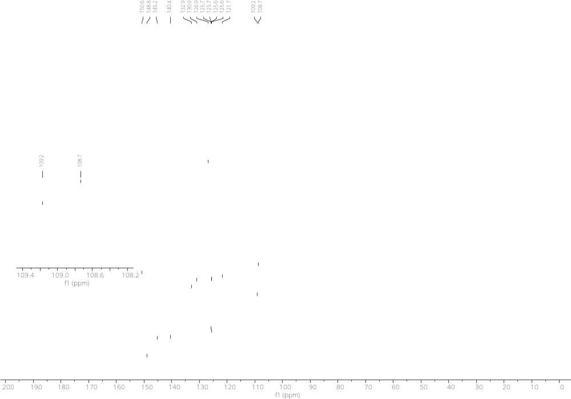
Figure S56. ¹³C-NMR of (E)-2-(4-(trifluoromethyl)styryl)imidazo[1,2-a]pyrimidine (4j)

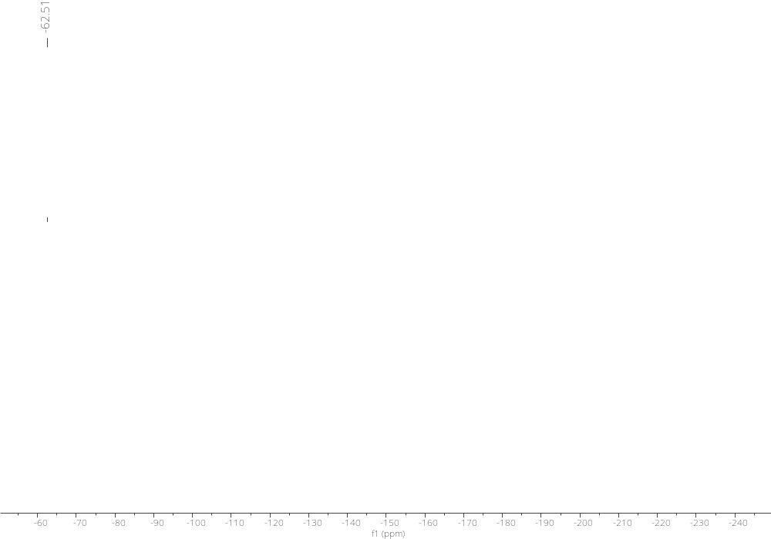
Figure S57. ¹⁹F-NMR of (E)-2-(4-(trifluoromethyl)styryl)imidazo[1,2-a]pyrimidine (4j)

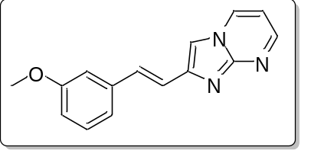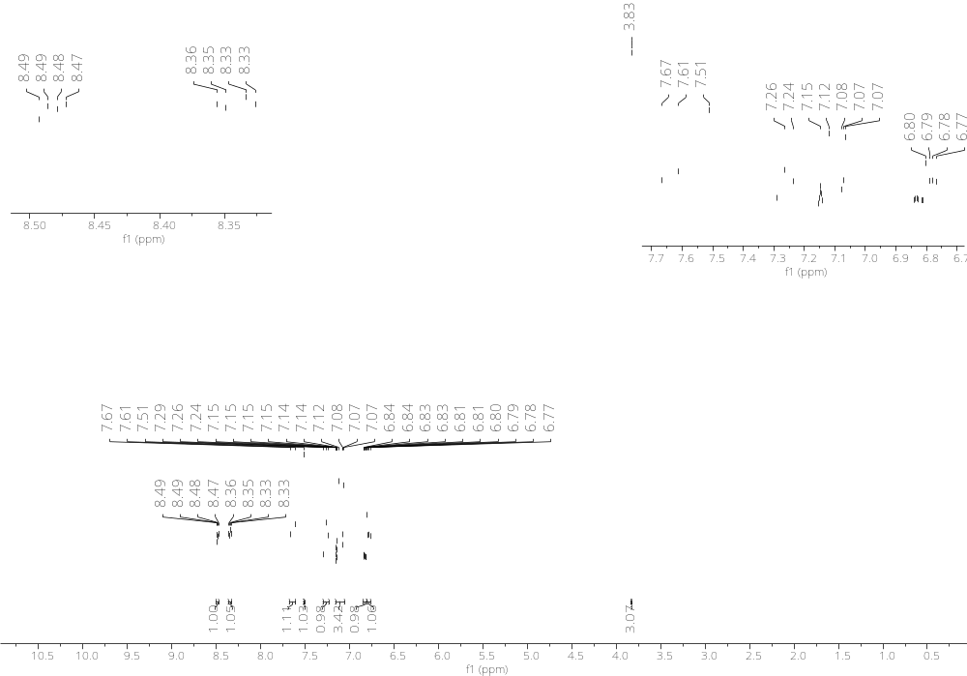
Figure S58. ¹H-NMR of (E)-2-(3-methoxystyryl)imidazo[1,2-a]pyrimidine (4k)

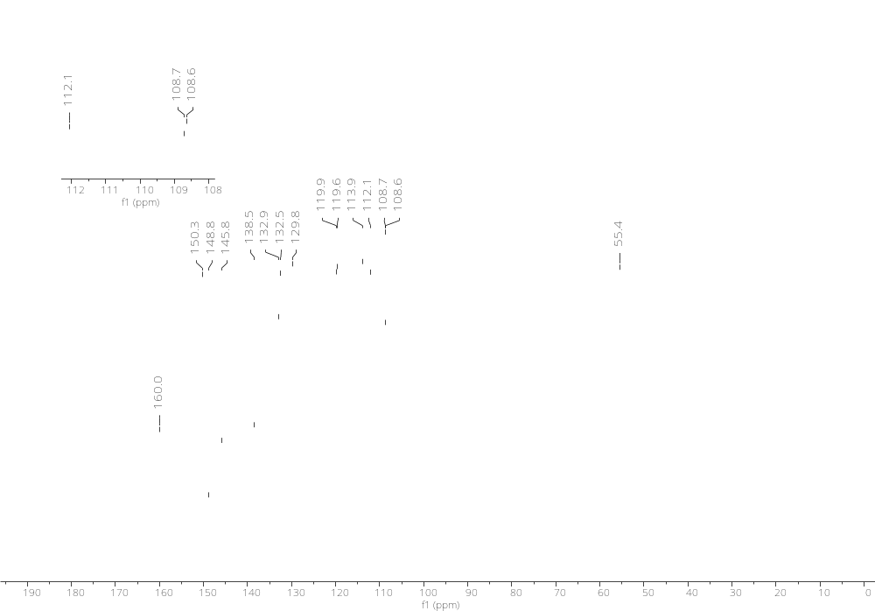
Figure S59. ¹³C-NMR of (E)-2-(3-methoxystyryl)imidazo[1,2-a]pyrimidine (4k)
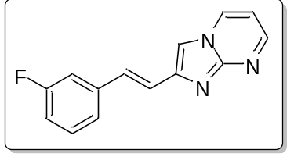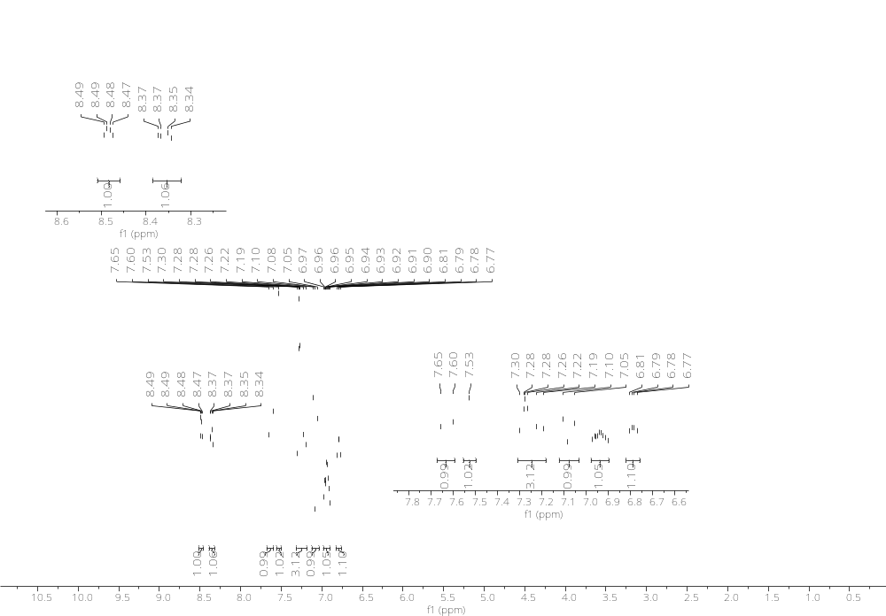
Figure S60. ¹H-NMR of (E)-2-(3-fluorostyryl)imidazo[1,2-a]pyrimidine (4l)

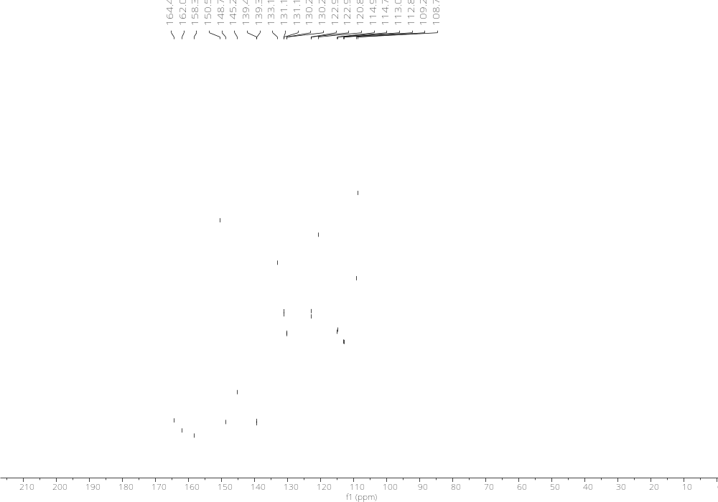
Figure S61. ¹³C-NMR of (E)-2-(3-fluorostyryl)imidazo[1,2-a]pyrimidine (4l)
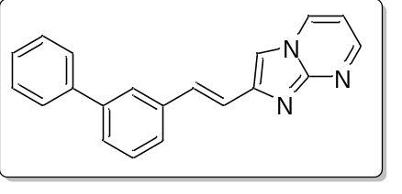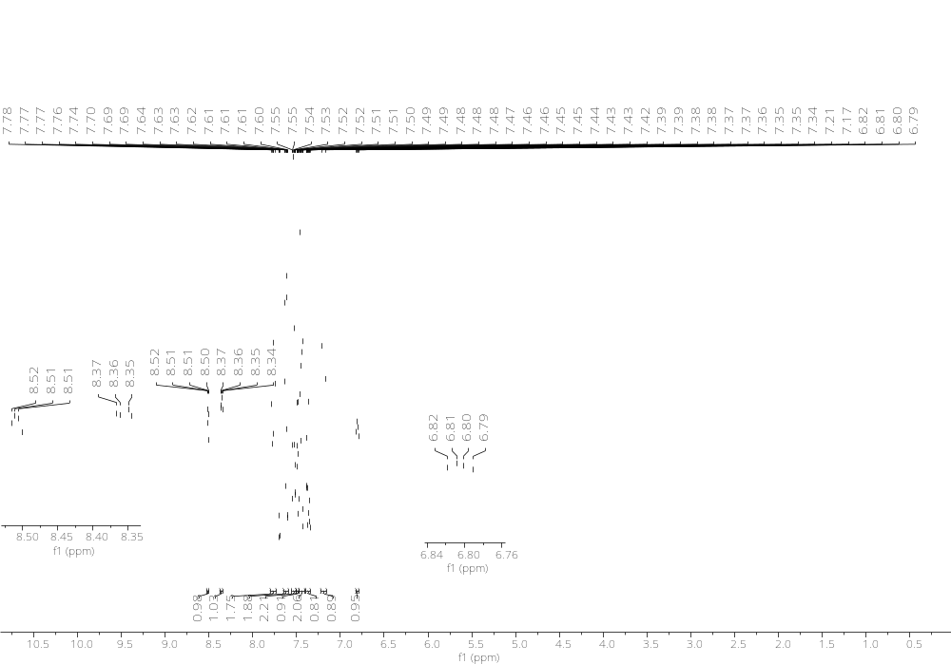
Figure S62. ¹H-NMR of (E)-2-(2-([1,1'-biphenyl]-3-yl)vinyl)imidazo[1,2-a]pyrimidine (4m)

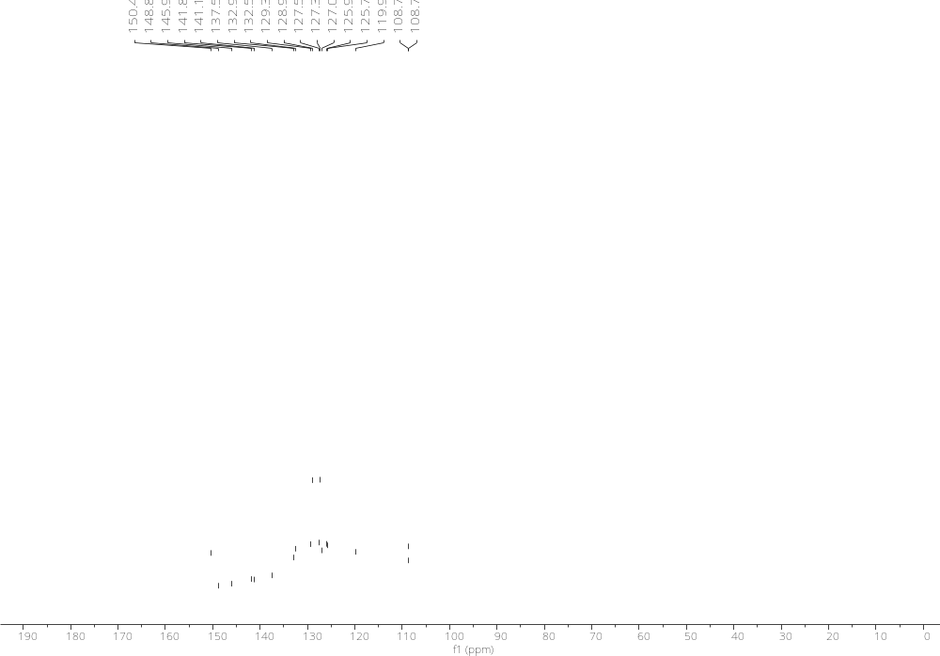
Figure S63. ¹³C-NMR of (E)-2-(2-([1,1'-biphenyl]-3-yl)vinyl)imidazo[1,2-a]pyrimidine (4m)

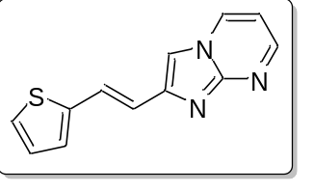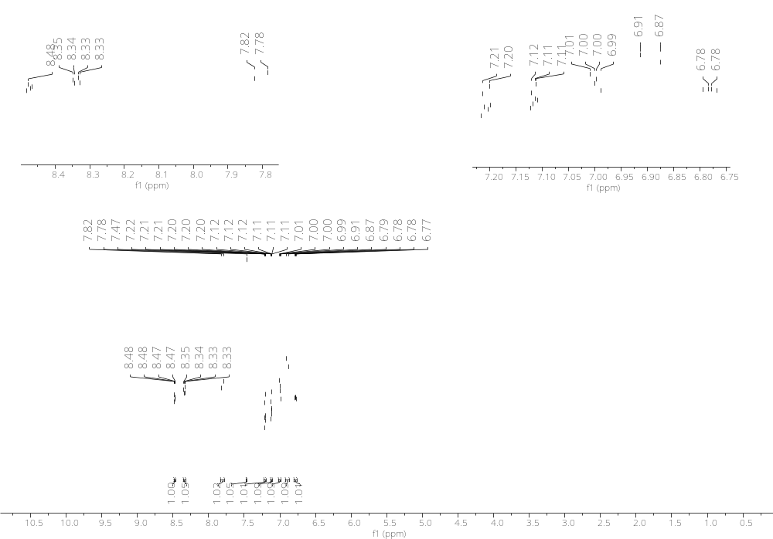
Figure S64. ¹H-NMR of (E)-2-(2-(thiophen-2-yl)vinyl)imidazo[1,2-a]pyrimidine (4n)
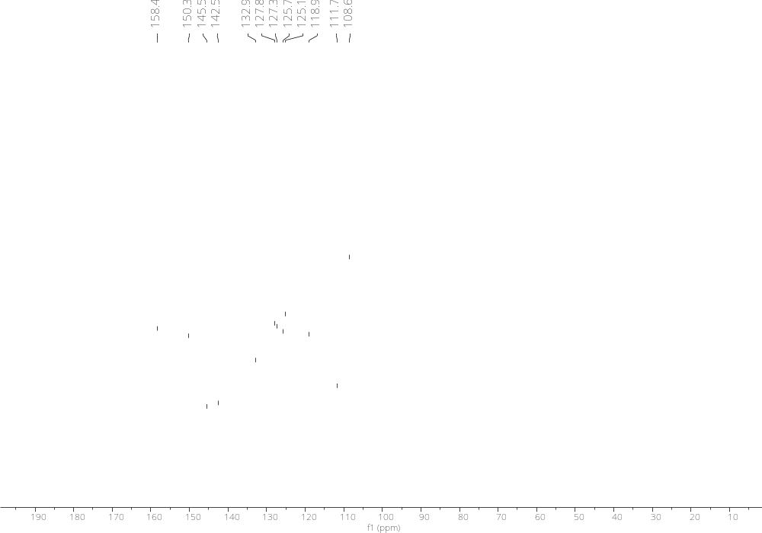
Figure S65. ¹³C-NMR of (E)-2-(2-(thiophen-2-yl)vinyl)imidazo[1,2-a]pyrimidine (4n)

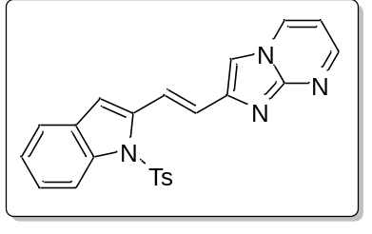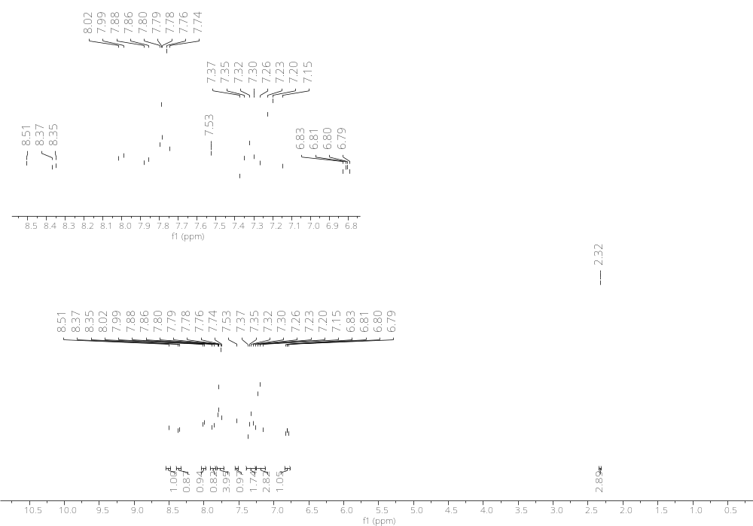
Figure S66. ¹H-NMR of (E)-2-(2-(1-tosyl-1H-indol-2-yl)vinyl)imidazo[1,2-a]pyrimidine (4o)

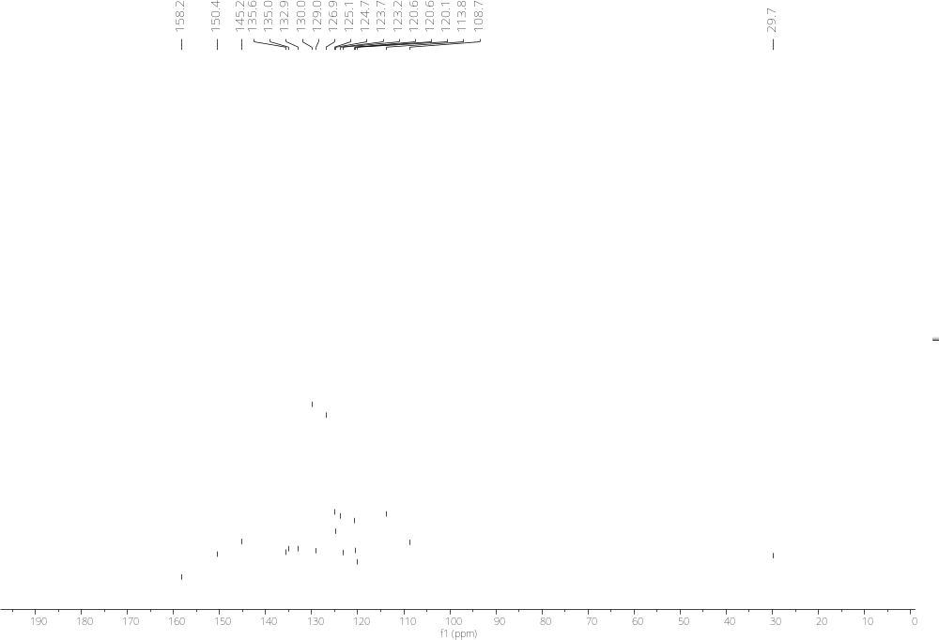
Figure S67. ¹³C-NMR of (E)-2-(2-(1-tosyl-1H-indol-2-yl)vinyl)imidazo[1,2-a]pyrimidine (4o)

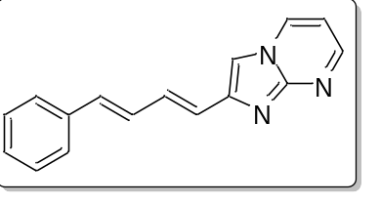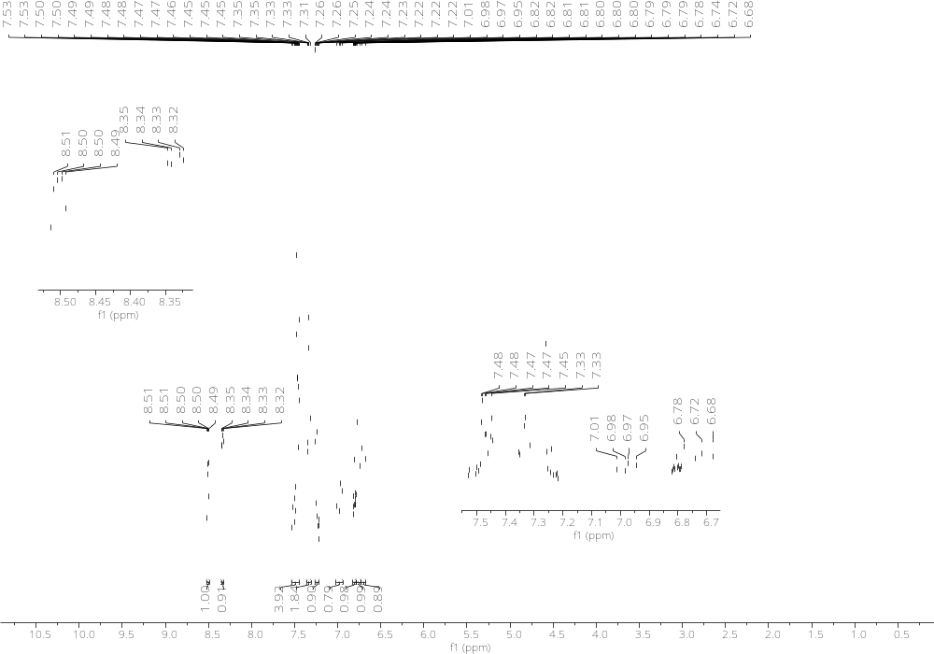
Figure S68. ¹H-NMR of 2-((1E,3E)-4-phenylbuta-1,3-dien-1-yl)imidazo[1,2-a]pyrimidine (4p)

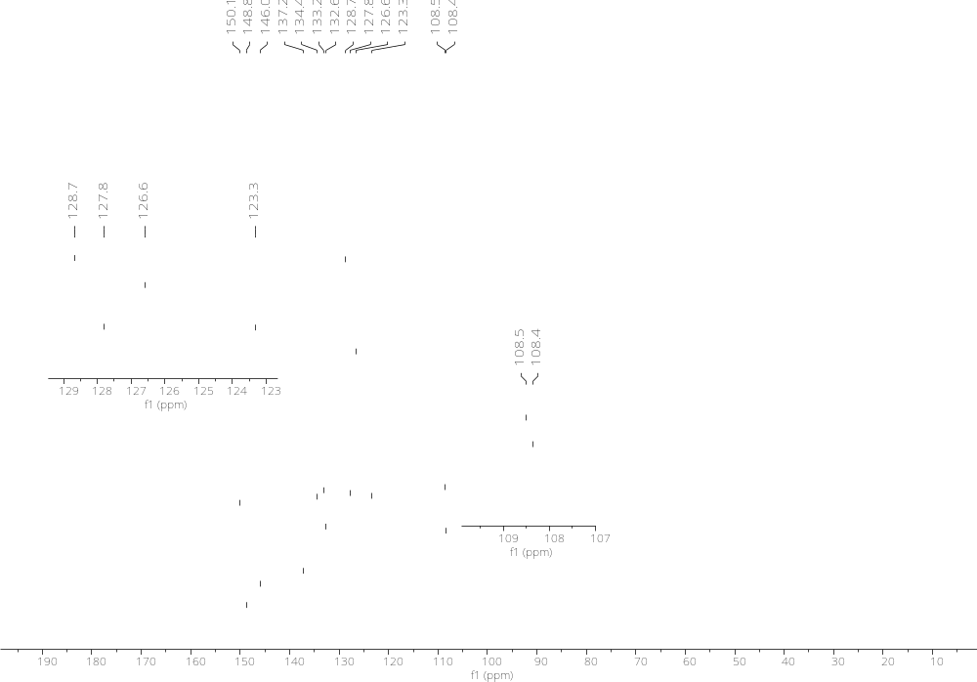
Figure S69. ¹³C-NMR of 2-((1E,3E)-4-phenylbuta-1,3-dien-1-yl)imidazo[1,2-a]pyrimidine (4p)
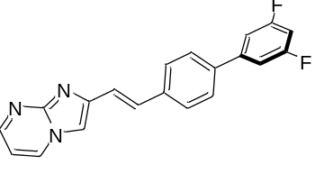
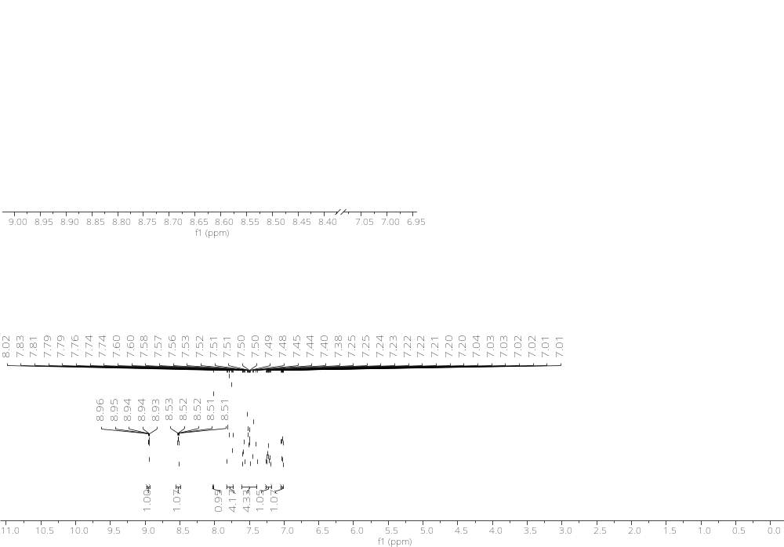
Figure S70. (E)-2-(2-(3',5'-difluoro-[1,1'-biphenyl]-4-yl)vinyl)imidazo[1,2-a]pyrimidine (4q)

Table S1. Percentage of cell growth inhibition of compounds 4a–p.
Compound | Percentage of growth inhibition
Compound | U251 | SKLU-1 | COS7
4a | 3.94 | 3.8 | NC
4b | 4.9 | 11.14 | NC
4c | 21.3 | 44.58 | 7.25
4d | 34.4 | 33.5 | NC
4e | 15.74 | NC | NC
4f | 9.86 | 7.15 | 15.95
4g | 48.27 | 25.67 | NC
4h | 4.19 | 7.704 | NC
4i | 4.4 | 5.4 | NC
4j | 8.54 | NC | NC
4k | 12.47 | 13.41 | NC
4l | 8.4 | 10.4 | NC
4m | 27.46 | 32.12 | 20.85
4n | 6.93 | 9.43 | 6.02
4o | 16.61 | 15.27 | 21.03
4p | 15.36 | 9.73 | NC
Etoposide | 97.8 | 86.7 | 81.8

