Supplementary File
Gait-related cross-frequency coupling in the subthalamic nucleus of parkinsonian patients
AmirAli Farokhniaee, Chiara Palmisano, Jasmin Del Vecchio Del Vecchio, Jens Volkmann, and Ioannis U. Isaias
Abbreviations: LFP, local field potential; PAC, phase-amplitude coupling; PSD, power spectral density; S, standing; STN, subthalamic nucleus (+/-, more or less dopaminergic innervation); W, walking.

Power Spectral Densities
The total PSDs for each patient and state were computed and the results are presented in Figures S1 and S2 for the STN- and STN+ group, respectively. For each of the subplots (top and middle rows) in Figures S1 and S2, the PSD of 100 epochs for 20 seconds were computed (dashed magenta for standing and dashed cyan for walking) and the average of these 100 trials were plotted in a thick line (red for standing, blue for walking). These are normalized to the total integral of the PSD. Note that this is done on the concatenated LFPs. The subplots at the bottom are repetitions of all the mean patient PSDs during standing and walking, red and blue (dashed), respectively, and their overall mean (thick red and blue lines).
Figure S1. Top and middle rows: the PSDs for individual subjects in the STN- group. Bottom row: the mean PSDs for the STN- LFPs and the grand average for all patients (bold lines, red for standing and blue for walking states).
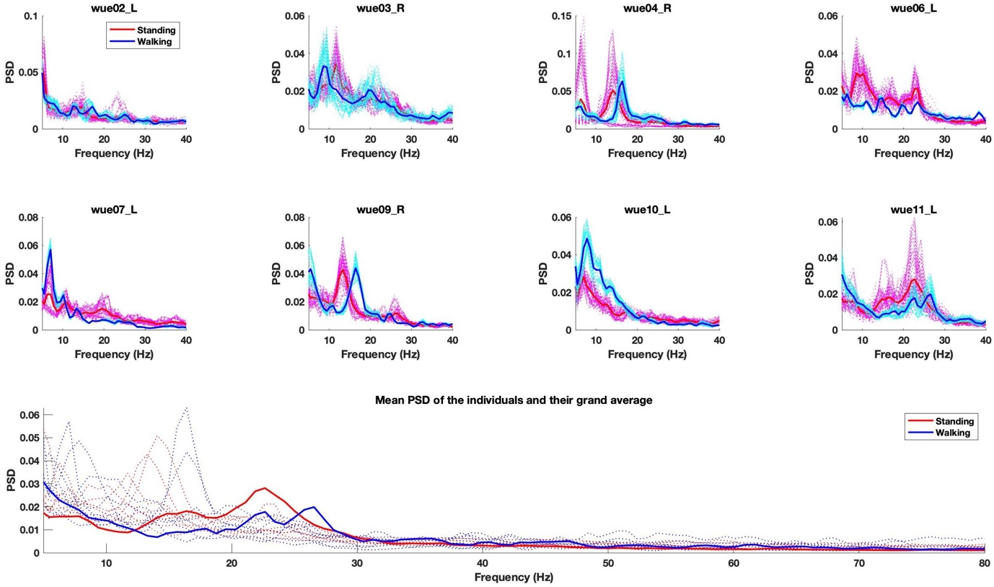
Figure S2. Top and middle rows: the PSDs for individual subjects in the STN+ group. Bottom row: the mean PSDs for the STN+ LFPs and the grand average for all patients (bold lines, red for standing and blue for walking states).
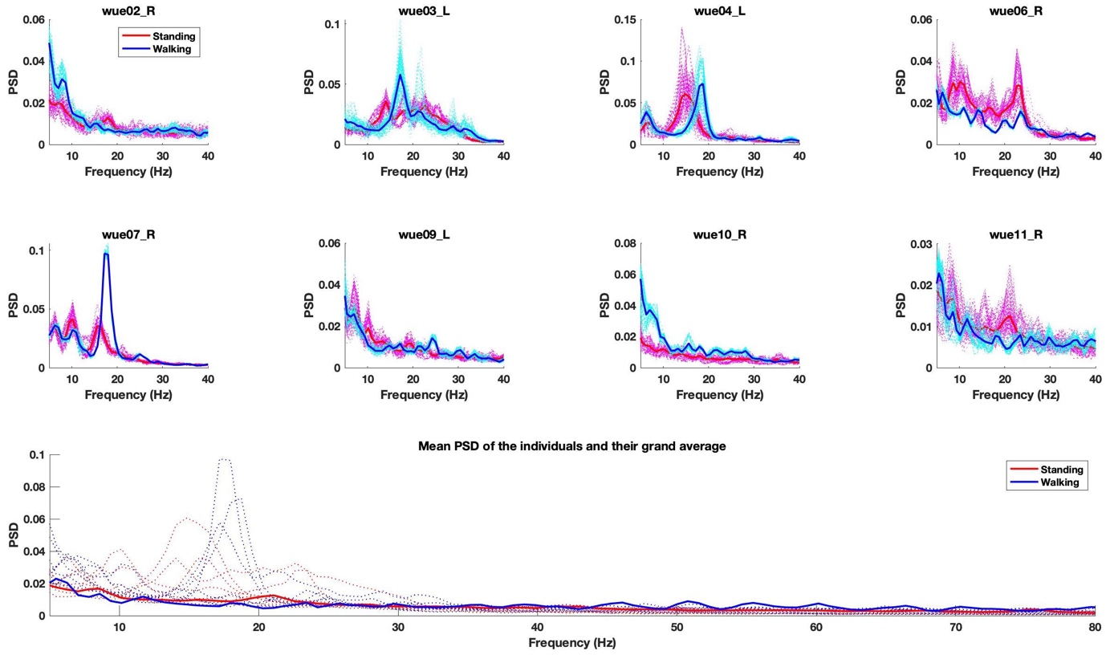

Band power distributions in different rhythms
We computed the alpha (5-12 Hz), beta (13-30 Hz), and gamma (40-100 Hz) powers (normalized with respect to the total LFP power from 5 to 100 Hz) and plotted their distributions. In addition, we divided the beta band to low (13-20 Hz) and high bands (21-30 Hz) to check whether there would be a change in the smaller ranges of beta-band rhythm. No significant differences between the mean of the standing and walking state distributions was seen in any case (Kruskal-Wallis test).
Figure S3. (A) alpha (p=0.17), (B) beta (p=0.4), (C) low-beta (p=0.46), (D) high-beta (p=0.3), and (E) gamma-band power (p=0.6) distributions during standing and walking states for the STN- group.
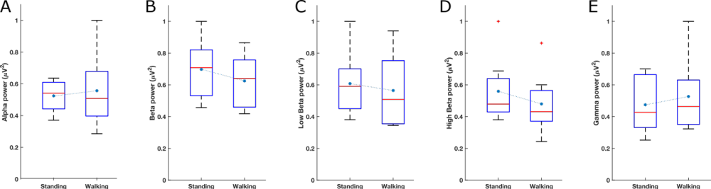

Figure S4. (A) alpha (p=0.67), (B) beta (p=0.75), (C) low-beta (p=0.46), (D) high-beta (p=0.29), and (E) gamma-band power (p=0.34) distributions during standing and walking states for the STN+ group.
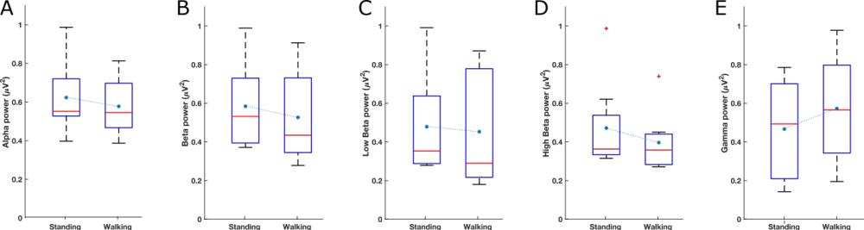
Figure S5. Individual PAC diagrams in the standing and walking states.
WUE02
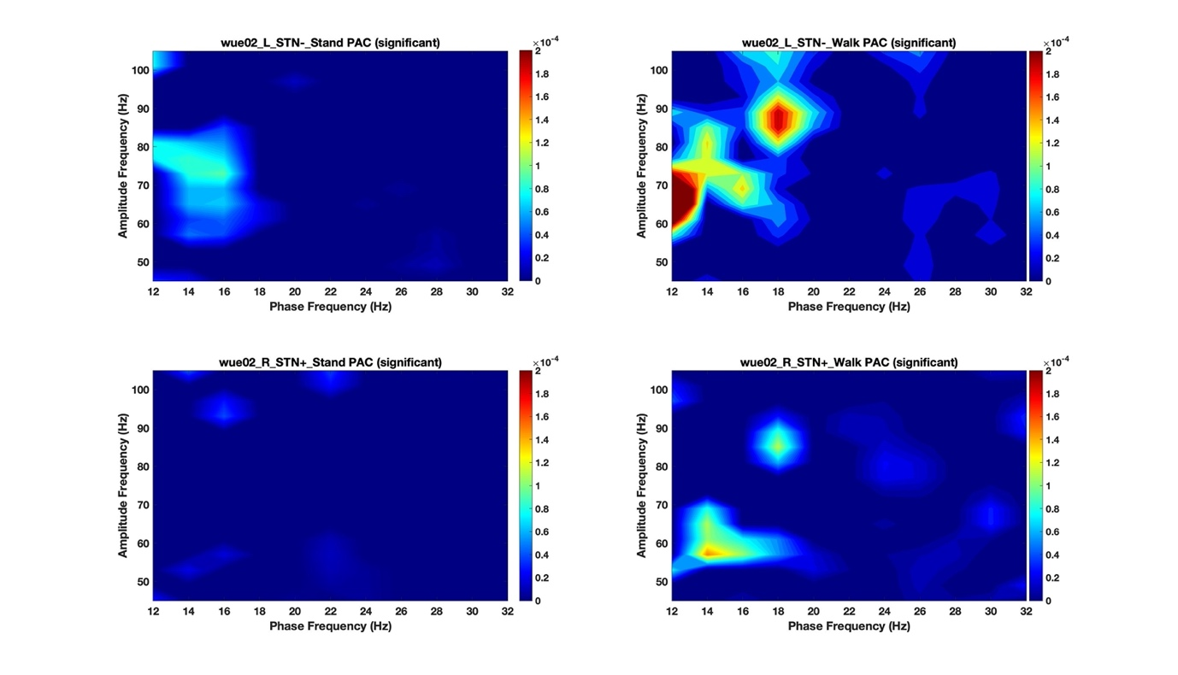

WUE03
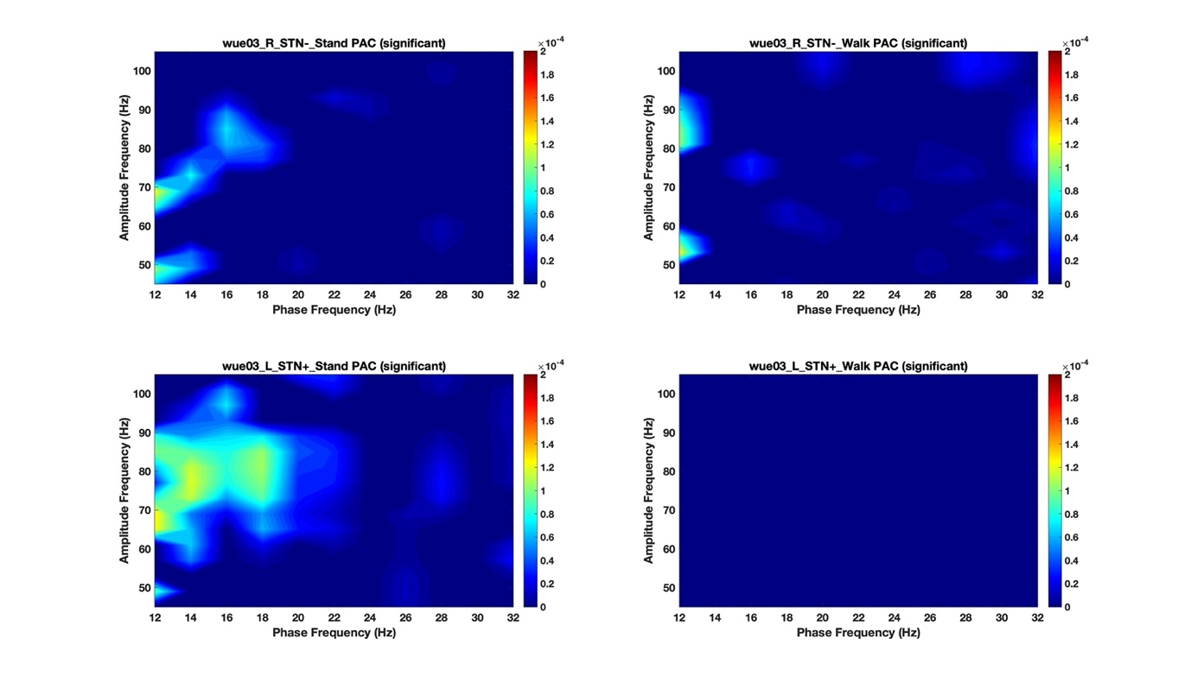
WUE04
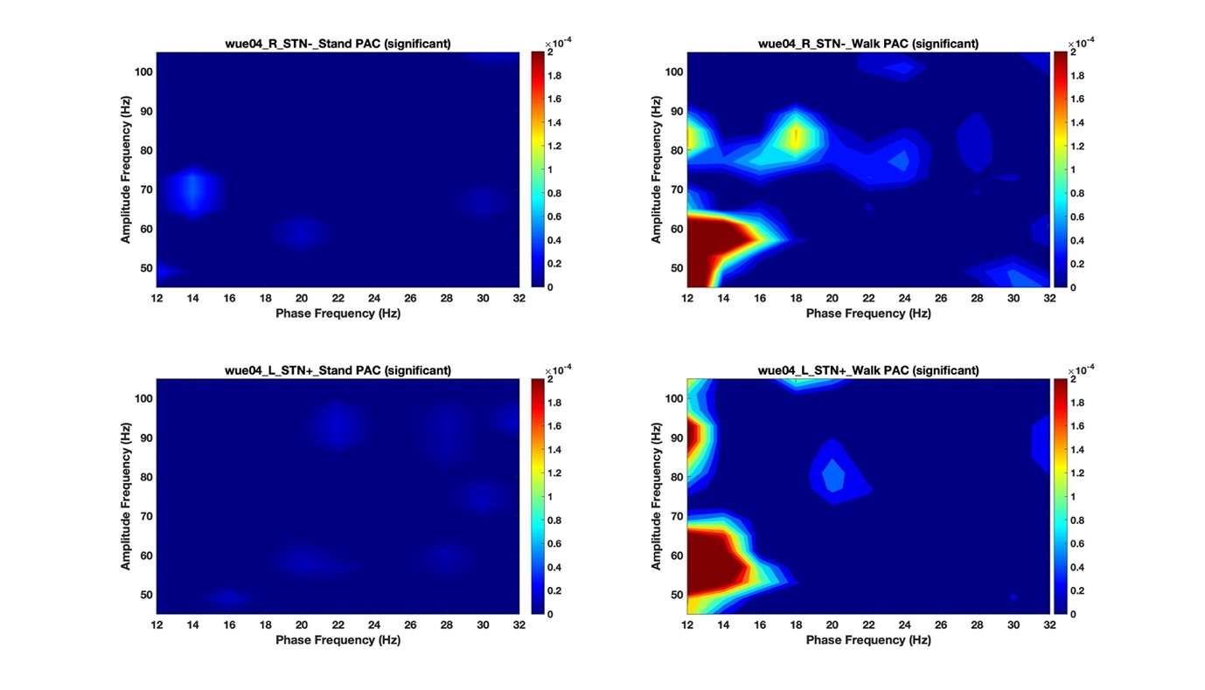

WUE06
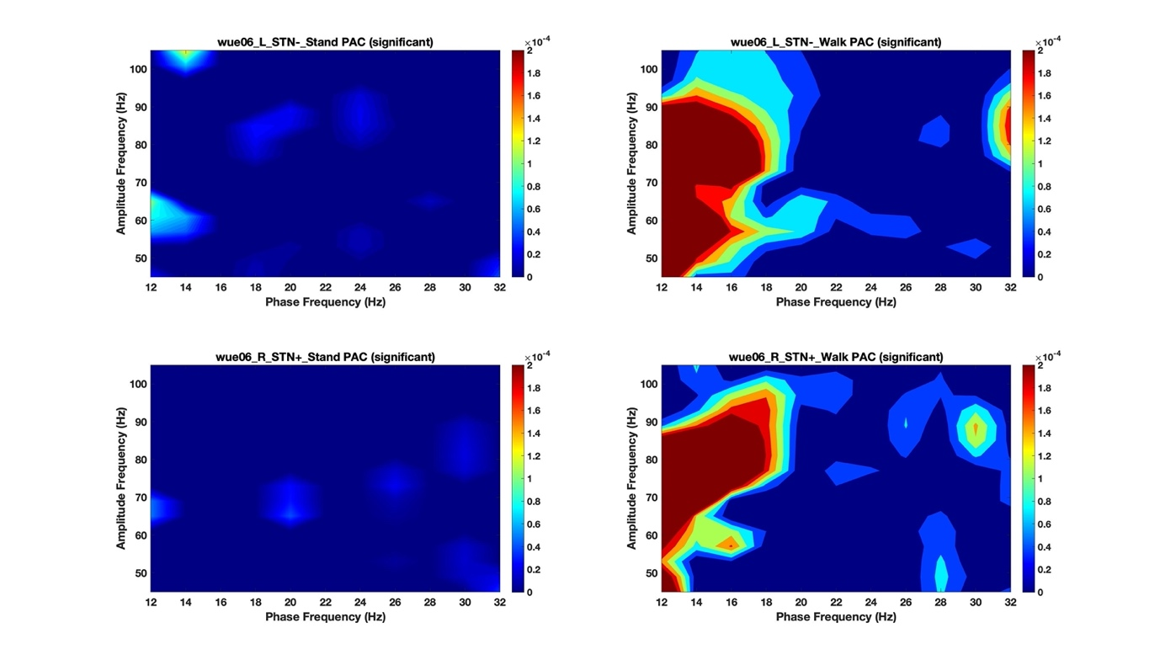
WUE07
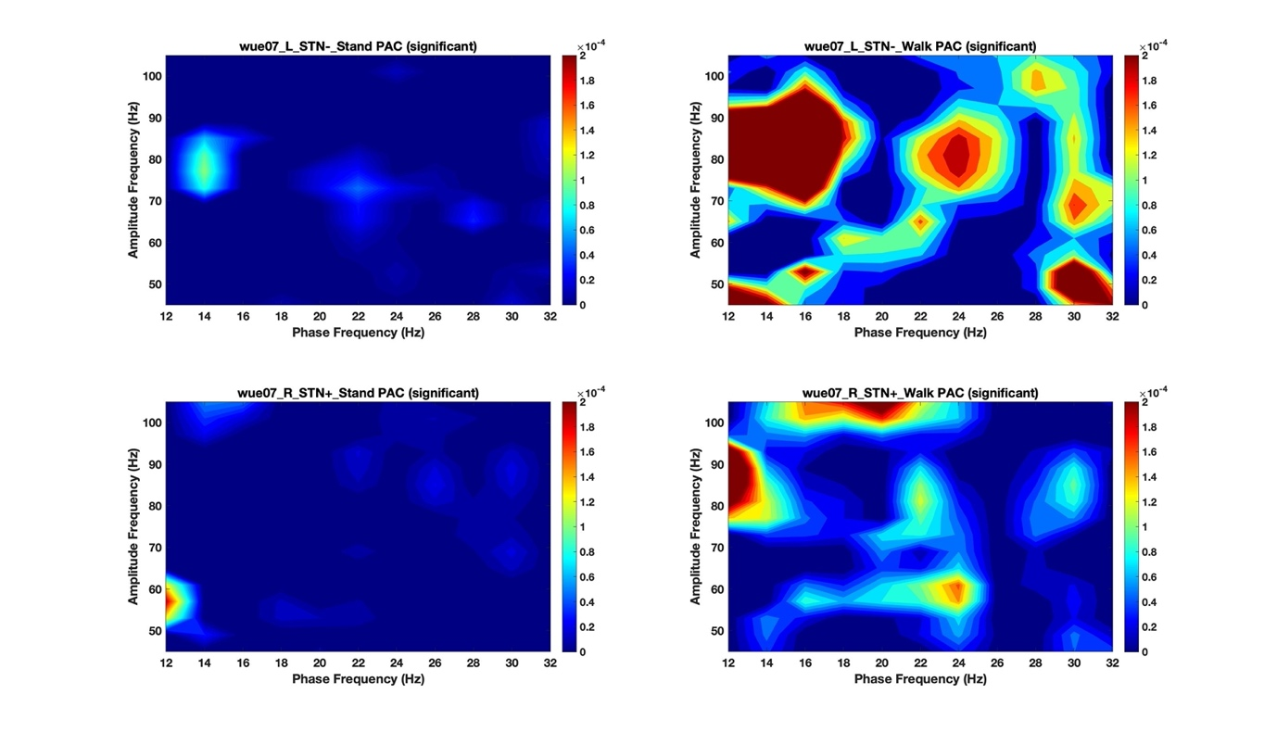

WUE09
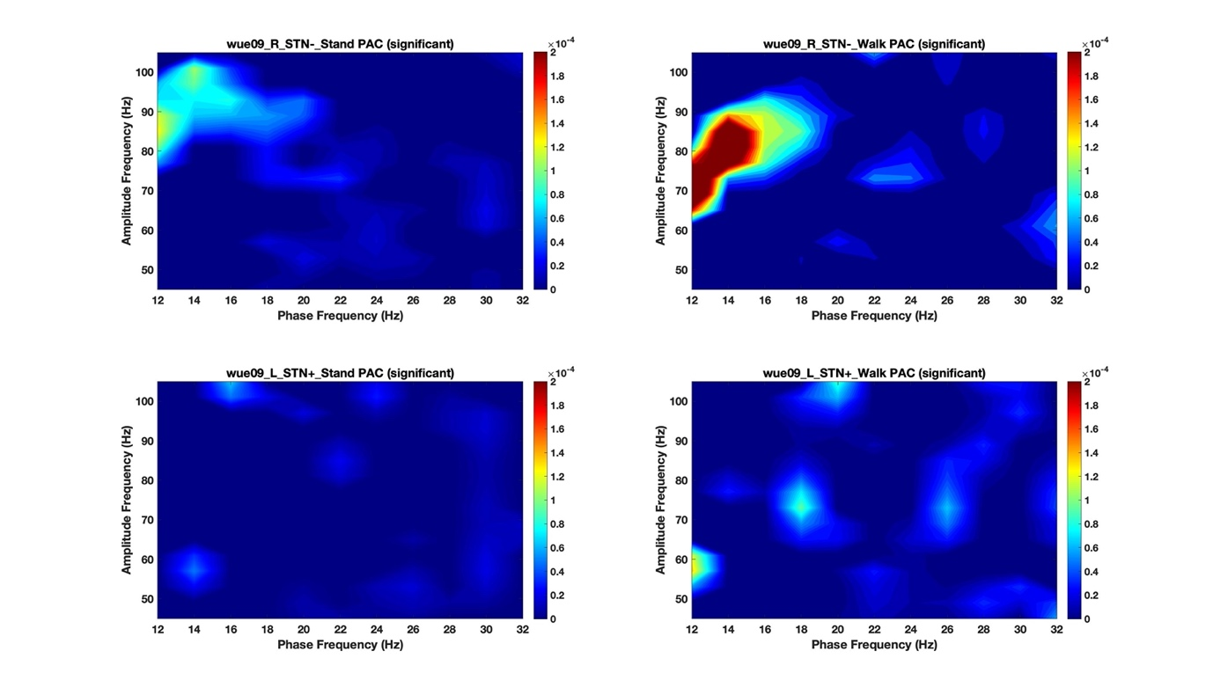
WUE10
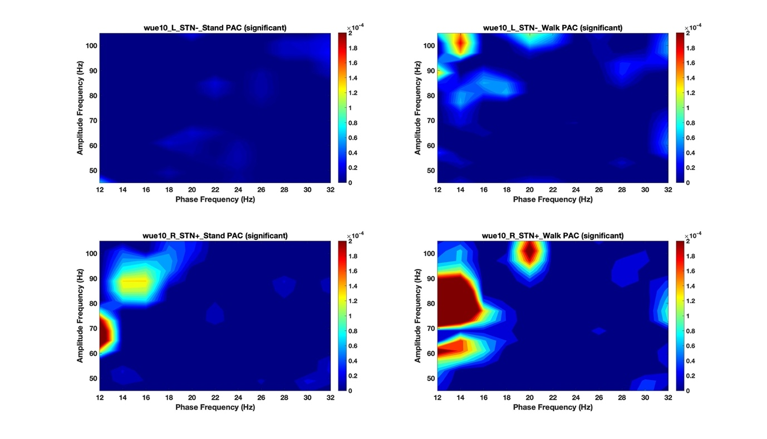

WUE11
