Supplemental Material
Graphical Abstract

Supplementary Figure 1. (A) The distribution of SUV_{max} at the anastomotic sites with FAPI-PET imaging and FDG-PET imaging, respectively; FAPI-PET (n=74) and FDG-PET (n=68). (B) Proportions of SUV_{max}, with thresholds of 2.5 and 5, in the two PET imaging modalities, respectively; FAPI-PET (n=74) and FDG-PET (n=68). (C) Quantitative analysis of SUV_{max} at the anastomotic sites and its corresponding gastrointestinal background for the two PET imaging modalities; FAPI-PET (n=74) and FDG-PET (n=68). (D) Ratio of anastomotic SUV_{max} to its corresponding gastrointestinal background SUV_{max}; FAPI-PET (n=74) and FDG-PET (n=68). (E) The correlation of the anastomotic SUV_{max} on FAPI-PET and FDG-PET in paired FAPI-FDG PET imaging (n=64).

Supplementary Figure 2. (A) Quantitative analysis of SUV_{max} at the abdominal incision sites and the corresponding abdominal background on the two PET imaging modalities, FAPI-PET (n=74) and FDG-PET (n=68). (B) The ratio of incisional SUV_{max} to its corresponding abdominal background SUV_{max}; FAPI-PET (n=74) and FDG-PET (n=68). (C) The correlation of incisional SUV_{max} with FAPI-PET and FDG-PET in paired FAPI-FDG PET imaging (n=64).

Supplementary Figure 3. (A) Tumor stage-based quantitative analysis of anastomotic SUV_{max} (T1, n=3 or 2, since one T1 patient underwent FAPI-PET only; T2, n=3; T3, n=23 or 22; T4, n=30). No statistical difference was found among the groups. (B) Degree-based quantitative analysis of anastomotic SUV_{max} with different levels of differentiation (well differentiated, n=2; moderately differentiated, n=26; poorly differentiated, n=31; mucinous=4); ns. no statistical difference was found among the groups.

Supplementary Figure 4. (A) Comparison of the anastomotic ratio between non-recurrence and recurrence groups based on paired FAPI-FDG PET imaging, non-recurrence (n=55), and recurrence (n=5). The blue line refers to paired PET imaging for each recurrent patient. Patient ID: #63, #59, #57, #18, and #32. (B) Comparison of the surgery-PET imaging interval time between non-recurrence and recurrence groups on paired FAPI-FDG PET imaging; non-recurrence (n=55) and recurrence (n=5).
Supplementary Figure 5. The sensitivity, specificity, positive predictive value (PPV), negative predictive value (NPV), and accuracy of the two PET imaging modalities for detecting anastomotic recurrence in patients longer than 12 months post-surgery. Numbers in red, blue, and black refer to increased, decreased, and unchanged trends, respectively (compared with the results in Figure 2.B).

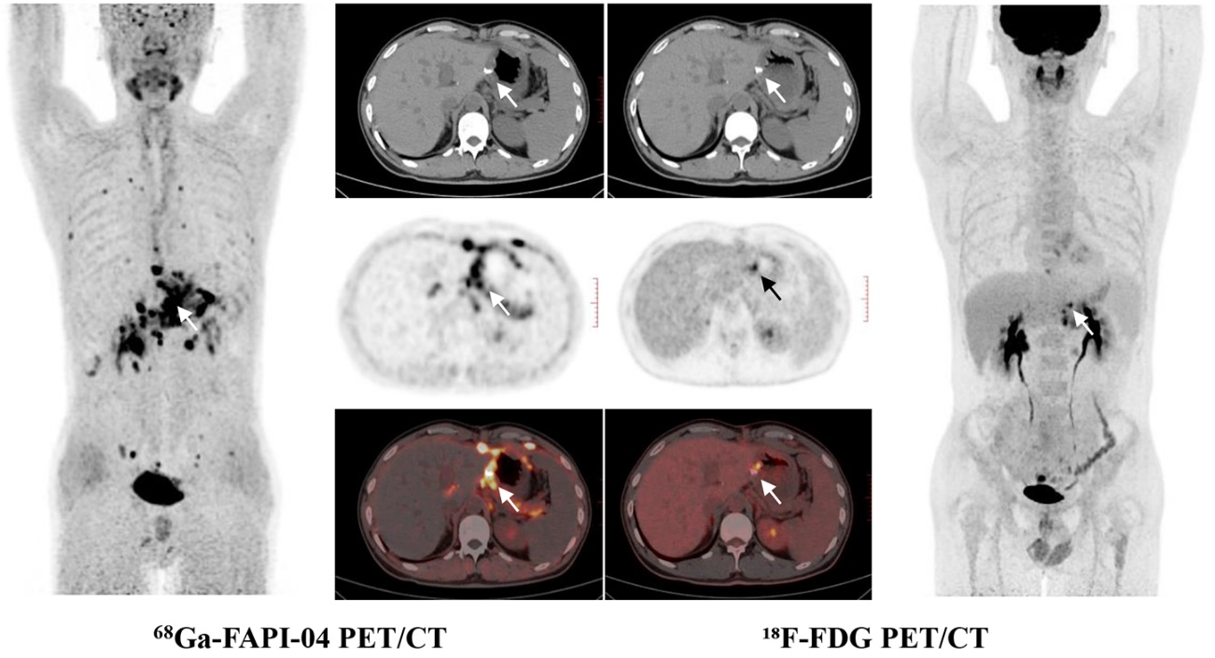
Supplemental Figure 6. FAPI⁺/FDG⁺, Recurrence⁺ A 36-year-old male patient (ID #57) with poorly differentiated adenocarcinoma at gastric antrum, 15.9 months after radical distal gastrectomy, abnormal PET signal was verified on both FAPI-PET and FDG-PET imaging at anastomotic site respectively, (FAPI-PET, arrows, SUV_{max}=13.7; FDG-PET arrows, SUV_{max}=8.3), subsequent endoscopic pathology demonstrated anastomotic recurrence of adenocarcinoma.
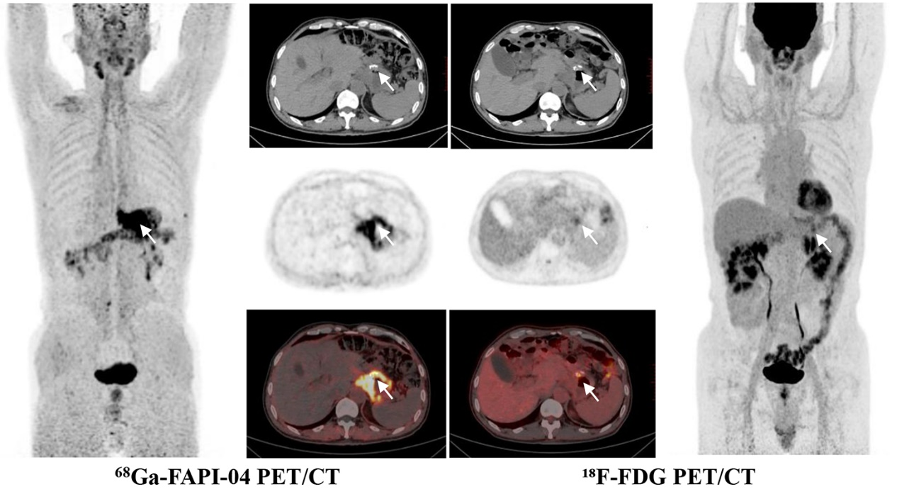
Supplemental Figure 7. FAPI⁺/FDG⁺, Recurrence⁺ A 63-year-old male patient (ID #63) with poorly differentiated adenocarcinoma at gastric antrum, 23.4 months after radical distal gastrectomy, abnormal PET signal was verified on both FAPI-PET and FDG-PET imaging at anastomotic site respectively, (FAPI-PET, arrows, SUVmax=14.5; FDG-PET arrows, SUVmax=5.0), endoscopic pathology supported anastomotic recurrence of adenocarcinoma.
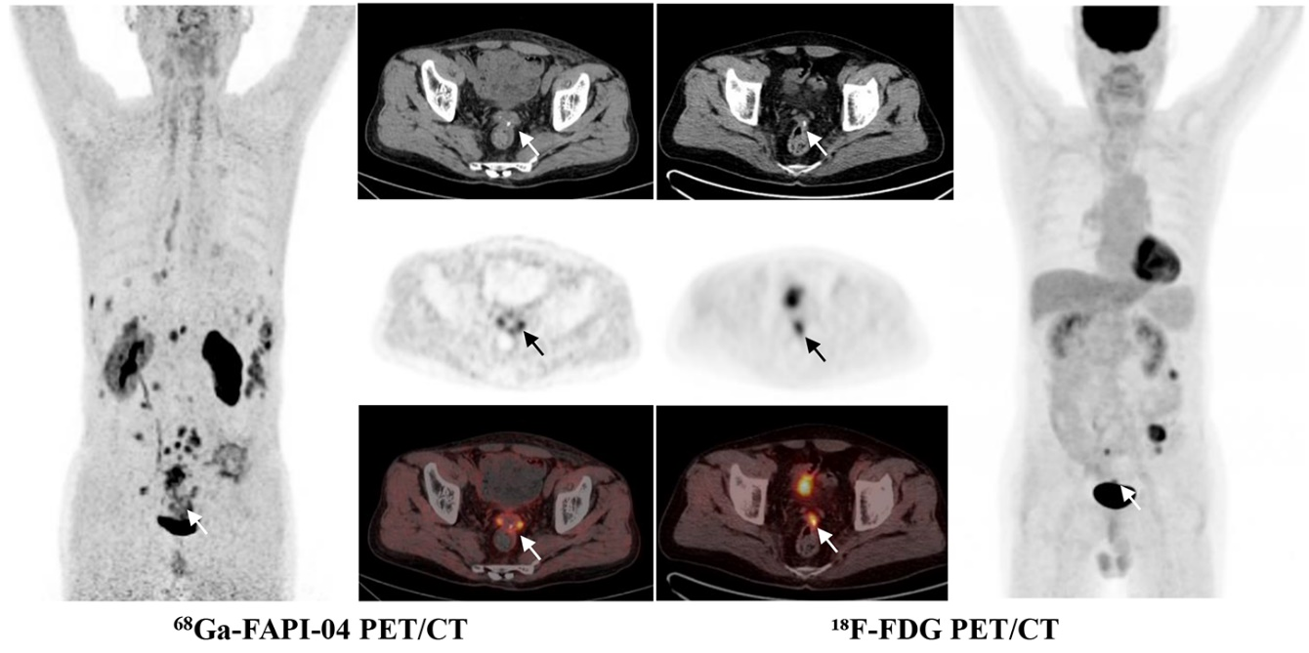
Supplemental Figure 8. FAPI⁺/FDG⁺, Recurrence⁺ A 61-year-old male postoperative patient (ID #18) with moderately differentiated adenocarcinoma at sigmoid colon. 77.2 months after surgery, abnormal PET signal was verified on both FAPI-PET and FDG-PET imaging at anastomotic site respectively, (FAPI-PET, arrows, SUVmax=8.2; FDG-PET arrows, SUVmax=6.0), subsequent endoscopic pathology demonstrated anastomotic recurrence of adenocarcinoma.
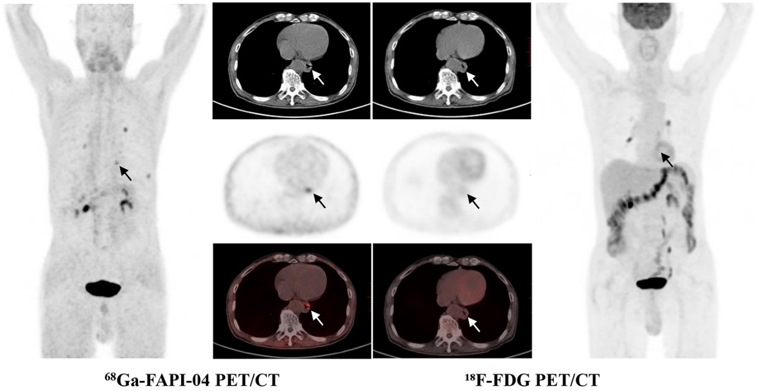
Supplemental Figure 9. FAPI⁺/FDG⁻, Recurrence⁺ A 75-year-old male gastric cancer patient (ID #32) who underwent total gastrectomy, the pathology post-surgery revealed poorly differentiated adenocarcinoma mixed with mucinous adenocarcinoma. FAPI-PET revealed visually positive tracer accumulation at anastomotic site (arrows, SUVmax=3.8), while FDG-PET showed no suspected signal at corresponding site (arrows, SUVmax=1.4) 30.4 months post-surgery. However, adenocarcinoma cell was found by endoscopic pathology which supported anastomotic recurrence.
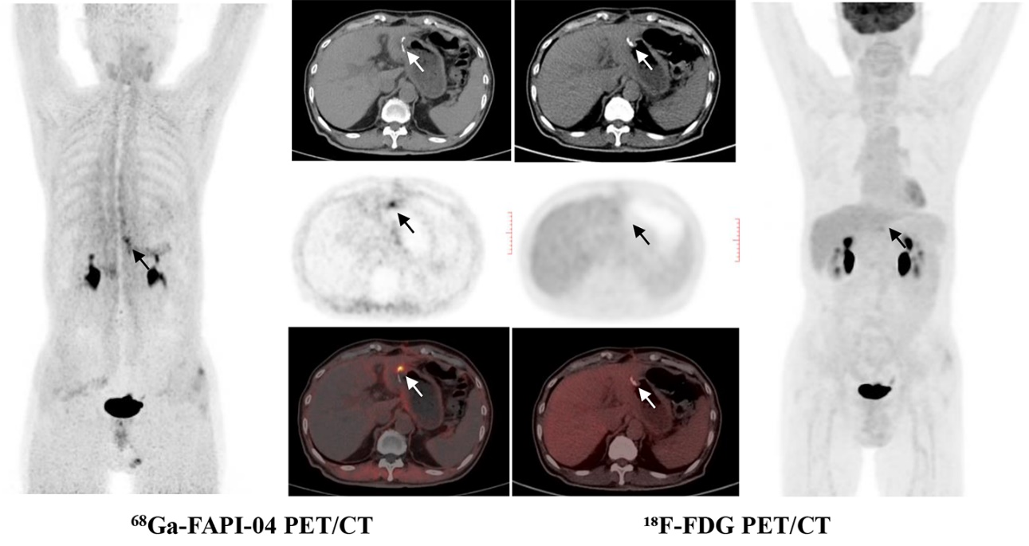
Supplemental Figure 10. FAPI⁺/FDG⁻, Recurrence⁻ A 71-year-old male patient (ID #55) with moderately differentiated adenocarcinoma at gastric body who underwent ⁶⁸Ga-FAPI-04 PET/CT imaging at 5.9 months after radical distal gastrectomy. FAPI-PET revealed visually positive tracer accumulation at anastomotic site (arrows, SUVmax=8.9), while FDG-PET without obviously suspected signal at corresponding site (arrows, SUVmax=3.6). No recurrence was observed by following endoscopy and clinical follow-up 3 months after PET imaging.

Supplementary Figure 11. A year-based quantitative analysis of anastomotic SUV_{max} was conducted among non-recurrent patients based on the two PET imaging modalities. The upper column is FDG-PET imaging, and the lower column is FAPI-PET imaging; n= (FAPI-PET, FDG-PET): within 1 year (34, 29), 1-2 years (18, 16), 2-3 years (7, 9), and over 3 years (6, 5); no statistical difference was found among the groups.

Supplementary Figure 12. (A) The changes over time in the SUV_{max} ratio at surgical wounds for the two PET imaging modalities. Anastomotic sites, n= (FAPI-PET, FDG-PET): 0-3 months (1, 1), 4-6 months (13, 12), 7-9 months (14, 11), 10-12 months (6, 5), 13-18 months (7, 8), 19-24 months (11, 8), 25-30 months (3, 4), 31-36 months (4, 5), and over 36 months (6, 5). Abdominal incision sites, n= (FAPI-PET, FDG-PET): 0-3 months (2, 2), 4-6 months (13, 12), 7-9 months (14, 11), 10-12 months (6, 5), 13-18 months (10, 11), 19-24 months (11, 8), 25-30 months (3, 4), 31-36 months (5, 6), and over 36 months (8, 7). The anastomotic SUV_{max} ratios were analyzed among the non-recurrent patients; no statistical difference was found among the groups. (B) The correlation of the anastomotic SUV_{max} ratios for FAPI-PET and FDG-PET with postoperative times, respectively; FAPI-PET: r=-0.2830, P=0.0223, (n=65); FDG-PET: r=-0.0667, P=0.6158, (n=59). (C) The correlation of the incisional SUV_{max} ratio for FAPI-PET and FDG-PET with postoperative times, FAPI-PET: r=-0.4549, P<0.0001 (n=74); FDG-PET: r=-0.4453, P=0.0002 (n=68).

Supplementary Figure 13. A graphical explanation for matched/mismatched PET imaging and its corresponding recurrent/non-recurrent results. ¹⁸F-FDG can be taken up by tumor cells and macrophages (red area), which might result in mistaking inflammatory lesions for tumors. Novel ⁶⁸Ga-FAPI-04 takes advantage of cancer-associated fibroblasts in tumor stroma to image primary tumors and tumor metastasis. However, since fibroblasts are also involved in the wound healing process (green area), the same paired PET imaging phenotype exhibited completely different recurrent/non-recurrent results (e.g., both recurrent and non-recurrent patients displayed the same FAPI⁺FDG⁻ results). In non-recurrent patients, since two phases exist in the wound healing process, FAPI⁻FDG⁺ might reflect the inflammation-dominant phase (rich in macrophages), FAPI⁺FDG⁻ might reflect the fibrosis repair-dominant phase (rich in fibroblasts). Furthermore, FAPI⁺FDG⁺ might reflect the combination of inflammation and fibrosis repair because of multiple injuries at wound site.

