Population genomics of fall armyworm in Brazil and Argentina revealed by Genotyping-by-Sequencing and implications for pest management

Tamylin K. Ishizuka^{1,4}, Erick M. G. Cordeiro², Alessandro Alves-Pereira¹, Carlos E. A. Batista³, María G. Murúa⁵, José B. Pinheiro³, Amit Sethi⁸, Rodney N. Nagoshi⁶, Josemar Foresti⁴, Maria I. Zucchi^{1,7*}
¹ Institute of Biology, State University of Campinas, Campinas, Brazil. ² Department of Entomology, University of São Paulo–ESALQ/USP, Piracicaba, Brazil. ³ Department of Genetics, University of São Paulo–ESALQ/USP, Piracicaba, Brazil. ⁴ Corteva Agriscience, Mogi Mirim, SP, Brazil. ⁵Instituto de Tecnología Agroindustrial del Noroeste Argentino, Estación Experimental Agroindustrial Obispo Colombres, Consejo Nacional de Investigaciones Científicas y Técnicas (ITANOA-EEAOC-CONICET) and Facultad de Ciencias Naturales e Instituto Miguel Lillo (Universidad Nacional de Tucumán), Tucumán, Argentina. ⁶United States Department of Agriculture-Agricultural Research Service, Gainesville, Florida, United States of America. ⁷Agência Paulista de Tecnologia dos Agronegócios, Pólo Regional Centro-Sul, Piracicaba, Brazil. ⁸Corteva Agriscience, Johnston, Iowa, United States of America. *email: mizucchi@sp.gov.br

Table S1. Genetic diversity estimates of fall armyworm (Spodoptera frugiperda) populations from 15 locations of Brazil and Argentina estimated from 3309 SNP loci. Most populations were not found at equilibrium. Brazilian populations featured lower observed heterozygosity than the expected at p < 0.05. The coefficient F_{IS} also indicated that the Brazilian populations collected in corn fields had significant inbreeding. On the other hand, the fall armyworm populations from Argentina featured more outbreeding and private alleles.
Population | Ap | %P | H_{O} | H_{E} | π | F_{IS}
BA02 | 0 | 52.3 | 0.0609* | 0.0650 | 0.0669 ± 0.0017 | 0.03
BA03 | 0 | 54.1 | 0.0616* | 0.0660 | 0.0679 ± 0.0017 | 0.03*
DF | 0 | 55.6 | 0.0620* | 0.0674 | 0.0692 ± 0.0017 | 0.04*
GO | 0 | 61.5 | 0.0600* | 0.0668 | 0.0683 ± 0.0016 | 0.05*
MT01 | 1 | 60.2 | 0.0594* | 0.0677 | 0.0692 ± 0.0017 | 0.06*
MT02 | 0 | 56.6 | 0.0593* | 0.0657 | 0.0674 ± 0.0017 | 0.05*
SP | 1 | 59.4 | 0.0586* | 0.0666 | 0.0681 ± 0.0017 | 0.07*
PR | 0 | 35.3 | 0.0604 | 0.0636 | 0.0676 ± 0.0020 | 0.03*
MA01 | 0 | 38.3 | 0.0593* | 0.0662 | 0.0699 ± 0.0020 | 0.04*
MA02 | 9 | 39.6 | 0.0616* | 0.0715 | 0.0748 ± 0.0021 | 0.04*
RS | 0 | 13.0 | 0.0524* | 0.0451 | 0.0571 ± 0.0028 | 0.01
SC | 0 | 45.5 | 0.0602* | 0.0640 | 0.0665 ± 0.0018 | 0.03
AR01 | 46 | 22.0 | 0.0887* | 0.0688 | 0.0723 ± 0.0027 | -0.03
AR02 | 1 | 9.3 | 0.0498* | 0.0375 | 0.0451 ± 0.0025 | -0.01
AR03 | 49 | 20.9 | 0.0611 | 0.0618 | 0.0641 ± 0.0025 | 0.02
*Significant values (p < 0.05).
Ap: number of private alleles; %P: percentage of polymorphic loci; H_{O}: observed heterozygosity; H_{E}: expected heterozygosity; π: nucleotide diversity ± standard error; F_{IS}: inbreeding coefficient.

Table S2. Gene Ontology (GO) biological process description for outlier loci under positive selection. *associated with populations. **associated with host strains and populations. Loci with no mark are associated with host strains.
Loci | Similar to | e-Value | Mean similarity (%) | GO description
SNP_18** | zinc-type alcohol dehydrogenase-like protein C1773.06c | 0 | 98.53 | Oxidoreductases
SNP_29 | solute carrier family 35 member C2 | 0 | 95.94 | integral component of membrane
SNP_41** | dynein heavy chain 5, axonemal isoform X2 | 0 | 98.06 | microtubule-based movement
SNP_67 | UNC93-like protein | 0 | 99.49 | regulation of potassium ion transport
SNP_96 | insulin-like growth factor 2 mRNA-binding protein 1 isoform X2 | 0 | 99.48 | mRNA transport
SNP_110 | carboxyl-terminal PDZ ligand of neuronal nitric oxide synthase protein-like isoform X3 | 0 | 97.17 | localization
SNP_127** | epithelial discoidin domain-containing receptor 1-like isoform X1 | 0 | 98.91 | peptidyl-tyrosine phosphorylation
SNP_137** | lysophospholipid acyltransferase 5-like | 0 | 98.76 | lipid modification
SNP_150 | alpha-mannosidase 2-like | 0 | 99.22 | mannose metabolic process
SNP_160 | hepatic leukemia factor-like isoform X10 | 2.4E-156 | 95.46 | regulation of transcription by RNA polymerase II
SNP_162 | ATP synthase subunit gamma, mitochondrial-like | 0 | 93.41 | ATP synthesis coupled proton transport
SNP_184** | protein bric-a-brac 1-like isoform X1 | 0 | 97.29 | eye-antennal disc morphogenesis
SNP_230 | ras-related protein Rab6 isoform X1 | 1.9E-156 | 100 | GTPase activity
SNP_240* | protein eiger | 0 | 93.07 | immune response
SNP_262 | electron transfer flavoprotein subunit alpha, mitochondrial | 0 | 99.7 | electron transport chain
SNP_264 | alkaline ceramidase | 0 | 98.74 | ceramide metabolic process
SNP_333* | cullin-associated NEDD8-dissociated protein 1 | 0 | 98.41 | SCF complex assembly
SNP_365* | RNA-binding protein 24-B-like isoform X1 | 5.08E-93 | 94.7 | RNA binding
SNP_421 | odorant receptor 46a-like | 0 | 98.95 | detection of chemical stimulus involved in sensory perception of smell
SNP_574 | protein obstructor-E isoform X2 | 6.6E-167 | 99.32 | chitin binding
SNP_582 | ras-related protein Rab-9B | 2.5E-173 | 99.21 | GTPase activity
SNP_599 | replication factor C subunit 1-like | 0 | 93.49 | DNA replication
SNP_648* | GTPase-activating protein | 0 | 96.36 | regulation of GTPase activity
SNP_677 | filamin-C isoform X1 | 0 | 97.79 | actin cytoskeleton organization
SNP_682 | aquaporin AQPAe.a-like | 3.5E-158 | 97.76 | transmembrane transport
SNP_883 | methylglutaconyl-CoA hydratase, mitochondrial-like | 0 | 98.59 | catalytic activity
SNP_925 | ER lumen protein-retaining receptor | 9.8E-132 | 99.43 | protein retention in ER lumen
SNP_1055* | ABC transporter C family member 13 | 0 | 96.52 | transmembrane transport
SNP_1060** | exportin-1 | 0 | 99.02 | protein export from nucleus
SNP_1104* | kinesin-like protein CG14535 isoform X1 | 0 | 97.94 | microtubule-based movement
SNP_1137* | transcription factor sem-2-like isoform X1 | 5.8E-159 | 99.5 | DNA binding
SNP_1208 | guanine nucleotide exchange factor subunit Rich-like isoform X4 | 0 | 98.85 | intracellular protein transport
SNP_1209* | cuticle protein 19-like | 1.75E-97 | 90.68 | structural constituent of cuticle
SNP_1215 | uncharacterized protein LOC118265954 | 0 | 92.4 | protein transport
SNP_1249 | disintegrin and metalloproteinase domain-containing protein 11 | 0 | 97.07 | proteolysis
SNP_1263* | RNA-binding protein Musashi homolog Rbp6 isoform X2 | 0 | 96.32 | RNA binding
SNP_1291* | CAD protein isoform X2 | 0 | 95.89 | carbohydrate metabolic process
SNP_1391 | peroxisomal acyl-coenzyme A oxidase 3 | 0 | 96.11 | fatty acid beta-oxidation
SNP_1428 | semaphorin-2A isoform X2 | 0 | 99.34 | cell differentiation
SNP_1434* | chymotrypsin-like serine protease precursor | 0 | 94.27 | proteolysis
SNP_1513* | uncharacterized protein LOC118267576 | 1.6E-113 | 96.59 | integral component of membrane
SNP_1559* | esterase FE4-like | 0 | 98.12 | isoprenoid biosynthetic process
SNP_1568 | decaprenyl-diphosphate synthase subunit 1 | 0 | 97.89 | isoprenoid biosynthetic process
SNP_1595* | uncharacterized protein LOC110373722 isoform X1 | 6.49E-97 | 98.89 | integral component of membrane
SNP_1654 | lissencephaly-1 homolog | 0 | 99.61 | microtubule sliding; cell division
SNP_1699* | unconventional myosin ID | 0 | 94.73 | cytoskeletal motor activity
SNP_1714 | uncharacterized protein LOC118269482 | 0 | 94.18 | integral component of membrane
SNP_1749 | receptor-type guanylate cyclase gcy-1 | 0 | 97.7 | cGMP biosynthetic process
SNP_1780 | mothers against decapentaplegic homolog 6 | 0 | 98.37 | regulation of developmental process
SNP_1823* | homeotic protein Sex combs reduced-like | 0 | 97.52 | regulation of transcription by RNA polymerase II
SNP_1831 | homeotic protein antennapedia | 7.2E-158 | 99.54 | regulation of transcription by RNA polymerase II
SNP_1853 | cuticular protein lCPAP1-B | 9.2E-116 | 95.75 | chitin binding
SNP_1949 | octopamine receptor beta-3R-like | 0 | 99.71 | G protein-coupled receptor signaling pathway
SNP_1957* | complexin isoform X1 | 3.66E-28 | 100 | neurotransmitter transport
SNP_1977* | cyclin-dependent kinase inhibitor 1-like isoform X2 | 1.3E-140 | 94.97 | negative regulation of cyclin-dependent protein serine/threonine kinase activity
SNP_1997 | dynein heavy chain 1, axonemal-like | 0 | 95.8 | microtubule-based movement
SNP_2124 | uncharacterized protein LOC118271900 | 0 | 95.99 | signal transduction
SNP_2183* | uncharacterized protein LOC118271592 | 0 | 97.25 | positive regulation of protein tyrosine kinase activity
SNP_2213* | transmembrane protein 184B isoform X1 | 0 | 97.45 | integral component of membrane
SNP_2301* | probable kinetochore protein nuf2 isoform X2 | 0 | 99.11 | regulation of microtubule polymerization or depolymerization
SNP_2355** | protein kinase DC2 | 0 | 99.94 | protein phosphorylation
SNP_2359* | bcl-2-related ovarian killer protein homolog A-like | 3.3E-134 | 99.73 | regulation of apoptotic process
SNP_2374 | phosphatidylserine synthase 1-like | 0 | 98.59 | phosphatidylserine biosynthetic process
SNP_2396 | dopa decarboxylase | 0 | 99.71 | cellular amino acid metabolic process
SNP_2399 | E3 ubiquitin-protein ligase MIB1-like | 0 | 99.07 | Notch signaling pathway; protein ubiquitination
SNP_2407* | platelet-activating factor acetylhydrolase IB subunit beta homolog | 2.5E-169 | 99.38 | oogenesis
SNP_2526* | tumor necrosis factor alpha-induced protein 8-like protein isoform X1 | 1.4E-137 | 99.53 | regulation of apoptotic process
SNP_2532* | phorbol ester/diacylglycerol-binding protein unc-13-like | 9.88E-86 | 98.8 | chemical synaptic transmission
SNP_2552 | A disintegrin and metalloproteinase with thrombospondin motifs 7 | 0 | 95.29 | integrin-mediated signaling pathway
SNP_2659* | homeobox protein cut isoform X7 | 0 | 97.62 | cell development
SNP_2700 | CLIP domain-containing serine protease 2-like isoform X1 | 0 | 95.13 | proteolysis
SNP_2719 | N-alpha-acetyltransferase 40 | 0 | 94.34 | histone acetylation
SNP_2720 | DNA polymerase alpha subunit B-like | 0 | 98.08 | DNA replication
SNP_2763 | neurexin-1-like isoform X2 | 0 | 99.02 | anatomical structure morphogenesis
SNP_2792* | uncharacterized protein LOC118276239 | 0 | 98.63 | proteolysis
SNP_2799* | uncharacterized protein LOC118276304 | 0 | 94.68 | chitin binding
SNP_2804* | spondin-2 isoform X1 | 0 | 97.27 | cell adhesion
SNP_2809 | phospholipase D3-like isoform X1 | 0 | 98.1 | oogenesis
SNP_2863** | endoribonuclease Dicer-like | 0 | 94.14 | production of miRNAs involved in gene silencing by miRNA
SNP_2876 | RNA/RNP complex-1-interacting phosphatase-like | 9E-161 | 92.91 | protein dephosphorylation
SNP_2948 | irregular chiasm C-roughest protein-like isoform X2 | 0 | 96.03 | compound eye development
SNP_2960 | non-canonical poly(A) RNA polymerase protein Trf4-1-like | 0 | 98.54 | RNA polyadenylation
SNP_3034 | fibroblast growth factor 22 isoform X1 | 2.2E-142 | 99.25 | signal transduction
SNP_3069* | mothers against decapentaplegic homolog 4 isoform X3 | 0 | 94.75 | regulation of developmental process
SNP_3074 | dopamine receptor 2-like | 0 | 98.23 | G protein-coupled receptor signaling pathway
SNP_3077 | cytochrome P450 CYP314A1 | 0 | 99.54 | ecdysteroid biosynthesis
SNP_3101 | neuronal PAS domain-containing protein 4B-like | 0 | 98.96 | positive regulation of transcription by RNA polymerase II
SNP_3112* | neurogenic locus protein delta | 0 | 95.44 | Notch signaling pathway
SNP_3139* | cuticular protein SlCPAP1-J | 0 | 98.19 | chitin binding
SNP_3180* | presequence protease, mitochondrial | 0 | 96.71 | proteolysis
SNP_3192* | uncharacterized protein LOC118279893 | 0 | 94.4 | integral component of membrane
SNP_3208 | putative fatty acyl-CoA reductase CG5065 | 0 | 97.38 | lipid metabolic process
SNP_3227 | anoctamin-4-like isoform X1 | 0 | 98.48 | protein dimerization
SNP_3271* | proline-, glutamic acid- and leucine-rich protein 1-like | 0 | 99.18 | regulation of transcription, DNA-templated

Table S3. Outlier loci under positive selection with blast hits in NCBI with > 90% similarity. *associated with populations. **associated with host strains and populations. Loci with no mark are associated with host strains.
Loci | Similar to | e-Value | Mean similarity (%)
SNP_44 | uncharacterized protein LOC118266193 | 0 | 97.89
SNP_46** | transient receptor potential cation channel subfamily A member 1-like isoform X8 | 0 | 99.28
SNP_49 | protein apterous-like isoform X1 | 0 | 90.7
SNP_51 | E3 ubiquitin-protein ligase RBBP6 isoform X2 | 0 | 96.12
SNP_53** | epidermal growth factor receptor isoform X2 | 0 | 98.83
SNP_58 | activin receptor type-1C-like isoform X3 | 0 | 95.24
SNP_64** | uncharacterized protein LOC118264930 | 0 | 95.95
SNP_66 | uncharacterized protein LOC118261817 isoform X1 | 0 | 100
SNP_70 | cyclic nucleotide-gated cation channel subunit A-like isoform X1 | 0 | 98.49
SNP_77** | uncharacterized protein LOC118268191 isoform X1 | 0 | 98.67
SNP_78 | nuclear receptor subfamily 2 group E member 1-like | 0 | 99.37
SNP_81* | SCY1-like protein 2 isoform X1 | 0 | 98.41
SNP_95** | eukaryotic translation initiation factor 4 gamma 3-like isoform X5 | 0 | 99.61
SNP_102** | uncharacterized protein LOC118265176 | 1.9E-126 | 97.22
SNP_103 | proton-coupled amino acid transporter-like protein pathetic | 0 | 99.49
SNP_104 | nuclear hormone receptor FTZ-F1 | 0 | 97.86
SNP_113 | protein scabrous | 0 | 94.88
SNP_133* | BPTI/Kunitz domain-containing protein-like isoform X2 | 6.3E-109 | 97.22
SNP_134** | T-cell acute lymphocytic leukemia protein 1 homolog isoform X6 | 2.8E-157 | 99.34
SNP_135** | circadian locomoter output cycles protein kaput-like isoform X1 | 0 | 98.77
SNP_147** | uncharacterized protein LOC118263576 | 0 | 93.83
SNP_148 | nostrin-like isoform X2 | 0 | 99.31
SNP_155** | proton-coupled amino acid transporter-like protein CG1139 isoform X1 | 0 | 99.15
SNP_156 | GRB10-interacting GYF protein 2-like isoform X1 | 0 | 98.16
SNP_158 | solute carrier family 35 member F6 | 0 | 95.63
SNP_164 | protein furry-like isoform X1 | 0 | 99.89
SNP_167 | ecdysone-induced protein 78C-like isoform X2 | 0 | 99.95
SNP_171 | E3 ubiquitin-protein ligase UHRF1-like | 0 | 96.69
SNP_176** | potassium voltage-gated channel protein Shaker-like isoform X1 | 0 | 98.55
SNP_179* | calcium/calmodulin-dependent 3',5'-cyclic nucleotide phosphodiesterase 1-like isoform X2 | 0 | 99.02
SNP_189 | chromatin complexes subunit BAP18-like isoform X4 | 3.34E-89 | 98.89
SNP_190 | chondroitin sulfate proteoglycan 4-like isoform X1 | 0 | 99.51
SNP_198 | coiled-coil domain-containing protein CG32809-like isoform X8 | 0 | 99.97
SNP_199 | E3 ubiquitin-protein ligase MYCBP2-like isoform X13 | 0 | 99.42
SNP_203** | kalirin-like isoform X1 | 0 | 98.75
SNP_217** | zinc transporter 2-like isoform X2 | 0 | 99.31
SNP_243* | uncharacterized protein LOC118271946 isoform X3 | 0 | 99.84
SNP_249 | uncharacterized protein LOC118271979 | 0 | 97.02
SNP_256 | voltage-dependent calcium channel subunit alpha-2/delta-3-like isoform X1 | 0 | 99.78
SNP_274 | insulin-like receptor | 0 | 98.63
SNP_304 | C-Maf-inducing protein-like | 0 | 96.52
SNP_315 | protein grainyhead isoform X1 | 0 | 99.19
SNP_323* | uncharacterized protein LOC118276435 | 2.3E-106 | 98.29
SNP_374 | guanine nucleotide exchange factor DBS-like isoform X1 | 0 | 98.35
SNP_379 | myocyte-specific enhancer factor 2 isoform X1 | 0 | 98.29
SNP_396* | protein bunched, class 2/F/G isoform-like isoform X1 | 0 | 97.61
SNP_423** | cytochrome P450 4d2-like isoform X1 | 0 | 98.67
SNP_437* | polypyrimidine tract-binding protein 1 isoform X2 | 0 | 99.39
SNP_444* | cAMP-specific 3',5'-cyclic phosphodiesterase, isoform F isoform X1 | 0 | 97.94
SNP_462 | coiled-coil domain-containing protein 6-like isoform X3 | 0 | 95.55
SNP_465* | hypothetical protein SFRURICE_020353 | 0 | 99.77
SNP_466* | protein still life, isoform SIF type 1-like isoform X1 | 0 | 99.91
SNP_477 | constitutive coactivator of PPAR-gamma-like protein 1 isoform X1 | 0 | 99.64
SNP_487* | uncharacterized protein LOC118281882 isoform X2 | 0 | 97.07
SNP_492** | dihydrolipoyl dehydrogenase | 0 | 97.98
SNP_511* | DNA polymerase epsilon subunit 4 | 8.5E-108 | 96.19
SNP_523* | akirin-like | 3.2E-106 | 94.39
SNP_557* | WD repeat-containing protein 5 | 0 | 99.75
SNP_563* | ecdysone-induced protein 74EF isoform X1 | 0 | 96.93
SNP_617 | uncharacterized protein LOC118262780 isoform X4 | 0 | 93.72
SNP_619 | probable G-protein coupled receptor No18 isoform X1 | 0 | 96.64
SNP_634* | protein takeout-like | 4.8E-173 | 98.75
SNP_684 | zinc finger protein DZIP1L-like | 0 | 94.49
SNP_693* | asparagine-rich zinc finger protein AZF1 | 0 | 99.54
SNP_719 | gamma-aminobutyric acid type B receptor subunit 1-like isoform X1 | 0 | 99.06
SNP_758* | LOW QUALITY PROTEIN: synembryn-A-like | 0 | 92.15
SNP_773* | proton channel OtopLc-like | 0 | 97.3
SNP_798* | semaphorin-2A-like isoform X2 | 0 | 99.06
SNP_816** | teneurin-a isoform X2 | 0 | 99.57
SNP_892 | thrombospondin type-1 domain-containing protein 7A-like | 0 | 98.01
SNP_931 | class A basic helix-loop-helix protein 15-like | 3.39E-97 | 98.95
SNP_934 | protein yellow-like isoform X2 | 0 | 99.24
SNP_938 | sodium-dependent nutrient amino acid transporter 1-like | 0 | 97.39
SNP_941** | uncharacterized protein LOC118264104 isoform X1 | 0 | 99.31
SNP_960 | heparan sulfate glucosamine 3-O-sulfotransferase 3A1 | 0 | 98.61
SNP_983 | serine/threonine-protein kinase ATR-like | 0 | 98.27
SNP_997 | protein winged eye-like isoform X2 | 0 | 99.24
SNP_1001** | uncharacterized protein LOC118264324 | 0 | 95.15
SNP_1010* | cadherin-86C isoform X1 | 0 | 98.39
SNP_1021 | protein expanded-like | 0 | 99.62
SNP_1024** | juvenile hormone acid O-methyltransferase-like isoform X2 | 0 | 100
SNP_1034 | dachshund homolog 2 isoform X9 | 0 | 99.89
SNP_1041 | uncharacterized protein LOC118265239 isoform X1 | 0 | 98.85
SNP_1085** | uncharacterized protein LOC118265544 | 0 | 98.82
SNP_1086 | uncharacterized protein LOC118264958 | 0 | 98.18
SNP_1088 | uncharacterized protein LOC118265490 | 0 | 98.39
SNP_1092 | gremlin-2-like isoform X2 | 7.8E-150 | 100
SNP_1114 | CUGBP Elav-like family member 3-B isoform X1 | 0 | 98.51
SNP_1127 | WD repeat-containing protein on Y chromosome-like | 0 | 96.23
SNP_1149 | hemicentin-2-like isoform X1 | 0 | 99.8
SNP_1195 | dystroglycan-like isoform X1 | 0 | 100
SNP_1214 | sporozoite surface protein 2-like isoform X26 | 3.22E-84 | 93.27
SNP_1217 | hypothetical protein SFRURICE_000691 | 0 | 95.22
SNP_1219* | cerebellar degeneration-related protein 2-like isoform X3 | 0 | 99.34
SNP_1233 | uncharacterized protein LOC118267214 isoform X3 | 0 | 100
SNP_1239 | thioredoxin reductase 1, mitochondrial-like isoform X1 | 0 | 99.96
SNP_1242* | 2-oxoglutarate dehydrogenase, mitochondrial-like isoform X2 | 0 | 98.25
SNP_1283 | speract receptor-like isoform X2 | 0 | 98.54
SNP_1313* | ecdysone-inducible protein E75 isoform X1 | 0 | 99.66
SNP_1321 | tetratricopeptide repeat protein 37 | 0 | 98.38
SNP_1325* | Ca(2+)/calmodulin-responsive adenylate cyclase-like isoform X2 | 0 | 95.75
SNP_1345 | peroxisomal targeting signal 1 receptor-like | 0 | 98.26
SNP_1351 | uncharacterized protein LOC118266951 | 0 | 99.27
SNP_1352 | zinc carboxypeptidase-like | 0 | 96.4
SNP_1358 | uncharacterized protein LOC118266809 | 0 | 98.41
SNP_1361** | E3 ubiquitin-protein ligase HECW2-like isoform X2 | 0 | 98.65
SNP_1371 | protein outspread-like isoform X1 | 0 | 98.95
SNP_1379* | somatostatin receptor type 2-like | 0 | 99.66
SNP_1474* | F-actin-monooxygenase MICAL3-like isoform X2 | 0 | 96.3
SNP_1477 | proteoglycan 4-like isoform X1 | 0 | 99.34
SNP_1547 | tachykinin-like peptides receptor 86C isoform X2 | 0 | 99.56
SNP_1577** | uncharacterized protein LOC118268079 | 0 | 98.22
SNP_1583* | uncharacterized protein LOC110374604 | 0 | 98.11
SNP_1618 | titin-like | 0 | 98.47
SNP_1750* | calcitonin gene-related peptide type 1 receptor-like isoform X1 | 0 | 97.74
SNP_1764 | protein halfway-like isoform X2 | 0 | 98.66
SNP_1767 | SPRY domain-containing SOCS box protein 3-like isoform X1 | 0 | 99.75
SNP_1771 | mucin-17 isoform X1 | 0 | 97.34
SNP_1772 | uncharacterized protein LOC118269350 | 1.63E-77 | 96.42
SNP_1878* | protein held out wings-like isoform X3 | 0 | 98.77
SNP_1967* | myotubularin-related protein 5 isoform X2 | 0 | 91.22
SNP_1993* | WD repeat domain phosphoinositide-interacting protein 4-like | 0 | 95.86
SNP_1999* | uncharacterized protein LOC118271498 | 0 | 97.4
SNP_2011 | neurobeachin-like isoform X9 | 0 | 99.97
SNP_2056 | brain tumor protein-like isoform X2 | 0 | 99.93
SNP_2082 | espin-like isoform X1 | 0 | 98.6
SNP_2094* | beta-1,4-N-acetylgalactosaminyltransferase bre-4-like | 0 | 97.9
SNP_2099 | uncharacterized protein LOC118272254 | 0 | 99.75
SNP_2127 | uncharacterized protein LOC118272157 | 0 | 91.82
SNP_2132 | protein split ends-like | 0 | 97.36
SNP_2146 | carboxypeptidase B-like | 3.3E-172 | 93.25
SNP_2196 | low-density lipoprotein receptor-related protein 2-like isoform X1 | 0 | 99.64
SNP_2229 | probable helicase senataxin | 0 | 95.05
SNP_2243 | ADP-ribosylation factor-like protein 4C | 9.3E-143 | 100
SNP_2272 | tyrosine-protein phosphatase Lar-like isoform X1 | 0 | 99.8
SNP_2284 | facilitated trehalose transporter Tret1-like isoform X4 | 0 | 99.25
SNP_2325 | sodium- and chloride-dependent glycine transporter 1-like | 0 | 98.64
SNP_2326* | uncharacterized protein LOC118273335 | 1.4E-179 | 93.81
SNP_2328 | protein eyes shut | 0 | 95.72
SNP_2336 | tyrosine-protein kinase transmembrane receptor Ror-like isoform X2 | 0 | 97.51
SNP_2345 | muscleblind-like protein 1 isoform X3 | 0 | 95.03
SNP_2387 | homeotic protein spalt-major-like isoform X2 | 0 | 99.62
SNP_2424* | E3 ubiquitin-protein ligase lubel-like isoform X1 | 0 | 97.53
SNP_2432 | piezo-type mechanosensitive ion channel component-like isoform X7 | 0 | 98.43
SNP_2449 | leucine-rich repeats and immunoglobulin-like domains protein 2 isoform X2 | 0 | 99.24
SNP_2507* | sentrin-specific protease 2-like | 0 | 90.19
SNP_2585* | uncharacterized protein LOC118273925 isoform X2 | 1.3E-155 | 99.27
SNP_2586* | flocculation protein FLO11 | 0 | 98.6
SNP_2620* | flotillin-2 isoform X2 | 0 | 99.76
SNP_2622 | bromodomain-containing protein 1-like isoform X2 | 0 | 94.99
SNP_2624* | LIM/homeobox protein Lhx1-like isoform X2 | 0 | 99.29
SNP_2631* | mevalonate kinase | 0 | 99.47
SNP_2668* | uncharacterized protein CG3556-like isoform X1 | 0 | 98.72
SNP_2671 | max-binding protein MNT-like isoform X1 | 0 | 95.04
SNP_2692 | RNA-binding protein Nova-2 isoform X1 | 0 | 96.56
SNP_2705 | uncharacterized protein LOC111350172 | 1.34E-97 | 99.29
SNP_2718 | DNA replication licensing factor Mcm5-like | 0 | 99.86
SNP_2719 | UDP-glucuronosyltransferase 1-2-like | 0 | 99.38
SNP_2744 | zinc finger protein 541-like isoform X1 | 0 | 98.63
SNP_2774* | phosphofurin acidic cluster sorting protein 1-like isoform X1 | 0 | 98.44
SNP_2798 | polycystic kidney disease protein 1-like 3 | 0 | 99.63
SNP_2806 | delta-1-pyrroline-5-carboxylate synthase-like isoform X2 | 0 | 98.84
SNP_2861 | protein couch potato-like | 6.6E-170 | 91.72
SNP_2884 | uncharacterized protein LOC111357656 | 5.9E-66 | 98.75
SNP_2921* | max dimerization protein 1-like isoform X2 | 1.6E-123 | 98.96
SNP_2931 | uncharacterized protein LOC118276751 isoform X1 | 0 | 98.76
SNP_2936 | uncharacterized protein LOC118276986 | 0 | 94.16
SNP_2968 | transient receptor potential channel pyrexia-like | 0 | 94.82
SNP_2971** | KH domain-containing, RNA-binding, signal transduction-associated protein 2-like isoform X1 | 0 | 98.67
SNP_2982 | serine protease Hayan-like isoform X2 | 0 | 90.56
SNP_3006 | far upstream element-binding protein 1-like isoform X2 | 0 | 97.96
SNP_3014* | regulator of G-protein signaling loco-like | 0 | 99.53
SNP_3019* | inverted formin-2-like isoform X1 | 0 | 98.23
SNP_3055 | UPF0518 protein GI14169-like isoform X2 | 0 | 94.9
SNP_3060 | tight junction protein ZO-1-like isoform X3 | 0 | 99.58
SNP_3066 | trithorax group protein osa-like isoform X2 | 0 | 100
SNP_3068* | katanin p60 ATPase-containing subunit A-like 1 isoform X1 | 0 | 98.63
SNP_3091* | microtubule-associated protein Jupiter-like isoform X2 | 1.7E-158 | 95.72
SNP_3120* | rho guanine nucleotide exchange factor 17-like isoform X2 | 0 | 98.94
SNP_3147 | BRCA1-associated RING domain protein 1-like | 0 | 98.96
SNP_3171* | hypothetical protein SFRUCORN_004731 | 0 | 99.78
SNP_3179* | transcriptional activator Myb-like isoform X6 | 0 | 99.18
SNP_3210 | zinc finger protein 525-like | 0 | 98.97
SNP_3213 | uncharacterized protein LOC118280315 | 0 | 95
SNP_3216 | TBC1 domain family member 1 isoform X2 | 0 | 97.82
SNP_3218 | P protein-like isoform X1 | 0 | 96.87
SNP_3230 | ankyrin repeat domain-containing protein 50 isoform X2 | 0 | 95.76
SNP_3241 | plasma membrane calcium-transporting ATPase 2 isoform X1 | 0 | 98.71
SNP_3246 | uncharacterized protein LOC118280573 isoform X2 | 0 | 97.14
SNP_3298 | uncharacterized threonine-rich GPI-anchored glycoprotein PJ4664.02-like | 0 | 100

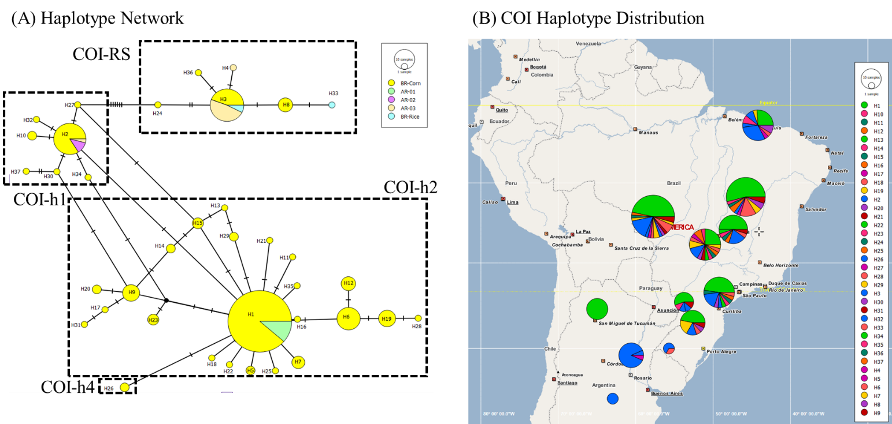

Figure S1. Haplotypes of fall armyworm based on mtCOIB gene sequences from Brazil and Argentina. (A) Network showing the genetic relationships among COI haplotypes among Brazilian samples collected from corn and from rice crops, and Argentinian samples grouped by locality. Each circle represents a unique haplotype, the circle size is proportional to the number of sequences, small black circles represent unobserved haplotypes and dashes represent mutational steps. (B) Spatial distribution of haplotypes. Colors indicate different mitochondrial haplotypes (N = 37).

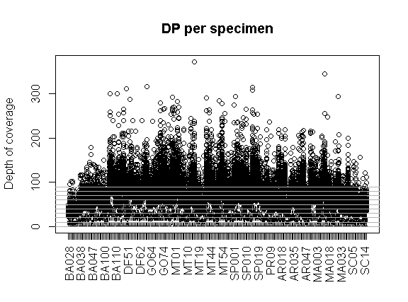

Figure S2. Depth of coverage (DP) per sample of fall armyworm. Average coverage per individual (ID in the x axis) was 23x. Each circle represents one SNP locus.

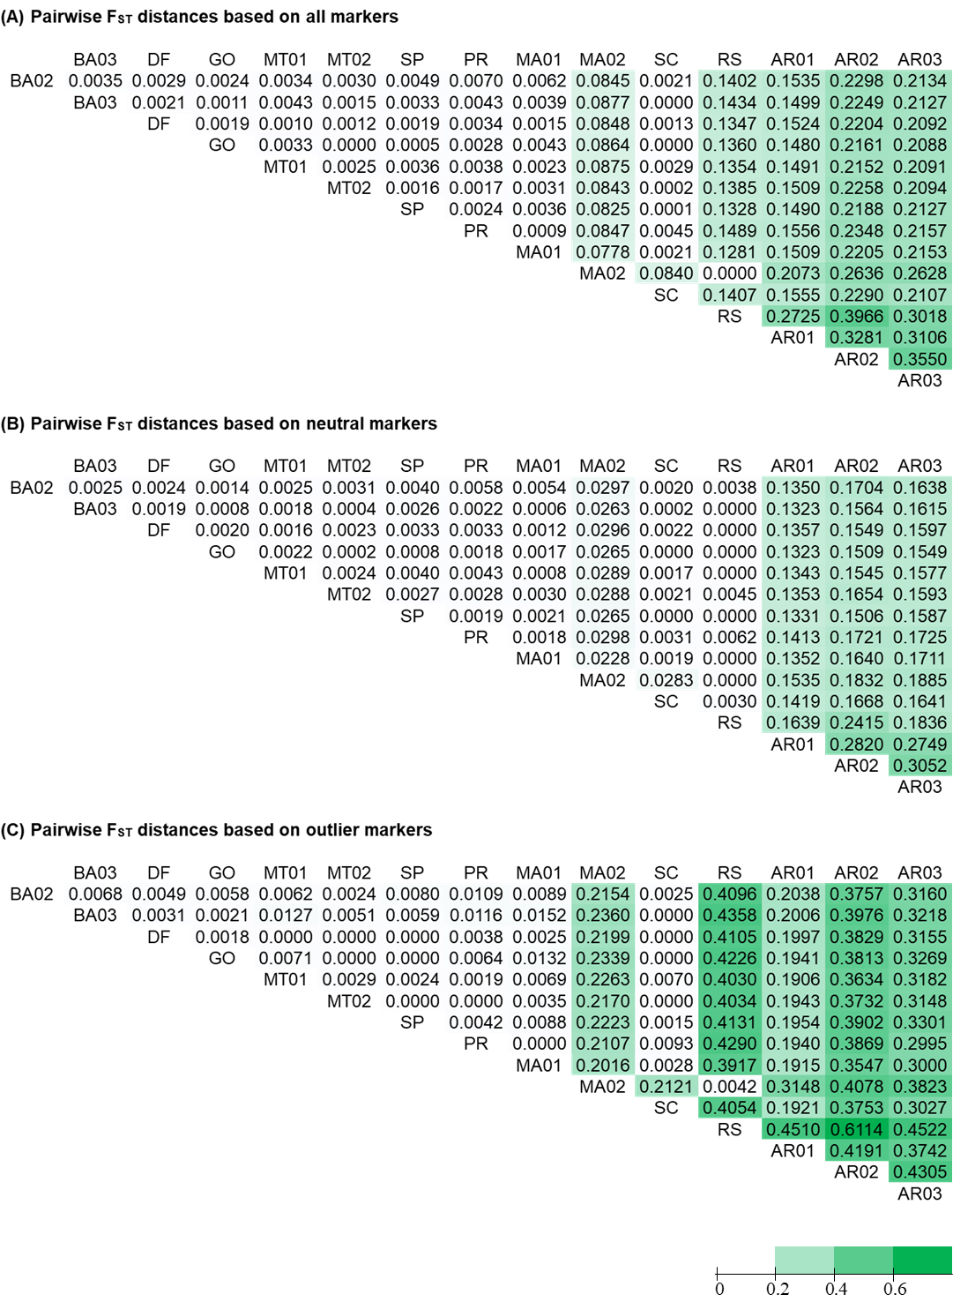

Figure S3. Pairwise F_{ST} for fall armyworm sampling locations. (A) F_{ST} calculated with all variant loci (3309 SNPs). (B) F_{ST} calculated using neutral markers (2853 SNPs). (C) F_{ST} was calculated using candidates putatively under positive selection (456 SNPs) obtained by three methods (FLK, PCAdapt, FstHet). Darker green color represents a higher degree of differentiation.

Table S4. Geographic distance matrix showing the straight-line distances (Km) between locations. Darker orange indicates longer distances.
 | BA02 | BA03 | DF | GO | MT01 | MT02 | SP | PR | AR01 | AR02 | AR03 | MA01 | MA02 | RS
BA03 | 75
DF | 426 | 487
GO | 827 | 872 | 440
MT01 | 1347 | 1345 | 1157 | 854
MT02 | 1327 | 1328 | 1127 | 816 | 42
SP | 1291 | 1358 | 874 | 671 | 1408 | 1366
PR | 1606 | 1662 | 1182 | 820 | 1270 | 1230 | 477
AR01 | 2492 | 2527 | 2115 | 1677 | 1475 | 1457 | 1607 | 1133
AR02 | 3098 | 3153 | 2674 | 2297 | 2444 | 2415 | 1875 | 1492 | 1127
AR03 | 2553 | 2605 | 2132 | 1741 | 1931 | 1858 | 1381 | 955 | 728 | 568
MA01 | 1060 | 990 | 1470 | 1796 | 1972 | 1934 | 2345 | 2614 | 3335 | 4090 | 3529
MA02 | 1108 | 1038 | 1518 | 1844 | 1889 | 1976 | 2393 | 2662 | 3380 | 4138 | 3577 | 1.4
RS | 2213 | 2272 | 1787 | 1444 | 1800 | 1763 | 966 | 625 | 1040 | 910 | 475 | 3235 | 3283
SC | 1785 | 1847 | 1360 | 1052 | 1561 | 1521 | 523 | 291 | 1242 | 1353 | 875.3 | 2821 | 2869 | 443

