Supplementary Materials for

Solar thermal textiles: a nature-inspired evolution of an old commodity

Wesley Viola, Peiyao Zhao, Trisha L. Andrew
Correspondence to: tandrew@umass.edu

This PDF file includes:

Materials and Methods
Supplementary Note 1
Figs. S1 to S8
Tables S1 and S2
References (1-6)

Materials and Methods

PEDOT film deposition

Films of PEDOT-Cl were deposited onto ripstop nylon using a custom-built reactor and process described in previous reports.(18) Briefly, 3,4-ethylenedioxythiophene (EDOT) (95%, TCI America), was reacted with iron (III) chloride (FeCl₃) (97%, Sigma Aldrich) in the vapor phase at low pressures maintained at approximately 750 mTorr. EDOT was evaporated at 95ºC and delivered into the chamber via a needle valve (Swagelok SS-4JB) that was typically opened a quarter turn. The volume of EDOT in the glass bulb was monitored over the course of the deposition to ensure a monomer flow rate of 5-10 sccm. FeCl₃ was sublimed by heating to >205ºC in a Luxel RADAK II furnace. The substrate stage was heated to 150ºC over the course of the deposition. Real-time film growth rate was monitored by a quartz crystal microbalance (QCM) located inside the chamber. Due to the different positioning of the QCM relative to the sample stage, a correction factor is needed to account for film growth rate variations. By measuring actual film thickness post-deposition using a Dektak profilometer, a tooling factor of 0.24 was determined. Film growth rate was kept at 2 nm/s. After the desired film thickness was reached, the sample stage was allowed to cool below 60ºC under vacuum. To remove residual iron salts and oligomers, samples were immediately rinsed with dilute acid (0.5 M HCl) for 30 minutes followed by a methanol rinse.

Textiles

Agribon AG-19 (140μm thickness measured with calipers) was purchased from Johnny’s Selected Seeds. Ripstop nylon (60μm), cotton terry (1000μm), and cotton jersey (310μm) were purchased from Joann’s Fabrics. Samples were cut to 5x5cm dimensions. Agribon samples were cut to 6x6cm dimensions and supported by a 5mm thick plastic frame. Omni-Heat samples (160μm) were cut from the inside of a Columbia brand jacket.

Environmental chamber and thermoregulation characterization

An insulated chamber 12”x12”x9” was made with R-5 insulation board. Two silicone heaters (Tempco, 5x5cm²) were inset into a block of insulation with thermistors placed atop the skin heater and between the skin and guard heater. Manila paper was chosen as the outer “skin” surface because it has an albedo representative of human skin (Figure S8). Another thermistor set one inch above and one inch to the side of the skin monitored environment temperature. This thermistor was shielded with foil to measure the true air temperature under irradiance. A cooler consisting of a pump circulating chamber air through a filled 0.5 L liquid nitrogen Dewar was used. An Adafruit Feather M0 microcontroller monitored skin temperature and adjusted the environmental temperature until T_{skin} = 33ºC using hysteresis control. The guard heater was set to maintain the same temperature within 0.3 ºC as the skin heater, ensuring 1D heat transport upward. A steady state measurement was taken such that the skin temperature varied no more than 0.3 ºC over the course of at least 15 minutes. Error bars provided are the standard deviation of environmental temperature during the measurement. For light conditions, a Feit 33W/300W equivalent LED bulb was used; light intensity was measured with a light meter placed in the same position as the skin heater. The spectrum was measured with a fluorimeter (Horiba Scientific) (Figure S9). For the higher radiances (data in Figure S6), a solar simulator was used (Oriel). Measurements were taken with humidity levels in the range of 20-40%. A small thermoregulation dependence (~1ºC) on humidity was observed (Figure S10).

Optical characterization

A FLIR TG165 was used to measure the infrared properties of the nylon, PEDOT-nylon, and AG-19 and capture thermal images. A fabric sample was placed on a heated (60ºC) 15x15 cm copper block covered with 3M Super 88 electrical tape (ε = 0.95)(38) and the apparent emissivity (Ɛ) was measured assuming the fabric samples (<140 μm thick) reached 60ºC. Transmissivity (τ) was measured by covering the FLIR detector with the fabric samples, measuring the apparent temperature of the 60ºC block from 6 cm away, and applying Equation 2 where T_{obj} is the temperature of the fabric sample and T_{amb} is the ambient temperature.(38) Transmissivity was subtracted from apparent emissivity to obtain the true emissivity. Finally, reflectivity (⍴) was calculated from true emissivity and transmissivity by Kirchhoff’s law. For our heat transfer analyses, we then assume that transmitted light is effectively absorbed (as it would be by the skin) so emissivity is reported and used assuming opaque samples. The optical transmission micrograph was taken using a Nikon Ti2 Eclipse with a 40x objective and a 440nm source.
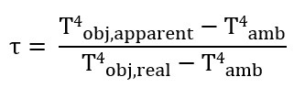 (1)
Solar radiance on a vertical human body

To make the on-body radiance estimation, the human body was approximated by a vertical cylinder of height 1.7 m and surface area 1.8 m². Similar approximations have been previously made.(28) Extraterrestrial radiance values on a vertical surface on June 21st and Dec 21st in Boston, MA were obtained using the SOLPOS function (NREL). On-body radiance is then approximated as 80% of extraterrestrial radiance on the projected vertical area (A_{xy} = 0.568 m²) per total surface area (A_{tot} = 1.8 m²) as in Equation 2.
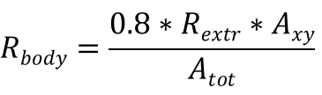 (2)
Wearability characterization

The Agribon AG-19 fabric was sewn with cotton thread and ironed to form pleated baffles. The PEDOT-nylon was then sewn to the bottom. During testing, the open ends of the baffles were covered with plastic. was characterized by sealing textile sample discs (3.1 cm²) to vials containing 3 g of Dri-Rite. Placed in a sealed chamber with a humidity of approximately 60%, the mass change of the vials was recorded at two-hour intervals. The mass gain was then divided by the surface area of the samples to obtain the water vapor transmission rate.

Washing test

Textiles were washed using a 30 minute total cycle. A solution of Gain laundry detergent was made per manufacturer's recommended usage and the textile was immersed with stirring for 15 minutes followed by immersion in fresh DI water with stirring for 15 minutes. The textile was allowed to dry for at least three hours in a hood before characterization. This procedure was repeated three times.

Supplementary Text

Heat transfer model assumption

To evaluate the impact of fabric optical properties on personal heating, a one-dimensional steady-state heat transfer model analysis was performed. This model is based on the control volume and energy balance analysis of heat radiation, conduction, and convection between the ambient environment and clothed human body. For simplification, the following assumptions are given:

1) The fabric is assumed to be opaque.
2) The temperature and the metabolic heat generation rate of the human skin is constant.
2) Heat convection is uniform between the ambient environment and the body.
3) The heat transfer between the clothed human body and the environment is one-dimensional transport through infinite parallel plans.
4) There is no convection between the skin and fabric.
5) Air gap thickness is small (1.4mm) and homogeneous.
6) The material optical properties are constant.
7) The environment and the skin are assumed to be the ideal black bodies.
8) The temperature of the textile is assumed to be uniform.
9) Assuming this is a steady-state heat transfer process, no heat accumulation occurs.
10) Assuming no forced convection between fabric and environment.
11) Assuming a personal thermal comfort condition (constant T_{skin}=33ºC) and evaporative heat loss occurs.

In prior works, the natural convective heat transfer coefficient (NCHTC) was taken as a constant.(14, 27) Since the temperature range in our study is significantly wider than in previous, the dependence of NCHTC on ΔT (the difference between T_{t} and T_{e}) was included in the model. In our case, we varied NCHTC for a horizontal hot plate based on the Eqn. S1 adapted from W.H. McAdam.(39)

h= K*ΔT^{(⅓)} (S1)

The exponent ⅓ is determined by the Rayleigh number (Ra) which for our system is estimated to be around 2*10⁹ by Equation S2. the parameter names and values used for calculation of Ra are listed in Table S2.

$Ra=\frac{Cp*L3*⍴2*g*ΔT*β}{K*ⲙ}$ (S2)

The constant K in Eqn. S1 was estimated to be 2.41 by taking h(ΔT=10) = 4, which aligns with previous literature.(14, 27) The effective length is equal to the area of the hot plate divided by the perimeter.

Heat transfer model formulation

This model relates fabric optical and thermoregulation properties. Steady state energy (heat) balances were made at the skin surface and textile surface

At skin surface:
q_{gen}-q_{rad,s}*(1-⍴_{t})+q_{rad,t} -q_{cond}=0 (3)

At textile surface:
q_{rad,s}*(1-⍴_{t} )-2*q_{rad,t}+q_{rad,e}*(1-⍴_{t})+q_{cond}-q_{conv}+ɑ*Q_{light}= 0 (4)

q_{gen}-human metabolic heat generation rate
q_{conv}-convective heat flux between the textile and ambient environment
q_{cond}-conductive heat flux from the skin to the textile
q_{rad,s}-radiative heat flux from the human body
q_{rad,e}-radiative heat flux from the environment
q_{rad,t}-radiative heat flux from the textile

According to the Stefan-Boltzmann law, Newton’s law of cooling and Fourier’s law, the conductive, convective, and radiation term can be represented as,

q_{rad,s=}Ɛ_{s}*𝜎*T_{s}⁴ (5)
q_{rad,e=}Ɛ_{e}*𝜎*T_{e}⁴ (6)
q_{rad,t=}Ɛ_{t}*𝜎*T_{t}⁴ (7)
q_{cond=}(k_{a}/t_{a})* (T_{s}-T_{t}) (8)
q_{conv=}2.41*(T_{s}-T_{t}) ^{(⅓)}*(T_{s}-T_{t}) (9)

Based on the energy balance analysis on the controlled volume, the two unknowns, T_{e} and T_{t} can be solved when the input Ɛ_{t} and ɑ vary from 0 to 1. The calculation and data visualization are completed on Matlab (version R2018b (MathWorks, Inc)). This generated a 3-dimensional plot showing the temperature map at different optical properties of the textile. Two experimental data points for nylon and PEDOT-nylon are also plotted.

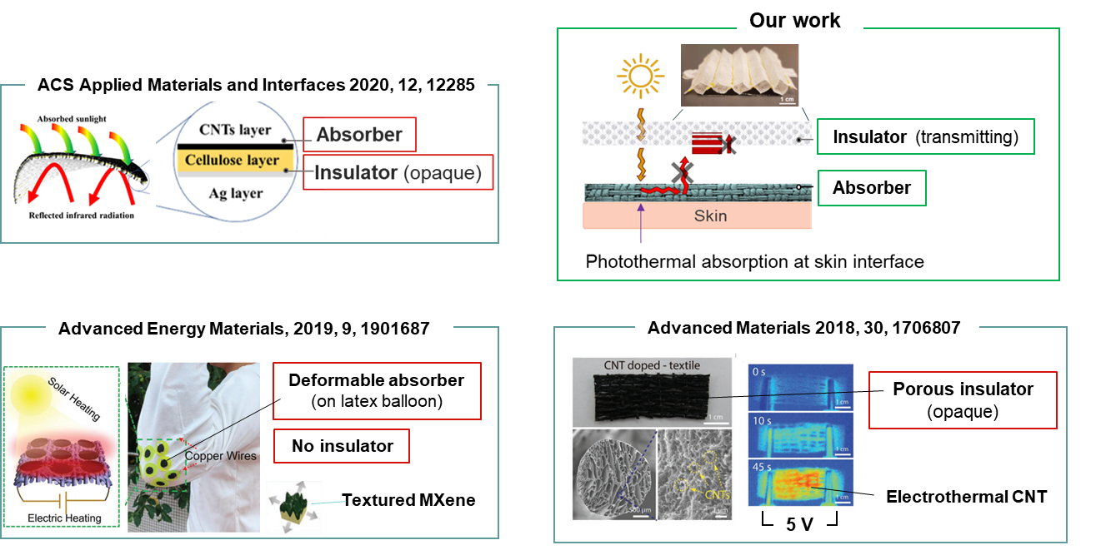

Fig. S1. A graphical overview of previously reported polar bear fur mimics which use darkly-colored outer surface and opaque insulators as compared to our absorber-transmitter insulator structured textile.

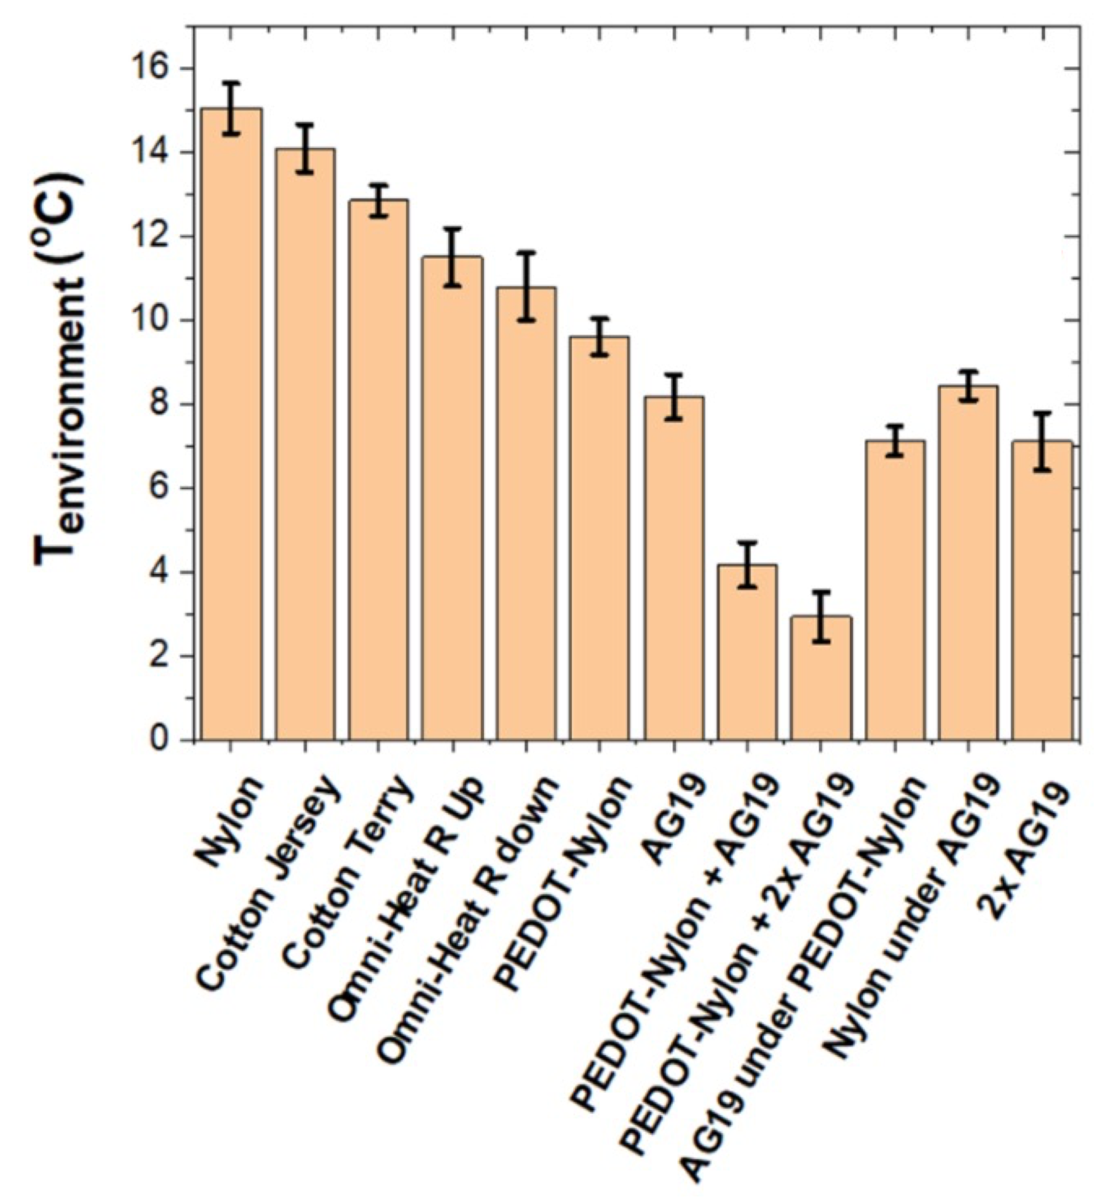
Figure S2. Additional thermoregulation characterizations including different configurations of the fabrics used for the bilayer solar thermal textile. Note the reduced heating effect of the reversed transmitter-absorber structure (AG19 under PEDOT-nylon) in which the darkly colored PEDOT faces outward.

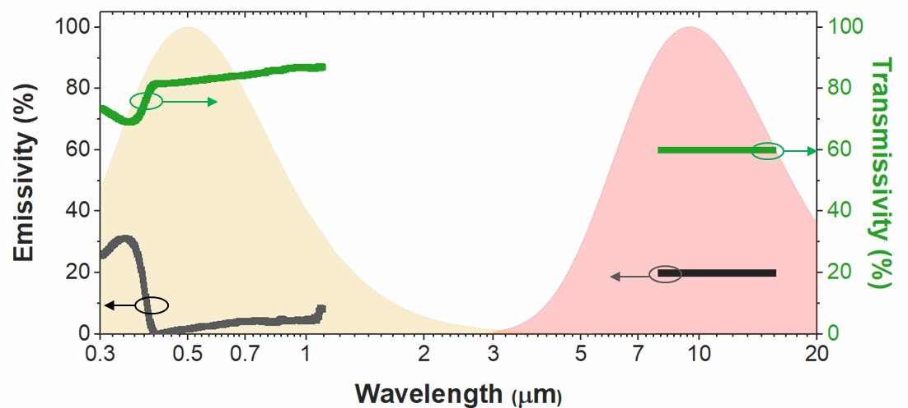

Fig. S3. Emissivity and transmissivity of spun-bonded Agribon AG-19 fabric compared against the blackbody spectrum of the sun (5,504 ºC) and human body (33 ºC).

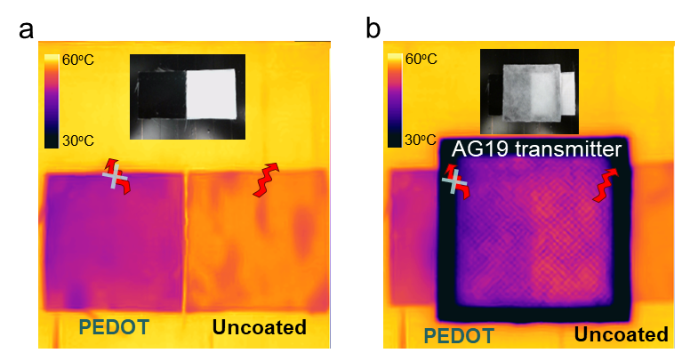

Fig. S4. Absorber optics affect thermal behavior in absorber-only and absorber-transmitter textiles. Photographs and infrared images comparing coated and uncoated nylon fabrics on a heat source (60ºC) as a absorber-only and b absorber-transmitter structures.

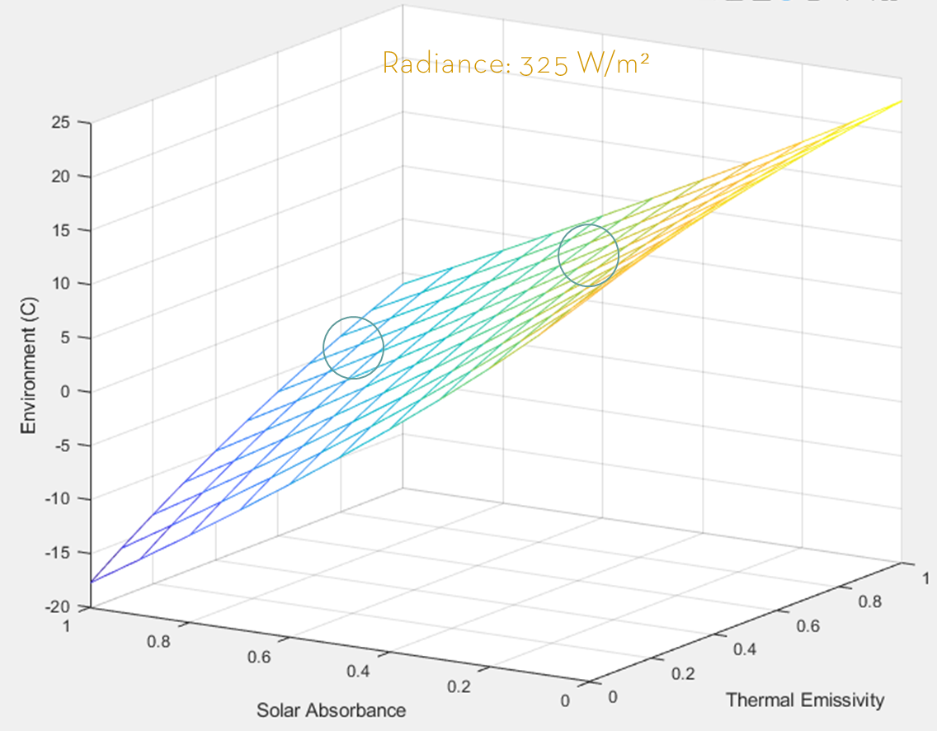

Fig. S5. Results of the textile thermoregulation simulation with a visible light radiance of 325 W/m². The expected temperature range of uncoated nylon and PEDOT coated nylon are indicated.

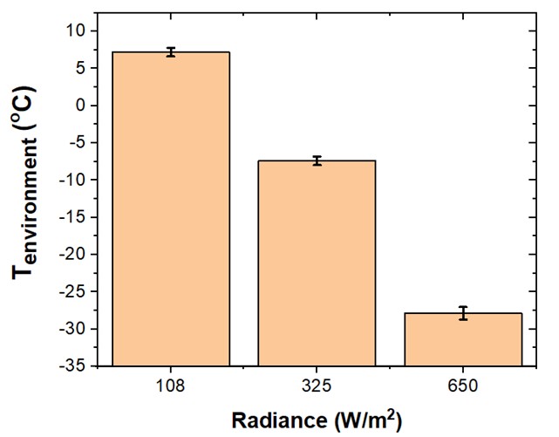

Fig. S6. Thermoregulation characterization of the bilayer textile exposed to a solar simulator-generated radiance of 108, 325, and 650 W/m².

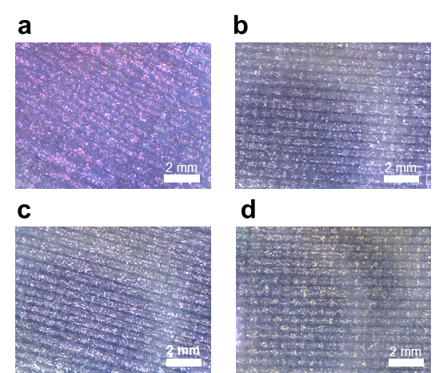

Fig. S7. Optical microscopy of PEDOT-nylon absorber a initially and after b one, c two, d and three washings with laundry detergent. Scale bars are 2mm.

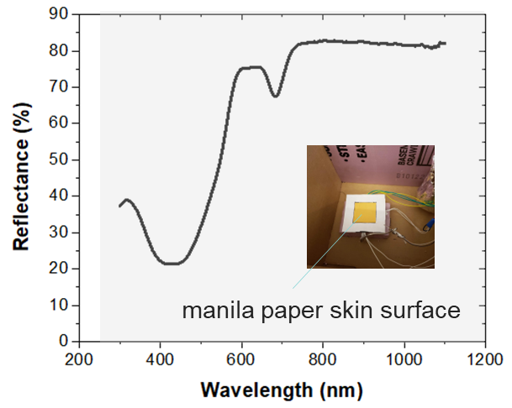
Fig. S8. Reflectance spectrum of manila paper used for skin surface.

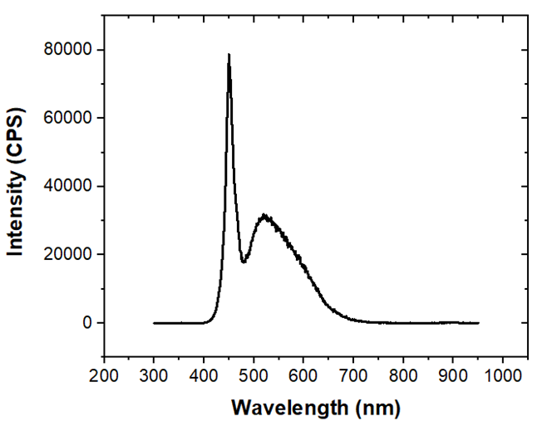

Fig. S9. Spectrum of the commercial LED light (130 W/m²) used for the environmental chamber.

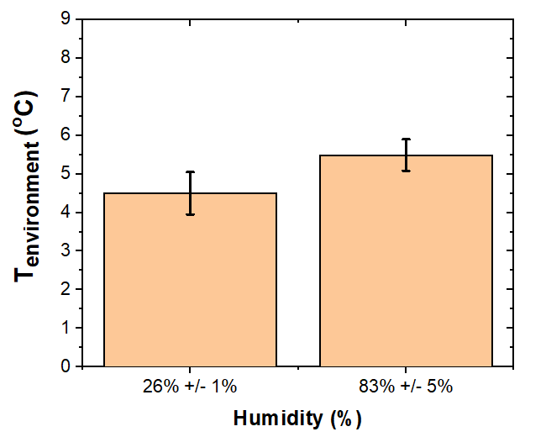

Fig. S10. Thermoregulation dependence on humidity. Low temperature ratings of the bilayer textile for low (26%) and high (83%) chamber humidity levels.

Table S1. Input parameters and their nomenclature used for heat transfer model analysis.

Symbol | Definition | Value | Unit
q_{gen} | metabolic heat generation rate per unit area | 75 | W/m²
Q_{light} | Solar light intensity | 130 | W/m²
T | Temperature | Skin, T_{s}=306.15  Environment, T_{e}  Textile, T_{t} | K
ta | Air gap thickness | 1.4 | mm
ka | Thermal conductivity of air | 0.026 | W/m*K
𝜎 | Stefan-Boltzmann constant | 5.67*10⁻⁸ | W/m²*K⁴
Ɛ | IR emissivity | Skin, Ɛ_{s} = 0.98  Environment, Ɛ_{e} = 1  Nylon, Ɛ_{t} = 1-⍴_{t} = 0.65  PEDOT/Nylon, Ɛ_{t} = 1-⍴_{t} = 0.48 | unitless
⍴ | IR reflectivity | Nylon, ⍴_{t = 0.2}  _{PEDOT-nylon} ⍴_{t = 0.46} | unitless
ɑ | Visible light absorptivity | Nylon, ɑ = 0.47  PEDOT-nylon, ɑ = 0.91 | unitless

Table S2. Properties of ambient air at 30°C and atmospheric pressure.(39)

Parameter Name | Value | Unit
C_{p}, specific heat capacity | 1.0065*10³ | J/kg.K
K, heat conductivity | 0.026 | W/m.K
ⲙ, dynamic viscosity | 1.868*10⁻⁵ | kg/m.s
⍴, density | 1.1649 | kg/m³
g, earth gravity acceleration | 9.81 | m/s²
β, thermal expansion coefficient | 3.32*10⁻³ | K⁻¹
L, effective length | 1.25 | unitless
ΔT, temperature difference between air and hot surface | 10 | unitless

References
1. L. Zhang, M. Fairbanks, T. L. Andrew, Rugged Textile Electrodes for Wearable Devices Obtained by Vapor Coating Off-the-Shelf, Plain-Woven Fabrics. Adv. Funct. Mater. 27, 1–9 (2017).
2. R. P. Madding, Emissivity measurement and temperature correction accuracy considerations. Thermosense XXI. 3700, 393–401 (1999).
3. R. Steadman, The Assessment of Sultriness Part II. J. Appl. Meteorol. (1979).
4. J. K. Tong, X. Huang, S. V. Boriskina, J. Loomis, Y. Xu, G. Chen, Infrared-Transparent Visible-Opaque Fabrics for Wearable Personal Thermal Management. ACS Photonics. 2, 769–778 (2015).
5. L. Cai, A. Y. Song, P. Wu, P. C. Hsu, Y. Peng, J. Chen, C. Liu, P. B. Catrysse, Y. Liu, A. Yang, C. Zhou, C. Zhou, S. Fan, Y. Cui, Warming up human body by nanoporous metallized polyethylene textile. Nat. Commun. 8 (2017).
6. M. H. McAdam, Heat Transmission (McGraw-Hill, New York, ed. 3rd, 1954).

