Supplementary materials:
High crop yield losses induced by potential HONO sources —— a case study in the North China Plain

Content:
Table S1. A brief comparison of OH production rate through HONO/O₃ photolysis from literature (Ratio = P_{(OH)} via HONO photolysis/ P_{(OH)} via O₃ photolysis). 4
Table S2. A brief summary of modelling studies considering potential HONO sources and the corresponding enhancement of O₃ induced by the considered potential HONO sources. 6
Table S3 Statistics of wheat/maize yields (Ton) in 2016 in China (from National Bureau of Statistics of China). 7
Table S4. Model performance statistics for hourly HONO mixing ratios at the rural/urban site in July of 2016. 7
Table S5. The averaged diurnal HONO mixing ratios (ppb) at the two observational sites for cases Base and 6S, and observations. 7
Table S6. Model performance statistics for 69-site-averaged diurnal O₃ mixing ratios (±SD) (ppb) during wheat and maize growing seasons. 8
Table S7 Summary of RYLs calculated by the 14 ER equations in NCP. 9
Table S8. Physical and chemical options in the WRF-Chem model used in this study 10
Table S9 Simulation schemes in this study 10
Table S10. Performance metrics (index of agreement (IOA), RMSE (root-mean-square error) and MB (mean bias)) of the WRF-Chem model simulations (air temperature, relative humidity, wind speed and direction) for 410 meteorological sites in northern China during March 01 – May 31 (wheat growing season) and July 01 – September 30 (maize growing season) of 2016. 11

Fig.S1 The relative contributions of the six potential HONO sources and the reaction of OH with NO to surface HONO mixing ratios for the 6S case at the rural site (a), the urban site (b) and the 69 NCP monitoring sites (c). 12
Fig.S2 Comparison of simulated and observed hourly O₃ averages for 69 monitoring sites in domain 2 during wheat (March-May) and maize (July-September) growing seasons in 2016. 12
Fig.S3 Comparison of simulated regionally-averaged surface OH between base and 6S cases in NCP during wheat (a) and maize (b) growing seasons in 2016. 13
Fig.S4 Comparison of simulated regionally-averaged surface HO₂ between base and 6S cases in NCP during wheat (a) and maize (b) growing seasons in 2016. 13
Fig.S5 Diurnal mean variations of O₃ production rates and loss rates including major production and loss reactions, net O₃ production rates for 69 monitoring sites in domain 2 during wheat (a, b) and maize (c, d) growing seasons in 2016 for the Base and 6S cases. 13
Fig.S6 Summary of daily maximum 8-h (10:00-17:59) averaged surface O₃ enhancements induced by the potential HONO sources during the wheat/maize growing season in NCP in 2016. 14
Fig.S7 The wheat RY for the base and 6S cases and the corresponding RYL induced by the potential HONO sources calculated by ER equations AOT40_1 (a1–c1), AOT40_2 (a2–c2), AOT40_3 (a3–c3), AOT40_4 (a4–c4), M7_1 (a5–c5), SUM06_1 (a6–c6), SUM06_2 (a7–c7), W126_1 (a8–c8) and W126_2 (a9–c9) in NCP in 2016. 17
Fig.S8 The maize RY for the base and 6S cases and the corresponding RYL induced by the potential HONO sources calculated by ER equations AOT40_5(a1–c1), AOT40_6(a2–c2), M7_2(a3–c3), M12(a4–c4) and W126_3(a5–c5) in NCP in 2016. 18
Fig.S9 Comparison of diurnal mean simulations (Base, 6S, 6S_100α and 6S_200α) and observations of HONO at the rural (a) and urban (b) sites in NCP in 2016. 19
Fig. S10 Comparison of diurnal mean simulations (Base, Nit_1, Nit_7, Nit_30 and Nit_120) of HONO for the rural (a) and urban (b) sites in NCP in 2016 (J_{nitrate} and J_{HNO3} denote the photolysis frequencies of nitrate and gas nitric acid, respectively). 19
Fig.S11 Comparison of simulated (Base, 6S, Base_115VOCs and 6S_115VOCs cases, Base_85NO_{x} and 6S_85NO_{x} cases) and observed 69-site-averaged diurnal O₃ (a), and the corresponding O₃ enhancements (b) in the North China Plain during wheat growing seasons in 2016. 20
Fig.S12 Box plots of the relative yield loss (RYL) induced by the potential HONO sources for the three emission scenarios (decreasing 15% NO_{x} emissions, default emissions and increasing 15% VOC emissions) in NCP in 2016. The numbers at the top of the box plots denote the mean RYL value. 20
Fig.S13 Comparison of simulated and observed hourly-averaged NO₂ for 69 monitoring sites in domain 2 during wheat (March-May) and maize (July-September) growing seasons in 2016. 21
Fig.S14 Comparison of simulated and observed diurnal mean variations of NO₂ for 69 monitoring sites in domain 2 for wheat (a) and maize (b) during growing seasons in 2016. 21

Tables:
Table S1. A brief comparison of OH production rate through HONO/O₃ photolysis from literature (Ratio = P_{(OH)} via HONO photolysis/ P_{(OH)} via O₃ photolysis).
Location | Lon, Lat | Year | Season | P_{(OH)} via HONO photolysis | P_{(OH)} via O₃ photolysis | Ratio | Reference
New York City, US | 40.73°N, 73.82°W | 2004 | Winter | 4.22 ppb day⁻¹ | 0.09 ppb day⁻¹ | ~48 | (Ren et al., 2006a)
Whiteface Mountain, US | 44.39°N, 73.86°W | 2002 | Summer | 5.54 ppb day⁻¹ | 4.89 ppb day⁻¹ | ~1.1 | (Ren et al., 2006b)
Guangzhou, CN | 23.13°N, 113.26°E | 2006 | Summer | 9.10 ppb h⁻¹ (11:00–14:59) | 1.60 ppb h⁻¹ (11:00–14:59) | ~5.7 | (Lu et al., 2010)
Backgarden, CN | 23.5°N, 113.02°E | 2006 | Summer | 0.97 ppb h⁻¹ (11:00–14:59) | 1.72 ppb h⁻¹ (11:00–14:59) | ~0.6 | (Lu et al., 2010)
Santiago, CL | 33.45°S 70.67°W | 2005 | Winter/  Summer | 6.23/5.60 ppb h⁻¹ (daytime average) | 0.01/0.27 ppb h⁻¹ (daytime average) | ~623/  ~20.7 | (Elshorbany et al., 2010)
Beijing, CN | 39.99°N, 116.31°E | 2007 | Summer | 3.0 ppb h⁻¹ (daytime average) | 0.4 ppb h⁻¹ (daytime average) | ~7.5 | (Liu et al., 2012)
Palaiseau, FR | 48.72°N, 2.21°E | 2009 | Summer | 0.25 ppb h⁻¹ (daytime average) | 0.16 ppb h⁻¹ (daytime average) | ~1.5 | (Michoud et al., 2012)
New York City, US | 40.73°N, 73.82°E | 2009 | Summer | 0.31 ppb h⁻¹ (daytime average) | 0.23 ppb h⁻¹ (daytime averaged) | ~1.4 | (Lin et al., 2012)
Concordia station, Antarctic | 75.10°S, 123.31°E | 2011-2012 | Summer | 0.29 ppb h⁻¹ (noontime) | 0.02 ppb h⁻¹ (noontime) | ~12.8 | (Kukui et al., 2014)
Los Angeles, US | 34.14°N, 118.12°W | 2010 | Summer | 0.44 ppb h⁻¹ (noontime) | 1.20 ppb h⁻¹ (noontime) | ~0.36 | (Young et al., 2012)
Houston, US | 29.72°N, 95.34°W | 2009 | Spring | ~0.6 ppb h⁻¹ (noontime) | ~1.5 ppb h⁻¹ (noontime) | ~0.4 | (Ren et al., 2013)
Tung Chung, CN | 113.93°E, 22.30°N | 2011 | Summer-autumn | ~1.6 ppb h⁻¹ (daytime average) | ~1.2 ppb h⁻¹ (daytime average) | ~1.3 | (Xue et al., 2016)
London, UK | 51.52°N, 0.21°W | 2012 | Summer | 1.66 ppb h⁻¹ (11:00–14:59) | 0.51 ppb h⁻¹ (11:00–14:59) | ~3.3 | (Whalley et al., 2018)
Nanjing, CN | 118.°570 E, 32°070 N | 2017-2018 | 1-year | 1.16 ppb h⁻¹ (08:00–16:00) | 0.41 ppb h⁻¹ (08:00–16:00) | ~2.8 | (Liu et al., 2019)
Shenzhen, CN | 22.60°N, 113.97°E | 2018 | Autumn | ~1.3 ppb h⁻¹ (daytime average) | ~0.5 ppb h⁻¹ (daytime average) | ~2.6 | (Yu et al., 2020)
Dongying, CN | 37.75°N, 118.97°E | 2017 | Summer | 0.5 ppb h⁻¹ (daytime average) | 1.2 ppb h⁻¹ (daytime average) | ~0.4 | (Chen et al., 2020)
Dongying, CN | 37.75°N, 118.97°E | 2017 | Winter-spring | ~0.25 ppb h⁻¹ (daytime average) | ~0.07 ppb h⁻¹ (daytime average) | ~3.5 | (Gu et al., 2020)
Nanjing, CN | 32.20°N, 118.71°E | 2015 | Winter | 0.95 ppb h⁻¹ (monthly average) | 0.33 ppb h⁻¹ (monthly average) | ~2.9 | (Zheng et al., 2020)
Changzhou, CN | 31.8°N, 119.9°E | 2017 | Spring | ~2.7 (noontime) | ~6.7 (noontime) | ~0.4 | (Shi et al., 2020)
Shanghai, CN | 121.5° E, 31.33° N | 2018 | Summer | ~0.6 ppb h⁻¹ (noontime) | ~1.1 ppb h⁻¹ (noontime) | ~0.6
Heshan, CN | 22.73° N, 112.93° E | 2014 | Autumn | ~1.3 ppb h⁻¹ (noontime | ~0.6 ppb h⁻¹ (noontime | ~2.2 | (Tan et al., 2019)
Beijing, CN | 39.99°N, 116.5°E | 20171-2018 | Winter | 1.0 ppb h⁻¹ (noontime | 0.1 ppb h⁻¹ (noontime | ~10 | (Ma et al., 2019)
Chongqing, CN | 106.57°E, 29.64°N | 2015 | Summer | 0.57 ppb h⁻¹ (daytime average) | 0.33 ppb h⁻¹ (daytime average) | ~1.7 | (Tan et al., 2019)
Hong Kong, CN | 22.22°N, 114.25°E | 2012 | Autumn-winter | / | / | ~0.5 | (Li et al., 2018)
Hong Kong, CN | 22.32°N, 114.17°E | 2015 | Spring | 13.4 ppb h⁻¹ (daytime average) | 0.22 ppb h⁻¹ (daytime average) | ~60 | (Yun et al., 2017)
Shanghai, CN | 31.3°N, 121.48°E | 2013 | Summer | 1.2 ppb h⁻¹ (noontime | 0.4 ppb h⁻¹ (noontime | ~3 | (Nan et al., 2017)

Table S2. A brief summary of modelling studies considering potential HONO sources and the corresponding enhancement of O₃ induced by the considered potential HONO sources.
Study site | Study period | Model | Mechanism | O₃ enhancement (ppb) | Reference
Los Angeles | August, 1987 | UAM | CB-IV | 1–9 | (Calvert et al., 1994)
Houston | September, 1993 | CTM | MOZART-v2 | 7 | (Lei, 2004)
Beijing | June, 2000 | CMAQ-MADRID | CB-IV | 67(maximum) | (Xu et al., 2006)
Northeast Philadelphia | July, 2001 | CMAQ | CB05 | 2.4 | (Sarwar et al., 2008)
U.S. | July, 2001/2002 | CMAQ | CB05 | 6–9 | (Sarwar et al., 2009)
Mexico City | Marh, 2006 | WRF-Chem | SAPRC 99 | 6 | (Li et al., 2010)
BTH | August, 2007 | WRF-Chem | CBM-Z | 3–10 | (Li et al., 2011)
Houston | August-Sep., 2006 | CMAQ | SAPRC 99 | 11(maximum) | (Czader et al., 2012)
Global | / | EMAC | MECCA1 | 6 | (Elshorbany et al., 2012)
Pearl River Delta | October, 2004 | CMAQ | CB05 | 6 | (Zhang et al., 2012)
North China Plain | August, 2007 | WRF-Chem | CBM-Z | 2.0–4.9 | (An et al., 2013)
BTH | August, 2007 | WRF-Chem | CBM-Z | 6 | (Tang et al., 2014)
Houston | April, 2009 | CAMx | CB06 | 3.9 | (Couzo et al., 2015)
Pearl River Delta | August, 2011 | WRF-Chem | CBM-Z | 2.4–6.7 | (Zhang et al., 2016)
China | June-July, 2014 | WRF-Chem | CBM-Z | 2.9–6.2 | (Zhang et al., 2017)
Global | January, April, July and October, 2015 | GEOS-Chem | CB05 | 10 (winter) | (Lu et al., 2018)
Pearl River Delta | January, 2017 | CMAQ | CB05e51 | 24 | (Fu et al., 2019)
BTH | August, 2006 | WRF-Chem | MOZART-4 | 4-5 | (Zhang et al., 2019)
Eastern China | July,2013 October,2015 | WRF-Chem | MOZART-4 | 8-37(summer);  1–19(winter) | (Guo et al., 2020)
Eastern China | February, 2017 | WRF-Chem | MOZART-4 | 6-7 | (Zhang et al., 2020)
North China Plain | March to May, 2016 | WRF-Chem | MOZART-4 | 8.1 | This work (wheat)
North China Plain | July to September, 2016 | WRF-Chem | MOZART-4 | 8.2 | This work (maize)

Table S3 Statistics of wheat/maize yields (Ton) in 2016 in China (from National Bureau of Statistics of China).
Province | Wheat yield | Maize yield | NCP region
Henan | 3.47x10⁷ | 1.75x10⁷ | √
Shandong | 2.34x10⁷ | 2.07x10⁷ | √
Hebei | 1.43x10⁷ | 1.75x10⁷ | √
Anhui | 1.39x10⁷ | 4.62x10⁶ | √
Jiangsu | 1.12x10⁷ | 2.34x10⁶ | √
Xinjiang | 7.23x10⁶ | 6.85x10⁶
Shaanxi | 4.45x10⁶ | 5.45x10⁶
Hubei | 4.28x10⁶ | 2.97x10⁶
Sichuan | 4.13x10⁶ | 7.93x10⁶
Shanxi | 2.73x10⁶ | 8.89x10⁶
Gansu | 2.68x10⁶ | 5.61x10⁶
Neimenggu | 1.70x10⁶ | 2.14x10⁷
Yunnan | 8.94x10⁵ | 7.57x10⁶
Tianjin | 6.09x10⁵ | 1.18x10⁶ | √
Guizhou | 5.97x10⁵ | 3.24x10⁶
Ningxia | 4.09x10⁵ | 2.16x10⁶
Qinghai | 3.31x10⁵ | 1.81x10⁵
Heilongjiang | 2.90x10⁵ | 3.13x10⁷
Zhejiang | 2.54x10⁵ | 3.05x10⁵
Xizang | 2.31x10⁵ | 2.70x10⁴
Chongqing | 1.96x10⁵ | 2.65x10⁶
Shanghai | 1.21x10⁵ | 2.10x10⁴
Beijing | 8.50x10⁴ | 4.32x10⁵ | √
Hunan | 5.90x10⁴ | 1.89x10⁶
Jiangxi | 2.60x10⁴ | 1.30x10⁵
Liaoning | 2.20x10⁴ | 1.47x10⁷
Guangxi | 1.10x10⁴ | 2.79x10⁶
Fujian | 6.00x10³ | 2.18x10⁵
Guangdong | 3.00x10³ | 8.10x10⁵
Jilin | 1.00x10³ | 2.83x10⁷
Total | 1.29x10⁸ | 2.20x10⁸

Table S4. Model performance statistics for hourly HONO mixing ratios at the rural/urban site in July of 2016.

Case | Concentrations (ppb) | MB (ppb) | NMB (%) | RMSE (ppb) | IOA
Obs | 0.43/0.63 | / | / | / | /
Base | 0.01/0.02 | -0.42/-0.61 | -97.67/-96.83 | 0.55/0.87 | 0.43/0.43
6S | 0.60/0.55 | 0.17/-0.08 | 23.33/-12.70 | 0.53/0.63 | 0.65/0.67

Table S5. The averaged diurnal HONO mixing ratios (ppb) at the two observational sites for cases Base and 6S, and observations.
Hour | Base  (rural) | 6S  (rural) | Obs  (rural) |  | Base  (urban) | 6S  (urban) | Obs  (urban)
0 | 0.006 | 1.235 | 0.711 |  | 0.004 | 1.255 | 0.923
1 | 0.006 | 1.328 | 0.75 |  | 0.004 | 1.270 | 0.903
2 | 0.006 | 1.368 | 0.765 |  | 0.004 | 1.285 | 1.021
3 | 0.006 | 1.356 | 0.778 |  | 0.004 | 1.256 | 0.981
4 | 0.006 | 1.307 | 0.737 |  | 0.003 | 1.261 | 1.103
5 | 0.006 | 1.264 | 0.727 |  | 0.003 | 1.329 | 1.178
6 | 0.006 | 1.167 | 0.611 |  | 0.006 | 1.068 | 0.962
7 | 0.012 | 0.614 | 0.535 |  | 0.012 | 0.395 | 0.687
8 | 0.021 | 0.279 | 0.354 |  | 0.021 | 0.215 | 0.511
9 | 0.028 | 0.223 | 0.259 |  | 0.035 | 0.167 | 0.347
10 | 0.035 | 0.207 | 0.192 |  | 0.052 | 0.165 | 0.395
11 | 0.036 | 0.179 | 0.187 |  | 0.057 | 0.148 | 0.242
12 | 0.032 | 0.130 | 0.214 |  | 0.047 | 0.111 | 0.207
13 | 0.023 | 0.103 | 0.172 |  | 0.038 | 0.092 | 0.187
14 | 0.017 | 0.086 | 0.159 |  | 0.029 | 0.079 | 0.203
15 | 0.013 | 0.077 | 0.167 |  | 0.024 | 0.079 | 0.207
16 | 0.011 | 0.072 | 0.164 |  | 0.020 | 0.077 | 0.291
17 | 0.009 | 0.070 | 0.178 |  | 0.015 | 0.090 | 0.331
18 | 0.006 | 0.087 | 0.211 |  | 0.010 | 0.090 | 0.363
19 | 0.006 | 0.199 | 0.300 |  | 0.006 | 0.122 | 0.554
20 | 0.006 | 0.41 | 0.387 |  | 0.005 | 0.264 | 0.511
21 | 0.005 | 0.641 | 0.515 |  | 0.005 | 0.572 | 0.653
22 | 0.005 | 0.867 | 0.644 |  | 0.004 | 0.828 | 0.76
23 | 0.005 | 1.082 | 0.684 |  | 0.004 | 1.089 | 0.82
mean | 0.013 | 0.598 | 0.433 |  | 0.017 | 0.554 | 0.597

Table S6. Model performance statistics for 69-site-averaged diurnal O₃ mixing ratios (±SD) (ppb) during wheat and maize growing seasons.
Hour | wheat Base | wheat 6S | wheat Obs | maize Base | maize 6S | maize Obs
0 | 9.7(±5.9) | 12.7(±7.5) | 27.5(±10.1) | 11.9(±4.9) | 15.4(±6.7) | 28.6(±7.9)
1 | 9.6(±5.7) | 12.6(±7.3) | 25.9(±9.8) | 11.5(±4.6) | 14.9(±6.1) | 26.7(±6.6)
2 | 9.2(±5.4) | 12.0(±7.0) | 24.1(±9.0) | 10.8(±4.0) | 13.9(±5.6) | 24.5(±6.1)
3 | 9.3(±5.2) | 12.1(±6.7) | 22.3(±8.1) | 10.3(±4.0) | 13.3(±5.3) | 22.4(±6.9)
4 | 9.2(±4.9) | 11.8(±6.3) | 21.0(±7.7) | 9.8(±3.9) | 12.5(±5.0) | 20.9(±6.4)
5 | 8.9(±4.6) | 11.5(±5.9) | 19.3(±7.1) | 9.1(±3.7) | 11.6(±4.6) | 18.9(±6.0)
6 | 9.7(±4.7) | 12.2(±5.9) | 18.6(±7.2) | 9.6(±3.7) | 12.0(±4.4) | 18.3(±5.7)
7 | 13.00(±5.6) | 15.7(±7.0) | 20.9(±7.9) | 14.7(±4.9) | 18.4(±6.4) | 21.1(±5.2)
8 | 18.1(±7.2) | 21.9(±9.0) | 26.9(±9.6) | 22.6(±6.9) | 28.2(±9.2) | 28.4(±7.0)
9 | 25.1(±8.7) | 30.3(±10.5) | 34.8(±10.5) | 31.5(±7.6) | 39.2(±10.6) | 38.4(±9.5)
10 | 32.3(±9.3) | 38.8(±10.9) | 43.1(±12.5) | 39.9(±8.8) | 48.8(±12.2) | 49.2(±10.9)
11 | 38.3(±10.2) | 45.7(±11.5) | 50.5(±13.9) | 48.1(±10.1) | 57.5(±13.6) | 58.7(±12.7)
12 | 43.7(±10.9) | 51.7(±12.1) | 56.7(±15.5) | 55.0(±11.2) | 64.4(±14.8) | 66.0(±15.9)
13 | 48.1(±11.3) | 56.4(±12.5) | 61.0(±16.1) | 60.2(±11.8) | 69.3(±15.5) | 70.3(±16.6)
14 | 51.4(±11.5) | 59.8(±12.7) | 63.1(±16.2) | 63.2(±12.2) | 72.0(±16.0) | 72.0(±18.5)
15 | 52.5(±11.7) | 60.9(±13.1) | 63.5(±16.5) | 64.4(±12.2) | 73.0(±16.3) | 72.0(±16.9)
16 | 52.0(±11.6) | 60.3(±13.1) | 62.5(±16.6) | 63.7(±12.2) | 72.1(±16.4) | 70.1(±16.4)
17 | 49.0(±11.8) | 57.1(±13.1) | 58.4(±16.4) | 59.4(±12.5) | 67.5(±16.4) | 65.5(±15.6)
18 | 37.6(±13.6) | 44.7(±14.6) | 51.4(±16.1) | 46.5(±15.2) | 53.7(±18.3) | 57.1(±13.9)
19 | 22.2(±11.3) | 27.7(±12.9) | 44.0(±15.0) | 31.4(±12.9) | 37.9(±15.3) | 491(±13.0)
20 | 15.5(±8.5) | 19.9(±10.3) | 38.7(±13.7) | 21.5(±8.9) | 26.8(±11.2) | 42.6(±10.6)
21 | 13.0(±7.6) | 16.9(±9.4) | 35.0(±12.6) | 17.1(±7.2) | 21.6(±9.2) | 37.8(±9.4)
22 | 11.4(±7.0) | 14.8(±8.7) | 32.1(±11.7) | 14.4(±6.2) | 18.4(±8.1) | 34.2(±7.8)
23 | 10.3(±6.5) | 13.5(±8.1) | 30.1(±11.0) | 12.6(±5.4) | 16.3(±7.3) | 31.5(±7.3)

Table S7 Summary of RYLs calculated by the 14 ER equations in NCP.
Crop | Equations | RYL Ranges | RYL mean | Median RYL
Wheat | AOT40_1 | 0.010-0.155 | 0.074 | 0.073
Wheat | AOT40_2 | 0.015-0.225 | 0.108 | 0.105
Wheat | AOT40_3 | 0.021-0.319 | 0.153 | 0.149
Wheat | AOT40_4 | 0.020-0.186 | 0.110 | 0.112
Wheat | M7_1 | 0.009-0.052 | 0.030 | 0.031
Wheat | SUM06_1 | 0.013-0.477 | 0.207 | 0.201
Wheat | SUM06_2 | 0.000-0.459 | 0.147 | 0.133
Wheat | W126_1 | 0.001-0.296 | 0.117 | 0.109
Wheat | W126_2 | 0.000-0.254 | 0.076 | 0.063
mean for wheat |  |  | 0.114 | 0.108
Maize | AOT40_5 | 0.013-0.057 | 0.031 | 0.031
Maize | AOT40_6 | 0.024-0.106 | 0.058 | 0.057
Maize | M7_2 | 0.001-0.024 | 0.012 | 0.012
Maize | M12 | 0.002-0.065 | 0.034 | 0.034
Maize | W126_3 | 0.000-0.082 | 0.028 | 0.025
mean for maize |  |  | 0.033 | 0.032

Table S8. Physical and chemical options in the WRF-Chem model used in this study
Options | WRF-Chem
Advection scheme | Runge-Kutta 3rd order
Boundary layer scheme | YSU
Cloud microphysics | Lin et al. (1983)
Cumulus parameterization | New Grell scheme
Land-surface model | Noah
Long-wave radiation | RRTM
Short-wave radiation | Goddard
Surface layer | Revised MM5 Monin-Obukhov scheme
Aerosol option | MOSAIC
Chemistry option | Updated MOZART mechanism
Photolysis scheme | F-TUV

Table S9 Simulation schemes in this study
Case | HONO source | E_{VOCs} | E_{NOx} | Simulation duration
Base | default (OH + NO → HONO) | default | default | Whole
6S | default + 6 potential HONO sources | default | default | Whole
Base_115VOCs | default (OH + NO → HONO) | ↑15% | default | Wheat growing season
6S_115VOCs | default + 6 potential HONO sources | ↑15% | default | Wheat growing season
Base_85NO_{x} | default (OH + NO → HONO) | default | ↓15% | Wheat growing season
6S_85NO_{x} | default + 6 potential HONO sources | default | ↓15% | Wheat growing season
6S_100α | default + 6 potential HONO sources (α=100) | default | default | July 01–August 12
6S_200α | default + 6 potential HONO sources s(α=200) | default | default | July 01–August 12
A | Traffic emissions | default | default | July 01–August 12
B | Soil emissions | default | default | July 01–August 12
C | Indoor emissions | default | default | July 01–August 12
D | NO₂ heterogeneous reactions on aerosol surfaces | default | default | July 01–August 12
E | NO₂ heterogeneous reactions on ground surface | default | default | July 01–August 12
Nit_1 | J_{nitrate}/J_{HNO3} = 1 | default | default | July 01–August 12
Nit_7 | J_{nitrate}/J_{HNO3} = 7 | default | default | July 01–August 12
Nit_30 | J_{nitrate}/J_{HNO3} = 30 | default | default | July 01–August 12
Nit_120 | J_{nitrate}/J_{HNO3} = 120 | default | default | July 01–August 12

Table S10. Performance metrics (index of agreement (IOA), RMSE (root-mean-square error) and MB (mean bias)) of the WRF-Chem model simulations (air temperature, relative humidity, wind speed and direction) for 410 meteorological sites in northern China during March 01 – May 31 (wheat growing season) and July 01 – September 30 (maize growing season) of 2016.
 | IOA | RMSE | MB | Reference
T (℃) | 0.99 | 1.55 | -0.24 | This work (wheat)
 | 0.95 | 2.08 | 0.64 | This work (maize)
 | 0.90 | 2.5 | 0.2 | (Wang et al., 2014)
 | 0.90 | / | -0.9 | (Wang et al., 2010)
 | 0.88 | / | 0.5 | (Li et al., 2012)
 | / | 3.1 | 0.8 | (Zhang et al., 2012)
RH (%) | 0.86 | 11.80 | -9.94 | This work (wheat)
 | 0.80 | 13.97 | -11.61 | This work (maize)
 | 0.78 | 16.3 | -5.5 | (Wang et al., 2014)
 | 0.78 | / | -1.3 | (Wang et al., 2010)
 | 0.86 | / | -1.1 | (Li et al., 2012)
 | / | 17.4 | -5.7 | (Zhang et al., 2012)
WS (m s⁻¹) | 0.63 | 1.54 | 1.42 | This work (wheat)
 | 0.56 | 1.43 | 1.27 | This work (maize)
 | 0.56 | 2.5 | 1.6 | (Wang et al., 2014)
 | 0.65 | 2.1 | 0.9 | (Wang et al., 2010)
 | 0.62 | 1.5 | 0.6 | (Li et al., 2012)
 | / | 2.2 | 1.1 | (Zhang et al., 2012)
WD Bias | 0-45° | 45-90° | >90°
percentage | 50.17% | 23.32% | 26.51% | This work (wheat)
percentage | 52.73% | 23.69% | 23.58% | This work (maize)

Figures:

Fig.S1 The relative contributions of the six potential HONO sources and the reaction of OH with NO to surface HONO mixing ratios for the 6S case at the rural site (a), the urban site (b) and the 69 NCP monitoring sites (c).

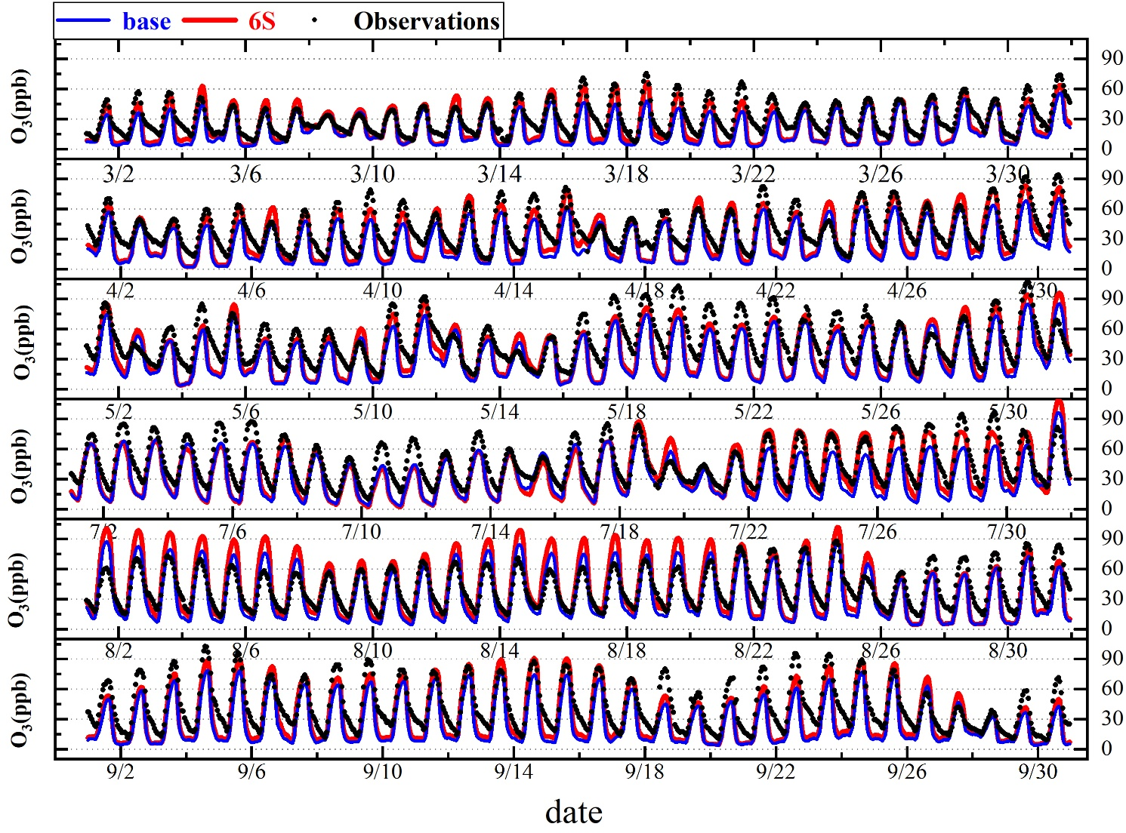
Fig.S2 Comparison of simulated and observed hourly O₃ averages for 69 monitoring sites in domain 2 during wheat (March-May) and maize (July-September) growing seasons in 2016.

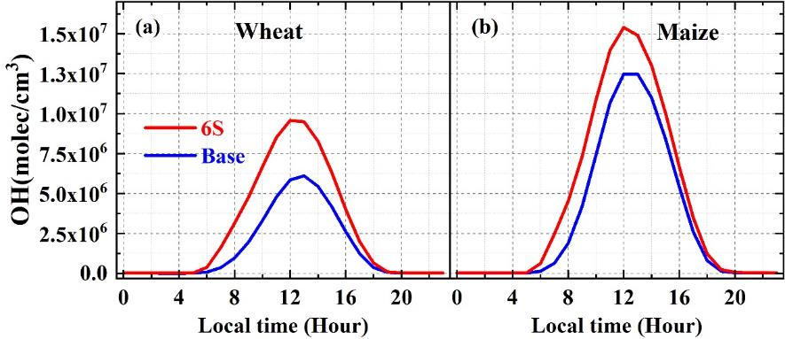
Fig.S3 Comparison of simulated regionally-averaged surface OH between base and 6S cases in NCP during wheat (a) and maize (b) growing seasons in 2016.

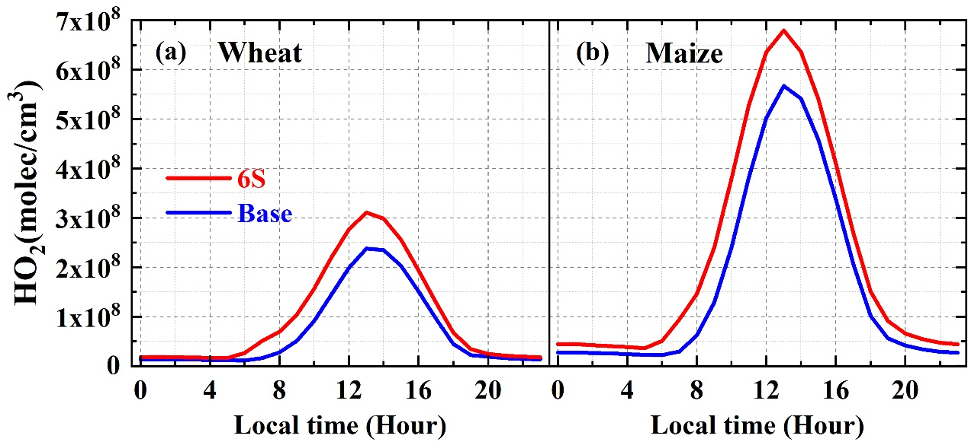
Fig.S4 Comparison of simulated regionally-averaged surface HO₂ between base and 6S cases in NCP during wheat (a) and maize (b) growing seasons in 2016.

Fig.S5 Diurnal mean variations of O₃ production rates and loss rates including major production and loss reactions, net O₃ production rates for 69 monitoring sites in domain 2 during wheat (a, b) and maize (c, d) growing seasons in 2016 for the Base and 6S cases.

Fig.S6 Summary of daily maximum 8-h (10:00-17:59) averaged surface O₃ enhancements induced by the potential HONO sources during the wheat/maize growing season in NCP in 2016.

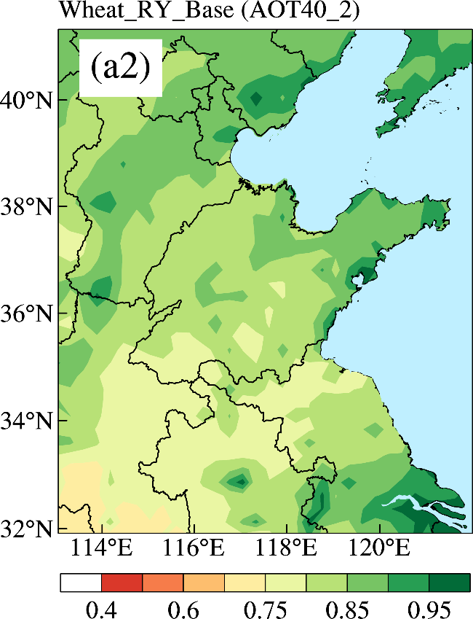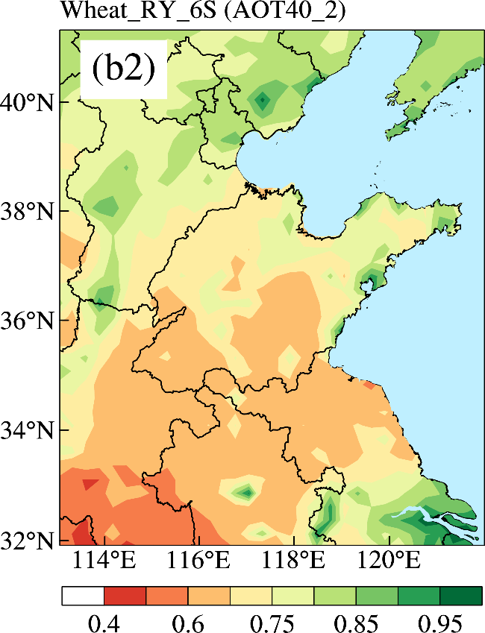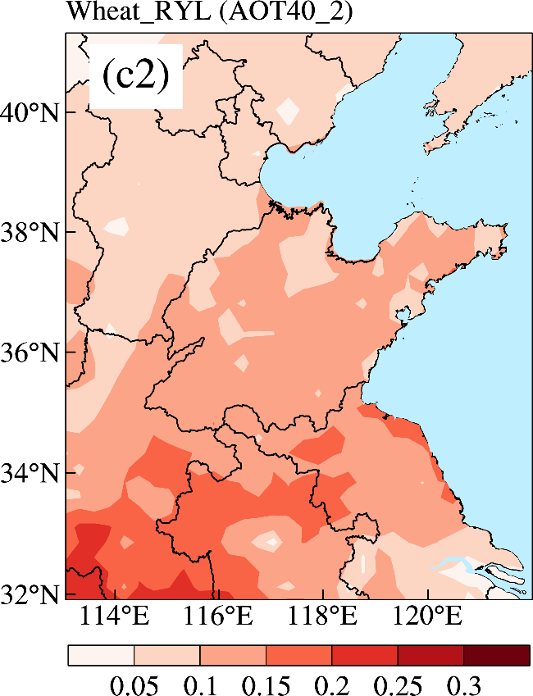

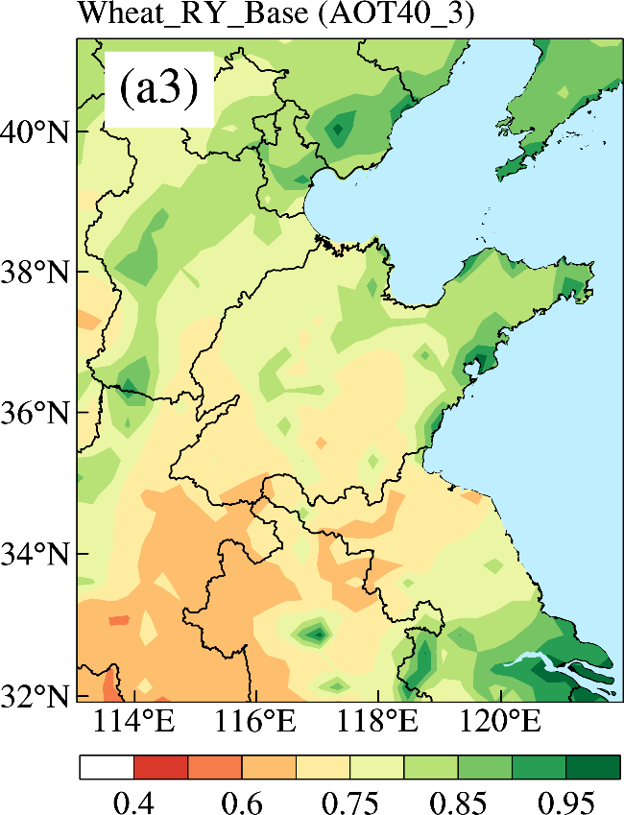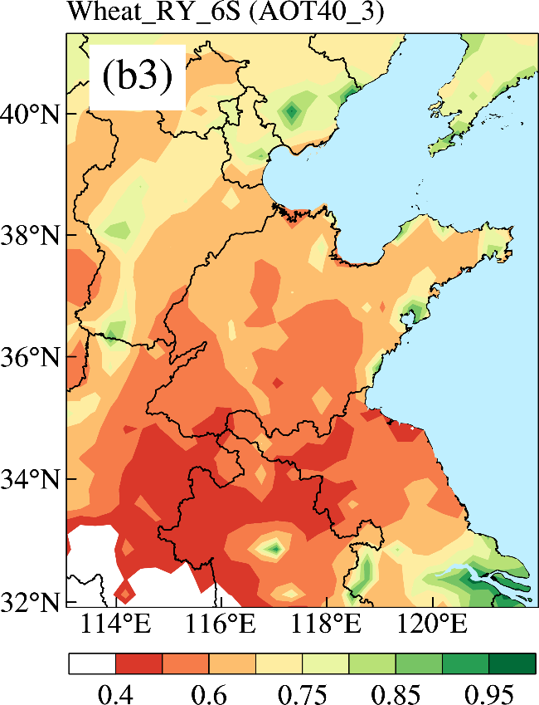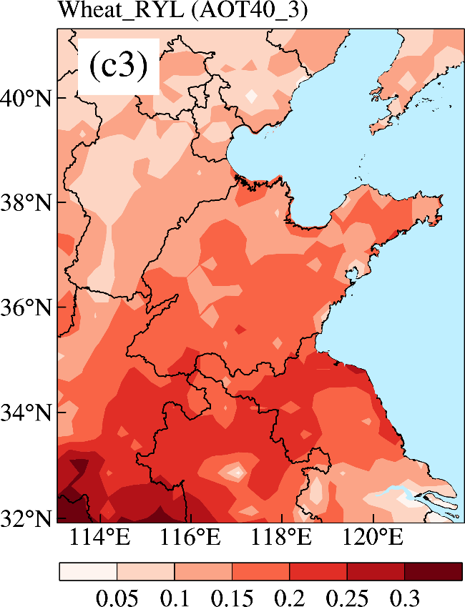

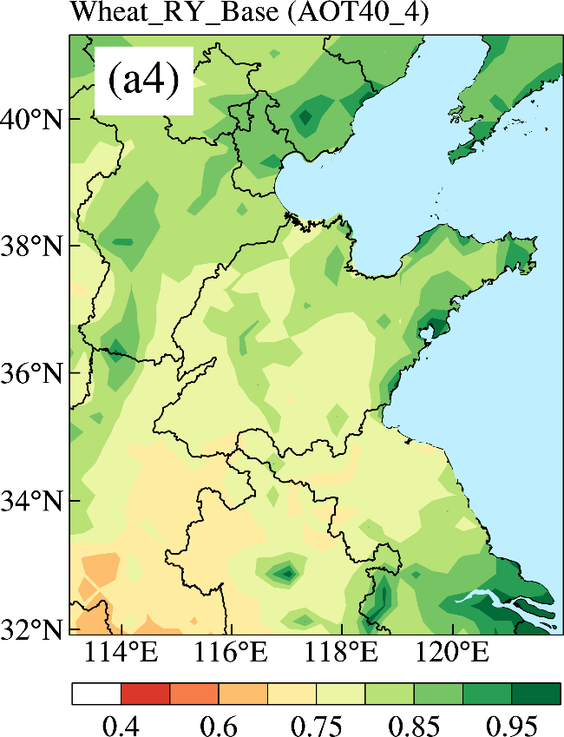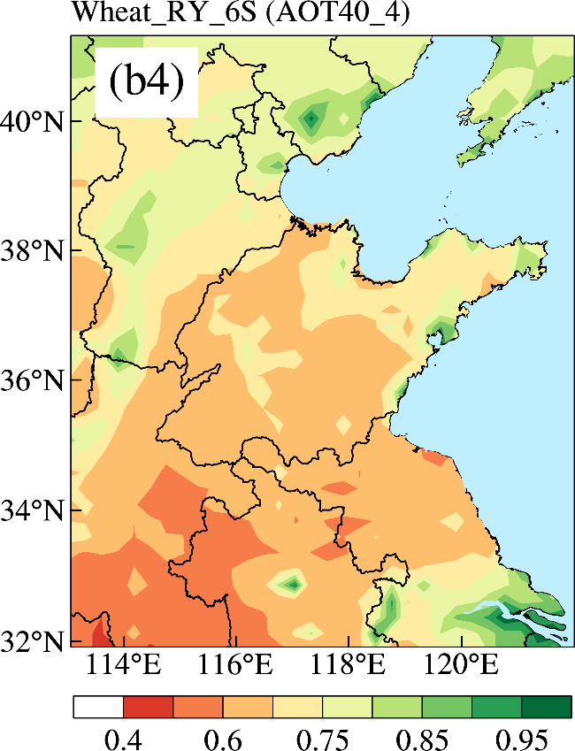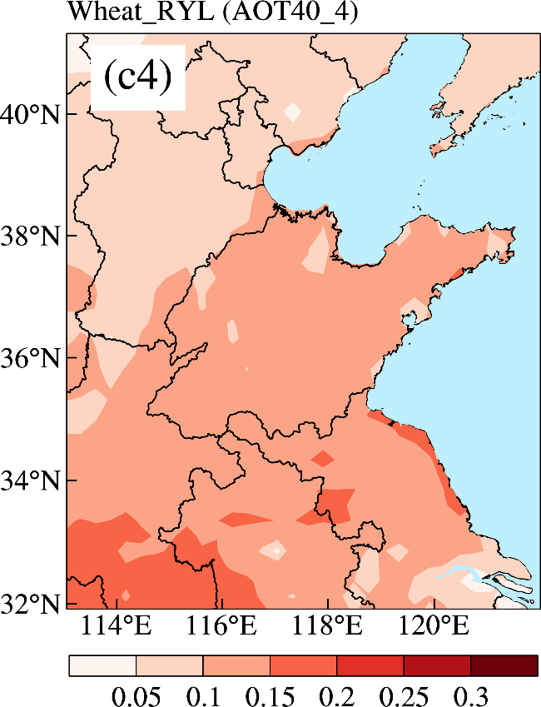

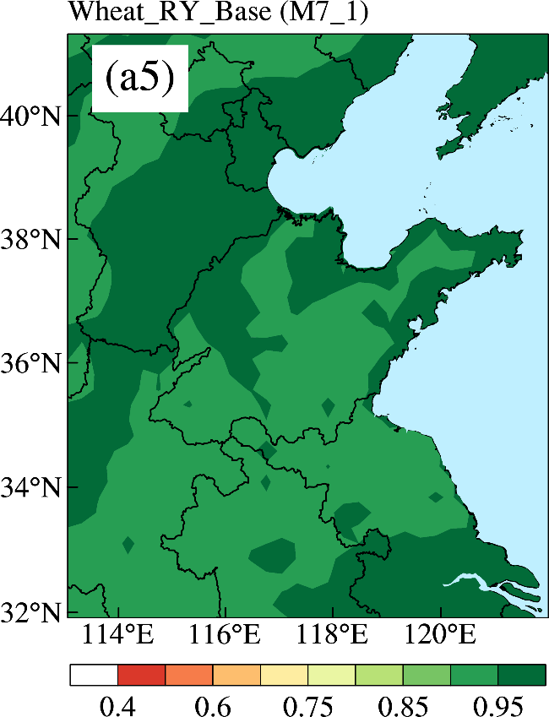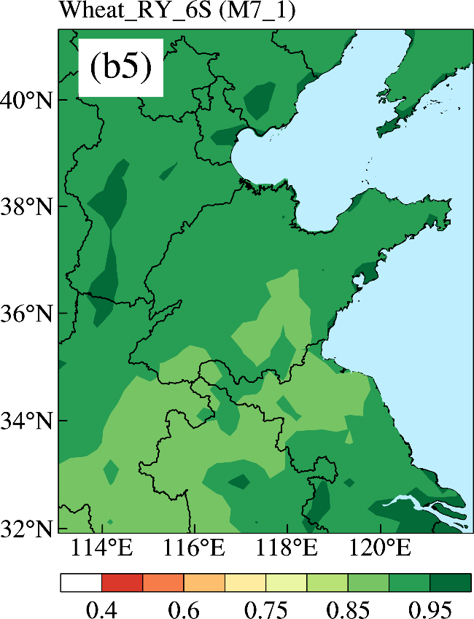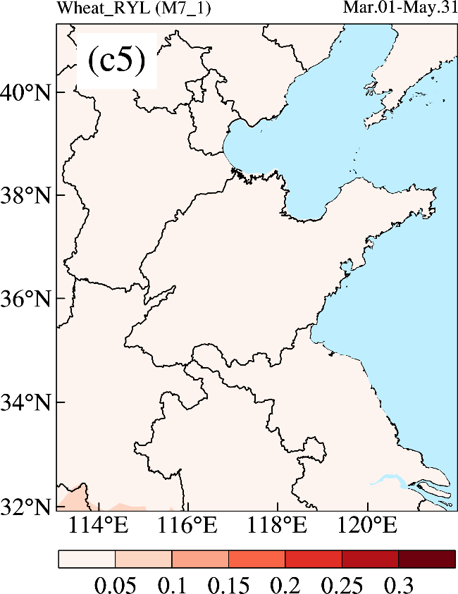

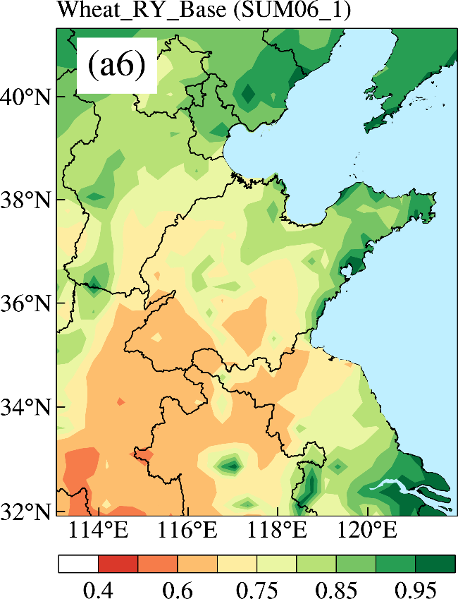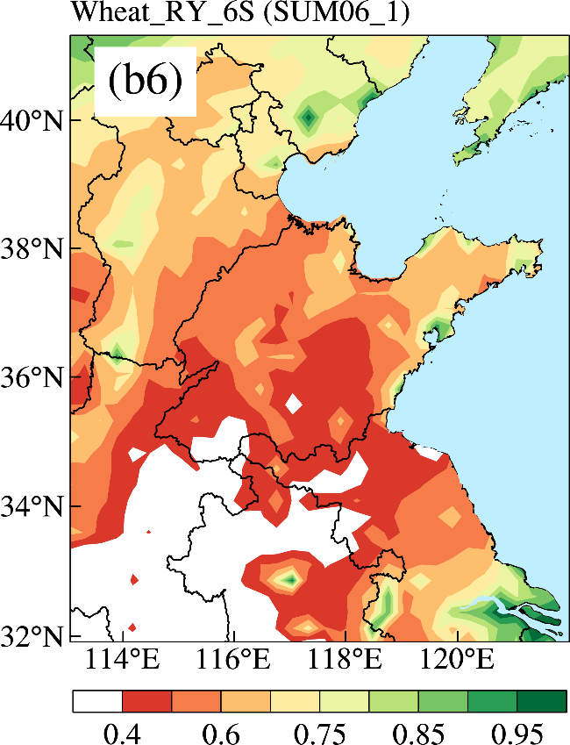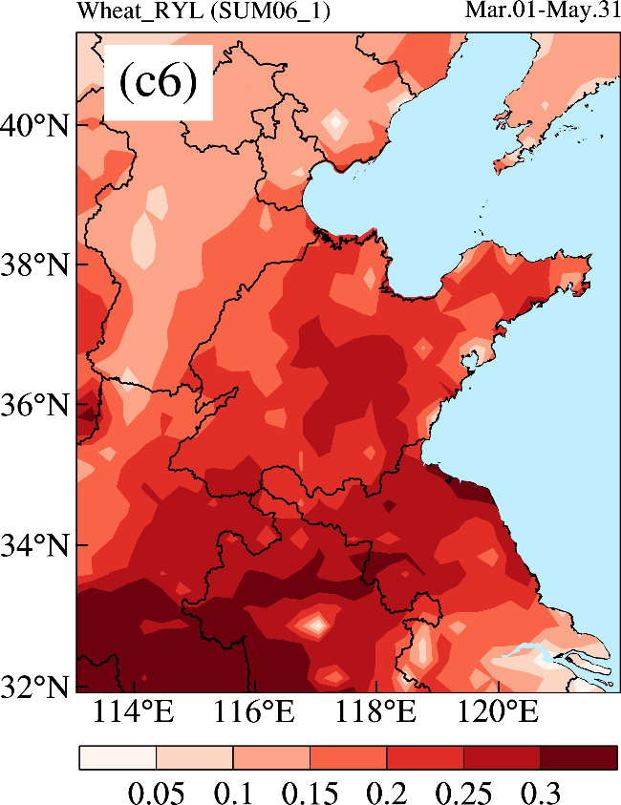

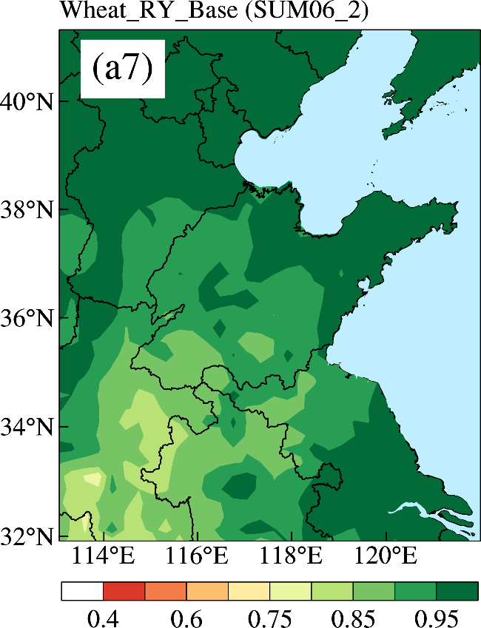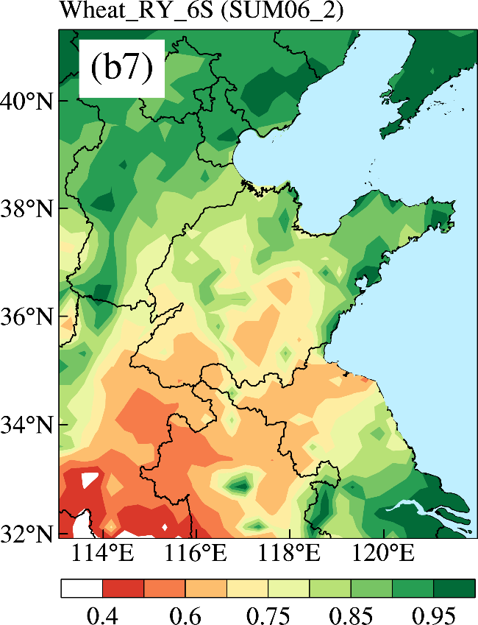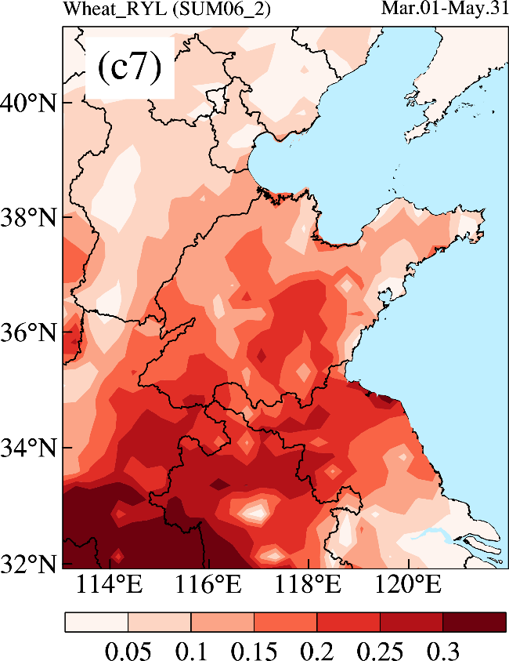

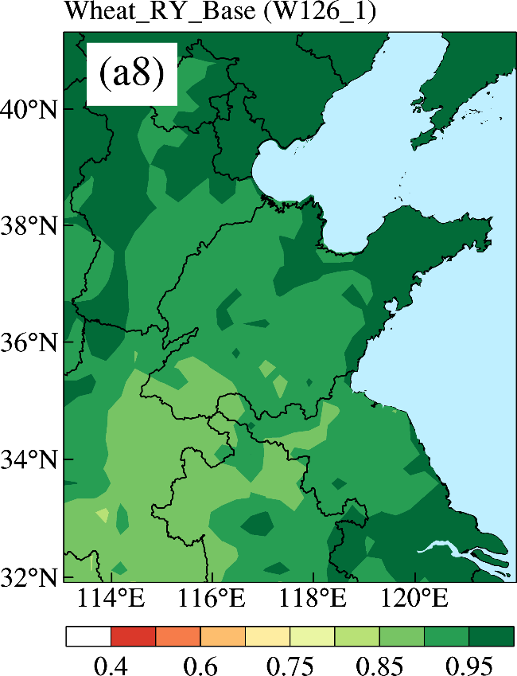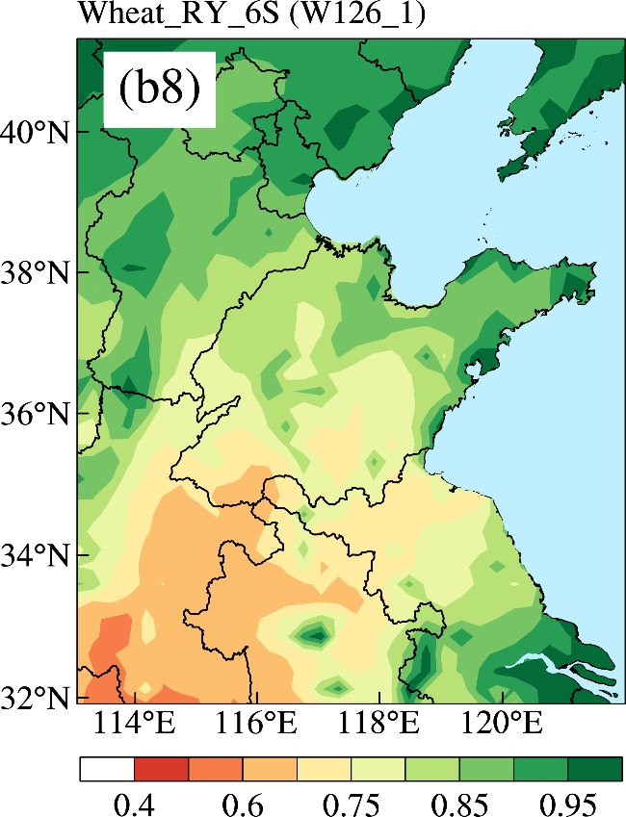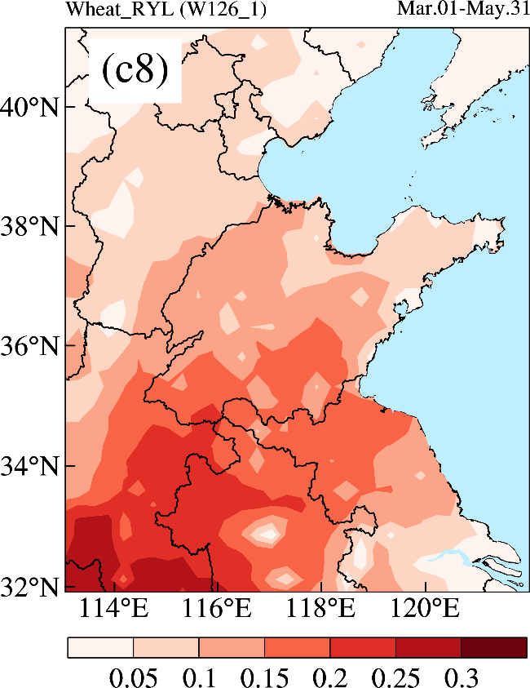

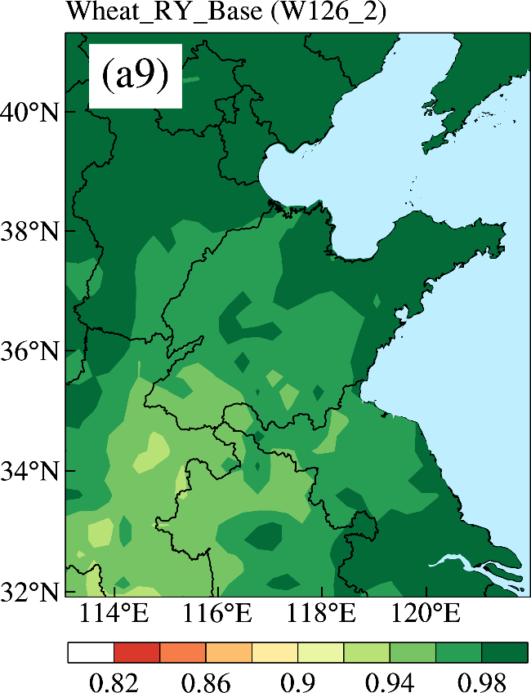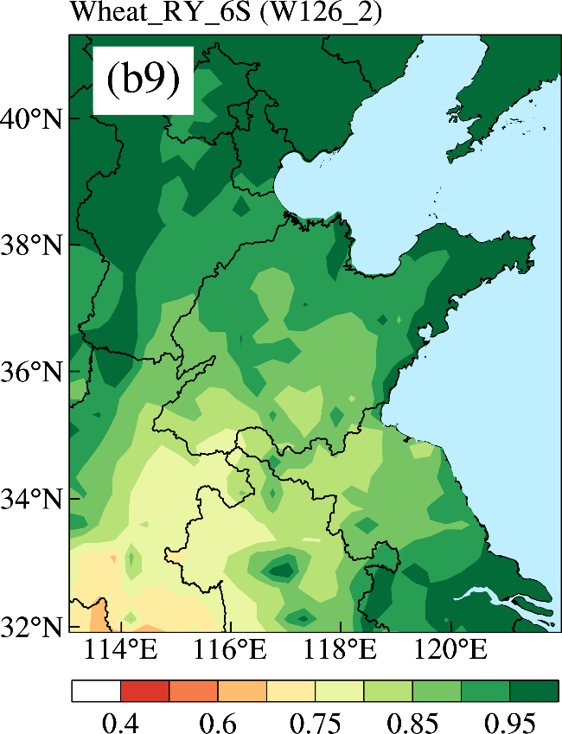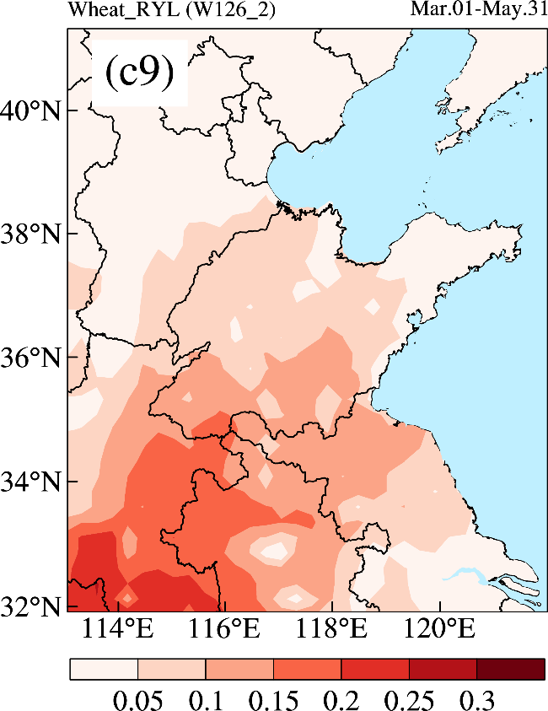

Fig.S7 The wheat RY for the base and 6S cases and the corresponding RYL induced by the potential HONO sources calculated by ER equations AOT40_1 (a1–c1), AOT40_2 (a2–c2), AOT40_3 (a3–c3), AOT40_4 (a4–c4), M7_1 (a5–c5), SUM06_1 (a6–c6), SUM06_2 (a7–c7), W126_1 (a8–c8) and W126_2 (a9–c9) in NCP in 2016.

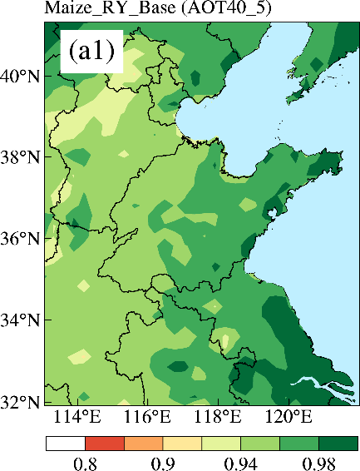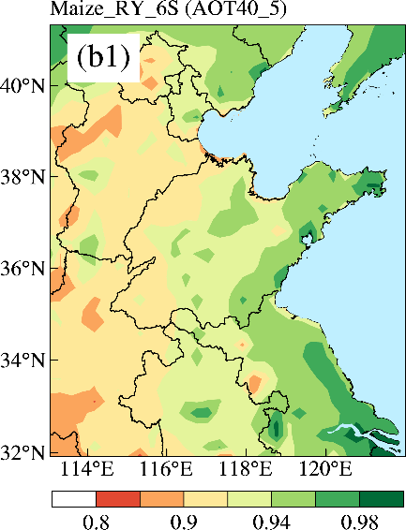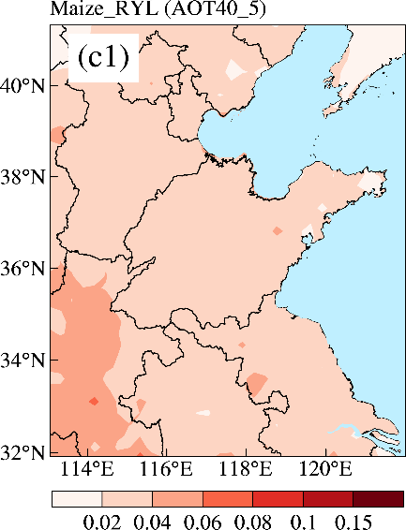

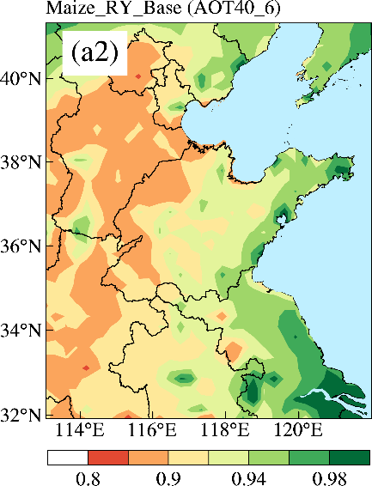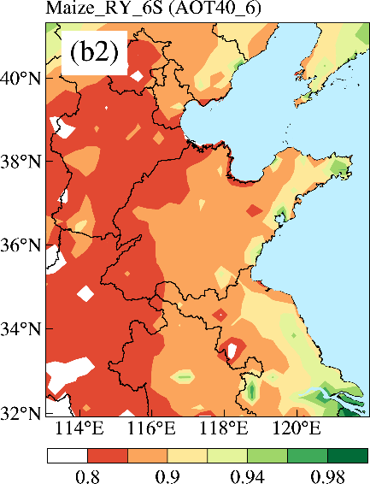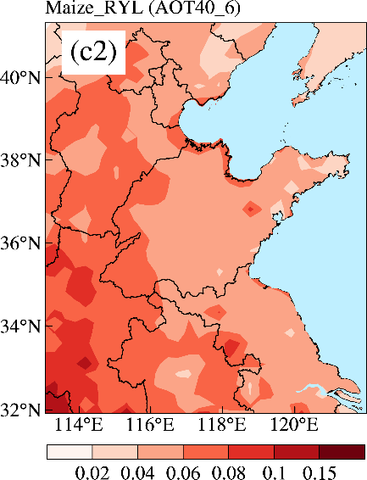

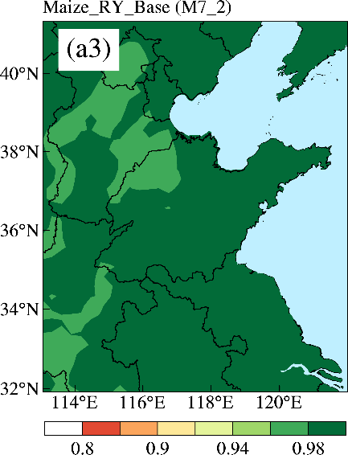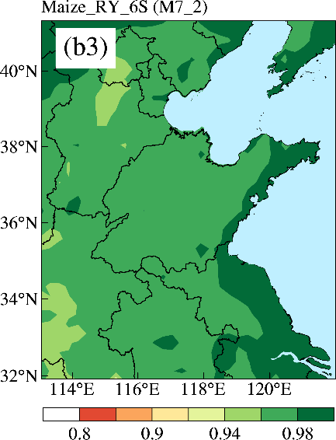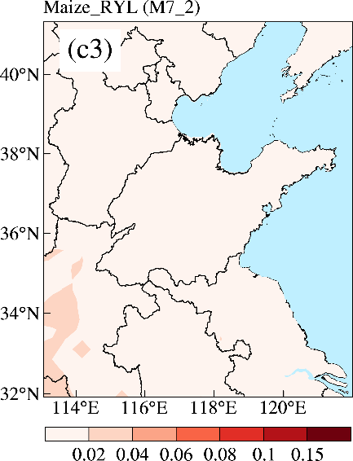

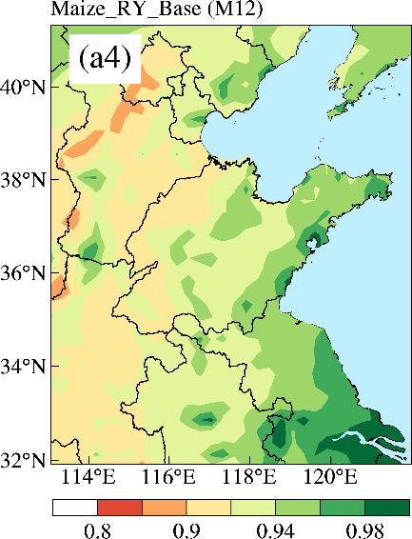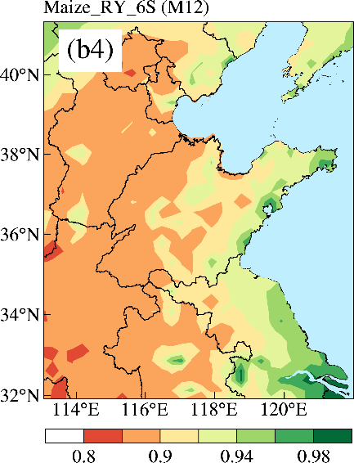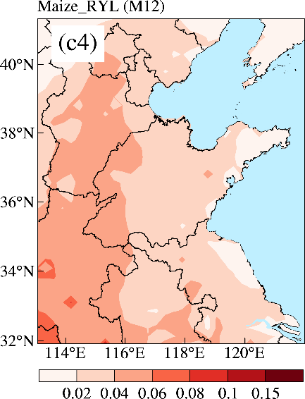

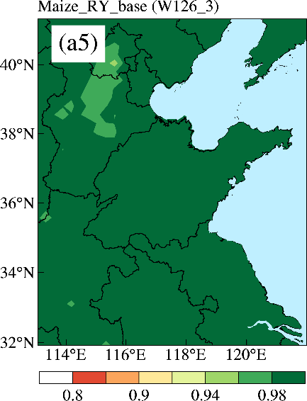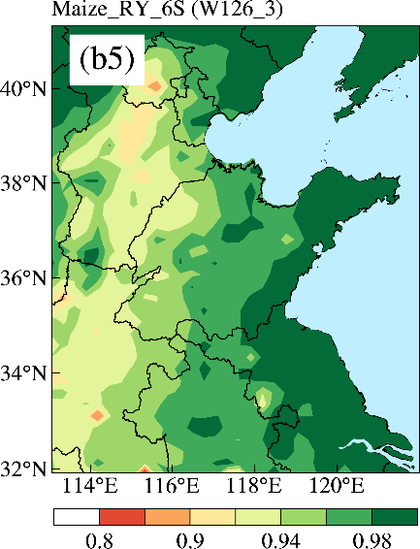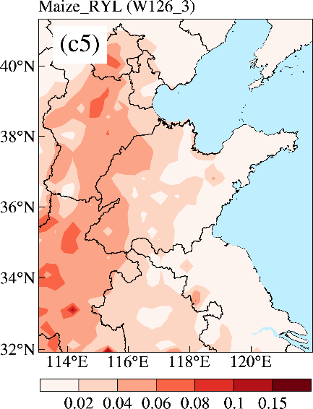

Fig.S8 The maize RY for the base and 6S cases and the corresponding RYL induced by the potential HONO sources calculated by ER equations AOT40_5(a1–c1), AOT40_6(a2–c2), M7_2(a3–c3), M12(a4–c4) and W126_3(a5–c5) in NCP in 2016.

Fig.S9 Comparison of diurnal mean simulations (Base, 6S, 6S_100α and 6S_200α) and observations of HONO at the rural (a) and urban (b) sites in NCP in 2016.

Fig. S10 Comparison of diurnal mean simulations (Base, Nit_1, Nit_7, Nit_30 and Nit_120) of HONO for the rural (a) and urban (b) sites in NCP in 2016 (J_{nitrate} and J_{HNO3} denote the photolysis frequencies of nitrate and gas nitric acid, respectively).

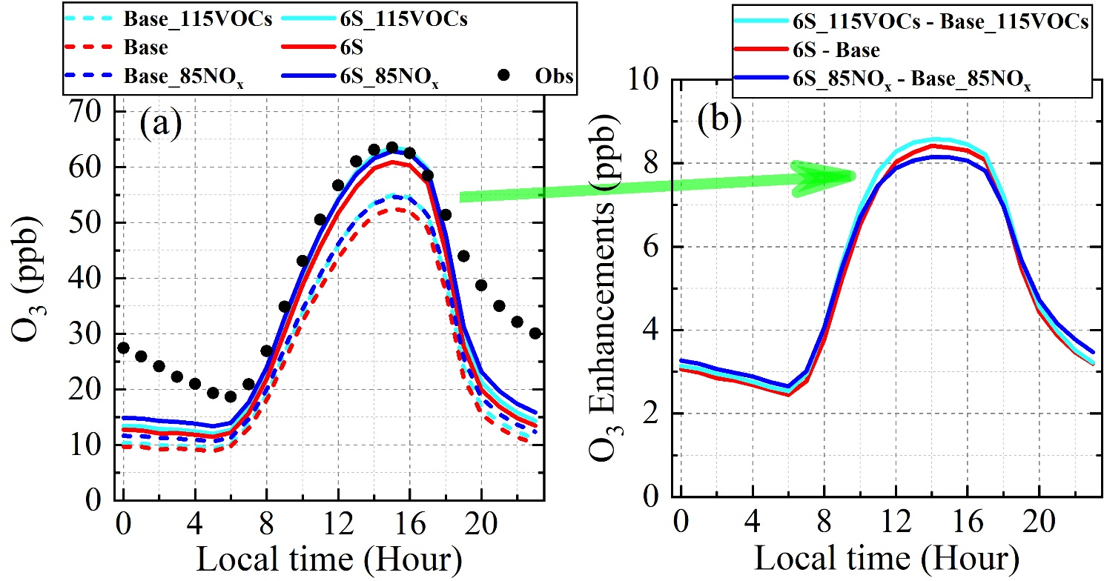
Fig.S11 Comparison of simulated (Base, 6S, Base_115VOCs and 6S_115VOCs cases, Base_85NO_{x} and 6S_85NO_{x} cases) and observed 69-site-averaged diurnal O₃ (a), and the corresponding O₃ enhancements (b) in the North China Plain during wheat growing seasons in 2016.

Fig.S12 Box plots of the relative yield loss (RYL) induced by the potential HONO sources for the three emission scenarios (decreasing 15% NO_{x} emissions, default emissions and increasing 15% VOC emissions) in NCP in 2016. The numbers at the top of the box plots denote the mean RYL value.

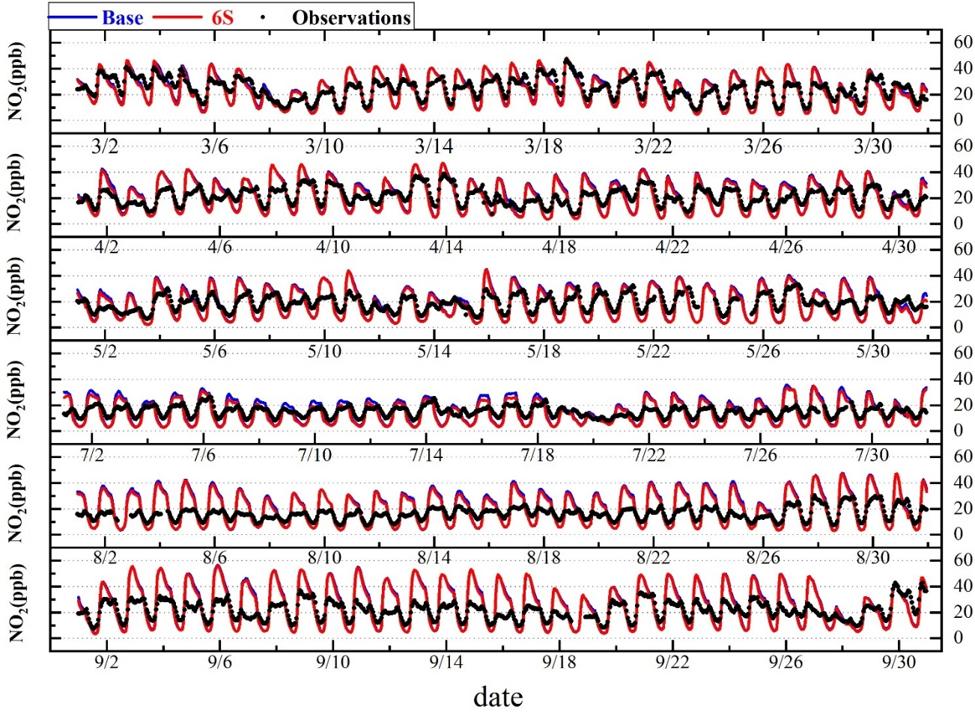
Fig.S13 Comparison of simulated and observed hourly-averaged NO₂ for 69 monitoring sites in domain 2 during wheat (March-May) and maize (July-September) growing seasons in 2016.

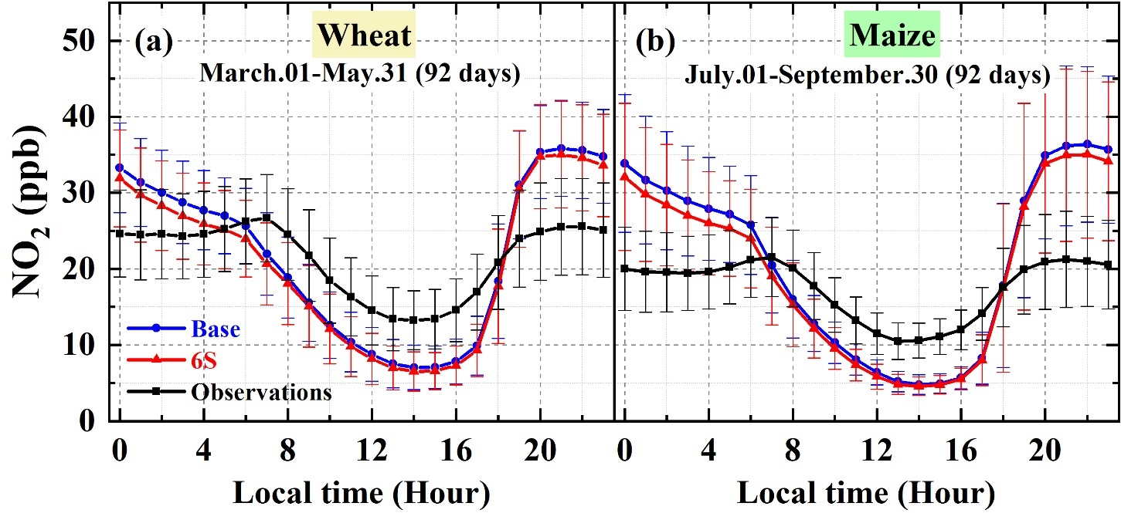
Fig.S14 Comparison of simulated and observed diurnal mean variations of NO₂ for 69 monitoring sites in domain 2 for wheat (a) and maize (b) during growing seasons in 2016.

Reference:
An, J.L., Li, Y., Chen, Y., Li, J., Qu, Y., Tang, Y.J., 2013. Enhancements of major aerosol components due to additional HONO sources in the North China Plain and implications for visibility and haze. Advances in Atmospheric Sciences 30, 57-66.
Calvert, J.G., Yarwood, G., Dunker, A.M., 1994. An Evaluation of the Mechanism of Nitrous-Acid Formation in the Urban Atmosphere. Research on Chemical Intermediates 20, 463-502.
Chen, T.S., Xue, L.K., Zheng, P.G., Zhang, Y.N., Liu, Y.H., Sun, J.J., Han, G.X., Li, H.Y., Zhang, X., Li, Y.F., Li, H., Dong, C., Xu, F., Zhang, Q.Z., Wang, W.X., 2020. Volatile organic compounds and ozone air pollution in an oil production region in northern China. Atmospheric Chemistry and Physics 20, 7069-7086.
Couzo, E., Lefer, B., Stutz, J., Yarwood, G., Karamchandani, P., Henderson, B., Vizuete, W., 2015. Impacts of heterogeneous HONO formation on radical sources and ozone chemistry in Houston, Texas. Atmospheric Environment 112, 344-355.
Czader, B.H., Rappengluck, B., Percell, P., Byun, D.W., Ngan, F., Kim, S., 2012. Modeling nitrous acid and its impact on ozone and hydroxyl radical during the Texas Air Quality Study 2006. Atmospheric Chemistry and Physics 12, 6939-6951.
Elshorbany, Y.F., Kleffmann, J., Kurtenbach, R., Lissi, E., Rubio, M., Villena, G., Gramsch, E., Rickard, A.R., Pilling, M.J., Wiesen, P., 2010. Seasonal dependence of the oxidation capacity of the city of Santiago de Chile. Atmospheric Environment 44, 5383-5394.
Elshorbany, Y.F., Steil, B., Bruhl, C., Lelieveld, J., 2012. Impact of HONO on global atmospheric chemistry calculated with an empirical parameterization in the EMAC model. Atmospheric Chemistry and Physics 12, 9977-10000.
Fu, X., Wang, T., Zhang, L., Li, Q.Y., Wang, Z., Xia, M., Yun, H., Wang, W.H., Yu, C., Yue, D.L., Zhou, Y., Zheng, J.Y., Han, R., 2019. The significant contribution of HONO to secondary pollutants during a severe winter pollution event in southern China. Atmospheric Chemistry and Physics 19, 1-14.
Gu, R.R., Zheng, P.G., Chen, T.S., Dong, C., Wang, Y.N., Liu, Y.M., Liu, Y.H., Luo, Y.Y., Han, G.X., Wang, X.F., Zhou, X.H., Wang, T., Wang, W.X., Xue, L.K., 2020. Atmospheric nitrous acid (HONO) at a rural coastal site in North China: Seasonal variations and effects of biomass burning. Atmospheric Environment 229, 11.
Guo, Y., Zhang, J., An, J., Qu, Y., Liu, X., Sun, Y., Chen, Y., 2020. Effect of vertical parameterization of a missing daytime source of HONO on concentrations of HONO, O₃ and secondary organic aerosols in eastern China. Atmospheric Environment 226, 117208.
Kukui, A., Legrand, M., Preunkert, S., Frey, M.M., Loisil, R., Roca, J.G., Jourdain, B., King, M.D., France, J.L., Ancellet, G., 2014. Measurements of OH and RO₂ radicals at Dome C, East Antarctica. Atmospheric Chemistry and Physics 14, 12373-12392.
Lei, W., 2004. Chemical characterization of ozone formation in the Houston-Galveston area: A chemical transport model study. Journal of Geophysical Research 109.
Li, G., Lei, W., Zavala, M., Volkamer, R., Dusanter, S., Stevens, P., Molina, L.T., 2010. Impacts of HONO sources on the photochemistry in Mexico City during the MCMA-2006/MILAGO Campaign. Atmospheric Chemistry and Physics 10, 6551-6567.
Li, L., Chen, C.H., Huang, C., Huang, H.Y., Zhang, G.F., Wang, Y.J., Wang, H.L., Lou, S.R., Qiao, L.P., Zhou, M., Chen, M.H., Chen, Y.R., Streets, D.G., Fu, J.S., Jang, C.J., 2012. Process analysis of regional ozone formation over the Yangtze River Delta, China using the Community Multi-scale Air Quality modeling system. Atmospheric Chemistry and Physics 12, 10971-10987.
Li, Y., An, J.L., Min, M., Zhang, W., Wang, F., Xie, P.H., 2011. Impacts of HONO sources on the air quality in Beijing, Tianjin and Hebei Province of China. Atmospheric Environment 45, 4735-4744.
Li, Z.Y., Xue, L.K., Yang, X., Zha, Q.Z., Tham, Y.J., Yan, C., Louie, P.K.K., Luk, C.W.Y., Wang, T., Wang, W.X., 2018. Oxidizing capacity of the rural atmosphere in Hong Kong, Southern China. Science of the Total Environment 612, 1114-1122.
Lin, Y. , Farley, R. , Orville, H. , 1983. Bulk parameterization of the snow field in a cloud model. J. Appl. Meteorol. 22, 1065–1092 .
Lin, Y.C., Schwab, J.J., Demerjian, K.L., Bae, M.S., Chen, W.N., Sun, Y., Zhang, Q., Hung, H.M., Perry, J., 2012. Summertime formaldehyde observations in New York City: Ambient levels, sources and its contribution to HO_{x} radicals. J Geophys Res-Atmos 117, 14.
Liu, Y.L., Nie, W., Xu, Z., Wang, T.Y., Wang, R.X., Li, Y.Y., Wang, L., Chi, X.G., Ding, A.J., 2019. Semi-quantitative understanding of source contribution to nitrous acid (HONO) based on 1 year of continuous observation at the SORPES station in eastern China. Atmospheric Chemistry and Physics 19, 13289-13308.
Liu, Z., Wang, Y., Gu, D., Zhao, C., Huey, L.G., Stickel, R., Liao, J., Shao, M., Zhu, T., Zeng, L., Amoroso, A., Costabile, F., Chang, C.C., Liu, S.C., 2012. Summertime photochemistry during CAREBeijing-2007: ROx budgets and O-3 formation. Atmospheric Chemistry and Physics 12, 7737-7752.
Lu, K.D., Zhang, Y.H., Su, H., Shao, M., Zeng, L.M., Zhong, L.J., Xiang, Y.R., Chang, C.C., Chou, C.K.C., Wahner, A., 2010. Regional ozone pollution and key controlling factors of photochemical ozone production in Pearl River Delta during summer time. Sci China Chem 53, 651-663.
Lu, X.C., Wang, Y.H., Li, J.F., Shen, L., Fung, J.C.H., 2018. Evidence of heterogeneous HONO formation from aerosols and the regional photochemical impact of this HONO source. Environmental Research Letters 13, 12.
Ma, X.F., Tan, Z.F., Lu, K.D., Yang, X.P., Liu, Y.H., Li, S.L., Li, X., Chen, S.Y., Novelli, A., Cho, C.M., Zeng, L.M., Wahner, A., Zhang, Y.H., 2019. Winter photochemistry in Beijing: Observation and model simulation of OH and HO₂ radicals at an urban site. Science of the Total Environment 685, 85-95.
Michoud, V., Kukui, A., Camredon, M., Colomb, A., Borbon, A., Miet, K., Aumont, B., Beekmann, M., Durand-Jolibois, R., Perrier, S., Zapf, P., Siour, G., Ait-Helal, W., Locoge, N., Sauvage, S., Afif, C., Gros, V., Furger, M., Ancellet, G., Doussin, J.F., 2012. Radical budget analysis in a suburban European site during the MEGAPOLI summer field campaign. Atmospheric Chemistry and Physics 12, 11951-11974.
Nan, J.L., Wang, S.S., Guo, Y.L., Xiang, Y.J., Zhou, B., 2017. Study on the daytime OH radical and implication for its relationship with fine particles over megacity of Shanghai, China. Atmospheric Environment 154, 167-178.
Ren, X.R., Brune, W.H., Mao, J.Q., Mitchell, M.J., Lesher, R.L., Simpas, J.B., Metcalf, A.R., Schwab, J.J., Cai, C.X., Li, Y.Q., Demerjian, K.L., Felton, H.D., Boynton, G., Adams, A., Perry, J., He, Y., Zhou, X.L., Hou, J., 2006a. Behavior of OH and HO₂ in the winter atmosphere in New York city. Atmospheric Environment 40, S252-S263.
Ren, X.R., Brune, W.H., Oliger, A., Metcalf, A.R., Simpas, J.B., Shirley, T., Schwab, J.J., Bai, C.H., Roychowdhury, U., Li, Y.Q., Cai, C.X., Demerjian, K.L., He, Y., Zhou, X.L., Gao, H.L., Hou, J., 2006b. OH, HO₂, and OH reactivity during the PMTACS-NY Whiteface Mountain 2002 campaign: Observations and model comparison. J Geophys Res-Atmos 111, 12.
Ren, X.R., van Duin, D., Cazorla, M., Chen, S., Mao, J.Q., Zhang, L., Brune, W.H., Flynn, J.H., Grossberg, N., Lefer, B.L., Rappengluck, B., Wong, K.W., Tsai, C., Stutz, J., Dibb, J.E., Jobson, B.T., Luke, W.T., Kelley, P., 2013. Atmospheric oxidation chemistry and ozone production: Results from SHARP 2009 in Houston, Texas. J Geophys Res-Atmos 118, 5770-5780.
Sarwar, G., Pinder, R.W., Appel, K.W., Mathur, R., Carlton, A.G., 2009. Examination of the impact of photoexcited NO₂ chemistry on regional air quality. Atmospheric Environment 43, 6383-6387.
Sarwar, G., Roselle, S.J., Mathur, R., Appel, W., Dennis, R.L., Vogel, B., 2008. A comparison of CMAQ HONO predictions with observations from the northeast oxidant and particle study. Atmospheric Environment 42, 5760-5770.
Shi, X.-W., Ge, Y.-F., Zhang, Y.-C., Ma, Y., Zheng, J., 2020. HONO Observation and Assessment of the Effects of Atmospheric Oxidation Capacity in Changzhou During the Springtime of 2017. Huan jing ke xue= Huanjing kexue 41, 1123-1131.
Tan, Z.F., Lu, K.D., Hofzumahaus, A., Fuchs, H., Bohn, B., Holland, F., Liu, Y.H., Rohrer, F., Shao, M., Sun, K., Wu, Y.S., Zeng, L.M., Zhang, Y.S., Zou, Q., Kiendler-Scharr, A., Wahner, A., Zhang, Y.H., 2019a. Experimental budgets of OH, HO₂, and RO₂ radicals and implications for ozone formation in the Pearl River Delta in China 2014. Atmospheric Chemistry and Physics 19, 7129-7150.
Tan, Z.F., Lu, K.D., Jiang, M.Q., Su, R., Wang, H.L., Lou, S.R., Fu, Q.Y., Zhai, C.Z., Tan, Q.W., Yue, D.L., Chen, D.H., Wang, Z.S., Xie, S.D., Zeng, L.M., Zhang, Y.H., 2019. Daytime atmospheric oxidation capacity in four Chinese megacities during the photochemically polluted season: a case study based on box model simulation. Atmospheric Chemistry and Physics 19, 3493-3513.
Tang, Y., An, J., Li, Y., Wang, F., 2014. Uncertainty in the uptake coefficient for HONO formation on soot and its impacts on concentrations of major chemical components in the Beijing–Tianjin–Hebei region. Atmospheric Environment 84, 163-171.
Wang, F., An, J., Li, Y., Tang, Y., Lin, J., Qu, Y., Chen, Y., Zhang, B., Zhai, J., 2014. Impacts of uncertainty in AVOC emissions on the summer ROx budget and ozone production rate in the three most rapidly-developing economic growth regions of China. Advances in Atmospheric Sciences 31, 1331-1342.
Wang, X., Zhang, Y., Hu, Y., Zhou, W., Lu, K., Zhong, L., Zeng, L., Shao, M., Hu, M., Russell, A.G., 2010. Process analysis and sensitivity study of regional ozone formation over the Pearl River Delta, China, during the PRIDE-PRD2004 campaign using the Community Multiscale Air Quality modeling system. Atmospheric Chemistry and Physics 10, 4423-4437.
Whalley, L.K., Stone, D., Dunmore, R., Hamilton, J., Hopkins, J.R., Lee, J.D., Lewis, A.C., Williams, P., Kleffmann, J., Laufs, S., Woodward-Massey, R., Heard, D.E., 2018. Understanding in situ ozone production in the summertime through radical observations and modelling studies during the Clean air for London project (ClearfLo). Atmospheric Chemistry and Physics 18, 2547-2571.
Xu, J., Zhang, Y.H., Wang, W., 2006. Numerical study on the impacts of heterogeneous reactions on ozone formation in the Beijing urban area. Advances in Atmospheric Sciences 23, 605-614.
Xue, L.K., Gu, R.R., Wang, T., Wang, X.F., Saunders, S., Blake, D., Louie, P.K.K., Luk, C.W.Y., Simpson, I., Xu, Z., Wang, Z., Gao, Y., Lee, S.C., Mellouki, A., Wang, W.X., 2016. Oxidative capacity and radical chemistry in the polluted atmosphere of Hong Kong and Pearl River Delta region: analysis of a severe photochemical smog episode. Atmospheric Chemistry and Physics 16, 9891-9903.
Young, C.J., Washenfelder, R.A., Roberts, J.M., Mielke, L.H., Osthoff, H.D., Tsai, C., Pikelnaya, O., Stutz, J., Veres, P.R., Cochran, A.K., VandenBoer, T.C., Flynn, J., Grossberg, N., Haman, C.L., Lefer, B., Stark, H., Graus, M., de Gouw, J., Gilman, J.B., Kuster, W.C., Brown, S.S., 2012. Vertically Resolved Measurements of Nighttime Radical Reservoirs; in Los Angeles and Their Contribution to the Urban Radical Budget. Environmental science & technology 46, 10965-10973.
Yu, D., Tan, Z.F., Lu, K.D., Ma, X.F., Li, X., Chen, S.Y., Zhu, B., Lin, L.L., Li, Y.T., Qiu, P.P., Yang, X.P., Liu, Y.H., Wang, H.C., He, L.Y., Huang, X.F., Zhang, Y.H., 2020. An explicit study of local ozone budget and NO_{x}-VOCs sensitivity in Shenzhen China. Atmospheric Environment 224, 13.
Yun, H., Wang, Z., Zha, Q.Z., Wang, W.H., Xue, L.K., Zhang, L., Li, Q.Y., Cui, L., Lee, S.C., Poon, S.C.N., Wang, T., 2017. Nitrous acid in a street canyon environment: Sources and contributions to local oxidation capacity. Atmospheric Environment 167, 223-234.
Zhang, H., Li, J., Ying, Q., Yu, J.Z., Wu, D., Cheng, Y., He, K., Jiang, J., 2012. Source apportionment of PM2.5 nitrate and sulfate in China using a source-oriented chemical transport model. Atmospheric Environment 62, 228-242.
Zhang, J., An, J., Qu, Y., Liu, X., Chen, Y., 2019. Impacts of potential HONO sources on the concentrations of oxidants and secondary organic aerosols in the Beijing-Tianjin-Hebei region of China. The Science of the total environment 647, 836-852.
Zhang, J., Guo, Y., Qu, Y., Chen, Y., Yu, R., Xue, C., Yang, R., Zhang, Q., Liu, X., Mu, Y., Wang, J., Ye, C., Zhao, H., Sun, Q., Wang, Z., An, J., 2020. Effect of potential HONO sources on peroxyacetyl nitrate (PAN) formation in eastern China in winter. Journal of Environmental Sciences 94, 81-87.
Zhang, L., Li, Q.Y., Wang, T., Ahmadov, R., Zhang, Q., Li, M., Lv, M.Y., 2017. Combined impacts of nitrous acid and nitryl chloride on lower-tropospheric ozone: new module development in WRF-Chem and application to China. Atmospheric Chemistry and Physics 17, 9733-9750.
Zhang, L., Wang, T., Zhang, Q., Zheng, J.Y., Xu, Z., Lv, M.Y., 2016. Potential sources of nitrous acid (HONO) and their impacts on ozone: A WRF-Chem study in a polluted subtropical region. J Geophys Res-Atmos 121, 3645-3662.
Zhang, R., Sarwar, G., Fung, J.C.H., Lau, A.K.H., Zhang, Y.H., 2012. Examining the Impact of Nitrous Acid Chemistry on Ozone and PM over the Pearl River Delta Region. Advances in Meteorology 2012, 1-18.
Zheng, J., Shi, X.W., Ma, Y., Ren, X.R., Jabbour, H., Diao, Y.W., Wang, W.W., Ge, Y.F., Zhang, Y.C., Zhu, W.H., 2020. Contribution of nitrous acid to the atmospheric oxidation capacity in an industrial zone in the Yangtze River Delta region of China. Atmospheric Chemistry and Physics 20, 5457-5475.

