Supporting Information

Collaboratively Hydrothermal and Calcination Fabrication of ZnOS Heterostructures for Visible-Light-Driven H₂ Production

Xue-Li Chen^{a,}*, ChenXiang Lin^{b}, LanHai Laiª, Kai Zhengª, SongTao Liª, Yonglin Chenª, Haitao Li ^{a,}*

- Jiangxi Provincial Key Laboratory of Low-Carbon Solid Waste Recycling, School of Geography and Environmental Engineering, Gannan Normal University, Ganzhou 341000, P. R. China.
- Guangxi Key Laboratory of Natural Polymer Chemistry and Physics, Nanning Normal University, Nanning 530001, China
*Corresponding Author: Xueli Chen (e-mail: xueli089@foxmail.com); Haitao Li (e-mail: lihaitao103904@126.com).

1. Experimental Section/Methods
1.1. Materials
Chemicals including ZnSO₄, Na₃C₃N₃S₃·9H₂O, hydrochloric acid, KOH, ethyl alcohol were purchased from Tansoole Chemical Technology Ltd. (Shanghai, China). All chemical reagents were analytically pure grade (AR) and used without further purification, unless otherwise specified. All solutions were prepared using deionized water (DI water, 18.2 M cm) produced from Milli-Q purification system (Millipore, USA).
1.2. Synthesis of the ZnO/ZnS-x heterostructures
Water solution (25 mL) containing Na₃C₃N₃S₃·9H₂O (x mol (x = 1.0, 2.0, 3.0, 4.0)), and ZnSO₄ (1 mol, 1.61g) in 25 mL Teflon-lined steel autoclaves were heated at 160 °C for 48 h. The autoclaves were then cooled to room temperature at a rate of 10 °C/h. The white powder was washed with water and dried in vacuum overnight. The white powder was pyrolyzed at 500 °C for 2.0 h under air atmosphere at the flow rate of 25 mL min⁻¹ to obtain a series of products denoted ZnOS-x. Finally, the ZnOS-x was investigated as an photocatalysts for hydrogen evolution.
1.3. Characterization of the ZnO/ZnS-x heterostructures
The morphological details of the desired samples were examined with Transmission electron microscopy (TEM, JEOL, Japan) and Scanning electron microscopy-Energy dispersive X-ray (SEM-EDX, LEO1530VP, ZEISS), respectively. The structures and crystal phases of the desired samples were obtained by the X-ray diffraction (XRD, Bruker D8 Advance) using a Cu Kα (1.541 Å) source. The surface properties of the desired samples were characterized using X-ray photoelectron spectroscopy (XPS, Thermo Escalab 250xi) with an Al Ka X-ray source (1486.6eV) and Fourier transform infrared (FTIR, Bruker Vector 33). The binding energy of XPS was calibrated using the C1s level at 284.6eV as an internal standard. Raman spectra was obtained by using a high-resolution Raman spectrophotometer (Horiba Jobin-Yvon LabRAM-800). The specific surface areas of the desired samples were determined by the Brunauer−Emmett−Teller method (BET) according to N₂ adsorption-desorption isotherm at 77 K (Autosorb-iQ, Quantachrome). UV-vis diffuse reflectance absorption spectra (DRS) were recorded on a Shimadzu UV-2600 UV-vis-NIR spectrophotometer with BaSO₄ as the reference. Steady-state PL spectra (excitation at 360 nm) were measured with a Hitachi F-4500 fluorescence spectrophotometer. Time-resolved photoluminescence spectra (TRPS) were obtained on an Edinburgh FLS 980 fluorescence spectrophotometer. The Zn leaching was determined by using Inductively Coupled Plasma Mass Spectrometry (ICP-MS) (NexION 1000G), and the detection limits for Zn was below 0.1 μg/L.
1.4. Photocatalytic property experiments
The measurements were performed in a gas-closed circulation system (AuLight, Beijing, China, CEL-SPH2N). A Xe-lamp (CEL-HXF300, 300 W) equipped with λ ≥ 400 nm cutoff filter was used as visible-light source, and the temperature was maintained at 5°C using a homoeothermic cooling circulation pump. The H₂ evolution rate was quantified by an online gas chromatograph (GC7920, TCD detector, TDX-01). The apparent quantum yield (AQY) measurement was carried on the above conditions except for incident monochromatic light obtaining from a bandpass filter (λ = 450, 500, 520, and 550 nm). The incident photon number was detected by using a calibrated Si photodiode (CEL-NP2000, AuLight, Beijing, China), and the AQY was calculated via the following equation^{[1]}.
$$AQY (\%)=\frac{2*number of evolved H2 molecules}{number of incident photons}$$

[1] Wang, J. M.; Zheng, Y.; Peng, T. Y.; Zhang, J.; Li, R. J. Asymmetric Zinc Porphyrin Derivative-Sensitized Graphitic Carbon Nitride for Efficient Visible-Light-Driven H₂ Production. ACS Sustainable Chem. Eng. 2017, 5, 7549-7556.

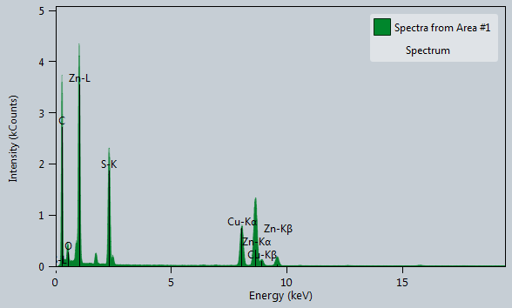
Figure S1. SEM spectra of ZnOS-3.

Figure S2. FT-IR spectra of ZnOS-X.

Figure S3. XPS survey spectrum of HBC.

Figure S4. UV-vis diffuse-reflectance spectra of ZnOS-3.

Figure S5. Photoluminescence emission spectra (excitation wavelength = 360nm) of ZnOS-3.

Figure S6. photocurrent-time dependence of ZnOS-3.

Figure S7. PXRD patterns of ZnOS-3 after photocatalytic H₂ evolution reaction.

Table S1 Specific surface area of the ZnOS-x.
 | S_{BET} (m²/g) | R² | C
ZnOS-1 | 17 | 0.99994 | 87.7
ZnOS-2 | 19.2 | 0.99994 | 83.693
ZnOS-3 | 20.2 | 0.99995 | 75.192
ZnOS-4 | 4 | 0.99959 | 101.163

Table S2 ICP-MS results for the molar ratio of of the ZnOS-3 before and after photocatalytic reaction.
 | before | after
ZnOS-3 (ppm) | 2.56 | 2.18

