Appendix 1.
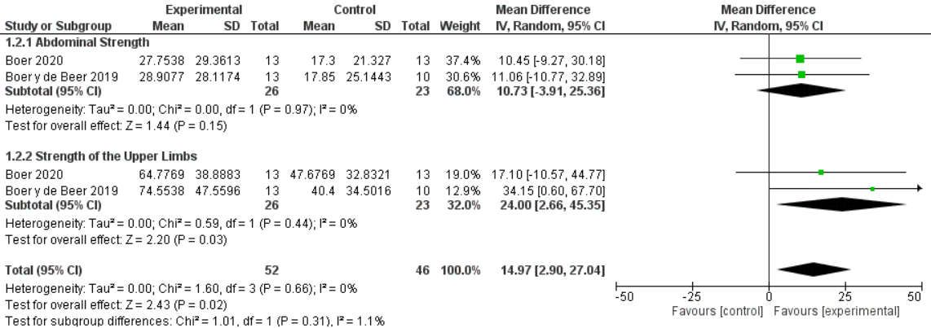
Figure 4. Aerobic exercise in water versus control, outcome: Abdominal strength and strength of the Upper Limbs

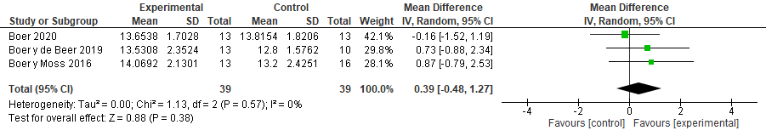
Figure 5. Aerobic exercise in water versus aerobic exercise on a firm surface, outcome: Muscular strength – Sit to Stand Test

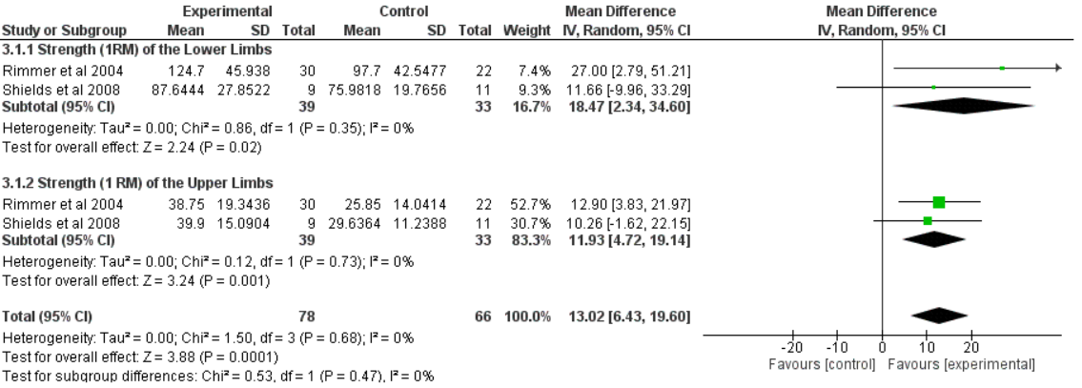
Figure 6. Combined exercise versus progressive resistance exercise, outcome: Strength of the Lower and Upper Limbs – 1RM

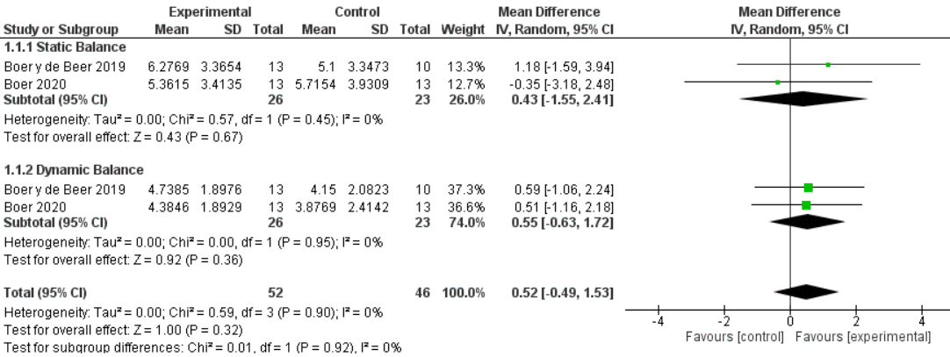
Figure 7. Aerobic exercise in water versus control, outcome: Static and Dynamic Balance

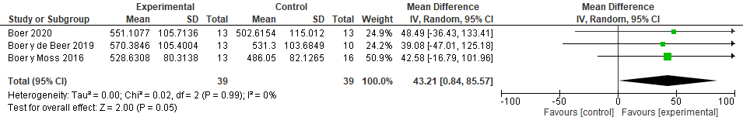
Figure 8. Aerobic exercise in water versus aerobic exercise on a firm surface, outcome: Functional Tasks - 6MWD.

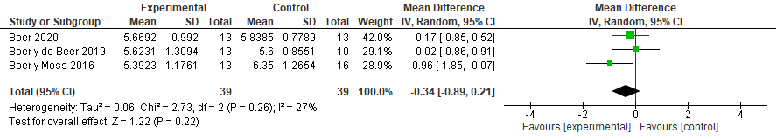
Figure 9. Aerobic exercise in water versus aerobic exercise on a firm surface, outcome: Functional Tasks - 8 ft up and go.

