Electronic coupling between perovskite nanocrystal and fullerene modulates hot carrier capture
Yusheng Liª†, Junke Jiang^{b,e}†, Dandan Wang*ª, Dong Liuª, Shota Yajimaª, Hua Liª, Akihito Fuchimotoª, Hongshi Li^{c}, Guozheng Shiª, Shuzi Hayaseª, Shuxia Tao^{b}, Jiangjian Shi^{d}, Qingbo Meng*^{d}, Chao Ding*ª, Qing Shen*ª
^{a.} Faculty of Informatics and Engineering, The University of Electro-Communications, 1-5-1 Chofugaoka, Chofu, Tokyo 182-8585, Japan.
^{b.} Materials Simulation and Modelling, Department of Applied Physics, Eindhoven University of Technology, 5600 MB Eindhoven, The Netherlands.
^{c.} Institute of New Energy Materials Chemistry, School of Materials Science and Engineering, Nankai University, TongYan street 38, Jinnan District, Tianjin 300350, China
^{d.} Key Laboratory for Renewable Energy, Beijing Key Laboratory for New Energy Materials and Devices, Institute of Physics, Chinese Academy of Sciences, Beijing 100190, P. R. China
^{e.} Present Address: Université Rennes, ENSCR, CNRS, ISCR-UMR 6226, F-35000 Rennes, France
† These authors contributed equally *Corresponding authors: qbmeng@iphy.ac.cn, wdd2395360261@gmail.com, ding@jupiter.pc.uec.ac.jp, shen@pc.uec.ac.jp (Lead Contact)
Experimental Details
Materials
Oleic acid (OA, 90%), oleylamine (OAm, 70%), octadecene (ODE, technical grade 90% ), Cesium carbonate (Cs₂CO₃, 99.99%) phenyl-C61-butyric acid methyl ester (PCBM, >99.5%), bis(1-[3-(methoxycarbonyl)propyl]-1-phenyl)-[6.6]C62 (Bias-PCBM, 99.5%), tetrahydrofuran (THF, ≥99.9), chlorobenzene (CB, 99.8%), tetrahydrofuran-d8 (THF-d8, ≥99.5 atom % D), chlorobenzene-d5(CB-d5, ≥99.5 atom % D), hydrochloric acid (HCl, 37 wt. % in H₂O), Methanol (MeOH, ≥ 99.9%) and acetic acid (HAc, ≥99%) were purchased from Sigma Aldrich. Lead halide (PbI₂ ,99.99%), Lead Bromide (PbBr₂, >98%), methyl acetate (MeOAc, anhydrous 99.5%) n-hexane (99%) and toluene (98%) were purchased from Wako.

Methods
Synthesis of colloidal CsPbI₃ quantum dots (NCs)
The synthesis was performed following the method in paper¹ with slight modification. First, 2.1324g OA, 0.6 g of Cs₂CO₃ and 20 mL ODE were mixed in a 100 mL three-neck flask, then degassed at 120 °C about 40 mins under vacuum and kept at 100°C until needed. Subsequently, 0.4 g of PbI₂ and 20 mL ODE were mixed in a 50 mL three-neck flask at 120 °C for 30 mins under vacuum. A mixture of OA and OAm (3 mL each) were preheated at 60 °C, then was injected into the PbI₂ solution and kept at 120 °C about 30 mins. Subsequently, the mixture was heated to 160 °C under N₂, then 3.2 mL of the Cs-oleate precursor was immediately injected into the reaction flask, reacted 5~8 seconds, then quickly quenched to room temperature in ice bath. The colloidal solution was separated into four tubes and added 45mL MeOAc, then centrifuged at 8500 rpm for 4 min. The precipitated NCs were dispersed in 4 mL of hexane and stored in refrigerator at 4 °C for 24 hours, then centrifuged at 4000 rpm for 2 min. Before being used, the NCs solution was centrifuged at 7000 rpm for 5 min. The supernatant was dried with N₂, then dispersed into 50 mg/mL CsPbI₃ NCs n-hexane solution.

Synthesis PCBA and [Bias]PCBA
PCBA was obtained by the hydrolysis of PCBM². In a typical synthesis, a solution of PCBM (100 mg, 0.147 mmol) in chlorobenzene (20 mL) was refluxed under nitrogen atmosphere for 3 h. HCl (12 M, 6 mL) and acetic acid (30 mL) were added to the solution in one portion. The reaction mixture was refluxed for 16 h. The solvent was removed under reduced pressure to give a residue, which was purified by precipitation from MeOH for three times to obtain a brown solid PCBA. [Bias]PCBA is synthesized with the same method from Bis(1-[3-(methoxycarbonyl) propyl]-1-phenyl)-[6.6]C62 (mixture of isomers, Bia-PCBM) but with slight modification according to molar ratio.

Preparation of Fullerene solution
PCBM and Bias-PCBM were dissolved in CB (0.02mmol/mL), PCBA and [Bias]PCBA were dissolved in the mixture of CB and THF (volume ratio=1:1, 0.02mmol/mL). The solutions were then allowed to stir for 30min under 50°C.

CsPbI₃ NC-fullerene hybrid
The CsPbI₃ NCs solution (50uL, n-hexane) was added 2 uL of fullerene derivative solutions, then stirred 2 mins. The colors of CsPbI₃ NC solutions mixed with PCBM and Bias-PCBM were nearly unchanged, while CsPbI₃ NC solutions once mixed with PCBA and [Bias]PCBA quickly transformed into black, then precipitated when centrifuged at 4000 rpm for 2 mins. The precipitations were redispersed into toluene and centrifuged at 4000 rpm for 2 mins. The NCs were dried with N₂ then redispersed into 500 ul chlorobenzene or toluene assisted with 30 mins ultrasound. The same results can also be obtained by straightly introducing fullerene into CsPbI₃ NC solution. It is noted that the influence of the THF can be ignored in our experiments.

Characterization
The phase identification was carried out using a powder X-ray diffraction (XRD, TTR-III, Rigaku Corp., Japan). The morphology and crystal structure of the prepared samples were characterized using a transmission electron microscopy (JEM-2100F). UV-vis absorption spectra were measured with a spectrophotometer (HITACHI, U-3900H, Japan). Photoluminescence Quantum Yield (PLQY) and matched steady luminesce steady Photoluminescence (PL) are measured with the Absolute PLQY Measurement System (from C11347 Hamamatsu, Japan) at an excitation power of 0.1 mW. The attenuated total reflection mode of Fourier transform infrared spectra (ATR-FTIR) were recorded using a Nicolet 6700 FTIR spectrophotometer equipment. The maximum valence band levels are measured with photoelectron yield spectroscopy (PYS, BUNKOKEIKI, KV205-HK). X-ray photoelectron spectroscopy (XPS) data were accumulated on a photoelectron spectrometer, JPS-90MX (JEOL, Ltd., Japan). Solution nuclear magnetic resonance (NMR) spectra were recorded with a JEOL ECA-500 (500 MHz) instrument. Excitation intensity-dependent PL, transient PL, and PL for Stern-Volmer plot are all recorded with the PL system from TOKYO INSTRUMENT, INC. A 473 nm pulsed diode laser (pulse width 90 ps, repetition up to 100MHz, peak power is 4mW) was used as the excitation source. A circle adjustable neutral density filter was adopted to adjust the excitation intensity. The PL detection is used with a PMT together with a TCSPC module. Transient absorption (TA) measurements were performed using a fs TA setup. The laser source was a titanium/sapphire laser (CPA-2010, Clark-MXR Inc.) with a wavelength of 775 nm, a repetition rate of 1 KHz, and a pulse width of 120 fs. The light was separated into two parts. One part was incident on a sapphire plate to generate white light for the probe beam. The other part was used to pump an optical parametric amplifier (OPA) (a TOAPS from Quantronix) to generate light pulses with a wavelength tunable from 290 nm to 3 μm. It was used as a pump light to excite the sample. In this study, a pump light with a wavelength of 470 nm was used to excite the NCs.

Computational Details
Density functional theory calculation
All structures were optimized by performing DFT calculations implemented in the Vienna ab initio simulation package (VASP)³. The Perdew-Burke-Ernzerhof (PBE) functional within the generalized gradient approximation (GGA) was used⁴. The outermost s, p, and d (in the case of Pb) electrons were treated as valence electrons, whose interactions with the remaining ions were modeled by pseudopotentials generated within the projector-augmented wave (PAW) method^{5, 6}. An energy cutoff of 500 eV and a k-point scheme of 4 × 4 × 1 were used to achieve energy and force convergence of 0.1 meV and 20 meV Å⁻¹, respectively. For the projected density of states (PDOS) calculation, the Brillouin zone was sampled by an 8×8×1 k-mesh.
Structural models
We constructed CsPbI₃ surface models with the top and bottom surfaces being the [0 0 1] facets terminated by CsI and PbI₂ layer, respectively (Figure S13). The surfaces were modeled using slab models consisting of (2 × 2) cells in the x and y direction and five repeating units (20 Cs atoms, 20 Pb atoms, and 60 I atoms). In order to understand the NCs surface ligand effect, the slab model used above were passivated by oleate (C₁₈H₃₄O₂⁻: OA⁻), PCBA, or PCBM on CsI-termination and PbI₂-termination, respectively, with different configurations (see atomistic molecular models of ligands in Figure S14). A vacuum of 20 Å in the z-direction is set to avoid the periodic effect. The dipole correction along the z-direction is considered. We note that the ligand slab model for investigating the surface of NCs was validated in our previous works ^{7, 8}. During the structural optimization, ions on the bottom were fixed to mimic the bulk nature while all other ions (including the ligands on top of the surface) were allowed to relax, optimized to their minimum energy configuration.
Ligand binding energy
The ligand binding affinity (E_{b}) of the ligands to the NCs surface is computed as:
E_{b} = (E_{tot} – E_{NCs} - E_{lig})/S
where E_{tot} is the energy of the slab model passivate with ligands, E_{NCs} the energy of the slab model (the perovskite NCs) without the ligand, and E_{lig} the energy of the ligand, and S is the surface area of the interfaces. The more negative the E_{b}, the stronger the binding strength between ligand and NCs.
Charge density distribution analysis
In order to investigate the interaction and nature of bonding states between ligand and perovskite, the charge density difference (CDD) is calculated. The yellow and cyan represent the electron accumulation and depletion, respectively.

Supplementary Figures
Figure S1. Powder XRD patterns of CsPbI₃ NCs and CsPbI3 NC-fullerene hybrid. All samples display as identical cubic phase.

Figure S2. TEM of CsPbI₃ NCs. The average diameter of as-prepared CsPbI₃ NC is about 14.6 nm.

Figure S3. Nuclear magnetic resonance spectroscopy of PCBA and [Bias]PCBA. Inset of Figure zooms in on the region of chemical shifts for the hydrogen atom in the -COOH group.

Figure S4. The absorption spectrum of PCBM, PCBA, [Bias]PCBM, and [Bias]PCBA respectively.

Figure S5. (a) Energy level diagram (valence band maximum (VBM)/highest occupied molecular orbital (HOMO) and conduction band minimum (CBM)/lowest unoccupied molecular orbital (LUMO)) of CsPbI₃ NCs film and fullerene films. VBM/LUMO was acquiring from the photoelectron yield spectroscopy (PYS) in (b)-(e) according to Y^{1/3} ∝ (hυ-E_{v}), where Y is photoelectron yield, hυ is photo energy, E_{v} is VBM energy level. The band gap (E_{g}) of fullerene was determined from (g) the second derivative spectrum of fullerene. VBM/HOMO was calculated by combing CBM/LUMO and E_{g}. It is noted that the E_{g} of CsPbI₃ NCs was acquired by fitting ABS with Elliot equation which will be discussed later. The differences of energy level information in bulk and solution were ignored at here.

Figure S6. Absorption spectra of colloidal CsPbI₃ NCs, CsPbI3 NC-fullerene hybrid dispersions, and only fullerene solution. Compared with the absorption of intrinsic CsPbI₃ NCs, the absorption coming from fullerene can be neglected.

Figure S7. (a) TA kinetics of CsPbI₃ NCs probed at 1.88eV under pump fluence (J) from 16 μJ/cm² to 485 μJ/cm². (b) The intensity of TA signal in Figure (a) at around 1 ns as a function of J. The initial average generated exciton (e-h pair) numbers per NCs (<N>) are calculated by fitting the diagram with ∆A/A(J) ∝ 1-exp(-<N>) =1-exp(-J∙σ), where σ is the absorption cross section of the NCs.

Figure S8. Evolution-associated spectra (EAS) of CsPbI₃ NCs obtained by performing global analysis on the TA spectrum under pump fluence of (a) 16 μJ/cm², (b) 200 μJ/cm². In pump fluence of 16 μJ/cm², the EAS contains two simple components corresponding to TA spectrum at 0.839 ps and 1.544 ns (> 1 ns) respectively. The first component (EAS1, the black curve) is composed of PIA at low energy (bandgap renormalization) and broadened PB with high-energy tail (PB of hot carriers). The second component (EAS2, the red curve) consists of PB signal at ground state (GSB) and excited carrier absorption at band edge. At energy lower than isosbestic point (IBP), EAS2 is contributed by exciton absorption, thus can be perfectly fitted with gaussian function (see dotted line). Any new PB feature observed at this IBP can be attributed to the HC’s contribution. This is a key point in the HC dynamic analysis in the work. In pump fluence of 200 μJ/cm², EAS contains at least four components which are difficult to be assigned.

Figure S9. Higher energy tails of transient absorption spectrums are fitted by Maxwell–Boltzmann distribution (black dot line) to extract HC temperature. (a)-(e) The signals of CsPbI₃ NCs, CsPbI₃ NC-PCBM hybrid, CsPbI₃ NC-[Bias]PCBM hybrid, CsPbI₃ NC-PCBA hybrid, and CsPbI₃ NC-[Bias]PCBA hybrid, respectively. The pump fluence is 200 μJ/cm² (<N>~2.3). (f) The signal of CsPbI₃ NCs under pump fluence of 16 μJ/cm² (<N>~0.2).

Figure S10. Pseudo color TA maps of (a) PCBM, (b) [Bias]PCBM, (c) PCBA, (d) [Bias]PCBA. The pump fluence is 485 μJ/cm².

Figure S11. Pseudo color TA maps of (a) CsPbI₃ NC-PCBM hybrid, (b) CsPbI₃ NC-[Bias]PCBM hybrid, (c) CsPbI₃ NC-PCBA hybrid, (d) CsPbI₃ NC-[Bias]PCBA hybrid. The pump fluence is 16 μJ/cm².
Figure S12. Pseudo color TA maps of (a) CsPbI₃ NC-PCBM, (b) CsPbI₃ NC-[Bias]PCBM, (c) CsPbI₃ NC-PCBA, (d) CsPbI₃ NC-[Bias]PCBA. The pump fluence is 200 μJ/cm².

Figure S13. Pseudo color TA maps of (a) CsPbI₃ NC, (b) CsPbI₃ NC-PCBM, (c) CsPbI₃ NC-[Bias]PCBM, (d) CsPbI₃ NC-PCBA (e) CsPbI₃ NC-[Bias]PCBA. The pump fluence is 485 μJ/cm².

Figure S14. The transient kinetic at IBP for CsPbI₃ NC and CsPbI₃ NC-fullerene hybrid under pump fluence of (a) 16 μJ/cm², (b) 485 μJ/cm².

Figure S15. PL spectra of CsPbI₃ NCs colloidal solution titrated with varying quantity of (a) PCBA, (b) [Bias]PCBA, (c) PCBM and (d) [Bias]PCBM. (e) Shift of PL maxima with relative to PL maxima of intrinsic CsPbI₃ NCs. We noted that the unnormal PL signal of 5.367×10⁻⁶ mM [Bias]PCBA (inset of (b)) is as consequence of the scattered light from the environment.

Figure S16. XPS signals of Pb 4f, Cs 1s and I 3d. (a)-(c) correspond to the samples prepared by droplet coating NC solutions. (d)-(f) correspond to the samples prepared by spin coating fullerene onto the CsPbI₃ NC films that alkyl ligands have been removed. In each Figure, the bottom curve to the top curve represents CsPbI₃ NC, CsPbI₃ NC-PCBM, CsPbI₃ NC-[Bias]PCBM, CsPbI₃ NC-PCBA, CsPbI₃ NC-[Bias]PCBA, respectively.

Figure S17. (a) FTIR of CsPbI₃ NC, CsPbI₃ NC-PCBM, CsPbI₃ NC–PCBA, PCBM, PCBA and OA. (b) FTIR of CsPbI₃ NC, CsPbI₃ NC-[Bias]PCBM, CsPbI₃ NC-[Bias]PCBA, [Bias]PCBM and [Bias]PCBA.

Figure 18. Excitation power dependent PL spectrum. Fitting these curves with a power law I_{PL}~L_{exc}^{α}, where I_{PL} is PL intensity, L_{exc} is the power of the exciting laser (wavelength 470 nm, much higher than the band gap of NCs), α is coefficient related to exciton emission mechanism, yielded α~0.98 for CsPbI₃ NC, CsPbI₃ NC-PCBM and CsPbI₃ NC-[Bias]PCBM, a~1.42 for CsPbI₃ NC-PCBA and CsPbI₃ NC-[Bias]PCBA. According to well-established rules that the coefficient α = 1 is in the case of bound exciton emission and α = 2 is in the case of free exciton emission, the excitons in intrinsic CsPbI₃ NC could be treated as bound excitons, meanwhile PCBM and [Bias]PCBM seem not to change the properties of excitons. The increased α in CsPbI₃ NC-PCBA hybrid and CsPbI₃ NC-[Bias]PCBA hybrid substantiates the exciton delocalization. It is thought as the energy level alignment at the interface give rise to local electric field lowering the potential barrier at the quantum boundaries.

a
Figure S19. Determination of Urbach energy by fitting Urbach’s tail where is an exponential increase in absorbance with energy. According to α(E)=α₀exp[(E-E₁)/E_{u}], the Urbach energy (E_{u}) is about 19.7 meV. What can be clearly seen is that Urbach’s tail occurred at a lower energy stage than the bulge of absorption edge.

Figure 20. The band edge absorption of (a) CsPbI₃ NC, (b) CsPbI₃ NC-PCBM, (c) CsPbI₃ NC-[Bias]PCBM, (d) CsPbI₃ NC-PCBA, and (e) CsPbI₃ NC-[Bias]PCBA fitted with Elliott formula. The black line is the fitting result that contains the contribution of continuous band (Con) and exciton absorption (Exc).

Figure 21. Time-resolved photoluminescence (TRPL) of CsPbI₃ NCs and CsPbI3 NC-fullerene hybrid. Insets of Figure is the zoom of TRPL curves with short decay. It shows a lifetime within the instrument response function (IRF, ~100 ps) for CsPbI₃ NC-PCBA hybrid and CsPbI₃ NC-[Bias]PCBA hybrid indicating fast cold carrier transfer from CsPbI₃ NCs to PCBA and [Bias]PCBA.

Figure S22. (a) Structural models of CsPbI₃ with CsI-termination on the top and PbI₂-termination on the bottom. Molecular structure of (b) oleate (C₁₈H₃₄O₂⁻: OA⁻), (c) PCBA, and (d) PCBM, respectively.

Figure S23. Structural models of CsPbI₃ NCs surfaces passivated by OA, PCBA, and PCBM ligands, respectively. The layers inside the red rectangle regions were fixed, while the top layer includes ligands, was relaxed during geometry optimization.

Figure S24. The charge density difference (CDD) of NC-OA, NC-PCBA, and NC-PCBM with CsI-termination and PbI₂-termination, respectively. The yellow and cyan regions indicate the charge accumulation and depletion, respectively, and the isosurface is 0.002 e/Å³.

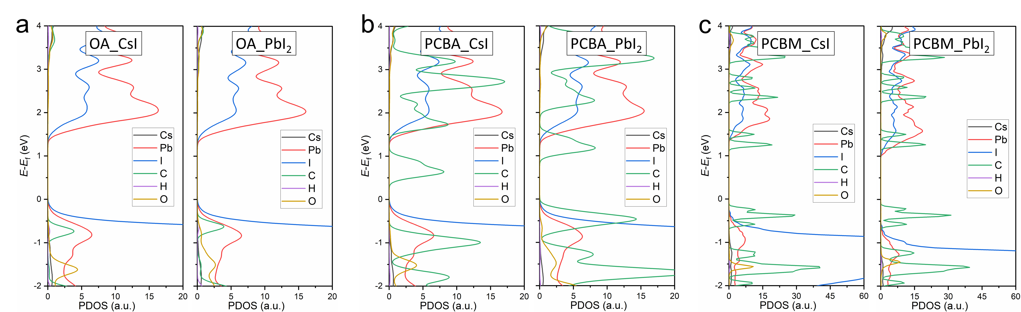
Figure 25. Partial density of state (pDOS) of (c) NC-OA, (d) NC-PCBA, and (e) NC-PCBM, respectively.
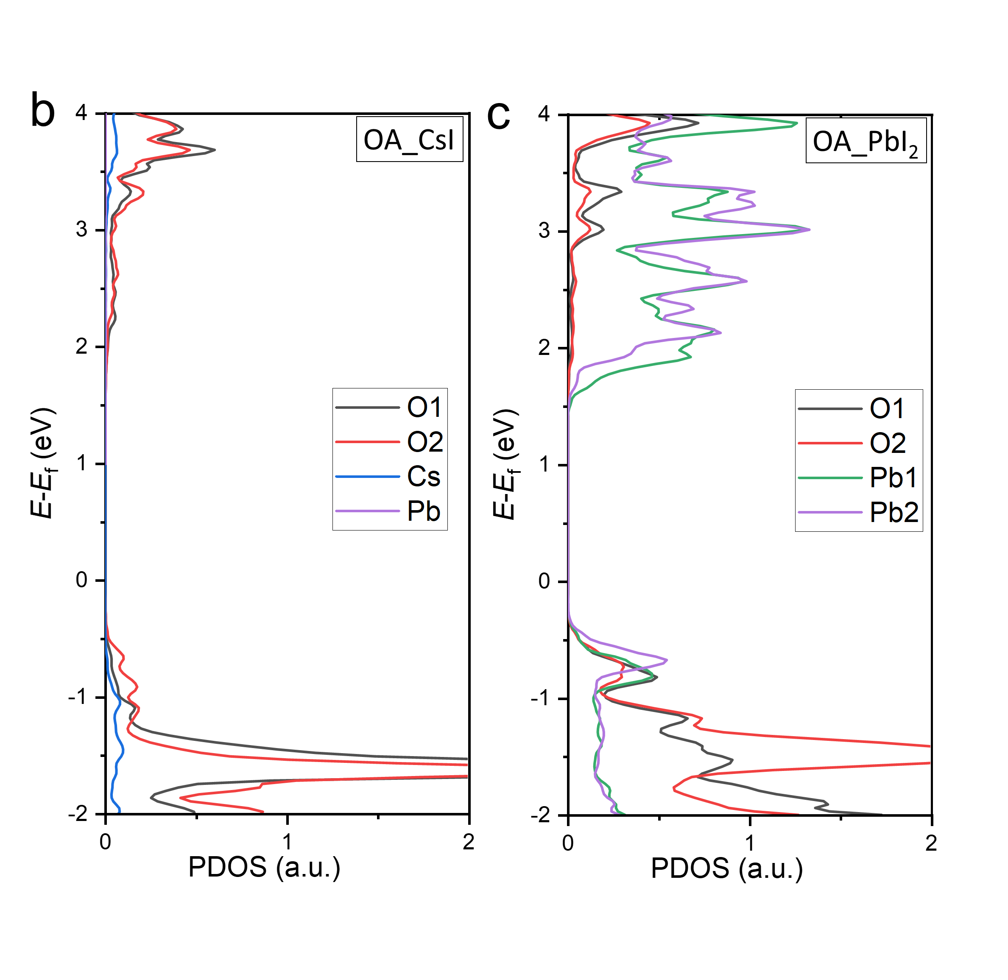
Figure 26. The partial density of state (pDOS) of the bonding atoms at interface between OA molecule and (a) CsI termination, (b) PbI2 termination.

Supplementary Tables

Table S1. Parameters fitted from absorption spectrums with Elliott formula.
 | CsPbI₃ | CsPbI₃-PCBM | CsPbI₃-[Bias]PCBM | CsPbI₃  -PCBA | CsPbI₃-[Bias]PCBA
E_{g} (eV) | 1.92 | 1.92 | 1.92 | 1.90 | 1.90
E_{b} (meV) | 25 | 25 | 25 | 7 | 7
T (meV) | 32 | 32 | 32 | 31 | 31

Table S2. Bond lengths of two oxygens with nearest Pb, C and Cs atoms.
Distance (Å) | Pb-O (1) | Pb-O (2) | C-O (1) | C-O (2) | Cs-O (1) | Cs-O (2)
CsI-termination OA | 2.83 | 2.46 | 1.26 | 1.30 | 3.13 | 3.14
CsI-termination PCBA | 3.21 | 2.42 | 1.26 | 1.30 | 2.98 | 3.16
PbI₂-termination OA | 2.44 | 2.44 | 1.28 | 1.28 | 3.20 | 3.20
PbI₂-termination PCBA | 2.51 | 2.43 | 1.27 | 1.29 | - | -
The ion radii of Pb²⁺, Cs⁺ and O²⁻ are 1.2 Å, 1.67 Å and 1.4 Å respectively. Bonding modes (bidentate mode, bridging mode and monodentate mode) are distinguished by comparing the bond length with the sum of related atom radii.

Supplementary Notes
Note 1. Three temperature model (TTM)
TTM that couples the rate equations of hot carrier and phonons was widely applied to describe hot carrier relaxation and electron-phonon interaction, such as spin-lattice relaxation in manganite oxides⁹, hot electron relaxion in Bi₂Sr₂CaCu₂O_{8+δ}¹⁰, hot carrier dynamics in graphene¹¹ and so on. In this work, we adopted the modified TTM developed by M. Monti at el.¹², which has been successfully used in depicting hot carrier cooling in Sn-Pb mixed perovskite. This model assumes that HCs lose temperature by carrier- longitudinal optical (LO) phonon interaction and give rise to the raising of LO phonon temperature. The HC cooling will be prolonged under high pump fluence by Auger reheating. Meanwhile, LO phonons release its excessive energy by decay into transverse optical phonon or acoustic phonon. According to previous phonon decay mechanism, the temperature of low energy phonon can be replaced with lattice temperature, besides, only one LO phonon branch was adopted here. The coupled rate Equations are shown as following:
(1)
(2)
T_{c}, T_{p,i}, T_{L}, C_{e,i}, C_{p,i}, k_{e}, k_{p}, G_{ep,i}, G_{pp,i} are respectively carrier temperature, phonon temperature, lattice temperature, electron heat capacity, phonon heat capacity, electron heat conductivity, phonon heat conductivity, coupling constant of electron with the phonon branch, coupling constant of phonon branch with the lattice. The term G_{A}(T_{g}+T_{c}) represents Auger heating, where G_{A} = k_{A}N(t) and T_{g}=2E_{g}/3k_{B}, k_{A} is Auger recombination rate, N(t) is carrier density, E_{g} is bandgap. The Time-dependent HC temperature curves in the main text were numerically fitted with the above equations. By separating the terms in Equation S(1)-(2), one can distinguish the contributions that slow the HC cooling.

Note 2. Energy loss rate
The underlying energy loss mechanisms are determined by the pump fluence and relaxion stage. For low pump fluence, the HC relaxation is dominated by the carrier-phonon interaction. Under the condition of L-O phonon interaction mode, the energy loss rate¹³:
(3)
where τ_{qa} is the rate constant of LO phonons into thermal equilibrium with acoustic phonons. ħω₀ is the phonon energy, T_{a} is the temperature of acoustic phonons, T_{c} is the temperature of LO phonons, N_{q}(T_{p}) and N_{q}(T_{a}) are the LO-phonon occupation numbers for phonon temperature T_{q}=T_{p} and T_{q}=T_{a} respectively. Assuming the HC carrier-LO-phonon system is governed by the decay of LO-phonons into acoustic phonons, the practical energy loss rate can be fitted according to the expression¹⁴:
(4)

For high pump fluence, HC relation is determined the competition between energy outflow through carrier-phonon interaction and energy inflow due to Auger reheating. In the beginning, carrier-phonon interaction dominated over Auger reheating, thus the energy loss rate can be fitted with Equation S(4). As the decrease of phonon-related relaxation rate, the HC cooling will be dominated by Auger reheating process, where the energy loss rate is approximately proportional to (T_{c}-T_{L})² ¹⁵.

Note 3. Fluorescence quenching mechanisms.
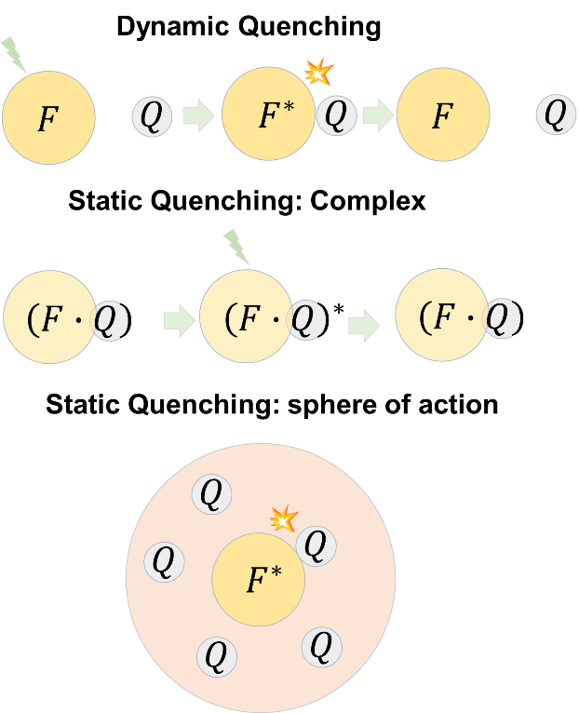
Schematic diagram of quenching mechanisms mentioned in main text.
(1) Dynamic quenching
In this case, fluorophore and quencher are independent with each other in the dispersion solution before photo stimulation. Excitation light will compel fluorophore to transform from ground state ([F]) to excited state ([F*]). In advance of relaxation by [F*] itself, the quencher (Q) must diffuse and collide with [F*]. Through this kind of dynamic contact, [F*] releases its excess energy and returns to [F]. In general, there is no permanent change in both molecules, thus whole process is either just photo physical reaction or formation of transient exciplexes. Since dynamic quenching only affects the properties of [F*], the absorption spectrum of [F] will not be perturbed.
(2) Static quenching: By forming complex
In this case, fluorophore and quencher in the dispersion solution tend to form a static complex ([F∙Q]) by chemical bonding and the complex is nonfluorescent. Energy transfer in this process dispense with the collisional encounters, instead through their own transport channel, thus usually is faster than dynamic quenching. Besides, the formation of ground state complex usually results in some changes in absorption spectrum.
(3) Static quenching: By forming a “sphere of action”
In this case, the static component is on account of forming complex, but rather because the f1uorophore is surrounded by adjacent quenchers at the moment of photo excitation. Frank and Vavilov¹⁶ postulated there exists a relative static “sphere of action” around excited fluorophore within which the collision quenching immediate happened with unity probability, and outside of which quenching probability is zero. Different from the condition of forming complex, the essence of this case is that f1uorophore and quencher are bound within the “sphere of action”, however, collide to quench. It means that this kind of quenching usually has higher quenching velocity than dynamic quenching, however, will not result in perturbation of the absorption.
(4) Combined dynamic and static quenching
Apart from above mentioned single mechanism, in practical quenching processes, there may exist both dynamic and static quenching within same system. Stern-Volmer analysis is frequently used to distinguish these complicated mechanisms.

Note 4. Stern-Volmer theory and the quenching models used in main text.
Stern-Volmer analysis is one of the most powerful methods for assessing mechanisms behind quenching of fluorescence¹⁷.
(1) Stern-Volmer equation for standard dynamic quenching
In general, this process can be described by a simple equation:
(5)
For stable PL measurement, the quenching is thought to be dynamic equilibrium under continuous illumination. In the absence and presence of quencher, we have
(6)
(7)
, in which [F*] and [F*]₀ are the concentration of fluorophore in excited state in the absence and presence of quencher respectively, [Q] is the concentration quencher, G(t) is the generation rate of F* stimulated by continuous illumination, γ and κ are intrinsic recombination rate and collision rate constant, respectively. According to the equation S(6) and S(7),
(8)
Since the PL intensity is proportional to the concentration of fluorophore in excited state, the fraction PL intensity in absence and presence of quencher can be depicted as F₀/F=1+K_{D}[Q], K_{D} is dynamic quenching constant.
(2) Stern-Volmer equation for standard static quenching (by forming complex)
In general, this process can be described by a simple equation:
(9)
Where [F∙Q] is the concentration of complex. The static quenching constant (K_{s}) is same with the reaction constant of equation S(9), that is
(10)
By substituting concentration to PL intensity and rearranging equation S(10), we have
(11)
(3) Downward deviation from Stern-Volmer equation
In this case, the total fluorophores ([F₀]) can be separated as inaccessible [F_{i0}]) and accessible([F_{a0}]) fluorophores, this is
(12)
Since the PL quenching is only contributed by [F_{a0}] which follows dynamic quenching equation, we have
(13)
(14)
Subtraction of equation S(13) and S(14) and arrangement of the solution yields
(15)
Where f_{a} is the fraction of initial PL contributed by accessible population (f_{a}=F_{a0}/F₀), K_{a} is quenching constant of accessible population.
(4) Stern-Volmer equation for static quenching (by forming a “sphere of action”)
The modified S-V equation to describe the quenching with “sphere of action” is
(16)
The factor exp(-[Q]υN/1000) depict the reduction proportion of PL due to the existence of “sphere of action”, in which [Q]υN/1000 is the average number of quenchers.
(5) Stern-Volmer equation for combined dynamic and static quenching (by forming complex)
To depict our positive S-V plots, we propose to use the formula combining the standard dynamic quenching model and the modified static quenching model¹⁸⁻²⁰ where fluorophore has multiple binding sites for quencher.
In general, the equation to describe combined dynamic and static quenching is

(17)
The factors in right hand side of equation are the contributions of dynamic quenching and static quenching to total PL quenching respectively. However, this equation is only suitable for the situation where ground state complex is formed by one fluorophore and one quencher. Similar to biomacromolecule, the big surface area of NCs may makes the number of quenchers onto the surface of per NC greater than one:
(18)
the binding constant (K_{B}) of the static complex can be written as
(19)
in which n is the number of binding sites per NC. Thus, the modified static quenching equation is
(20)
Similar equation has been used in previous research of biomacromolecule.
For the combined dynamic and static quenching, F/F₀ can be acquire by the product of the fraction (f_{d},) not quenched by collision and the fraction (f_{s},) not complexed as following
(21)
Thereby, the quenching equation can be written as
(22)

Note 5. Discussion about X-ray photoelectron spectrum (XPS) and attenuated total reflection mode of Fourier transform infrared spectra (ATR-FTIR).

X-ray photoelectron spectrum (XPS) are performed to reveal the bonding interactions. For the samples prepared by straightly dipping NC colloidal solutions onto quartz glass, it is found that the peaks of Pb 4f, Cs 3d/5, I 3d nearly keep unchanged after the introduction of fullerene with this method. However, when the fullerene were spin-coated onto CsPbI₃ NC film that alkyl ligand had been removed with Methyl acetate, visible shifts of binding energy were observed compared with the intrinsic CsPbI₃ NCs (having been removed ligands). Meanwhile, PCBA and [Bias]PCBA drive Pb 4f core level shift toward higher energies and Cs 3d/5, I 3d toward lower binding energies than PCBM and [Bias]PCBM. Coupled the shift of binding energy in both cases, the order of the interaction strength is speculated to be OA≥PCBA/[Bias]PCBA>>PCBM/[Bias]PC
BM, which illustrates that PCBA and [Bias]PCBA would prefer anchoring onto the atoms uncapped with OA rather than extensively replacing OA group by traditional ligand exchange.

For ATR-FTIR measurements, the samples of solid film on silicon substrate are prepared with the same methods as the first group of XPS but with excessive addition of fullerene for enhancing the signals of fullerene to observable intensity. As shown in Figure S17 (a), oleic acid (OA), PCBM and PCBA exhibit distinguishable characteristic stretching vibration of carbonyl group, ν_{OA}(C=O) ≈ 1708 cm⁻¹, ν_{PCBM}(C=O) ≈ 1708 cm⁻¹, ν_{PCBA}(C=O) ≈ 1699 cm⁻¹. It is noted the peak at ~1732 cm⁻¹ in PCBA is provided by residual PCBM in PCBA. For intrinsic CsPbI₃ NCs, OA exists in the form of oleate bound to surface of NC with carboxylate group, where asymmetric (ν_{as}(COO) = 1530 cm⁻¹) and symmetric (ν_{s}(COO) = 1409 cm⁻¹). For CsPbI₃ NC-PCBA hybrid, υ_{PCBA}(C=O) shifts to lower frequency (tens of wavenumber), which may be caused by coordination or hydrogen bond fracture in solution. The intense peaks at 1216 cm⁻¹ in spectrum of CsPbI₃-PCBA NCs is assigned to the stretching vibration of C-O (υ_{PCBA}(C-O)). In general, the molecules in the presence of carboxylic acid group coordinate with metallic compounds through splitting C=O and C-O into -COO⁻ to form either bidentate chelating or bidentate bridging ring structure with metal atoms. The existing of υ_{PCBA}(C=O) and υ_{PCBA}(C-O) indicates that a large proportion of PCBA molecule still exist in the form of PCBA rather than PCBA ions. Besides, no υ_{OA}(C=O) signal at 1708 cm⁻¹ is observed after the introduction of excessive PCBA. These results illustrate that the bound oleate molecules have not been replaced in quantity by the excessive introduction of PCBA. The discussion applies equally as well to CsPbI₃ NC-[Bias]PCBA hybrid.

Note 6. Discussion about the shift of PL peak in this work

In Figure S15, we observed interesting shifts of PL, which seems related to quenching stages. Along with the addition of fullerene, PL maxima is gradually blue shifted relative to intrinsic CsPbI₃ NCs at the first stage of S-V plot and red shifted back at the second stage, whereas only much smaller blue shift existed for PCBM and [Bias]PCBM as quenchers. Numerous detailed papers have been published on discussing the shift of PL, however unable to reach a consistent explanation due to the diversity and complexity of experimental subjects. Precise interpretation of shift of PL requires a more detailed experiment which is beyond our study. Here, we try to provide possible explanation according to existing data. To our knowledge, the factors involved in this system possibly leading to the shift of PL maxima include general and specific solvent effects, exciton delocalization, surface defect effects. Besides, some of these effects may be related with each other. By general and specific solvent effects, we mean the transition dipole moment of CsPbI₃ NCs and the reactive fields induced in the surrounding molecules (general solvent effects), and specific chemical interactions, such as the formation of complexes or exciplexes (specific solvent effects). Solvent effects usually represent entire influences of all the molecules surrounding fluorophore (NCs). Nevertheless, it is reasonable to focus on the interactions between NCs and fullerene since the only difference in the solvent is the fullerene we added. If we assume that there are only general solvent effects, the orientation polarization of fullerene will result in red shift of PL according to Lippert equation²¹ and the degree of red shift resulting from PCBA and [Bias]PCBA should bigger than PCBM and [Bias]PCBM (consider the polarity). Obviously, the assumption is not tallied with the actual results, which means we can neglect the general solvent effects on blue shift of PL.
In the main text, we have demonstrated the formation of ground state complexes in CsPbI₃ NC-PCBA hybrid and CsPbI₃ NC-[Bias]PCBA hybrid. This effect can be classified as specific solvent effect. Besides, for the CsPbI₃-PCBM NCs and CsPbI₃ NC-[Bias]PCBM hybrid, specific solvent effects may come from the formation of transient exciplexes. The formation of complexes or exciplexes can result in two reverse effects for the carriers: charge transfer state and exciton dislocation (by partly dissociate to free carrier as discussed in main text). The former gives rise to red shift of PL, while the latter generates blue shift of PL. Combining the blue shift of PL existed in Figure S10, the latter effect is thought to be dominant. The discrepancy of shift could be attributed to the amplitudes of local field induced exciton dissociation in inner NC.
Defect related shift of PL has been reported in many cases. Defect passivation usually result in bule shift, whereas the generation of new defects may lead to red shift of PL. The suitable content of PCBA and [Bias]PCBA can anchored onto uncapped atoms at the surface of NCs to passivate surface defect, while excessive introduction attacks and removed very small amount of OA ligand on surface of NCs. These results may partly cause the shift of PL.

Note 7. Analysis of the changes of exciton binding energy by modelling optical absorption using Elliott's equation.

Considering the weak quantum confinement of CsPbI₃ NCs, the band edge absorption spectra in Figure S20 were modeled with Elliott formula. To acquire more appropriate description of the contribution coming from exciton and continuum band to the experimental absorption curves, the joint valence-band energy-momentum dispersion was introduced to modify the Elliott's equation referred previous work, that is
(23)
in which μ is the reduced electron-hole mass, b is the first-order correction coefficient of band energy. This analysis was based on the conceptual framework proposed by Michele Saba et al²². The broadening of absorption resulted from heterogeneity and disorder was stimulated by convolving Gauss functions with Equation S(24) as shown in following formula

(24)

The fitting parameters are tabulated in Table S1. Consequently, the exciton binding energy of CsPbI₃ NC-PCBA hybrid and CsPbI₃ NC-[Bias]PCBA hybrid exhibit significant decrease (from 25 meV to 7 meV). We also exclude other possibility that may lead to the discrepancy in band-edge energy states, including Urbach tail, indirect band. The Urbach tail can be firstly excluded because a very noticeable difference begins from the bulge of absorption edge which has already beyond the Urbach tail stage (Figure S19). Secondly, it is impossible to obtain a negative first derivative from Tauc formalism, which is used to describe Rashba effect caused two sub bands (direct band and indirect band), in a continuous absorption spectrum without any singularity. Rashba spin–orbit coupling gives rise to an indirect gap constituent into the original absorption, thus could be described with conventional Tauc formalism, which is composed of indirect (E_{ig}) and direct bandgap (E_{g}) terms scaled by proportionality factors A and B: α(E)=A×(E-E_{ig})²+B×(E-E_{g})^{1/2}. The first derivative of α(E)=2×A(E-E_{ig}) + 1/2×B×(E-E_{g})^{1/2}. As consequence of positive factors, A and B, it is impossible to get a negative derivative from this formula without any singularity. Even if we considered the broadening of each part of the absorption term resulted from heterogeneity and disorder by convolving with gauss functions, it is still cannot be used to depict the bulge of absorption edge.

Reference
1. Luther, J.M. Quantum dot–induced phase stabilization of α-CsPbI3 perovskite for high-efficiency photovoltaics. Science (2016).
2. Wei, Q., Nishizawa, T., Tajima, K. & Hashimoto, K. Self-Organized Buffer Layers in Organic Solar Cells. Adv. Mater. 20, 2211-2216 (2008).
3. G. Kresse, J.F. Efficiency of ab-initio total energy calculations for metals and semiconductors using a plane-wave basis set. Computational Materials Science 6, 15-50 (1996).
4. Perdew, J.P., Burke, K. & Ernzerhof, M. Generalized Gradient Approximation Made Simple. Phys. Rev. Lett. 77, 3865-3868 (1996).
5. Kresse, G. & Joubert, D. From ultrasoft pseudopotentials to the projector augmented-wave method. Physical Review B 59, 1758-1775 (1999).
6. Blöchl, P.E. Projector augmented-wave method. Physical Review B 50, 17953-17979 (1994).
7. Jiang, J., Liu, F., Shen, Q. & Tao, S. The role of sodium in stabilizing tin–lead (Sn–Pb) alloyed perovskite quantum dots. Journal of Materials Chemistry A 9, 12087-12098 (2021).
8. Liu, F. et al. Ultra-Halide-Rich Synthesis of Stable Pure Tin-Based Halide Perovskite Quantum Dots: Implications for Photovoltaics. ACS Applied Nano Materials 4, 3958-3968 (2021).
9. Averitt, R.D. & Taylor, A.J. Ultrafast optical and far-infrared quasiparticle dynamics in correlated electron materials. J. Phys.: Condens. Matter 14, R1357-R1390 (2002).
10. Perfetti, L. et al. Ultrafast Electron Relaxation in Superconducting by Time-Resolved Photoelectron Spectroscopy. Phys. Rev. Lett. 99, 197001 (2007).
11. Johannsen, J.C. et al. Direct View of Hot Carrier Dynamics in Graphene. Phys. Rev. Lett. 111, 027403 (2013).
12. Kirk, A.P. & Fischetti, M.V. Fundamental limitations of hot-carrier solar cells. Physical Review B 86 (2012).
13. Klimov, V.V., Haring Bolivar, P. & Kurz, H. Hot-phonon effects in femtosecond luminescence spectra of electron-hole plasmas in CdS. Phys Rev B Condens Matter 52, 4728-4731 (1995).
14. Li, M. et al. Slow cooling and highly efficient extraction of hot carriers in colloidal perovskite nanocrystals. Nat. Commun. 8, 14350 (2017).
15. Achermann, M., Bartko, A.P., Hollingsworth, J.A. & Klimov, V.I. The effect of Auger heating on intraband carrier relaxation in semiconductor quantum rods. Nat. Phys. 2, 557-561 (2006).
16. Frank, I.M., Vavilov, S. I. Über die Wirkungssphäre der Auslöschungsvargänge in den flureszierenden flusigkeiten. Z. Phys. 69:100-110 69, 100-110 (1931).
17. in Principles of Fluorescence Spectroscopy. (ed. J.R. Lakowicz) 277-330 (Springer US, Boston, MA; 2006).
18. Lehrer, S.S. & Fasman, G.D. The fluorescence of lysozyme and lysozyme substrate complexes. Biochem. Biophys. Res. Commun. 23, 133-138 (1966).
19. Nunes, S.M., Sguilla, F.S. & Tedesco, A.C. Photophysical studies of zinc phthalocyanine and chloroaluminum phthalocyanine incorporated into liposomes in the presence of additives. Braz. J. Med. Biol. Res. 37, 273-284 (2004).
20. Chipman, D.M., Grisaro, V. & Sharon, N. The Binding of Oligosaccharides Containing N-Acetylglucosamine and N-Acetylmuramic Acid to Lysozyme: THE SPECIFICITY OF BINDING SUBSITES. J. Biol. Chem. 242, 4388-4394 (1967).
21. Coruh, N. & Ozdogan, N. FLUORESCENT COUMARIN COMPONENTS OF THE BARK OF AESCULUS HIPPOCASTANUM. J. Liq. Chromatogr. Relat. Technol. 37, 1334-1350 (2014).
22. Saba, M. et al. Correlated electron-hole plasma in organometal perovskites. Nat. Commun. 5, 5049 (2014).

