Supplementary material for
Preparation of carbon self-doped g-C₃N₄ for efficiently degradation of Bisphenol A under visible light irradiation
Ling Lei, Xi He, Xiaoyu Lin, Yufeng Zhao, Chen Yang, Longzhe Cui, Guiping Wu*
Key Laboratory of Resources Conversion and Pollution Control of the State Ethnic Affairs Commission, College of Resources and Environmental Science, South-Central Minzu University, Wuhan 430074, P.R. China.

*Corresponding author: e-mail addresses: wuguiping@scuec.edu.cn (Guiping Wu)
Declarations of interest: none

Fig. S1. Schematic representation of C-doped g-C₃N₄ preparation process
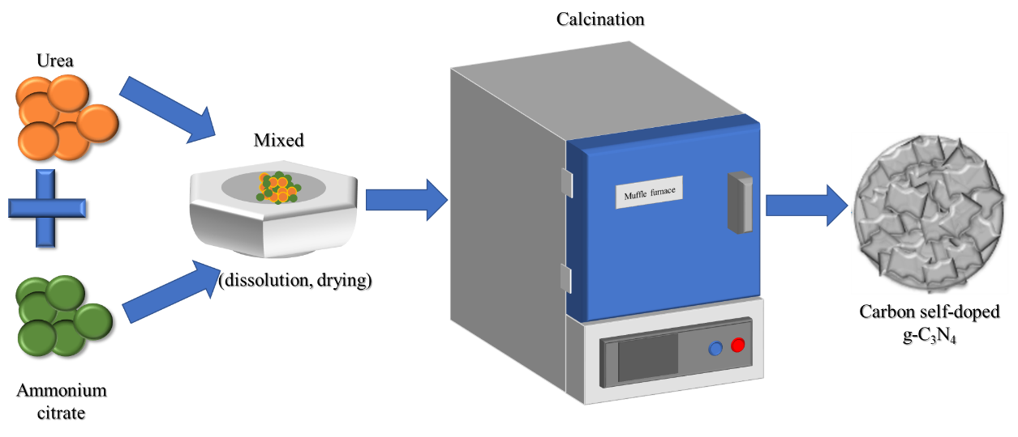

Fig. S2. Cycling experiments on the photocatalytic degradation of BPA by C_{0.02}CN
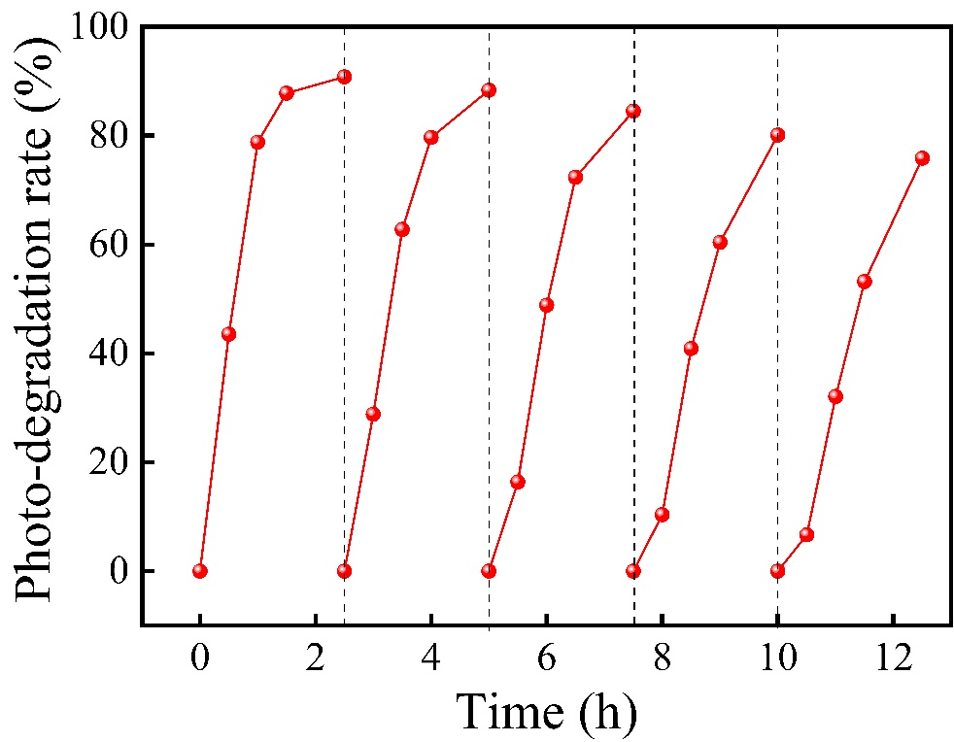
Fig. S3. SEM images of (a, b) g-C₃N₄, (c, d) C_{0.02}CN
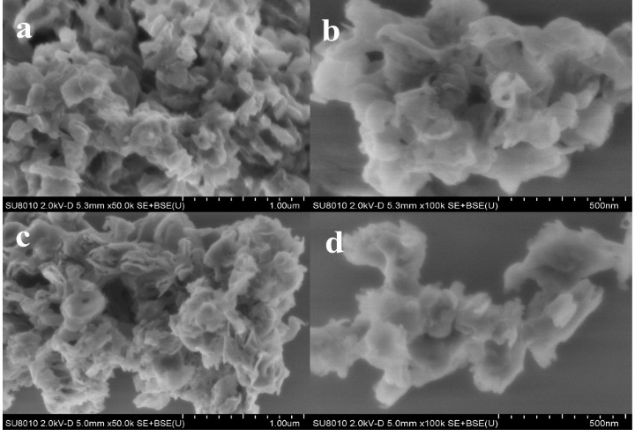
Fig. S4. N₂ adsorption-desorption isotherms of g-C₃N₄ and C_{0.02}CN
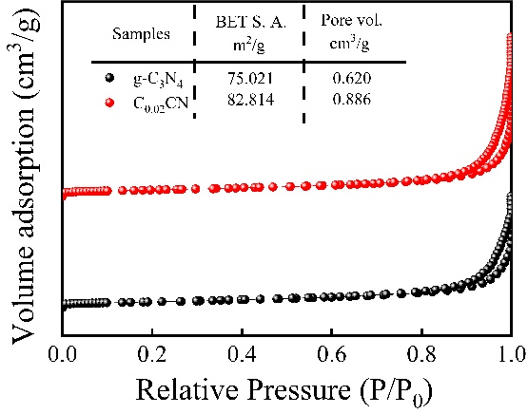

Table. S1. Fitting parameters for photocatalytic BPA degradation in the presence of C_{X}CN by pseudo-first-order model.
Reaction condition | k_{BPA} (min⁻¹) | R²
g-C₃N₄ | 0.00266 | 0.9655
C_{0.005}CN | 0.00990 | 0.9975
C_{0.01}CN | 0.01291 | 0.9968
C_{0.02}CN | 0.01778 | 0.9915
C_{0.05}CN | 0.00911 | 0.9973
C_{0.08}CN | 0.00877 | 0.9904

Table. S2. Comparison of studies on the photocatalysis of BPA using g-C₃N₄-related photocataly
Catalyst | Reaction promotors | Degradation condition | Degradation efficiency |  | References
C_{0.02}CN | None | Xenon(300W), λ ≥ 400 nm  Photocatalyst dosage = 0.5 g/L  Initial concentration of BPA(10mg/L) | 95.5% in 150 min | this paper
In₂O₃/OGCN | None | Xenon(300W), λ ≥ 420 nm  Photocatalyst dosage = 0.5 g/L  Initial concentration of BPA(50mg/L) | 91% in 180 min | (Ahmed Uddin et al. 2021)
MCN/HRP | None | Xenon(300W)  Photocatalyst dosage = 0.5 g/L  Initial concentration of BPA(10mg/L) | 85.7% in 50 min | (Haibo Zhang et al. 2020)
30-GNT | None | Sunlight,  Photocatalyst dosage = 0.5 g/L  Initial concentration of BPA(20mg/L) | 78% in 240 min | (Sutar et al. 2020)
APC-25 | None | Photocatalyst dosage = 0.1 g/L  Initial concentration of BPA(10mg/L) | 92.8% in 180 min | (Mei et al. 2018)
CNFe | 10mM PDS | LED lamps  Photocatalyst dosage = 0.5 g/L  Initial concentration of BPA(0.5mM) | 92% in 60 min | (Suding Yan et al. 2019)
g-C₃N₄/MIL-101(Fe) | persulfate | Xenon(300W), λ ≥ 400 nm  Photocatalyst dosage = 0.5 g/L  Initial concentration of BPA(10mg/L) | 98% in 60 min | (Yan Gong et al. 2018)
DMCN-3.5 | persulfate | Xenon(300W), λ ≥ 420 nm  Photocatalyst dosage = 0.5 g/L  Initial concentration of BPA(20mg/L) | Almost 100% in 15 min | (Sai Zhang et al. 2019)

Table. S3. The elemental compositions of g-C₃N₄ and C_{0.02}CN samples
sample | C (%) | N (%) | O (%) | C/N (%)
pristine g-C₃N₄ | 50.29 | 44.05 | 5.65 | 1.142
C_{0.02}CN | 57.01 | 35.52 | 7.47 | 1.605

Ahmed Uddin, Abdur Rauf, Tong Wu, Rizwan Khan, Yalin Yu, Ling Tan, Fang Jiang, Chen H (2021) In₂O₃/oxygen doped g-C₃N₄ towards photocatalytic BPA degradation: Balance of oxygen between metal oxides and doped g-C₃N₄. J Colloid Interf Sci 602, 261-273, http://doi.org/10.1016/j.jcis.2021.06.003.
Haibo Zhang, Jiacong Wu, Juan Han, Lei Wang, Wenli Zhang, Hongjun Dong, Chunmei Li, Wang Y (2020) Photocatalyst/enzyme heterojunction fabricated for high-efficiency photoenzyme synergic catalytic degrading Bisphenol A in water. Chem Eng J 385, 123764, http://doi.org/ARTN 123764
10.1016/j.cej.2019.123764.
Mei J, Zhang DP, Li N, Zhang MX, Gu XY, Miao SC, Cui SH, Yang J (2018) The synthesis of Ag₃PO₄/g-C₃N₄ nanocomposites and the application in the photocatalytic degradation of bisphenol A under visible light irradiation. J Alloy Compd 749, 715-723, http://doi.org/10.1016/j.jallcom.2018.03.251.
Sai Zhang, Shuang Song, Pengcheng Gu, Ran Ma, Dongli Wei, Guixia Zhao, Tao Wen, Riffat Jehan, Baowei Hu, Wang X (2019) Visible-light-driven activation of persulfate over cyano and hydroxyl group co-modified mesoporous g-C₃N₄ for boosting bisphenol A degradation. J. Mater. Chem. A 7, 5552, http://doi.org/10.1039/C9TA00339H.
Suding Yan, Yue Shi, Yufang Tao, Zhang H (2019) Enhanced persulfate-mediated photocatalytic oxidation of bisphenol A using bioelectricity and a g-C₃N₄/Fe₂O₃ heterojunction. Chem Eng J 359, 933-943, http://doi.org/10.1016/j.cej.2018.11.093.
Sutar RS, Barkul RP, Delekar SD, Patil MK (2020) Sunlight assisted photocatalytic degradation of organic pollutants using g-C₃N₄-TiO₂ nanocomposites. Arab J Chem 13, 4966-4977, http://doi.org/10.1016/j.arabjc.2020.01.019.
Yan Gong, Bo Yang, Hui Zhang, Zhao X (2018) A g-C₃N₄/MIL-101(Fe) heterostructure composite for highly efficient BPA degradation with persulfate under visible light irradiation. Journal of Materials Chemistry A 6, 23703, http://doi.org/10.1039/C8TA07915C.

