Supporting Information
Tribological interaction of plasma functionalized CaCO₃ nanoparticles with zinc and ashless dithiophosphate additives
Kimaya Vyavhareª, Richard B. Timmons^{b}, Ali Erdemir^{c}, and Pranesh B. Aswath^{a,*}

Corresponding Author: Pranesh B. Aswath, Materials Science and Engineering, P.O. Box 19031, University of Texas at Arlington, Arlington, TX 76019. Email: aswath@uta.edu; Phone: 817-272-0308.

1) 3D surface profile of wear scar developed on the cylindrical test specimen.
Fig. S1 3D surface profile of the wear scar developed on cylinder test specimen with lubrications (A) BO; (B) CaCO₃BM; (C) ZDDP350; (D) DDP350; (E) ZDDP350_CaCO₃BM; (F) DDP350_CaCO₃BM; and (G) ZDDP700
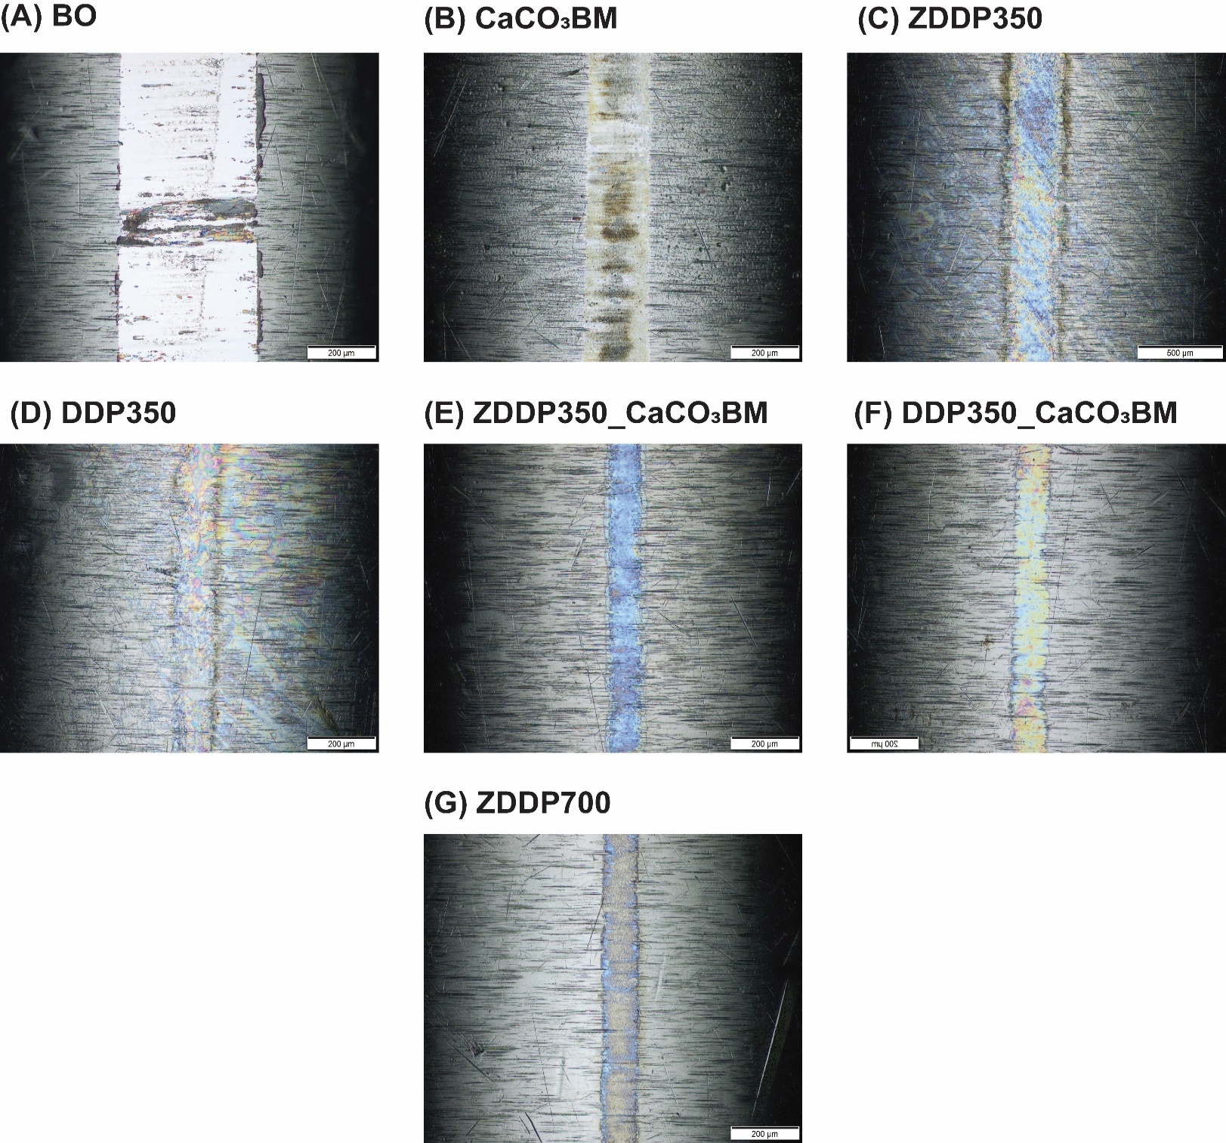
2) Optical microscopy results

Fig. S2 Optical microscopic images of the wear scar developed on cylinder test specimen with lubrications (A) BO; (B) CaCO₃BM; (C) ZDDP350; (D) DDP350; (E) ZDDP350_CaCO₃BM; (F) DDP350_CaCO₃BM; and (G) ZDDP700

Fig. S3 Optical micrographs of worn surfaces generated on flat steel specimen with formulations (A) BO; (B) CaCO₃BM; (C) ZDDP350; (D) DDP350; (E) ZDDP350_CaCO₃BM; (F) DDP350_CaCO₃BM; and (G) ZDDP700

