Table S1. Primer sequences are used for real-time PCR analysis
Accession ID | Gene | Primer sequence (5’→3’) | Amplicon size(bp)
NM_001012669 | FASN | F: ACCTCGTGAAGGCTGTGACTCA | 92
NM_001012669 | FASN | R: TGAGTCGAGGCCAAGGTCTGAA | 92
NM_174314 | ACACA | F: CATCTTGTCCGAAACGTCGAT | 101
NM_174314 | ACACA | R: CCCTTCGAACATACACCTCCA | 101
XM_024994960 | ACSBG2 | F: TTTTGTGGGCAACCAATATTGG | 113
XM_024994960 | ACSBG2 | R: CTTGATTTTGGTGAACACGAGT | 113
NM_174314 | FABP4 | F: CCAAACCCACTTTGATCATCGA | 147
NM_174314 | FABP4 | R: TTACGATGCTCTTGACTTTCCT | 147
NM_174742 | ADIPOQ | F: CTTAAGGAAGTAGCTTGAGCCT | 211
NM_174742 | ADIPOQ | R: TGAAGCAATCACCACAATCAAG | 211
NM_001076945 | SCD5 | F: TCATGGCCTTTGTTACTACACT | 203
NM_001076945 | SCD5 | R: ATTAAATCACATGTCCGCGTTC | 203
NM_001034034.2 | GAPDH | F: GGGTCATCATCTCTGCACCT | 180
NM_001034034.2 | GAPDH | R: GGTCATAAGTCCCTCCACGA | 180

Figure S1: Regulation of lipolysis in adipocytes signaling KEGG pathway in muscle tissue. Yellow shade denotes down-regulation while red shade denotes up-regulation of genes in the high-grain group.
Figure S2: Biosynthesis of unsaturated fatty acids signaling KEGG pathway in muscle tissue. Yellow shade denotes down-regulation while red shade denotes up-regulation of genes in the high-grain group.
Figure S3: PPAR signaling KEGG pathway in muscle tissue. Yellow shade denotes down-regulation while red shade denotes up-regulation of genes in the high-grain group.
Figure S4: Fatty acid biosynthesis signaling KEGG pathway in adipose tissue. Yellow shade denotes down-regulation while red shade denotes up-regulation of genes in the high-grain group.
Figure S5: Linoleic acid metabolism signaling KEGG pathway in adipose tissue. Yellow shade denotes down-regulation while red shade denotes up-regulation of genes in the high-grain group.
Figure S6: PPAR signaling KEGG pathway in adipose tissue. Yellow shade denotes down-regulation while red shade denotes up-regulation of genes in the high-grain group.

Figure S1:
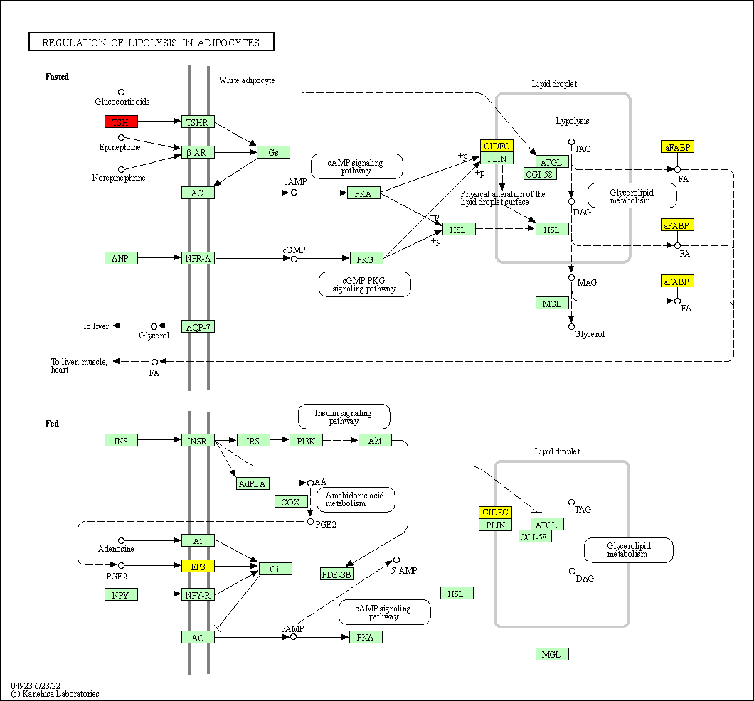

Figure S2:
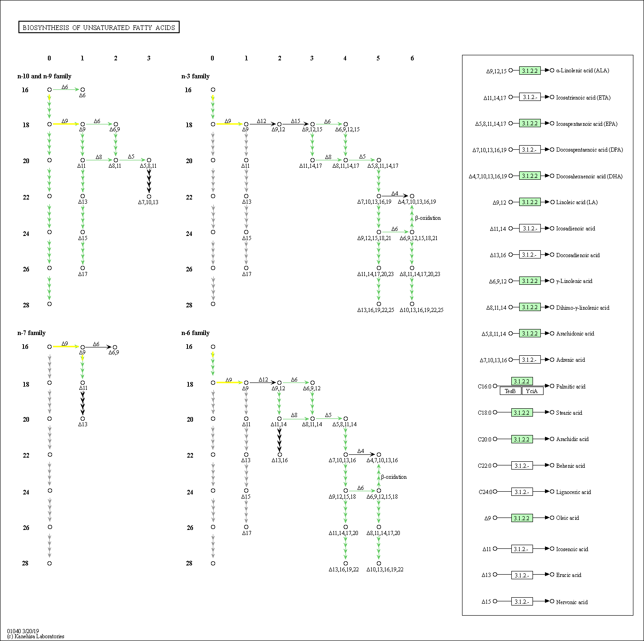

Figure S3:

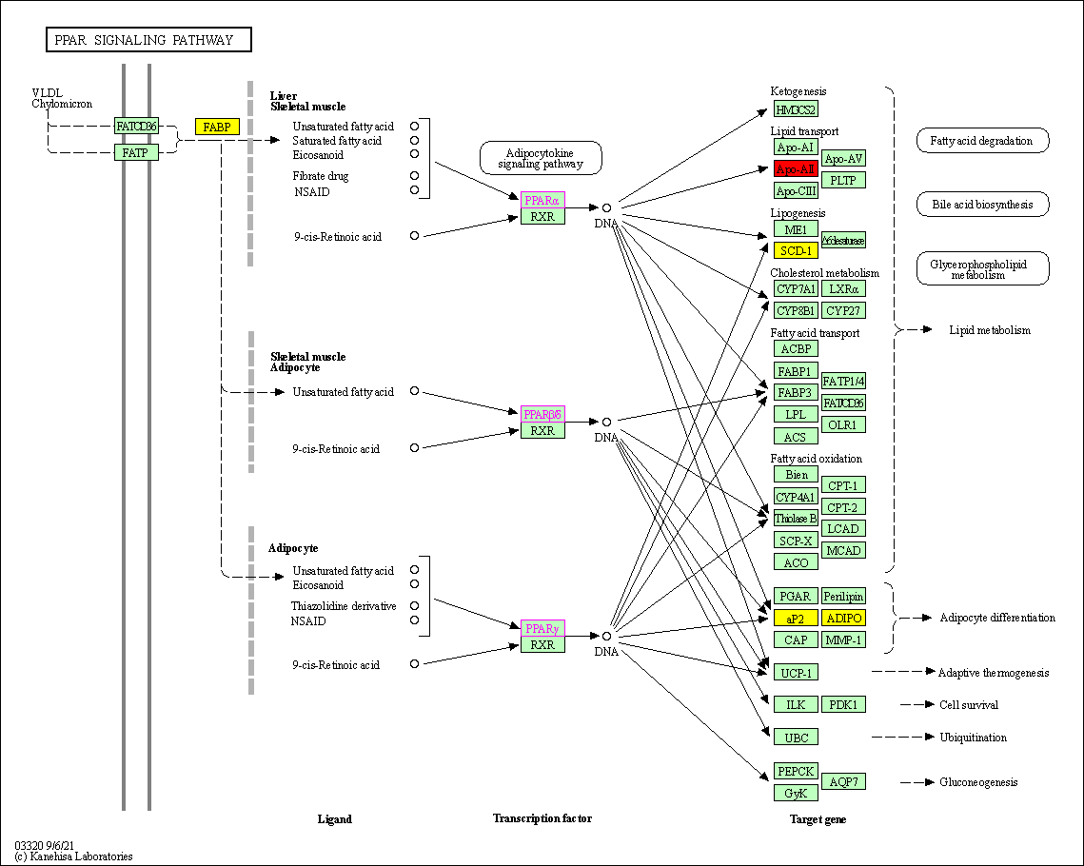

Figure S4:

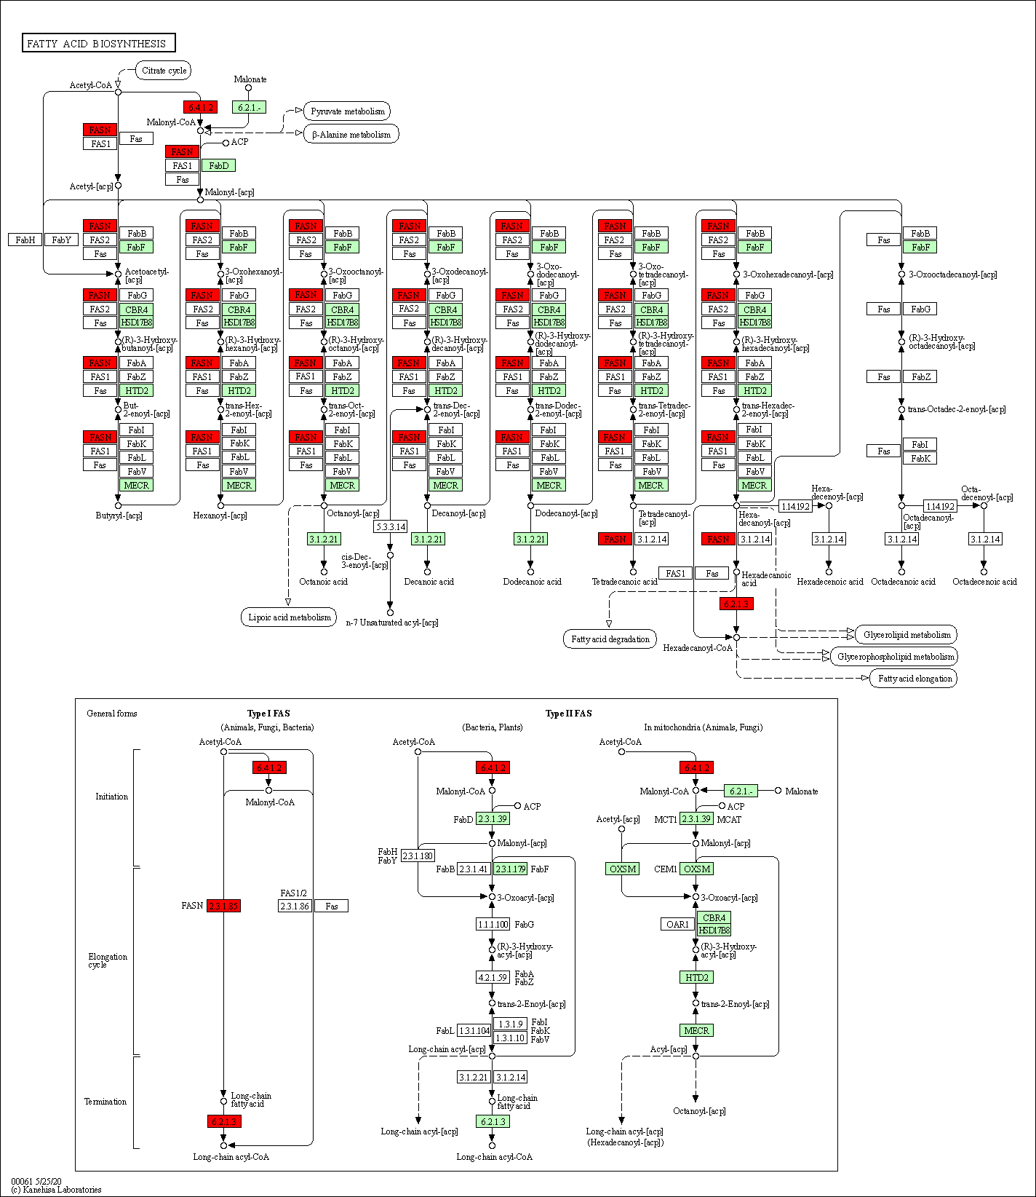

Figure S5:

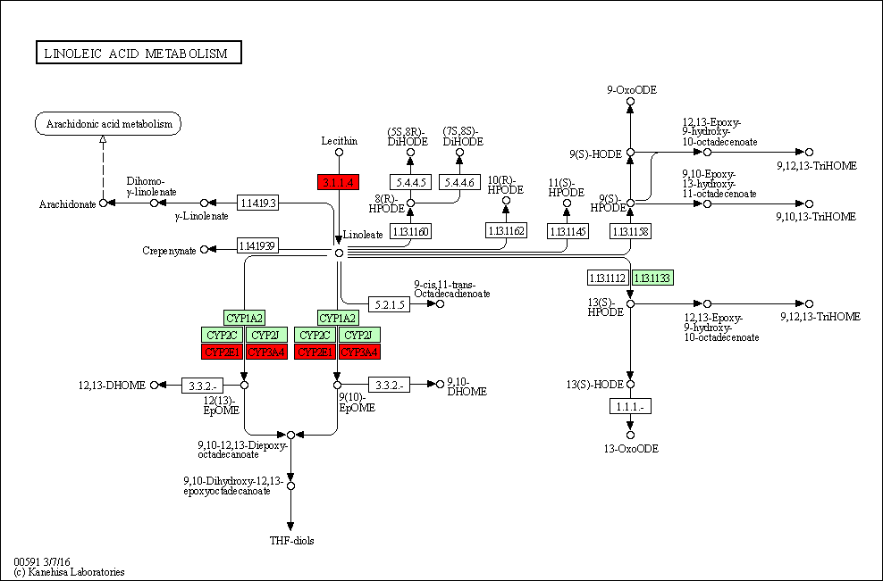

Figure S6:
