supplementary information
The stereoselective metabolic disruption of cypermethrin by a sub-acute study based on metabolomics

Sijia Gu¹, Quan Zhang^{1*}, Jinping Gu², Cui Wang³, Mengjie Chu¹, Jing Li¹, Xunjie Mo¹
- Key Laboratory of Microbial Technology for Industrial Pollution Control of Zhejiang Province, College of Environment, Zhejiang University of Technology, Hangzhou, Zhejiang, 310032, China.
- College of Pharmaceutical Sciences, Collaborative Innovation Center of Yangtze River Delta Region Green Pharmaceuticals, Zhejiang University of Technology, Hangzhou, Zhejiang, 310032, China.
- School of Life Science, Zhejiang Chinese Medical University, Hangzhou 310053, China.

*To whom correspondence should be addressed.
Phone: +86-571- 88871579.
E-mail address: quanzhang@zjut.edu.cn

Materials and Methods

Metabolomic analysis
UHPLC-MS instrumentation and data acquisition.
The gradient elution was performed as follows: 0~0.5 min, 95%B; 0.5~7.0 min, 95%~65% B; 7.0~8.0 min, 65%~40% B; 8.0~9.0 min, 40% B; 9.0~9.1 min, 40%~95% B; 9.1~12.0 min, 95% B.
The collision energy (CE) in the mass spectrometry for Triple TOF 5600 was set at 30 eV. ESI source conditions were set as follow: nebulizer gas (gas 1) pressure, 60 psi; heater gas (gas 2) pressure, 30 psi; curtain gas pressure, 35 psi; turbo spray temperature, 600 ◦C; ion spray voltage floating, +5000 (positive)/− 4000 (negative) V; declustering potential, 60 V.

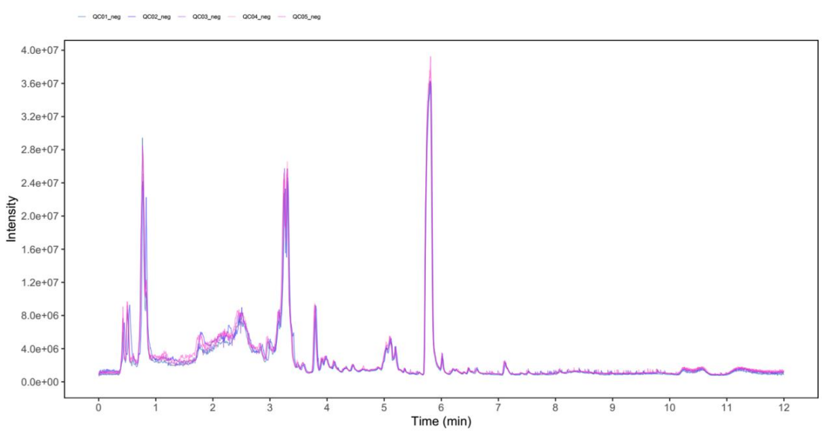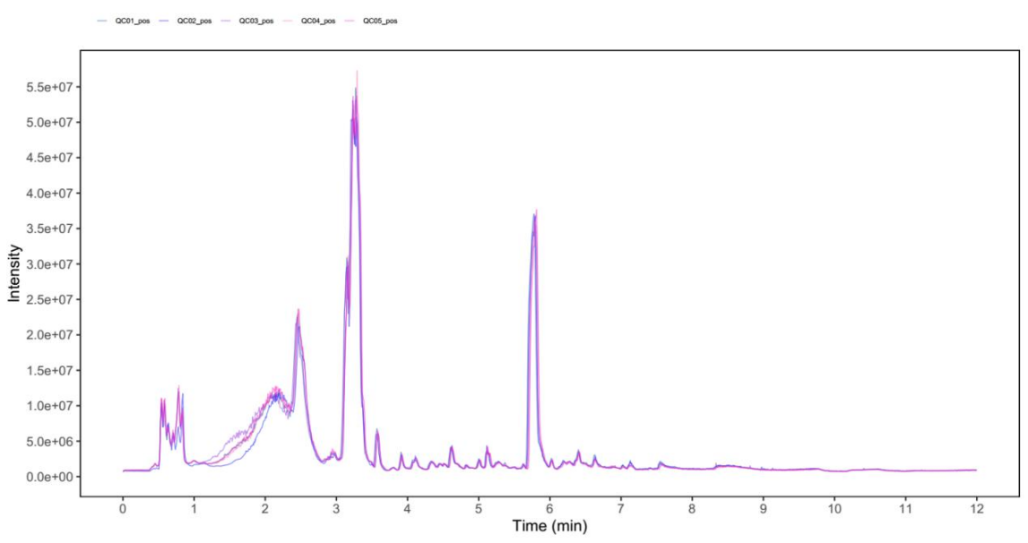
b
a
Figure S1. UHPLC-QTOF-MS detection of total ion chromatograms (TICs) in (a) ESI- and (b) ESI+ mode.

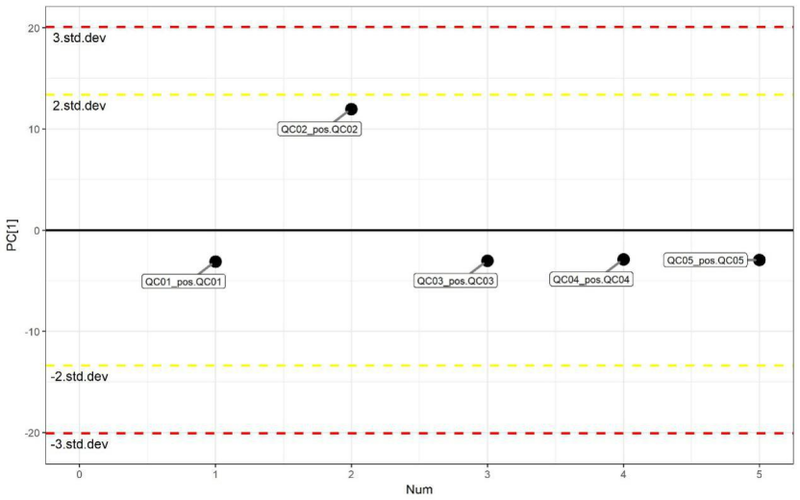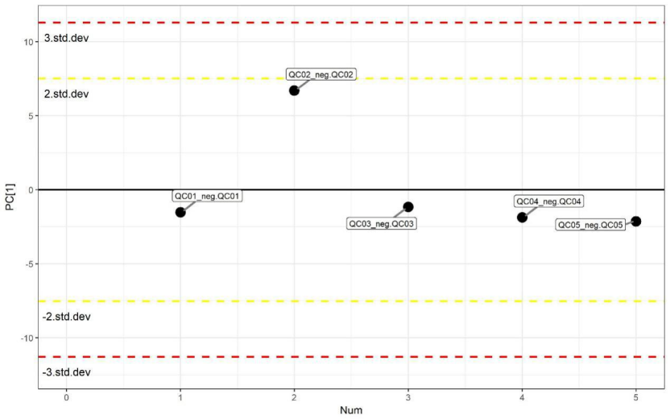
b
a
Figure S2. One-dimensional distribution of PCA for QC samples in (a) ESI- and (b) ESI+ mode.

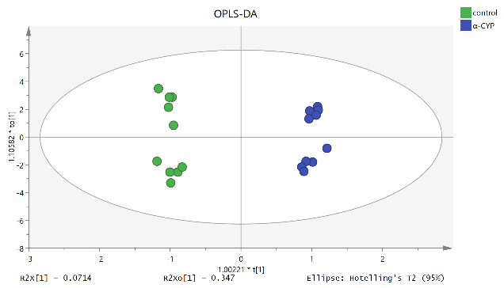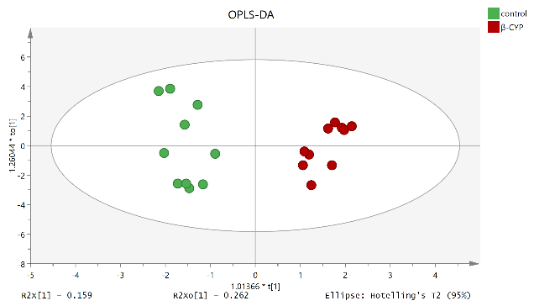
male
female
male
female
d
c
b
a

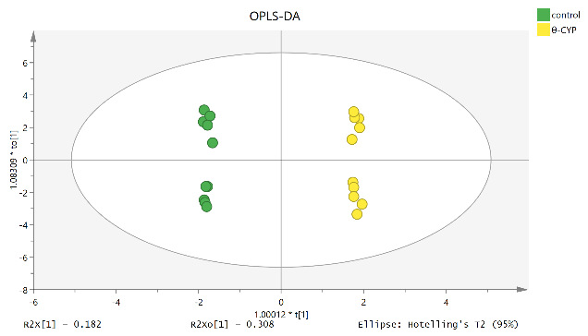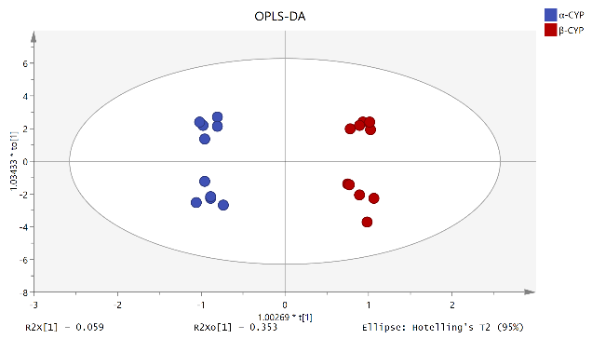
male
male
female
female
f
e
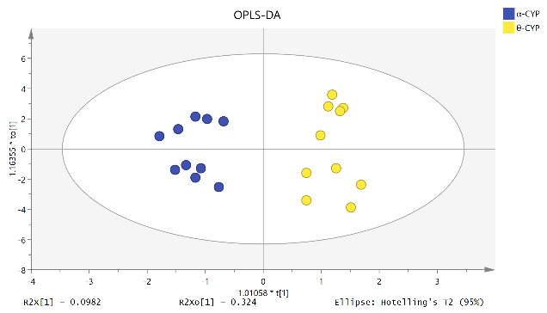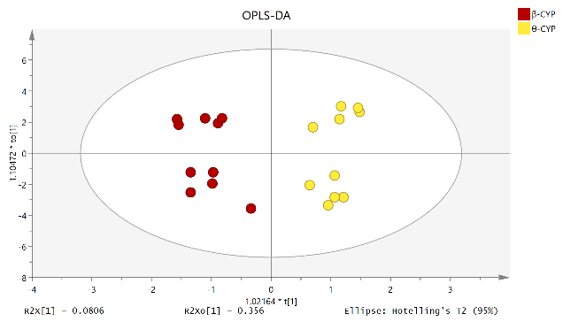
male
male
female
female
Figure S3. OPLS-DA score plots of plasma metabolites in ESI⁻ mode. (a) control group vs. α-CYP group; (b) control group vs. β-CYP group; (c) control group vs. θ-CYP group; (d) α-CYP group vs β-CYP group; （e）α-CYP group vs. θ-CYP group; （f）β-CYP group vs. θ-CYP group.

a
b
f
e
d
c
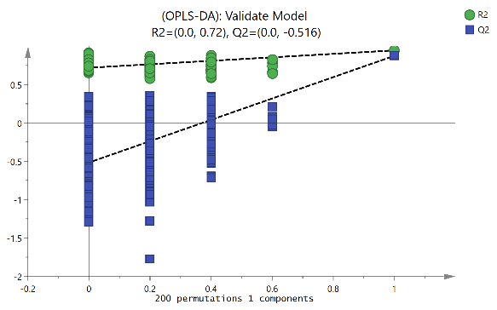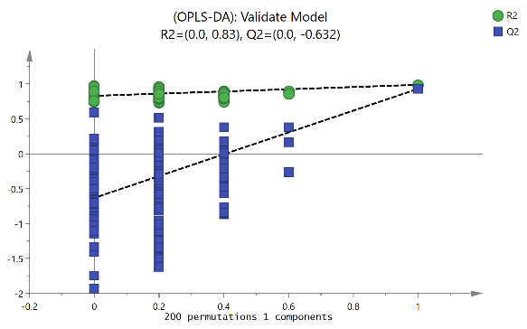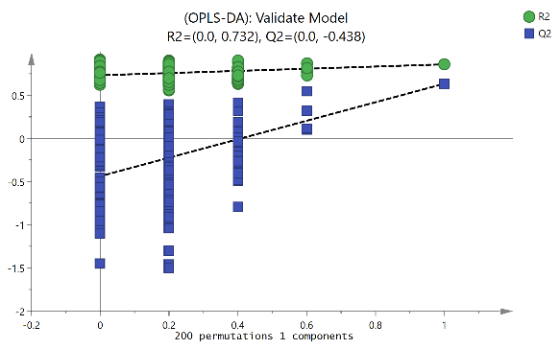
Figure S4. Permutation tests of the OPLS-DA model in ESI⁻ mode, each with 200 random orders. (a) control group vs. α-CYP group; (b) control group vs. β-CYP group; (c) control group vs. θ-CYP group; (d) α-CYP group vs β-CYP group; （e）α-CYP group vs. θ-CYP group; （f）β-CYP group vs. θ-CYP group.

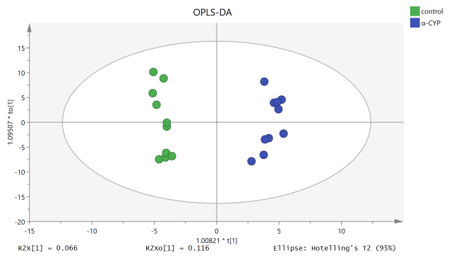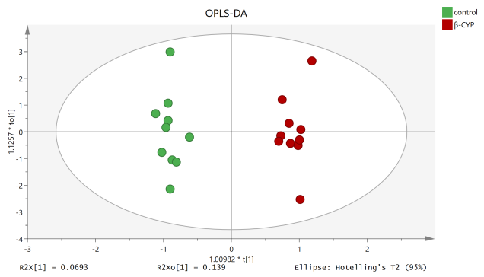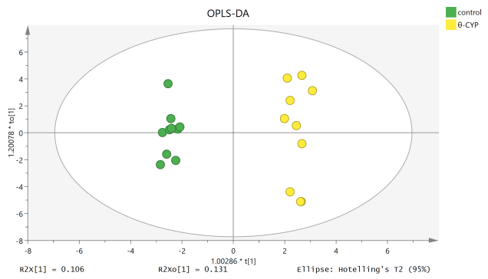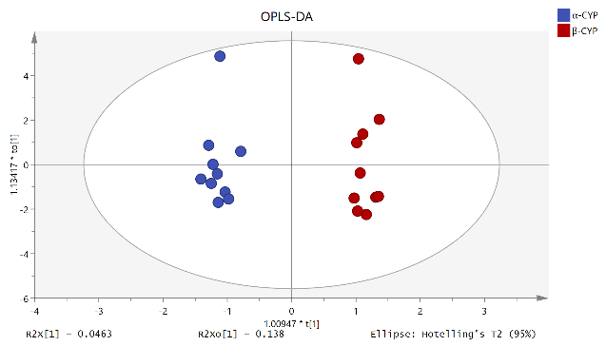
f
e
d
c
a
b
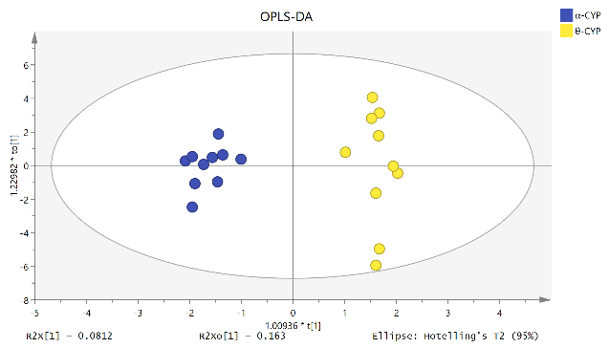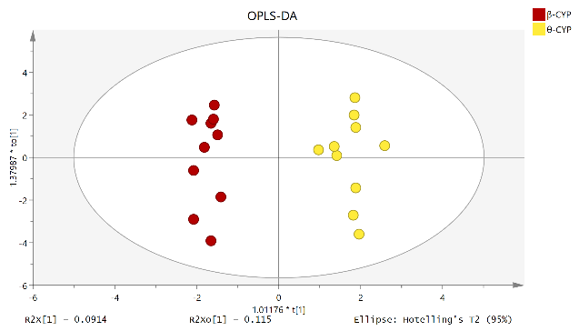
Figure S5. OPLS-DA score plots of plasma metabolites in ESI⁺ mode. (a) control group vs. α-CYP group; (b) control group vs. β-CYP group; (c) control group vs. θ-CYP group; (d) α-CYP group vs β-CYP group; （e）α-CYP group vs. θ-CYP group; （f）β-CYP group vs. θ-CYP group.

d
c
b
a
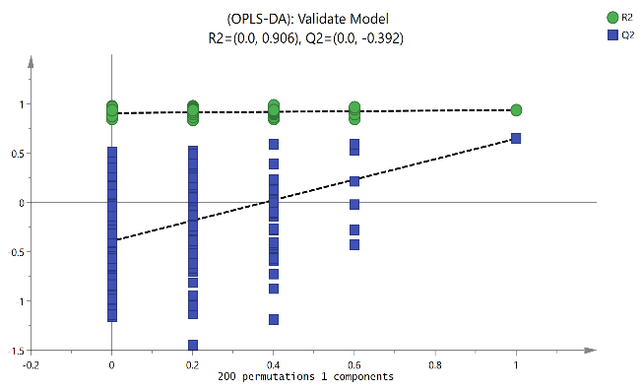
f
e
Figure S6. Permutation tests of the OPLS-DA model inESI⁺ mode, each with 200 random orders. (a) control group vs. α-CYP group; (b) control group vs. β-CYP group; (c) control group vs. θ-CYP group; (d) α-CYP group vs β-CYP group; （e）α-CYP group vs. θ-CYP group; （f）β-CYP group vs. θ-CYP group.

Table S1. DEMs in rats compared between the control and α-CYP groups
 | No. | Metabolites | Log₂FC | P value | VIP | Regulated | Gender
Neg |  | Nervonic acid | 0.7590 | 0.0147 | 1.9723 | ↑ | ♀
Neg |  | 5,8,11-Eicosatrienoic acid | 0.8729 | 0.0437 | 1.8020 | ↑ | ♀
Neg |  | Myristoleic acid | -0.7227 | 0.0082 | 2.2610 | ↓ | ♀
Neg |  | Gamma-Linolenic acid | 0.6402 | 0.0216 | 2.0229 | ↑ | ♀
Neg |  | L-Phenylalanine | -0.8530 | 0.0406 | 1.7959 | ↓ | ♀
Neg |  | Cytidine | -0.7280 | 0.0482 | 1.7691 | ↓ | ♀
Neg |  | Citrulline | -0.6593 | 0.0106 | 2.2168 | ↓ | ♀
Neg |  | D-Glucurono-6,3-lactone | 0.5902 | 0.0061 | 2.2909 | ↑ | ♀
Neg |  | 4-Hydroxyproline | -0.8248 | 0.0374 | 1.9130 | ↓ | ♀
Neg |  | Cortisol | 1.0753 | 0.0079 | 2.3582 | ↑ | ♀
Neg |  | N-Formyl-L-methionine | -0.6856 | 0.0137 | 2.0806 | ↓ | ♀
Neg |  | D-Glucuronic acid | 0.9871 | 0.0018 | 1.5930 | ↑ | ♀
Neg |  | Allocholic acid | 1.4917 | 0.0138 | 2.2074 | ↑ | ♂
Neg |  | Gingerol | -0.6477 | 0.0469 | 1.7722 | ↓ | ♂
Neg |  | 2-Isopropylmalic acid | 0.6243 | 0.0273 | 1.8340 | ↑ | ——
Neg |  | L-Leucine | -0.7297 | 0.0172 | 2.0569 | ↓ | ——
Neg |  | L-Glutamic acid | -0.8764 | 0.0234 | 1.3485 | ↓ | ——
Pos |  | PC(22:6(4Z,7Z,10Z,13Z,16Z,19Z)/15:0) | 0.6127 | 0.0007 | 3.0420 | ↑ | ♀
Pos |  | Rubraflavone A | 0.5988 | 0.0008 | 2.9608 | ↑ | ♀
Pos |  | 1-Methylhypoxanthine | 0.6832 | 0.0002 | 3.2129 | ↑ | ♀
Pos |  | Glucosamine 6-phosphate | 0.7565 | 0.0321 | 2.0123 | ↑ | ♀
Pos |  | N-Alpha-acetyllysine | 0.5855 | 0.0305 | 2.0536 | ↑ | ♂
Pos |  | Ureidoisobutyric acid | 1.1256 | 0.0034 | 2.7541 | ↑ | ♂
Pos |  | PC(16:1(9Z)/15:0) | 0.6544 | 0.0407 | 1.9447 | ↑ | ♂
Pos |  | 2-Phospho-D-glyceric acid | -0.8911 | 0.0138 | 2.3489 | ↓ | ♂
Pos |  | PC(P-18:0/22:5(4Z,7Z,10Z,13Z,16Z)) | -0.6443 | 0.0408 | 1.9693 | ↓ | ——
Pos |  | Dityrosine | 0.6277 | 0.0295 | 2.0958 | ↑ | ——
Pos |  | PC(P-16:0/20:3(5Z,8Z,11Z)) | -0.7018 | 0.0136 | 2.5576 | ↓ | ——
Pos |  | (6Z,9Z)-6,9-Pentadecadien-2-one | 0.5956 | 0.0458 | 2.1079 | ↑ | ——
Pos |  | PS(14:0/15:0) | 0.8136 | 0.00911 | 2.3976 | ↑ | ——
Pos |  | Dihydrobrassicasterol | 1.0264 | 0.0206 | 2.2961 | ↑ | ——
Pos |  | (E)-2',4,4',6'-Tetrahydroxy-3',5'-diprenylchalcone | 0.4617 | 0.0425 | 2.0565 | ↑ | ——
Pos |  | N-Acetyl-D-glucosamine | 0.7271 | 0.0359 | 2.0400 | ↑ | ——
Pos |  | Cortisol | 0.6233 | 0.0074 | 2.4911 | ↑ | ——
Pos |  | 1-Methyladenine | 0.5886 | 0.0050 | 2.6137 | ↑ | ——
Pos |  | LysoPC(16:0) | -0.6572 | 0.0450 | 2.0932 | ↓ | ——
Pos |  | lysoPC(26:1(5Z)) | 0.6029 | 0.0332 | 1.8732 | ↑ | ——
Pos |  | beta-D-Glucosamine | -1.1034 | 0.0441 | 1.9204 | ↓ | ——

Table S2. DEMs in rats compared between the control vs β-CYP groups.
 | No. | Metabolites | Log2FC | P value | VIP | Regulated | Gender
Neg |  | Oleic acid | -1.3550 | 0.0239 | 1.9097 | ↓ | ♀
Neg |  | Citrulline | -0.8034 | 0.0032 | 2.3868 | ↓ | ♀
Neg |  | Tricosanoic acid | -1.2648 | 0.0162 | 2.0362 | ↓ | ♀
Neg |  | D-Glucurono-6,3-lactone | 0.6397 | 0.0020 | 2.2712 | ↑ | ♀
Neg |  | [10]-Dehydrogingerdione | -0.8461 | 0.0150 | 1.9429 | ↓ | ♀
Neg |  | Cytidine | -0.6511 | 0.0285 | 1.8877 | ↓ | ♀
Neg |  | Carmine red | -1.1604 | 0.0290 | 1.7445 | ↓ | ♀
Neg |  | Allocholic acid | 3.1979 | 0.0005 | 2.6582 | ↑ | ♀♂
Neg |  | Cortisol | 2.4474 | 0.0003 | 2.7845 | ↑ | ♀♂
Neg |  | Cis-5-Caffeoylquinic acid | -0.5867 | 0.0361 | 1.7807 | ↓ | ♂
Neg |  | Nervonic acid | 0.7684 | 0.0064 | 2.1959 | ↑ | ——
Neg |  | 4-Hydroxyproline | -0.5954 | 0.0441 | 1.6648 | ↓ | ——
Neg |  | L-Phenylalanine | -0.6663 | 0.0324 | 1.8028 | ↓ | ——
Neg |  | 4-Dodecylbenzenesulfonic Acid | -0.9718 | 0.0409 | 1.7673 | ↓ | ——
Neg |  | p-Cresol sulfate | -0.5982 | 0.0479 | 1.6581 | ↓ | ——
Neg |  | N-methyl-L-glutamic Acid | -0.6168 | 0.0418 | 1.6644 | ↓ | ——
Neg |  | 1-Methylhistidine | -1.5424 | 0.0422 | 1.6525 | ↓ | ——
Pos |  | 5-Acetamidovalerate | -0.5903 | 0.0105 | 2.5825 | ↓ | ♀
Pos |  | PS(18:0/22:0) | -0.6318 | 0.03110 | 2.0712 | ↓ | ♀
Pos |  | Dihydrobrassicasterol | 2.3450 | 0.0024 | 2.9625 | ↑ | ♀♂
Pos |  | Gluconic acid | 0.6872 | 0.0158 | 1.8760 | ↑ | ♀♂
Pos |  | PG(16:0/16:0) | -0.5899 | 0.0431 | 1.9687 | ↓ | ♂
Pos |  | PS(14:0/15:0) | 0.7391 | 0.0074 | 2.3593 | ↓ | ♂
Pos |  | PC(16:1(9Z)/22:5(4Z,7Z,10Z,13Z,16Z)) | -0.6722 | 0.0324 | 2.1746 | ↓ | ——
Pos |  | LysoPA(16:0/0:0) | -0.8917 | 0.0308 | 1.9823 | ↓ | ——
Pos |  | LysoPC(24:1(15Z)) | -0.6331 | 0.0035 | 1.857 | ↓ | ——
Pos |  | Asparaginyl-Tyrosine | -0.6928 | 0.0156 | 2.3171 | ↓ | ——
Pos |  | PC(18:2(9Z,12Z)/15:0) | -0.8214 | 0.0332 | 1.9775 | ↓ | ——
Pos |  | N-Acetyl-D-glucosamine | 0.5995 | 0.0315 | 1.9899 | ↑ | ——
Pos |  | Elaidic carnitine | 0.8507 | 0.0109 | 2.4783 | ↑ | ——

Table S3. DEMs in rats compared between the control and θ-CYP groups.
 | No. | Metabolites | Log2FC | P value | VIP | Regulated | Gender
Neg |  | Oleic acid | -2.0867 | 0.02127 | 1.6084 | ↓ | ♀
Neg |  | L-Phenylalanine | -0.5947 | 0.0009 | 2.1462 | ↓ | ♀
Neg |  | Citrulline | -0.7218 | 0.0044 | 2.0148 | ↓ | ♀
Neg |  | Tricosanoic acid | -1.5267 | 0.0356 | 1.4707 | ↓ | ♀
Neg |  | D-Glucuronic acid | 0.6914 | 0.0002 | 2.3576 | ↑ | ♀
Neg |  | Gluconic acid | 0.7109 | 0.0018 | 2.0546 | ↑ | ♀
Neg |  | D-Glucurono-6,3-lactone | 0.6040 | 0.0004 | 2.1707 | ↑ | ♀♂
Neg |  | Pentadecanoic acid | 0.9700 | 0.0002 | 2.3941 | ↑ | ♀♂
Neg |  | Cortisol | 2.4204 | 0.0003 | 2.5335 | ↑ | ♀♂
Neg |  | Nervonic acid | 1.3539 | 0.0004 | 2.4095 | ↑ | ♀♂
Neg |  | Allocholic acid | 3.3915 | 9.21E-05 | 2.6616 | ↑ | ♀♂
Neg |  | Alpha-Linolenic acid | 0.6535 | 0.0209 | 1.6376 | ↑ | ♂
Neg |  | Alpha-Hydroxyisobutyric acid | 0.6334 | 0.0380 | 1.4967 | ↑ | ♂
Neg |  | 1-Methylhistidine | -0.9504 | 0.0004 | 2.2641 | ↓ | ♂
Neg |  | 5-Methoxyindoleacetate | 1.7597 | 0.0157 | 1.7955 | ↑ | ♂
Neg |  | Adenylsuccinic acid | -1.7485 | 0.0290 | 1.5874 | ↓ | ♂
Neg |  | Hypogeic acid | 0.9759 | 0.0090 | 1.7975 | ↑ | ——
Neg |  | Myristic acid | 0.7119 | 0.0219 | 1.5799 | ↑ | ——
Neg |  | Myristoleic acid | -0.6215 | 0.0081 | 1.9536 | ↓ | ——
Neg |  | Orotidine | -0.6201 | 0.0290 | 1.5632 | ↓ | ——
Neg |  | Uridine | -0.7158 | 0.0473 | 1.4005 | ↓ | ——
Neg |  | N-methyl-L-glutamic Acid | -0.6444 | 0.02670 | 1.6682 | ↓ | ——
Pos |  | 5-Acetamidovalerate | -0.6543 | 0.0225 | 2.0172 | ↓ | ♀
Pos |  | Methyl bisnorbiotinyl ketone | -0.6182 | 0.0208 | 2.0959 | ↓ | ♀
Pos |  | 13,14-Dihydro PGE1 | 1.3881 | 0.0004 | 2.9280 | ↑ | ♀
Pos |  | N-Acetyl-D-glucosamine | 0.6304 | 0.0035 | 2.4472 | ↑ | ♀
Pos |  | Glycosminine | 0.7027 | 0.0469 | 1.8656 | ↑ | ♀
Pos |  | Glucosamine 6-phosphate | 0.9721 | 0.0049 | 2.0401 | ↑ | ♀
Pos |  | Trimethylamine N-oxide | 0.7892 | 0.0034 | 2.0135 | ↑ | ♀
Pos |  | Dihydrobrassicasterol | 2.7018 | 0.0022 | 2.7889 | ↑ | ♀♂
Pos |  | 2-Methylbutyroylcarnitine | -0.6776 | 0.0011 | 2.7223 | ↓ | ♀♂
Pos |  | PC(20:5(5Z,8Z,11Z,14Z,17Z)/20:3(5Z,8Z,11Z)) | -2.9817 | 0.0399 | 1.8638 | ↓ | ♂
Pos |  | 2-Phospho-D-glyceric acid | -0.8057 | 0.0083 | 2.3857 | ↓ | ♂
Pos |  | N-Acetylserine | -0.5872 | 0.0007 | 2.7140 | ↓ | ♂
Pos |  | PC(20:5(5Z,8Z,11Z,14Z,17Z)/22:5(4Z,7Z,10Z,13Z,16Z)) | -0.8848 | 0.0485 | 1.7639 | ↓ | ♂
Pos |  | Propionylcarnitine | -0.9658 | 0.0360 | 1.9191 | ↓ | ♂
Pos |  | PC(P-18:0/22:5(4Z,7Z,10Z,13Z,16Z)) | -0.9020 | 0.0029 | 2.5340 | ↓ | ♂
Pos |  | PS(22:4(7Z,10Z,13Z,16Z)/20:0) | -0.6487 | 0.0464 | 1.8063 | ↓ | ♂
Pos |  | PS(18:0/22:0) | -0.7641 | 0.0320 | 1.8707 | ↓ | ♂
Pos |  | PE(24:1(15Z)/18:3(6Z,9Z,12Z)) | -0.8493 | 0.0479 | 1.7843 | ↓ | ♂
Pos |  | PG(16:0/16:0) | -0.6179 | 0.0199 | 2.0510 | ↓ | ♂
Pos |  | L-Theanine | -0.5951 | 0.0361 | 1.8139 | ↓ | ♂
Pos |  | Phenol glucuronide | 0.8734 | 0.0309 | 1.5643 | ↑ | ——
Pos |  | PA(20:0/22:6(4Z,7Z,10Z,13Z,16Z,19Z)) | 1.1475 | 0.0302 | 2.0317 | ↑ | ——
Pos |  | PC(P-16:0/20:3(5Z,8Z,11Z)) | -0.5930 | 0.0269 | 2.0742 | ↓ | ——
Pos |  | L-Hexanoylcarnitine | 0.6323 | 0.0395 | 1.8755 | ↑ | ——
Pos |  | N-a-Acetyl-L-arginine | 0.8211 | 0.0111 | 2.3010 | ↑ | ——
Pos |  | 5-Hexenyl glucosinolate | 0.6636 | 0.0391 | 1.8849 | ↑ | ——
Pos |  | PS(14:0/15:0) | 0.8334 | 0.0070 | 2.3249 | ↑ | ——
Pos |  | N-methyl-L-glutamic Acid | 0.8730 | 0.0487 | 1.8507 | ↑ | ——
Pos |  | 6-(Hydroxymethyl)-2,4(1H,3H)-pteridinedione | 1.1240 | 0.0200 | 2.0585 | ↑ | ——
Pos |  | Cortisol | 0.6406 | 0.0109 | 2.1844 | ↑ | ——
Pos |  | 1-Methyladenine | 0.7357 | 0.0261 | 2.0732 | ↑ | ——
Pos |  | Allysine | -0.7390 | 0.0206 | 2.0852 | ↓ | ——
Pos |  | Deoxyribose 1-phosphate | -0.8212 | 0.0145 | 2.3410 | ↓ | ——
Pos |  | beta-D-Glucosamine | -.1.2385 | 0.0032 | 1.9034 | ↓ | ——

Table S4. DEMs in rats compared between α-CYP vs β-CYP groups
 | No. | Metabolites | Log₂FC | P value | VIP | Regulated | Gender
Neg |  | p-Toluenesulfonic acid | 1.1485 | 0.0346 | 2.2913 | ↑ | ♀
Neg |  | Allocholic acid | 1.7062 | 0.0031 | 2.9927 | ↑ | ♀♂
Neg |  | Cortisol | 1.3721 | 0.0025 | 3.0155 | ↑ | ♀♂
Neg |  | Octadecanedioic acid | 0.4556 | 0.0274 | 2.2108 | ↑ | ♂
Pos |  | Dihydrobrassicasterol | 1.3186 | 0.0101 | 2.5491 | ↑ | ♀
Pos |  | PC(22:4/16:0) | -0.5173 | 0.0182 | 2.4031 | ↓ | ♀♂
Pos |  | Ureidoisobutyric acid | -0.6347 | 0.0331 | 2.1295 | ↓ | ♂
Pos |  | Thiamine | -0.4807 | 0.0171 | 2.3713 | ↓ | ♂
Pos |  | 5,7-Dihydroxy-6,8-dimethylflavanone | -0.5287 | 0.0298 | 2.1664 | ↓ | ♂
Pos |  | Aspartame | -0.5053 | 0.0322 | 2.1004 | ↓ | ♂
Pos |  | PS(15:0/14:0) | -1.1482 | 0.0478 | 2.1737 | ↓ | ♂
Pos |  | 2-Phospho-D-glyceric acid | -.6501 | 0.0044 | 1.9532 | ↑ | ♂
Pos |  | Methionyl-Glutamine | -0.5111 | 0.0097 | 2.4099 | ↓ | ——
Pos |  | Methylpicraquassioside A | -0.6847 | 0.0348 | 2.1446 | ↓ | ——
Pos |  | PC(20:5/22:5) | -0.8142 | 0.0282 | 2.1478 | ↓ | ——
Pos |  | Pantothenic acid | -0.4944 | 0.0443 | 1.9665 | ↓ | ——
Pos |  | Acrimarine | -0.4475 | 0.0140 | 2.1980 | ↓ | ——
Pos |  | Muconin | -0.4771 | 0.0384 | 2.0692 | ↓ | ——
Pos |  | Elaidic carnitine | 0.4955 | 0.0344 | 2.1279 | ↑ | ——

Table S5. DEMs in rats compared between α-CYP vs θ-CYP groups
 | No. | Metabolites |  | Log₂FC | P value | VIP | Regulated | Gender
Neg |  | Cholic acid |  | 1.3059 | 0.0201 | 2.1750 | ↑ | ♀
Neg |  | Isolithocholic acid |  | 0.9864 | 0.0172 | 2.2447 | ↑ | ♀
Neg |  | Lithocholic acid |  | 1.4150 | 0.0086 | 2.4795 | ↑ | ♀
Neg |  | LysoPA(16:0/0:0) |  | 1.2089 | 0.00334 | 2.3999 | ↑ | ♀
Neg |  | Allocholic acid |  | 1.8998 | 0.0004 | 2.6737 | ↑ | ♂
Neg |  | Pentadecanoic acid |  | 0.6522 | 0.0044 | 2.2515 | ↑ | ♂
Neg |  | Octadecanedioic acid |  | 0.7071 | 0.00159 | 2.5649 | ↑ | ♂
Neg |  | Cortisol |  | 1.3451 | 0.00319 | 2.5247 | ↑ | ♂
Neg |  | 5-Methoxyindoleacetate |  | 1.3636 | 0.0029 | 2.4332 | ↑ | ♂
Neg |  | Nervonic acid |  | 0.5949 | 0.0327 | 1.9188 | ↑ | ——
Neg |  | Prostaglandin B2 |  | 1.0220 | 0.0040 | 2.4458 | ↑ | ——
Neg |  | Diethylphosphate |  | 0.6882 | 0.0354 | 2.1201 | ↑ | ——
Neg |  | Triamcinolone |  | 1.5649 | 0.0294 | 1.4620 | ↑ | ——
Neg |  | Hypogeic acid |  | 0.6044 | 0.0388 | 1.5587 | ↑ | ——
Neg |  | Adenylsuccinic acid |  | -1.7467 | 0.0265 | 1.9375 | ↓ | ——
Neg |  | Orotidine |  | -0.6393 | 0.0337 | 1.5718 | ↓ | ——
Pos |  | Trimethylamine N-oxide |  | 0.5924 | 0.0060 | 2.6109 | ↑ | ♀
Pos |  | LysoPE(16:0/0:0) |  | 2.1221 | 0.0342 | 1.9499 | ↑ | ♀
Pos |  | LysoPC(18:2(9Z,12Z)) |  | 1.2361 | 0.0150 | 2.2269 | ↑ | ♀
Pos |  | Thromboxane B3 | 0.6634 |  | 0.0200 | 2.0810 | ↑ | ♀
Pos |  | 10-Hydroxy-3-methoxy-1,3,5,7-cadinatetraen-9-one | 0.5126 |  | 0.0481 | 1.9045 | ↑ | ♀
Pos |  | Methyl bisnorbiotinyl ketone | -0.4697 |  | 0.0195 | 2.0201 | ↓ | ♀
Pos |  | Cholic acid | 1.6721 |  | 0.0369 | 1.9870 | ↑ | ♀
Pos |  | PC(20:5(5Z,8Z,11Z,14Z,17Z)/22:5(4Z,7Z,10Z,13Z,16Z)) | -0.9809 |  | 0.0188 | 2.0286 | ↓ | ♂
Pos |  | Ureidoisobutyric acid | -1.1784 |  | 0.0067 | 2.5728 | ↓ | ♂
Pos |  | Sucrose | -0.7494 |  | 0.0445 | 1.9684 | ↓ | ♂
Pos |  | PC(20:4(5Z,8Z,11Z,14Z)/18:0) | -0.6115 |  | 0.0212 | 2.0184 | ↓ | ♂
Pos |  | 2-Methylbutyroylcarnitine | -0.6248 |  | 0.0050 | 2.5068 | ↓ | ♂
Pos |  | PC(P-18:1(11Z)/18:4(6Z,9Z,12Z,15Z)) | -0.5919 |  | 0.0112 | 2.3755 | ↓ | ♂
Pos |  | Dihydrobrassicasterol | 1.6754 |  | 0.0065 | 2.4871 | ↑ | ♂
Pos |  | 4-Hydroxy-1H-indole-3-acetonitrile | -0.6357 |  | 0.0178 | 2.2065 | ↓ | ♂
Pos |  | Asparaginyl-Alanine | -0.7268 |  | 0.0319 | 1.8999 | ↓ | ——
Pos |  | (E)-2',4,4',6'-Tetrahydroxy-3',5'-diprenylchalcone | -0.5038 |  | 0.0493 | 2.0832 | ↓ | ——
Pos |  | N4-Acetylcytidine | 2.0790 |  | 0.0461 | 1.8473 | ↑ | ——
Pos |  | Diethanolamine | -0.4801 |  | 0.0315 | 1.8348 | ↓ | ——
Pos |  | Retinal | -0.6956 |  | 0.0351 | 1.8414 | ↓ | ——
Pos |  | Niacinamide | -0.6273 |  | 0.0412 | 1.7702 | ↓ | ——
Pos |  | PA(20:0/22:6(4Z,7Z,10Z,13Z,16Z,19Z)) | 0.8990 |  | 0.0467 | 1.8449 | ↑ | ——
Pos |  | 5-Hexenyl glucosinolate | 0.8061 |  | 0.0148 | 2.2930 | ↑ | ——
Pos |  | cis-5-Tetradecenoylcarnitine | 1.5950 |  | 0.0343 | 2.1366 | ↑ | ——
Pos |  | Tetradecanoylcarnitine | 1.6690 |  | 0.0410 | 2.0713 | ↑ | ——
Pos |  | Asymmetric dimethylarginine | -0.6831 |  | 0.0408 | 1.8977 | ↓ | ——

Table S6. DEMs in rats compared between β-CYP vs θ-CYP groups.
 | No. | Metabolites | log2FC | P value | VIP | Regulated | Gender
Neg |  | Cholic acid | 1.9730 | 0.0024 | 2.3952 | ↑ | ♀
Neg |  | Isolithocholic acid | 1.5035 | 0.0064 | 2.3066 | ↑ | ♀
Neg |  | Taurochenodesoxycholic acid | 1.5489 | 0.0016 | 2.4253 | ↑ | ♀
Neg |  | Alpha-Hydroxyisobutyric acid | 0.5981 | 0.0124 | 1.9828 | ↑ | ♀
Neg |  | 2-Hydroxyxanthone | 0.6461 | 0.0440 | 1.8447 | ↑ | ♀
Neg |  | L-Leucine | -0.4968 | 0.0013 | 2.5649 | ↓ | ♀♂
Neg |  | 5-Methoxyindoleacetate | 1.4017 | 0.0023 | 2.5730 | ↑ | ♂
Neg |  | Nervonic acid | 0.5856 | 0.0241 | 2.0321 | ↑ | ——
Neg |  | Adenine | -0.4872 | 0.0446 | 1.6509 | ↓ | ——
Neg |  | L-Isoleucine | -0.7050 | 0.0374 | 1.8853 | ↓ | ——
Neg |  | Hexadecanedioic acid | 0.6014 | 0.0477 | 1.7038 | ↑ | ——
Neg |  | Pentadecanoic acid | 0.7663 | 0.0395 | 1.6858 | ↑ | ——
Neg |  | Hippuric acid | 0.7647 | 0.0449 | 1.7754 | ↑ | ——
Neg |  | LysoPA(16:0/0:0) | 1.5902 | 0.0221 | 1.7873 | ↑ | ——
Neg |  | Diethylphosphate | 0.7198 | 0.0466 | 1.6891 | ↑ | ——
Neg |  | Glucosamine 6-phosphate | 0.5741 | 0.0286 | 1.8694 | ↑ | ——
Neg |  | Triamcinolone | 1.9604 | 0.0187 | 1.9290 | ↑ | ——
Neg |  | L-Methionine | -0.5968 | 0.0012 | 2.5649 | ↓ | ——
Neg |  | N-Methyl-a-aminoisobutyric acid | -0.6031 | 0.0326 | 1.7333 | ↓ | ——
Pos |  | Trimethylamine N-oxide | 0.7523 | 0.0082 | 2.4580 | ↑ | ♀
Pos |  | LysoPE(16:0/0:0) | 2.6372 | 0.0053 | 2.8235 | ↑ | ♀
Pos |  | Cholic acid | 2.5138 | 0.0049 | 2.8706 | ↑ | ♀
Pos |  | (3b,21b)-12-Oleanene-3,21,28-  triol 28 | 3.4167 | 0.0066 | 2.7797 | ↑ | ♀
Pos |  | Tetracosahexaenoic acid | 1.4696 | 0.0299 | 2.1879 | ↑ | ♀
Pos |  | LysoPC(18:2(9Z,12Z)) | 1.8971 | 0.0027 | 2.9534 | ↑ | ♀
Pos |  | 5,8-Dihydroxy-3-(4-hydroxybenzyl)-7-methoxy-4-chromanone 8-acetate | 1.6412 | 0.0479 | 1.8430 | ↑ | ♀
Pos |  | 13,14-Dihydro PGE1 | 1.2507 | 0.0029 | 2.8016 | ↑ | ♀
Pos |  | Bretylium | -0.6317 | 0.0196 | 2.0769 | ↓ | ♂
Pos |  | MG(20:4(5Z,8Z,11Z,14Z)/0:0/0:0) | 0.4798 | 0.0398 | 2.1471 | ↑ | ——
Pos |  | Trigonelline | 0.5620 | 0.0329 | 2.1400 | ↑ | ——
Pos |  | Allysine | -0.6811 | 0.0319 | 2.1686 | ↓ | ——
Pos |  | PC(P-18:0/22:5(4Z,7Z,10Z,13Z,16Z)) | -0.7177 | 0.0381 | 2.1169 | ↓ | ——
Pos |  | N-a-Acetyl-L-arginine | 0.7948 | 0.0201 | 2.4358 | ↑ | ——
Pos |  | Tetradecanoylcarnitine | 2.3711 | 0.0266 | 2.4288 | ↑ | ——
Pos |  | cis-5-Tetradecenoylcarnitine | 1.9328 | 0.0281 | 2.3872 | ↑ | ——
Pos |  | 4-Hydroxy-1H-indole-3-acetonitrile | -0.6390 | 0.0181 | 2.1263 | ↓ | ——
Pos |  | Thiomorpholine 3-carboxylate | 0.5010 | 0.0142 | 2.3220 | ↑ | ——
Pos |  | Hyoscyamine | -1.3727 | 0.0302 | 2.0491 | ↓ | ——
Pos |  | Cerulenin | 0.4252 | 0.0318 | 2.1991 | ↑ | ——
Pos |  | 2-Phospho-D-glyceric acid | -0.6543 | 0.0013 | 2.2460 | ↓ | ——

Table S7. Differentially expressed metabolites in rats compared between four groups.
Subclass | NO. | Metabolites | Retention time | m/z | P value | Significance of multiple comparisons
 |  |  |  |  |  | control  Vs α-CYP | control  Vs β-CYP | control  Vs θ-CYP | α-CYP  Vs β-CYP | α-CYP  Vs θ-CYP | β-CYP  Vs θ-CYP
Fatty Acids |  | Nervonic acid | 43.12 | 365.34 | 0.000 | * | * | *** |  | ** | **
Fatty Acids |  | Pentadecanoic acid | 48.46 | 241.22 | 0.001 |  |  | *** |  | ** | *
Fatty Acids |  | Myristoleic acid | 66.63 | 224.76 | 0.007 | ** |  | **
Fatty Acids |  | Octadecanedioic acid | 179.24 | 312.73 | 0.001 |  |  | ** | * | ***
Fatty Acids |  | Oleic acid | 36.64 | 280.89 | 0.003 |  | * | ***
Fatty Acids |  | Hypogeic acid | 48.56 | 253.22 | 0.009 |  |  | ** |  | *
Fatty Acids |  | Myristic acid | 50.01 | 227.20 | 0.038 |  | * | **
Fatty Acids |  | Tricosanoic acid | 36.68 | 352.85 | 0.007 | * | ** | **
Fatty Acids |  | 5-Acetamidovalerate | 325.05 | 160.07 | 0.026 |  | * | **
Fatty Acids |  | Tetracosahexaenoic acid | 169.209 | 357.28 | 0.042 |  |  | * |  |  | **
Fatty Acids |  | Ureidoisobutyric acid | 355.93 | 147.01 | 0.004 | ** |  |  |  | **
Fatty esters |  | Elaidic carnitine | 166.39 | 426.19 | 0.012 |  | ** |  | * |  | *
Fatty esters |  | 2-Methylbutyroylcarnitine | 259.58 | 245.18 | 0.002 |  | * | ** |  | **
bile acids |  | Cholic acid | 235.49 | 407.28 | 0.012 |  |  | ** |  | **
bile acids |  | Isolithocholic acid | 91.82 | 375.29 | 0.036 |  |  |  |  | * | **
bile acids |  | Allocholic acid | 168.23 | 406.98 | 0.000 | * | *** | *** | * | **
bile acids |  | Lithocholic acid | 92.34 | 376.29 | 0.019 |  |  |  |  | * | **
bile acids |  | Taurochenodesoxycholic acid | 237.83 | 498.31 | 0.023 |  |  |  |  |  | **
eicosanoids |  | Thromboxane B3 | 428.56 | 351.16 | 0.036 |  |  |  |  | * | **
eicosanoids |  | Prostaglandin B2 | 107.43 | 334.21 | 0.028 |  |  |  |  | ** | *
eicosanoids |  | 13,14-Dihydro PGE1 | 203.39 | 356.27 | 0.002 | * |  | ** |  |  | **
Steroids |  | Cortisol | 165.45 | 361.00 | 0.000 | * | *** | *** | ** | **
Steroids |  | Triamcinolone | 180.41 | 428.26 | 0.004 |  |  | * |  | ** | **
amino acids derivatives |  | L-Phenylalanine | 261.68 | 164.07 | 0.002 | * | * | ***
amino acids derivatives |  | L-Leucine | 269.31 | 129.68 | 0.001 | ** |  | *** |  |  | **
amino acids derivatives |  | 1-Methylhistidine | 397.25 | 168.03 | 0.031 |  | * | **
amino acids derivatives |  | N-methyl-L-glutamic Acid | 400.68 | 160.03 | 0.015 | ** | ** | *
amino acids derivatives |  | N-Acetylserine | 304.00 | 146.08 | 0.044 |  | * | **
amino acids derivatives |  | N-a-Acetyl-L-arginine | 372.61 | 216.13 | 0.031 |  |  | ** |  |  | *
amino acids derivatives |  | Citrulline | 394.25 | 174.04 | 0.015 | * | ** | *
amino acids derivatives |  | Allysine | 358.86 | 145.11 | 0.053 |  |  | * |  | * | *
Sugar derivatives |  | D-Glucurono-6,3-lactone | 228.45 | 175.02 | 0.001 | ** | ** | ***
Sugar derivatives |  | D-Glucuronic acid | 388.66 | 193.04 | 0.012 |  |  | **
Sugar derivatives |  | Glucosamine 6-phosphate | 296.08 | 257.05 | 0.0023 | * |  | * |  |  | *
Sugar derivatives |  | Sucrose | 368.82 | 365.10 | 0.048 | * |  |  |  | **
Sugar derivatives |  | 5-Hexenyl glucosinolate | 333.09 | 401.12 | 0.029 |  |  | * |  | **
Sugar derivatives |  | N-Acetyl-D-glucosamine | 269.51 | 222.10 | 0.032 | * | * | **
Sugar derivatives |  | 2-Phospho-D-glyceric acid | 373.88 | 186.05 | 0.012 | * |  | * | * |  | *
purine derivatives |  | 1-Methylhypoxanthine | 107.80 | 151.06 | 0.007 | ** | * | *
lysoglycerophospholipids |  | LysoPA(16:0/0:0) | 204.72 | 408.28 | 0.023 |  |  | * |  | * | **
lysoglycerophospholipids |  | LysoPC(18:2(9Z,12Z)) | 235.39 | 519.34 | 0.015 |  |  | ** |  |  | **
lysoglycerophospholipids |  | LysoPE(16:0/0:0) | 235.31 | 453.33 | 0.021 |  |  | ** |  |  | *
Indoles and derivatives |  | 5-Methoxyindoleacetate | 35.39 | 204.00 | 0.001 |  |  | *** |  | ** | **
Acyclic polyamines and derivatives |  | Adenylsuccinic acid | 66.49 | 457.87 | 0.044 |  |  | * |  | *
Phospholipid |  | PC(P-16:0/20:3(5Z,8Z,11Z)) | 97.70 | 768.59 | 0.016 | ** | * | *
 |  | PG(16:0/16:0) | 45.38 | 723.52 | 0.05 |  | * | *
 |  | PS(14:0/15:0) | 228.03 | 693.86 | 0.011 | ** | * | **
 |  | PA(20:0/22:6(4Z,7Z,10Z,13Z,16Z,19Z)) | 153.83 | 777.55 | 0.011 |  |  | ** |  | * | *
 |  | PC(16:1(9Z)/15:0) |  |  | 0.043 | **
 |  | PC(22:6(4Z,7Z,10Z,13Z,16Z,19Z)/15:0) | 154.76 | 792.06 | 0.045 | ** |  | *
 |  | PC(20:5(5Z,8Z,11Z,14Z,17Z)/22:5(4Z,7Z,10Z,13Z,16Z)) | 95.21 | 854.57 | 0.024 |  | * | ** |  |  | *
Polyketides |  | Rubraflavone A | 228.08 | 406.94 | 0.001 | *** | ** | **
Others |  | Methyl bisnorbiotinyl ketone | 201.50 | 216.08 | 0.022 |  |  | **
Others |  | Trimethylamine N-oxide | 333.21 | 76.08 | 0.011 |  |  | ** |  | ** | *

