Supporting Information
Article title: Temperature-mediated climatic factors dominate intraspecific variation and ecological adaptation strategies for traits of Phragmites australis rather than soil properties
Authors: Zhichao Xu, Huamin Liu, Lu Wen, Jinghui Zhang^{1,2,3}, Xiaoyun Xin¹, Jinpeng Hu¹, Xin Kou¹, Dongwei Liu^{1,2,3}, Yi Zhuo^{1,2,3}, Lixin Wang^{1,2,3†}

1. College of Ecology and Environment, Inner Mongolia University, Hohhot 010021, China
2. Collaborative in novation Center for Grassland Ecological Security (Jointly Supported by the Ministry of Education of China and Inner Mongolia Autonomous Region), Hohhot 010021, China
3. Ministry of Education Key Laboratory of Ecology and Resource Use of the Mongolian Plateau, Hohhot 010021, China
†Corresponding author. E-mail address: Lxwang@imu.edu.cn (Lixin Wang)
Postal address: School of Ecology and Environment, Inner Mongolia University, No.235 College Road West, 010021 Hohhot, China.

The following Supporting Information is available for this article:

Supporting Information Appendix S1
Study Area and Background environment data
Fig. S1 Geographical locations of lakes for each trait measured of Phragmites australis across lakeshore wetland that was used in this study. XHK, MNAB, and GLD, Located on the North, southwestern and southeastern shores of Hulun Lake, respectively in Hulunber; BEL, Buir Lake on China-Mongolia border; CGNE and ZGST, Chagannur lake and Zagustai lake in Xilingol; HJN, Hongjiannao lake in Ordos Inner Mongolia and Yulin in Shaanxi; NLH, Narin Lake in Bayanner; BG and TG, Bagadabusu lake and Tonggunaoer lake in Tenggeli desert of Alxa; BDD and BDX, Badain lake fresh water and Badain lake salt in Badain Jaran Desert of Alxa; JYH, Juyan Lake in ejina of Alxa. Among them, XHK, MNAB, GLD, BEL, ZGST and HJN belong to the semi-arid region, and CGNE, NLH, BG, TG, BDD, BDX and JYH are located in the arid region. 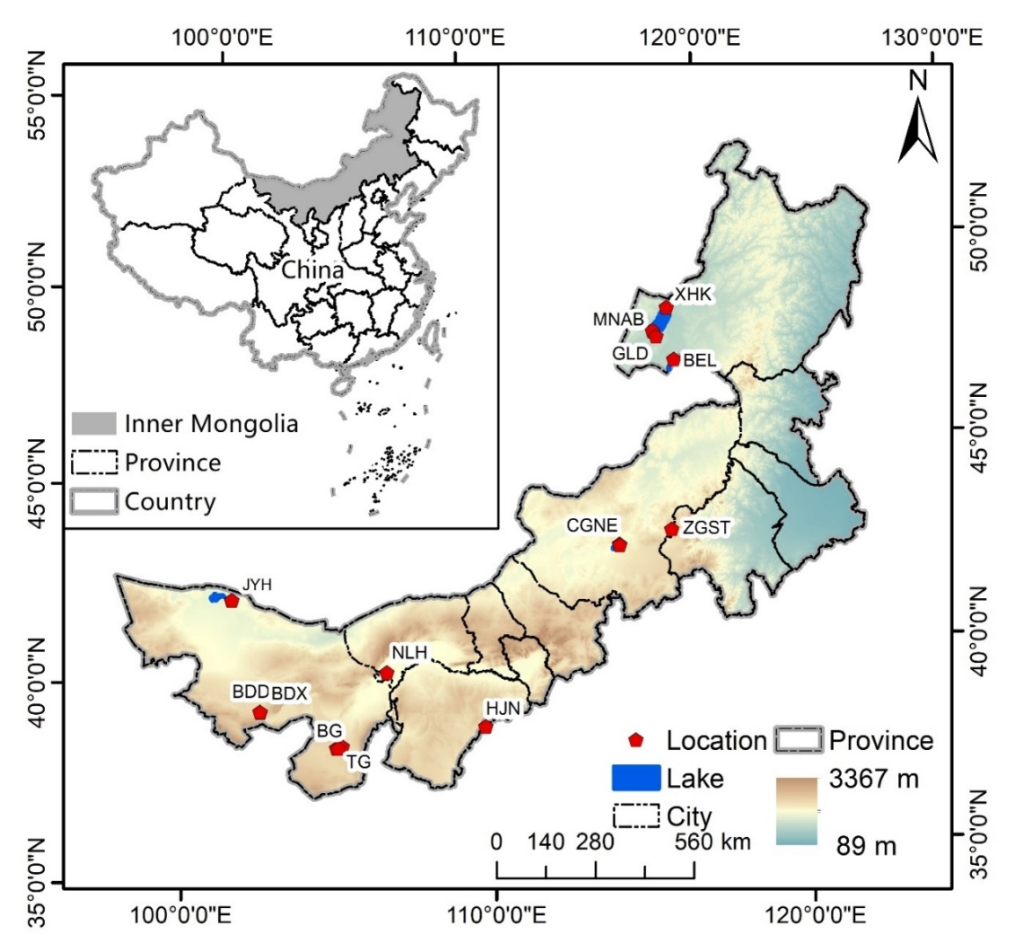
Table S1 Environmental features of the study localities of lakeshore wetlands in two regions with semi-arid and arid. Lat, latitude; Lon, longitude; E, elevation; MAT, mean annual temperature; TAR, Temperature Annual Range; MAP, mean annual precipitation; PS, precipitation seasonality; PET, potential evapo-transpiration; AI, aridity index.
Region | Semi-Arid |  |  |  |  |  | Arid
Localities | XHK | GLD | MNAB | BEL | ZGST | HJN | CGNE | NLH | TG | BG | BDD | BDX | JYH
Lat (°N） | 49.32 | 48.76 | 48.61 | 47.96 | 43.69 | 39.12 | 43.45 | 40.56 | 38.70 | 38.67 | 39.55 | 39.55 | 42.33
Lon (°E) | 117.68 | 117.05 | 117.16 | 117.71 | 116.88 | 109.91 | 114.97 | 106.64 | 105.13 | 104.94 | 102.37 | 102.36 | 101.27
E (m) | 529.91 | 532.14 | 526.47 | 574.43 | 1289.51 | 1223.12 | 999.93 | 1038.01 | 1289.10 | 1270.01 | 1323.32 | 1318.06 | 899.50
MAT (℃） | 0.28 | 0.78 | 0.89 | 0.48 | 0.93 | 7.05 | 2.82 | 8.19 | 8.99 | 9.11 | 9.06 | 9.16 | 8.34
TAR (℃） | 53.00 | 51.80 | 54.50 | 54.40 | 50.70 | 46.00 | 49.80 | 46.10 | 45.90 | 45.80 | 46.80 | 46.80 | 49.80
MAP (mm) | 295 | 247 | 255 | 264 | 337 | 370 | 244 | 118 | 158 | 155 | 88 | 90 | 43
PS (mm) | 113.94 | 111.63 | 108.73 | 110.26 | 111.66 | 107.62 | 114.16 | 105.53 | 89.84 | 91.17 | 89.56 | 86.09 | 90.42
PET (mm yr⁻¹) | 1052 | 1055 | 1142 | 1080 | 1148 | 1421 | 1283 | 1738 | 1727 | 1710 | 1860 | 1858 | 1823
AI | 0.28 | 0.23 | 0.22 | 0.24 | 0.29 | 0.26 | 0.19 | 0.07 | 0.09 | 0.09 | 0.05 | 0.05 | 0.02

Supporting Information Appendix S2
Variation of Phragmites australis functional traits in different moisture gradients
At the local scale, Phragmites australis functional traits in lakeshore wetlands responded significantly to soil moisture gradients, with different traits responding differently to moisture gradients (Fig. S2-S4, Table S2). The variation of morphological traits in response to moisture gradients was more significant in the western arid region, including NLH, BG and JYH (Fig. S2). LDMC and SLA showed opposite responses to moisture gradients in the arid region of the west and the semi-arid region of the east. Moisture gradients had a negative effect on the nitrogen content of most lakeshore wetlands P. australis roots, stems and leaves, and a positive impact on carbon content (Fig. S3). For stoichiometric ratios, the moisture gradient had a positive impact on the C:N of P. australis roots, stems, and leaves in most lakeshore wetlands, and there was no consistent conclusion on the C:P and N:P due to uncertainty about the phosphorus content in each organ (Fig. S4).

Fig. S2 Log response ratios of morphological traits in Phragmites australis at high and low moisture gradients in lakeshore wetlands. Asterisks at the top of each barplot denote statistically significant differences between the two moisture gradients.
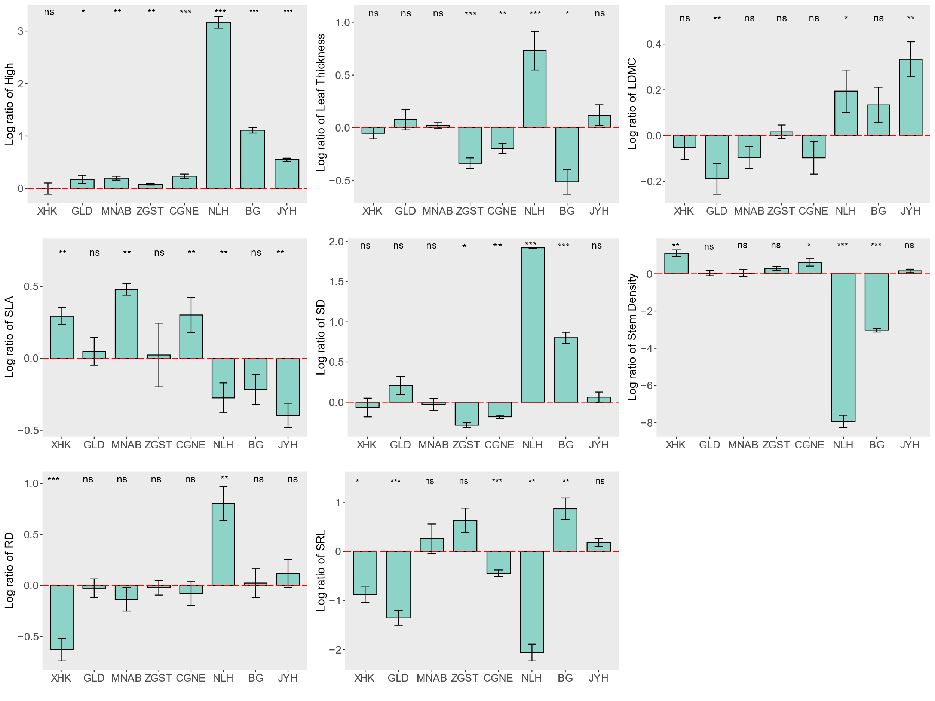

Fig. S3 Log response ratios of nutrient contents in Phragmites australis leaves, stems and roots at high and low moisture gradients in lakeshore wetlands. Asterisks at the top of each barplot denote statistically significant differences between the two moisture gradients.
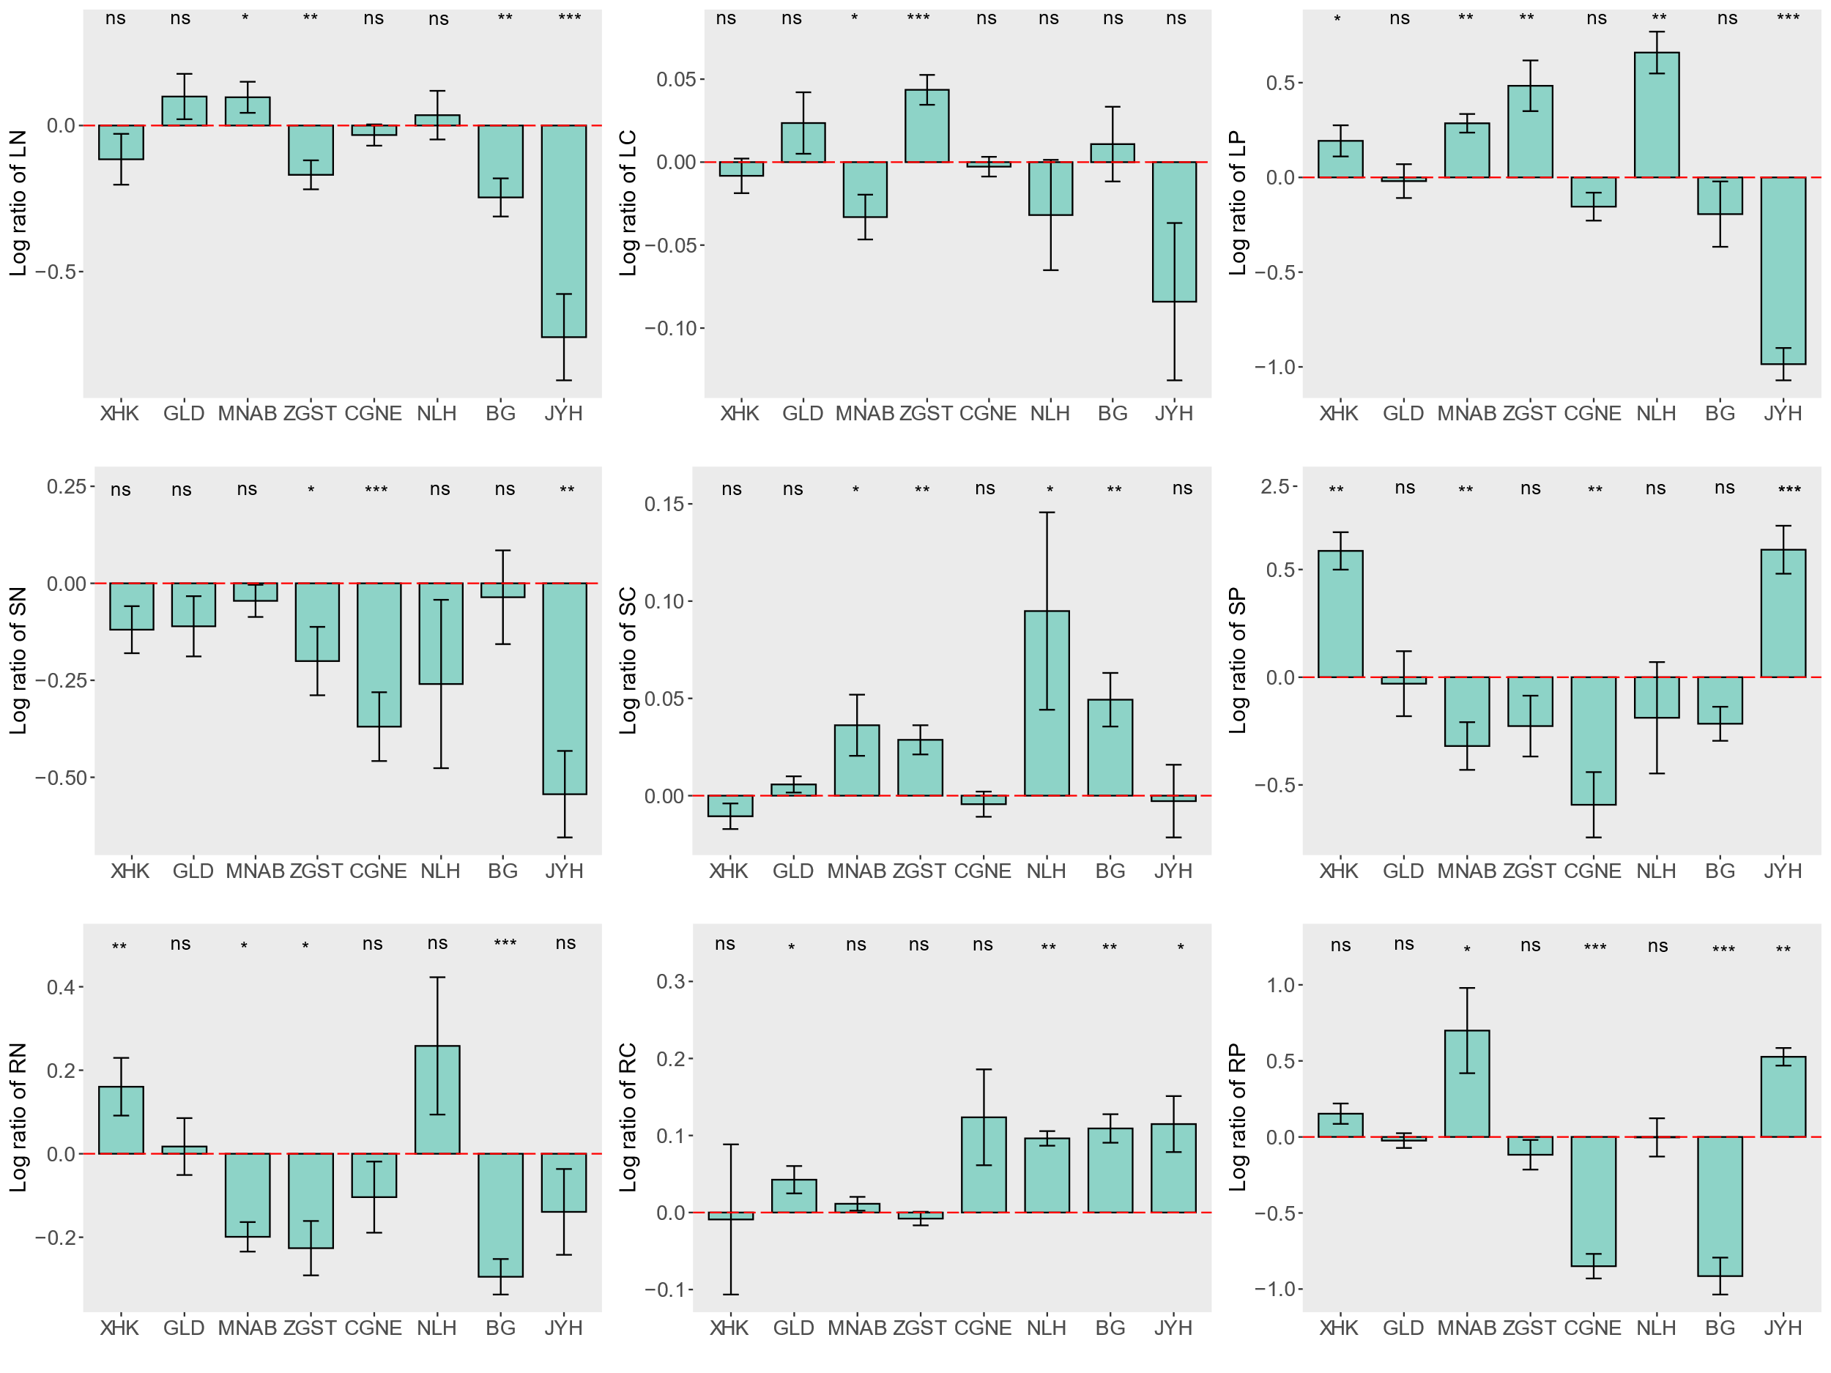

Fig. S4 Log response ratios of stoichiometric ratios in Phragmites australis leaves, stems and roots at high and low moisture gradients in lakeshore wetlands. Asterisks at the top of each barplot denote statistically significant differences between the two moisture gradients.
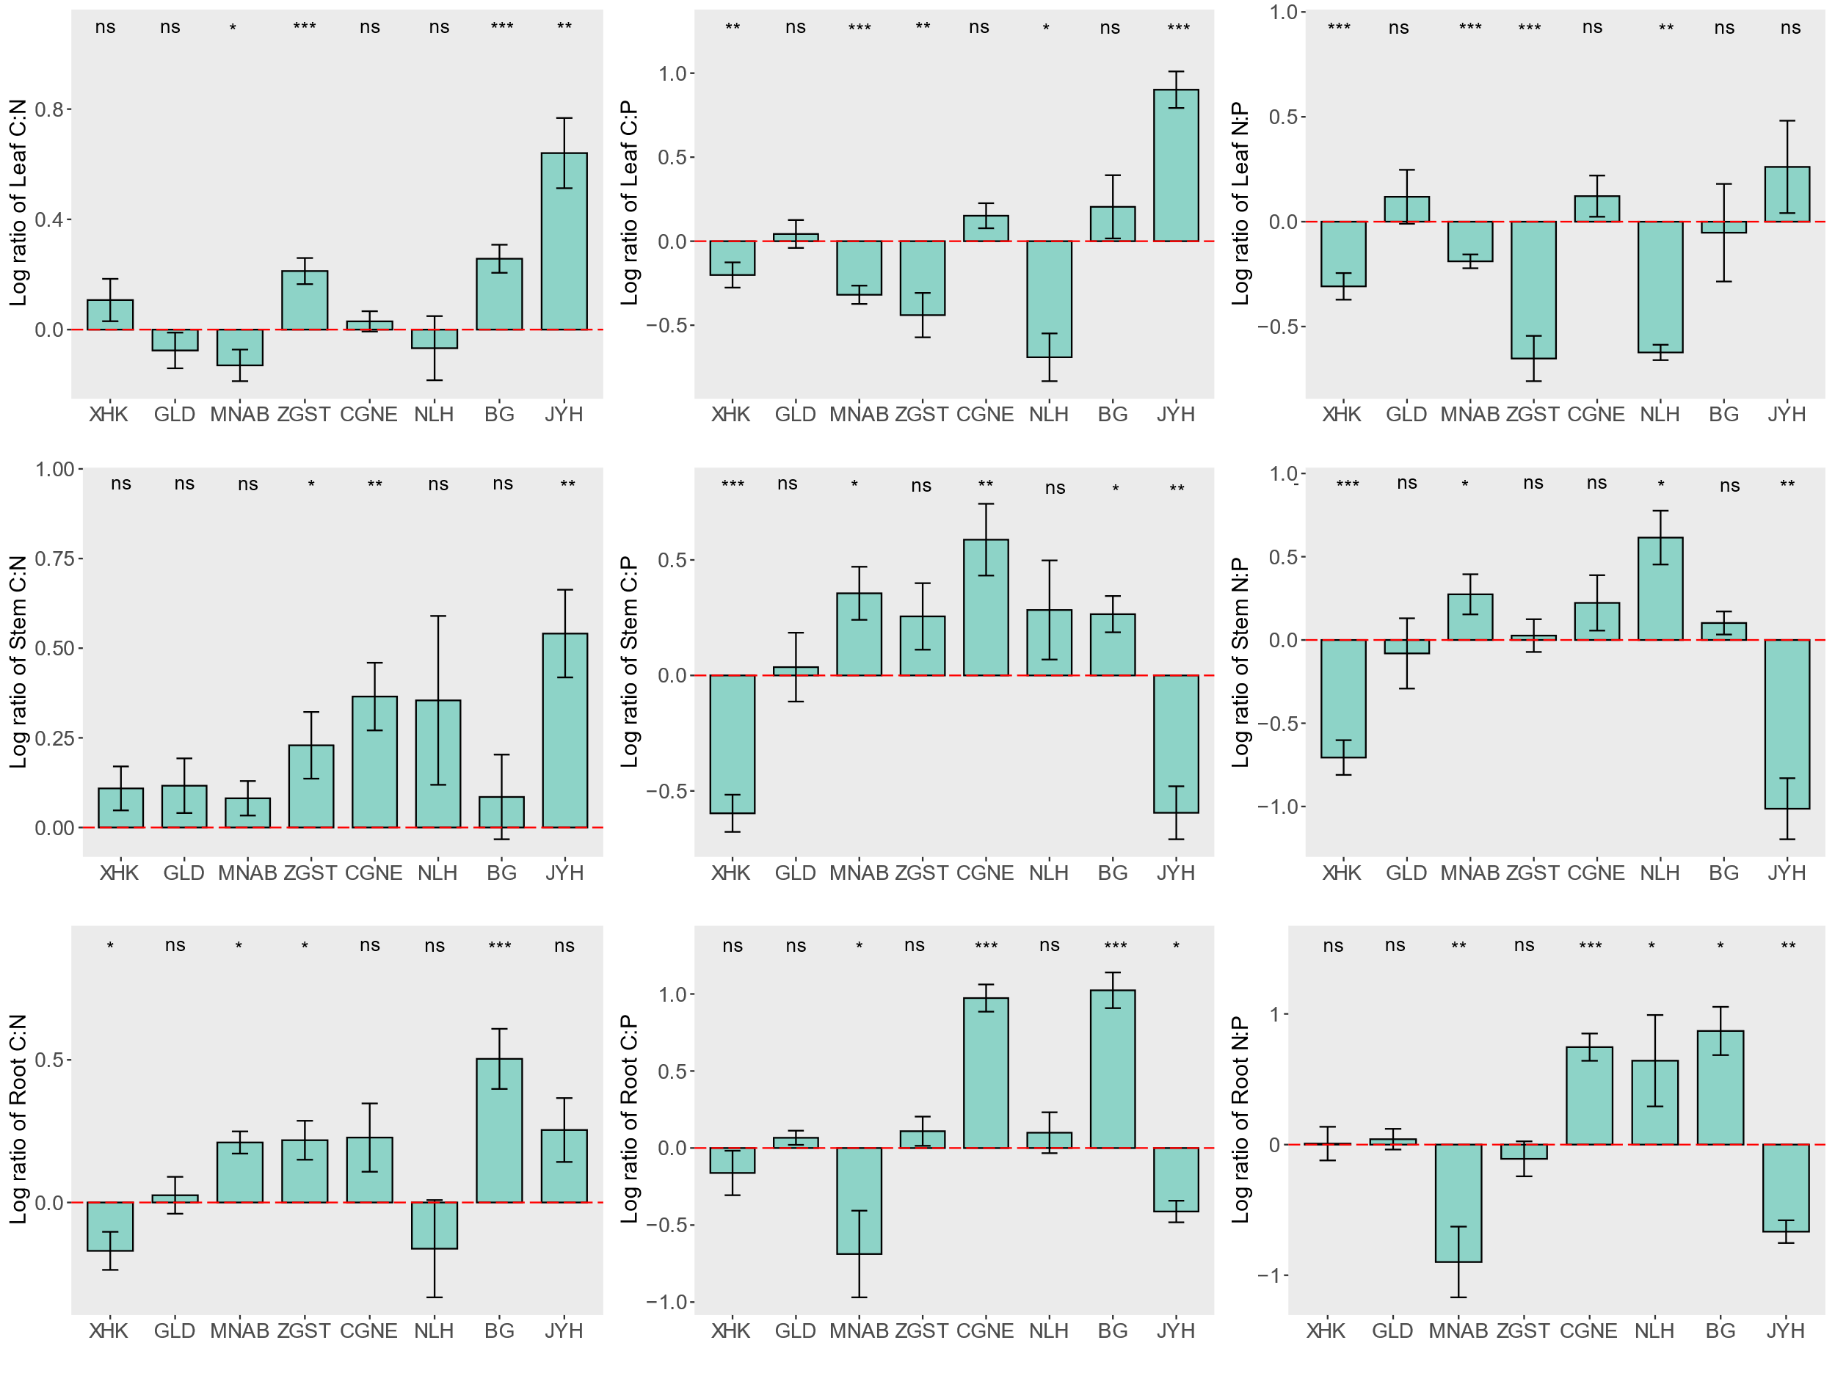

Table S2 On One-way ANOVA analysis (F-values) for morphological traits, nutrient contents, and stoichiometric ratios of Phragmites australis in two moisture gradients with high and low. Significance (p-value) is shown in parentheses.
Region | Semi-Arid |  |  |  | Arid
Localities | XHK | GLD | MNAB | ZGST | CGNE | NLH | BG | JYH
High | 0.05 | 5.56 | 11.8 | 13.56 | 40.48 | 1094 | 540.7 | 250.9
High | (0.835) | (0.04) | (0.008) | (0.006) | (<0.001) | (<0.001) | (<0.001) | (<0.001)
Leaf.Thickness | 0.87 | 0.96 | 0.548 | 40.21 | 19.51 | 44.34 | 9.57 | 1.90
Leaf.Thickness | (0.378) | (0.355) | (0.48) | (<0.001) | (0.002) | (<0.001) | (0.015) | (0.205)
LDMC | 1.65 | 13.1 | 4.66 | 0.189 | 0.893 | 6.15 | 1.093 | 13.48
LDMC | (0.235) | (0.007) | (0.062) | (0.676) | (0.372) | (0.048) | (0.326) | (0.006)
SLA | 19.16 | 0.183 | 23.96 | 0.195 | 12.07 | 17.88 | 2.04 | 22.82
SLA | (0.002) | (0.68) | (0.001) | (0.67) | (0.008) | (0.005) | (0.191) | (0.001)
SD | 0.48 | 4.33 | 0.196 | 7.76 | 11.45 | 1158 | 199 | 0.97
SD | (0.507) | (0.071) | (0.67) | (0.024) | (0.009) | (<0.001) | (<0.001) | (0.353)
Stem.Density | 15.07 | 0.21 | 0.04 | 2.68 | 7.34 | 129.7 | 188.8 | 3.074
Stem.Density | (0.004) | (0.66) | (0.85) | (0.14) | (0.026) | (<0.001) | (<0.001) | (0.118)
RD | 29.21 | 0.19 | 2.28 | 0.04 | 0.23 | 27.71 | 0.01 | 1.29
RD | (<0.001) | (0.67) | (0.17) | (0.86) | (0.64) | (0.001) | (0.92) | (0.29)
SRL | 11.24 | 34.41 | 1.56 | 4.53 | 29.45 | 31.36 | 15.7 | 0.98
SRL | (0.01) | (<0.001) | (0.25) | (0.06) | (<0.001) | (0.001) | (0.004) | (0.35)
LN | 3.01 | 1.81 | 5.41 | 19.17 | 0.74 | 0.59 | 13.23 | 33.26
LN | (0.121) | (0.216) | (0.04) | (0.002) | (0.413) | (0.469) | (0.006) | (<0.001)
LC | 0.81 | 2.51 | 9.66 | 28.85 | 0.07 | 0.32 | 0.33 | 4.65
LC | (0.395) | (0.152) | (0.01) | (<0.001) | (0.789) | (0.591) | (0.581) | (0.06)
LP | 9.19 | 0.04 | 53.41 | 11.87 | 4.08 | 18.83 | 2.53 | 70.02
LP | (0.02) | (0.85) | (<0.001) | (0.008) | (0.078) | (0.004) | (0.15) | (<0.001)
SN | 2.05 | 3.46 | 0.36 | 6.17 | 27.06 | 3.59 | 0.24 | 16.96
SN | (0.19) | (0.09) | (0.56) | (0.038) | (<0.001) | (0.107) | (0.635) | (0.003)
SC | 3.34 | 1.54 | 6.42 | 15.27 | 0.58 | 12 | 20.59 | 0.03
SC | (0.105) | (0.25) | (0.035) | (0.004) | (0.468) | (0.013) | (0.002) | (0.869)
SP | 13.98 | 0.006 | 13.2 | 2.786 | 17.75 | 2.59 | 4.45 | 30.55
SP | (0.005) | (0.94) | (0.006) | (0.134) | (0.003) | (0.159) | (0.068) | (<0.001)
RN | 1.90 | 0.11 | 7.83 | 8.02 | 1.78 | 1.61 | 32.46 | 1.583
RN | (0.005) | (0.755) | (0.023) | (0.022) | (0.219) | (0.251) | (<0.001) | (0.244)
RC | 0.06 | 6.69 | 0.48 | 0.69 | 3.49 | 35.25 | 11.62 | 10.46
RC | (0.803) | (0.032) | (0.507) | (0.428) | (0.098) | (0.001) | (0.009) | (0.012)
RP | 3.79 | 0.14 | 11.12 | 1.68 | 57.57 | 0.37 | 32.84 | 17.8
RP | (0.087) | (0.723) | (0.010) | (0.231) | (<0.001) | (0.566) | (<0.001) | (0.003)
L_C:N | 3.57 | 1.2 | 8.21 | 34.53 | 0.855 | 0.34 | 28.88 | 21.37
L_C:N | (0.096) | (0.305) | (0.021) | (<0.001) | (0.382) | (0.581) | (<0.001) | (0.002)
L_C:P | 13.58 | 0.236 | 46.86 | 11.45 | 3.29 | 12.63 | 1.911 | 136.7
L_C:P | (0.006) | (0.64) | (<0.001) | (0.009) | (0.107) | (0.012) | (0.204) | (<0.001)
L_N:P | 43.15 | 1.154 | 29.74 | 29.8 | 1.49 | 14.39 | 0.16 | 2.01
L_N:P | (<0.001) | (0.314) | (<0.001) | (<0.001) | (0.257) | (0.009) | (0.704) | (0.194)
S_C:N | 1.37 | 3.87 | 1.061 | 6.854 | 25.15 | 4.84 | 0.42 | 19.09
S_C:N | (0.276) | (0.085) | (0.333) | (0.031) | (0.001) | (0.07) | (0.537) | (0.002)
S_C:P | 42.73 | 0.32 | 9.25 | 2.99 | 18.78 | 5.15 | 8.85 | 19.35
S_C:P | (<0.001) | (0.586) | (0.016) | (0.122) | (0.002) | (0.064) | (0.018) | (0.002)
S_N:P | 34.25 | 0.07 | 6.71 | 0.13 | 2.15 | 6.49 | 0.92 | 15.89
S_N:P | (<0.001) | (0.796) | (0.032) | (0.729) | (0.18) | (0.044) | (0.366) | (0.004)
R_C:N | 6.64 | 0.26 | 9.88 | 8.56 | 4.35 | 0.06 | 37.65 | 5.23
R_C:N | (0.033) | (0.623) | (0.014) | (0.019) | (0.070) | (0.82) | (<0.001) | (0.052)
R_C:P | 2.39 | 0.596 | 9.88 | 1.57 | 68.52 | 1.28 | 194.9 | 8.59
R_C:P | (0.161) | (0.462) | (0.014) | (0.245) | (<0.001) | (0.301) | (<0.001) | (0.019)
R_N:P | 0.01 | 0.15 | 11.75 | 1.32 | 39.48 | 7.93 | 11.1 | 12.15
R_N:P | (0.944) | (0.712) | (0.008) | (0.284) | (<0.001) | (0.031) | (0.010) | (0.008)

Supporting Information Appendix S3
Ecological adaptation strategies based on plant economic spectrum
Based on the principal component analysis (Fig. 6), revealed the resource utilization and ecological adaptation strategies of P. australis in different regions. The results of principal component analysis for leaf traits showed that PC1 and PC2 occupied 66.56% and 17.06% of the variance explained, respectively (Fig. 6A). Except for LTH and LC, the remaining leaf traits contributed significantly to the PC1 axis (Table S3). One side of the PC1 axis exhibits P. australis plants with extensive SLA, LN, L_C:P and L_N:P, small LDMC, LP and L_C:N, showing a "fast investment-gain" (acquisition type) strategy. The other side has a small SLA, LN, L_C:P and L_N:P, and large LDMC, LP and L_C:N, exhibiting a "slow-investment-gain" (conservative) strategy. The PC1 axis is comparable to the "investment-return" strategy axis of the leaf economic spectrum theory, which leads us to define an LES. Most of the P. australis in the arid region are clustered on the conservative side of the LES and the semi-arid region is clustered on the acquisitive side, and the scores of the PC1 axis were significantly higher in the arid region than in the semi-arid region (p < 0.001, Table S4).
The results of principal component analysis for stem traits showed that PC1 and PC2 occupied 50.32% and 34.2% of the variance explained, respectively (Fig. 6B). The SN, SC and S_C:N were not correlated with the PC1 axis, and all other stem traits contributed to the PC1 axis (Table S3). One side of the PC1 axis exhibits P. australis stem traits with large SDE, SN and SP, small SD, S_C:N, S_C:P and S_N:P, and a "fast investment-gain" type (acquisition type) strategy. The other side of the PC1 axis is characterized by small SDE, SN and SP, large SD, S_C:N, S_C:P and S_N:P, "slow investment-return" (conservative) strategies. The PC1 axis of the stem trait also corresponds to the "investment-return" strategy axis in the economic spectrum and can define a SES. Arid and semi-arid region P. australis were distributed on both conserved and acquired sides of the SES representation, and both were not significant on the PC1 axis (p > 0.05, Table S4).
The results of principal component analysis for root traits showed that PC1 and PC2 occupied 51.51% and 25.14% of the variance explained, respectively (Fig. 6C). Only RP, R_C:N, R_C:P and R_N:P contributed with the PC1 axis of root traits, and RD and SRL with the PC2 axis, so the economic spectrum of P. australis roots was not present (Table S3).
The results of principal component analysis for whole-plant traits showed that PC1 and PC2 occupied 32.23% and 30.41% of the variance explained, respectively (Fig. 6D). All traits except LDMC and RC contributed significantly to the PC1 axis (Table S3). One side of the PC1 axis exhibited P. australis traits with extensive SLA, SRL, SDE, LN, SN, RN, L_C:P, L_N:P, S_C:P, S_N:P, R_C:P, R_N:P, and small SD, RD, LTH, LP, SP, RP, L_C:N, S_C:N, R_C:N, exhibiting " Fast investment-income" (acquisition) strategy. The PC1 axis can be defined as the "investment-return" strategy axis in the whole-plant economic spectrum theory. Most of the P. australis in semi-arid regions were distributed on the acquisition side and those in arid regions on the conservative side, and the PC1 axis scores for P. australis traits were significantly higher in the arid regions than in the semi-arid regions (p < 0.001, Table S4).

Table S3 Correlation coefficients between individual traits and the scores of the first and second principal components in each of the leaf, stem, root and whole-plant economics spectrum. (*, P < 0.05; **, P < 0.01; ***, P < 0.001).
Traits |  | Leaf |  |  |  | Stem |  |  |  | Root |  |  |  | Whole-Plant
Traits |  | PC1 |  | PC2 |  | PC1 |  | PC2 |  | PC1 |  | PC2 |  | PC1 |  | PC2
Leaf | LTH | -0.185 |  | -0.879 | *** |  |  |  |  |  |  |  |  | -0.325 | ** | -0.335 | **
Leaf | LDMC | -0.361 | ** | 0.207 |  |  |  |  |  |  |  |  |  | -0.176 |  | 0.021
Leaf | SLA | 0.481 | *** | 0.234 |  |  |  |  |  |  |  |  |  | 0.247 | * | 0.279 | *
Leaf | LN | 0.349 | ** | 0.524 | *** |  |  |  |  |  |  |  |  | 0.367 | ** | 0.320 | **
Leaf | LC | 0.025 |  | -0.011 |  |  |  |  |  |  |  |  |  | -0.272 | * | 0.272 | *
Leaf | LP | -0.934 | *** | 0.204 |  |  |  |  |  |  |  |  |  | -0.465 | *** | -0.232
Leaf | L_C:N | -0.368 | ** | -0.569 | *** |  |  |  |  |  |  |  |  | -0.457 | *** | -0.257 | *
Leaf | L_C:P | 0.926 | *** | -0.147 |  |  |  |  |  |  |  |  |  | 0.471 | *** | 0.240
Leaf | L_N:P | 0.949 | *** | 0.032 |  |  |  |  |  |  |  |  |  | 0.541 | *** | 0.285 | *
Stem | SDI |  |  |  |  | -0.474 | *** | 0.566 | *** |  |  |  |  | -0.437 | *** | -0.725 | ***
Stem | SDE |  |  |  |  | 0.625 | *** | -0.633 | *** |  |  |  |  | 0.247 | * | 0.791 | ***
Stem | SN |  |  |  |  | 0.185 |  | -0.392 | ** |  |  |  |  | 0.544 | *** | 0.340 | **
Stem | SC |  |  |  |  | -0.211 |  | 0.653 | *** |  |  |  |  | -0.626 | *** | -0.499 | ***
Stem | SP |  |  |  |  | 0.721 | *** | 0.564 | *** |  |  |  |  | -0.639 | *** | 0.432 | ***
Stem | S_C:N |  |  |  |  | -0.171 |  | 0.461 | *** |  |  |  |  | -0.594 | *** | -0.344 | **
Stem | S_C:P |  |  |  |  | -0.766 | *** | -0.484 | *** |  |  |  |  | 0.585 | *** | -0.565 | ***
Stem | S_N:P |  |  |  |  | -0.635 | *** | -0.676 | *** |  |  |  |  | 0.832 | *** | -0.341 | **
Root | RD |  |  |  |  |  |  |  |  | -0.046 |  | -0.593 | *** | -0.265 | * | -0.543 | ***
Root | SRL |  |  |  |  |  |  |  |  | 0.088 |  | 0.961 | *** | 0.316 | * | 0.214
Root | RN |  |  |  |  |  |  |  |  | 0.312 |  | 0.032 |  | 0.366 | ** | 0.193
Root | RC |  |  |  |  |  |  |  |  | 0.096 |  | -0.189 |  | -0.011 |  | -0.207
Root | RP |  |  |  |  |  |  |  |  | -0.901 | *** | -0.042 |  | -0.761 | *** | 0.387 | **
Root | R_C:N |  |  |  |  |  |  |  |  | -0.401 | *** | 0.012 |  | -0.422 | *** | -0.282 | *
Root | R_C:P |  |  |  |  |  |  |  |  | 0.884 | *** | -0.151 |  | 0.666 | *** | -0.526 | ***
Root | R_N:P |  |  |  |  |  |  |  |  | 0.913 | *** | -0.073 |  | 0.738 | *** | -0.381 | **

Table S4 Differences in PC1 and PC2 scores between semi-arid and arid regions (mean ± SE)
PCA | Axis | Region |  | Significant test
PCA | Axis | Semi-Arid | Arid | F-value | P
Leaf | PC1 | -0.16±0.04 | 0.13±0.07 | 14.03 | 0
Leaf | PC2 | -0.16±0.06 | 0.14±0.06 | 15.86 | 0
Stem | PC1 | 0.08±0.05 | -0.07±0.09 | 1.88 | 0.176
Stem | PC2 | 0.30±0.04 | -0.26±0.07 | 46.45 | 0
Root | PC1 | -0.16±0.05 | 0.14±0.08 | 10.16 | 0.002
Root | PC2 | 0.02±0.07 | -0.01±0.08 | 0.09 | 0.759
Whole-plant | PC1 | -0.34±0.06 | 0.29±0.09 | 33.68 | 0
Whole-plant | PC2 | -0.05±0.04 | 0.04±0.13 | 0.45 | 0.505

