Supplementary Information

Decrypting the programming of β-methylation in virginiamycin M biosynthesis

S. Collin, et al.

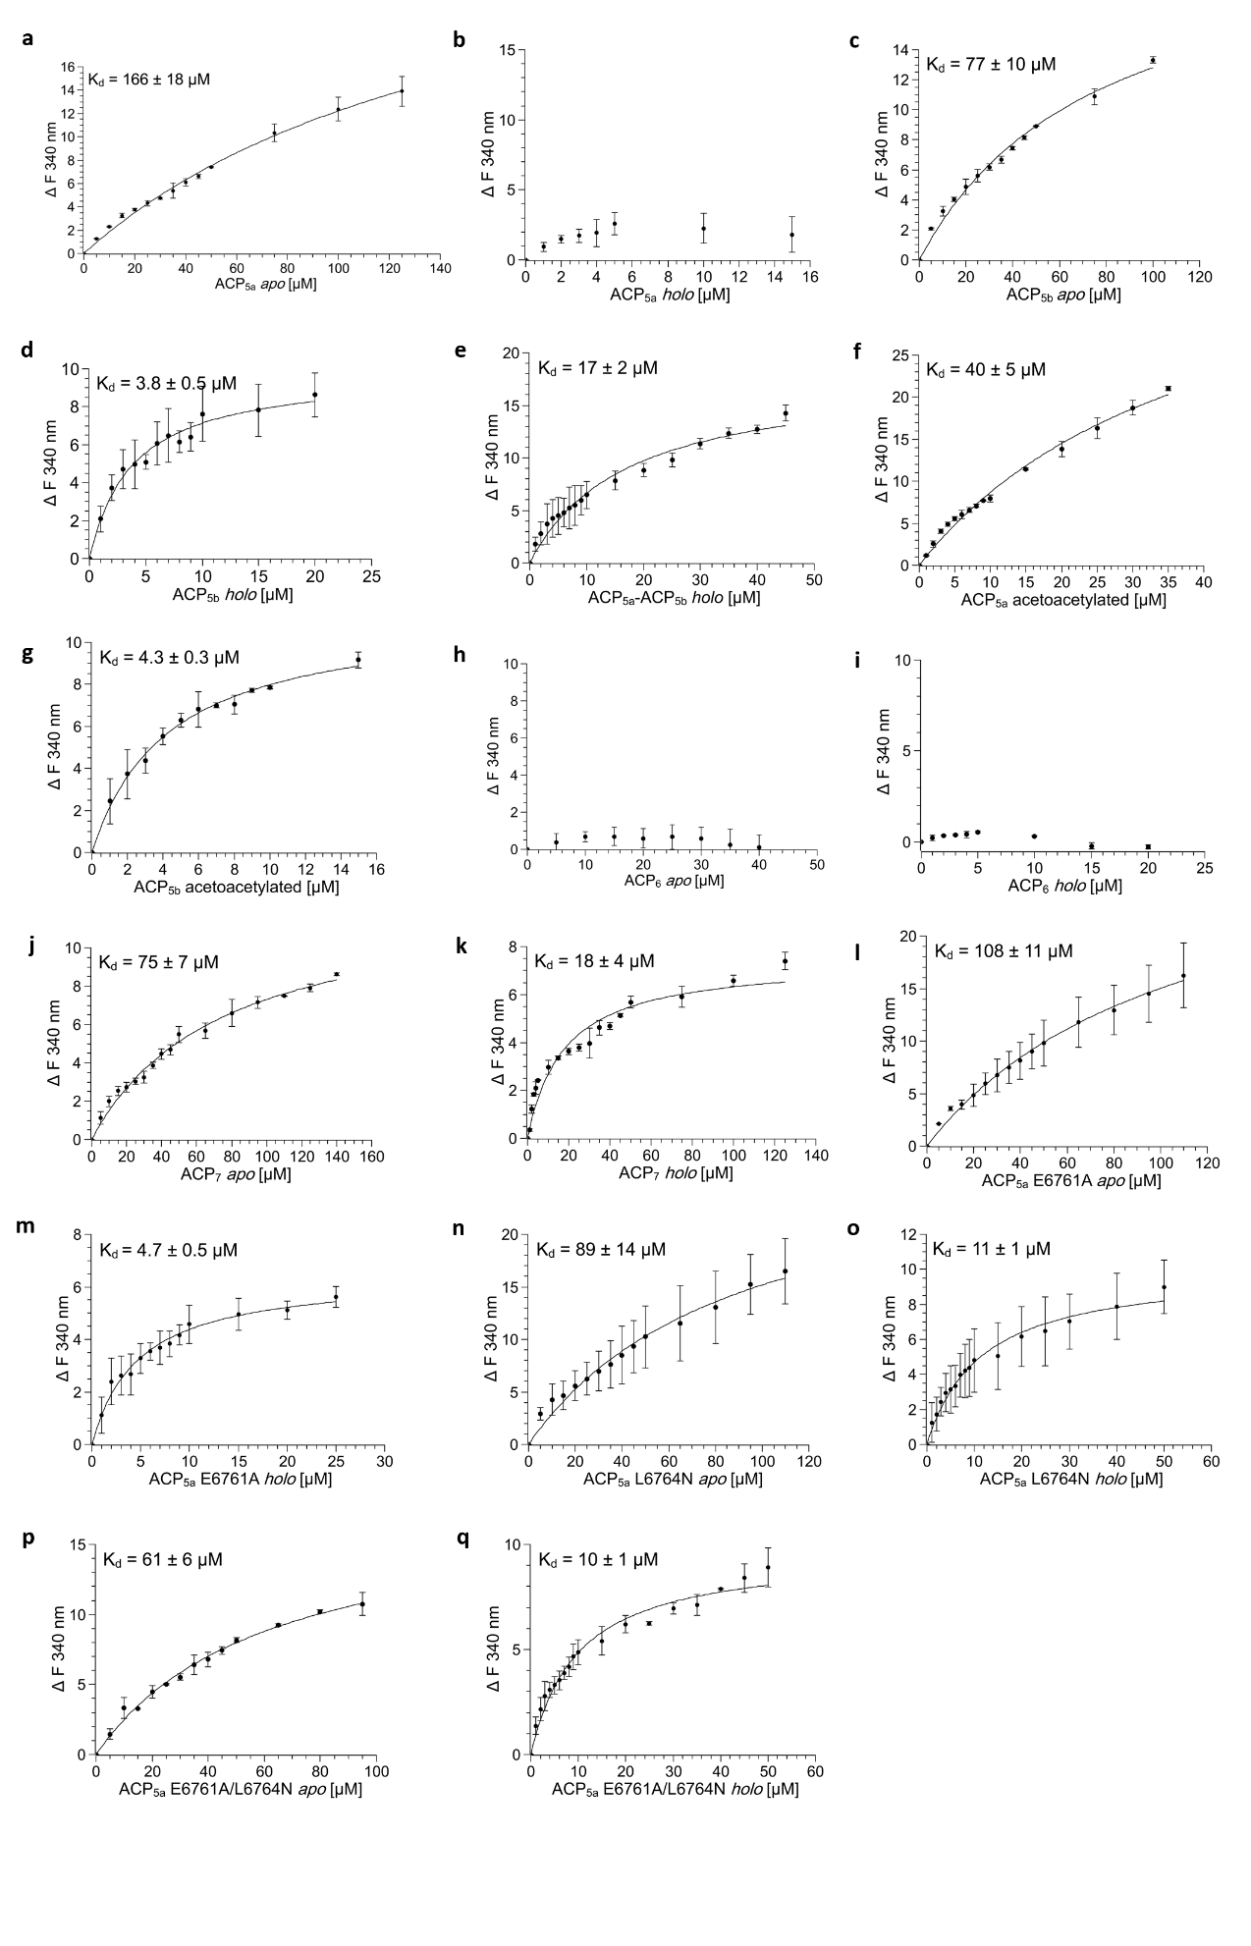Supplementary Fig. 1 │ Investigation of binding between VirC and ligand ACP domains by tryptophan fluorescence quenching. VirC (5 μM) florescence intensity in the presence of increasing concentrations of ligands was recorded by fluorescence spectroscopy. Ligand concentrations vs. changes in fluorescence intensity at 340 nm were then plotted for: a. apo-ACP_{5a}; b. holo-ACP_{5a}; c. apo-ACP_{5b}; d. holo-ACP_{5b}; e. holo-ACP_{5a}-ACP_{5b}; f. acetoacetyl-ACP_{5a}; g. acetoacetyl-ACP_{5b}; h. apo-ACP₆; i. holo-ACP₆; j. apo-ACP₇; k. holo-ACP_{7;} l. apo-ACP_{5a} E6761Ap; m. holo-ACP_{5a} E6761A, n. apo-ACP_{5a} L6764N; o. holo-ACP_{5a} L6764N; p. apo-ACP_{5a} E6761A/L6764N apo; and, q. holo-ACP_{5a} E6761A/L6764N. Data from two independent experiments were analysed via nonlinear regression using a one site-specific binding model (F = F_{max}*X/(K_{d} + X), where X is the ligand concentration, F is the fluorescence intensity, F_{max} is the maximum specific binding and K_{d} is the equilibrium binding constant) in SciDAVis 1.D013. The measured binding affinities are summarised in Extended Data Table 1.
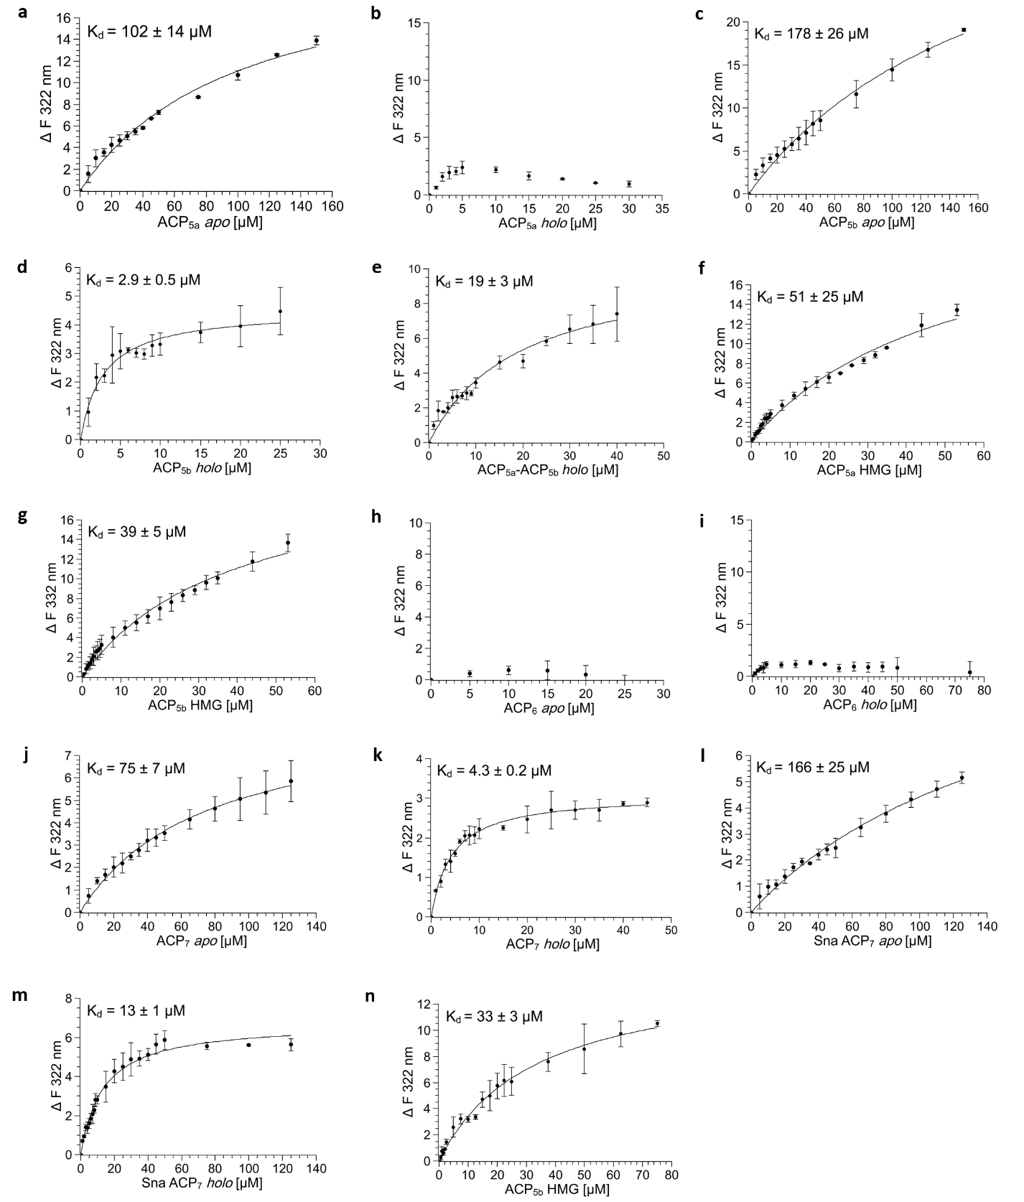

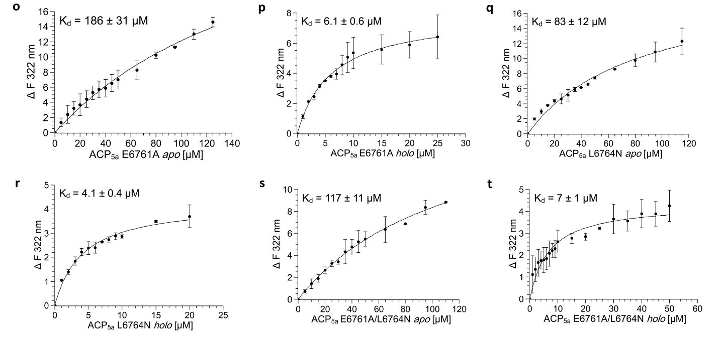
Supplementary Fig. 2 │ Investigation of binding between VirD/VirD E128Q and ligand ACP domains by tryptophan fluorescence quenching. VirD or VirD E128Q (5 μM) florescence intensity in the presence of increasing concentrations of ligands was recorded by fluorescence spectroscopy. Ligand concentrations vs. changes in fluorescence intensity at 322 nm were plotted for: a. apo-ACP_{5a}; b. holo-ACP_{5a}; c. apo-ACP_{5b}; d. holo-ACP_{5b}; e. holo-ACP_{5a}-ACP_{5b}; f. HMG-ACP_{5a}; g. HMG-ACP_{5b}; h. apo-ACP₆; i. holo-ACP₆; j. apo-ACP₇; k. holo-ACP₇; l. Sna apo-ACP₇; m. Sna holo-ACP₇; n. VirD E128Q mutant and HMG-ACP_{5b}; o. apo-ACP_{5a} E6761A; p. holo-ACP_{5a} E6761A; q. apo-ACP_{5a} L6764N; r. holo-ACP_{5a} L6764N; s. apo-ACP_{5a} E6761A/L6764N; and, t. holo-ACP_{5a} E6761A/L6764N. Data from two independent experiments were analysed via nonlinear regression using a one site-specific binding model (F = F_{max}*X/(K_{d} + X), where X is the ligand concentration, F is the fluorescence intensity, F_{max} is the maximum specific binding and K_{d} is the equilibrium binding constant) in SciDAVis 1.D013. The measured binding affinities are summarised in Extended Data Table 1.
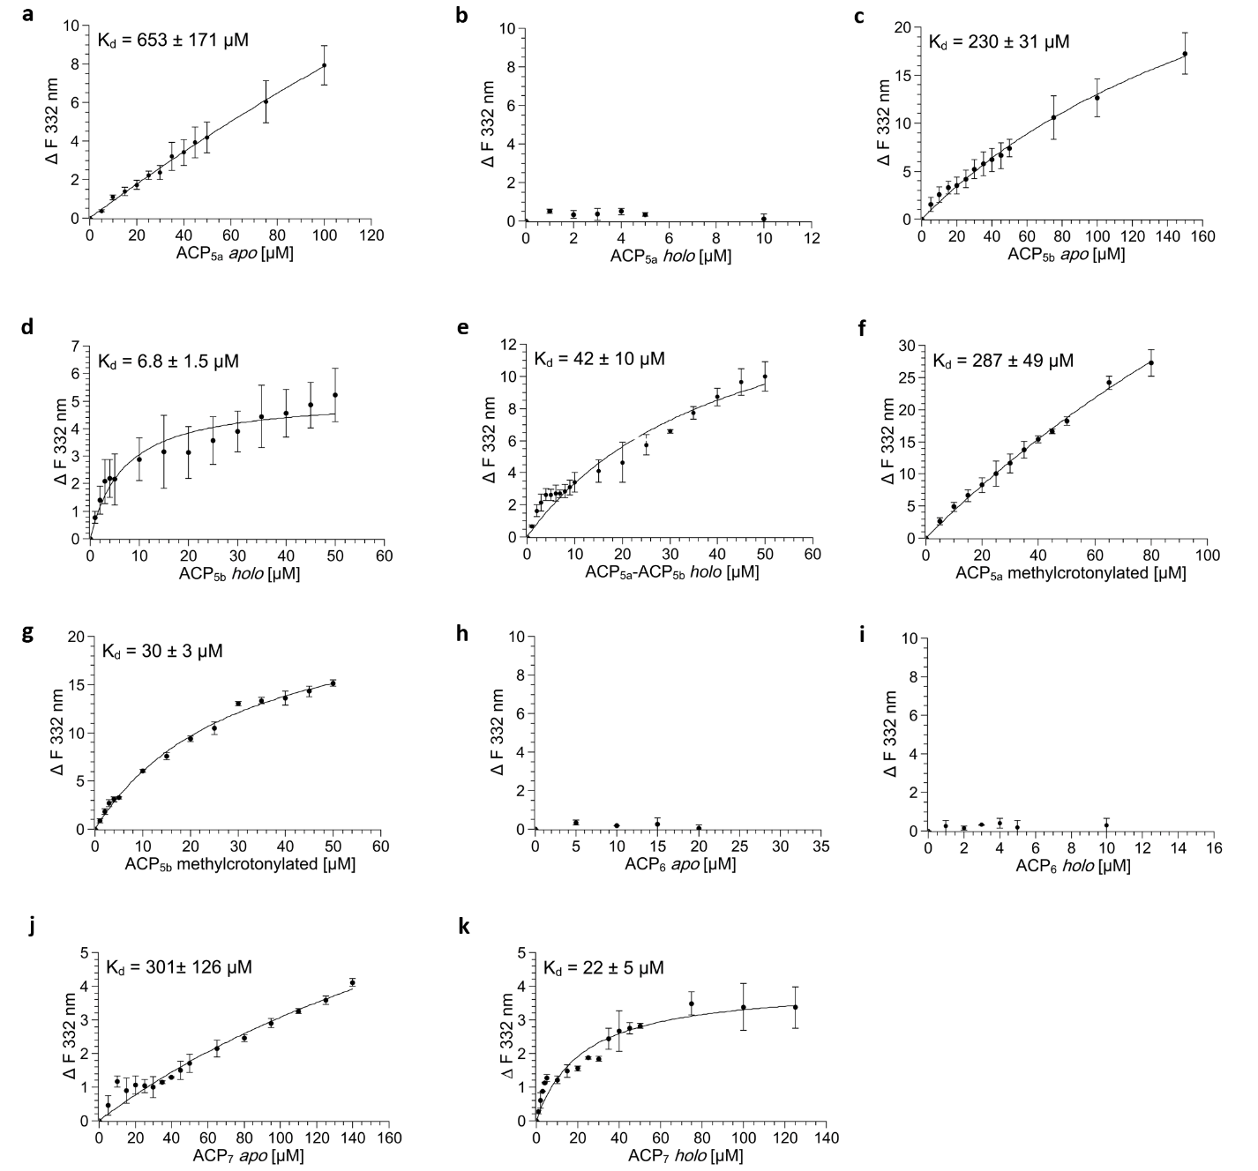
Supplementary Fig. 3 │ Investigation of binding between VirE and ligand ACP domains by tryptophan fluorescence quenching. VirE (5 μM) florescence intensity in the presence of increasing concentrations of ligands was recorded by fluorescence spectroscopy. Ligand concentrations vs. changes in fluorescence intensity at 332 nm were plotted for: a. apo-ACP_{5a}; b. holo-ACP_{5a}; c. apo-ACP_{5b}; d. holo-ACP_{5b}; e. holo-ACP_{5a}-ACP_{5b}; f. methylcrotonyl-ACP_{5a}; g. methylcrotonyl-ACP_{5b}; h. apo-ACP₆; i. holo-ACP₆; j. apo-ACP₇; and, k. holo-ACP₇. Data from two independent experiments were analysed via nonlinear regression using a one site-specific binding model (F = F_{max}*X/(K_{d} + X), where X is the ligand concentration, F is the fluorescence intensity, F_{max} is the maximum specific binding and K_{d} is the equilibrium binding constant) in SciDAVis 1.D013. The measured binding affinities are summarised in Extended Data Table 1.

Supplementary Fig. 4 │ Standard curve of commercial virginiamycin M 1 for quantification of metabolites 1−3. Accurate quantification of Vir M 1 was achieved by generation of a standard curve based on commercial Vir M, and was used to estimate the yields of the closely structurally-related metabolites 2 and 3 (Extended Data Table 2). Peak areas corresponding to 1 were calculated from the extracted ion chromatograms (EICs) using [M+H]⁺ = 526.2548. A dilution series within the concentration range of 0.00000026−0.02 mg mL⁻¹ was analysed. The integrated area of the 0.00000026 dilution sample was out of the linear range, and so was not included in the final data treatment. This procedure produced an essentially linear standard curve (R² =1.00), as shown, for conversion of peak areas into titers (the obtained yields were then divided by 200 to correct for the concentration factor during sample preparation for HPLC-MS). Source data are available for this figure.
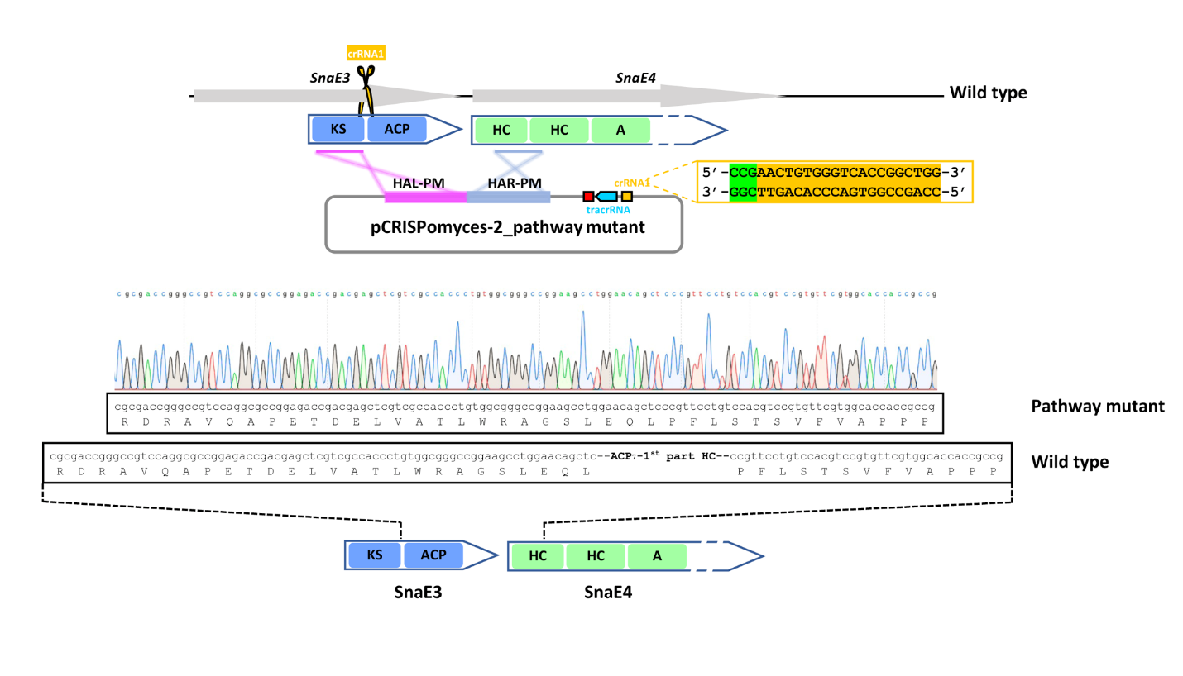Supplementary Fig. 5 │ Illustration of the strategy for generation of the Sna pathway inactivation mutant in Streptomyces pristinaespiralis ATCC 25486 by CRISPR-Cas9¹. Schematic representation of pathway inactivation targeting the interface between modules 7 and 8. The sequencing confirming the identity of the targeted mutant is shown. Abbreviations: KS, ketosynthase; ACP, acyl carrier protein; HC, heterocyclisation; A, adenylation; HAL, homology arm left; HAR, homology arm right; PM, pathway mutant.

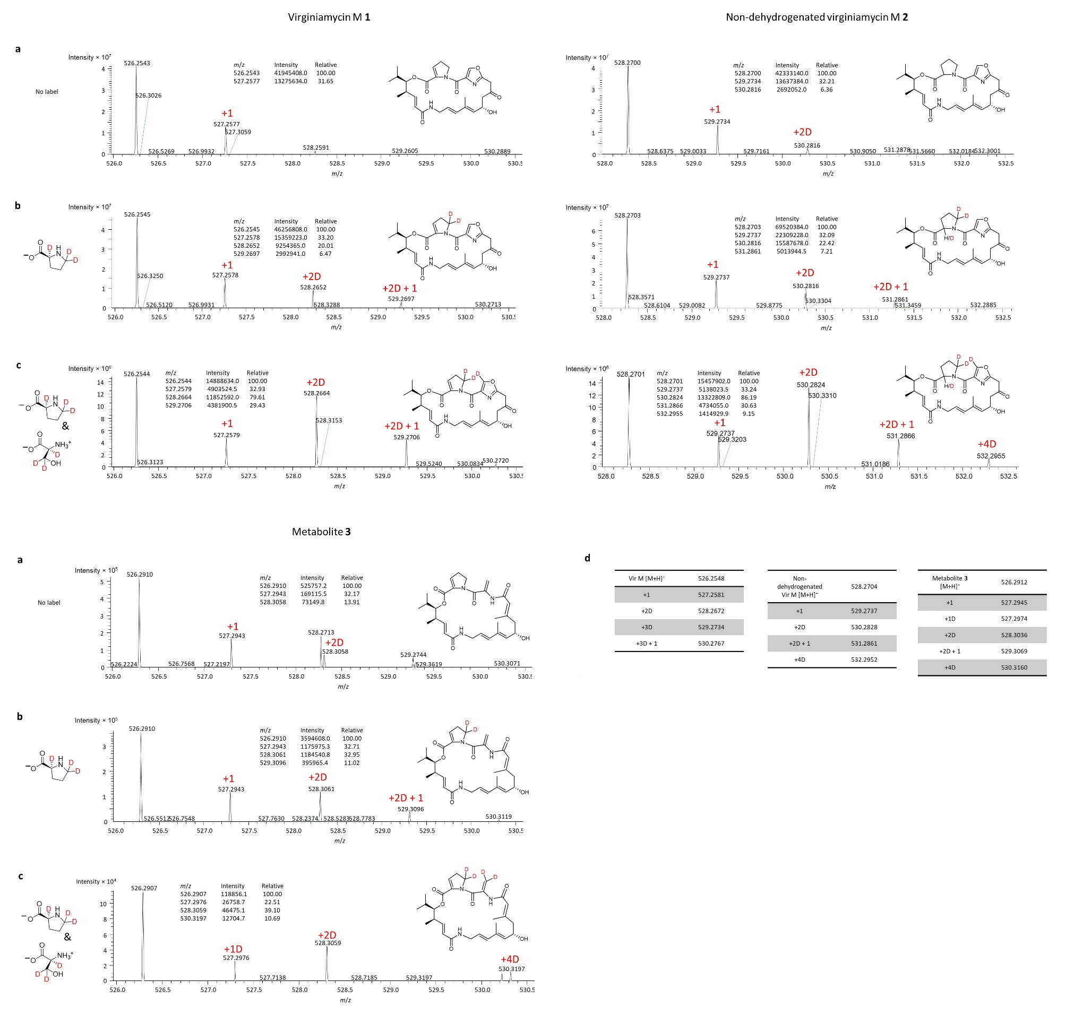
Supplementary Fig. 6 │ Patterns of isotope incorporation into metabolites 1−3 in the presence of labelled amino acids. These experiments were conducted independently of those shown in Extended Data Fig. 8, and thus are complementary. a. Mass spectrum ([M+H⁺]) obtained in the absence of feeding (the calculated masses for 1−3 are presented in Extended Data Table 2). b. Feeding L-proline-2,5,5-D₃. c. Feeding of L-proline-2,5,5-D₃ and L-serine-2,3,3-D3. In a−c, the label +1 indicates a peak with the mass of a natural isotopic peak of the adjacent peak of lower mass (mass difference ca. 1.0033). The label +D indicates a mass difference consistent with incorporation of one or more deuteriums (mass difference for each D of ca. 1.0062). In each case, the relative peak intensities are shown in inset. For metabolite 3, the masses observed for the +2D and +4D peaks exhibit a larger than expected difference relative to the calculated masses (d.). By way of explanation, at a nominal resolution of 60 K (200 m/z, FWHM), the resolution obtained for MS signals close to m/z = 500 is approximately 40 K (Fig. 1), which is not always sufficient to determine with high precision the exact masses of compounds of interest. Thus, experimentally-determined m/z ratios can sometimes be slightly shifted compared to theoretical m/z values, as can be observed in particular for the di-deuterated form of metabolite 3 (m/z_{exp} = 528.3060 and m/z_{theo} = 528.3037, i.e. 4.3 ppm). By way of comparison, the m/z ratio values obtained for the non-deuterated form of metabolite 3 are closer to the calculated values, whether for the monoisotopic peak (m/z_{exp} = 526.2909 and m/z_{theo} = 526.2912, i.e. 0.6 ppm) or the corresponding M+1 isotopic peak (m/z_{exp} = 527.2942 and m/z_{theo} = 527.2945, i.e. 0.6 ppm). Overall, the important observation is that the +2D peak intensity substantially increases in the presence of the labelled amino acids, consistent with their incorporation. The +1D peak observed for metabolite 3 may arise from conversion in the cell of L-serine-2,3,3-D3 to Gly-2-D1 by an endogenous serine hydroxymethyl transferase (SHMT).
Supplementary Table 1 │ List of primers used in this work.
Oligonucleotides (5′-3′)* | Usage | Oligo no.
Protein expression in E. coli
TTTCGCGGATCCGCGGGCCGTCAGGAGGAG | ACP_{5a}ACP_{5b}_For | 8581
TTTCCGAAGCTTTCAGACCGGGGCGGCGCGTCC | ACP_{5a}ACP_{5b}_Rev | 8584
CGGCTCGACCCGGAGGCGACCTTCCTGACCCTG | ACP_{5a} E6761A_For | D320
CAGGGTCAGGAAGGTCGCCTCCGGGTCGAGCCG | ACP_{5a} E6761A_Rev | D319
CCGGAGGAGACCTTCAACACCCTGGGCGTCGAC | ACP_{5a} L6764N_For | D321
GTCGACGCCCAGGGTGTTGAAGGTCTCCTCCGG | ACP_{5a} L6764N_Rev | D322
CTCGACCCGGAGGCGACCTTCAACACCCTGGGC | ACP_{5a} E6761A/L6764N_For | D545
GCCCAGGGTGTTGAAGGTCGCCTCCGGGTCGAG | ACP_{5a} E6761A/L6764N_Rev | D546
TTTCGCGGATCCGCTGCGGCGGATGACGGC | ACP₆_For | 8585
TTTCCGAAGCTTTCACCGGGCGGCGACCAGGTG | ACP₆_Rev | 8586
AAAAGGATCCATGTATGGGGAAGCGGTGACCGAGCAGCTG | ACP₇_For | G164
AAAAAAGCTTTCAGTGGGCGCGGTCGGCGGACAGGTG | ACP₇_Rev | G165
AAAAGGATCCATGTATCATGTCGCCGTCACGTCCGCCGTCGCG | Sna ACP₇_For | F799
AAAAAAGCTTTCAGGCCTGGTCGGGGGCGTGAAG | Sna ACP₇_Rev | F800
TTTCGCGGATCCAAGCCGGTCGGCATCGAAGCC | VirC_For | 9716
TTTCGCAAGCTTTCATCGGCCGTCCCCCAGCC | VirC_Rev | 9717
accaagcaggccgcctacagcggcacggcggcg | VirC C114A_For | D547
cgccgccgtgccgctgtaggcggcctgcttggt | VirC C114A_Rev | D548
Cccgagtcggcggcggcggtcgcggccatgggc | VirC C114A/Q334A/R335A/R338A_For | D549
gcccatggccgcgaccgccgccgccgactcggg | VirC C114A/Q334A/R335A/R338A_Rev | D550
TTTCGCGGATCCAGCCACCCGGACGCCGTGCG | VirD_For | 9718
TTTCGCAAGCTTTCATGCCGCCGCTCCGGCCTC | VirD_Rev | 9719
GCTCACCCAGGTGCTGGCCGGGCTGGTCCCGGC | VirD E128Q_For | C729
GCCGGGACCAGCCCGGCCAGCACCTGGGTGAGC | VirD E128Q_Rev | C730
TTTCGCGGATCCAGCCCGGTCACGGCGCGC | VirE_For | 9720
TTTCGCAAGCTTTCAGGGGTGTCGGAGGCCGGC | VirE_Rev | 9721
CRISPR-based engineering in S. pristinaespiralis
ACGCCCAGCCGGTGACCCACAGTT | sgRNA_PM_For | E507
AAACAACTGTGGGTCACCGGCTGG | sgRNA_PM_Rev | E508
ttgccgccgggcgttttttatctagaGCCGAGGACGGCCTGTGCCGCAGCTTCGGC | HAL_PM_For | E511
CGGACGTGGACAGGAACGGGAGCTGTTCCAGGCTTCCGGCCCGCCACAGG | HAL_PM_Rev | E512
CCCGTTCCTGTCCACGTCCGTGTTCGTGGC | HAR_PM_For | E514
cctttttacggttcctggcctctagaCGGCGGGGCCGGTGAGGACCGACTCGTCGC | HAR_PM_Rev | E516
*Introduced restriction sites are underlined, “GGATCC” is the restriction recognition site of BamHI, “AAGCTT” of HindIII, “GAATTC” of EcoRI, and “TCTAGA” of XbaI; Red = represent mutagenesis nucleotides, while the base pairs coding for an additional Tyr are indicated in bold. Key: HAL, Homologous Arm Left; HAR, Homologous Arm Right; PM, pathway inactivation mutant.

Strains/mutants | Description and use (resistance) | Reference
S. pristinaespiralis
ATCC | S. pristinaespiralis ATCC 25486 wild type strain | DMSZ
Pathway mutant | Inactivation mutant at the module 7/module 8 interface (SnaE3) (Apra^{R}) | This work
E. coli
DH5α | General cloning strain | ²
ET12567/pUZ8002 | Non-methylating strain containing a mobilisation plasmid for conjugation with Streptomyces (Kan^{R}, Cm^{R}) | ³
BL21 | BL21 (DE3), a widely used T7 expression strain | Novagen
BL21/pLM-302_VirC | Strain for VirC overexpression (Kan^{R}) | This work
BL21/pLM-302_ VirC C114A/Q334A/R335A/R338A | Strain for VirC C114A/Q334A/R335A/R338A overexpression (Kan^{R}) | This work
BL21/pBG-102_VirD | Strain for VirD overexpression (Kan^{R}) | This work
BL21/pBG-102_VirD E128Q | Strain for VirD E128Q overexpression (Kan^{R}) | This work
BL21/pBG-102_VirE | Strain for VirE overexpression (Kan^{R}) | This work
BL21/pBG-102_ACP_{5a} | Strain for ACP_{5a} overexpression (Kan^{R}) | This work
BL21/pBG-102_ACP_{5b} | Strain for ACP_{5b} overexpression (Kan^{R}) | This work
BL21/pBG-102_ACP_{5a}-ACP_{5b} | Strain for ACP_{5a}-ACP_{5b} overexpression (Kan^{R}) | This work
BL21/pBG-102_ACP_{5a} E6761A | Strain for ACP_{5a} E6761A overexpression (Kan^{R}) | This work
BL21/pBG-102_ACP_{5a} L6764N | Strain for ACP_{5a} L6764N overexpression (Kan^{R}) | This work
BL21/pBG-102_ACP_{5a} E6761A/L6764N | Strain for ACP_{5a} E6761A/L6764N overexpression (Kan^{R}) | This work
BL21/pBG-102_ACP₆ | Strain for ACP₆ overexpression (Kan^{R}) | This work
BL21/pBG-102_ACP₇ | Strain for ACP₇ overexpression (Kan^{R}) | This work
BL21/pBG-102_Sna ACP₇ | Strain for Sna ACP₇ overexpression (Kan^{R}) | This work
Supplementary Table 2 │ List of strains used in this work.
Supplementary Data Table 3 │ Summary of SAXS data.
 | holo-ACP_{5b}−VirC | VirD | VirE | holo-ACP_{5b}−VirD
Structural parameters from Guinier fits, P(r) functions, MW estimates
Guinier analysis
I(0) (cm⁻¹) | 0.10 ± 0.00015 | 0.11 ± 0.00017 | 0.29 ± 0.00043 | 0.16 ± 0.00018
R_{g} (Å) | 29.28 ± 0.06 | 28.68 ± 0.07 | 32.77 ± 0.08 | 31.80 ± 0.06
q_{min} (Å⁻¹) | 0.005 | 0.005 | 0.005 | 0.005
qR_{g} max (Å⁻¹) | 1.3 | 1.3 | 1.3 | 1.3
P(r) analysis
I(0) cm⁻¹ | 0.1016 ± 0.1239E⁻⁰³ | 0.1091 ± 0.1245E⁻⁰³ | 0.2859 ± 0.3211E⁻⁰³ | 0.1555 ± 0.1435E⁻⁰³
R_{g} (Å) | 29.2 ± 0.1 | 28.54 ± 0.11 | 33.03 ± 0.29 | 31.79 ± 0.16
D_{max} (Å) | 101.69 | 88.95 | 122.55 | 110.53
q range (Å⁻¹) | 0.07 - 0.2780 | 0.07 - 0.2784 | 0.07 - 0.2438 | 0.07 - 0.2516
χ² (total estimate from GNOM) | 0.8989 | 0.9455 | 0.6790 | 0.8859
Porod Volume (Å⁻³) (ratio V_{p}/calculated M) | 141215 | 130507 | 138694 | 140370
Estimation of the Molecular Weight (MW)
MW from chemical composition (kDa) | 110.66 | 78.92 | 81.37 | 110.02
MW (Bayesian inference) (kDa) | 85.650 | 74.325 | 94.225 | 94.225
Credibility interval (kDa) | 79.60 − 89.70 | 71.45 −79.60 | 86.95 − 95.80 | 89.70 − 99.20
MW probability (%), Credibility interval (%) | 40.89, 97.53 | 49.95, 92.95 | 45.16, 90.37 | 61.73, 90.14
Oligomeric state | tetramer | trimer | trimer | hexamer
Report modelling results
CRYSOL (with default parameters)  No constant subtraction | Crystal structures (PDB load) |  | Modelled structures (PDB load)
PDB ID | 5KP6 | 8AHZ | doi: DOREL (tbp) | 8HAQ
χ² | 1.524 | 2.102 | 6.24 | 5.105
Predicted R_{g} (Å) | 29.09 | 25.67 | 31.97 | 32.16
Predicted envelope diameter (Å) | 107.10 | 84.32 | 124.1 | 101.7
Vol (Å), Ra (Å), Dro (e Å⁻³) | 143593, 1.74, 0.05 | 101814, 1.80, 0.00 | 107249, 1.80, 0.075 | 142111, 1.80, 0.00

Supplementary Data Table 4 │ Data collection, phasing and refinement statistics for SAD (SeMet) structures.
 | Se-VirD high resolution | Se-VirD | holo-ACP_{5b}−VirD
Data collection
Space group | P 4₁2₁2 | P 4₁2₁2 | H3
Cell dimensions
a, b, c (Å) | 84.31, 84.31, 230.19 | 84.31, 84.31, 230.19 | 144.88, 144.88, 88.78
α, β, γ (°) | 90.00, 90.00, 90.00 | 90.00, 90.00, 90.00 | 90.00, 90.00, 120.00
 |  | Peak
Wavelength | 0.953709 | 0.979260 | 0.95370
Resolution (Å) | 59.62-1.76 (1.81-1.76) | 47.41-2.02 (2.07-2.02) | 36.23-2.10 (2.16-2.10)
R_{merge} (%) | 7.1 (75.3) | 13.3 (87.9) | 12.5 (146.7)
R_{pim} (%) | 2.9 (31.5) | 2.6 (18.2) | 3.7 (45.2)
I / σI | 19.5 (2.4) | 20.3 (3.5) | 15.5 (3.0)
Number of total observations | 1027674 | 1425966 | 479439
Number of unique reflections | 81872 | 54825 | 40571
Completeness (%) | 99.0 (85.9) | 99.6 (94.9) | 100 (100)
Redundancy | 12.6 (11.6) | 26.0 (22.7) | 11.8 (11.1)
Wilson B-factors (Å²) | 26.5 | ND | 40.8
Refinement
Resolution (Å) | 57.78-1.70 |  | 41.85-2.10
No. reflections | 6616 |  | 40571
R, R_{free} | 0.159, 0.180 |  | 0.183, 0.238
No. atoms | 5851 |  | 5127
Protein | 5261 |  | 4736
Ligand/ion | 152 |  | 69
Water | 438 |  | 322
Average B-factors, all atoms (Å²) | 29.0 |  | 39.0
R.m.s deviations
Bond lengths (Å) | 0.0086 |  | 0.0123
Bond angles (°) | 1.5167 |  | 1.7890

Supplementary Table 5 │ NMR and refinement statistics for protein structures.
 | ACP_{5a} | ACP₆ | ACP₇
NMR distance and dihedral constraints
Distance constraints
Total NOE | 1822 | 1208 | 1763
Intra-residue | 379 | 376 | 409
Inter-residue | 1443 | 832 | 1354
Sequential (|i – j| = 1) | 444 | 349 | 476
Medium-range (|i – j| < 4) | 521 | 267 | 488
Long-range (|i – j| > 5) | 478 | 216 | 390
Intermolecular | 0 | 0 | 0
Hydrogen bonds | 0 | 0 | 0
Total dihedral angle restraints
φ | 55 | 46 | 47
ψ | 55 | 46 | 47
Structure statistics
Violations (mean and s.d.)
Distance constraints (Å) | 0.064 ± 0.012 | 0.088 ± 0.033 | 0.088 ± 0.023
Dihedral angle constraints (º) | 0 ± 0 | 0 ± 0 | 0 ± 0
Max. dihedral angle violation (º) | 0 | 0 | 0
Max. distance constraint violation (Å) | 0.09 | 0.14 | 0.13
Deviations from idealised geometry
Bond lengths (Å) | 0.010 ± 5.53E-5 | 0.011 ± 7.68E-5 | 0.011 ± 9.78E-05
Bond angles (º) | 2.046 ± 0.014 | 2.112 ± 0.019 | 2.169 ± 0.016
Impropers (º) | N/A | N/A | N/A
Average pairwise r.m.s. deviation** (Å) | Residues 6734−6809 | Residues 1082−1158 | Residues 1877−1944
Heavy | 0.43 ± 0.08 | 0.87 ± 0.13 | 0.53 ± 0.09
Backbone | 1.23 ± 0.15 | 1.71 ± 0.14 | 1.11 ± 0.12
**Pairwise r.m.s. deviation was calculated among 20 refined structures.

Supplementary References
1. Cobb, R. E., Wang, Y. & Zhao, H. High-efficiency multiplex genome editing of Streptomyces species using an engineered CRISPR/Cas system. ACS Synth. Biol. 4, 723–728 (2015).
2. Hanahan, D. Studies on transformation of Escherichia coli with plasmids. J. Mol. Biol. 166, 557–580 (1983).
3. MacNeil, D. J. et al. Analysis of Streptomyces avermitilis genes required for avermectin biosynthesis utilizing a novel integration vector. Gene 111, 61–68 (1992).

