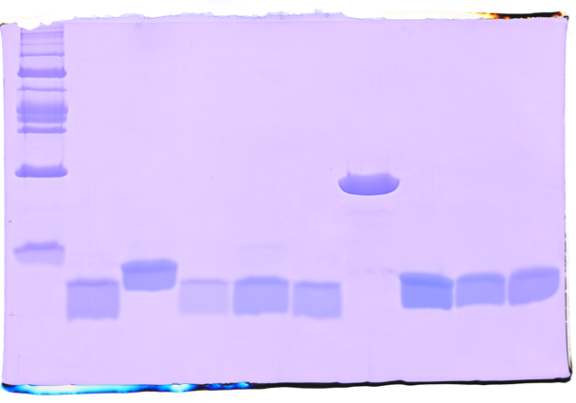
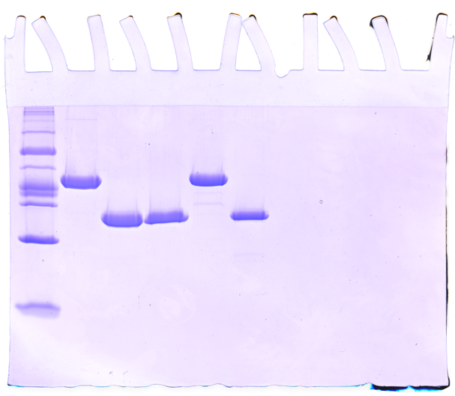
a
ACP_{5a}
MW (kDa)
ACP_{5b}
ACP_{5a} E6761A
ACP_{5a} L33N
ACP_{5a} E6761A/L6764N
ACP₆
ACP_{5a}-ACP_{5b}
ACP₇
Sna ACP₇
97
66
53
44.8

24

12
MW (kDa)
VirC
VirD
VirC quadruple mutant
VirD E128Q
97
66
53
44.8

24

12

b

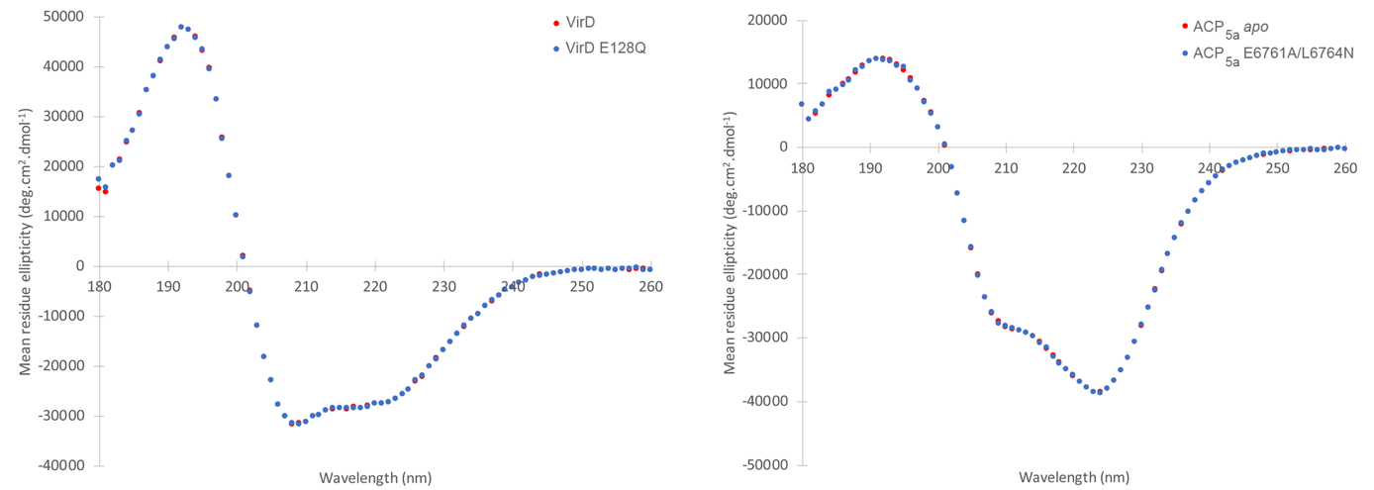

Extended Data Fig. 1 │ Evidence for the purity of proteins and structural integrity of mutants used in this study. a. SDS-PAGE analysis of constructs used in this study. Gel 1: VirD (calc’d: 26.3 kDa); VirC (calc’d: 45.7 kDa); VirE (calc’d: 27.1 kDa); VirC quadruple mutant C114A/Q334A/R335A/R338A (calc’d: 45.5 kDa); VirD E128Q mutant (calc’d: 26.3 kDa). Gel 2: ACP_{5a} (calc’d: 8.8 kDa); ACP_{5b} (calc’d: 9.2 kDa); ACP_{5a} E6761A (calc’d: 8.8 kDa); ACP_{5a} L6764N (calc’d: 8.8 kDa); ACP_{5a} E6761A/L6764N (calc’d: 8.8 kDa); ACP_{5a}-ACP_{5b} (calc’d: 19.4 kDa); ACP₆ (calc’d: 8.8 kDa); ACP₇ (calc’d: 8.9 kDa); and, Sna ACP₇ (calc’d: 10.4 kDa). The molecular weights of the markers are indicated. b. CD analysis of select mutants. VirD vs. VirD E128Q and ACP_{5a} vs. ACP_{5a} E6761A/L6764N. As the spectra are essentially superimposable, this analysis showed that the mutations did not significantly alter the structure of each protein, although minor differences between ACP_{5a} and the double mutant were detected. Source data are available for this figure.
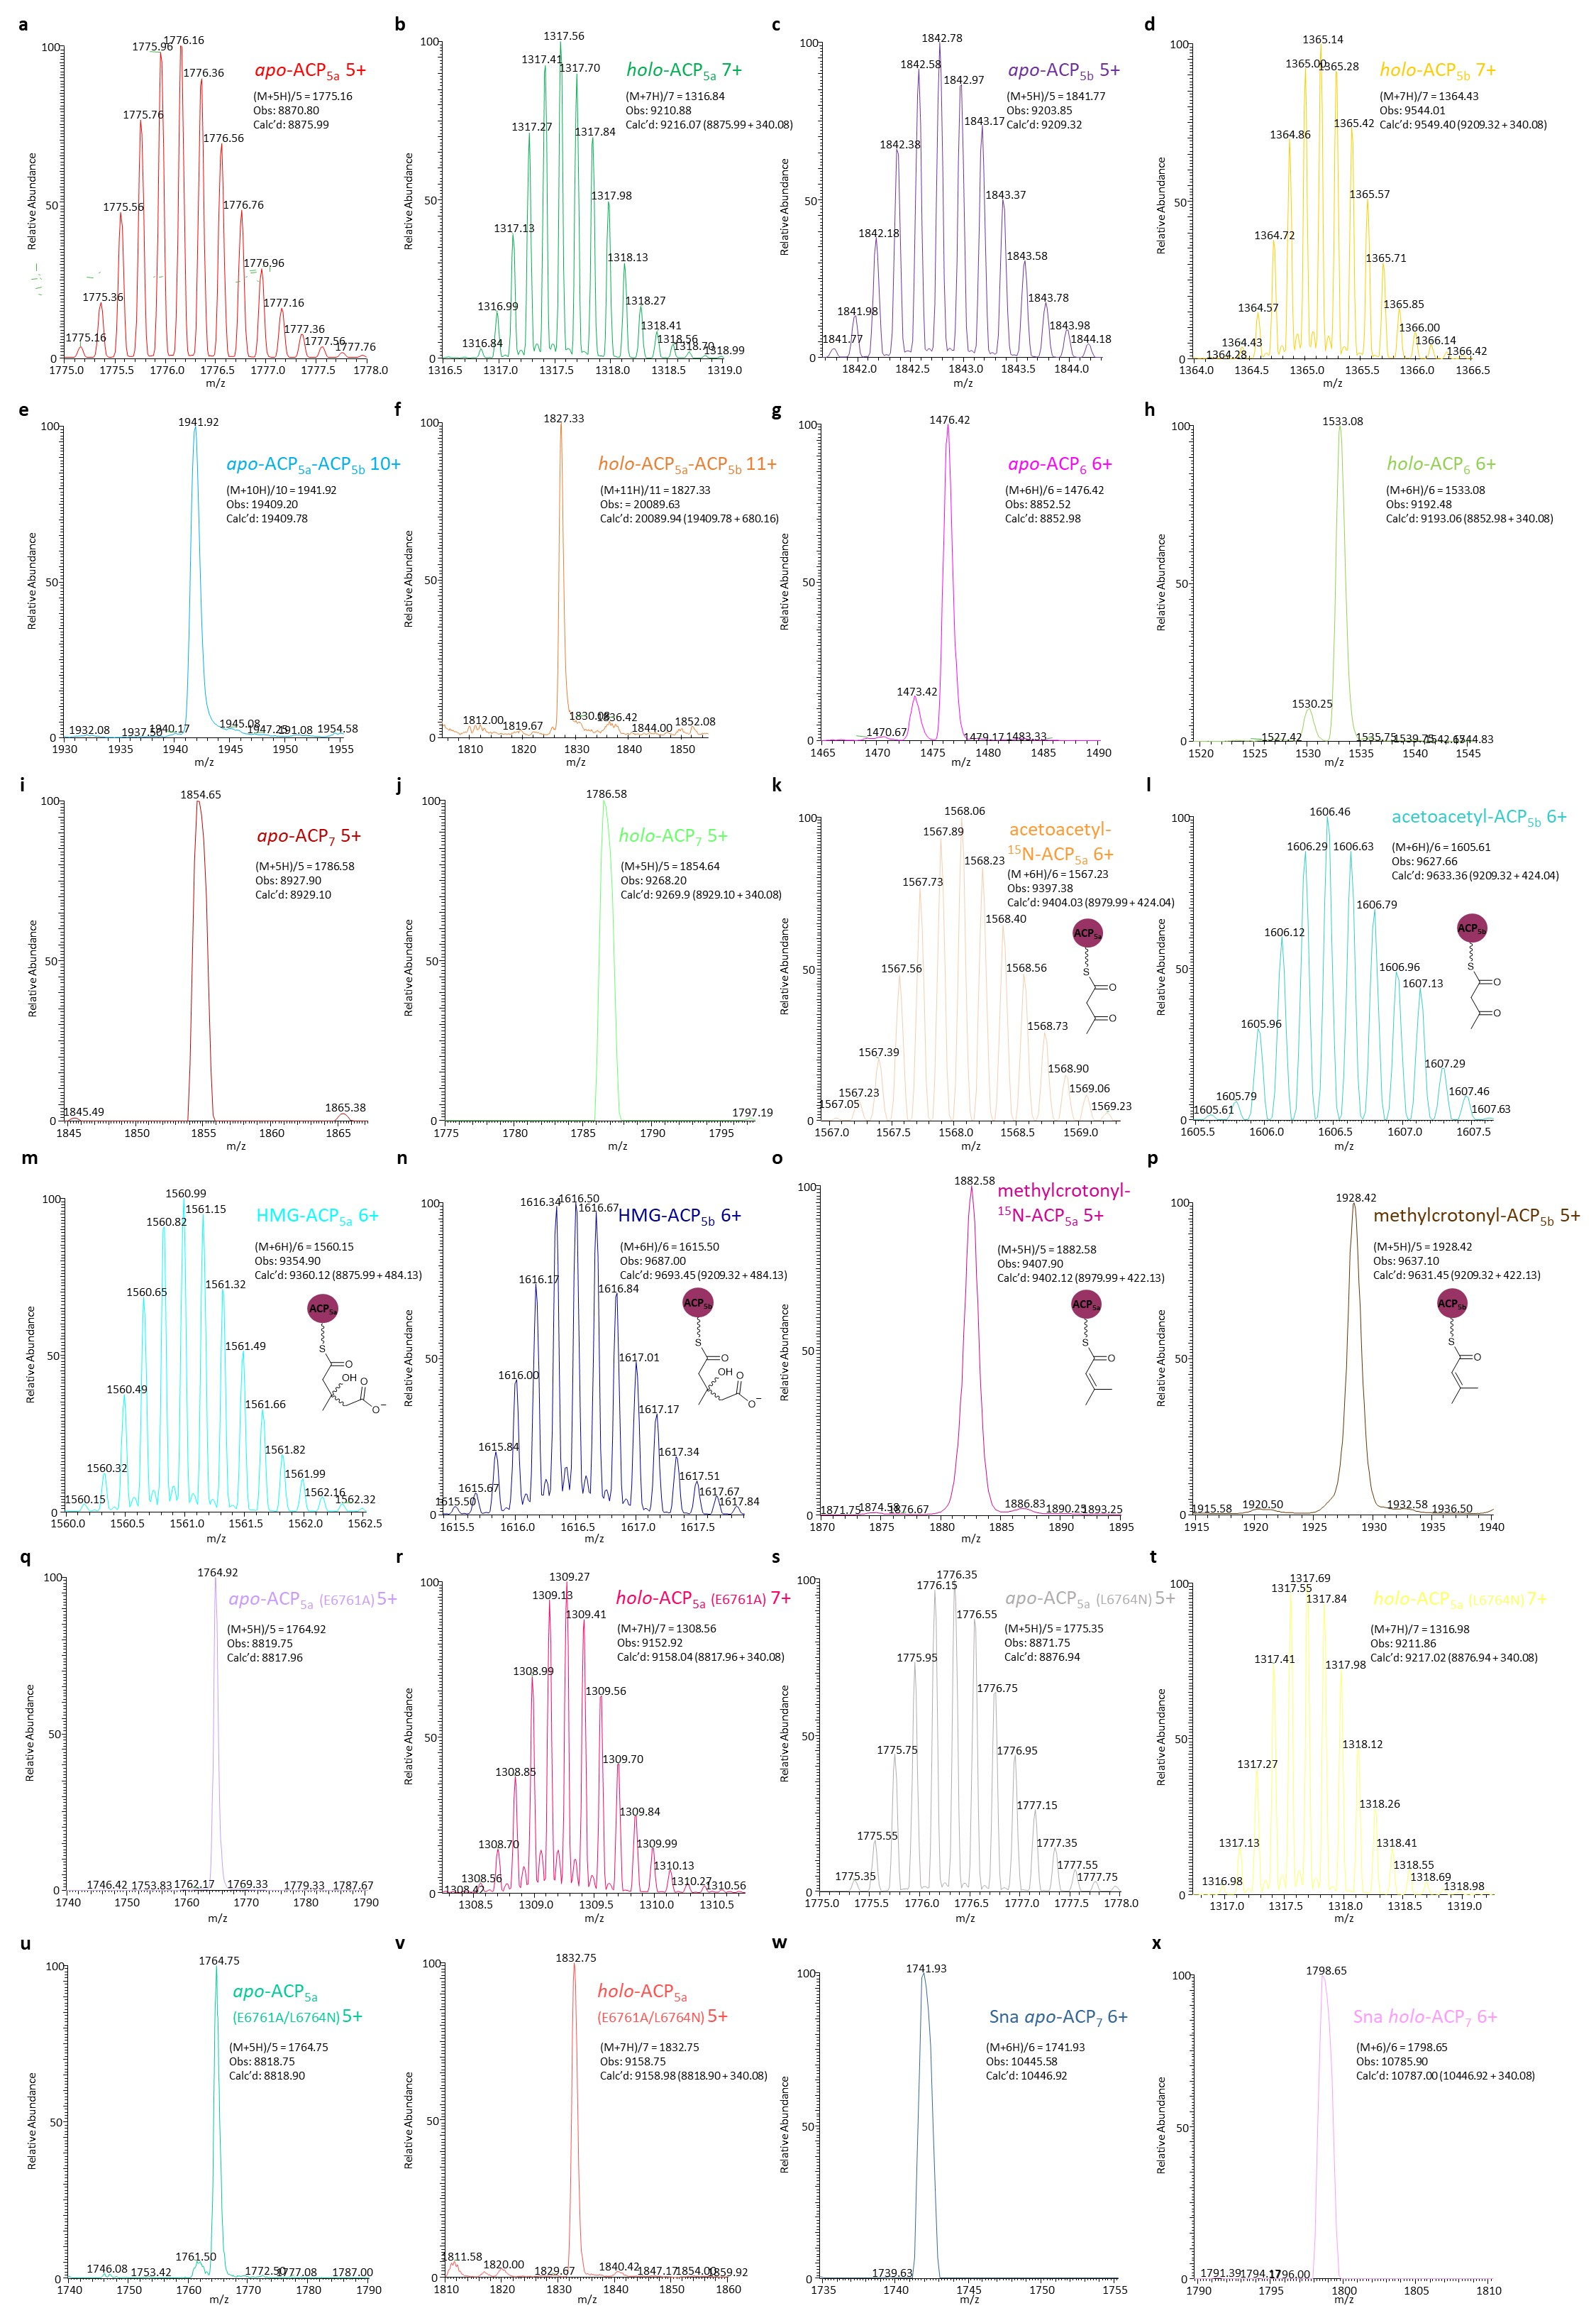
Extended Data Fig. 2 │ Verification of the modification states of the investigated ACP domains by HPLC-MS. The molecular weights of the following ACPs were determined by HPLC-MS: a. apo-ACP_{5a}; b. holo-ACP_{5a}; c. apo-ACP_{5b}; d. holo-ACP_{5b}; e. apo-ACP_{5a}-ACP_{5b}; f. holo-ACP_{5a}-ACP_{5b}; g. apo-ACP₆; h. holo-ACP₆; i. apo-ACP₇; j. holo-ACP₇; k. acetoacetyl-¹⁵N-ACP_{5a}; l. acetoacetyl-ACP_{5b}; m. HMG-ACP_{5a}; n. HMG-ACP_{5b}; o. methylcrotonyl-¹⁵N-ACP_{5a}; p. methylcrotonyl-ACP_{5b}; q. apo-ACP_{5a} (E6761A); r. holo-ACP_{5a} (E6761A); s. apo-ACP_{5a} (L6764N); t. holo-ACP_{5a} (L6764N); u. apo-ACP_{5a} (E6761A/L6764N); v. holo-ACP_{5a} (E6761A/L6764N); w. Sna apo-ACP₇; x. Sna holo-ACP₇. In each case, the data representing a single charge state are shown, along with the observed and the calculated molecular weights. For the analyses carried out at high-resolution (60K), the full suite of isotopic peaks is visible (in such cases the monoisotopic peak was used to calculate the observed molecular weight), while for analysis at lower resolution (3 or 7.5K), only a broad peak centred on the monoisotopic value was observed. For convenience, certain ¹⁵N-labelled ACPs prepared for the NMR-based structure eludication were modified and assayed, as indicated. In panels k−p, the structures of the three employed substrate analogues are shown.
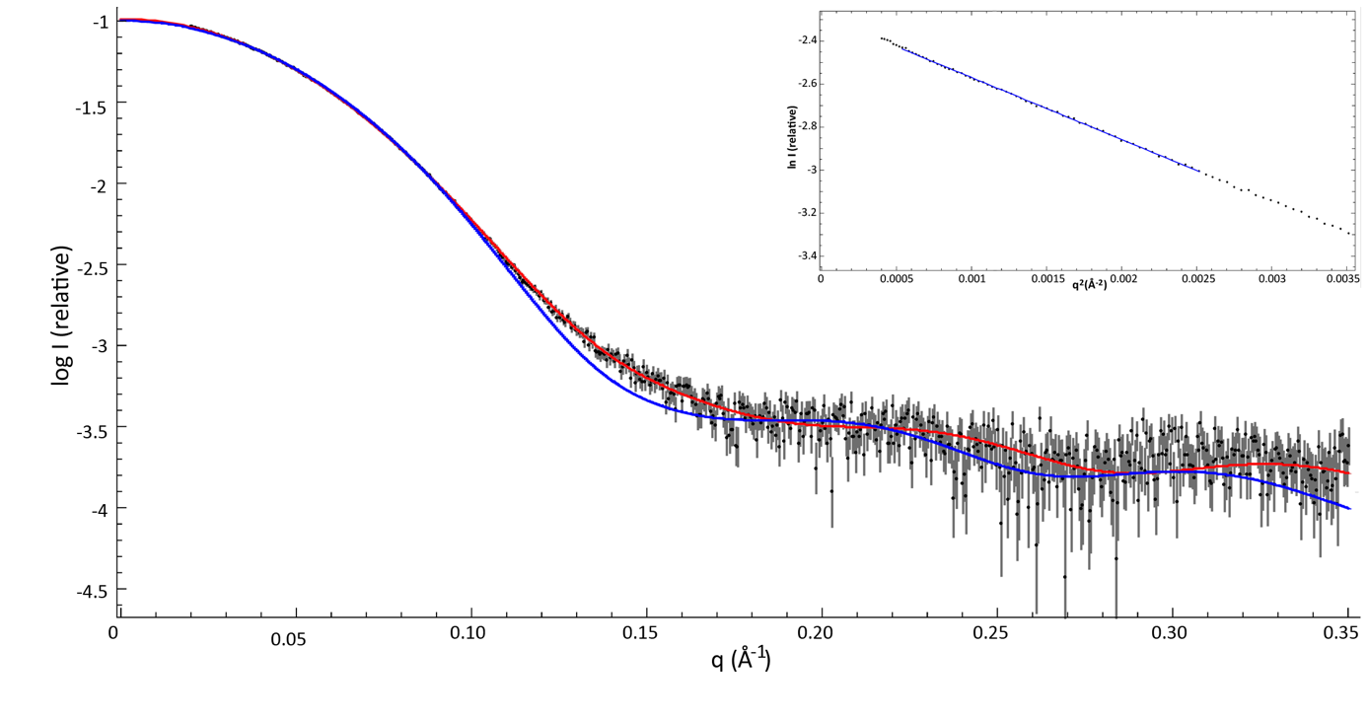
a

b
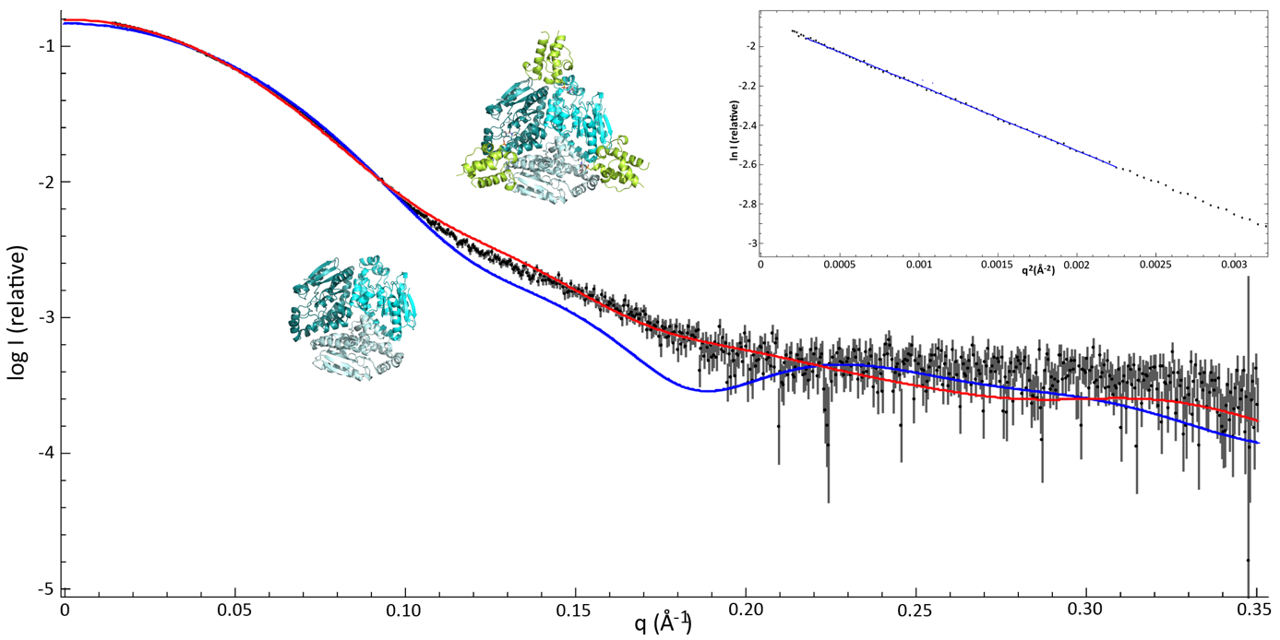
Extended Data Fig. 3 │ Fits between experimental SAXS data and the obtained crystal structures. a. Experimental SAXS curve obtained from the holo-ACP_{5b}−VirC complex (in black) fit to the theoretical scattering data generated from the CurD dimer (in blue) and from the acetyl-ACP_{D}−CurD complex (PDB ID: 5KP6) (in red) using CRYSOL¹⁶. The Guinier plot is inset. The discrepancies between the theoretical scattering curves for dimeric CurD and the acetyl-ACP_{D}−CurD complex, and the experimentally determined data for the holo-ACP_{5b}−VirC complex (χ²), were calculated at 6.193 and 1.524, respectively. b. Experimental SAXS scattering curve obtained from the holo-ACP_{5b}−VirE complex (in black) fit to the theoretical scattering data generated from homology models of trimeric VirE (in blue) and holo-ACP_{5b}−VirE complex (in red), generated using Alphafold¹⁹. The Guinier plot is inset. Comparison of the experimental SAXS curve obtained from the holo-ACP_{5b}−VirE complex, with those calculated from the VirE and holo-ACP_{5b}−VirE complex models, gave χ² values of 20.523 and 5.105, respectively.

a

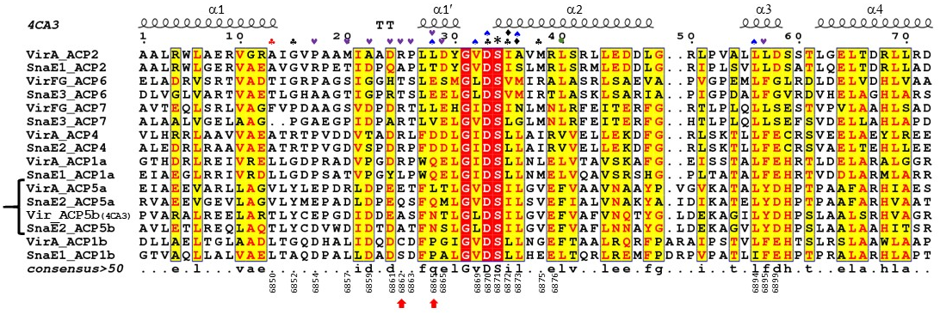

b
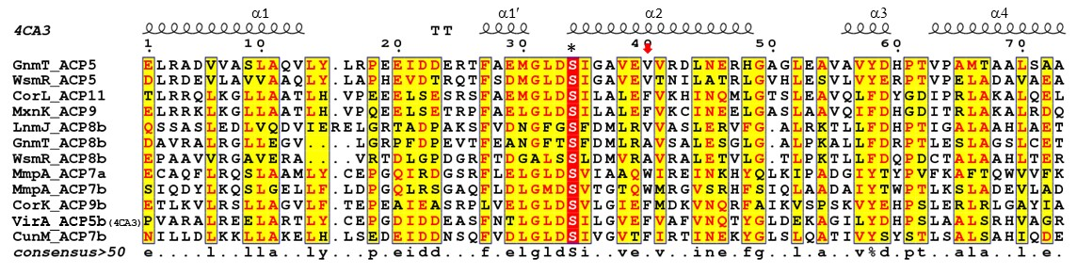

Extended Data Fig. 4 │ Comparative sequence analysis of trans-AT PKS ACPs. a Sequences of virginiamycin (Vir) and pristinamycin (Sna) ACPs, numbered according to the module in which they appear (Fig. 1). The ACPs present in the modules targeted for β-methylation are indicated with a bracket. Legend: * = Catalytic Ser; ♣ = Residues contributing to the interface with VirD (red, only residue position differing between ACP_{5b} and ACP_{5a});♦= Residues comprising the Asp-binding oxyanion hole; ♠ = ACP/VirD specificity determinants, acting via a hydrogen-bond network; • = Position of the W flag; ♥ = Residues contributing to key surface electrostatic features; ↑ = Residues mutated in ACP_{5a}. b Sequences of ACP domains from modules within trans-AT PKSs in which β-modification occurs. The labels ‘a’ and ‘b’ refer to the first and second domains, respectively, of tandem ACPs. Both MmpA ACP_{7a} and ACP_{7b} have been included, as these formed the basis for the W flag (position indicated with ↓) hypothesis of ACP recognition⁷. This analysis shows that like the Vir system, multiple β-modification ACPs incorporate an F at this position, but equally that other residues are present (V and A). Legend of subunit names: Vir, virginiamycin⁹; Sna, pristinamycin²⁶; Gnm, guangnanmycin⁶⁸; Wsm, weishanmycin⁶⁸; Cor, corallopyronin⁶⁹; Mxn, myxopyronin⁷⁰; Lnm, leinamycin⁷¹; Mmp, mupirocin⁷; Cun, cuniculene⁷².

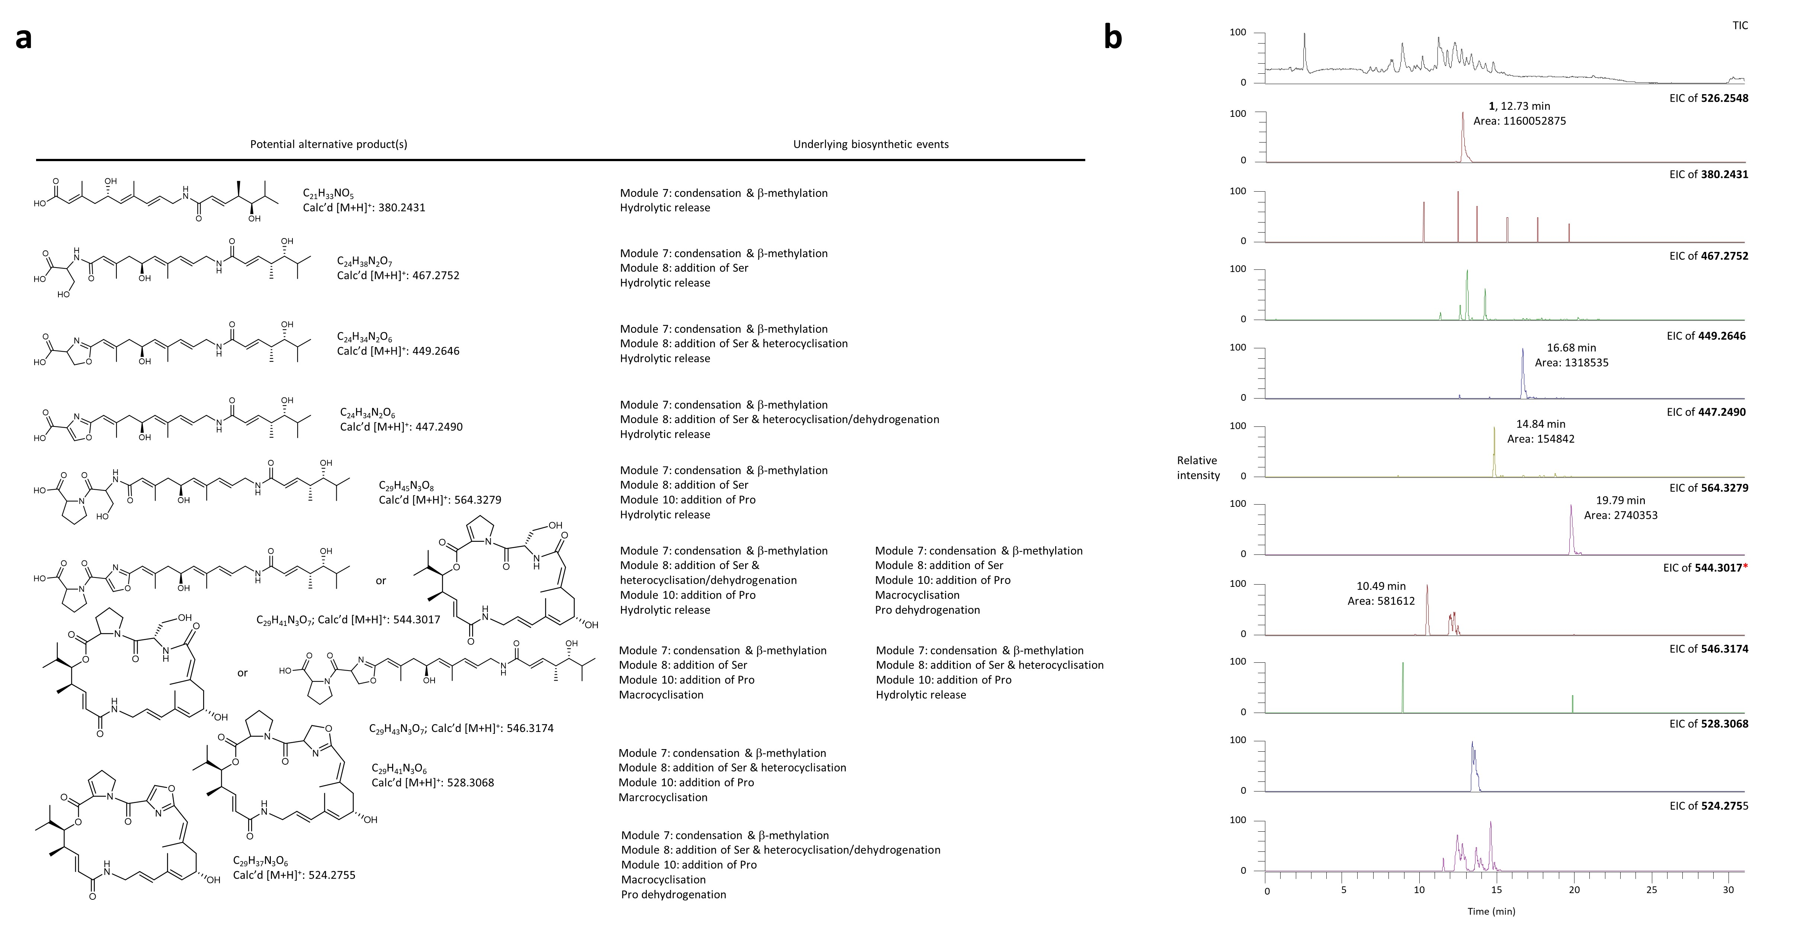
Extended Data Fig. 5 │ High-resolution MS analysis for additional metabolites produced by wild type S. pristinaespiralis ATCC 25486. a. Theoretical products derived from β-methylation in module 7, followed by variable biosynthetic events catalysed by the domains located downstream, with carboxylic acids released by spontaneous hydrolysis. In each case, the metabolite structure, its molecular formula and calculated mass ([M+H]⁺) are indicated. b. EICs corresponding to the calculated masses in a. (mass tolerance set to 10 ppm), with the EIC of 1 shown as a control. For detected peaks, the retention times and measured peak areas are indicated. *The potential hydrated form of derivative 3.
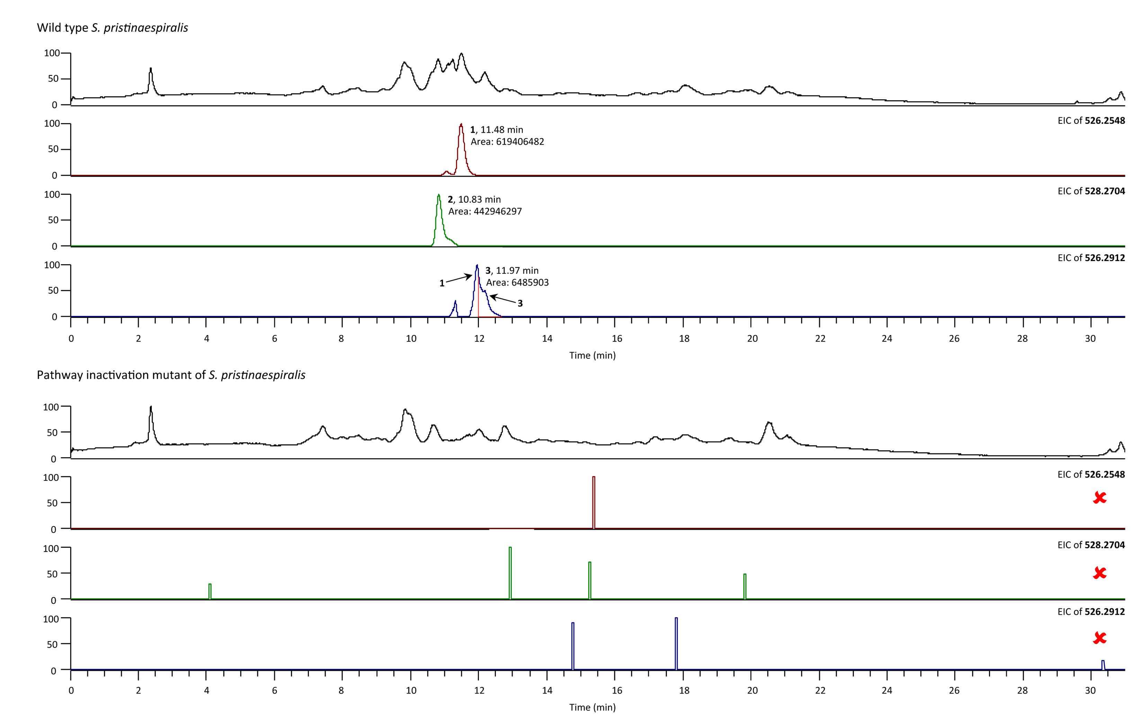
Extended Data Fig. 6 │ Comparison of the metabolic spectrum of S. pristinaespiralis wild type with that of the pathway inactivation mutant. For each strain, the EICs of the exact masses corresponding to metabolites 1−3 are shown. Note: the retention times for 1−3 do not correspond to those reported elsewhere in the ms (i.e. Extended Data Table 2), as the metabolites eluted differently following replacement of the original HPLC column.

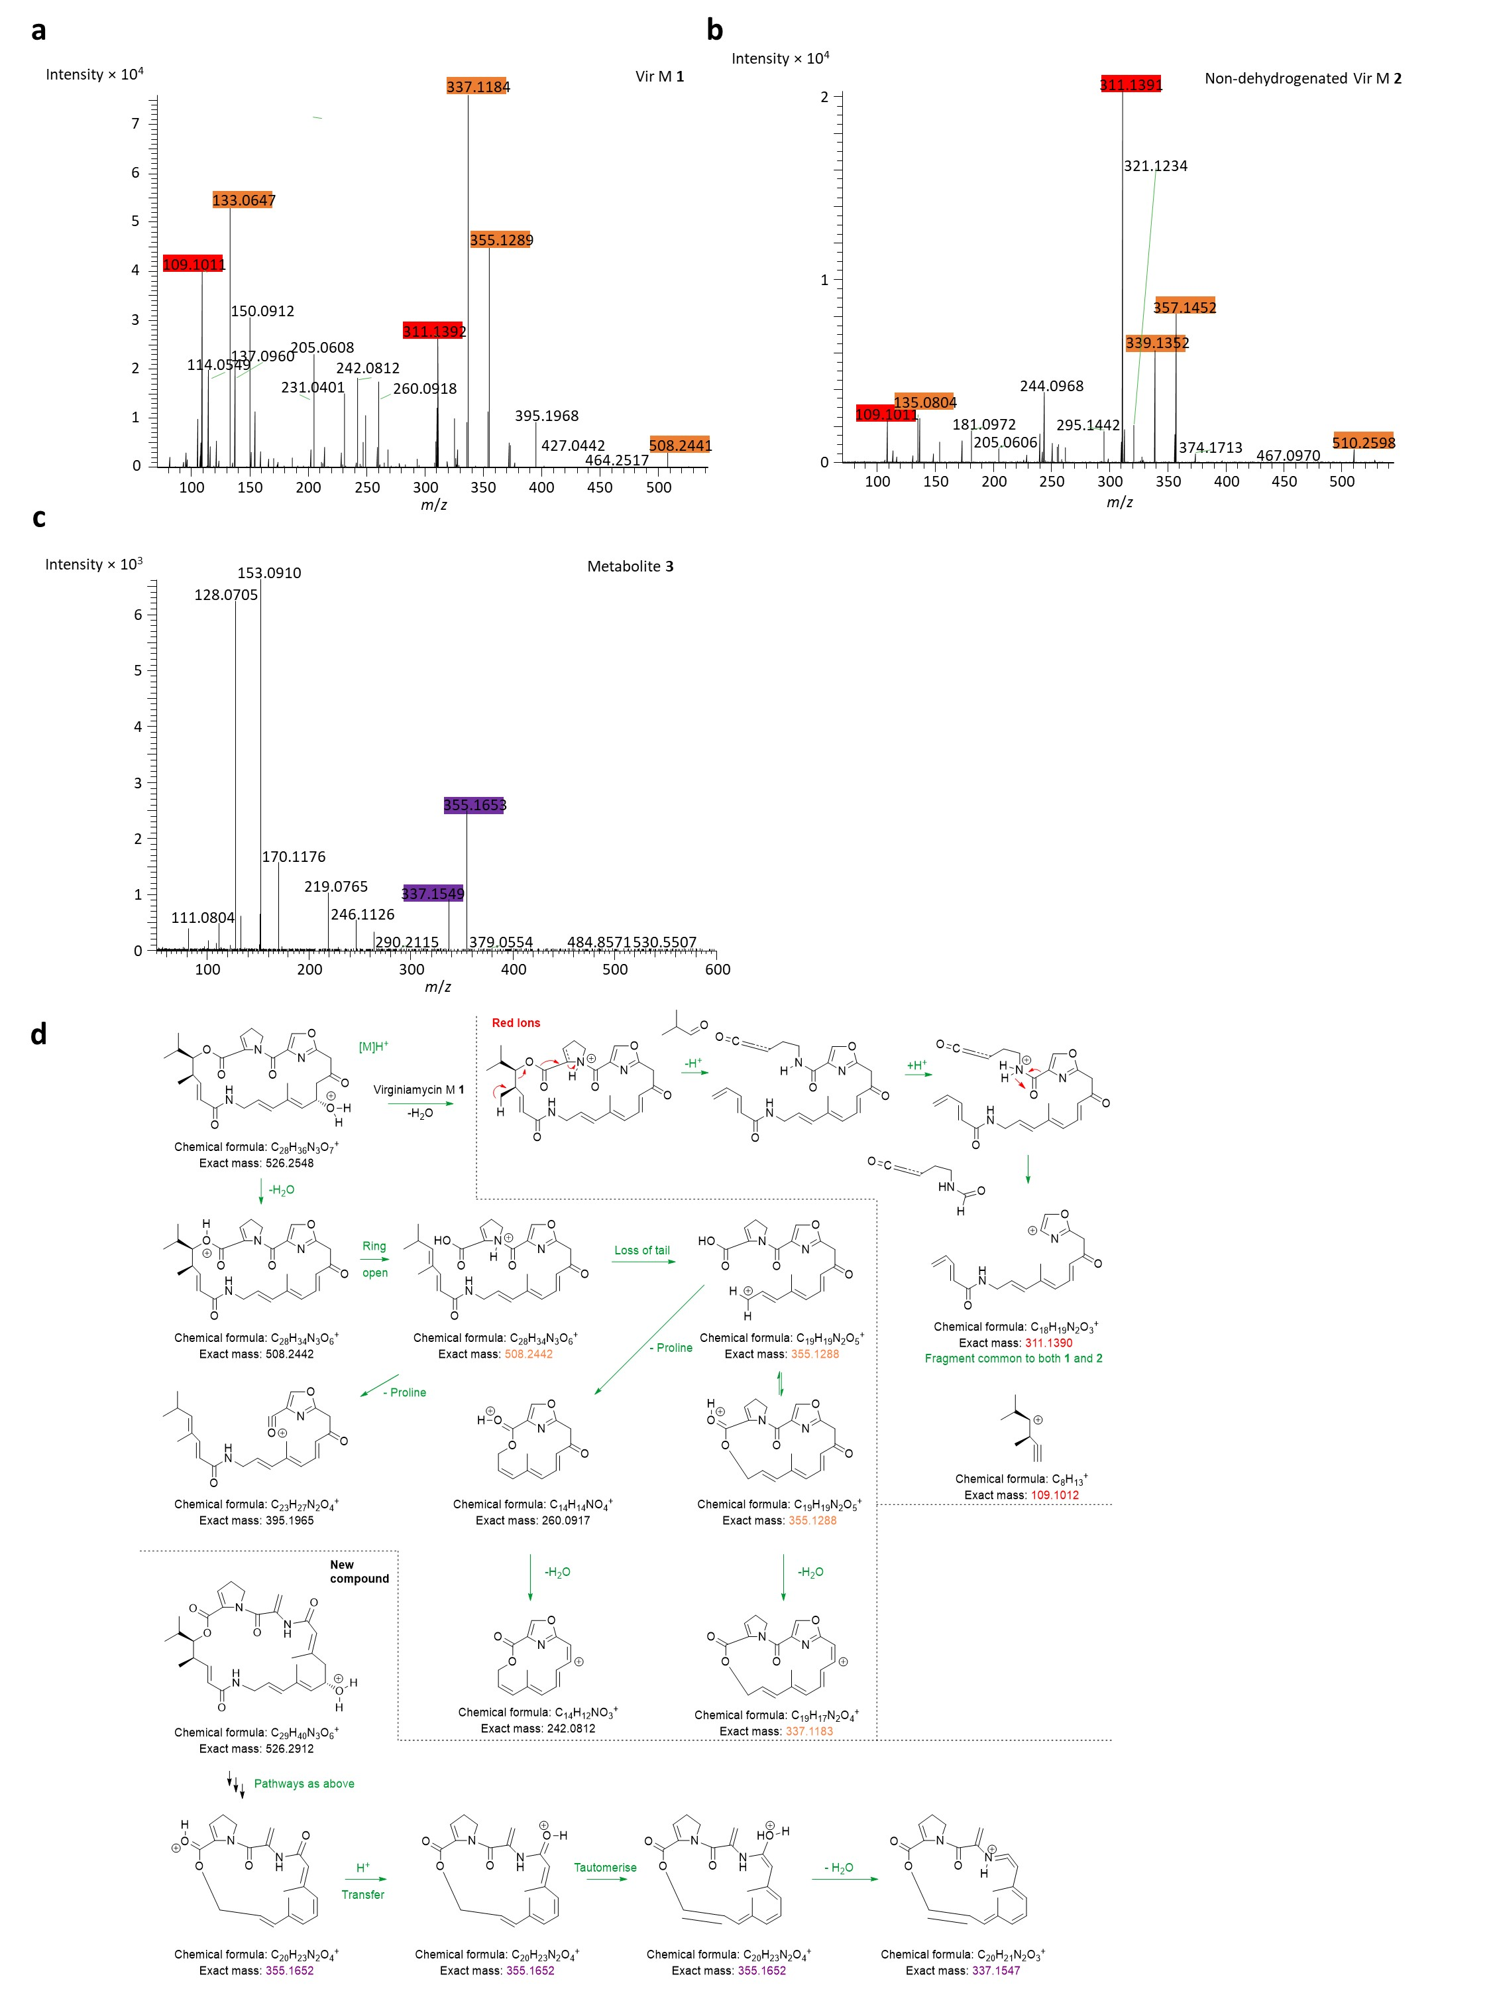

Extended Data Fig. 7 │ High-resolution MS² analysis of metabolites 1−3. MS² fragmentation was carried out on the respective parent ions of metabolites: a. 1, b. 2 and c. 3. Fragments differing by 2 Da between 1 and 2, and therefore likely encompassing the proline/2-pyrroline, respectively, are indicated by orange boxes. The red boxes identify fragments common to 1 and 2, while the purple fragments of 3 exhibit the same increase in mass relative to the corresponding fragments of 1 as that seen between the parental molecules 3 and 1. d. Proposed fragmentation of 1 ([M+H]⁺) to yield fragments highlighted by orange and red boxes, as well as of 3 ([M+H]⁺) to yield the fragments highlighted by purple boxes.
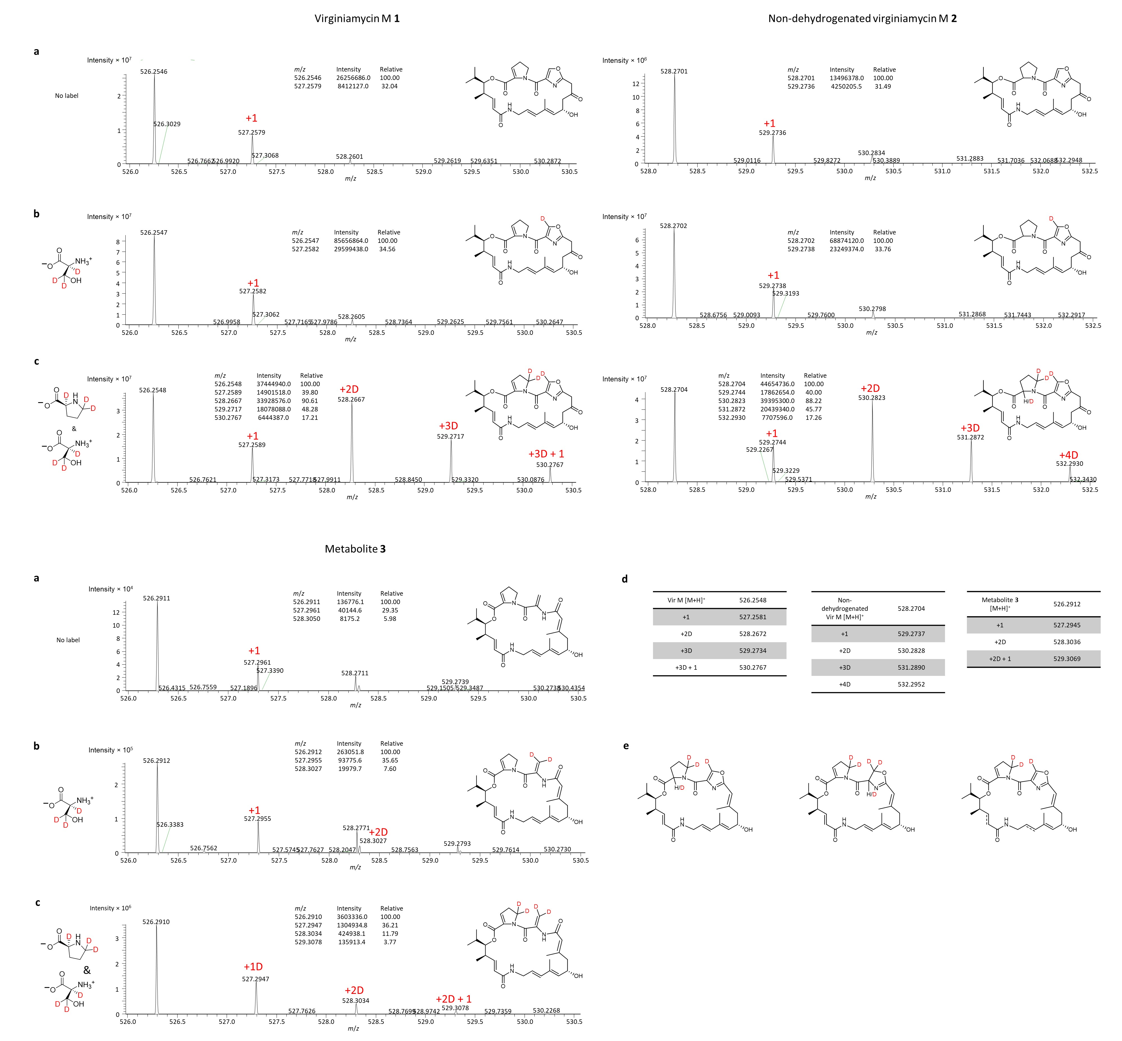
Extended Data Fig. 8 │ Patterns of isotope incorporation into metabolites 1−3 in the presence of labelled amino acids. a. Mass spectrum ([M+H⁺]) obtained in the absence of feeding (the calculated masses for 1−3 are presented in Extended Data Table 2). b. Feeding of L-serine-2,3,3-D₃. c. Feeding of L-proline-2,5,5-D₃ and L-serine-2,3,3-D3. In a−c, the label +1 indicates a peak with the mass of a natural isotopic peak of the adjacent monoisotopic peak (mass difference ca. 1.0033). The label +D indicates a mass difference consistent with incorporation of one or more deuteriums (mass difference for each D of ca. 1.0062). In each case, the relative peak intensities are shown in inset. Globally, the different patterns observed for 3 relative to 1 and 2 are consistent with incorporation of two deuteriums from both Pro and Ser, and therefore with the proposed divergence in post-incorporation chemistry occurring on the Ser (dehydration instead of heterocyclisation/dehydrogenation). d. Calculated masses for the incorporation peaks observed in a−c. e. Alternative structures for 3 with identical exact masses ([M+H⁺] = 526.2912), and which can be explained using classical PKS/NRPS biochemistry. In each case, the labelling patterns expected in the presence of fed combined L-proline-2,5,5-D₃ and L-serine-2,3,3-D₃ are indicated. The third structure incorporates a single site of saturation as indicated by the dashed lines, which could be introduced spontaneously by a cellular reductase.

Extended Data Table 1 │ Summary of tryptophan fluorescence quenching results.
 | VirC | VirD | VirE
Ligand | K_{d} (µM) | K_{d} (µM) | K_{d} (µM)
apo-ACP_{5a} | 166 ± 18 | 102 ± 14 | 653 ± 171
holo-ACP_{5a} | n.d. | n.d. | n.d.
apo-ACP_{5b} | 77 ± 10 | 178 ± 26 | 171 ± 31
holo-ACP_{5b} | 3.8 ± 0.5 | 2.9 ± 0.5 | 6.8 ± 1.5
holo-ACP_{5a}-ACP_{5b} | 17 ± 2 | 19 ± 3 | 42 ± 10
apo-ACP₆ | n.d. | n.d. | n.d.
holo-ACP₆ | n.d. | n.d. | n.d.
apo-ACP₇ | 75 ± 7 | 75 ± 7 | 301 ± 126
holo-ACP₇ | 18 ± 3 | 4.3 ± 0.2 | 22 ± 5
acetoacetyl-ACP_{5a} | 40 ± 5 | - | -
acetoacetyl-ACP_{5b} | 4.3 ± 0.3 | - | -
HMG-ACP_{5a} | - | 51 ± 25 | -
HMG-ACP_{5b} | - | 39 ± 5 | -
methylcrotonyl-ACP_{5a} | - | - | 287 ± 49
methylcrotonyl-ACP_{5b} | - | - | 30 ± 3
apo-ACP_{5a} E6761A | 108 ± 11 | 186 ± 31 | -
holo-ACP_{5a} E6761A | 4.7 ± 0.5 | 6.1 ± 0.6 | -
apo-ACP_{5a} L6764N | 89 ± 14 | 83 ± 12 | -
holo-ACP_{5a} L6764N | 11 ± 1 | 4.1 ± 0.4 | -
apo-ACP_{5a} E6761A/L6764N | 61 ± 6 | 117 ± 11 | -
holo-ACP_{5a} E6761A/L6764N | 10 ± 1 | 7 ± 1 | -
apo-Sna ACP₇ | 78 ± 10 | 166 ± 25 | -
holo-Sna ACP₇ | 13 ± 1 | 13 ± 1 | -
n.d. = no binding detected.

Extended Data Table 2 │ Spectroscopic and yield data for metabolites 1−3.
Compound | Chemical formula | Retention time (min) | Calculated m/z ratio  [M+H]⁺ | Observed m/z ratio [M+H]⁺ | Major MS² fragmentsª | Integrated peak areas^{b} | Calculated titer  (mg L⁻¹)^{c}
Virginiamycin M (Vir M) 1 | C₂₈H₃₅N₃O₇ | 12.50−12.66 | 526.2548 | 526.2549  (+0.38 ppm) | 508.2441, 395.1968, 355.1289, 337.1184, 311.1392, 260.0918, 242.0812, 231.0401, 205.0608, 150.0912, 137.0960, 133.0647, 114.0549, 109.1011 | 1792296235  1670983468  1275350367 | 0.12 ± 0.02
Non-dehydrogenated Vir M 2 | C₂₈H₃₇N₃O₇ | 11.69−11.99 | 528.2704 | 528.2701  (−0.57 ppm) | 510.2598, 357.1452, 339.1352, 321.1234, 311.1391, 295.1442, 244.0968, 135.0804, 109.1011 | 1097693947  1017328497  1463514063 | 0.09 ± 0.01
Doubly β-methylated derivative 3 | C₂₉H₃₉N₃O₆ | 13.35−13.71 | 526.2912 | 526.2909  (−0.57 ppm) | 355.1653, 337.1549, 246.1126, 219.0765, 170.1176, 153.0910, 128.0705, 111.0804 | 27013749  19879608  26359953 | 0.0006 ± 0.0003

ªOrange: fragments differing by 2 Da between 1 and 2, and thus likely containing the Pro/2-pyrroline residue; red: fragments common to 1 and 2; purple: fragments of 3 which exhibit the same increase in mass relative to the corresponding fragments of 1 as that seen between the parental molecules 3 and 1.
^{b}The data were obtained from three biological replicates. The integrated peak areas were converted to titres using the calculation described in Supplementary Fig. 4.
^{c}While yields of all three metabolites were substantially improved by addition of XAD-16 resin (by ≥ 25−50-fold, bringing them closer to those previously reported for S. pristinaespiralis ATCC25486 (13 mg L⁻¹)⁷³), the clearest labelling results were obtained in its absence, making the presented titres most relevant.

