Supporting information for
Title: A rad50 germline mutation induces the ataxia-telangiectasia phenotype in a transparent medaka model

Authors: Shinichi Chisada^{1,†}, Kouki Ohtsuka^{2,}*,†, Masachika Fujiwara³, Masao Yoshida¹, Satsuki Matsushima², Takashi Watanabe², Kanae Karita¹, Hiroaki Ohnishi²
Affiliations: ¹Department of Hygiene and Public Health, Kyorin University School of Medicine; Mitaka, Tokyo 181-8611, Japan. ²Department of Laboratory Medicine, Kyorin University School of Medicine; Mitaka, Tokyo 181-8611, Japan. ³Department of Pathology, Kyorin University School of Medicine; Mitaka, Tokyo 181-8611, Japan.
*Corresponding author: kouki7@ks.kyorin-u.ac.jp

This file includes:
Supporting information
Figures S1 and S2
Tables S1
Legends for Movies S1 and S2
Other supporting materials for this manuscript include the following:
Movies S1 and S2

Supporting Information
Creation of an analytical model and extraction of the head and body coordinates of swimming medaka from movies via DeepLabCut. DeepLabCut (version 2.0) was used to create an analytical model of medaka swimming and to extract the coordinates of the head and body positions. First, 19 frames were automatically extracted using the “kmeans” algorithm from the video of one wildtype medaka. In these frames, the head position was labeled between the left and right eyes. The body position was labeled between the left and right pectoral fins. The size of each marker was 5 µm. Nineteen frames were used as the training dataset in DeepLabCut. Next, DeepLabCut was trained 50,000 times to recognize the position of the head and body of the medaka in the movie based on the training dataset, and an analysis model of medaka swimming was generated. The analytical model of medaka swimming was used to analyze all movies of wildtype and rad50^{Δ2/+} medaka, and the head and body coordinates were extracted. The root mean square values were calculated from the coordinates using Microsoft Excel. The tail markers shown in the movies were not used in this study.

Supporting Figures

Figure S1. Hindbrain size. Ratio of the area of the hindbrain to area of the telencephalon, midbrain, and hindbrain in wildtype (WT) and rad50^{Δ2/+} medaka. The areas were calculated using images. Black dots and the short horizontal red lines represent the data obtained from one individual and the median, respectively. n.s. indicates the absence of a statistically significant difference (Mann–Whitney U test).

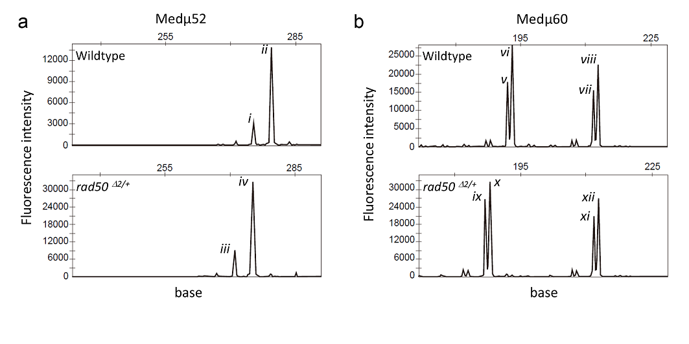 Figure S2. Changes in microsatellite loci. (a) Comparison of the Medμ52 locus between the wildtype (upper) and rad50^{Δ2/+} mutant (lower). (b) Comparison of the Medμ60 locus between wildtype (upper) and rad50^{Δ2/+} or rad50^{Δ2/Δ2} mutant (lower). In the upper panels of (a) and (b), data from one of the 13 wildtypes was shown as a representative. In the lower panel of (b), of the rad50^{Δ2/+} and rad50^{Δ2/Δ2} mutants with mutations in the Medμ60, data from one rad50^{Δ2/+} mutant was shown as a representative. Peaks i–xii represent the size of the PCR amplification products: 275 bases for i, 279 bases for ii, 271 bases for iii, 275 bases for iv, 192 bases for v, 193 bases for vi, 212 bases for vii and xi, 213 bases for viii and xii, 187 bases for ix, and 188 for x.

Supporting Table

Table S1. PCR and sequencing primers.
Primer name | Sequences* (5′-3′)
Primer 1 | TGATTGATCCCTTTTAGAAAAGACCTTGTG
Primer 2 | GCTCCTCTTTGTCCAGCTGGAA
Primer 3 | GATTGATCCCTTTTAGAAAAGACCTTGTG
Primer 4 | TGAGGAAATAAGACTATCAGTGAGACAAC
Medμ 45U | FAM-GTTTGGTGATGGGAGAAGAATAGT
Medμ 45L | TGACAAAAGGTGAGCAATAG
Medμ 52U | VIC-GATTGGACCTGTGACTCTAA
Medμ 52L | ATCTCTTGAAGGGTTTATACTG
Medμ 60U | NED-CCAGGAGAGGAATAATAAAC
Medμ 60L | TGGGAAAAGTGCTGTATAA
Medμ 58U | PET-TCACCAGTAGAAAACTTTACAG
Medμ 58L | AATGTCATAAAAAAGGGACTAA
*FAM, VIC, NED, and PET are fluorescent dyes.

Movie S1 (separate file). Stable swimming of wildtype.

Movie S2 (separate file). Unstable swimming of mutant.

