Supplementary Information for

Human and infrastructure exposure to large wildfires in the United States

Arash Modaresi Rad¹, John Abatzoglou², Jason Kreitler³, Mohammad Reza Alizadeh⁴, Amir AghaKouchak^{5,6}, Nicholas Hudyma¹, Nicholas Nauslar⁷, Mojtaba Sadegh^{1,*}

¹ Department of Civil Engineering, Boise State University, Boise, ID, UNITED STATES.
² Management of Complex Systems Department, University of California, Merced, Merced, CA, UNITED STATES.
³ US Geological Survey, Western Geographic Science Center, Boise, ID, UNITED STATES.
⁴ Department of Bioresource Engineering, McGill University, Quebec, CANADA.
⁵ Department of Civil and Environmental Engineering, University of California, Irvine, CA, UNITED STATES.
⁶ Department of Earth System Science, University of California, Irvine, CA, UNITED STATES.
⁷ Bureau of Land Management, National Interagency Fire Center, Boise, Idaho, UNITED STATES

* Correspondence to: mojtabasadegh@boisestate.edu

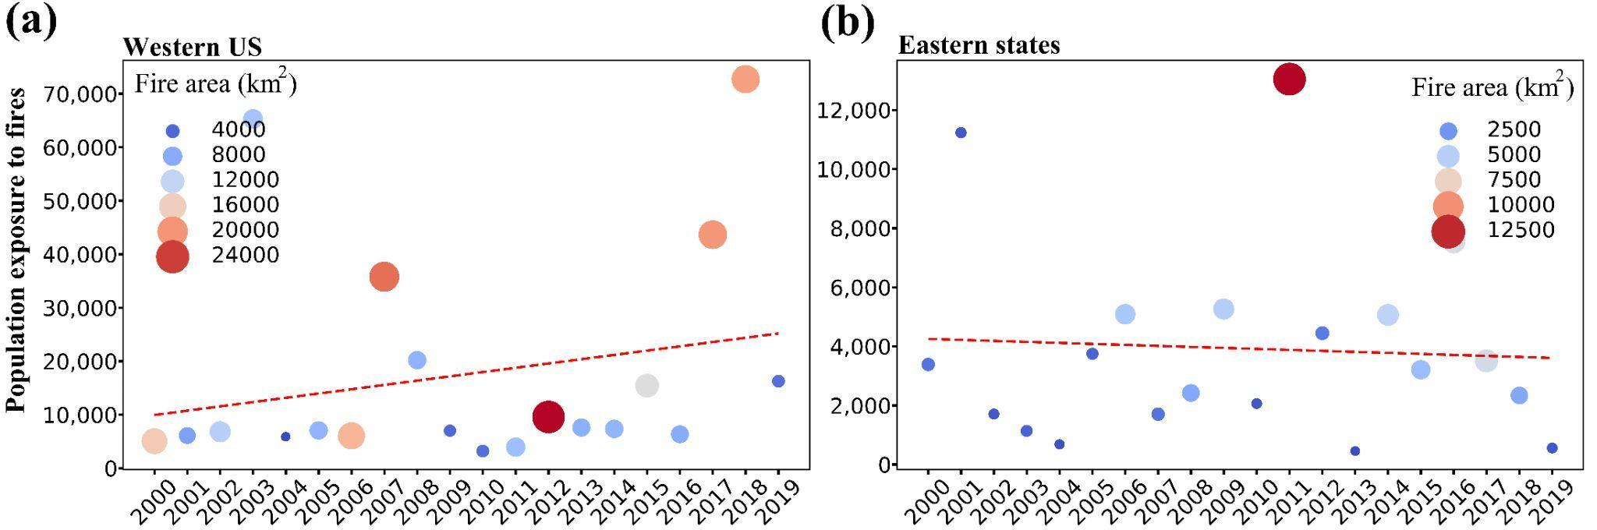
Fig. S1. Trends in primary population exposure to large forest fires in Western U.S. (a) and Eastern U.S. (b) from 2000-2019. The 11 states in the West of Contiguous U.S. are called Western U.S. (see Fig. 1c)

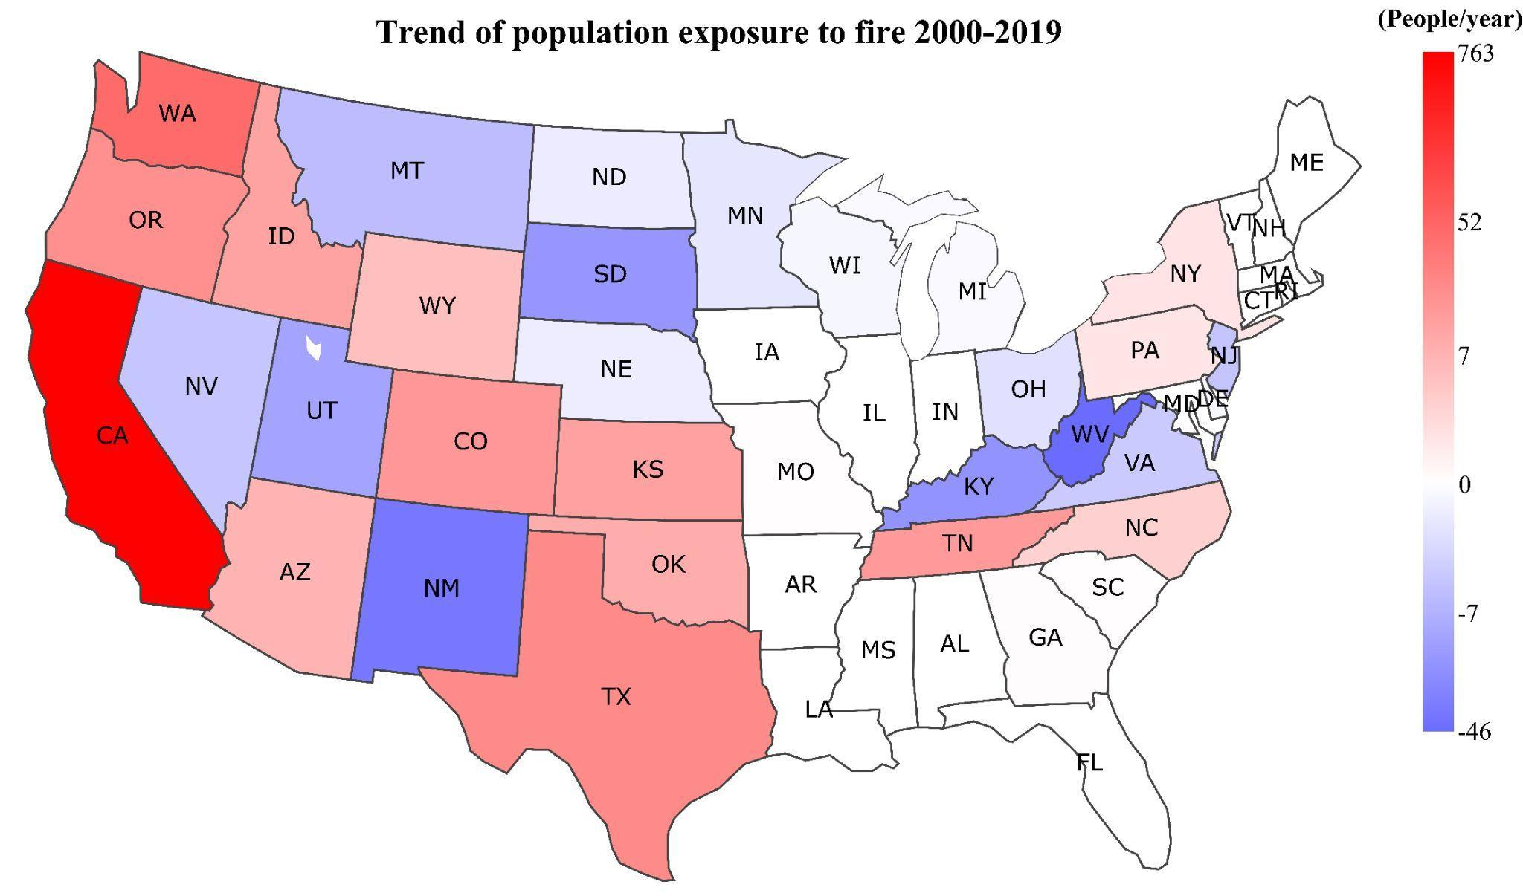
Fig. S2. Trends in primary population exposure to large forest fires in individual states from 2000-2019.

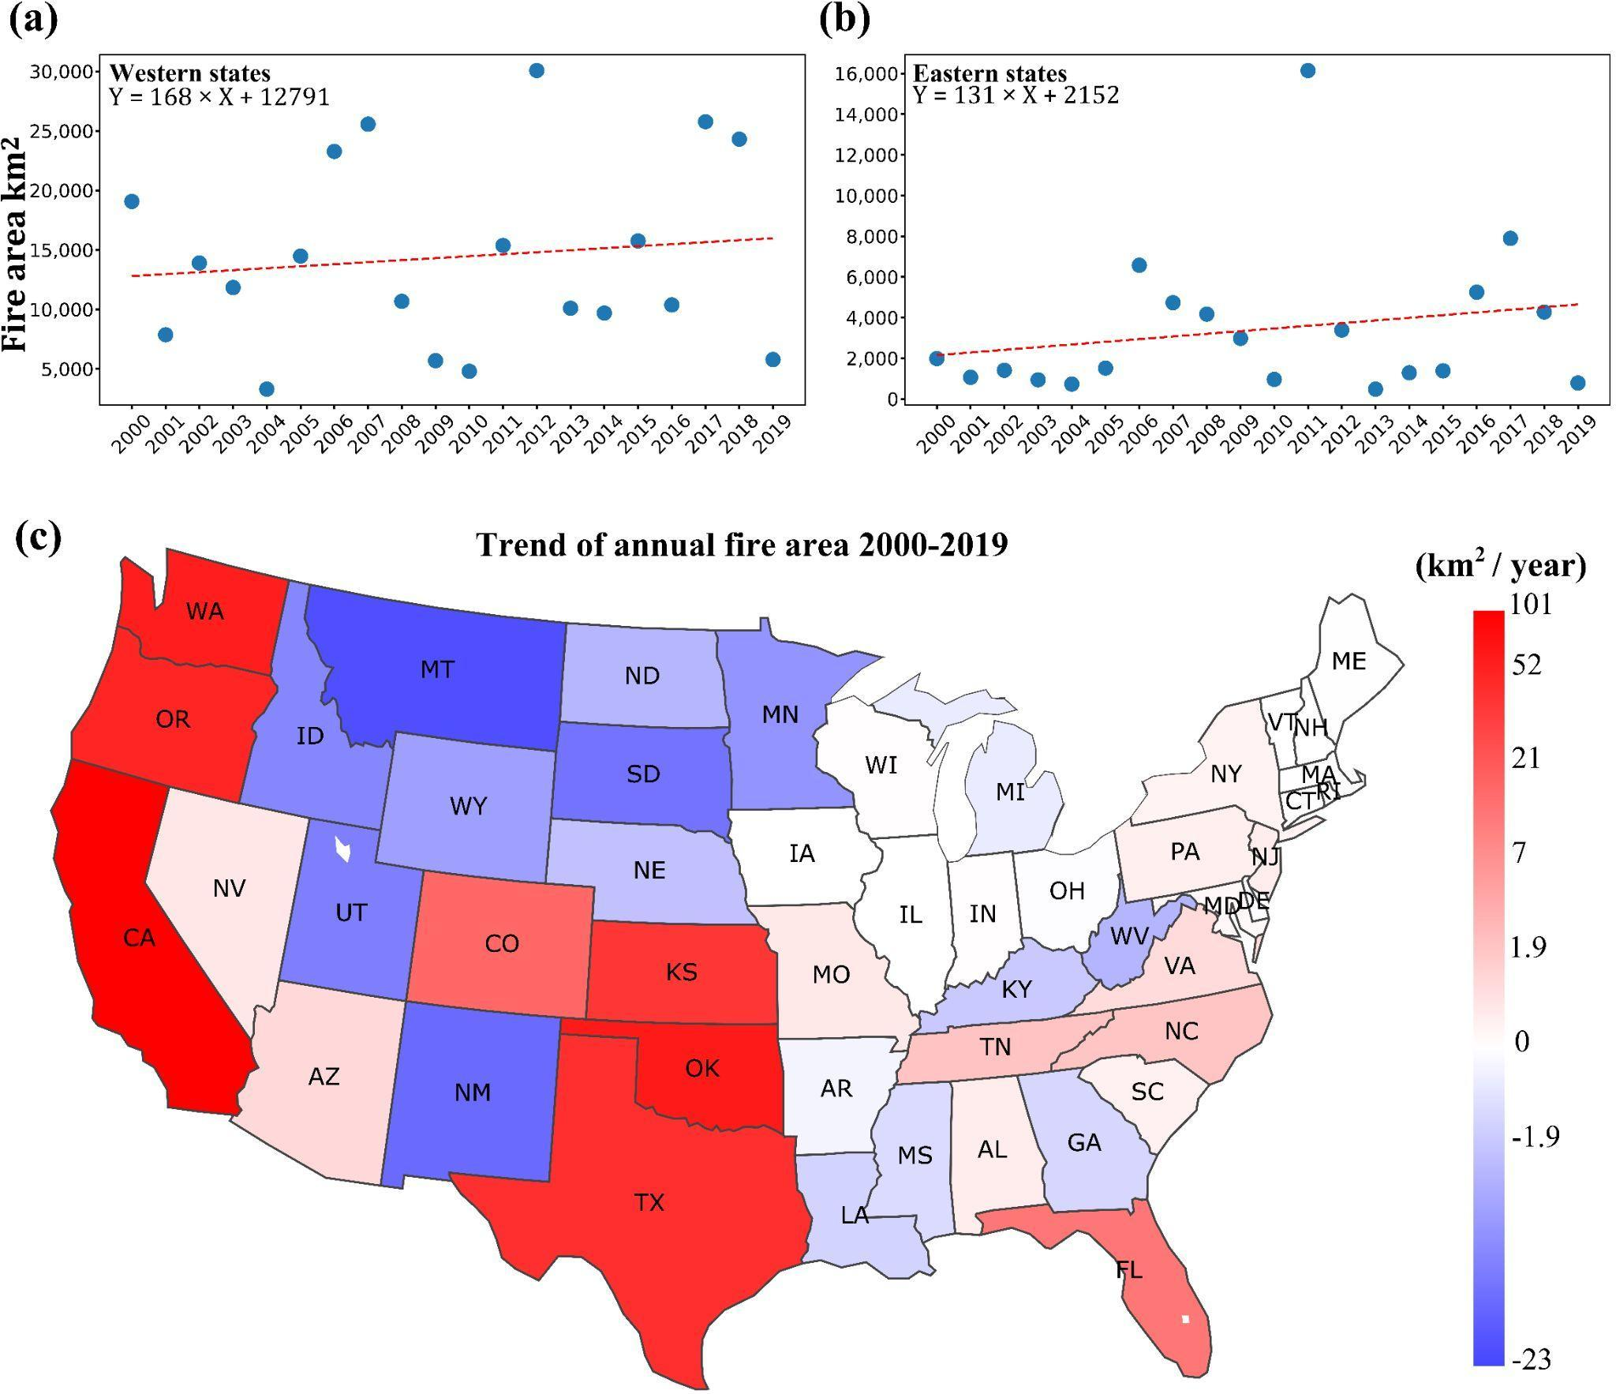
Fig. S3. Trends in fire area from 2000-2019. (a,b) Trends in the Western U.S. and Eastern U.S. (c) Trends in individual states. The 11 states in the West of Contiguous U.S. are called Western U.S.

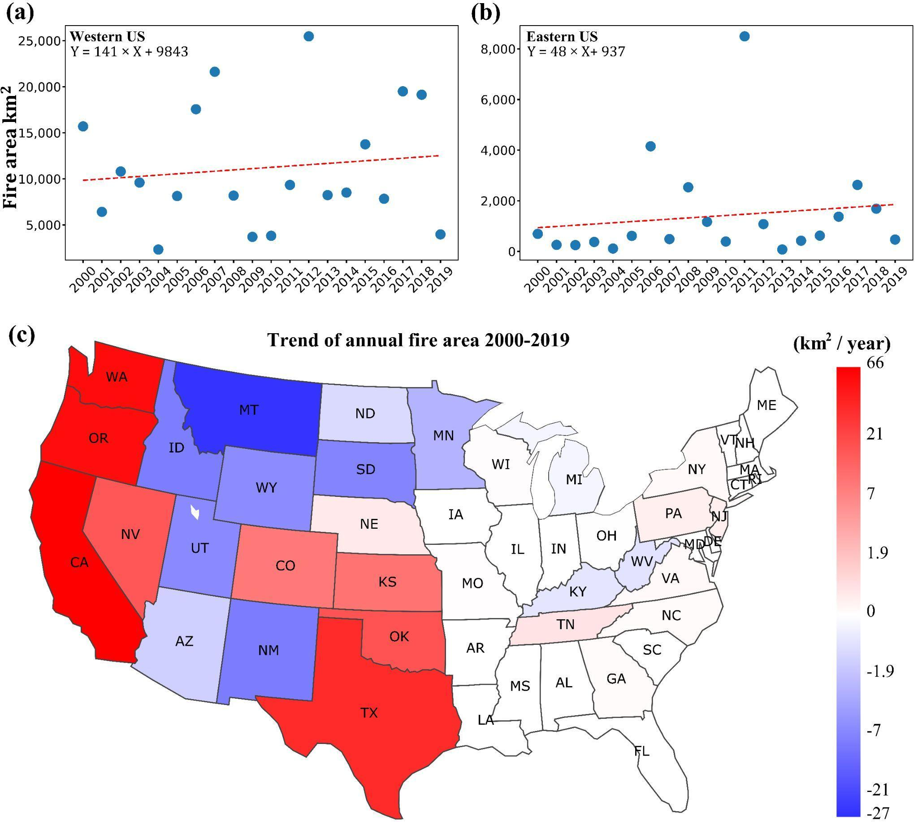
Fig. S4. Trends in forest fire area from 2000-2019. (a,b) Trends in the Western U.S. and Eastern U.S. (c) Trends in individual states. The 11 states in the West of Contiguous U.S. are called Western U.S.

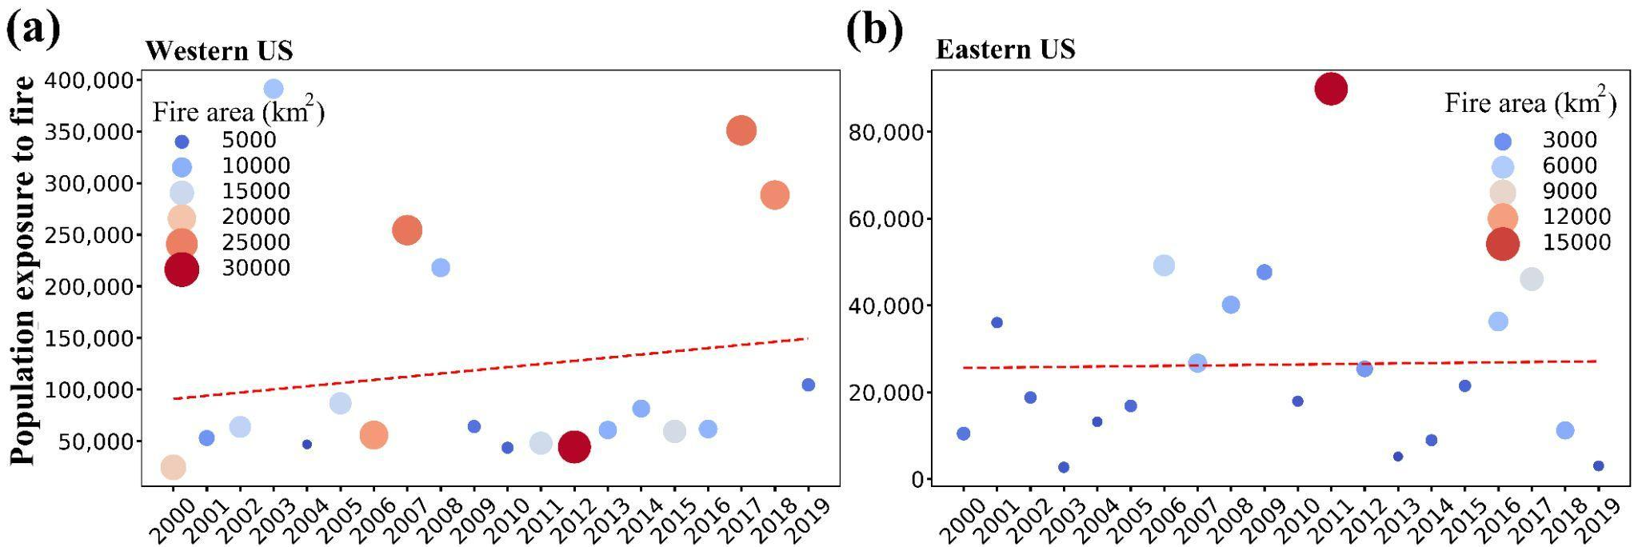
Fig. S5. Trends in accumulated primary and secondary (1 km buffer) population exposure to large fires in Western U.S. (a) and Eastern U.S. (b) from 2000-2019. Statistics are provided for population residing within a 1 km buffer from large fire perimeters.

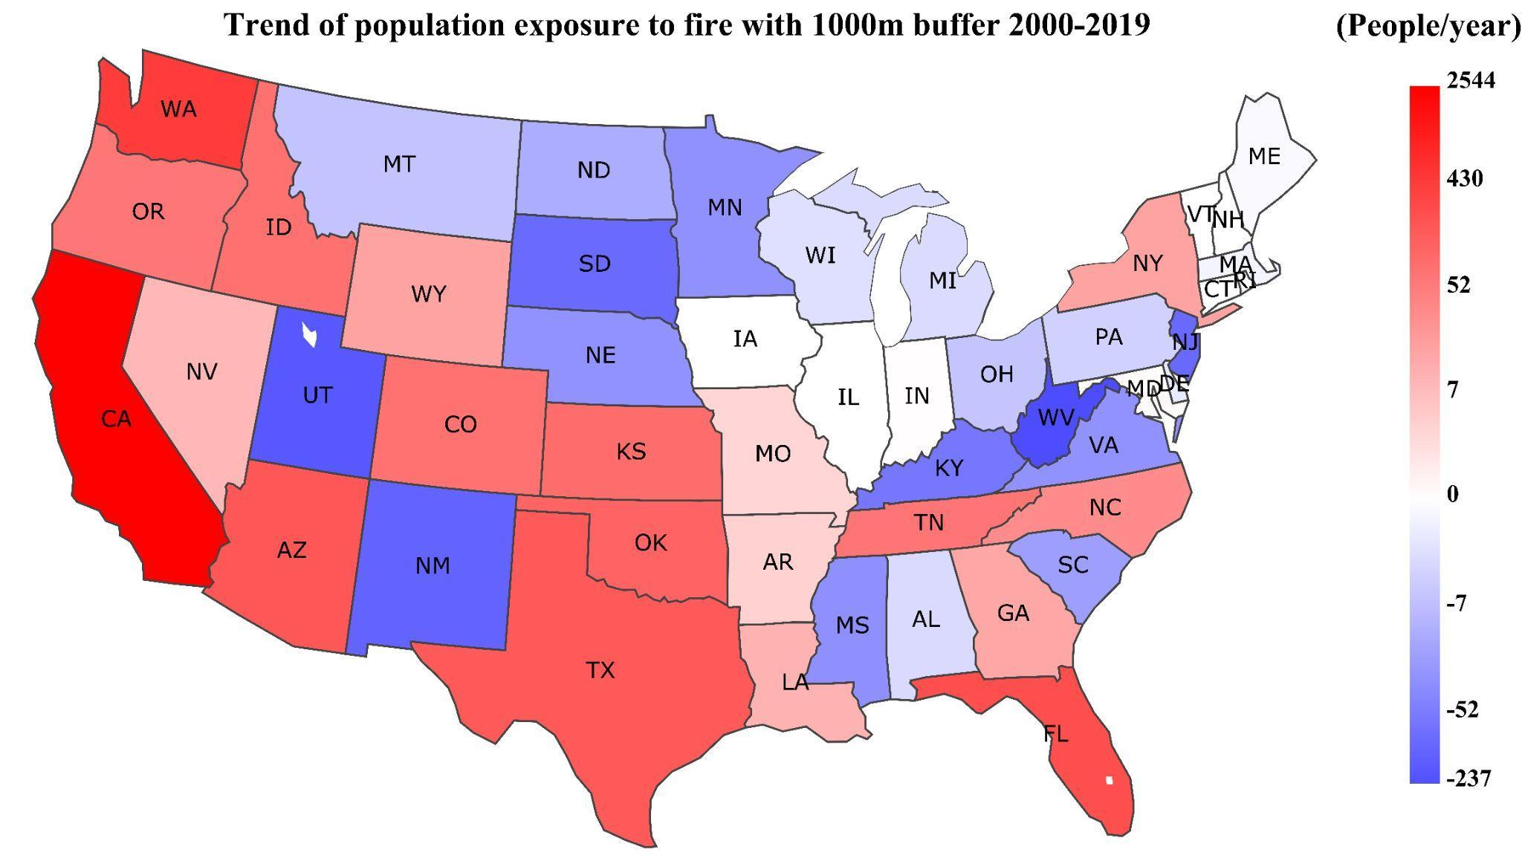
Fig. S6. Trends in accumulated primary and secondary (1 km buffer) population exposure to large fires in individual states from 2000-2019. Statistics are provided for population residing within a 1 km buffer from large fire perimeters.

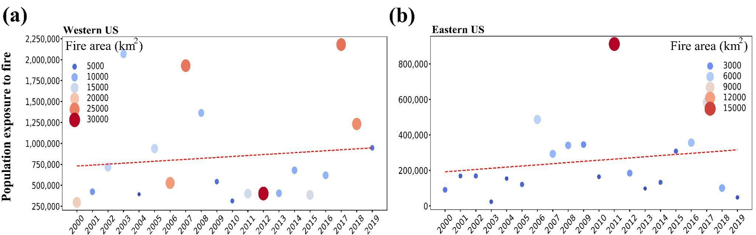
Fig. S7. Trends in accumulated primary and secondary (5 km buffer) population exposure to large fires in Western U.S. (a) and Eastern U.S. (b) from 2000-2019. Statistics are provided for population residing within a 5 km buffer from large fire perimeters.

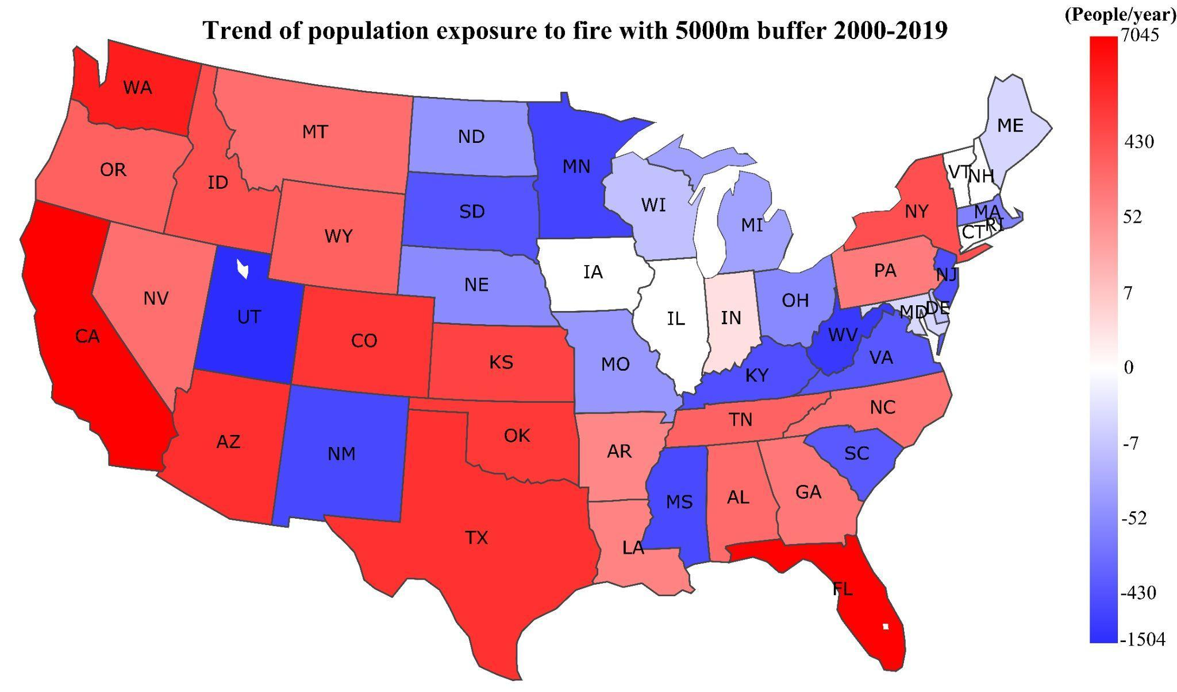
Fig. S8. Trends in accumulated primary and secondary (5 km buffer) population exposure to large fires in individual states from 2000-2019. Statistics are provided for population residing within a 5 km buffer from large fire perimeters.

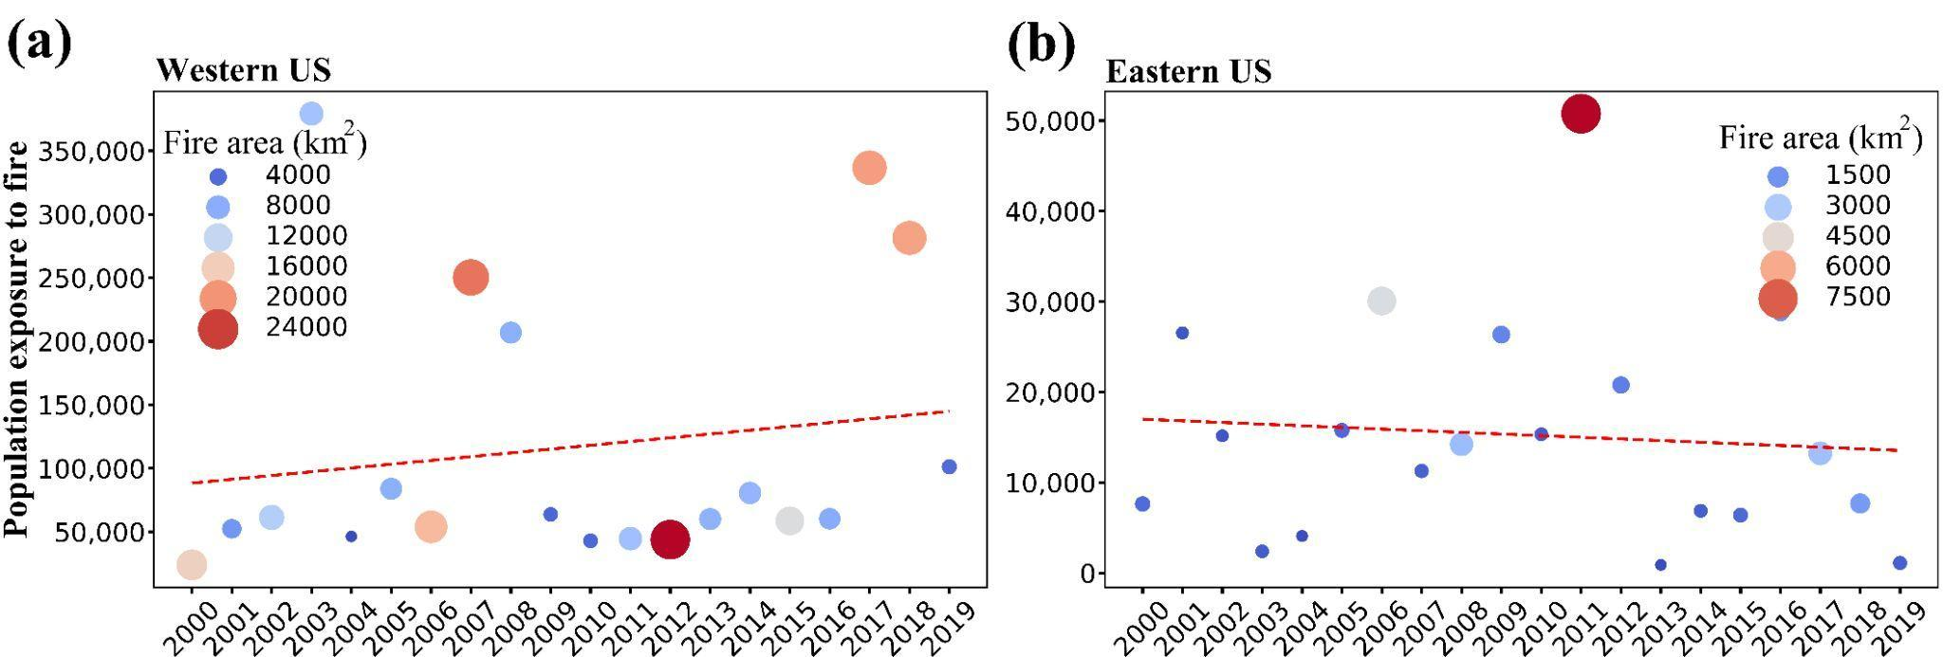
Fig. S9. Trends in accumulated primary and secondary (1 km buffer) population exposure to large forest fires in Western U.S. (a) and Eastern U.S. (b) from 2000-2019. Statistics are provided for population residing within a 1 km buffer from large forest fire perimeters.

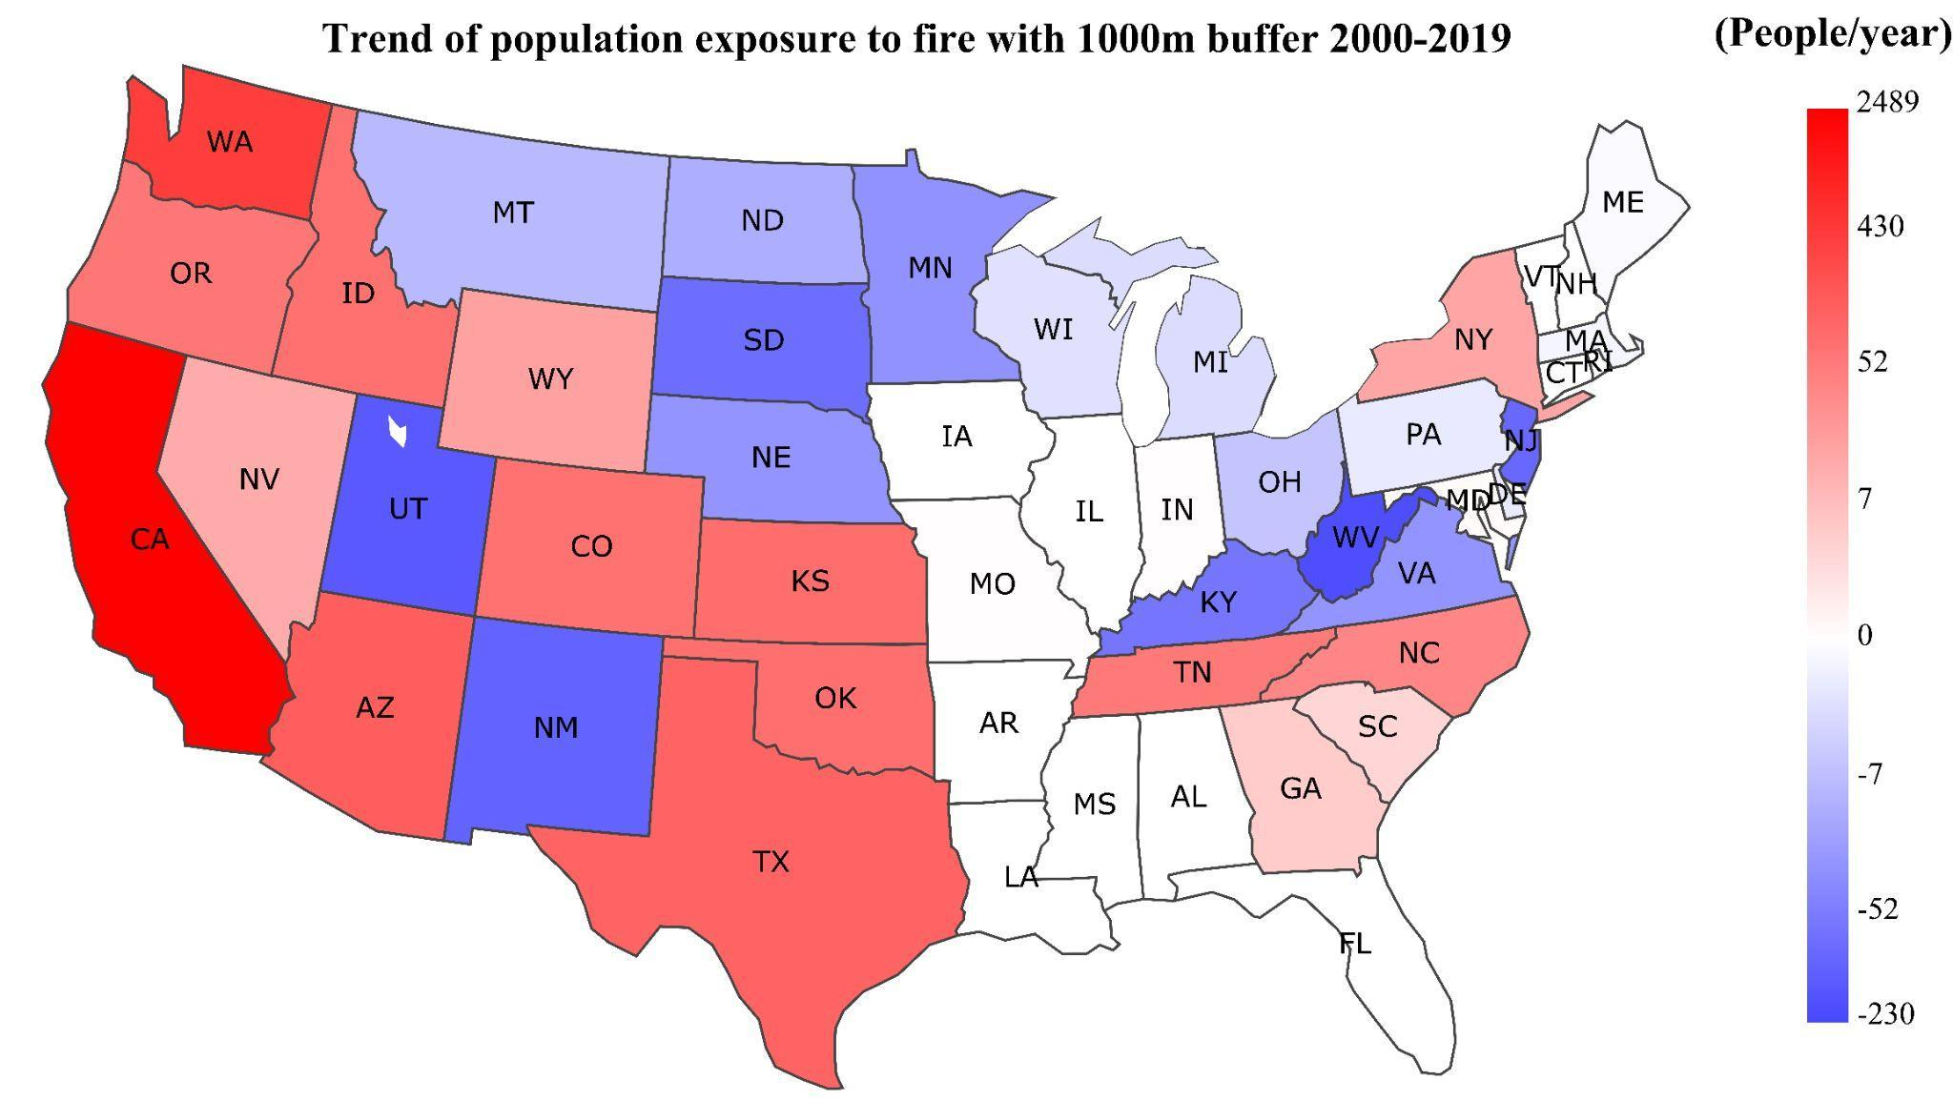
Fig. S10. Trends in accumulated primary and secondary (1 km buffer) population exposure to large forest fires in individual states from 2000-2019. Statistics are provided for population residing within a 1 km buffer from large forest fire perimeters.

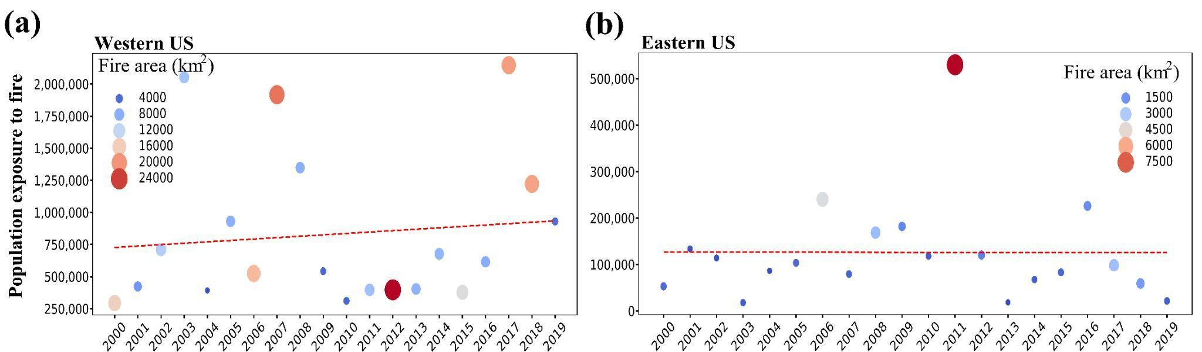
Fig. S11. Trends in accumulated primary and secondary (5 km buffer) population exposure to large forest fires in Western U.S. (a) and Eastern U.S. (b) from 2000-2019. Statistics are provided for population residing within a 5 km buffer from large forest fire perimeters.

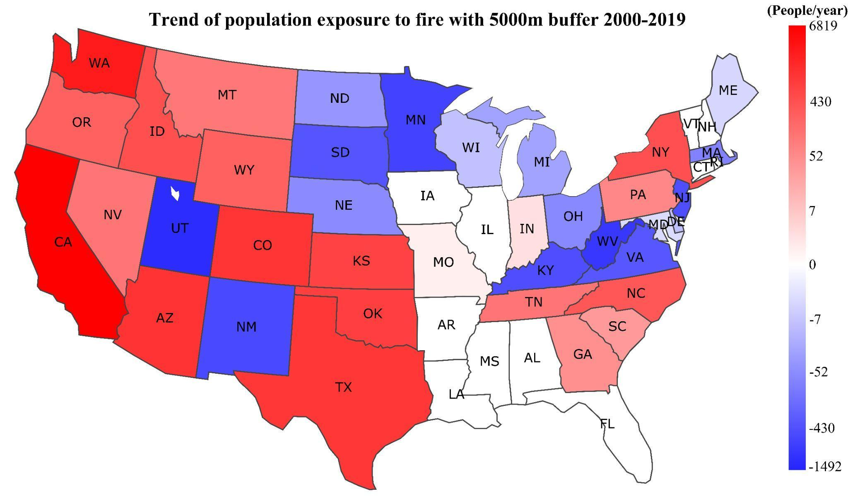Fig. S12. Trends in accumulated primary and secondary (5 km buffer) population exposure to large forest fires in individual states from 2000-2019. Statistics are provided for population residing within a 5 km buffer from large forest fire perimeters.

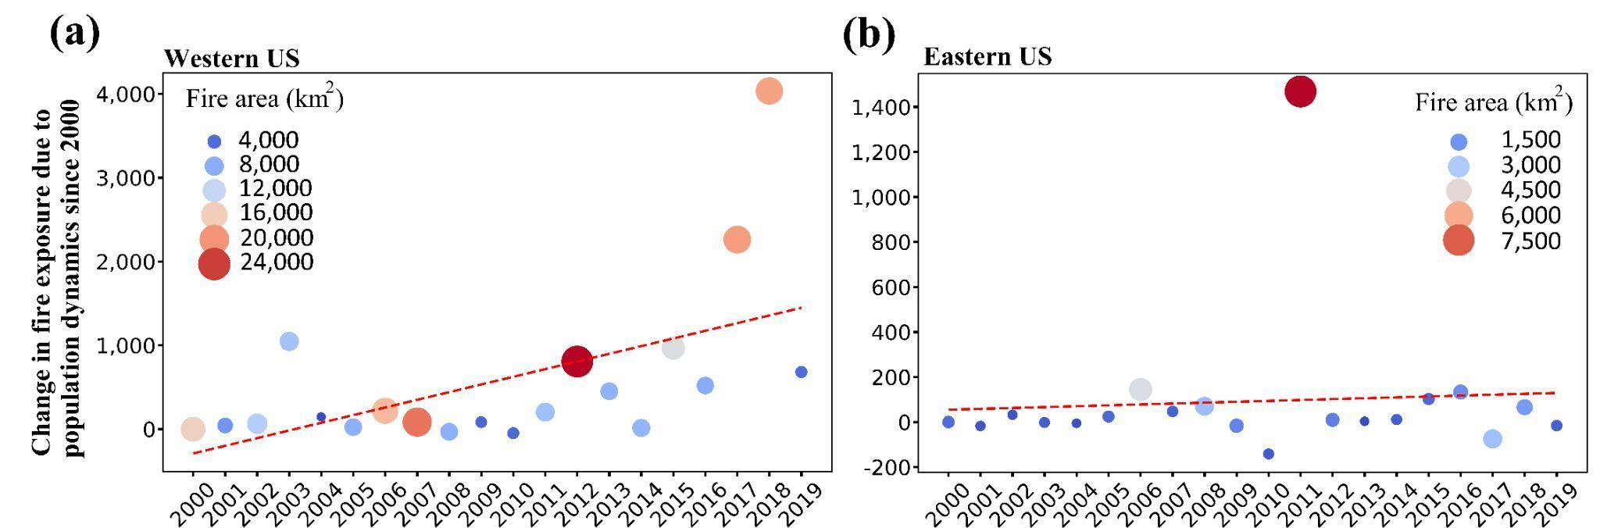

Fig. S13. Population dynamics’ contribution to primary population exposure to large forest fires in Western U.S. (a) and Eastern U.S. (b) from 2000-2019.

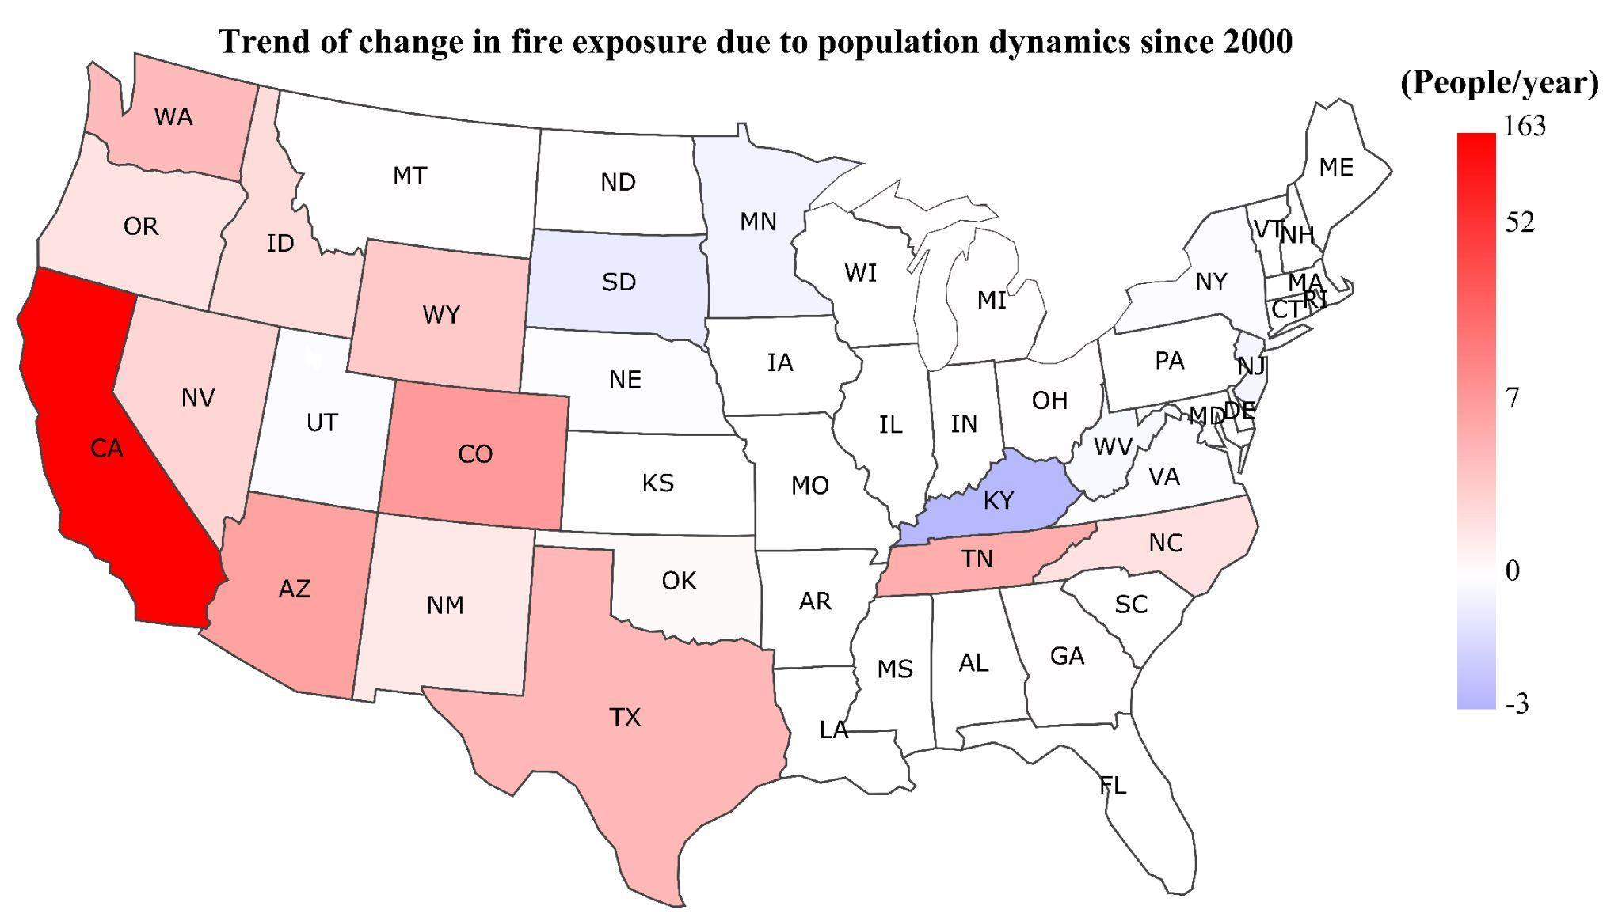
Fig. S14. Population dynamics’ contribution to primary population exposure to large forest fires in individual states from 2000-2019.

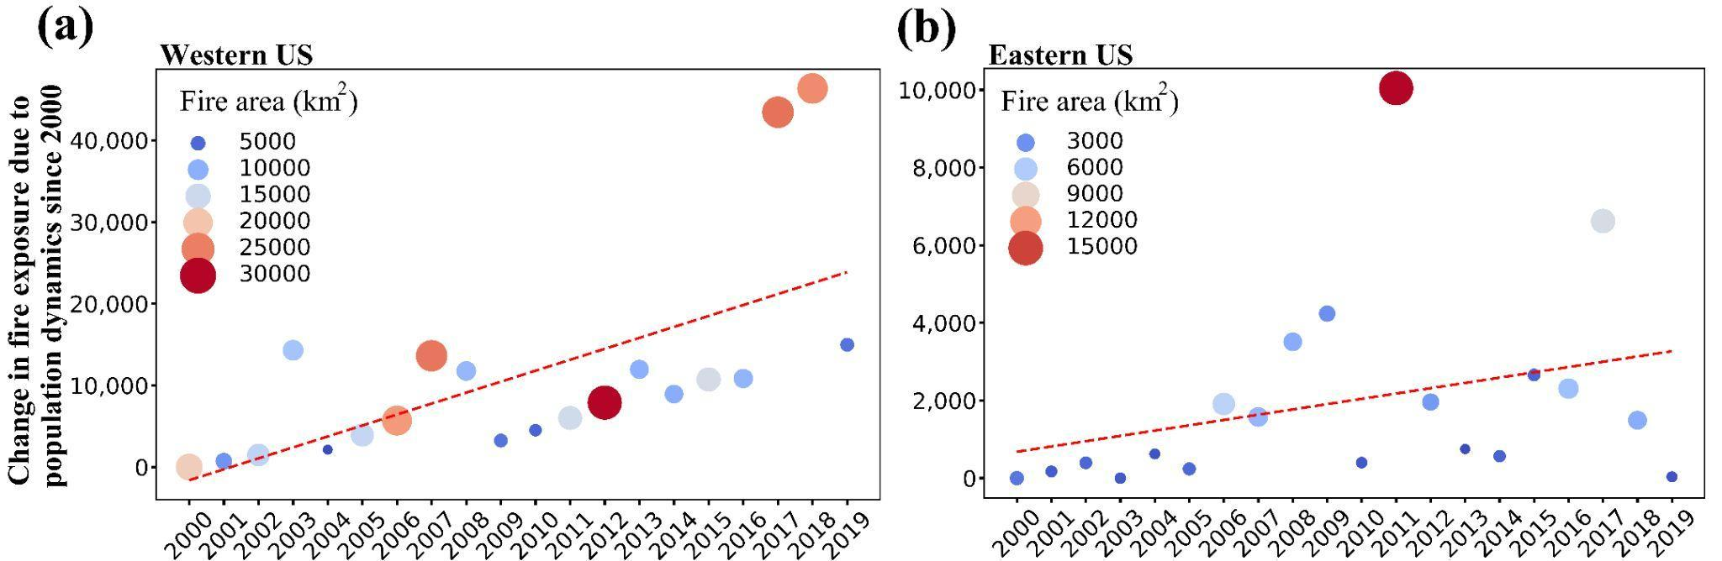

Fig. S15. Population dynamics’ contribution to accumulated primary and secondary population exposure (1 km buffer) to large fires in Western U.S. (a) and Eastern U.S. (b) from 2000-2019. Statistics are provided for population residing within a 1 km buffer from large fire perimeters.

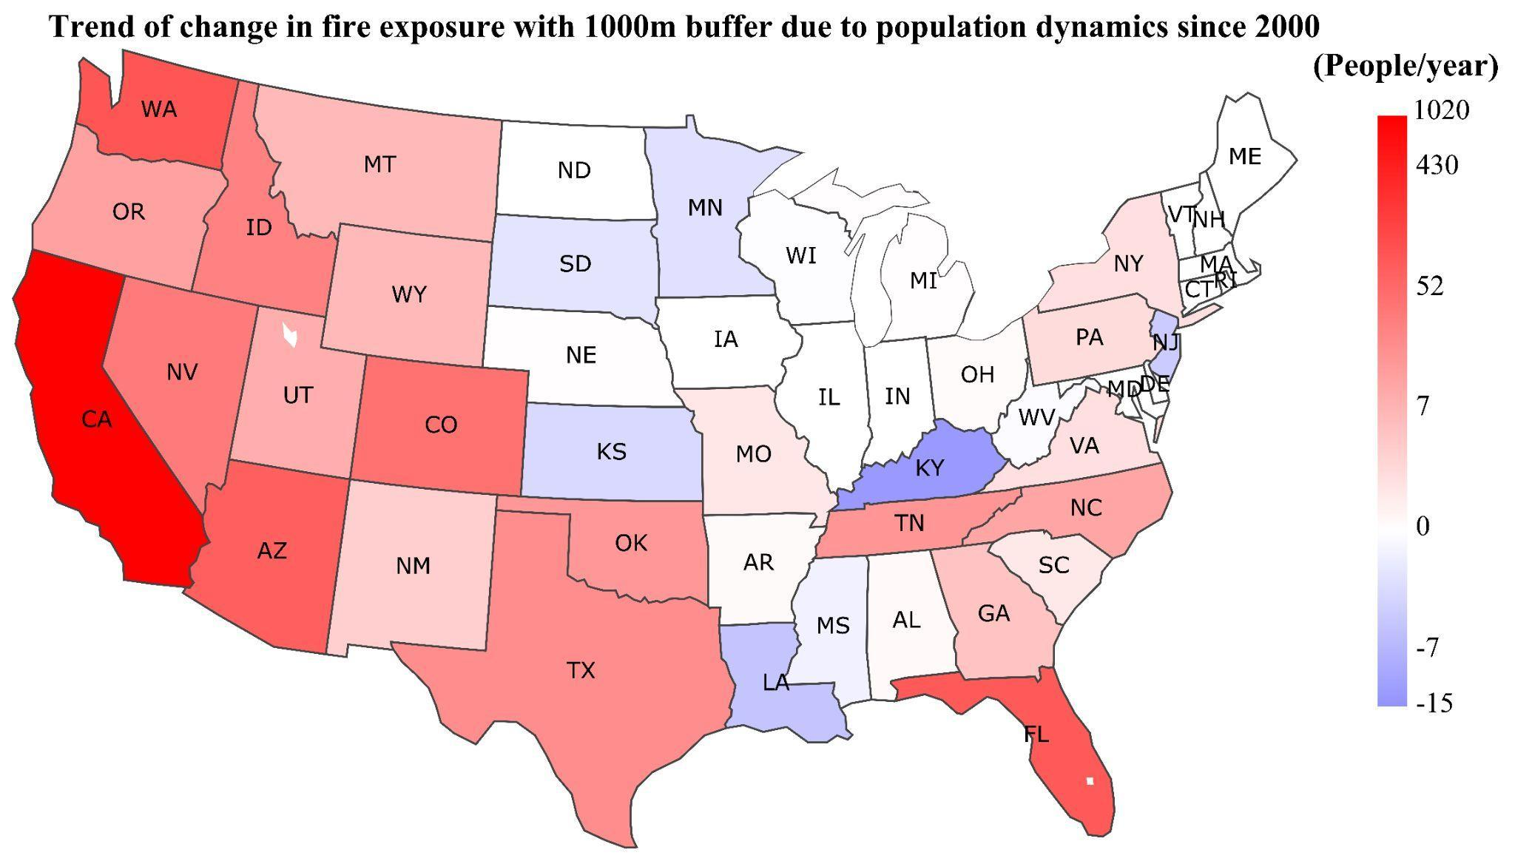
Fig. S16. Population dynamics’ contribution to accumulated primary and secondary population exposure (1 km buffer) to large fires in individual states from 2000-2019. Statistics are provided for population residing within a 1 km buffer from large fire perimeters.

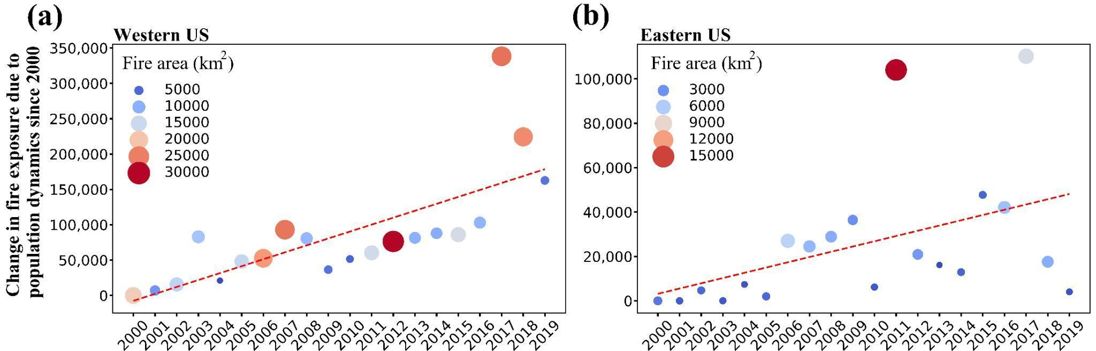

Fig. S17. Population dynamics’ contribution to accumulated primary and secondary population exposure (5 km buffer) to large fires in Western U.S. (a) and Eastern U.S. (b) from 2000-2019. Statistics are provided for population residing within a 5 km buffer from large fire perimeters.

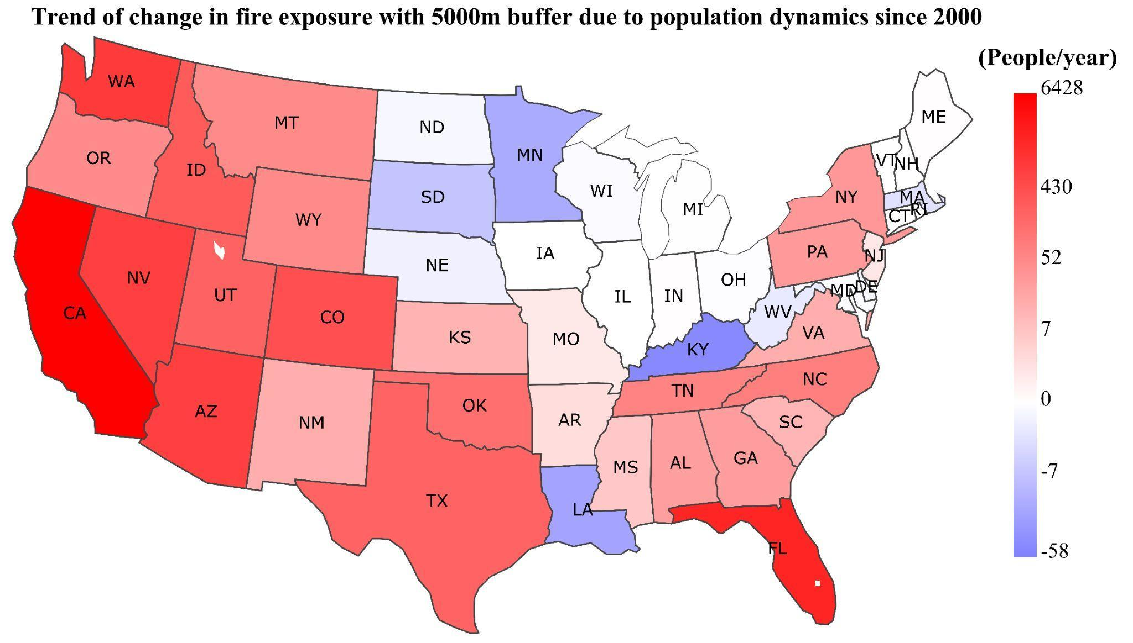
Fig. S18. Population dynamics’ contribution to accumulated primary and secondary population exposure (5 km buffer) to large fires in individual states from 2000-2019. Statistics are provided for population residing within a 5 km buffer from large fire perimeters.

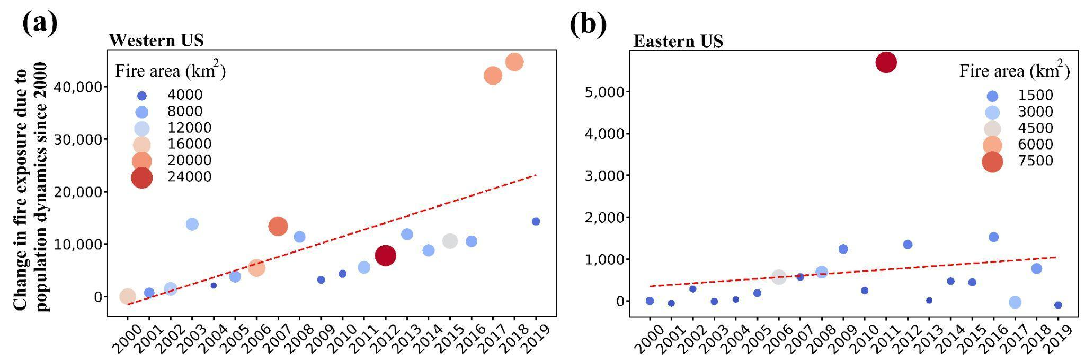

Fig. S19. Population dynamics’ contribution to accumulated primary and secondary population exposure (1 km buffer) to large forest fires in Western U.S. (a) and Eastern U.S. (b) from 2000-2019. Statistics are provided for population residing within a 1 km buffer from large forest fire perimeters.

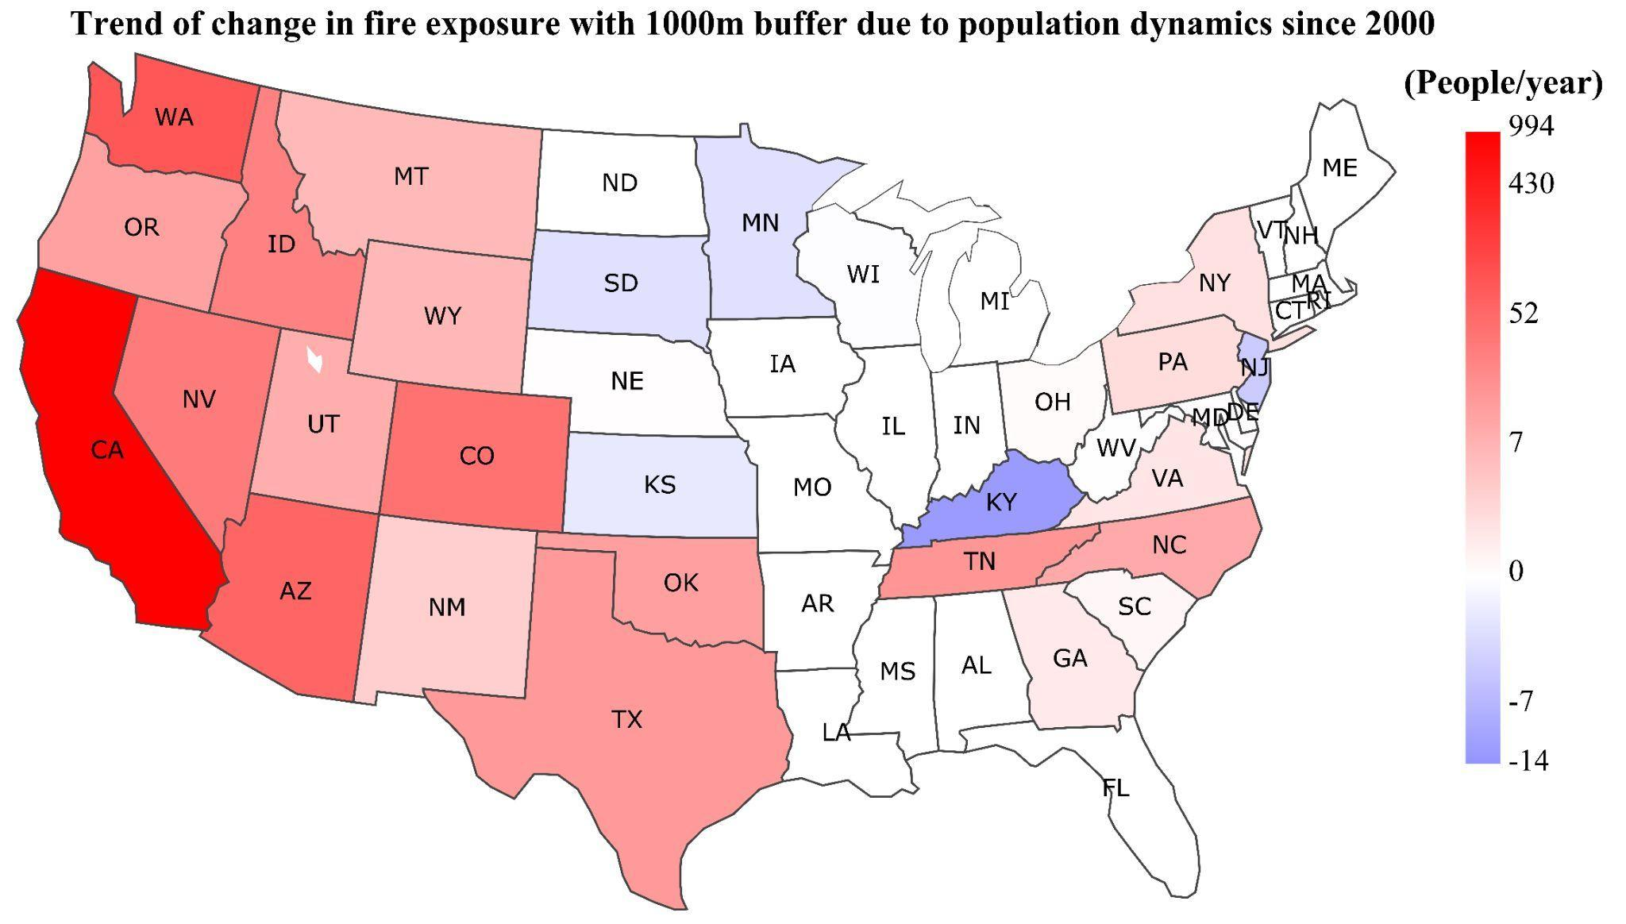
Fig. S20. Population dynamics’ contribution to accumulated primary and secondary population exposure (1 km buffer) to large forest fires in individual states from 2000-2019. Statistics are provided for population residing within a 1 km buffer from large forest fire perimeters.
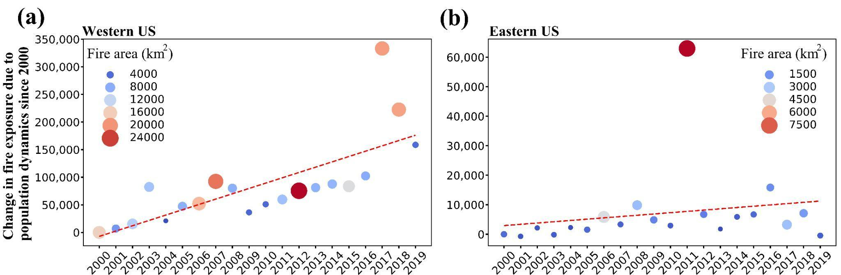

Fig. S21. Population dynamics’ contribution to accumulated primary and secondary population exposure (5 km buffer) to large forest fires in Western U.S. (a) and Eastern U.S. (b) from 2000-2019. Statistics are provided for population residing within a 5 km buffer from large forest fire perimeters.

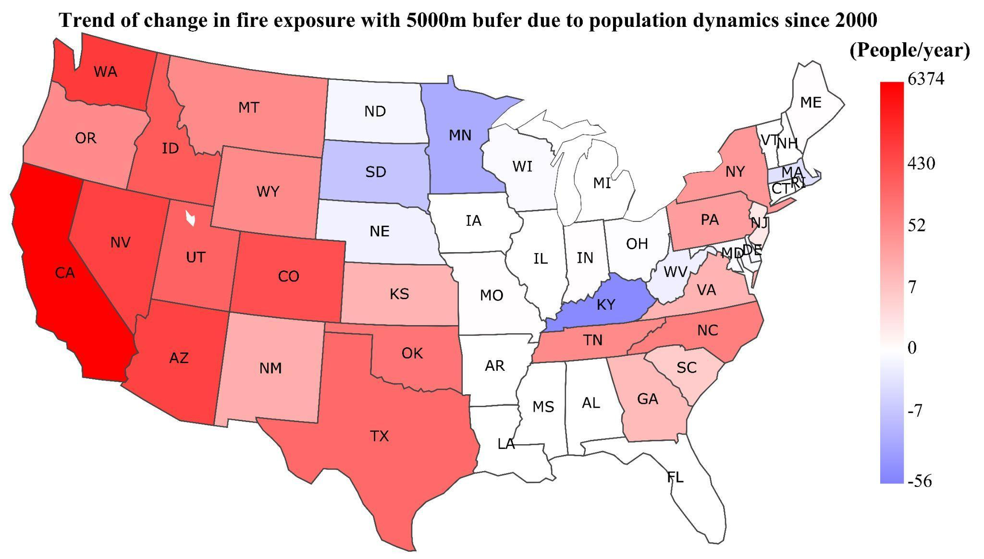
Fig. S22. Population dynamics’ contribution to accumulated primary and secondary population exposure (5 km buffer) to large forest fires in individual states from 2000-2019. Statistics are provided for population residing within a 5 km buffer from large forest fire perimeters.

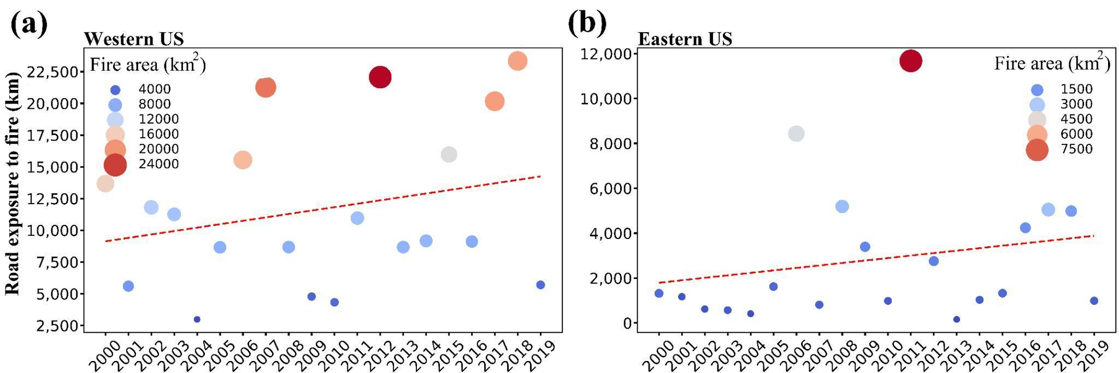
Fig. 23. Trends in road exposure to large forest fires in the Western U.S. (a) and Eastern U.S. (b) from 2000-2019.

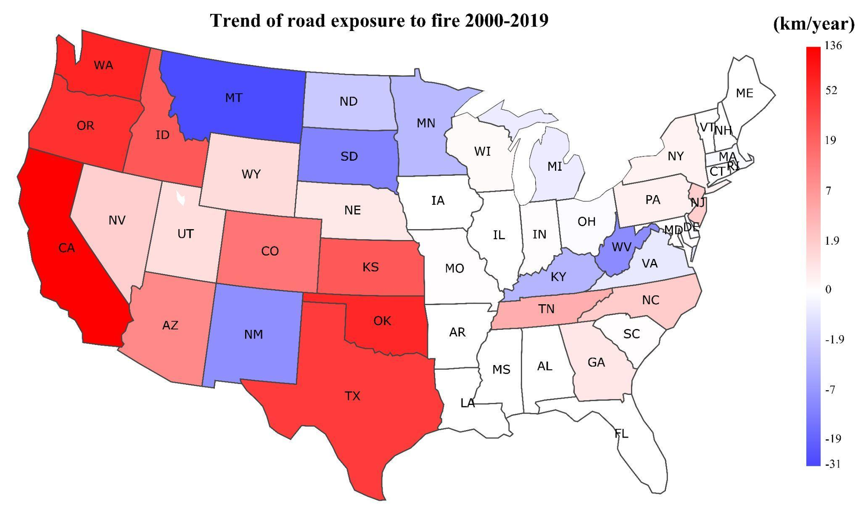
Fig. 24. Trends in road exposure to large forest fires in individual states from 2000-2019.

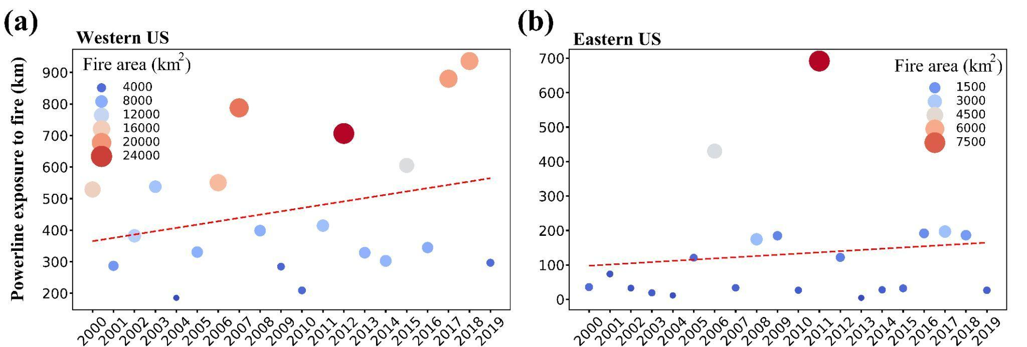
Fig. S25. Trends in power transmission lines’ exposure to large forest fires in the Western U.S. (a) and Eastern U.S. (b) from 2000-2019.

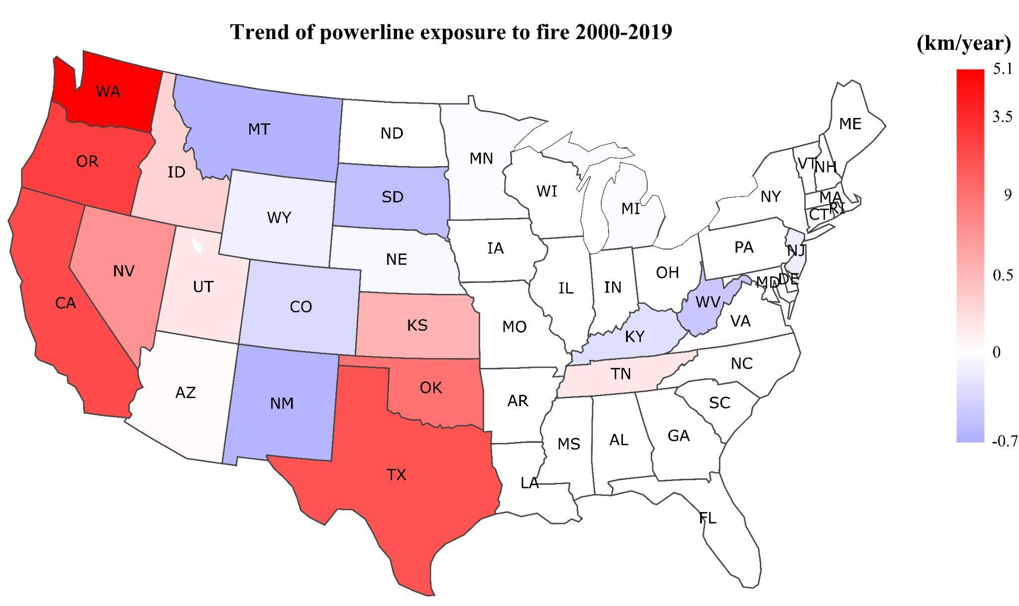
Fig. S26. Trends in power transmission lines’ exposure to large forest fires in individual states from 2000-2019.

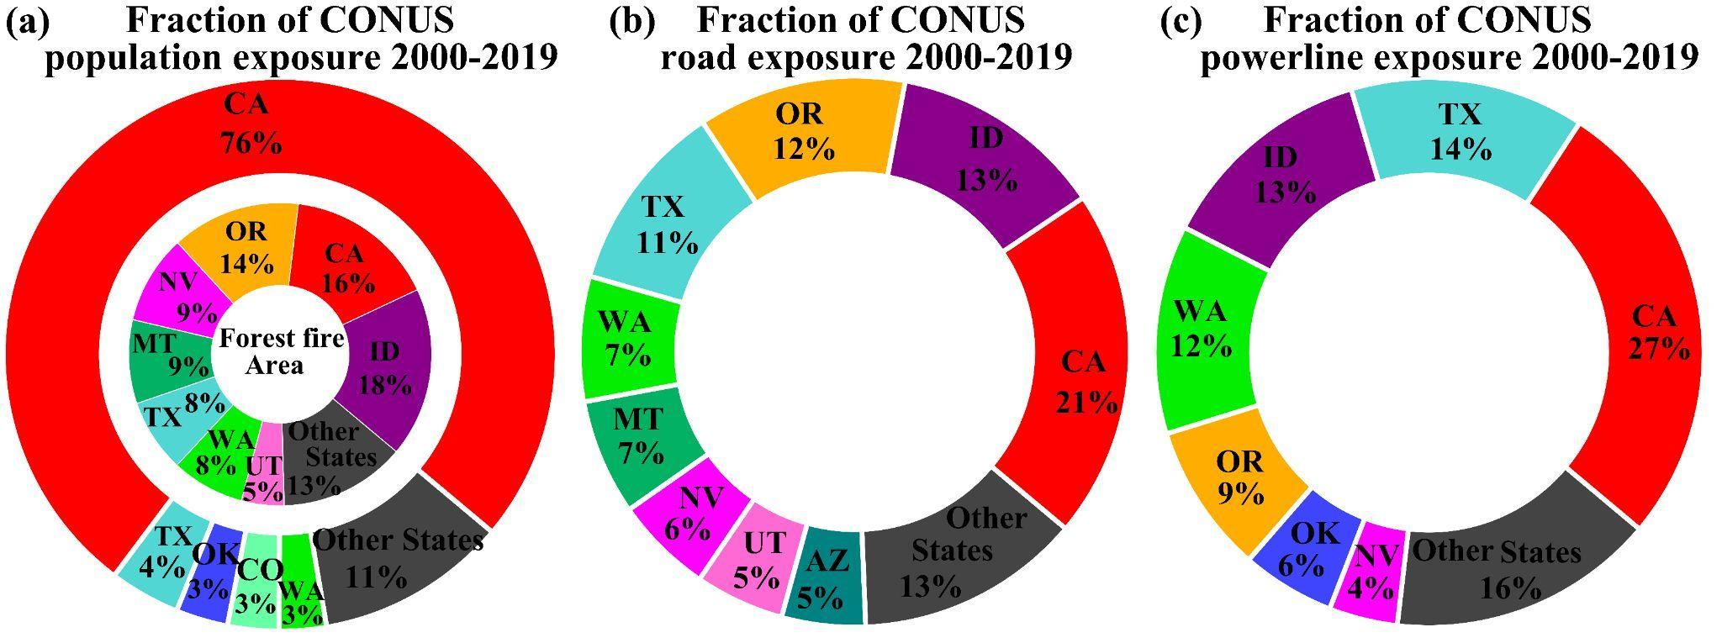
Fig. S27. Individual states’ share of the cumulative exposure to large forest fires in CONUS from 2000-2019. Fraction of cumulative (a) population exposure to large forest fires, and large forest fire area, (b) road exposure to large forest fires, and (c) powerline exposure to large forest fires from 2000-2019 in CONUS.

