Supplementary data
Title
The First Four Novel Curtobacterium Phages Isolated from Environmental Samples
Katrine Wacenius Skov Alanin^{1,2}, Nikoline S. Olsen², Amaru Miranda Djurhuus², Alexander Byth Carstens², Tue Kjærgaard Nielsen², Magnus Mulbjerg Rothgardt², Andreas Marieboe Russel², Natalia Wagner³, René Lametsch⁴, Frederik Bak², Rosanna Catherine Hennessy², Mette Haubjerg Nicolaisen², Lars Hestbjerg Hansen^{2,*} and Witold Kot^{2,*}.
¹Department for Environmental Science, Aarhus University, 4000 Roskilde, Denmark
²Department of Plant and Environmental Science, University of Copenhagen, 1871 Frederiksberg C, Denmark
³Institute for Microbiology and Biotechnology, Max Rubner-Institut, Hermann-Weigmann-Str. 1, D-24103 Kiel
⁴Department of Food Science, Faculty of Science, University of Copenhagen, Thorvaldsensvej 40, 1871 Frederiksberg, Denmark.
*Corresponding authors: Witold Kot wk@plen.ku.dk and Lars H. Hansen lhha@plen.ku.dk

Table of content
Online resource 1 Table S1.1-S1.4 BLASTn results
Online resource 2 Table S2.1-S2.4 Genomic similarity
Figure S2.1-S2.3 Proteomic tree
Online resource 3 Table S3.1-S3.4 List of annotations

Online resource 1 – BLASTn results

Table S1.1: BLASTn hits for Curtobacterium phage Penoan with either whole genome nucleotide sequence (top 3 hits) and BLASTp hits for the terminase protein sequence, large subunit (terL) (top 5 hits). Nucleotide similarity was calculated as described in Olsen et al., (2020)
Description  [Accession no.] | Whole genome or terL | Taxonomy | Query cover (%) | Percent identity (%) | Nucleotide similarity (%)
Arthrobacter phage LouisXIV [MN813695.1] | Whole genome | Siphoviridae;Decurrovirus | 10 | 65.44 | 6.54
Arthrobacter phage Yank [KU160674.1] | Whole genome | Siphoviridae;Decurrovirus | 11 | 65.25 | 7.18
Arthrobacter phage Muttlie [KU160658.1] | Whole genome | Siphoviridae;Decurrovirus | 12 | 65.13 | 7.82
Arthrobacter phage Taj14 [MF140431.1] | terL | Siphoviridae;Decurrovirus | 99 | 50.40 | -
Arthrobacter phage Swenson [MF140429.1] | terL | Siphoviridae;Decurrovirus | 99 | 50.20 | -
Arthrobacter phage Elkhorn [MF140409.1] | terL | Siphoviridae;Decurrovirus | 99 | 50.00 | -
Arthrobacter phage Decurro [NC_028692.1] | terL | Siphoviridae;Decurrovirus | 97 | 50.72 | -
Arthrobacter phage KylieMac [MF140415.1] | terL | Siphoviridae;Decurrovirus | 99 | 50.00 | -

Table S1.2: BLASTn hits for Curtobacterium phage Reje with either whole genome nucleotide sequence (top 4 hits) and BLASTp hits for the terminase protein sequence, large subunit (terL) (top 5 hits). Nucleotide similarity was calculated as described in Olsen et al., (2020)
Description  [Accession no.] | Whole genome or terL | Taxonomy | Query cover (%) | Percent identity (%) | Nucleotide similarity (%)
Curtobacterium phage Ayka [ON381767.1] | Whole genome | Podoviridae; Aykavirus | 43 | 68.78 | 29.6
 | terL | Podoviridae; Aykavirus | 99 | 64.51
Arthrobacter phage Mendel [NC_048740.1] | Whole genome | Podoviridae;Anjalivirus | 7 | 65.21 | 4.57
 | terL |  | 100 | 50.83 | -
Arthrobacter phage Anjali [NC_048739.1] | Whole genome | Podoviridae;Anjalivirus | 9 | 65.13 | 5.86
 | terL |  | 100 | 50.28 | -
Rhizobium phage RHph_N3_8 [MN988551.1] | Whole genome | Podoviridae | 4 | 64.04 | 2.56
 | terL | Podoviridae | 99 | 46.2 | -
Bacillus phage WhyPhy [NC_055917.1] | terL | Salasmaviridae;Bundooravirus | 95 | 31.58 | -

Table S1.3: BLASTn hits for Curtobacterium phage Pize with either whole genome nucleotide sequence (top 4 hits) and BLASTp hits for the terminase protein sequence, large subunit (terL) (top 5 hits). Nucleotide similarity was calculated as described in Olsen et al., (2020)
Description  [Accession no.] | Whole genome or terL | Taxonomy | Query cover (%) | Percent identity (%) | Nucleotide similarity (%)
Curtobacterium phage Ayka [ON381767.1] | Whole genome | Podoviridae;Aykavirus | 43 | 64.15 | 27.6
 | terL |  | 100 | 60.46
Arthrobacter phage Anjali [NC_048739.1] | Whole genome | Podoviridae;Anjalivirus | 7 | 72.68 | 5.09
 | terL |  | 99 | 50 | -
Arthrobacter phage Mendel [NC_048740.1] | Whole genome | Podoviridae;Anjalivirus | 7 | 63.56 | 4.45
 | terL |  | 99 | 48.85 | -
Microbacterium phage PineapplePizza [ON724010.1] | Whole genome | Podoviridae;unclassified Podoviridae | 5 | 63.90 | 3.2
Rhizobium phage RHph_N3_8 [MN988551.1] | terL | Podoviridae | 97 | 43.73 | -
Bacillus phage WhyPhy [NC_055917.1] | terL | Salasmaviridae;Bundooravirus | 96 | 30.68 | -

Table S1.4: BLASTn hits for Curtibacterium phage Parvaparticeps with either whole genome nucleotide sequence (top 3 hits) and BLASTp hits for the terminase protein sequence, large subunit (terL) (top 5 hits). Nucleotide similarity was calculated as described in Olsen et al., (2020)
Description  [Accession no.] | Whole genome or terL | Taxonomy | Query cover (%) | Percent identity (%) | Nucleotide similarity (%)
Microbacterium phage Cicada [MT498057.1] | Whole genome | Siphoviridae;Goodmanvirus | 22 | 69.05 | 15.19
 | terL |  | 91 | 53.57 | -
Microbacterium phage Zanella [MN369765.1] | Whole genome | Siphoviridae;Goodmanvirus | 21 | 69.05 | 14.50
 | terL |  | 91 | 52.74 | -
Microbacterium phage Johann [MK016497.1] | Whole genome | Siphoviridae;Goodmanvirus | 21 | 68.86 | 14.46
 | terL |  | 91 | 53.81 | -
Microbacterium phage Rasovi [MT310855.1] | terL | Siphoviridae;Goodmanvirus | 91 | 52.98 | -
Microbacterium phage Goodman [NC_048101.1] | terL | Siphoviridae;Goodmanvirus | 91 | 53.10 | -

Online resource 2 – Genomic similarity and Proteomic tree

Table S2.1: Genomic similarity based on proteome of Curtobacterium phage Penoan. Calculated in ViPTree using tBLASTx for genome-wide sequence similarity.
ID | Length  (bp) | Phage name | S_{G}
MZ333135 | 15,303 | Curtobacterium phage Penoan | 1
NC_047992 | 47,921 | Microbacterium phage Zeta1847 | 0.2543
NC_021347 | 142,563 | Rhodococcus phage E3 | 0.243
NC_019408 | 223,720 | Caulobacter virus Rogue | 0.2418
NC_019405 | 215,710 | Caulobacter virus phiCbK | 0.2321
NC_048045 | 220,934 | Caulobacter phage CcrBL10 | 0.2285
NC_019407 | 218,929 | Caulobacter virus Magneto | 0.2226
NC_047794 | 3,9522 | Streptomyces phage Picard | 0.2192
NC_019410 | 221,828 | Caulobacter virus Karma | 0.2179
NC_054727 | 136,361 | Mycobacterium phage Phrappuccino | 0.2168
NC_028692 | 15,524 | Arthrobacter phage Decurro | 0.2102
NC_028809 | 58,637 | Pseudomonas phage PaMx74 | 0.201
NC_019411 | 219,216 | Caulobacter virus Swift | 0.1951

Figure S2.1: Proteomic tree of Curtobacterium phage Penoan. The tree is constructed in ViPTree, and the figure shows part of the original tree that is constructed from a total of 4926 phage genomes.
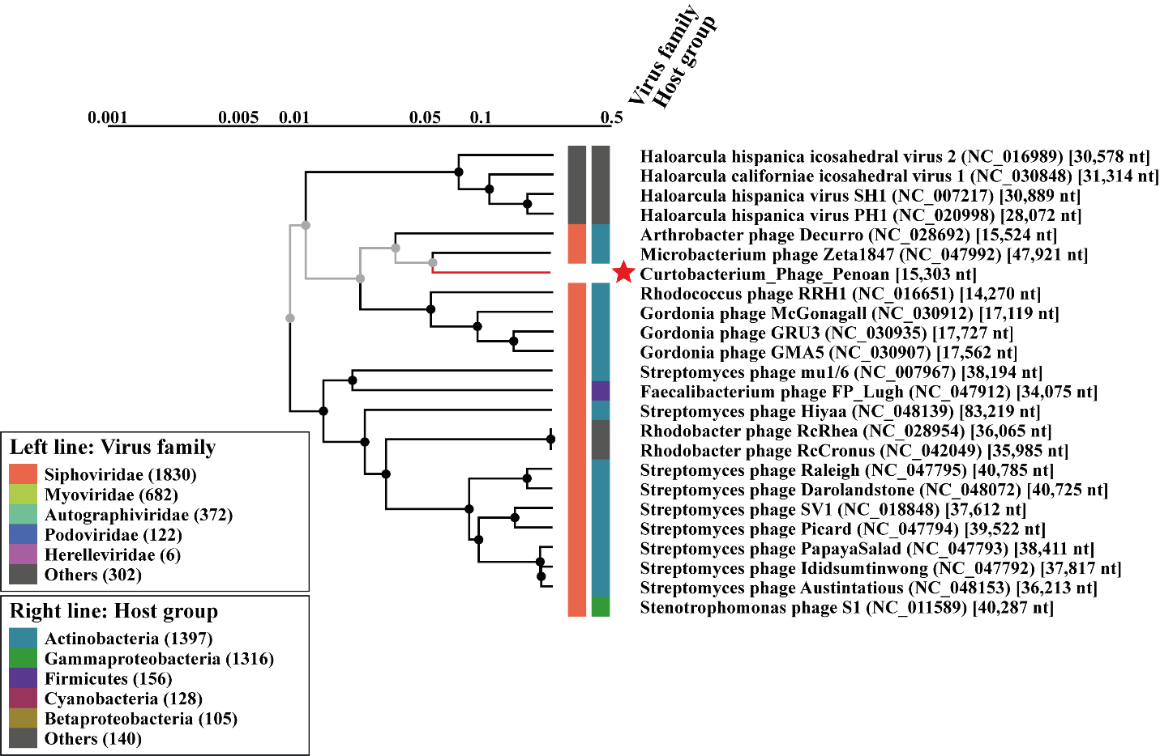

Table S2.2: Genomic similarity based on proteome of Curtobacterium phage Reje. Calculated in ViPTree using tBLASTx for genome-wide sequence similarity.
ID | Length  (bp) | Phage name | S_{G}
MZ333136 | 17,554 | Curtobacterium phage Reje | 1
MZ333134 | 18,290 | Curtobacterium phage Pize | 0.4731
ON381767 | 18,400 | Curtobacterium phage Ayka | 0.3836
NC_048739 | 19,679 | Arthrobacter phage Anjali | 0.2237
NC_048740 | 19,428 | Arthrobacter phage Mendel | 0.2196
DQ123818 | 17,171 | Actinomyces phage Av-1 | 0.1588
NC_009643 | 17,171 | Actinomyces virus Av1 | 0.1588
NC_048858 | 18,635 | Bifidobacterium phage BadAztec1 | 0.1109
NC_048859 | 18,899 | Bifidobacterium phage BadAargau2 | 0.1067
NC_049975 | 18,379 | Bacillus phage vB_BsuP-Goe1 | 0.0735
NC_049974 | 21,781 | Bacillus phage Gxv1 | 0.0722
NC_049976 | 18,753 | Bacillus phage Nf | 0.0708
NC_001423 | 19,366 | Bacillus phage PZA | 0.07
NC_011048 | 19,282 | Bacillus phage phi29 | 0.0698

Table S2.3: Genomic similarity based on proteome of Curtobacterium phage Pize. Calculated in ViPTree using tBLASTx for genome-wide sequence similarity.
ID | Length  (bp) | Phage name | S_{G}
MZ333134 | 18,290 | Curtobacterium phage Pize | 1
MZ333136 | 17,554 | Curtobacterium phage Reje | 0.4731
ON381767 | 18,400 | Curtobacterium phage Ayka | 0.3797
NC_048739 | 19,679 | Arthrobacter phage Anjali | 0.1902
NC_048740 | 19,428 | Arthrobacter phage Mendel | 0.1833
DQ123818 | 17,171 | Actinomyces phage Av-1 | 0.14
NC_009643 | 17,171 | Actinomyces virus Av1 | 0.14
NC_048859 | 18,899 | Bifidobacterium phage BadAargau2 | 0.1066
NC_048858 | 18,635 | Bifidobacterium phage BadAztec1 | 0.1016
NC_049972 | 18,932 | Bacillus phage vB_Bpu_PumA2 | 0.067
NC_004165 | 18,630 | Bacillus virus B103 | 0.0669
NC_049971 | 18,466 | Bacillus phage vB_Bpu_PumA1 | 0.0664
NC_049976 | 18,753 | Bacillus phage Nf | 0.0655
NC_049965 | 19,105 | Bacillus phage vB_BveP-Goe6 | 0.0654

Figure S2.2: Proteomic tree of Curtobacterium phage Reje and Pize. The tree is constructed in ViPTree, and the figure shows a part of the full tree that is constructed from a total of 4926 phage genomes.
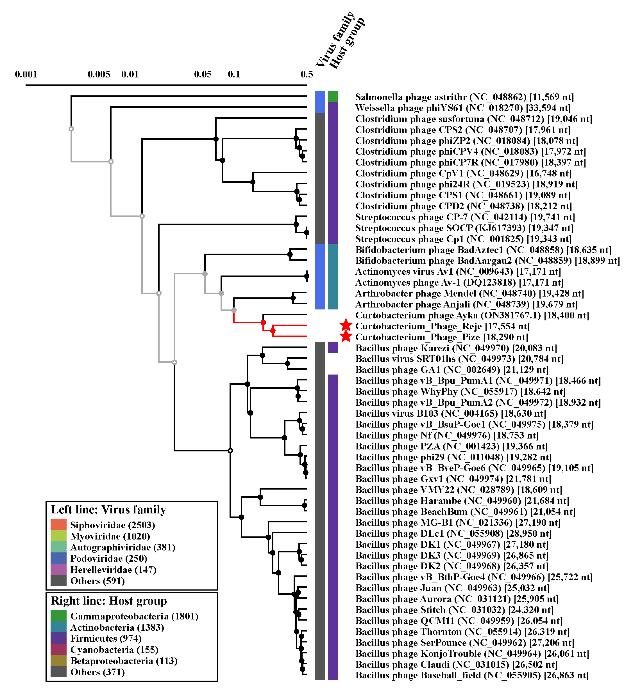

Table S2.4: Genomic similarity based on proteome of Curtobacterium phage Parvaparticeps. Calculated in ViPTree using tBLASTx for genome-wide sequence similarity.
ID | Length  (bp) | Phage name | S_{G}
MZ357096 | 40,289 | Curtobacterium phage Parvaparticeps | 1
NC_048101 | 42,363 | Microbacterium phage Goodman | 0.2327
NC_047792 | 37,817 | Streptomyces phage Ididsumtinwong | 0.1519
NC_048153 | 36,213 | Streptomyces phage Austintatious | 0.1493
NC_047793 | 38,411 | Streptomyces phage PapayaSalad | 0.1484
NC_054428 | 43,950 | Arthrobacter phage Sergei | 0.1439
NC_054425 | 43,746 | Arthrobacter phage MamaPearl | 0.1421
NC_041945 | 42,830 | Arthrobacter phage Pumancara | 0.1419
NC_041946 | 44,371 | Arthrobacter phage Wayne | 0.1409
NC_054424 | 4,3496 | Arthrobacter phage Litotes | 0.1407
NC_041941 | 43,336 | Arthrobacter phage HunterDalle | 0.1406
NC_047794 | 39,522 | Streptomyces phage Picard | 0.1399
NC_041942 | 44,183 | Arthrobacter phage Joann | 0.1397

Figure S2.3: Proteomic tree of Curtobacterium phage Parvaparticeps. The tree is constructed in ViPTree, and the figure shows part of the original tree that is constructed from a total of 4926 phage genomes.
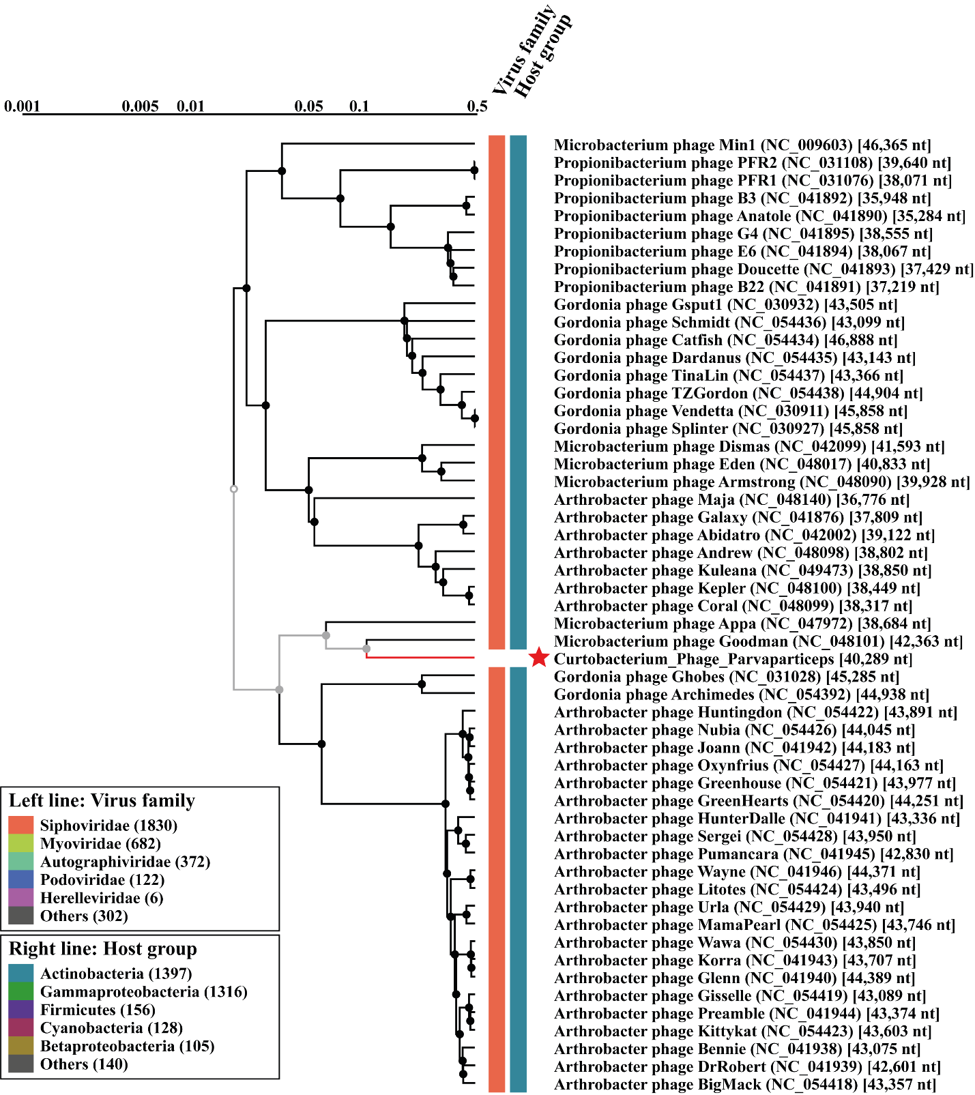

Online resource 3 – List of annotations

Table S3.1: CDS, position, predicted product and function in Curtobacterium phage Penoan, accession no. MZ333135. All CDS with unknown/hypothetical predicted product has been removed.
CDS | Genome position | Amino acids (n) | Strand | Predicted product | Putative function/Biological process
9 | 4,120 … 3,125 | 995 | - | Putative endolysin | Mediates lysis
12 | 7,622 … 6,162 | 1,460 | - | tape measure protein | Prescribes tail length and mediates DNA injection
16 | 8,944 … 8,495 | 449 | - | major tail protein | Structural protein
18 | 9,682 … 9,323 | 359 | - | head-tail connector | Structural protein
19 | 11,251 … 9,686 | 1,565 | - | major capsid | Structural protein
20 | 12,405 … 11,248 | 1,157 | - | portal protein | DNA packaging and delivery
21 | 13,954 … 12,467 | 1,487 | - | terminase | DNA packaging

Table S3.2: CDS, position, predicted product and function in Curtobacterium phage Reje, accession no. MMZ333136. All CDS with unknown/hypothetical predicted product has been removed.
CDS | Genome position | Amino acids (n) | Strand | Predicted product | Putative function/Biological process
1 | 554 … 1,015 | 461 | + | Single stranded DNA binding protein | Binds to ssDNA and help to initiate DNA replication, recombination and repair
3 | 1,927 … 3,651 | 1,724 | + | DNA polymerase | Replicates DNA
6 | 4,518 … 5,975 | 1,457 | + | major capsid protein | Structural protein
7 | 6,048 … 8,177 | 21,29 | + | major tail protein | Structural protein
8 | 8,174 … 9,127 | 953 | + | upper collar protein | Structural protein
9 | 9,128 … 9,817 | 689 | + | lower collar protein | Structural protein
10 | 9,814 … 11,550 | 1,736 | + | tail related protein | Structural protein
11 | 12,218 …11,550 | 668 | - | Putative peptidase | Mediates lysis
13 | 13.954 … 12,887 | 1,067 | - | terminase | DNA packaging

Table S3.3: CDS, position, predicted product and function in Curtobacterium phage Pize, accession no. MZ333134. All CDS with unknown/hypothetical predicted product has been removed.
CDS | Genome position | Amino acids (n) | Strand | Predicted product | Putative function/Biological process
1 | 471 … 1,010 | 539 | + | Single stranded DNA binding protein | Binds to ssDNA and help to initiate DNA replication, recombination and repair
3 | 1,951 … 3,594 | 1,643 | + | DNA polymerase | Replicates DNA
6 | 4,501 … 6,207 | 1,706 | + | major capsid protein | Structural protein
7 | 6,276 … 8,438 | 2,162 | + | major tail protein | Structural protein
8 | 8,435 … 9,376 | 941 | + | upper collar protein | Structural protein
9 | 9,376 … 10,065 | 689 | + | lower collar protein | Structural protein
13 | 13,138 … 14,184 | 1,046 | + | terminase | DNA packaging

Table S3.4: CDS, position, predicted product and function in Curtobacterium phage Parvaparticeps, accession no. MZ35709. All CDS with unknown/hypothetical predicted product has been removed.
CDS | Genome position | Amino acids (n) | Strand | Predicted product | Putative function/Biological process
2 | 679 … 2,964 | 2,285 | + | polymerase | Replicates either DNA or RNA
4 | 3,333 … 4,436 | 1,103 | + | putative adenylosuccinate synthetase | Potential important component in DNA modification
7 | 5 556 … 6,023 | 467 | + | putative deoxyuridine triphosphatase | Part of nucleotide metabolism
11 | 7,129 … 7,770 | 641 | + | putative endonuclease | Cleves polynucleotides
12 | 7,767 … 8,726 | 959 | + | exonuclease | Degrade polynucleotides from the host
13 | 8,726 … 9,028 | 302 | + | HNH endonuclease | DNA nicking
18 | 10,557 … 11,783 | 1,226 | + | putative recombinase | Catalyze site-specific recombination events within DNA
 | 12,099 … 12,165 | 66 |  | tRNA | Favors codons more common in the phage genome compared to the host genome
21 | 13,195 … 15,813 | 2,618 | + | Primase | Required for DNA synthesis initiation
23 | 17,958 … 16,552 | 1,406 | - | helicase | Required for DNA unwinding
29 | 20,688 … 19,915 | 773 | - | putative lysin | Mediates lysis
32 | 23,477 … 22,143 | 1,334 | - | minor tail protein | Structural protein
33 | 24,373 … 23,477 | 896 | - | tail related protein | Structural protein
34 | 26,694 … 24,370 | 2,324 | - | tape measure protein | Prescribes tail length and mediates DNA injection
36 | 28,010 … 27,492 | 518 | - | major tail protein | Structural protein
37 | 28,458 … 28,024 | 434 | - | minor capsid protein | Structural protein
38 | 28,829 … 28,458 | 371 | - | putative minor capsid protein | Structural protein
42 | 31,069 … 30,161 | 908 | - | major capsid protein | Structural protein
43 | 31,885 … 31,091 | 794 | - | putative scaffolding protein | Structural protein
46 | 33,796 … 32,681 | 1,115 | - | putative minor capsid protein | Structural protein
49 | 38,324 … 36,612 | 1,712 | - | portal protein | DNA packaging and delivery
50 | 39,684 … 38,329 | 1,355 | - | terminase | DNA packaging

