Supplementary data – online resource 1
Title
Three novel Erwinia billingiae phages represent three new genera isolated from Organic waste
Katrine Wacenius Skov Alanin^{1,2}, Nikoline S. Olsen², Amaru Miranda Djurhuus², Alexander Byth Carstens², Tue Kjærgaard Nielsen², Natalia Wagner³, René Lametsch⁴, Frederik Bak², Rosanna Catherine Hennessy², Mette Haubjerg Nicolaisen², Witold Kot^{2,*}, and Lars Hestbjerg Hansen^{2,*}.
¹Department for Environmental Science, Aarhus University, 4000 Roskilde, Denmark
²Department of Plant and Environmental Science, University of Copenhagen, 1871 Frederiksberg C, Denmark
³Institute for Microbiology and Biotechnology, Max Rubner-Institut, Hermann-Weigmann-Str. 1, D-24103 Kiel
⁴Department of Food Science, Faculty of Science, University of Copenhagen, Thorvaldsensvej 40, 1871 Frederiksberg, Denmark.
*Corresponding authors: Witold Kot wk@plen.ku.dk and Lars H. Hansen lhha@plen.ku.dk

Table of content
Online resource 1 Table S1.1-S1.3 BLASTn results
Online resource 2 Table S2.1-S2.3 Genomic similarity
Figure S2.1-S2.3 Proteomic tree
Online resource 3 Table S3.1-S3.3 List of annotations
Online resource 4 Table S4.1-S4.3 Proteome analysis

Table: S1.1: BLASTn hits for Erwinia phage Snitter with either whole genome nucleotide sequence (top 3 hits), and BLASTp hits for the terminase protein sequence, large subunit or small subunit (terL and terS, respectively) (top 5 hits). Nucleotide similarity was calculated as described in Olsen et al., (2020)
Description  [Accession no.] | Whole genome, terL, or terS | Taxonomy | Query cover (%) | Percent identity (%) | Nucleotide similarity (%)
Escherichia phage vB_EcoS_Chapo [MT682715.1] | Whole genome | Drexlerviridae; Tunavirinae; Tunavirus | 30 | 68.21 | 20.46
Escherichia phage vB_EcoS_W011D [NC_054893.1] | Whole genome | Drexlerviridae  Drexlerviridae › Tempevirinae › Changchunvirus › Changchunvirus W011D | 33 | 68.28 | 10.31
Escherichia phage vB_EcoS_PHB17 [NC_054892] | Whole genome | Drexlerviridae  Drexlerviridae › Tempevirinae › Changchunvirus › Changchunvirus PHB17 | 32 | 68.03 | 22.53
Pantoea phage vB_PagS_AAS23 [NC_048137.1] | terL | Sauletekiovirus | 99 | 77.07 | -
Escherichia phage vB_EcoS_Chapo [MT682715.1] | terL | Tunavirus | 99 | 77.07 | -
Escherichia phage vB_EcoS_IME347 [NC_047960.1] | terL | Badaguanvirus | 99 | 76.88 | -
Escherichia phage JMPW1 [NC_041874.1] | terL | Tunavirus | 99 | 76.88 | -
Shigella phage vB_SsoS-ISF002 [NC_041995.1] | terL | Tunavirus | 99 | 76.88 | -
Escherichia phage vB_EcoS_PHB17 [NC_054892.1] | terS | Changchunvirus | 93 | 57.14 | -
Escherichia phage damhaus [NC_049827.1] | terS | Hanrivervirus | 93 | 57.14 | -
Salmonella phage slyngel [NC_049821.1] | terS | Hanrivervirus | 93 | 56.52 | -
Escherichia phage herni [NC_049823.1] | terS | Hanrivervirus | 93 | 56.52 | -
Escherichia phage Henu8 [NC_049853.1] | terS | Hanrivervirus | 93 | 56.52 | -

Table: S1.2: BLASTn hits for Erwinia phage Pecta with either whole genome nucleotide sequence (top 3 hits) and BLASTp hits for the terminase protein sequence, large subunit (terL) (top 5 hits). Nucleotide similarity was calculated as described in Olsen et al., (2020)
Description  [Accession no.] | Whole genome or terL | Taxonomy | Query cover (%) | Percent identity (%) | Nucleotide similarity (%)
Citrobacter phage CVT22 [KP774835.2] | Whole genome | Zobellviridae; Citrovirus; Citrovirus coptotermitis | 28 | 67.27 | 18.84
Citrobacter phage CVT22 [KP774835.2] | terL | Zobellviridae; Citrovirus; Citrovirus coptotermitis | 99 | 67.91 | -
Pseudomonas phage GP100 [LT986460.2] | Whole genome | Zobellviridae | 10 | 65.95 | 6.60
Salinivibrio phage CW02 [JQ446452.1] | Whole genome | Zobellviridae; Salinovirus;  Salinovirus utanense | 10 | 66.85 | 6.70
Salinivibrio phage CW02 [JQ446452.1] | terL | Zobellviridae; Salinovirus;  Salinovirus utanense | 99 | 71.93 | -
Vibrio phage 1.264.O._10N.286.51.F2 [MG592629.1] | terL | Zobellviridae | 99 | 68.29 | -
Pseudomonas phage PSA11 [NC_007808.1] | terL | Paundecimvirus | 99 | 67.60 | -
Vibrio phage 1.235.O._10N.261.52.B2 [MG592599.1] | terL | Zobellviridae | 99 | 69.53 | -

Table: S1.3: BLASTn hits for Erwinia phage Zoomie with either whole genome nucleotide sequence (top 3 hits) and BLASTp hits for the terminase protein sequence, large subunit (terL) (top 5 hits). Nucleotide similarity was calculated as described in Olsen et al., (2020)
Description  [Accession no.] | Whole genome or terL | Taxonomy | Query cover (%) | Percent identity (%) | Nucleotide similarity (%)
Pantoea phage LIMElight [FR687252.1] | Whole genome  terL | Autographiviridae; Limelightvirus | 80  99 | 78.06  86.64 | 62.448  -
Shigella phage HRP29 [NC_048174.1] | Whole genome  terL | Autographiviridae; Slopekvirinae; Bucovirus; Bucovirus buco. | 22  98 | 73.53  72.77 | 16.18  -
Enterobacter phage phiKDA1 [NC_027980.1] | Whole genome  terL | Autographiviridae; Slopekvirinae; Koutsourovirus; Koutsourovirus KDA1 | 19  98 | 72.80  72.83 | 13.83  -
Klebsiella phage CX1 [MT090077.2] | terL | Drulisvirus | 98 | 68.69 | -
Escherichia phage Minorna [NC_048172.1] | terL | Drulisvirus | 98 | 69.67 | -

Supplementary data – online resource 2
Table S2.1: Genomic similarity based on proteome of Erwinia phage Snitter. Calculated in ViPTree using tBLASTx for genome-wide sequence similarity.
ID | Length  (bp) | Phage name | S_{G}
MZ333132 | 51,564 | Erwinia phage Snitter | 1
NC_054892 | 48,939 | Escherichia phage vB_EcoS_PHB17 | 0.3618
NC_042122 | 51,894 | Enterobacter phage Ec_L1 | 0.3567
NC_054893 | 49,847 | Escherichia phage vB_EcoS_W011D | 0.3548
NC_048137 | 51,170 | Pantoea phage vB_PagS_AAS23 | 0.3545
NC_031050 | 51,802 | Escherichia phage vB_EcoS_NBD2 | 0.353
NC_054894 | 49,526 | Escherichia phage Henu7 | 0.3527
NC_027350 | 49,816 | Citrobacter phage Stevie | 0.352
NC_049833 | 50,713 | Klebsiella phage vB_KpnS_SegesCirculi | 0.3504
NC_048065 | 49,665 | Citrobacter phage Sazh | 0.3492
NC_049826 | 51,662 | Escherichia phage aaroes | 0.3489
NC_047985 | 49,788 | Escherichia phage LL5 | 0.3488
NC_049831 | 50,309 | Shigella virus Sfin-3 | 0.3488
NC_049821 | 51,048 | Salmonella phage slyngel | 0.3484

Figure S2.1: Proteomic tree of Erwinia phage Snitter. The tree is constructed in ViPTree, and the figure shows part of the original tree that is constructed from a total of 2449 phage genomes.
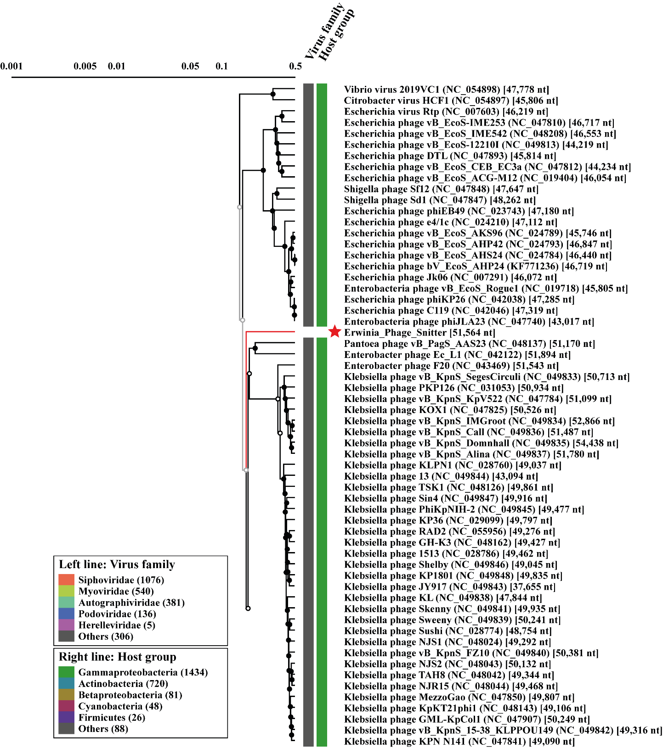

Table S2.2: Genomic similarity based on proteome of Erwinia phage Pecta. Calculated in ViPTree using tBLASTx for genome-wide sequence similarity.
ID | Length  (bp) | Phage name | S_{G}
MZ33131 | 49573 | Erwinia phage Pecta | 1
NC_027988 | 47636 | Citrobacter phage CVT22 | 0.3524
NC_031274 | 50509 | Pseudomonas phage O4 | 0.2015
NC_007808 | 49639 | Pseudomonas phage PA11 | 0.1998
NC_019540 | 49390 | Salinivibrio phage CW02 | 0.1725
NC_048630 | 45035 | Pseudoalteromonas phage HP1 | 0.0789
NC_021300 | 43882 | Pseudoalteromonas phage RIO-1 | 0.0769
HQ641346 | 48626 | Vibrio phage ICP2_2006_A | 0.0712
KM224878 | 50250 | Vibrio phage ICP2_2011_A | 0.0712
NC_015158 | 49675 | Vibrio phage ICP2 | 0.0706
NC_024791 | 50440 | Vibrio phage ICP2_2013_A_Haiti | 0.0685
NC_002519 | 39898 | Roseobacter phage SIO1 | 0.0657
NC_018280 | 38889 | Celeribacter phage P12053L | 0.0585

Figure S2.2: Proteomic tree of Erwinia phage Pecta. The tree is constructed in ViPTree, and the figure shows part of the original tree that is constructed from a total of 2449 phage genomes.
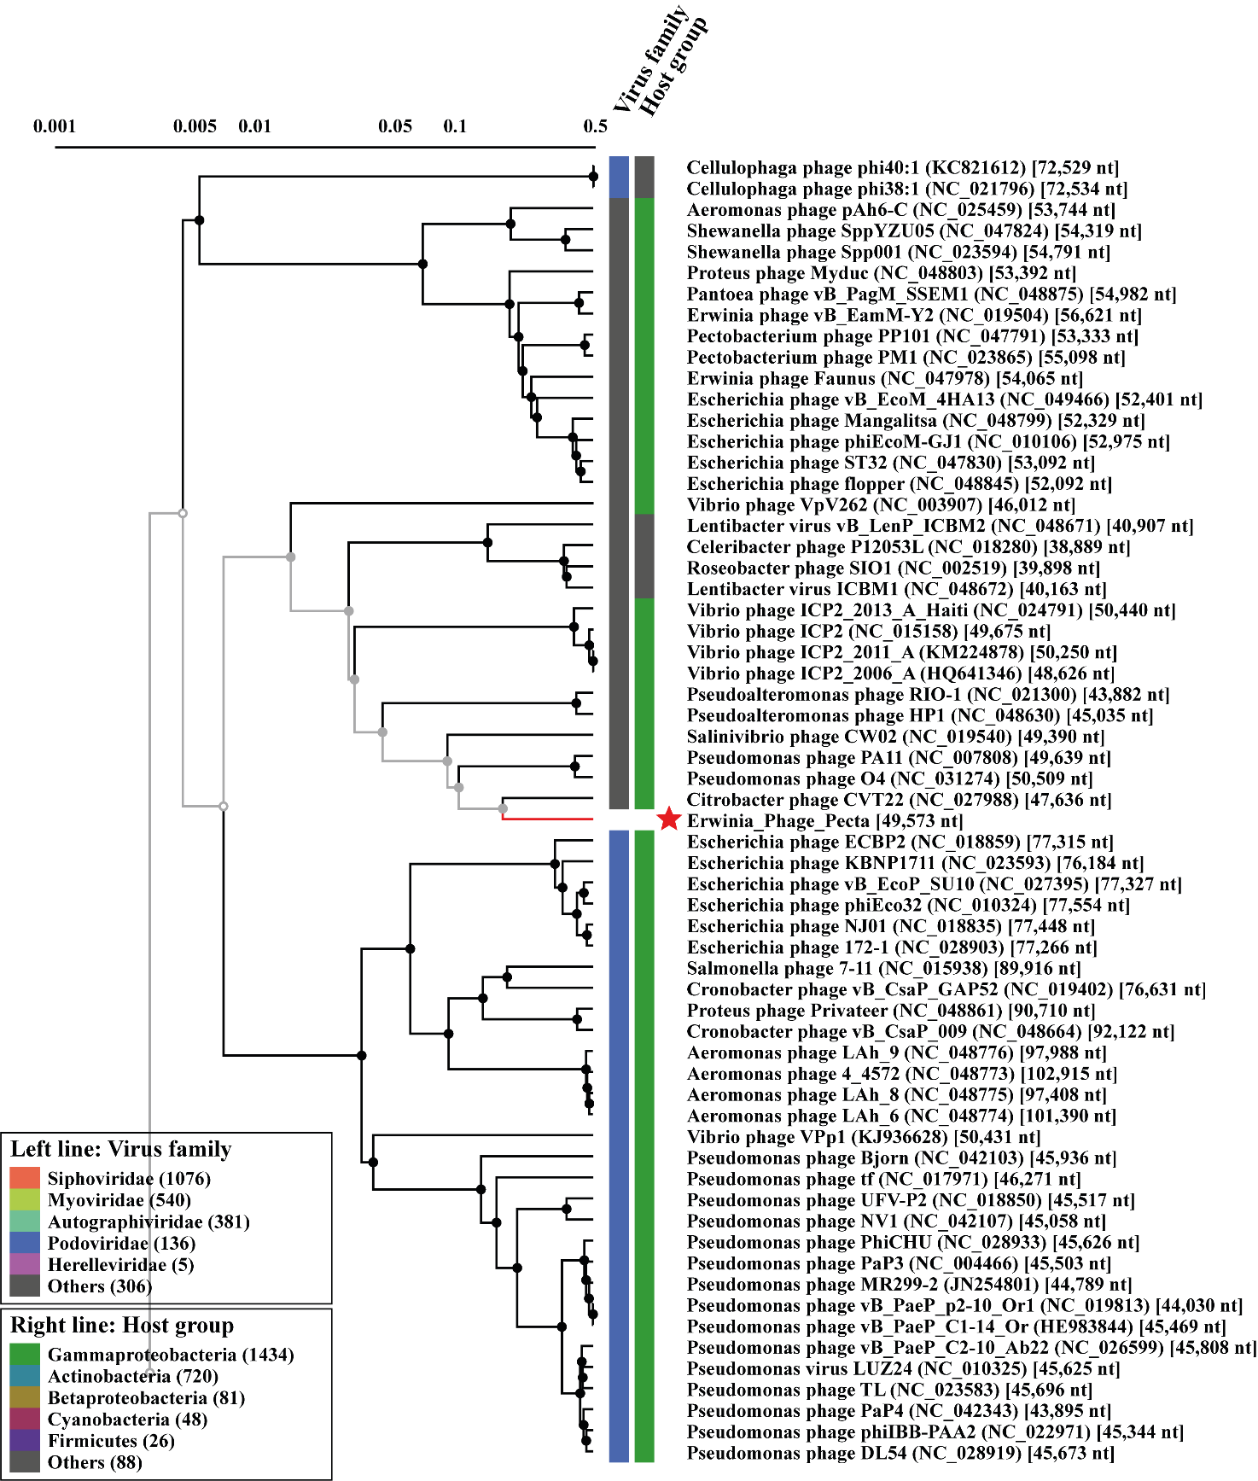

Table S2.3: Genomic similarity based on proteome of Erwinia phage Zoomie. Calculated in ViPTree using tBLASTx for genome-wide sequence similarity.
ID | Length  (bp) | Phage name | S_{G}
MZ333133 | 43,480 | Erwinia phage Zoomie | 1
NC_019454 | 44,546 | Pantoea phage LIMElight | 0.6026
NC_048174 | 43,630 | Shigella phage HRP29 (Buco) | 0.2873
NC_027980 | 43,804 | Enterobacter phage phiKDA1 | 0.2832
NC_028670 | 44,203 | Klebsiella phage KpV41 | 0.2807
NC_031025 | 42,201 | Klebsiella phage KpV475 | 0.2805
NC_028664 | 43,963 | Klebsiella phage Kp2 | 0.2786
NC_031246 | 43,267 | Klebsiella phage KpV71 | 0.2779
NC_047929 | 43,036 | Shigella phage SFN6B | 0.2767
NC_047811 | 44,094 | Klebsiella phage vB_KpnP_KpV74 | 0.2763
NC_047857 | 44,024 | Klebsiella phage phiKpS2 | 0.2762
NC_047787 | 42,641 | Klebsiella phage KPV811 | 0.2761
NC_048172 | 43,264 | Escherichia phage Minorna | 0.2759

Figure S2.3: Proteomic tree of Erwinia phage Zoomie. The tree is constructed in ViPTree, and the figure shows part of the original tree that is constructed from a total of 2449 phage genomes.
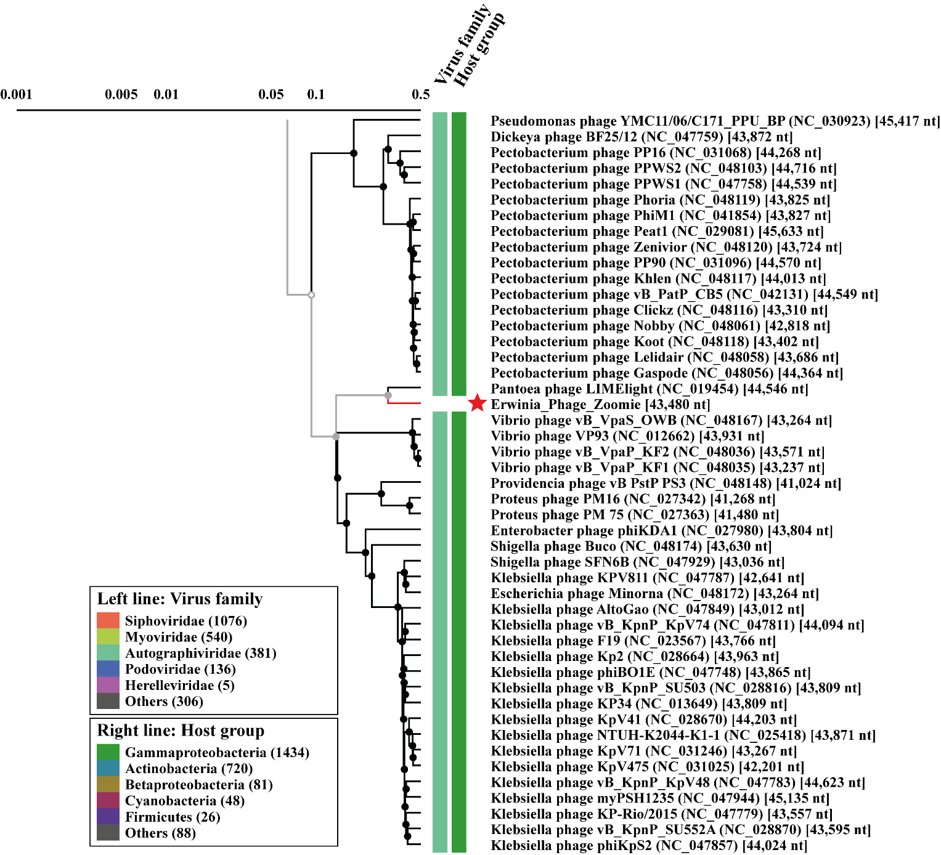

Supplementary data – online resource 2
Table S2.1: CDS, position, predicted product and function in Phage Snitter, accession no. MZ333132. All CDS with unknown/hypothetical predicted product have been removed.
CDS | Genome position | Amino acids (n) | Strand | Predicted product | Putative function/Biological process
5 | 1,758 … 2,432 | 675 | + | Putative DNA methylase | Recognizes and methylates one base in a specific sequence
10 | 5,541 … 5,149 | 393 | - | Putative spanin | Mediates lysis
11 | 6,029 … 5,538 | 492 | - | Lysin | Mediates lysis
20 | 9,728 … 8,976 | 753 | - | Putative DNA N-6-adenine-methyltransferase | Methylates the position N6 of adenines in a 5′-GATC-3′ sequences
21 | 10,234 … 9,800 | 435 | - | Putative nuclease | Cleves polynucleotides
22 | 12,266 … 10,221 | 2,046 | - | DNA helicase | Required for DNA unwinding
24 | 12,825 … 13,745 | 921 | + | Putative DNA primase/helicase | Required for DNA synthesis initiation and unwinding
25 | 13,859 … 15,763 | 1,905 | + | Putative tail protein | Structural protein
27 | 17,053 … 16,589 | 465 | - | Single-stranded DNA-binding protein | Binds to ssDNA and help to initiate DNA replication, recombination and repair
28 | 17,790 … 17,089 | 702 | - | Phage-associated recombinase | Catalyze site-specific recombination events within DNA
29 | 18,919 … 17,864 | 1,056 | - | Putative exonuclease | Degrade polynucleotides from the host
32 | 23,788 … 20,297 | 3,492 | - | Tail fiber protein | Structural protein
33 | 24,464 … 23,865 | 600 | - | Tail tip assembly protein I | Structural protein
34 | 25,177 … 24,461 | 717 | - | Tail tip assembly protein K | Structural protein
35 | 25,929 … 25,186 | 744 | - | Tail tip assembly protein L | Structural protein
36 | 26,350 … 26,000 | 351 | - | Tail fiber protein | Structural protein
37 | 29,507 … 26,355 | 3,153 | - | Tail tape measure protein | Prescribes tail length and mediates DNA injection
38 | 29,745 … 29,548 | 198 | - | Phage related hypothetical protein | Unknown
39 | 30,176 … 29,865 | 312 | - | Tail assembly chaperone | Structural protein
40 | 30,908 … 30,249 | 660 | - | Putative tail related protein | Structural protein
43 | 32,127 … 31,741 | 387 | - | Putative head-related protein | Structural protein
48 | 35,778 … 34,615 | 1,164 | - | Putative capsid and scaffold protein | Structural protein
49 | 36,541 … 35,768 | 774 | - | Putative head-related protein | Structural protein
50 | 37,850 … 36,519 | 1,332 | - | Putative portal protein | DNA packaging and delivery
51 | 39,468 … 37,906 | 1,563 | - | Terminase, large subunit | DNA packaging
52 | 39,996 … 39,478 | 519 | - | Terminase, small subunit | DNA packaging
 | 41,369 … 41,115 | 255 | - | tRNA-Asn | Favors codons more common in the phage genome compared to the host genome
60 | 43,395 … 42,814 | 582 | - | Putative kinase | Help in the suppression of host gene expression
61 | 44,161 … 43,523 | 639 | - | Putative polynucleotide kinase | Help in the suppression of host gene expression

Table S2.2: CDS, position, predicted product and function in Phage Pecta, accession no. MZ33131. All CDS with unknown/hypothetical predicted product have been removed.
CDS | Genome position | Amino acids (n) | Strand | Predicted product | Putative function/Biological process
1 | 197 … 1,186 | 990 | + | Putative tail fiber protein | Structural protein
2 | 1,187 … 1,387 | 201 | + | putative tail fiber assembly protein | Structural protein
4 | 3,259 … 3,750 | 492 | + | phage related protein | Unknown
5 | 3,750 … 5,360 | 1,611 | + | terminase, large subunit | DNA packaging
6 | 5,364 … 7,115 | 1,752 | + | putative portal protein | DNA packaging and delivery
9 | 8,261 … 9,202 | 942 | + | putative major capsid protein | Structural protein
11 | 9,622 … 10,380 | 759 | + | putative tail adaptor protein | Structural protein
19 | 20,493 … 21,053 | 561 | + | endolysin | Mediates lysis
21 | 21,332 … 21,535 | 204 | + | putative spanin | Mediates lysis
22 | 21,528 … 21,809 | 282 | + | endonuclease | Cleves polynucleotides
32 | 25,627 … 24,689 | 939 | - | putative exonuclease | Degrade polynucleotides from the host
43 | 29,168 … 28,362 | 807 | - | exonuclease | Degrade polynucleotides from the host
49 | 32,710 … 30,803 | 1,908 | - | putative DNA polymerase | Replicates DNA
66 | 40,146 … 39,331 | 816 | - | putative ligase | Important for virus metabolism, genome replication, recombination and repair

Table S2.3: CDS, position, predicted product and function in Phage Pecta, accession no. MZ333133. All CDS with unknown/hypothetical predicted product have been removed.
CDS | Genome position | Amino acids (n) | Strand | Predicted product | Putative function/Biological process
2 | 1,002 … 763 | 240 | - | Putative holin | Mediates lysis
3 | 1,409 … 1,008 | 402 | - | Putative spanin | Mediates lysis
6 | 4,386 … 2,533 | 1854 | - | Terminase, large subunit | DNA packaging
8 | 7,277 … 4,704 | 2,574 | - | Tail fiber related protein | Structural protein
11 | 14,941 … 14,267 | 675 | - | Internal virion protein | Important for genome ejection through host cell envelope
12 | 17,275 … 14,942 | 2,334 | - | Tail tubular related protein | Structural protein
13 | 17,839 … 17,285 | 555 | - | Tail tubular related protein | Structural protein
 | 17,944 … 17,868 | 77 | - | tRNA-Asn | Favors codons more common in phage genome compared to host genome
15 | 19,188 … 18,190 | 999 | - | Major capsid protein | Structural protein
16 | 20,055 … 19213 | 843 | - | Scaffolding related protein | Structural protein
20 | 24,994 … 22,544 | 2,451 | - | Putative RNA polymerase | Replicates RNA
22 | 25,641 … 25,108 | 534 | - | Putative nucleotide kinase | Help in the suppression of host gene expression
23 | 26,075 … 25,638 | 438 | - | Putative endonuclease | Cleves polynucleotides
26 | 27,412 … 26,459 | 954 | - | Exonuclease | Degrade polynucleotides from the host
33 | 33,257 … 30,894 | 2,364 | - | Putative DNA polymerase | Replicates DNA
34 | 34,529 … 33,267 | 1,263 | - | Putative helicase | Required for DNA unwinding
35 | 35,302 … 34,517 | 786 | - | Putative primase | Required for DNA synthesis initiation

Description (in silico prediction) | #CDS | Sum PEP Score | Coverage [%] | # Peptides | # PSMs | # Unique Peptides | # AAs | MW [kDa] | Calc. pI | Score Sequest  HT: Sequest HT | # Peptides (by Search Engine): Sequest HT
Trypsin | - | 8.313 | 32 | 6 | 11 | 6 | 231 | 24.4 | 7.18 | 17.21 | 6
Hypothetical | 15 | 1.527 | 6 | 3 | 3 | 3 | 378 | 42.8 | 6.92 | 0 | 3
Tail fiber protein | 32 | 1.231 | 2 | 2 | 2 | 2 | 1163 | 128.6 | 4.98 | 2.06 | 2
Tail tape measure | 37 | 8.15 | 8 | 10 | 10 | 10 | 1050 | 112.4 | 8.43 | 8.25 | 10
Putative tail related protein | 40 | 0.796 | 2 | 1 | 3 | 1 | 219 | 24 | 4.53 | 0 | 1
Hypothetical | 41 | 0.732 | 8 | 1 | 1 | 1 | 131 | 14.7 | 5.22 | 1.83 | 1
Hypothetical | 46 | 12.271 | 22 | 9 | 18 | 9 | 314 | 34.7 | 5.41 | 26.87 | 9
Hypothetical | 47 | 8.732 | 23 | 4 | 5 | 4 | 185 | 19.3 | 7.5 | 13.55 | 4
Putative portal protein | 50 | 3.991 | 9 | 4 | 4 | 4 | 443 | 49.3 | 5.22 | 9.36 | 4
Hypothetical | 62 | 4.185 | 15 | 4 | 4 | 4 | 308 | 33.8 | 5.72 | 8.45 | 4
Hypothetical | 63 | 0.978 | 17 | 1 | 1 | 1 | 87 | 9.2 | 4.64 | 2.82 | 1
Supplementary data – online resource 4
Table S4.1 Overview of gene products for Erwinia phage Snitter verified by MS identification as previously described by Olsen et al., (2022)[33]. Scores and values are from the Proteome Discover analysis
Table S4.2 Overview of gene products for Erwinia phage Pecta verified by MS identification as previously described by Olsen et al., (2022)[33]. Scores and values are from the Proteome Discover analysis
Description (in silico prediction) | #CDS | Sum PEP Score | Coverage [%] | # Peptides | # PSMs | # Unique Peptides | # AAs | MW [kDa] | Calc. pI | Score Sequest  HT: Sequest HT | # Peptides (by Search Engine): Sequest HT | # Razore Peptides
Trypsin | - | 12.408 | 33 | 5 | 6 | 5 | 231 | 24.4 | 7.18 | 23.02 | 5 | 0
Putative tail fiber protein | 1 | 30 | 9 | 16 | 9 | 1 | 32.8 | 4.75 | 84.82 | 9 | 0 | 115067746.4
Hypothetical | 3 | 128.889 | 34 | 20 | 57 | 20 | 626 | 65.4 | 5.81 | 216.7 | 20 | 0
Terminase, large subunit | 5 | 2.049 | 2 | 1 | 1 | 1 | 536 | 61.6 | 7.03 | 3.16 | 1 | 0
Putative portal protein | 6 | 218.566 | 72 | 36 | 96 | 36 | 583 | 66.8 | 4.87 | 381.79 | 36 | 0
Putative major capsid protein | 9 | 275.629 | 84 | 28 | 214 | 28 | 313 | 34.5 | 5.11 | 1007.54 | 28 | 0
Hypothetical | 10 | 1.546 | 13 | 2 | 4 | 2 | 117 | 11.7 | 8.62 | 8.2 | 2 | 0
Putative tail adaptor protein | 11 | 87.343 | 71 | 16 | 28 | 16 | 252 | 29 | 5.21 | 125.14 | 16 | 0
Hypothetical | 13 | 232.674 | 64 | 41 | 72 | 41 | 769 | 83.2 | 5.47 | 317.12 | 41 | 0
Hypothetical | 15 | 7.944 | 17 | 3 | 3 | 3 | 169 | 17.3 | 9.7 | 13.03 | 3 | 0
Hypothetical | 16 | 684.054 | 83 | 139 | 303 | 139 | 1580 | 172.9 | 6.24 | 1122.27 | 139 | 0
Hypothetical | 17 | 321.234 | 87 | 49 | 120 | 49 | 614 | 65.3 | 6.38 | 507.43 | 49 | 0
Endonuclease | 22 | 6.931 | 31 | 4 | 6 | 4 | 93 | 10.3 | 11.17 | 12.01 | 4 | 0
Hypothetical | 23 | 66.173 | 64 | 9 | 24 | 9 | 139 | 14.3 | 10.13 | 108.82 | 9 | 0
Hypothetical | 24 | 35.488 | 38 | 6 | 16 | 6 | 168 | 17.2 | 8.84 | 74.06 | 6 | 0
Hypothetical | 25 | 2.265 | 15 | 1 | 2 | 1 | 142 | 14 | 6.51 | 10.68 | 1 | 0
Hypothetical | 27 | 5.291 | 50 | 2 | 4 | 2 | 38 | 4.1 | 10.13 | 7.46 | 2 | 0
Putative Exonuclease | 32 | 3.055 | 7 | 2 | 3 | 2 | 312 | 36.1 | 7.21 | 5.49 | 2 | 0
Hypothetical | 79 | 1.273 | 15 | 1 | 1 | 1 | 74 | 8.2 | 11.33 | 2.68 | 1 | 0

Table S4.3 Overview of gene products for Erwinia phage Zoomie verified by MS identification as previously described by Olsen et al., (2022)[33]. Scores and values are from the Proteome Discover analysis
Description (in silico prediction) | #CDS | Sum PEP Score | Coverage [%] | # Peptides | # PSMs | # Unique Peptides | # AAs | MW [kDa] | Calc. pI | Score Sequest  HT: Sequest HT | # Peptides (by Search Engine): Sequest HT | # Razore Peptides
Hypothetical | 4 | 2.129 | 38 | 1 | 1 | 1 | 60 | 6.2 | 8.53 | 2.08 | 1 | 0
Hypothetical | 5 | 58.946 | 39 | 8 | 28 | 8 | 305 | 30.5 | 6.01 | 123.24 | 8 | 0
Tail fiber related protein | 8 | 333.06 | 80 | 61 | 134 | 61 | 857 | 93.5 | 6.02 | 433.31 | 61 | 0
Hypothetical | 9 | 306.869 | 67 | 92 | 140 | 92 | 1372 | 149.7 | 6.55 | 405.18 | 92 | 0
Hypothetical | 10 | 332.516 | 81 | 66 | 121 | 66 | 925 | 100.7 | 6 | 429.7 | 66 | 0
Internal virion protein | 11 | 15.217 | 42 | 6 | 7 | 6 | 224 | 23.7 | 6.13 | 17.59 | 6 | 0
Tail tubular related protein | 12 | 203.831 | 67 | 44 | 70 | 44 | 777 | 84.3 | 5.48 | 261.56 | 44 | 0
Tail tubular related protein | 13 | 37.722 | 67 | 7 | 10 | 7 | 184 | 20.8 | 7.34 | 37.53 | 7 | 0
Major capsid protein | 15 | 370.91 | 82 | 37 | 323 | 37 | 332 | 37.1 | 5.22 | 1327.24 | 37 | 0
Hypothetical | 17 | 131.57 | 66 | 27 | 43 | 27 | 526 | 57.7 | 4.94 | 153.13 | 27 | 0
Hypothetical | 18 | 43.799 | 76 | 6 | 8 | 6 | 123 | 12.7 | 9.64 | 51 | 6 | 0

