Supplementary materials
M0 pancreatic cancer: treatment and prognosis by primary site.

Zhongming Deng^{2#}, Zelin Zhang^{1#}, Zhenghua Ding^{2*} and Ping Cao^{1*}

*Correspondence: yawencp20220401@163.com; dingzhenghua2022@163.com
¹ Department of Oncology department，Xiangyang No.1 People's Hospital, Hubei University of Medicine, Xiangyang, 441000
² Department of General Surgery, Xiangyang No.1 People's Hospital, Hubei University of Medicine, Xiangyang, 441000

Supplementary figures.
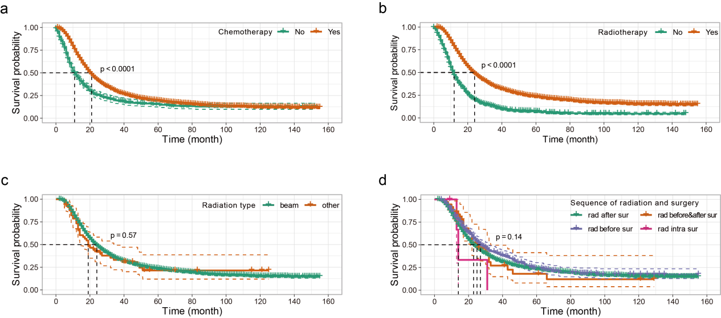
Sup figure 1. The influence of chemotherapy (a), radiotherapy (b), radiotherapy type (c), and the sequence of radiotion and surgery (d) on CSS (cancer specific survival) of pancretic cancer patients.
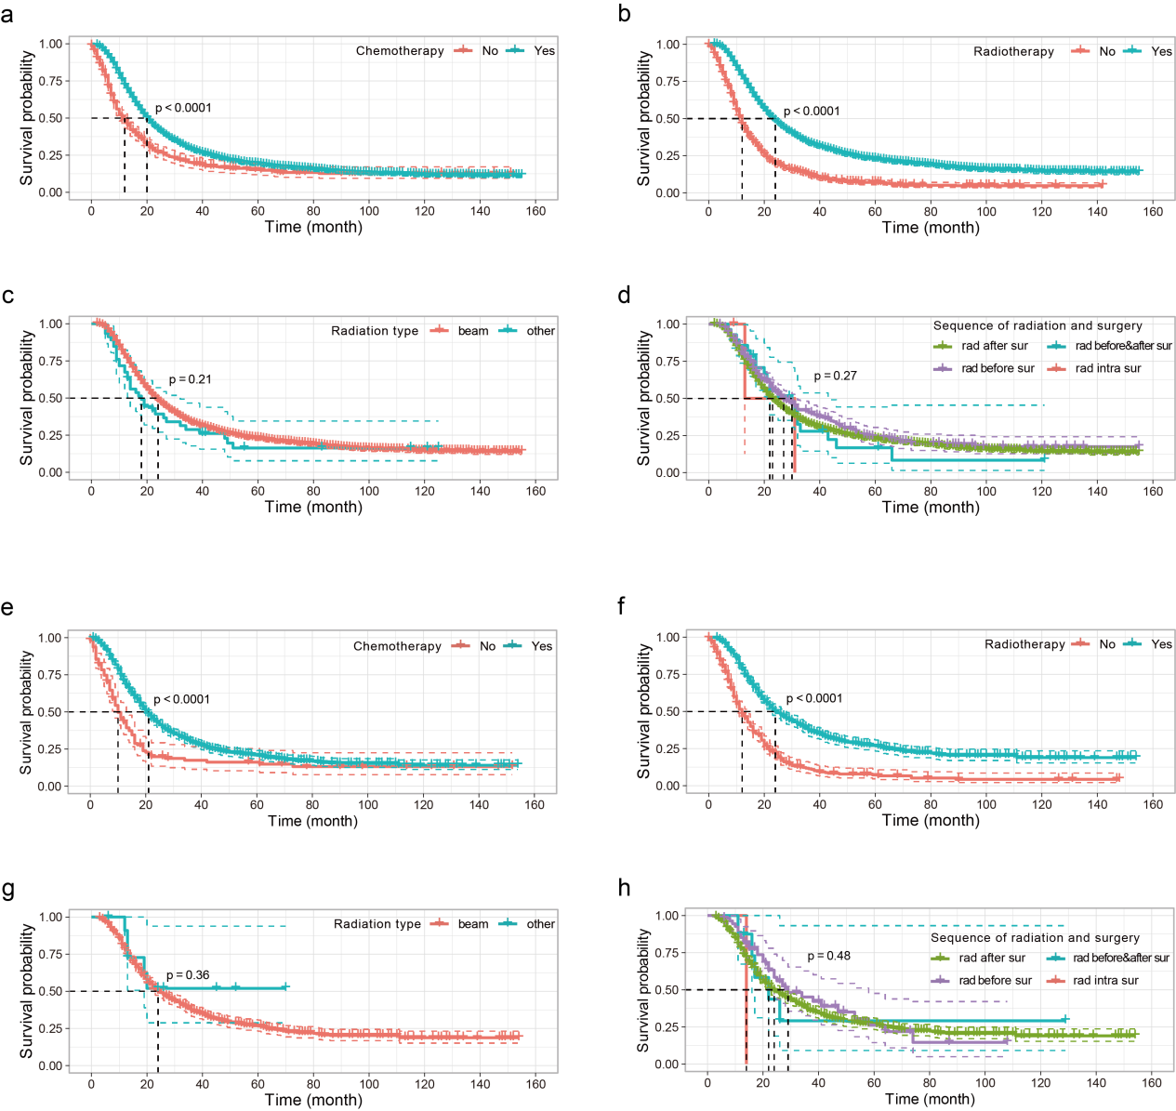
Sup figure 2. The influence of treatment on CSS (cancer specific survival) of pancretic cancer patients splited by primary site.
(a-d) in pancreatic head tumor patients: chemotherapy (a), radiotherapy (b), radiotherapy type (c), and the sequence of radiotion and surgery (d).
(e-h) in pancreatic bodytail tumor patients: chemotherapy (e), radiotherapy (f), radiotherapy type (g), and the sequence of radiotion and surgery (h).

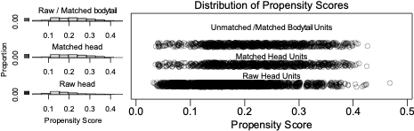
Sup figure 3. Distribution of M0 pancreatic cancer patients after propensity score matching.

Supplementary tables.

Sup table 1. Risk factors of overall survival (OS, a) and cancer specific survival (CSS,b) in M0 pancreatic tumors by univariate Cox regression analyses.
Variable | Overall survival (OS) |  | Cancer specific survival (CSS)
Variable | P value | OR (95% CI) | P value | OR (95% CI)
Age
18-49
50-59 | 0.703 | 0.978 (0.873,1.096) | 0.499 | 0.96 (0.854,1.08)
60-69 | 0.134 | 1.086 (0.975,1.209) | 0.326 | 1.057 (0.946,1.181)
>70 | 0.000 | 1.31 (1.175,1.46) | 0.000 | 1.237 (1.105,1.384)
Sex
Female
Male | 0.103 | 1.048 (0.99,1.11) | 0.643 | 1.014 (0.956,1.076)
Race | 0.303
black
white | 0.154 | 0.938 (0.859,1.024) | 0.401 | 0.961 (0.875,1.055)
other | 0.195 | 0.916 (0.802,1.046) | 0.402 | 0.942 (0.82,1.083)
Martial
married
never married | 0.434 | 1.038 (0.945,1.14) | 0.694 | 1.02 (0.924,1.126)
seperated | 0.000 | 1.147 (1.07,1.23) | 0.000 | 1.149 (1.068,1.235)
Insurance
insured
uninsured | 0.637 | 1.054 (0.847,1.312) | 0.525 | 1.076 (0.858,1.349)
Size
>4cm
2-4cm | 0.000 | 0.793 (0.743,0.846) | 0.000 | 0.791 (0.74,0.847)
0.1-2cm | 0.000 | 0.587 (0.53,0.649) | 0.000 | 0.565 (0.507,0.628)
Grade
well
intermediate | 0.001 | 1.177 (1.071,1.292) | 0.000 | 1.195 (1.082,1.32)
poor/undifferentiated | 0.000 | 1.491 (1.355,1.64) | 0.000 | 1.539 (1.391,1.702)
Primary site
bodytail
head | 0.832 | 1.008 (0.936,1.086) | 0.944 | 1.003 (0.928,1.084)
Stage
I
II | 0.000 | 1.282 (1.153,1.425) | 0.000 | 1.303 (1.164,1.458)
III | 0.000 | 2.296 (2.032,2.593) | 0.000 | 2.371 (2.085,2.697)
T stage
T1
T2 | 0.000 | 1.504 (1.238,1.827) | 0.000 | 1.65 (1.332,2.045)
T3 | 0.000 | 1.626 (1.357,1.949) | 0.000 | 1.8 (1.473,2.199)
T4 | 0.000 | 2.852 (2.354,3.454) | 0.000 | 3.21 (2.6,3.962)
TX | 0.000 | 3.427 (2.542,4.619) | 0.000 | 3.784 (2.753,5.201)
N stage
N0
N1 | 0.377 | 1.027 (0.968,1.089) | 0.168 | 1.044 (0.982,1.11)
NX | 0.000 | 2.548 (2.027,3.202) | 0.000 | 2.573 (2.028,3.265)
Lymph node
neg
pos | 0.000 | 1.425 (1.325,1.533) | 0.000 | 1.485 (1.374,1.604)
LN positive ratio
0
0.1-0.25 | 0.000 | 1.234 (1.14,1.336) | 0.000 | 1.278 (1.175,1.391)
0.26-0.5 | 0.000 | 1.808 (1.64,1.993) | 0.000 | 1.897 (1.713,2.101)
> 0.51 | 0.000 | 2.144 (1.873,2.453) | 0.000 | 2.239 (1.945,2.578)
Chemotherapy
No
Yes | 0.000 | 0.629 (0.572,0.692) | 0.000 | 0.634 (0.574,0.7)
Radiotherapy
No
Yes | 0.000 | 0.441 (0.415,0.469) | 0.000 | 0.436 (0.409,0.465)
Radiation type
No
beam | 0.000 | 0.441 (0.414,0.469) | 0.000 | 0.435 (0.408,0.465)
other | 0.000 | 0.443 (0.323,0.606) | 0.000 | 0.482 (0.352,0.661)
Sequence of radiation and surgery
Intraoperative radiation
Radiation after surgery | 0.131 | 0.469 (0.176,1.252) | 0.346 | 0.58 (0.187,1.799)
Radiation before and after surgery | 0.122 | 0.437 (0.153,1.249) | 0.358 | 0.571 (0.173,1.886)
Radiation prior to surgery | 0.083 | 0.418 (0.156,1.121) | 0.243 | 0.507 (0.162,1.584)
Cancer-directed surgery without radiation | 0.917 | 1.053 (0.395,2.811) | 0.636 | 1.315 (0.424,4.083)

Sup table 2. Risk factors of overall survival (OS, a) and cancer specific survival (CSS,b) in M0 pancreatic head tumors by univariate Cox regression analyses.
Variable | Overall survival (OS) |  | Cancer specific survival (CSS)
Variable | P value | OR (95% CI) | P value | OR (95% CI)
Age | 0.000 |  | 0.000
18-49
50-59 | 0.135 | 0.91 (0.804,1.03) | 0.083 | 0.893 (0.786,1.015)
60-69 | 0.532 | 1.038 (0.923,1.167) | 0.861 | 1.011 (0.896,1.141)
>70 | 0.001 | 1.229 (1.092,1.383) | 0.015 | 1.164 (1.03,1.316)
Sex
Female
Male | 0.088 | 1.056 (0.992,1.124) | 0.378 | 1.03 (0.965,1.1)
Race | 0.361 |  | 0.646
black
white | 0.094 | 0.919 (0.832,1.015) | 0.243 | 0.94 (0.846,1.043)
other | 0.225 | 0.912 (0.785,1.059) | 0.340 | 0.926 (0.792,1.084)
Martial | 0.020 |  | 0.026
married
never married | 0.817 | 1.012 (0.913,1.122) | 0.815 | 0.987 (0.885,1.101)
seperated | 0.005 | 1.115 (1.033,1.204) | 0.009 | 1.112 (1.026,1.205)
Insurance
insured
uninsured | 0.278 | 1.14 (0.9,1.446) | 0.262 | 1.151 (0.9,1.473)
Size | 0.000 |  | 0.000
>4cm
2-4cm | 0.000 | 0.754 (0.7,0.812) | 0.000 | 0.756 (0.699,0.817)
0.1-2cm | 0.000 | 0.562 (0.503,0.627) | 0.000 | 0.543 (0.483,0.61)
Grade | 0.000 |  | 0.000
well
intermediate | 0.011 | 1.142 (1.031,1.266) | 0.011 | 1.15 (1.032,1.281)
poor/undifferentiated | 0.000 | 1.458 (1.313,1.619) | 0.000 | 1.486 (1.331,1.659)
Stage | 0.000 |  | 0.000
I
II | 0.004 | 1.194 (1.058,1.348) | 0.003 | 1.214 (1.067,1.38)
III | 0.000 | 2.226 (1.936,2.559) | 0.000 | 2.292 (1.978,2.656)
T stage | 0.000 |  | 0.000
T1
T2 | 0.000 | 1.508 (1.217,1.867) | 0.000 | 1.647 (1.303,2.083)
T3 | 0.000 | 1.583 (1.3,1.928) | 0.000 | 1.739 (1.399,2.162)
T4 | 0.000 | 2.86 (2.318,3.53) | 0.000 | 3.181 (2.526,4.006)
TX | 0.000 | 3.75 (2.701,5.206) | 0.000 | 4.127 (2.912,5.848)
N stage | 0.000 |  | 0.000
N0
N1 | 0.998 | 1 (0.937,1.067) | 0.689 | 1.014 (0.947,1.085)
NX | 0.000 | 2.688 (2.048,3.529) | 0.000 | 2.848 (2.158,3.76)
Lymph node
neg
pos | 0.000 | 1.386 (1.279,1.502) | 0.000 | 1.441 (1.323,1.569)
LN positive ratio | 0.000 |  | 0.000
0
0.1-0.25 | 0.000 | 1.179 (1.08,1.287) | 0.000 | 1.216 (1.108,1.335)
0.26-0.5 | 0.000 | 1.819 (1.637,2.021) | 0.000 | 1.906 (1.706,2.129)
> 0.51 | 0.000 | 2.153 (1.861,2.492) | 0.000 | 2.246 (1.928,2.615)
Chemotherapy
No
Yes | 0.000 | 0.644 (0.579,0.716) | 0.000 | 0.652 (0.583,0.729)
Radiotherapy
No
Yes | 0.000 | 0.439 (0.41,0.471) | 0.000 | 0.436 (0.406,0.469)
Radiation type | 0.000 |  | 0.000
No
beam | 0.000 | 0.439 (0.409,0.47) | 0.000 | 0.435 (0.405,0.468)
other | 0.000 | 0.485 (0.347,0.679) | 0.000 | 0.533 (0.38,0.746)
Sequence of radiation and surgery | 0.000 |  | 0.000
Intraoperative radiation
Radiation after surgery | 0.234 | 0.503 (0.162,1.561) | 0.612 | 0.699 (0.175,2.796)
Radiation before and after surgery | 0.231 | 0.478 (0.143,1.598) | 0.618 | 0.691 (0.162,2.949)
Radiation prior to surgery | 0.170 | 0.45 (0.144,1.407) | 0.491 | 0.613 (0.152,2.469)
Cancer-directed surgery without radiation | 0.828 | 1.134 (0.365,3.522) | 0.515 | 1.585 (0.396,6.344)

Sup table 3. Risk factors of overall survival (OS, a) and cancer specific survival (CSS,b) in M0 pancreatic bodytail tumors by univariate Cox regression analyses.
Variable | Overall survival (OS) |  | Cancer specific survival (CSS)
Variable | P value | OR (95% CI) | P value | OR (95% CI)
Age
18-49
50-59 | 0.031 | 1.376 (1.03,1.838) | 0.047 | 1.356 (1.005,1.829)
60-69 | 0.039 | 1.334 (1.014,1.756) | 0.067 | 1.303 (0.981,1.731)
>70 | 0.000 | 1.742 (1.325,2.29) | 0.001 | 1.625 (1.223,2.158)
Sex
Female
Male | 0.847 | 1.013 (0.885,1.16) | 0.444 | 0.946 (0.821,1.09)
Race
black
white | 0.887 | 1.014 (0.835,1.232) | 0.675 | 1.045 (0.851,1.284)
other | 0.694 | 0.944 (0.709,1.257) | 0.935 | 1.012 (0.752,1.363)
Martial
married
never married | 0.168 | 1.169 (0.936,1.46) | 0.138 | 1.192 (0.945,1.502)
seperated | 0.002 | 1.303 (1.103,1.54) | 0.001 | 1.328 (1.117,1.579)
Insurance
insured
uninsured | 0.278 | 0.729 (0.412,1.291) | 0.418 | 0.789 (0.445,1.399)
Size
>4cm
2-4cm | 0.057 | 0.87 (0.754,1.004) | 0.045 | 0.858 (0.739,0.996)
0.1-2cm | 0.000 | 0.581 (0.431,0.784) | 0.000 | 0.555 (0.403,0.763)
Grade
well
intermediate | 0.012 | 1.344 (1.068,1.69) | 0.004 | 1.434 (1.119,1.837)
poor/undifferentiated | 0.000 | 1.651 (,) | 0.000 | 1.818 (1.413,2.34)
Stage
I
II | 0.000 | 1.565 (1.253,1.955) | 0.000 | 1.594 (1.257,2.021)
III | 0.000 | 2.462 (1.916,3.163) | 0.000 | 2.567 (1.97,3.346)
T stage
T1
T2 | 0.061 | 1.582 (0.979,2.557) | 0.036 | 1.778 (1.039,3.041)
T3 | 0.008 | 1.864 (1.179,2.95) | 0.004 | 2.144 (1.281,3.587)
T4 | 0.000 | 2.983 (1.859,4.787) | 0.000 | 3.522 (2.078,5.971)
TX | 0.009 | 2.62 (1.27,5.403) | 0.007 | 2.947 (1.352,6.424)
N stage
N0
N1 | 0.053 | 1.146 (0.998,1.315) | 0.021 | 1.185 (1.026,1.368)
NX | 0.000 | 2.296 (1.504,3.504) | 0.002 | 2.055 (1.292,3.267)
Lymph node
neg
pos | 0.000 | 1.587 (1.332,1.892) | 0.000 | 1.679 (1.394,2.023)
LN positive ratio
0
0.1-0.25 | 0.000 | 1.52 (1.255,1.841) | 0.000 | 1.612 (1.317,1.973)
0.26-0.5 | 0.000 | 1.631 (1.253,2.124) | 0.000 | 1.724 (1.306,2.275)
> 0.51 | 0.000 | 2.042 (1.426,2.924) | 0.000 | 2.135 (1.464,3.114)
Chemotherapy
No
Yes | 0.000 | 0.573 (0.465,0.707) | 0.000 | 0.568 (0.456,0.708)
Radiotherapy
No
Yes | 0.000 | 0.44 (0.382,0.507) | 0.000 | 0.428 (0.37,0.496)
Radiation type
No
beam | 0.000 | 0.443 (0.385,0.511) | 0.000 | 0.431 (0.372,0.499)
other | 0.004 | 0.27 (0.112,0.654) | 0.006 | 0.287 (0.119,0.695)
Sequence of radiation and surgery
Intraoperative radiation
Radiation after surgery | 0.319 | 0.369 (0.052,2.627) | 0.287 | 0.344 (0.048,2.45)
Radiation before and after surgery | 0.299 | 0.32 (0.037,2.746) | 0.319 | 0.335 (0.039,2.872)
Radiation prior to surgery | 0.247 | 0.309 (0.042,2.255) | 0.222 | 0.289 (0.039,2.117)
Cancer-directed surgery without radiation | 0.848 | 0.825 (0.116,5.879) | 0.815 | 0.791 (0.111,5.642)

Sup table 4. Test of propensity score matching.

Variable | Means Treated | Means Control | Std. Mean Diff. | Var. Ratio
distance | 0.21 | 0.21 | 0.00 | 1.00
Age | 2.97 | 2.96 | 0.01 | 1.01
Race | 1.95 | 1.96 | -0.01 | 1.25
Sex | 1.48 | 1.51 | -0.05 | 1.00
Grade | 2.27 | 2.27 | 0.00 | 0.97
T stage | 3.00 | 3.03 | -0.04 | 1.28
N stage | 1.55 | 1.54 | 0.01 | 1.07
Stage | 2.09 | 2.11 | -0.03 | 1.21
Chemotherapy | 1.89 | 1.90 | -0.02 | 1.05
Radiotherapy | 1.66 | 1.65 | 0.02 | 0.99
Size | 1.66 | 1.66 | 0.01 | 1.09
Martial | 1.63 | 1.61 | 0.02 | 1.04
Insurance | 1.49 | 1.49 | 0.00 | 0.99
Lymph node | 1.02 | 1.02 | 0.00 | 1.05

