Supplementary Information
Structure-Aromaticity-Spectroscopy Relationship in Conjugated Polymers
Masiyappan Karuppusamy^{a,b,#}, Shyam Vinod Kumar Panneer^{c,#}, Abigail Jennifer G^{d}, Elumalai Varathan^{d}, Ravva Mahesh Kumar^{e} and Venkatesan Subramanian^{a,c,f}*
ªCentre for High Computing, CSIR-Central Leather Research Institute, Adyar, Chennai - 600 020, India.
^{b}Academy of Scientific and Innovative Research (AcSIR), Ghaziabad - 201 002, India.
^{c}Inorganic and Physical Chemistry, CSIR-Central Leather Research Institute, Adyar, Chennai - 600 020, India.
^{d}Department of Chemistry, SRM Institute of Science and Technology, Kattankulathur, Chennai - 603 203, Tamil Nadu, India.
^{e}Department of Chemistry, SRM University - AP, Amaravati - 522 502, India.
^{f}Department of Chemistry, Indian Institute of Technology-Madras, Chennai - 600 036, India.
#equally contributed.

Table S1. Calculated NICS(0) and NICS(1) values (in ppm) along with the vertical excitation energy of benzene and benzene-based oligomers at B3LYP/6-311G(d,p) level of theory.
Molecule | Nucleus Independent Chemical Shift (NICS) |  | Vertical Excitation Energy (eV)
Molecule | NICS(0) | NICS(1) | Vertical Excitation Energy (eV)
Benzene oligomer (BZ_{n}; n=1-5)
BZ₁ | -8.89 | -11.13 | 7.45
BZ₂  Ring 1  Ring 2 | -16.44  -8.22  -8.22 | -20.93  -10.42  -10.51 | 6.84
BZ₃  Ring 1  Ring 2  Ring 3 | -23.71  -8.13  -7.45  -8.13 | -30.53  -10.42  -9.68  -10.43 | 6.74
BZ₄  Ring 1  Ring 2  Ring 3  Ring 4 | -30.96  -8.11  -7.38  -7.38  -8.10 | -40.27  -10.50  -9.69  -9.73  -10.34 | 6.68
BZ₅  Ring 1  Ring 2  Ring 3  Ring 4  Ring 5 | -38.15  -8.09  -7.36  -7.26  -7.36  -8.09 | -49.56  -10.33  -9.64  -9.54  -9.73  -10.32 | 6.65
Benzene oligomer with vinyl linkers (BZV_{n}; n=1-5)
BZV₁  Ring 1  Ring 2 | -15.40  -7.70  -7.70 | -20.27  -10.12  -10.15 | 4.31
BZV₂  Ring 1  Ring 2  Ring 3 | -21.82  -7.64  -6.54  -7.64 | -29.19  -10.04  -9.11  -10.04 | 3.65
BZV₃  Ring 1  Ring 2  Ring 3  Ring 4 | -28.21  -7.64  -6.47  -6.47  -7.64 | -38.98  -10.18  -9.29  -9.28  -10.22 | 3.35
BZV₄  Ring 1  Ring 2  Ring 3  Ring 4  Ring 5 | -34.59  -7.64  -6.46  -6.40  -6.46  -7.64 | -47.41  -10.09  -9.08  -9.05  -9.11  -10.07 | 3.19
BZV₅  Ring 1  Ring 2  Ring 3  Ring 4  Ring 5  Ring 6 | -40.97  -7.64  -6.46  -6.39  -6.39  -6.46  -7.64 | -56.37  -10.10  -9.07  -9.00  -9.03  -9.11  -10.06 | 3.09
Benzene oligomer with ethynyl linkers (BZE_{n}; n=1-5)
BZE₁  Ring 1  Ring 2 | -16.82  -8.41  -8.41 | -20.72  -10.36  -10.36 | 7.32
BZE₂  Ring 1  Ring 2  Ring 3 | -24.58  -8.37  -7.85  -8.37 | -30.29  -10.33  -9.63  -10.33 | 3.88
BZE₃  Ring 1  Ring 2  Ring 3  Ring 4 | -32.32  -8.36  -7.80  -7.80  -8.36 | -39.85  -10.33  -9.60  -9.60  -10.33 | 3.60
BZE₄  Ring 1  Ring 2  Ring 3  Ring 4  Ring 5 | -40.05  -8.36  -7.79  -7.75  -7.79  -8.36 | -49.40  -10.33  -9.59  -9.56  -9.59  -10.33 | 3.45
BZE₅  Ring 1  Ring 2  Ring 3  Ring 4  Ring 5  Ring 6 | -47.78  -8.35  -7.79  -7.74  7.74  7.79  8.35 | -58.94  -10.33  -9.59  -9.55  -9.55  -9.59  -10.32 | 3.36
Benzene oligomer with thiophene linkers (BZT_{n}; n=1-5)
BZT₁  Ring 1  Ring 2  Ring 3 | -25.55  -7.87  -9.81  -7.87 | -28.30  -10.14  -8.10  -10.05 | 4.15
BZT₂  Ring 1  Ring 2  Ring 3  Ring 4  Ring 5 | -41.57  -7.84  -9.59  -6.71  -9.59  -7.84 | -45.32  -10.17  -7.98  -8.95  -8.23  -9.99 | 3.65
BZT₃  Ring 1  Ring 2  Ring 3  Ring 4  Ring 5  Ring 6  Ring 7 | -57.94  -7.84  -9.64  -6.70  -9.52  -6.72  -9.67  -7.84 | -62.14  -9.95  -8.19  -8.82  -8.19  -8.85  -8.05  -10.08 | 3.43
BZT₄  Ring 1  Ring 2  Ring 3  Ring 4  Ring 5  Ring 6  Ring 7  Ring 8  Ring 9 | -74.12  -7.85  -9.66  -6.70  -9.46  -6.67  -9.55  -6.72  -9.66  -7.85 | -79.05  -9.95  -8.23  -8.95  -7.95  -8.76  -8.00  -8.82  -8.38  -10.00 | 3.33
BZT₅  Ring 1  Ring 2  Ring 3  Ring 4  Ring 5  Ring 6  Ring 7  Ring 8  Ring 9  Ring 10  Ring 11 | -90.08  -7.83  -9.60  -6.68  -9.44  -6.64  -9.44  -6.67  -9.54  -6.72  -9.67  -7.85 | -96.09  -9.98  -8.35  -8.86  -7.99  -8.80  -7.97  -8.93  -8.22  -8.82  -8.14  -10.06 | 3.27

Table S2. Calculated NICS(0) and NICS(1) values (in ppm) along with the vertical excitation energy of thiophene and thiophene-based oligomers at B3LYP/6-311G(d,p) level of theory.
Molecule | Nucleus Independent Chemical Shift (NICS) |  | Vertical Excitation Energy (eV)
Molecule | NICS(0) | NICS(1) | Vertical Excitation Energy (eV)
Thiophene oligomer (TH_{n}; n=1-5)
TH₁ | -13.88 | -11.33 | 9.89
TH₂  Ring 1  Ring 2 | -23.67  -11.83  -11.83 | -19.08  -9.58  -9.50 | 4.36
TH₃  Ring 1  Ring 2  Ring 3 | -33.23  -11.72  -9.79  -11.72 | -26.86  -9.43  -7.98  -9.45 | 3.68
TH₄  Ring 1  Ring 2  Ring 3  Ring 4 | -42.71  -11.68  -9.67  -9.67  -11.68 | -34.26  -9.43  -7.73  -7.67  -9.43 | 3.30
TH₅  Ring 1  Ring 2  Ring 3  Ring 4  Ring 5 | -52.17  -11.67  -9.63  -9.56  -9.63  -11.67 | -42.12  -9.42  -7.83  -7.65  -7.82  -9.40 | 3.07
Thiophene oligomer with vinyl linkers (THV_{n}; n=1-5)
THV₁  Ring 1  Ring 2 | -22.79  -11.39  -11.39 | -18.75  -9.40  -9.35 | 3.84
THV₂  Ring 1  Ring 2  Ring 3 | -31.81  -11.32  -9.17  -11.32 | -26.17  -9.27  -7.62  -9.28 | 3.11
THV₃  Ring 1  Ring 2  Ring 3  Ring 4 | -40.76  -11.29  -9.09  -9.09  -11.29 | -34.43  -9.46  -7.68  -7.85  -9.44 | 2.76
THV₄  Ring 1  Ring 2  Ring 3  Ring 4  Ring 5 | -49.74  -11.29  -9.07  -9.00  -9.07  -11.29 | -41.26  -9.30  -7.57  -7.54  -7.57  -9.28 | 2.56
THV₅  Ring 1  Ring 2  Ring 3  Ring 4  Ring 5  Ring 6 | -58.67  -11.28  -9.08  -8.98  -8.98  -9.08  -11.28 | -48.76  -9.29  -7.57  -7.52  -7.50  -7.61  -9.28 | 2.44
Thiophene oligomer with ethynyl linkers (THE_{n}; n=1-5)
THE₁  Ring 1  Ring 2 | -25.88  -12.94  -12.94 | -20.83  -10.27  -10.56 | 3.97
THE₂  Ring 1  Ring 2  Ring 3 | -37.74  -12.88  -11.97  -12.88 | -29.59  -10.17  -10.18  -9.24 | 3.34
THE₃  Ring 1  Ring 2  Ring 3  Ring 4 | -49.57  -12.86  -11.92  -11.92  -12.86 | -40.10  -10.58  -9.68  -9.44  -10.40 | 3.04
THE₄  Ring 1  Ring 2  Ring 3  Ring 4  Ring 5 | -61.41  -12.87  -11.91  -11.86  -11.91  -12.87 | -48.24  -9.26  -9.30  -10.26  -9.20  -10.23 | 2.87
THE₅  Ring 1  Ring 2  Ring 3  Ring 4  Ring 5  Ring 6 | -73.23  -12.85  -11.91  -11.85  -11.85  -11.91  -12.85 | -57.06  -10.18  -9.17  -9.19  -9.19  -9.15  -10.17 | 2.76
Thiophene oligomer with phenyl linkers (THP_{n}; n=1-5)
THP₁  Ring 1  Ring 2  Ring 3 | -30.39  -11.70  -6.99  -11.70 | -28.58  -9.88  -8.99  -9.71 | 4.19
THP₂  Ring 1  Ring 2  Ring 3  Ring 4  Ring 5 | -46.73  -11.70  -6.87  -9.61  -6.86  -11.69 | -45.89  -9.57  -9.05  -8.71  -9.02  -9.55 | 3.64
THP₃  Ring 1  Ring 2  Ring 3  Ring 4  Ring 5  Ring 6  Ring 7 | -62.69  -11.67  -6.83  -9.45  -6.66  -9.54  -6.85  -11.69 | -62.54  -9.61  -9.10  -8.20  -8.89  -7.82  -8.99  -9.93 | 3.43
THP₄  Ring 1  Ring 2  Ring 3  Ring 4  Ring 5  Ring 6  Ring 7  Ring 8  Ring 9 | -78.93  -11.69  -6.85  -9.54  -6.68  -9.51  -6.68  -9.48  -6.83  -11.69 | -79.94  -9.68  -9.28  -8.47  -9.13  -7.96  -8.80  -7.90  -9.04  -9.69 | 3.33
THP₅  Ring 1  Ring 2  Ring 3  Ring 4  Ring 5  Ring 6  Ring 7  Ring 8  Ring 9  Ring 10  Ring 11 | -95.34  -11.67  -6.85  -9.58  -6.69  -9.53  -6.69  -9.53  -6.69  -9.58  -6.85  -11.67 | -95.99  -9.71  -8.98  -8.05  -9.04  -8.18  -8.80  -7.81  -8.81  -8.12  -8.92  -9.55 | 3.27

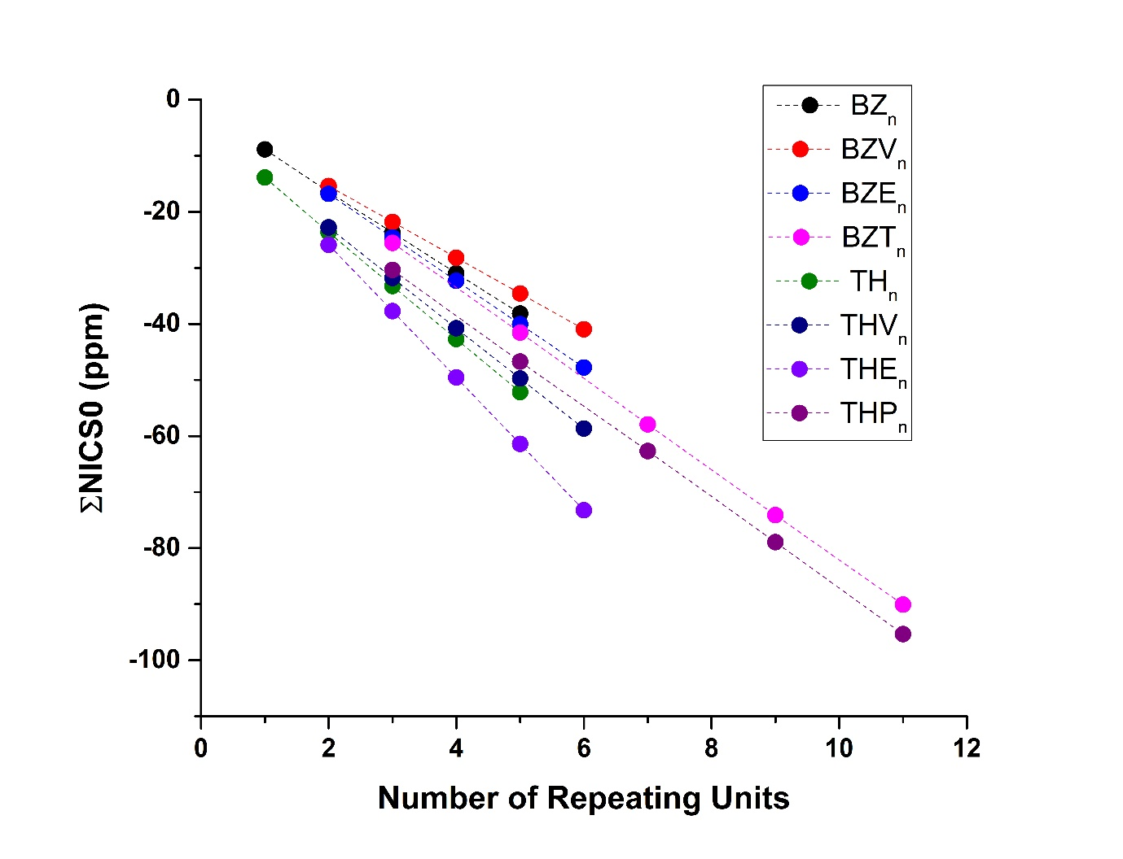
Figure S3: Correlation between the calculated ΣNICS0 and the number of repeating units in the studied oligomers at B3LYP/6-31G(d,p) level of theory.
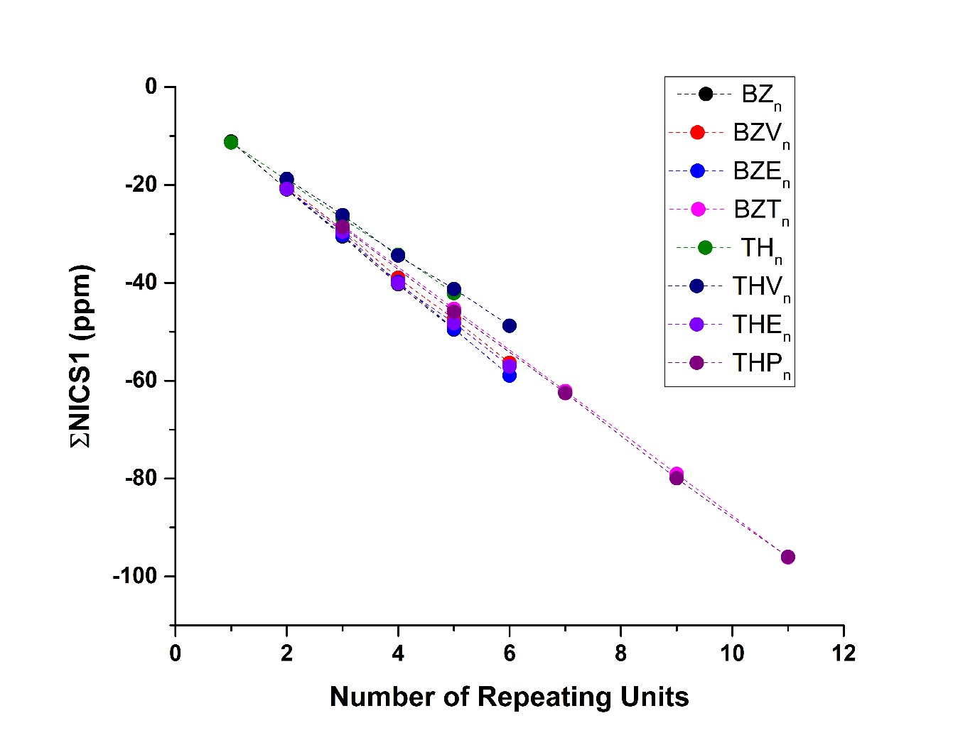
Figure S4: Correlation between the calculated ΣNICS1 and the number of repeating units in the studied oligomers at B3LYP/6-31G(d,p) level of theory.

Figure S5. The variation of First Transition Energy (calculated at ωB97X-D/6-31G(d,p) level of theory) with aromaticity (as predicted by 1/NICS0 at B3LYP/6-311G(d,p) level of theory) for benzene based oligomers

Figure S6. The variation of First Transition Energy (calculated at ωB97X-D/6-31G(d,p) level of theory) with aromaticity (as predicted by 1/NICS0 at B3LYP/6-311G(d,p) level of theory) for thiophene based oligomers

Figure S7. The variation of First Transition Energy (calculated at ωB97X-D/6-31G(d,p) level of theory) with aromaticity (as predicted by 1/NICS1 at B3LYP/6-311G(d,p) level of theory) for benzene based oligomers

Figure S8. The variation of First Transition Energy (calculated at ωB97X-D/6-31G(d,p) level of theory) with aromaticity (as predicted by 1/NICS1 at B3LYP/6-311G(d,p) level of theory) for thiophene based oligomers

Figure S9. The variation of λ_{max} (calculated at ωB97X-D/6-31G(d,p) level of theory) with aromaticity (as predicted by 1/NICS0 at B3LYP/6-311G(d,p) level of theory) for benzene based oligomers

Figure S10. The variation of λ_{max} (calculated at ωB97X-D/6-31G(d,p) level of theory) with aromaticity (as predicted by 1/NICS0 at B3LYP/6-311G(d,p) level of theory) for thiophene based oligomers

Figure S1. The variation of λ_{max} (calculated at ωB97X-D/6-31G(d,p) level of theory) with aromaticity (as predicted by 1/NICS1 at B3LYP/6-311G(d,p) level of theory) for benzene based oligomers

Figure S12. The variation of λ_{max} (calculated at ωB97X-D/6-31G(d,p) level of theory) with aromaticity (as predicted by 1/NICS1 at B3LYP/6-311G(d,p) level of theory) for thiophene based oligomers

Figure S13. The variation of reorganization energies (λ_{e} and λ_{h}, calculated at B3LYP/6-31G(d) level of theory) with aromaticity (as predicted by 1/NICS0 at B3LYP/6-311G(d,p) level of theory) for benzene based oligomers

Figure S14. The variation of reorganization energies (λ_{e} and λ_{h}, calculated at B3LYP/6-31G(d) level of theory) with aromaticity (as predicted by 1/NICS0 at B3LYP/6-311G(d,p) level of theory) for thiophene based oligomers

Figure S15. The variation of reorganization energies (λ_{e} and λ_{h}, calculated at B3LYP/6-31G(d) level of theory) with aromaticity (as predicted by 1/NICS1 at B3LYP/6-311G(d,p) level of theory) for benzene based oligomers

Figure S16. The variation of reorganization energies (λ_{e} and λ_{h}, calculated at B3LYP/6-31G(d) level of theory) with aromaticity (as predicted by 1/NICS1 at B3LYP/6-311G(d,p) level of theory) for thiophene based oligomers

