Supplementary materials
Supplementary Figure
Fig. S1 Non-metric multidimensional scaling (NMDS) analysis for the endophytic and rhizosphere fungi. The circle nodes with red color represented the samples of endophytic fungi, while triangle nodes with blue color represented the samples of rhizosphere one.
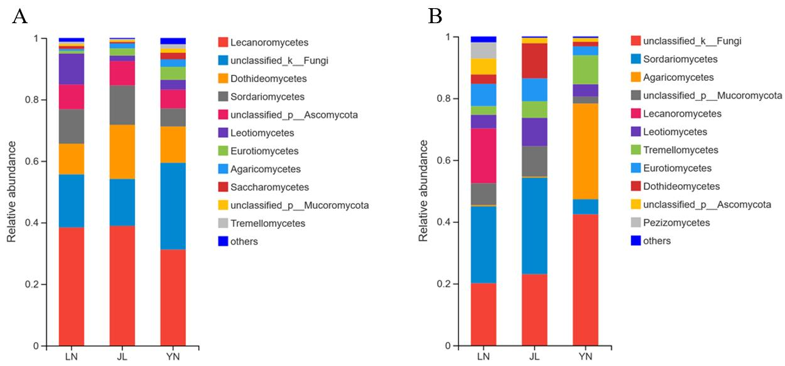
Fig. S2 Taxonomic structures of the root endophytic fungi (A) and rhizosphere fungi (B) at phylum level. Phylum relative abundance less than 0.01 were classified as “others”. “LN” means the samples sampled from Liaoning Province, China. “JL” means the samples sampled from Jilin Province, China. “YN” means the samples sampled from Yunnan Province, China.

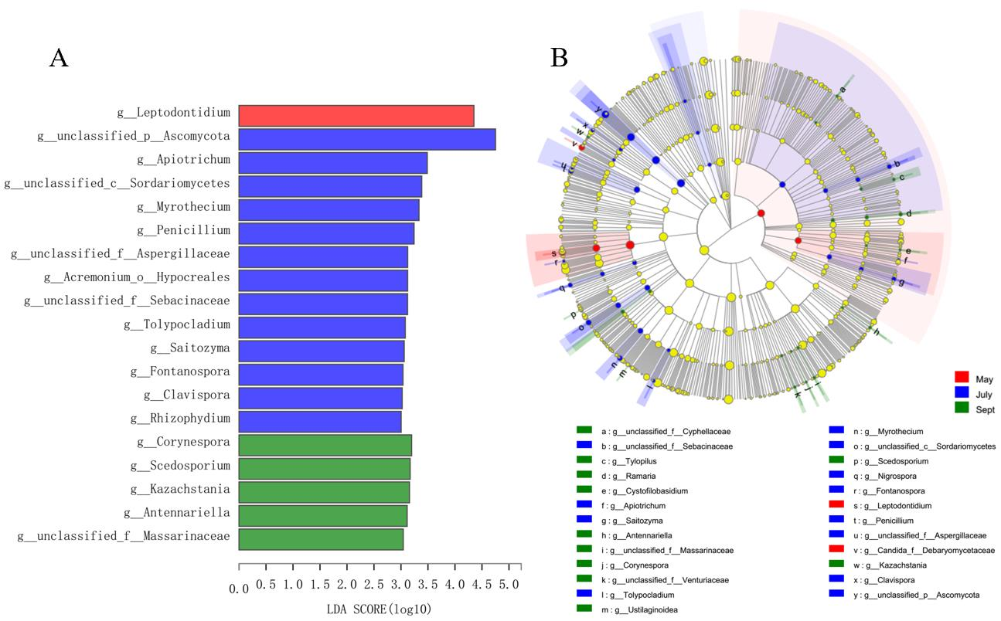
Fig. S3 Linear discriminant analysis (LDA) effect size (LEfSe). (A) The log10 of LDA score of the endophytic fungi of LN, and the higher the value, the higher the specificity. (B) Taxonomic cladogram of the discriminates analyzed by LEfSe. Rings from the inner to the outer portion of the graph represent taxonomic ranks from phylum to genus. The nodes in each taxonomic rank are defined at the same level of classification, and the sizes of nodes are proportional to their relative abundances.
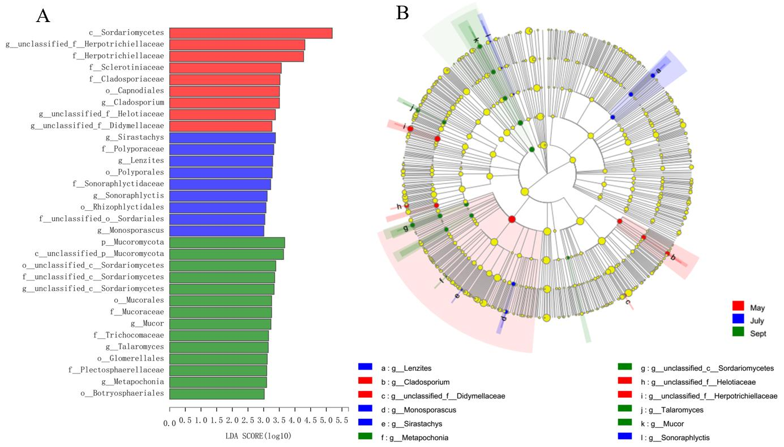
Fig. S4 Linear discriminant analysis (LDA) effect size (LEfSe). (A) The log10 of LDA score of the endophytic fungi of JL, and the higher the value, the higher the specificity. (B) Taxonomic cladogram of the discriminates analyzed by LEfSe.
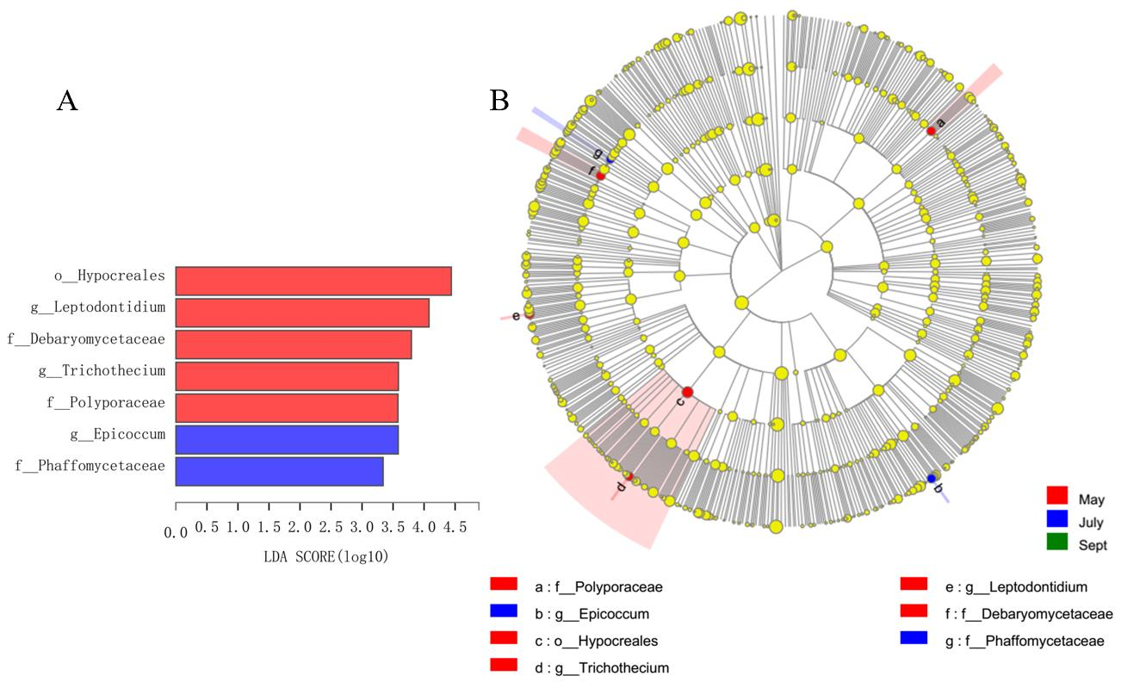
Fig. S5 Linear discriminant analysis (LDA) effect size (LEfSe). (A) The log10 of LDA score of the endophytic fungi of YN, and the higher the value, the higher the specificity. (B) Taxonomic cladogram of the discriminates analyzed by LEfSe.
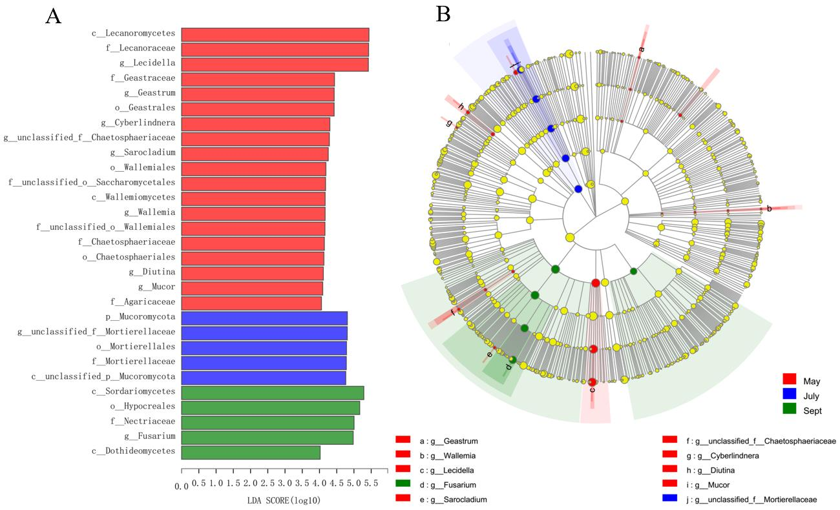
Fig. S6 Linear discriminant analysis (LDA) effect size (LEfSe). (A) The log10 of LDA score of the rhizosphere fungi of LN, and the higher the value, the higher the specificity. (B) Taxonomic cladogram of the discriminates analyzed by LEfSe.
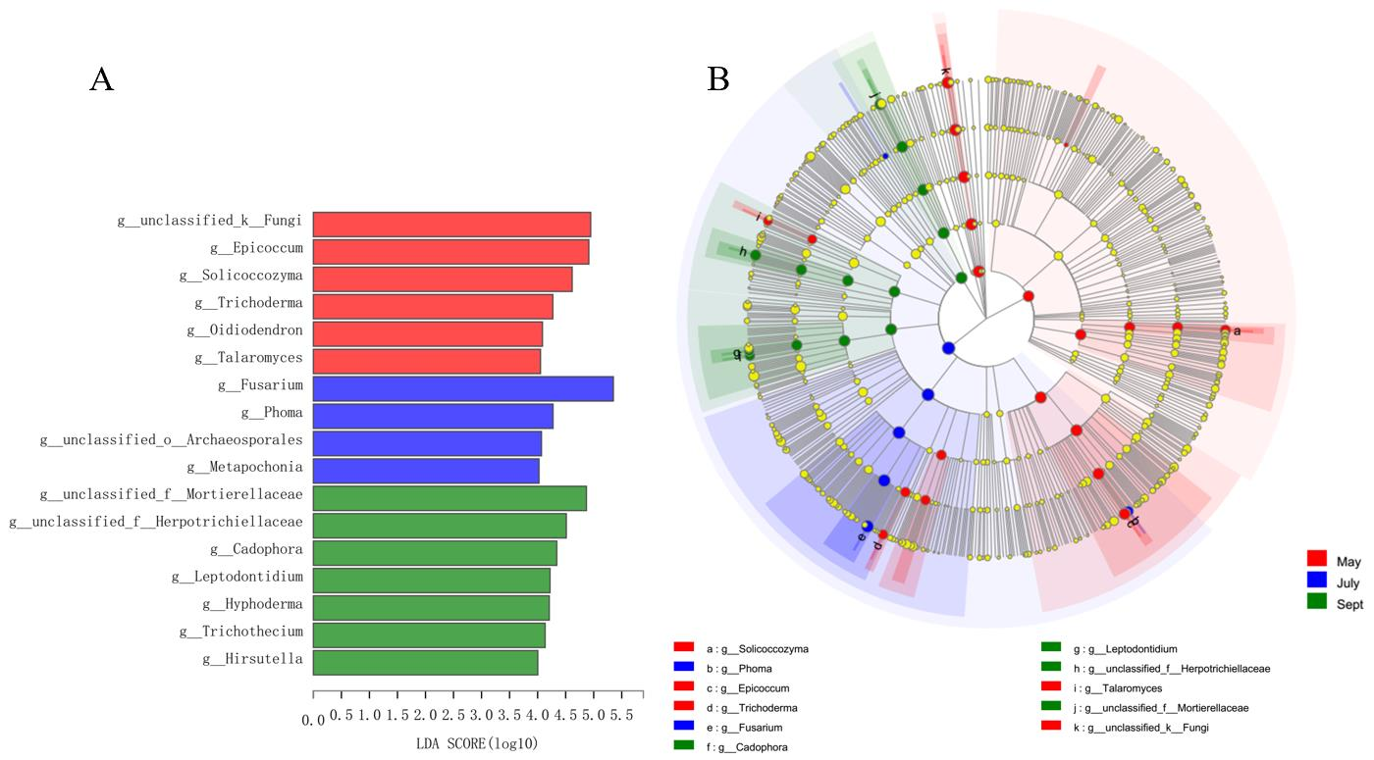
Fig. S7 Linear discriminant analysis (LDA) effect size (LEfSe). (A) The log10 of LDA score of the rhizosphere fungi of JL, and the higher the value, the higher the specificity. (B) Taxonomic cladogram of the discriminates analyzed by LEfSe.
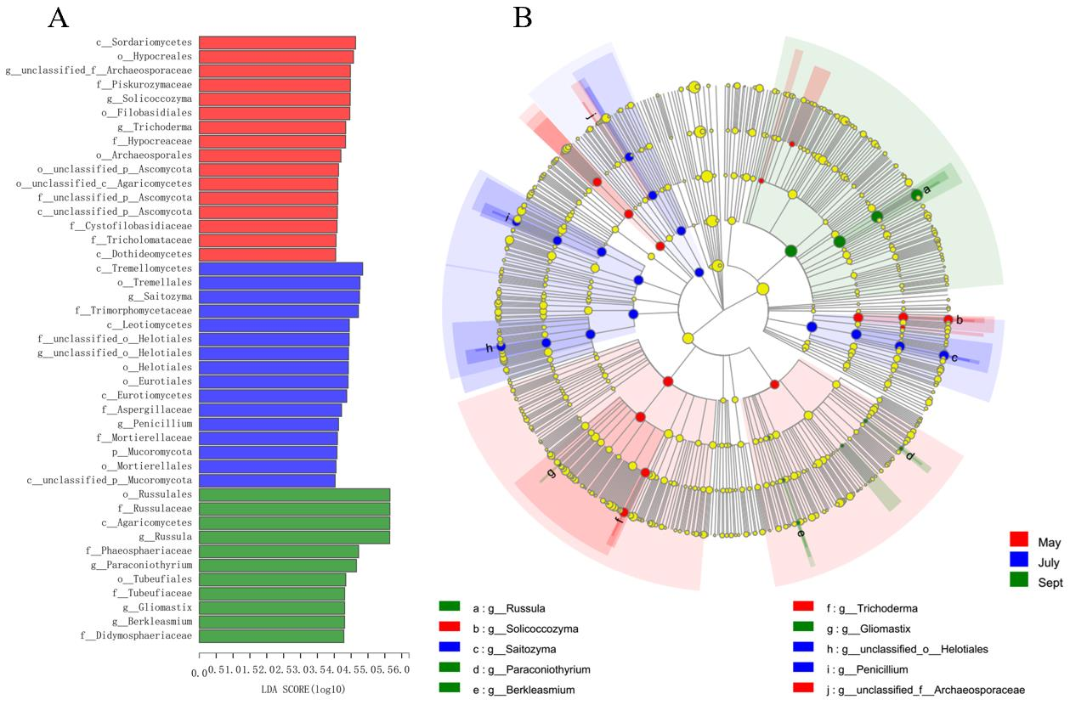
Figure S8 Linear discriminant analysis (LDA) effect size (LEfSe). (A) The log10 of LDA score of the rhizosphere fungi of YN, and the higher the value, the higher the specificity. (B) Taxonomic cladogram of the discriminates analyzed by LEfSe.
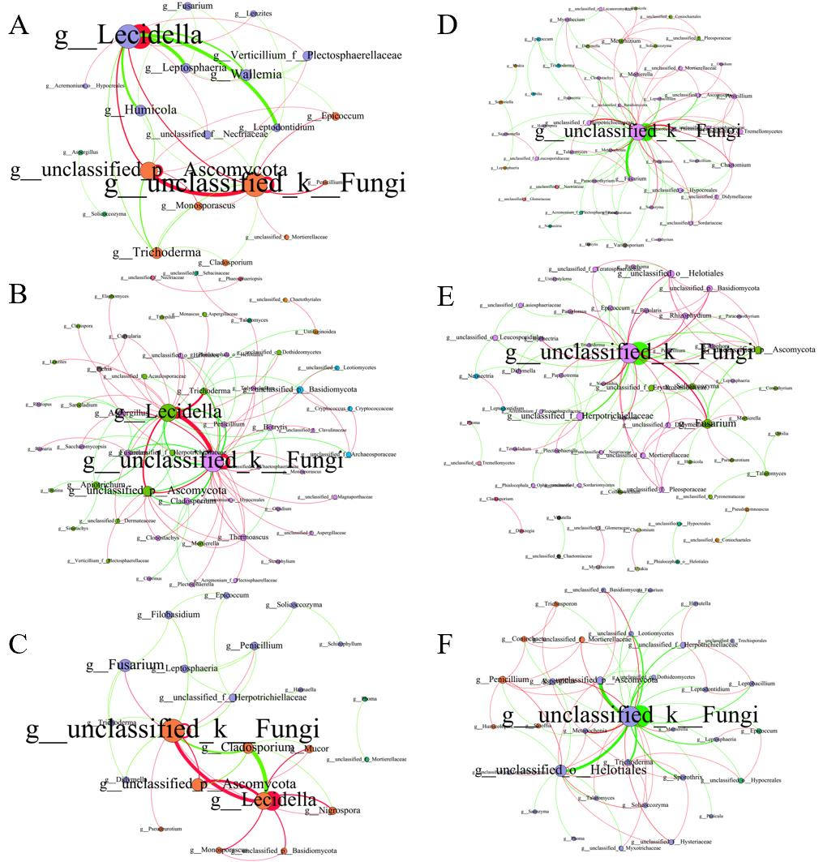
Fig. S9 The fungal co-occurrence networks of different origins based on a Spearman correlation analysis. The endophytic fungi of LN (A), JL (B) and YN (C) and rhizosphere fungi of LN (D), JL (E) and YN (F) were analyzed separately. The nodes are colored by the modules; the size of each node is proportional to the number of connections (degree), and the thickness of each connection between two nodes (edge) is proportional to the value of Spearman’s correlation coefficients. The red edges indicate positive interactions between two bacterial nodes, while the green edges indicate negative interactions.

Supplementary Table
Tab. S1 The plant physiological and biochemical indicators
 | Gentiopicroside  /(%) | Polysaccharide  /(%) | Root vitality  /(mg‧g⁻¹‧h⁻¹) | Plant Height  /(cm)
May_LN | 7.40±0.02e | 2.12±0.12^{b} | 1.617±0.265^{b} | 14.77±1.10e
May_JL | 7.82±0.13^{d} | 1.82±0.05^{c} | 1.343±0.083^{b} | 14.00±0.62e
May_YN | 7.99±0.14^{d} | 2.88±0.05ª | 1.157±0.055b^{c} | 10.50±0.44^{f}
July_LN | 9.71±0.26^{b} | 1.90±0.11^{c} | 0.2400±0.069^{cd} | 46.00±0.70^{c}
July_JL | 5.36±0.09^{f} | 1.62±0.04^{d} | 0.1967±0.025^{d} | 45.37±0.67^{c}
July_YN | 10.86±0.08ª | 3.02±0.05ª | 0.0600±0.020^{d} | 21.27±2.20^{d}
Sept_LN | 8.97±0.26^{c} | 1.53±0.23^{d} | 4.607±1.023ª | 67.00±1.00^{b}
Sept_JL | 8.02±0.03^{d} | 1.30±0.01e | 4.777±0.925ª | 71.33±2.08ª
Sept_YN | 7.44±0.02e | 2.90±0.02ª | 4.490±0.000ª | 21.33±2.08^{d}
Notes: The value represented the means ± SD of three independent experiments. Value with superscript letter a, b, c, d, e and f were significantly different across each column (P<0.05).

Tab. S2 The soil physicochemical properties
 | pH | SMC  /% | AP  /mg‧g⁻¹ | AN  / mg‧g⁻¹
May_LN | 5.39±0.09^{ab} | 0.0363±0.0107de | 19.03±4.75^{cde} | 86.98±10.84e
May_JL | 5.29±0.01^{bc} | 0.0453±0.0006^{cd} | 29.07±2.28^{bcd} | 95.54±2.26e
May_YN | 4.32±0.10e | 0.0473±0.0006^{cd} | 32.15±4.03^{bc} | 191.16±14.58ª
July_LN | 5.24±0.18^{bcd} | 0.0323±0.0092e | 27.42±4.47^{bcd} | 141.46±3.52^{cd}
July_JL | 5.24±0.01^{bc} | 0.1104±0.0022ª | 26.32±5.44^{bcd} | 162.24±6.38^{b}
July_YN | 5.06±0.03^{d} | 0.0505±0.0005^{c} | 16.78±2.14de | 132.40±10.86^{d}
Sept_LN | 5.36±0.11^{abc} | 0.0248±0.0111e | 69.64±18.06ª | 57.88±9.00^{f}
Sept_JL | 5.48±0.02ª | 0.0803±0.0003^{b} | 36.84±1.69^{b} | 140.13±6.00^{cd}
Sept_YN | 5.19±0.09^{cd} | 0.1146±0.0005ª | 6.83±0.40e | 158.00±8.89^{b}
Notes: The value represented the means±SD of three independent experiments. Value with superscript letter a, b, c, d, e and f were significantly different across each column (P<0.05).

Tab. S3 The top10 degree nodes for the endophytic fungal co-occurrence networks of LN
 | Nodes | degree | Eccentricity | Closness centrality | Betweeness centrality
LN | g__unclassified_k__Fungi | 13 | 2 | 0.74 | 53.37
LN | g__Lecidella | 13 | 2 | 0.74 | 52.43
LN | g__unclassified_p__Ascomycota | 9 | 2 | 0.63 | 10.37
LN | g__Wallemia | 5 | 3 | 0.52 | 5.37
LN | g__Humicola | 5 | 2 | 0.59 | 9.43
LN | g__Trichoderma | 5 | 3 | 0.57 | 5.00
LN | g__Leptosphaeria | 4 | 3 | 0.50 | 1.95
LN | g__Verticillium_f__Plectosphaerellaceae | 4 | 3 | 0.52 | 1.25
LN | g__Monosporascus | 3 | 3 | 0.47 | 0
LN | g__Epicoccum | 3 | 3 | 0.52 | 2.50

Tab. S4 The top10 degree nodes for the endophytic fungal co-occurrence networks of JL
 | Nodes | degree | Eccentricity | Closness centrality | Betweeness centrality
JL | g__unclassified_k__Fungi | 32 | 3 | 0.69 | 763.23
JL | g__Lecidella | 26 | 3 | 0.63 | 492.6
JL | g__unclassified_p__Ascomycota | 12 | 4 | 0.50 | 82.38
JL | g__Apiotrichum | 7 | 4 | 0.49 | 103.67
JL | g__Aspergillus | 7 | 4 | 0.49 | 86.70
JL | g__Trichoderma | 6 | 3 | 0.49 | 131.17
JL | g__unclassified_p__Basidiomycota | 6 | 3 | 0.49 | 67.88
JL | g__Cladosporium | 6 | 4 | 0.47 | 59.75
JL | g__Fusarium | 5 | 4 | 0.48 | 51
JL | g__Botrytis | 5 | 4 | 0.46 | 31.35

Tab. S5 The top10 degree nodes for the endophytic fungal co-occurrence networks of YN
 | Nodes | degree | Eccentricity | Closness centrality | Betweeness centrality
YN | g__unclassified_k__Fungi | 13 | 4 | 0.61 | 121.67
YN | g__Lecidella | 9 | 5 | 0.475 | 39.17
YN | g__unclassified_p__Ascomycota | 6 | 5 | 0.44 | 4.33
YN | g__Fusarium | 6 | 5 | 0.42 | 2.17
YN | g__Cladosporium | 5 | 5 | 0.45 | 5.17
YN | g__Mucor | 3 | 6 | 0.34 | 0
YN | g__Nigrospora | 3 | 5 | 0.43 | 0
YN | g__Leptosphaeria | 3 | 4 | 0.37 | 50
YN | g__Penicillium | 3 | 3 | 0.49 | 60
YN | g__unclassified_f__Herpotrichiellaceae | 3 | 4 | 0.45 | 10.17
Tab. S6 The top10 degree nodes for the rhizosphere fungal co-occurrence networks of LN
 | Nodes | degree | Eccentricity | closness centrality | betweeness centrality
LN | g__unclassified_k__Fungi | 40 | 2 | 0.85 | 951.17
LN | g__Penicillium | 6 | 3 | 0.49 | 2.83
LN | g__Chaetomium | 6 | 3 | 0.49 | 5.08
LN | g__Metarhizium | 6 | 3 | 0.50 | 69.00
LN | g__Fusarium | 6 | 3 | 0.49 | 6.00
LN | g__unclassified_f__Herpotrichiellaceae | 5 | 3 | 0.47 | 0.50
LN | g__Mortierella | 5 | 3 | 0.49 | 24.58
LN | g__unclassified_c__Tremellomycetes | 5 | 3 | 0.48 | 1.00
LN | g__unclassified_o__Hypocreales | 5 | 3 | 0.48 | 1.83
LN | g__unclassified_f__Mortierellaceae | 4 | 3 | 0.49 | 3.25

Tab. S7 The top10 degree nodes for the rhizosphere fungal co-occurrence networks of JL
 | Nodes | degree | Eccentricity | closness centrality | betweeness centrality
JL | g__unclassified_k__Fungi | 34 | 3 | 0.75 | 775
JL | g__Fusarium | 12 | 3 | 0.54 | 254.83
JL | g__unclassified_f__Herpotrichiellaceae | 9 | 4 | 0.49 | 145.67
JL | g__unclassified_o__Helotiales | 8 | 4 | 0.46 | 7.67
JL | g__unclassified_p__Ascomycota | 8 | 3 | 0.5 | 19.92
JL | g__unclassified_p__Basidiomycota | 5 | 4 | 0.45 | 0.67
JL | g__Rhizophydium | 5 | 4 | 0.45 | 0.67
JL | g__unclassified_f__Erythrobasidiaceae | 5 | 3 | 0.50 | 17.33
JL | g__Solicoccozyma | 5 | 3 | 0.48 | 23
JL | g__unclassified_o__Leucosporidiales | 4 | 4 | 0.46 | 41.58

Tab. S8 The top10 degree nodes for the rhizosphere fungal co-occurrence networks of YN
 | Nodes | degree | Eccentricity | closness centrality | betweeness centrality
YN | g__unclassified_k__Fungi | 31 | 2 | 0.89 | 403.47
YN | g__unclassified_o__Helotiales | 15 | 2 | 0.62 | 106.25
YN | g__unclassified_p__Ascomycota | 7 | 2 | 0.56 | 14.48
YN | g__Penicillium | 7 | 3 | 0.46 | 14.37
YN | g__Trichoderma | 5 | 2 | 0.54 | 4.59
YN | g__Aspergillus | 5 | 2 | 0.54 | 7.29
YN | g__unclassified_f__Herpotrichiellaceae | 4 | 3 | 0.50 | 1.00
YN | g__Coniochaeta | 4 | 3 | 0.52 | 3.39
YN | g__Sporothrix | 4 | 3 | 0.51 | 1.00
YN | g__unclassified_f__Mortierellaceae | 4 | 3 | 0.52 | 3.39

