Table 1. Optimization of the reaction conditions in the synthesis of N,3-bis(4-chlorophenyl)benzo[d]imidazo[2,1-b]thiazol-2-amine.
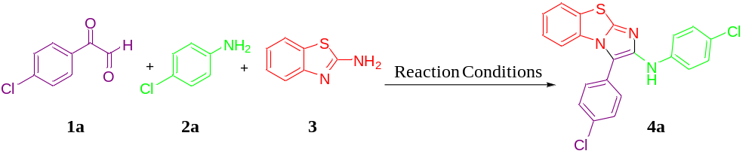
Entry | Solvent | Temp.ª | Yield (%)^{b}
1 | H₂O | r.t. | Trace
2 | CH₃CN | r.t. | Trace
3 | DMF | r.t. | Trace
4 | THF | r.t. | Trace
5 | Toluene | r.t. | Trace
6 | MeOH | r.t. | Trace
7 | EtOH | r.t. | Trace
8 | H₂O | reflux | 10
9 | CH₃CN | reflux | 20
10 | DMF | reflux | 35
11 | THF | reflux | 15
12 | Toluene | reflux | 45
13 | MeOH | reflux | 25
14 | EtOH | reflux | 86
ª Reaction conditions: solvent was 5 mL, reaction time was 5 h.
^{b} Isolated yield.

Table 2. Synthesis N,3-diphenylbenzo[d]imidazo[2,1-b]thiazol-2-amine 4a-h and 2,2'-oxybis(1-phenyl-2-(phenylamino)ethan-1-ones 5a-h
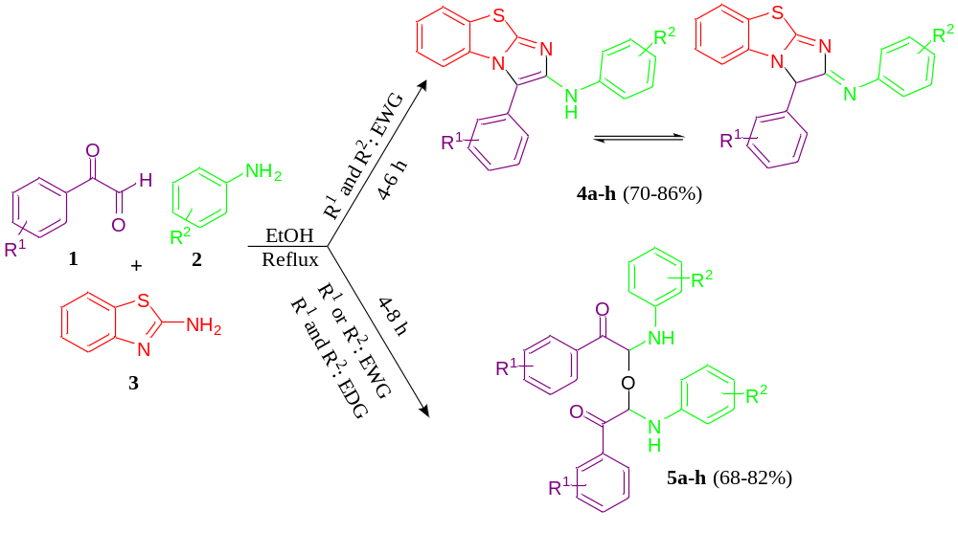

Compound | R¹ | R² | Product | Time (h) | Yield (%)ª
4a | 4-Cl | 4-Cl | 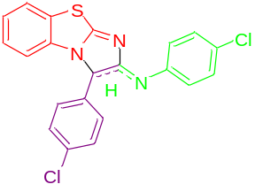 | 5 | 73
4b | 4-Br | 4-Cl | 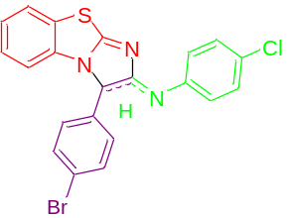 | 5 | 75
4c | 4-Cl | 4-Br | 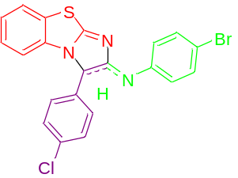 | 5 | 76
4d | 4-Br | 4-Br | 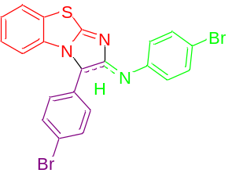 | 4 | 79
4e | 4-NO₂ | 4-Cl | 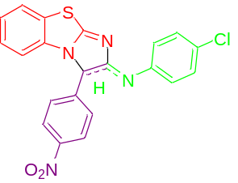 | 6 | 74
4f | 4-NO₂ | 4-Br | 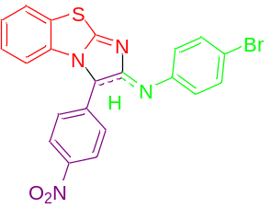 | 5 | 70

4g | 4-F | 4-Cl | 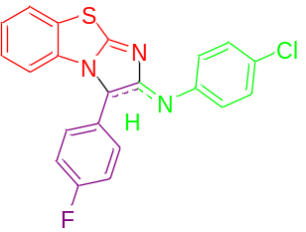 | 6 | 83
4h | 4-F | 4-Br | 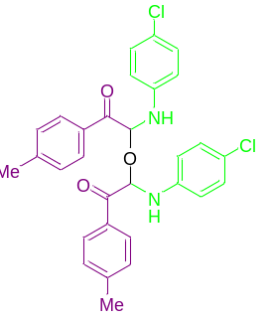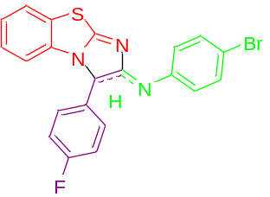 | 5 | 86
5a | 4-Me | 4-Cl | 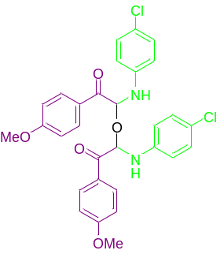 | 5 | 68
5b | 4-OMe | 4-Cl |  | 8 | 70
5c | H | 4-Cl | 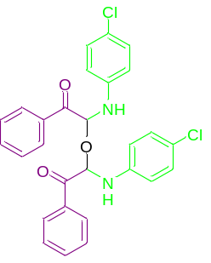 | 6 | 75

5d | H | 4-Br | 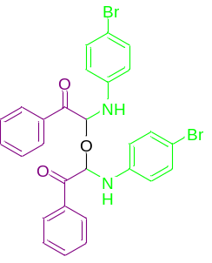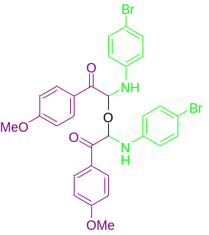 | 5 | 78
5e | 4-OMe | 4-Br |  | 7 | 69
5f | 4-Me | 4-Me | 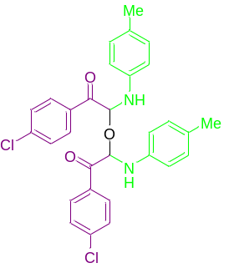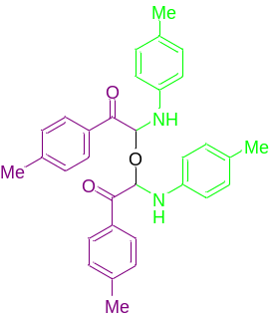 | 4 | 82
5g | 4-Cl | 4-Me | 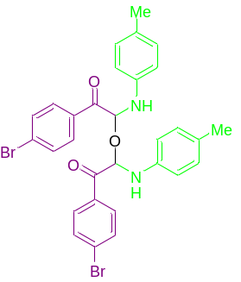 | 7 | 77
5h | 4-Br | 4-Me |  | 6 | 79

ª Isolated yield

