Supplemental Materials
Synthesis, Antimicrobial Evaluation, and Docking Studies of Substituted New Chromone linked 1,2,3-Triazoles
Amol S. Nipate^{a,b}, Chetan K. Jadhavª, Asha V Chateª, Vidya S. Dofeª, Prashant P. Dixit^{c}, Prachi Sharma^{d}, Charansingh. H. Gill*^{,a}
ªDepartment of Chemistry, Dr. Babasaheb Ambedkar Marathwada University, Aurangabad 431004, Maharashtra, India
^{b}Department of Chemistry, Shri Pundlik Maharaj Mahavidyalaya, Nandura Rly, Dist. Buldana-443404, MS, India
^{c}Department of Microbiology, Dr Babasaheb Ambedkar Marathwada University, Aurangabad Subcampus, Osmanabad. 413501, MS, India
^{d}Department of Chemistry, Birla Institute of technology and sciences, Pilani
E-mail: * chgill@gmail.com (C. H. Gill)
Table of contents
The spectroscopy of target compounds……….............................................1-30

General procedure for the synthesis (E)-3-(4-fluorophenyl)-1-(2-hydroxyphenyl)prop-2.en-1-one (2)
The synthesis (E)-3-(4-fluorophenyl)-1-(2-hydroxyphenyl)prop-2.en-1-one was prepared from using 2-Hydoxyacetophenones (0.01 mol) and 4-fluorobenzaldehyde (0.01 mol) were added to a solution of KOH (0.03 mol) in ethanol (15 mL) at 0–5 ⁰C. The reaction mixture was stirred 2–3 h at room temperature. Then the reaction mixture was quenched with crushed ice and neutralized carefully with 2 N HCl, and the obtained solid precipitate was filtered, washed with water, and dried. The crude product was crystallized with chloroform-ethanol to afford desired compound.
(E)-3-(4-fluorophenyl)-1-(2-hydroxyphenyl) prop-2-en-1-one (2)
Yellow solid, m.p. 96–98 ⁰C, yield: 68 %. IR (KBr, cm⁻¹): 3218 (OH), 2915 (CH), 1604 (C=O), 1562 (C=C). ¹H NMR (400 MHz, CDCl₃, dH ppm): 6.95 (ddd, 1H, J = 1.1, 7.2, 8.2 Hz, ArH), 7.03 (dd, 1H, J = 0.7, 8.4 Hz, ArH), 7.13 (t, 2H, J = 8.6 Hz, ArH), 7.51 (ddd, 1H, J = 1.8, 7.5, 7.7 Hz, ArH), 7.58 (d, 1H, J = 15.4 Hz, olefinic proton), 7.66 (dd, 2H, J = 5.3, 8.6 Hz, ArH), 7.89 (d, 1H, J = 15.4 Hz, olefinic proton), 7.92 (d, 1H, J = 1.8 Hz, ArH), 12.81 (s, 1H, OH). ¹³C NMR (100 MHz, CDCl₃, dC ppm): 116.1(CH), 116.3(CH), 118.6(CH), 118.8(CH), 119.7(C), 119.9(CH), 129.6(CH), 130.5(CH), 130.6(C), 130.8(CH), 136.4(CH), 144.1(CH), 163.6(C), 165.5(C), 193.5(C). LCMS Anal. For C₁₅H₁₁FO₂ (M + H) ⁺: Calculated 242.0743 Found: 243.1370
General procedure for the synthesis 2-(4-fluorophenyl)-3-hydroxy-4H-chromen-4-one (3)
To a mixture of (E)-3-(4-fluorophenyl)-1-(2-hydroxyphenyl)prop-2.en-1-one (0.010319 mol) sodium hydroxide (0.03095 mol) hydrogen peroxide (30%) in ethanol (10 mL) was stirred vigorously for 30 min and kept for 2-3 h ice cold condition. The progress of the reaction was monitored by TLC. After completion of reaction indicated by TLC, the reaction mixture was poured into ice cold water and acidified with 1 M HCl, and solid obtained was washed with water and crystallized from ethanol to afford pure product.
2-(4-Fluorophenyl)-3-hydroxy-4H-chromen-4-one (3)
Yellow solid, m. p. 152–154 ⁰C, yield: 74 %. IR (KBr, cm⁻¹): 3297 (OH), 2925 (CH), 1618 (C=O), 1572 (C=C). ¹ H NMR (400 MHz, CDCl₃, dH ppm): 7.11 (brs, 1H, OH), 7.22 (t, 2H, J = 8.6 Hz, Ar-H), 7.42 (ddd, 1H, J = 1.1, 7.5, 7.6 Hz, Ar-H), 7.58 (d, 1H, J = 8.4 Hz, Ar-H), 7.71 (ddd, 1H, J = 1.7, 7.1, 8.5 Hz, Ar-H), 8.24 (d, 1H, J = 1.8 Hz, Ar-H), 8.27–8.30 (m, 2H, Ar-H). ¹³C NMR (100 MHz, CDCl₃, d C ppm): 115.7(CH), 115.9(CH), 118.2(CH), 120.7(CH), 124.6(C), 125.5(C), 127.3(CH), 129.9(CH), 133.7(CH), 138.2(CH), 144.1(C), 155.3(C), 162.3(C), 164.8(C), 173.4(C). LCMS Anal. Calcd. For C₁₅H₉FO₃ (M+H) ⁺: Calculated 256.2286 Found: 257.1060
General procedure for the synthesis of compound 2-(4-fluorophenyl)-3-hydroxy-4H-chromen-4-one (4)
A mixture of substituted 2-(4-fluorophenyl)-3-hydroxy-4H-chromen-4-one (2) (0.00097568 mol, 0.25 gm) an propargyl bromide (3) (0.001365 mol, 0.1624 gm) (2) was dissolved in DMF (4 to 5 ml ) and to this solution K₂CO₃ (0.001951 mol, 0.269 gm ) was added. The reaction mixture was stirred at room temperature for 3-4 h. The progress of reaction was monitored by TLC. After completion of reaction the reaction mixture was poured on crushed ice and the precipitated solid was filtered, washed with water and crystallized from ethanol.
2-(4-Fluorophenyl)-3-(prop-2-ynyloxy)-4H-chromen-4-one (4)
Yellow solid, m. p. 106–108 ºC, yield: 74 %. IR (KBr, cm⁻¹): 3238(C-CH), 3069 (=CH), 2952 (–CH), 2108 (C-C), 1628 (C=O), 1600 (C=C). ¹H NMR (300 MHz, CDCl₃, dH ppm): 2.32 (t, 1H, J = 2.4 Hz, alkyne proton), 5.00 (d, 2H, J = 2.4 Hz, OCH₂), 7.16–7.26 (m, 2H, ArH), 7.42 (ddd, 1H, J = 1.2, 7.5, 7.6 Hz, ArH), 7.54 (dd, 1H, J = 1.2, 8.6 Hz, ArH), 7.70 (ddd, 1H, J = 1.8, 7.8, 7.8 Hz, ArH), 8.18 (dd, 2H, J = 5.4, 9.3 Hz, ArH), 8.26 (dd, 1H, J = 1.2, 8.0 Hz, ArH). ¹³C NMR (100 MHz, CDCl₃, dC ppm): 59.2(CH₂), 76.3(CH), 78.5(C), 115.5(CH), 115.7(CH), 118(CH), 124(CH), 124.9(C), 125.8(C), 127.1(CH), 131.3(CH), 133.7(CH), 138.4(CH), 155.2(C), 155.8(C), 162.8(C), 165.3(C), 174.8(C). HRMS Anal. For C₁₈H₁₁FO₃ (M+Na)⁺: Calculated 294.0692. Found: 316.9881
General procedure for the synthesis of phenyl azide derivatives (5a-q):
Aniline (0.5 g, 5.4 mmol) was charged into a 50 ml round -bottomed flask which was then placed into an ice water bath (0° -5°C). conc. HCl was added up to the formation of ppt & then by adding ethanol at 0 clear solution was form and stirred for 1 min. followed by the dropwise addition of a solution of NaNO₂ (3.87 mmol) in water (4.03 mL) over a period of 10 min with constant stirring. After stirring the reaction mixture for 1 h at 0 °C, a solution of NaN₃ (3.87mmol) in water (4.03 mL) was added to this mixture and allowed to stir at room temperature for 3 h. The progress of the reaction was monitored by TLC using ethyl acetate: hexane (1:9) as a solvent system. After completion of the reaction, the mixture was poured into water, extracted with ethyl acetate, dried over anhydrous sodium sulfate, and concentrated under vacuo to give azide, which was used further without purification.26
General procedure for synthesis of compounds (6a–q)
The title compounds was synthesized using mixture 2-(4-fluorophenyl)-3-(prop-2-ynyloxy)-4H-chromen-4-one (4a) (0.0006802 mol 0.2 gm) and freshly prepared substituted phenyl azide (5a-q) (0.0006802 mol 0.08 gm) were stirred in presence of CuSO₄.5H₂O (20 mol%) and sodium ascorbate (20 mol%) was dissolved in PEG-400. The reaction mixture was stirred for 6h at room temperature. The progress of the reaction was monitored by TLC. After stirring for 6h, the reaction mass was poured on crushed ice. The product obtained was filtered, washed with water, and crystallized from ethanol.
2-(4-fluorophenyl)-3-((1-phenyl-1H-1,2,3-triazol-4-yl)methoxy)-4H-chromen-4-one (6a)
Green Soild, m.p. 166 – 168 yield: 85 % IR (ATR µ max cm⁻¹) 1558.48 cm⁻¹ (N=N), 1465.90 cm⁻¹ (C=C), 2912.42cm⁻¹ C-H).
¹H NMR (400 MHz, CDCl₃) δ 8.32 (s, 1H, triazoyl-H), 8.12 (dd, J = 8.6, 5.4 Hz, 3H, Ar-H), 7.79 – 7.63 (m, 3H, Ar-H), 7.62 – 7.50 (m, 3H, Ar-H), 7.46 (t, J = 7.5 Hz, 2H, Ar-H), 7.18 (t, J = 8.6 Hz, 2H, Ar-H), 5.41 (s, 2H OCH₂). ¹³C NMR (101 MHz, CDCl₃) δ 175.05 (s, C=O), 165.25 (s, C), 155.28 (s, C), 133.69 (s, C), 131.09 (s, CH), 129.75 (s, CH), 128.81 (s, CH), 125.80 (s, CH), 124.94 (s, CH), 120.54 (s, CH), 118.05 (s, CH), 115.54 (s, CH), 65.08 (S, CH₂).
HRMS (ESI)+ Calculated for C₂₄H₁₆FN₃O₃ [M+H] +: Calculated 413.1176 and found 414.1234
2-(4-fluorophenyl)-3-((1-(2-methoxyphenyl)-1H-1,2,3-triazol-4-yl)methoxy)-4H-chromen-4-one (6b)
Green Soild, m.p. 158 – 160 yield: 82 %
¹H NMR (400 MHz, CDCl₃) δ 8.30 (s, 1H, triazoyl-H), 8.12 (dd, J = 20.4, 14.2 Hz, 3H, Ar-H), 7.71 (t, J = 8.5 Hz, 2H, Ar-H), 7.53 (d, J = 8.3 Hz, 1H, Ar-H), 7.42 (dd, J = 15.3, 7.6 Hz, 2H, Ar-H), 7.11 (dt, J = 14.7, 8.1 Hz, 4H, Ar-H), 5.46 (s, 2H, OCH₂), 3.77 (s, J = 38.0 Hz, 3H, OCH₃).
¹³C NMR (101 MHz, CDCl₃) δ 175.10 (s, C=O), 165.17 (s, C), 162.66 (s, C), 155.55 (s, C), 150.94 (s, C), 133.59 (s, C), 130.06 (s, CH), 127.21 (s, CH), 125.78 (s, CH), 124.83 (s, CH), 121.15 (s, CH), 118.01 (s, CH), 115.40 (s, CH), 112.19 (s, CH), 77.39 (s, CH), 64.91 (s, CH₂), 55.83 (s, OCH₃).
HRMS (ESI)⁺ Calculated for C₂₅H₁₈FN₃O₄[M⁺] ⁺: 443.1281 and found 444.1360
2-(4-fluorophenyl)-3-((1-(3-methoxyphenyl)-1H-1,2,3-triazol-4-yl)methoxy)-4H-chromen-4-one (6c)
Green Soild, m.p. 124 – 126 yield: 84 %
¹H NMR (400 MHz, CDCl₃) δ 8.31 (s, 1H, triazoyl-H), 8.18 – 8.07 (m, 3H, Ar-H), 7.73 (t, J = 7.7 Hz, 1H, Ar-H), 7.64 – 7.34 (m, 2H, Ar-H), 7.25 – 7.09 (m, 4H, Ar-H), 6.99 (d, J = 8.4 Hz, 1H, Ar-H), 5.40 (s, 2H, OCH₂), 3.85 (s, J = 42.8, Hz, 3H, OCH₃). ¹³C NMR (101 MHz, CDCl₃) δ 175.05 (s, C=O), 165.25 (s, C), 162.74 (s, C), 155.55 (s, C), 133.69 (s, C), 131.09 (d, CH), 130.50 (s, CH), 125.79 (s, CH), 124.94 (s, CH), 118.04 (s, CH), 115.76 (s, CH), 112.40 (s, CH), 106.25 (s, CH), 65.04 (s, CH₂), 55.63 (s, OCH₃).
HRMS (ESI)⁺ Calculated for C₂₅H₁₈FN₃O₄[M⁺] ⁺: 443.1281 and found 444.1360
2-(4-fluorophenyl)-3-((1-(4-methoxyphenyl)-1H-1,2,3-triazol-4-yl)methoxy)-4H-chromen-4-one (6d).
Yellow Soild, m.p. 190 – 192 yield: 80 %
¹H NMR (400 MHz, CDCl₃) δ 8.30 (s, 1H, triazoyl-H), 8.11 (s, 2H, Ar-H), 7.72 (s, 1H, Ar-H), 7.61 – 7.37 (m, 4H, Ar-H), 7.23 (d, J = 45.2 Hz, 2H, Ar-H), 7.00 (d, 2H, Ar-H), 5.38 (s, 2H, OCH₂), 3.82 (s, 3H, OCH₃).
3-((1-(2-chlorophenyl)-1H-1,2,3-triazol-4-yl)methoxy)-2-(4-fluorophenyl)-4H-chromen-4-one (6e)
Yellow Soild, m.p. 144 – 146 yield: 83 %
¹H NMR (400 MHz, CDCl₃) δ 8.28 (s, 1H, triazoyl-H), 8.15 (d, J = 5.8 Hz, 2H), 8.08 (s, 1H, Ar-H), 7.70 (t, J = 7.3 Hz, 1H, Ar-H), 7.54 (d, J = 6.7 Hz, 3H, Ar-H), 7.44 (d, J = 5.5 Hz, 3H, Ar-H), 7.17 (t, J = 8.1 Hz, 2H, Ar-H), 5.48 (s, 2H, OCH₂).
3-((1-(3-chlorophenyl)-1H-1,2,3-triazol-4-yl)methoxy)-2-(4-fluorophenyl)-4H-chromen-4-one (6f)
Yellow Soild, m.p. 134 – 136 yield: 77 %
HRMS (ESI)⁺ Calculated for C₂₄H₁₅ClFN₃O₃[M+H] ⁺: 447.0786 and found 448.0868
¹H NMR (400 MHz, CDCl₃) δ 8.31 (s, 1H, triazoyl-H), 8.12 (dd, J = 9.6 Hz, 3H, Ar-H), 7.78 – 7.70 (m, 2H, Ar-H), 7.58 (dd, J = 13.0 Hz, 2H, Ar-H), 7.52 – 7.40 (m, 3H, Ar-H), 7.29 (s, 1H, Ar-H), 7.23 – 7.12 (m, 2H, Ar-H), 5.41 (s, 2H, OCH₂).
3-((1-(4-chlorophenyl)-1H-1,2,3-triazol-4-yl)methoxy)-2-(4-fluorophenyl)-4H-chromen-4-one (6g)
Green Soild, m.p. 208 – 210 yield: 72 %
¹H NMR (400 MHz, CDCl₃) δ 8.31 (s, 1H, triazoyl-H), 8.13 (s, 3H, Ar-H), 7.73 (s, 1H, Ar-H), 7.65 (d, J = 6.3 Hz, 2H Ar-H), 7.52 (t, J = 21.4 Hz, 4H Ar-H), 7.19 (s, 2H, Ar-H), 5.39 (s, 2H, OCH₂).
3-((1-(4-chlorophenyl)-1H-1,2,3-triazol-4-yl)methoxy)-2-(4-fluorophenyl)-4H-chromen-4-one (6h)
Green Soild, m.p. 152 – 154 yield: 89 %
¹H NMR (400 MHz, CDCl₃) δ 8.30 (s, 1H, triazoyl-H), 8.12 (d, 3H, Ar-H), 7.89 (s, 1H, Ar-H), 7.71 (s, 1H, Ar-H), 7.58 – 7.49 (m, 1H, Ar-H), 7.47 – 7.24 (m, 4H, Ar-H), 7.15 (s, 2H, Ar-H), 5.43 (s, 2H, OCH₂).
HRMS (ESI)⁺ Calculated for C₂₅H₁₅F₂N₃O₃ [M+H] ⁺: 431.1099 and found 432.1154
2-(4-fluorophenyl)-3-((1-(4-fluorophenyl)-1H-1,2,3-triazol-4-yl)methoxy)-4H-chromen-4-one (6i)
Green Soild, m.p. 186 – 188 yield: 83 %
¹H NMR (400 MHz, CDCl₃) δ 8.30 (s, 1H, triazoyl-H), 8.11 (s, 2H, Ar-H), 7.62 (d, J = 35.9 Hz, 3H, Ar-H), 7.45 (s, 2H, Ar-H), 7.22 (s, 4H, Ar-H), 5.38 (s, 2H, OCH₂).
3-((1-(4-ethylphenyl)-1H-1,2,3-triazol-4-yl)methoxy)-2-(4-fluorophenyl)-4H-chromen-4-one
(6j)
Green Soild, m.p. 128 – 130 yield: 81 %
2-(4-fluorophenyl)-3-((1-(o-tolyl)-1H-1,2,3-triazol-4-yl)methoxy)-4H-chromen-4-one (6k)
Green Soild, m.p. 138 – 140 yield: 78 %
¹H NMR (400 MHz, CDCl₃) δ 8.27 (s, 1H, triazoyl-H), 8.17 (s, 2H, Ar-H), 7.90 (s, 1H, Ar-H), 7.71 (s, 1H, Ar-H), 7.55 (s, 1H, Ar-H), 7.42 (d, J = 7.6 Hz, 2H, Ar-H), 7.34 (s, 2H, Ar-H), 7.21 (d, J = 24.7 Hz, 3H, Ar-H), 5.44 (s, 2H,OCH₂), 2.11 (s, 3H, OCH₃).
2-(4-fluorophenyl)-3-((1-(m-tolyl)-1H-1,2,3-triazol-4-yl)methoxy)-4H-chromen-4-one (6l)
Green Soild, m.p. 126 – 128 yield: 80 %
¹H NMR (400 MHz, CDCl₃) δ 8.31 (d, 1H, triazoyl-H), 8.10 (s, 3H), 7.72 (s, 1H), 7.51 (dd, J = 31.2, 12.6 Hz, 4H), 7.22 (d, J = 39.3 Hz, 3H), 5.40 (s, 2H), 2.34(s, 3H, CH₃). ¹³C NMR (101 MHz, CDCl₃) δ 175.06 (s, C=O), 165.24 (s, C), 162.72 (s, C), 155.27 (s, C), 139.34 (s, C), 136.82 (s, C), 133.69 (s, C), 131.10 (d, J = 8.7 Hz, CH), 125.78 (s, CH), 124.93 (s, CH), 121.18 (s, CH), 118.04 (s, CH), 115.74 (s, CH), 65.08 (s, CH₂), 21.38 (s, CH₃).
2-(4-fluorophenyl)-3-((1-(p-tolyl)-1H-1,2,3-triazol-4-yl)methoxy)-4H-chromen-4-one (6m)
Brown Soild, m.p. 182 – 184 yield: 86 %
¹H NMR (400 MHz, CDCl₃) δ 8.31 (s, 1H, triazoyl-H), 8.10 (dd, J = 14.9, 9.2 Hz, 3H, Ar-H), 7.55 (d, J = 8.1 Hz, 3H, Ar-H), 7.45 (dd, J = 7.3 Hz, 2H, Ar-H), 7.29 (s, 2H, Ar-H), 7.17 (s, J = 8.3 Hz, 2H, Ar-H), 5.39 (s, 2H, OCH₂), 2.44 (s, 3H, CH₃). ¹³C NMR (101 MHz, CDCl3) δ 175.05 (s, C=O), 165.23 (s, C), 162.72 (s, C), 155.26 (s, C), 138.94 (s, C), 134.63 (s, C), 131.09 (d, J = 8.7 Hz, CH), 130.22 (s, CH), 125.78 (s, CH), 124.92 (s, CH), 120.43 (s, CH), 118.04 (s, CH), 115.74 (s, CH), 65.09 (s, CH₂), 21.09 (s, CH₃).
HRMS (ESI)+ Calculated for: C₂₅H₁₈FN₃O₃ [M+] ⁺: 427.1326 and found 428.1358
3-((1-(4-bromophenyl)-1H-1,2,3-triazol-4-yl)methoxy)-2-(4-fluorophenyl)-4H-chromen-4-one (6n)
Brown Soild, m.p. 198 – 200 yield: 82 %
¹H NMR (400 MHz, CDCl₃) δ 8.31 (s, 1H, triazoyl-H), 8.12 (dd, J = 8.2, 5.4 Hz, 3H, Ar-H), 7.78 – 7.63 (m, 3H, Ar-H), 7.21 (d, J = 20.0 Hz, 2H, Ar-H), 5.38 (s, 2H, OCH₂). ¹³C NMR (101 MHz, CDCl₃) δ 175.03 (s, C=O), 155.28 (s, C), 135.87 (s, C), 132.91 (s, C), 131.08 (d, J = 8.8 Hz, CH), 125.78 (s, CH), 124.97 (s, CH), 122.19 (d, J = 60.9 Hz, CH), 118.06 (s, CH), 115.79 (s, CH), 65.05 (s, CH₂).
HRMS (ESI)+ Calculated for C₂₄H₁₅BrFN₃O₃ [M+H] +: 491.0281 and found 493.0494
2-(4-fluorophenyl)-3-((1-(2-nitrophenyl)-1H-1,2,3-triazol-4-yl)methoxy)-4H-chromen-4-one (6o)
Green Soild, m.p. 126 – 128 yield: 83 %
¹H NMR (400 MHz, CDCl₃) δ 8.27 (s, 1H, triazoyl-H), 8.15 (dd, J = 8.4, 5.5 Hz, 2H, Ar-H), 8.06 (d, J = 8.0 Hz, 1H, Ar-H), 7.79 (t, J = 7.4 Hz, 1H, Ar-H), 7.71 (dd, J = 12.5, 7.1 Hz, 2H, Ar-H), 7.59 – 7.52 (m, 2H, Ar-H), 7.43 (t, J = 7.4 Hz, 1H, Ar-H), 7.19 (t, J = 8.5 Hz, 2H, Ar-H), 5.44 (s, 2H, OCH₂).
2-(4-fluorophenyl)-3-((1-(3-nitrophenyl)-1H-1,2,3-triazol-4-yl)methoxy)-4H-chromen-4-one (6p)
Green Soild, m.p. 182 – 184 yield: 79 %
¹H NMR (400 MHz, CDCl₃) δ 8.58 (s, 1H, triazoyl-H), 8.43 – 8.25 (m, 3H, Ar-H), 8.17 – 8.10 (m, 2H, Ar-H), 7.83 – 7.67 (m, 2H, Ar-H), 7.56 (d, J = 8.3 Hz, 1H, Ar-H), 7.46 (t, J = 7.1 Hz, 1H, Ar-H), 7.30 – 7.11 (m, 2H, Ar-H), 5.40 (s, 2H, OCH₂).
3-((1-(2,4-dichlorophenyl)-1H-1,2,3-triazol-4-yl)methoxy)-2-(4-fluorophenyl)-4H-chromen-4-one (6q)
Green Soild, m.p. 140 – 142 yield: 84 %
Compound 2 LCMS
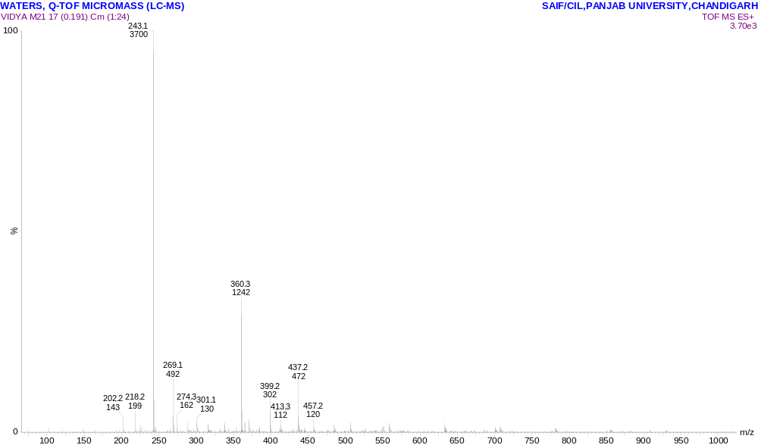
Compound 2 ¹H NMR, 400 MHz, CDCl₃
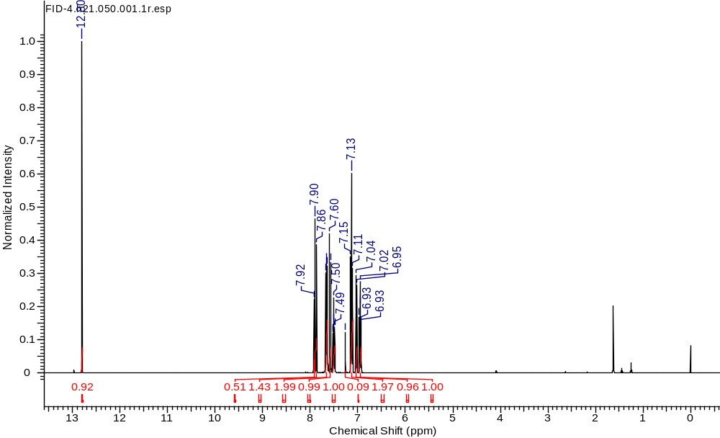

Compound 2 ¹³C NMR, 100 MHz, CDCl₃
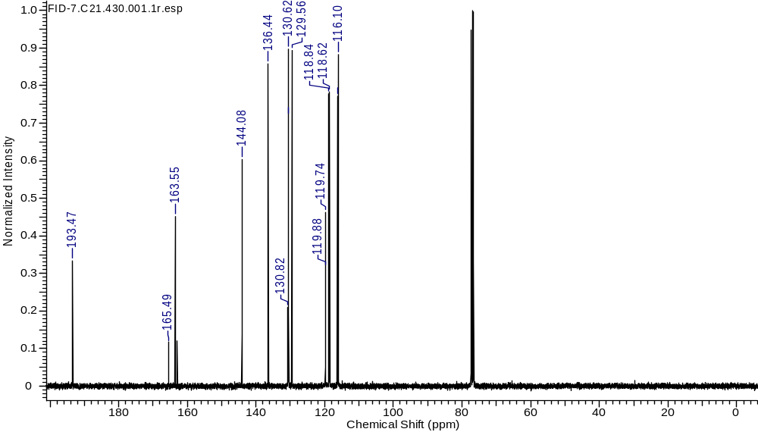
Compound 3 LCMS
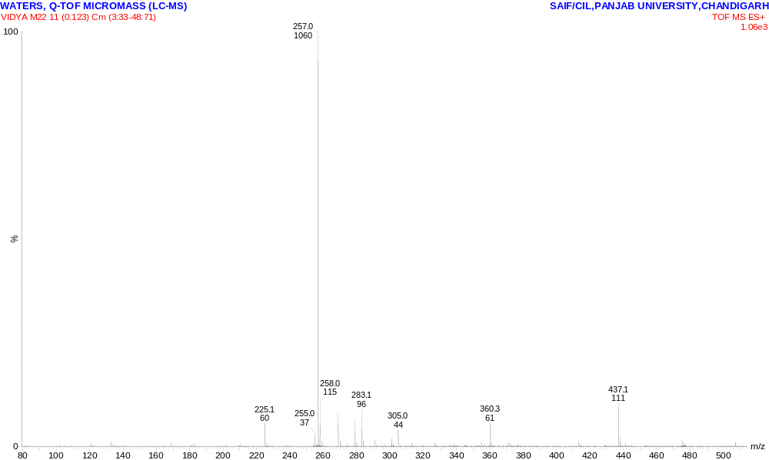

Compound 3 ¹H NMR, 400 MHz, CDCl₃
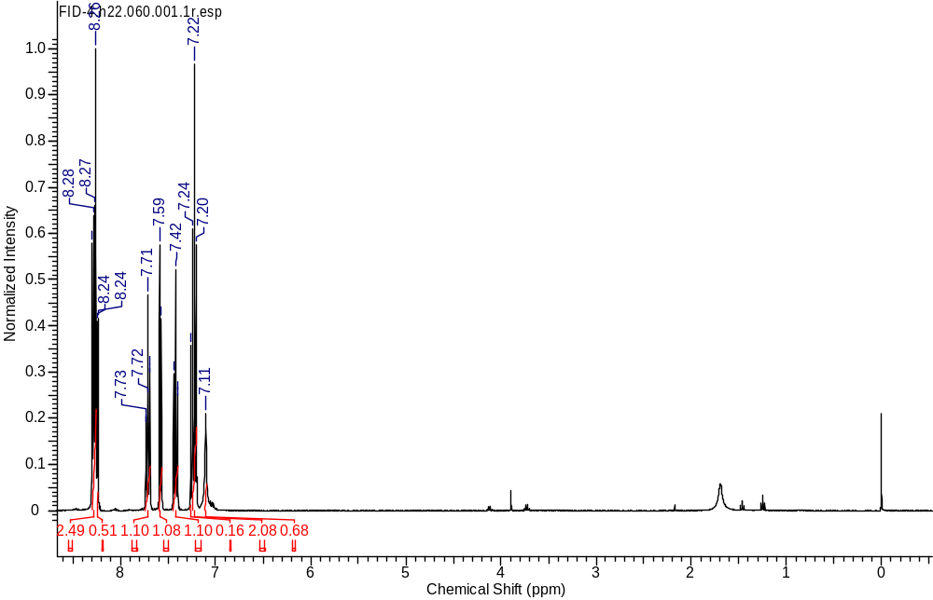
Compound 3 ¹³C NMR, 100 MHz, CDCl3

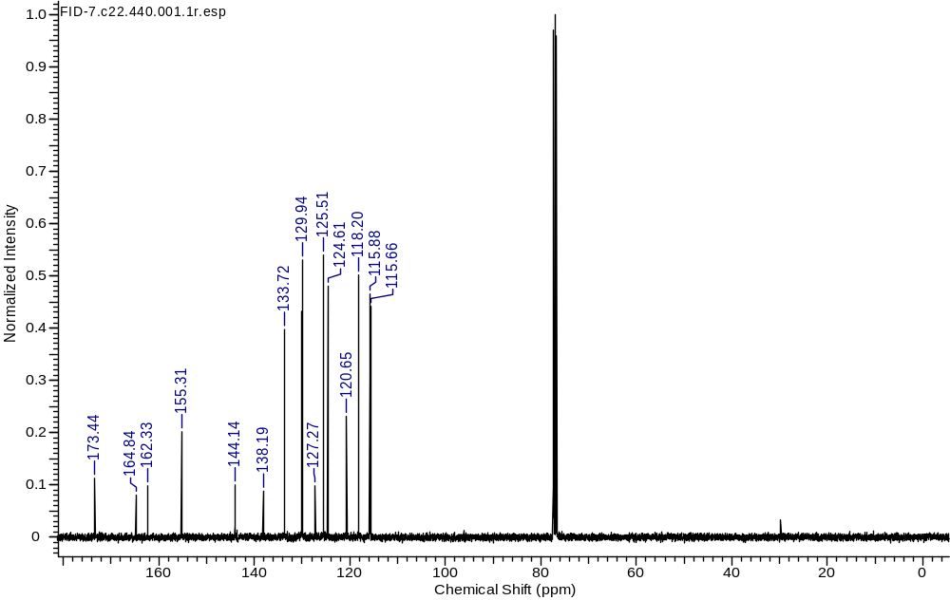
Compound 4 HRMS
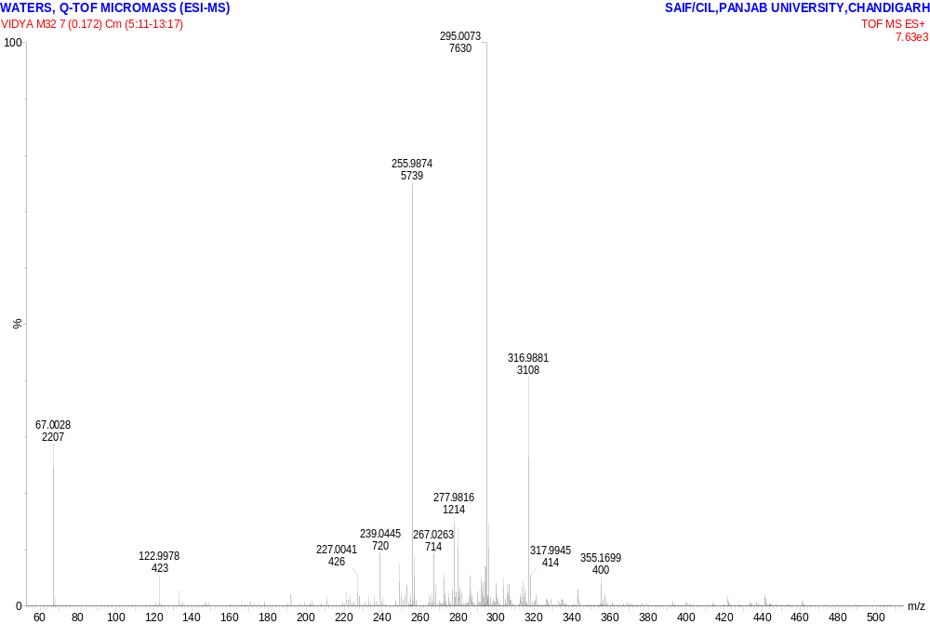
Compound 4 ¹HNMR 400 MHz, CDCl₃
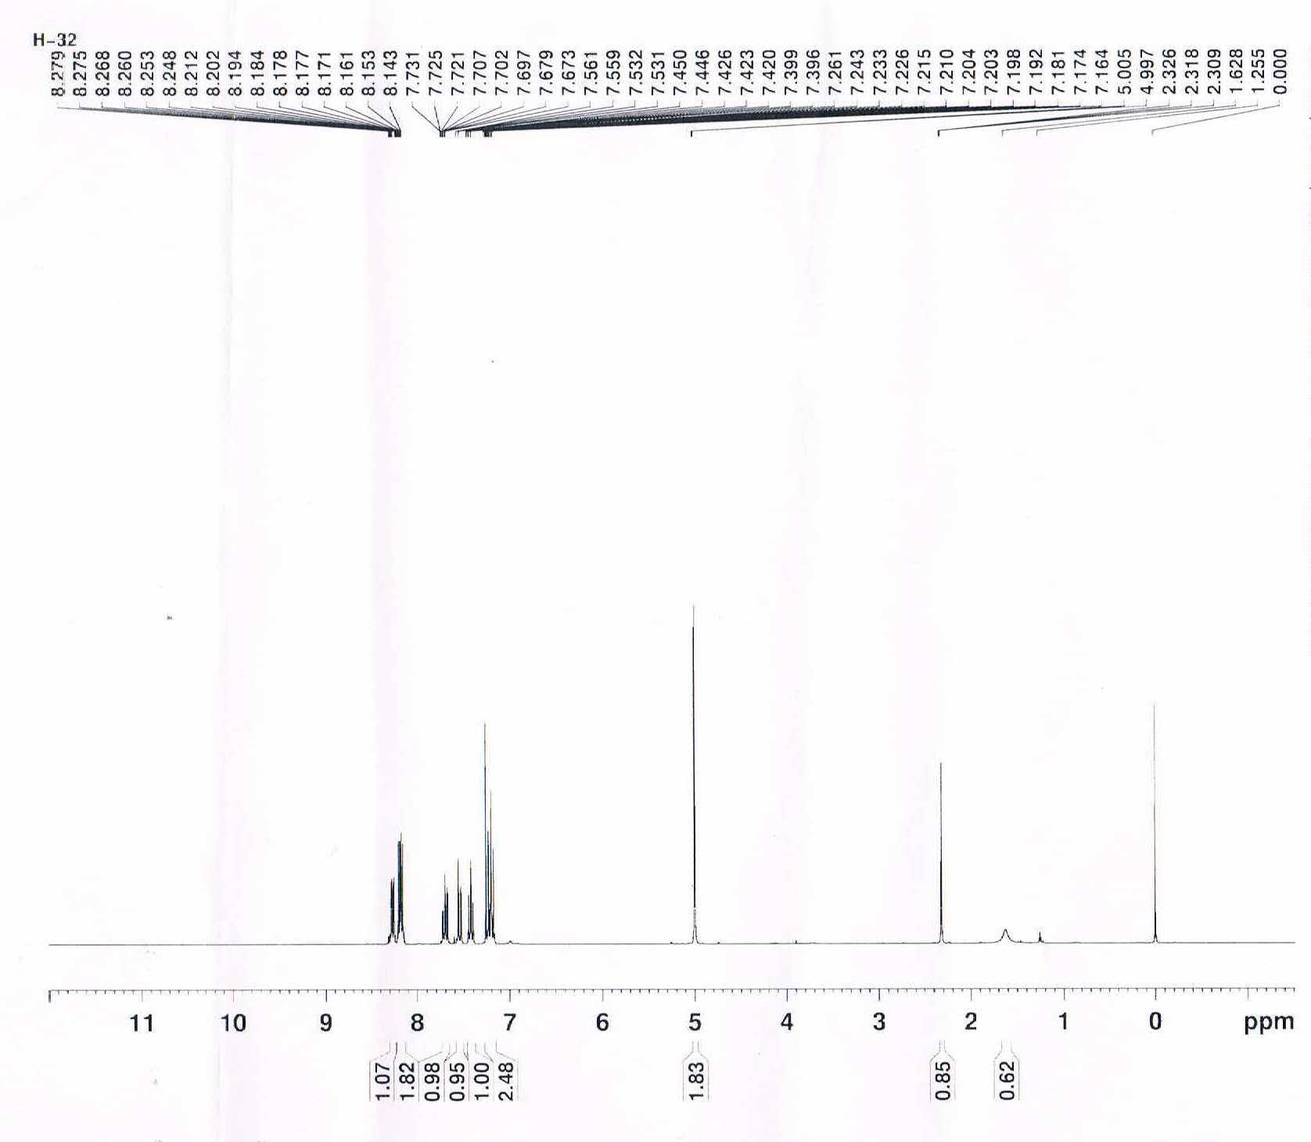
Compound 4 ¹³C NMR, 100 MHz, CDCl₃
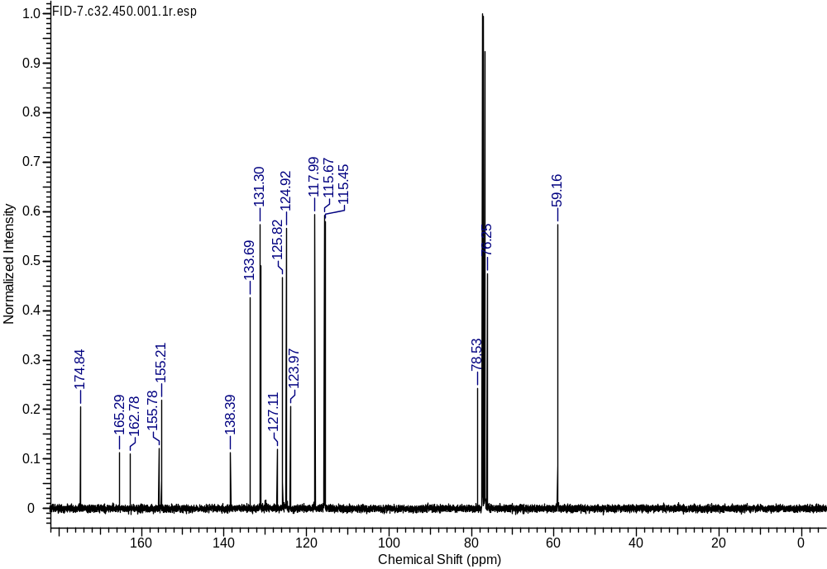

Compound 6a HRMS
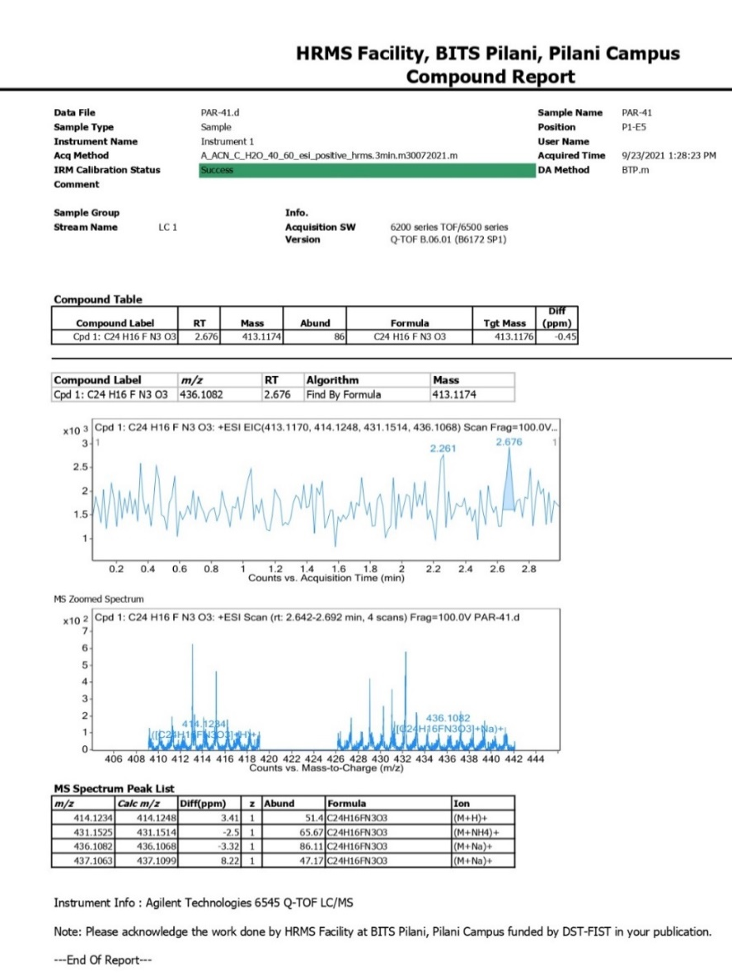
IR spectra of Compound (6a)
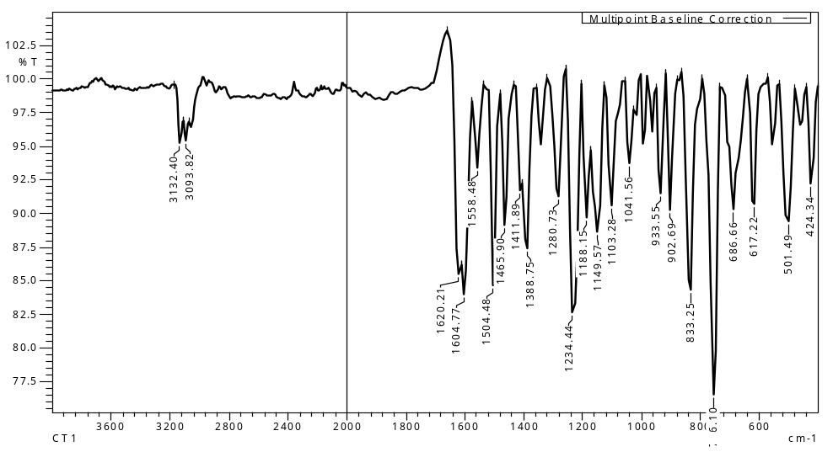
Compound 6a ¹HNMR 400 MHz, CDCl₃
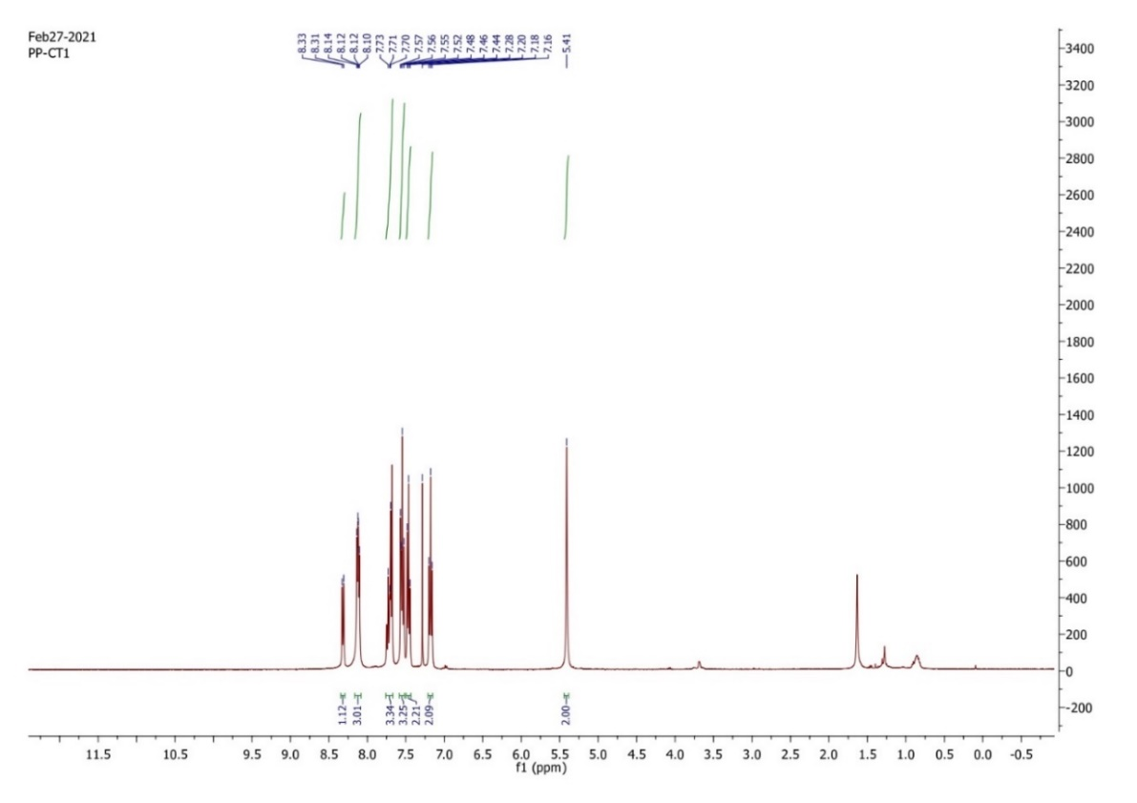
Compound 6a ¹³C NMR, 100 MHz, CDCl₃
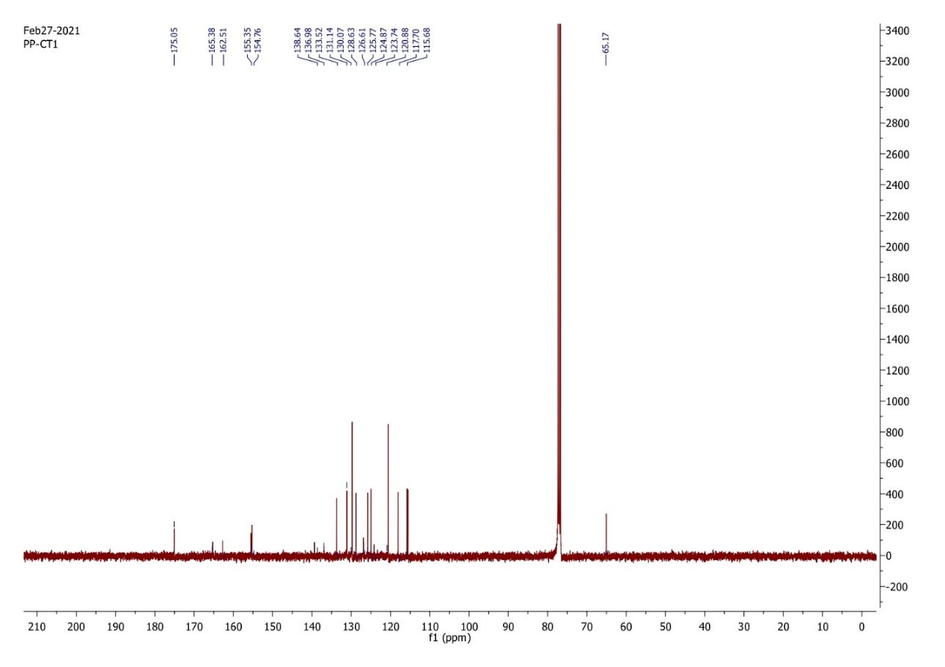
Compound 6b HRMS
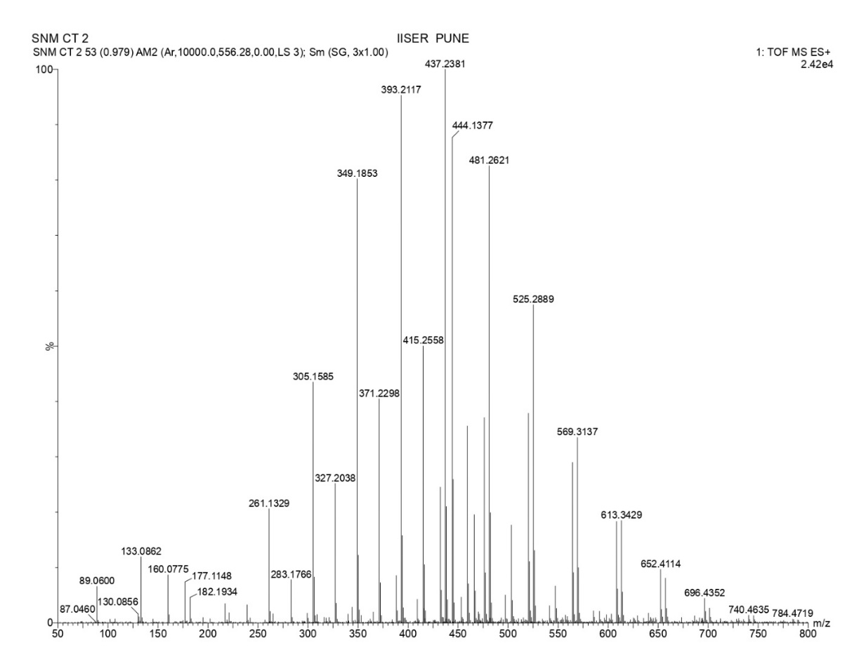

Compound 6b ¹HNMR 400 MHz, CDCl₃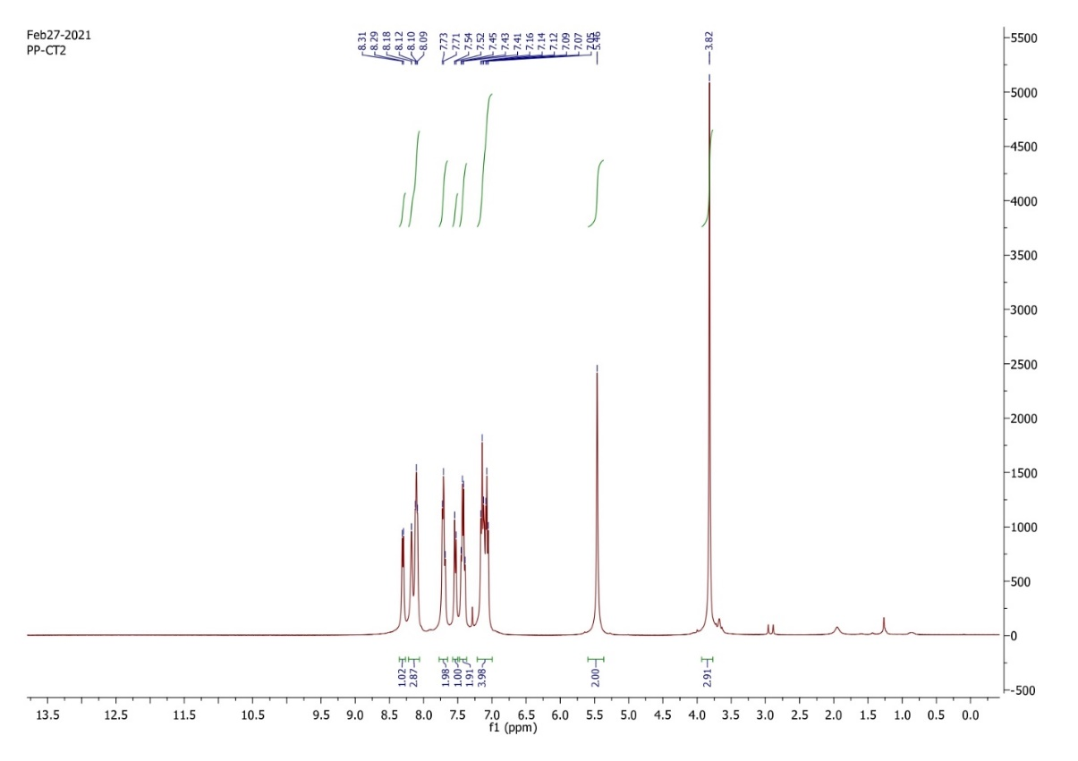
Compound 6b ¹³C NMR, 100 MHz, CDCl₃
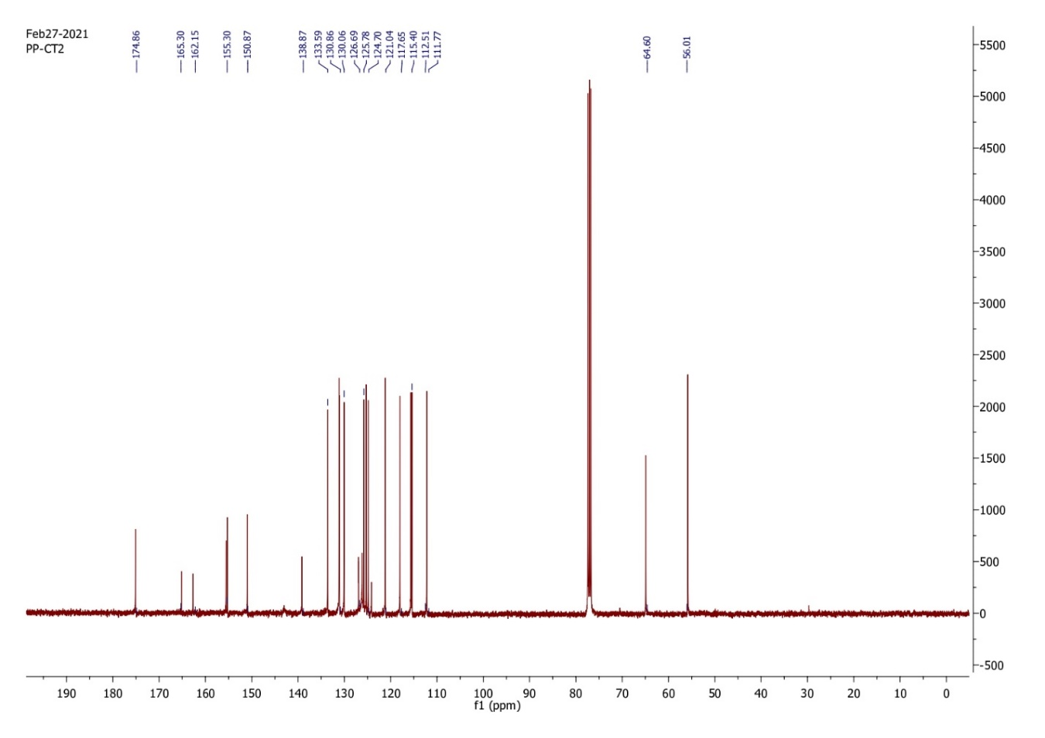
Compound 6C HRMS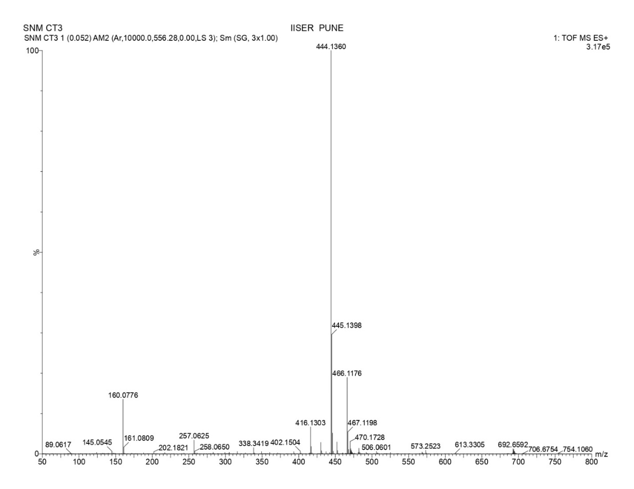
Compound 6c ¹HNMR 400 MHz, CDCl₃
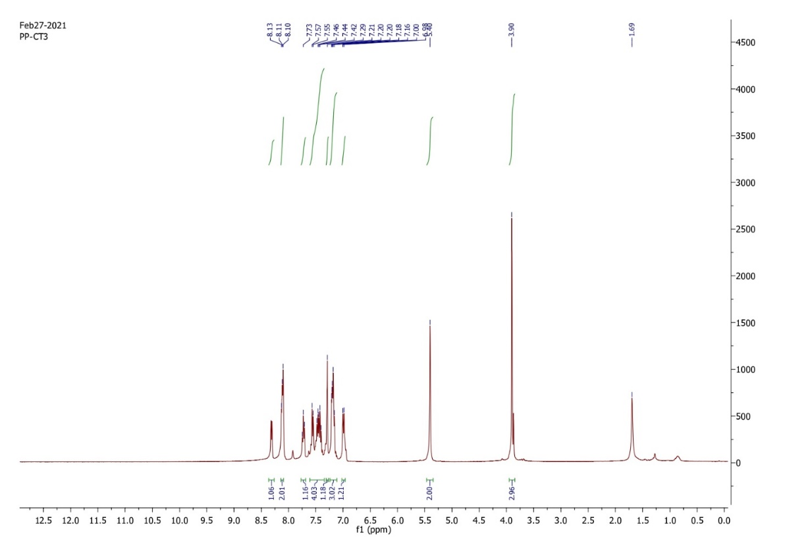
Compound 6c ¹³C NMR, 100 MHz, CDCl₃
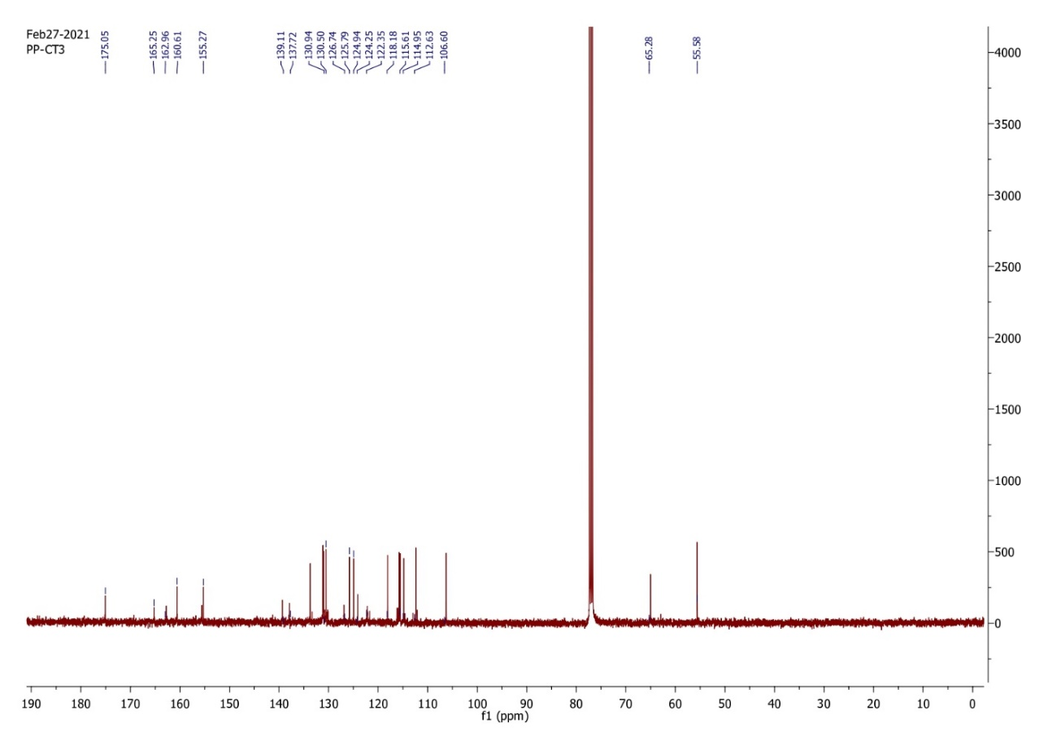
Compound 6d ¹HNMR 400 MHz, CDCl₃
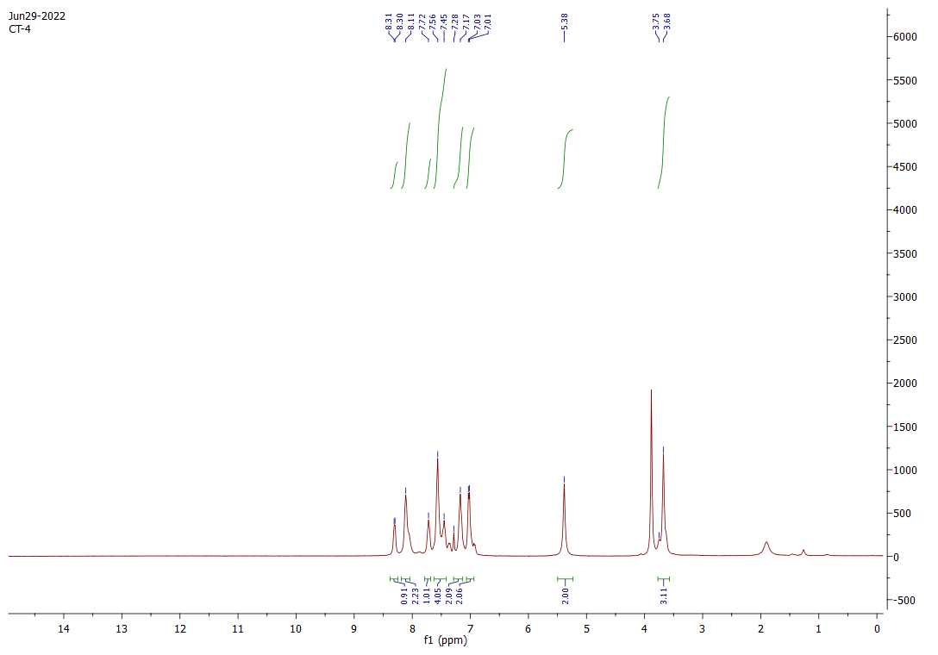

Compound 6e ¹HNMR 400 MHz, CDCl₃
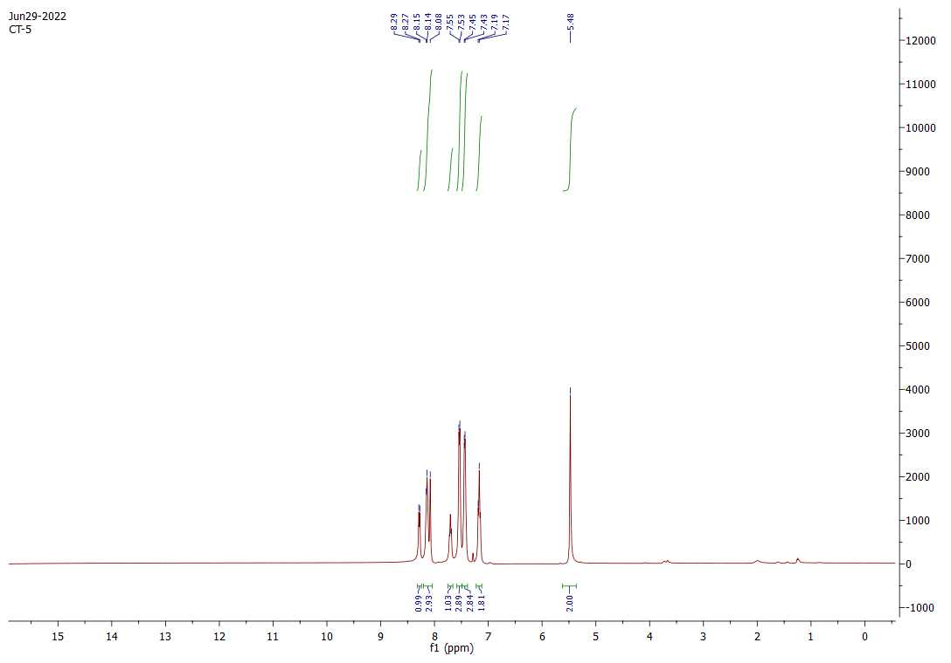
Compound 6f HRMS
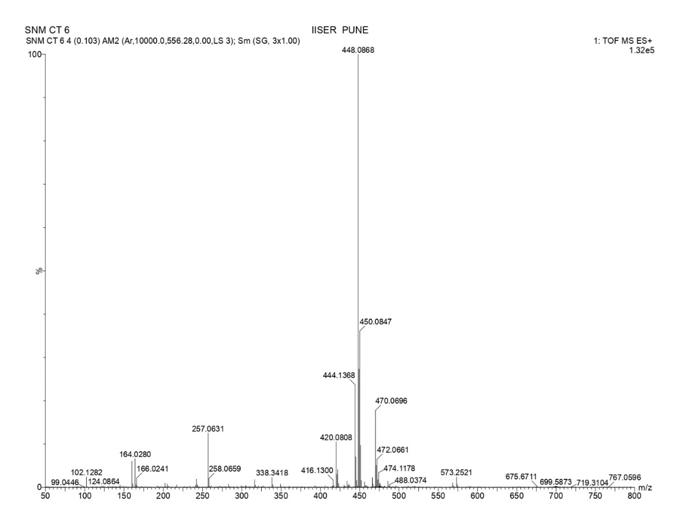
Compound 6f ¹HNMR 400 MHz, CDCl₃

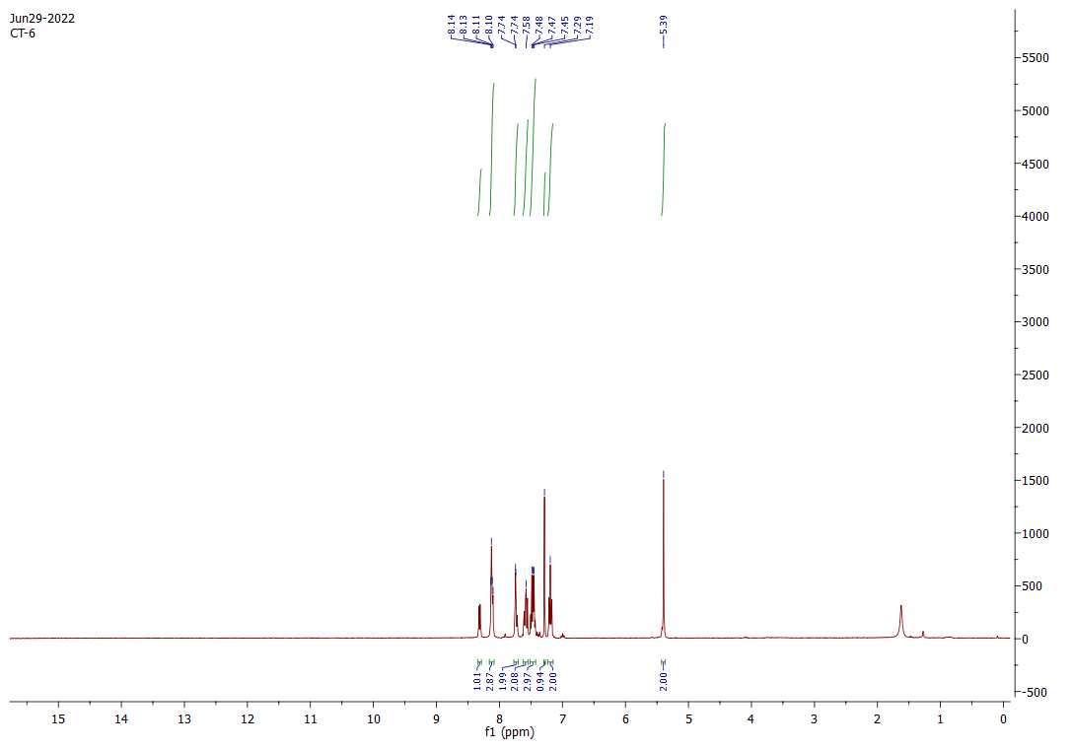
Compound 6g ¹HNMR 400 MHz, CDCl₃
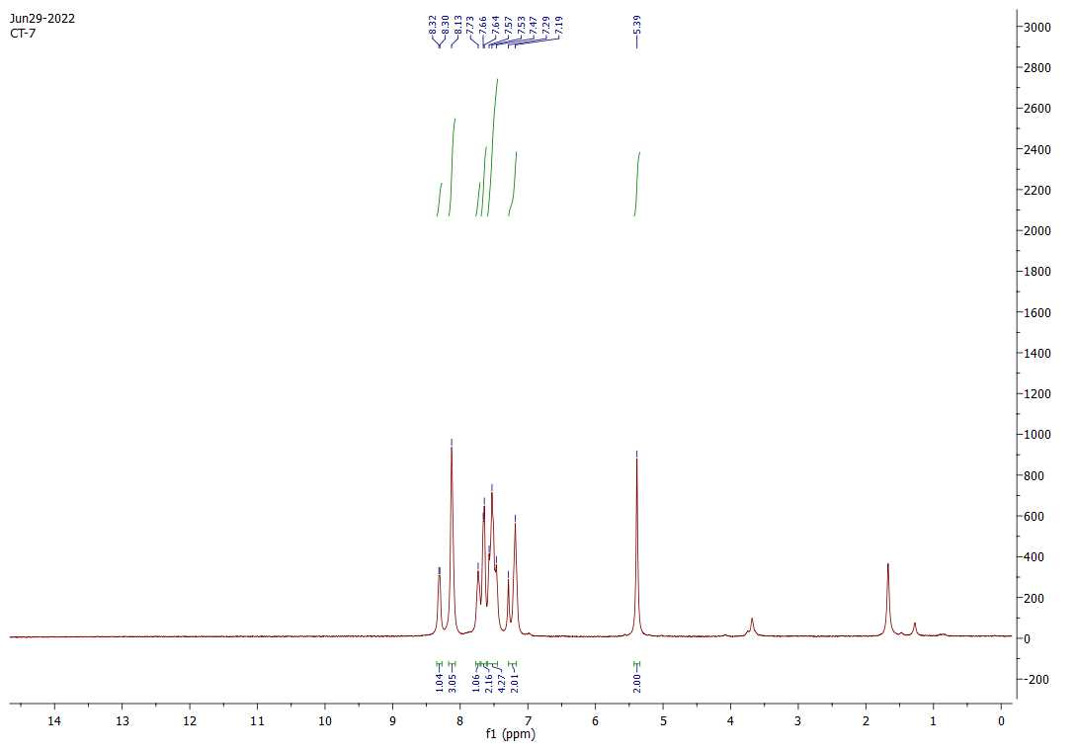
Compound 6h HRMS
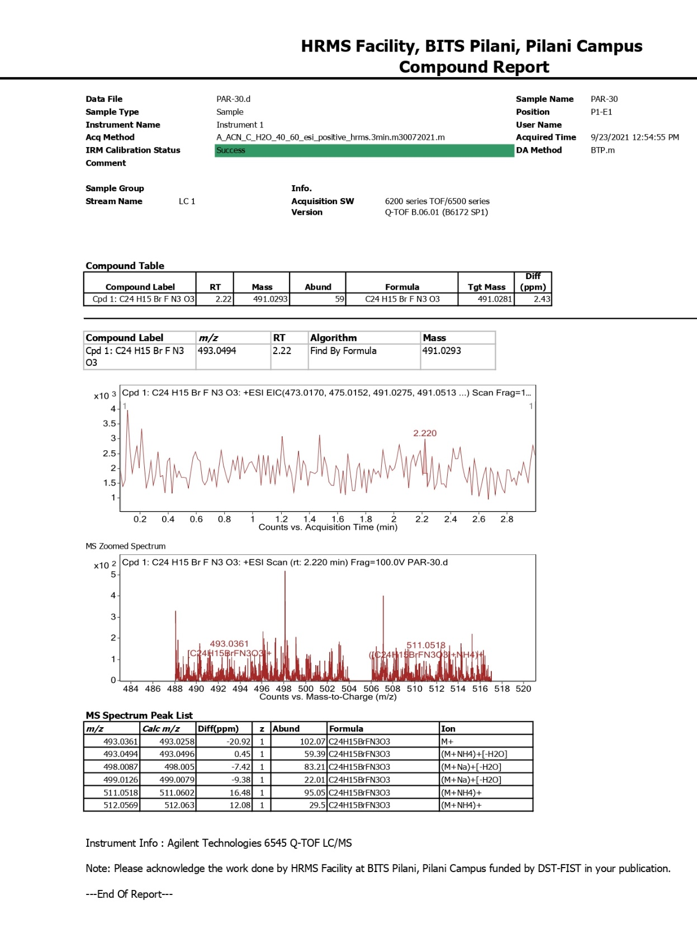

Compound 6h ¹HNMR 400 MHz, CDCl₃
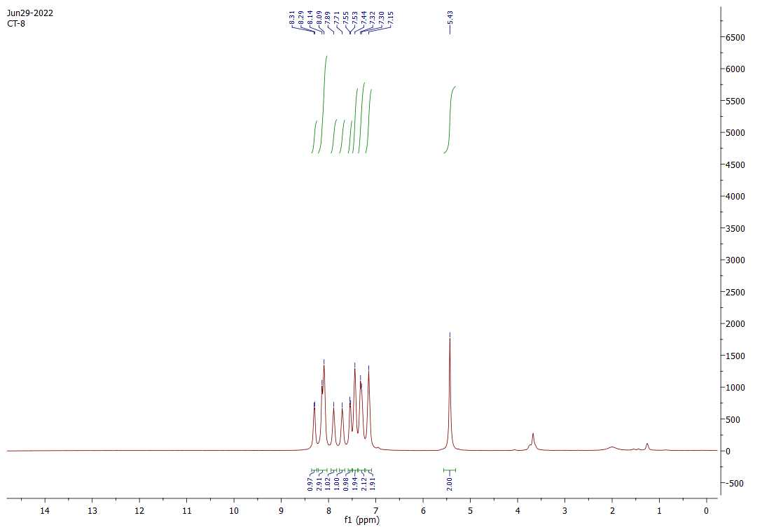
Compound 6i ¹HNMR 400 MHz, CDCl₃
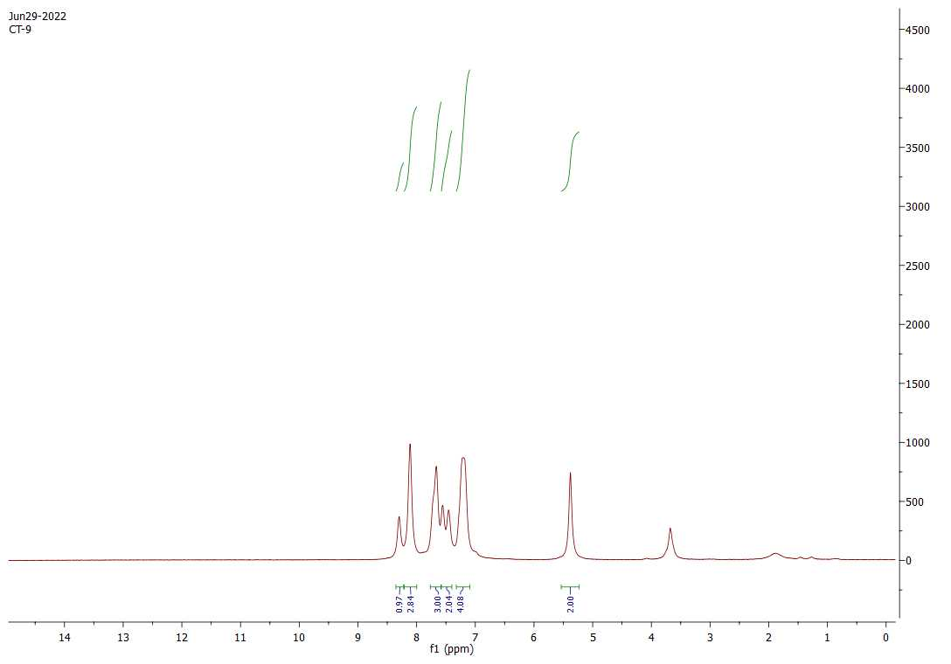

Compound 6k ¹HNMR 400 MHz, CDCl₃
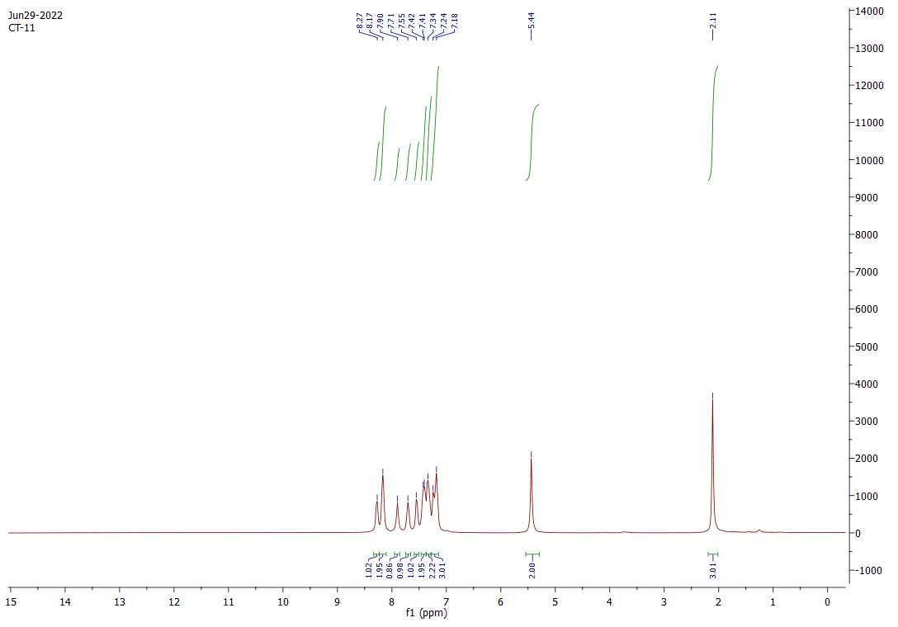
Compound 6l ¹HNMR 400 MHz, CDCl₃
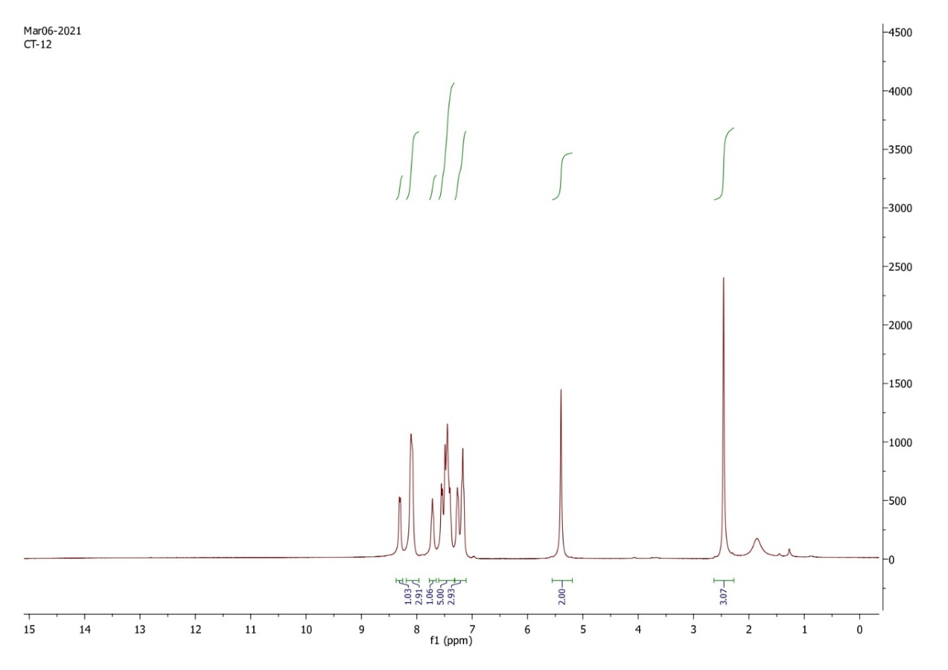
Compound 6l ¹³C NMR, 100 MHz, CDCl₃
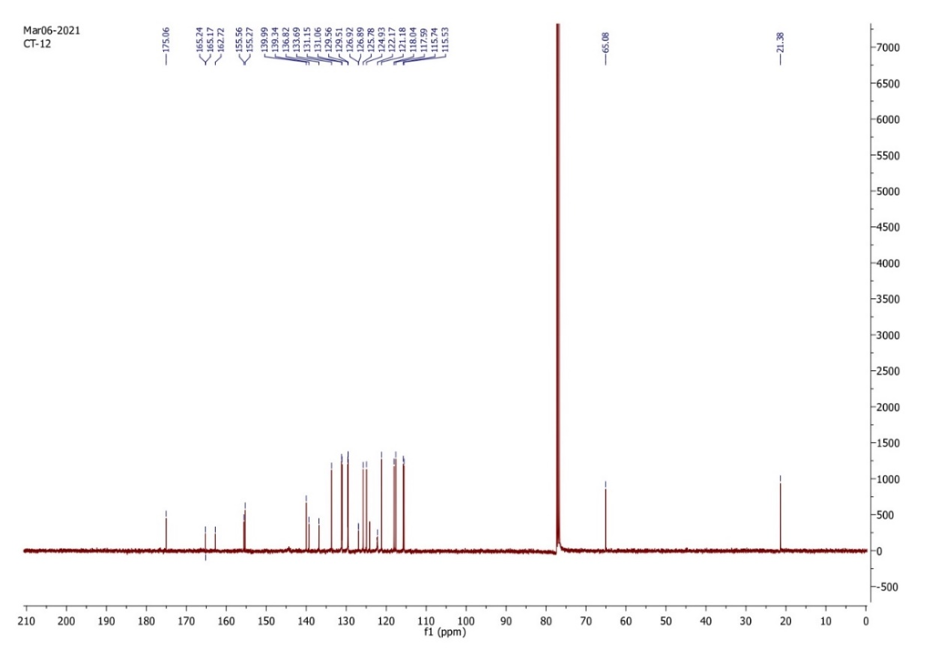

Compound 6m HRMS
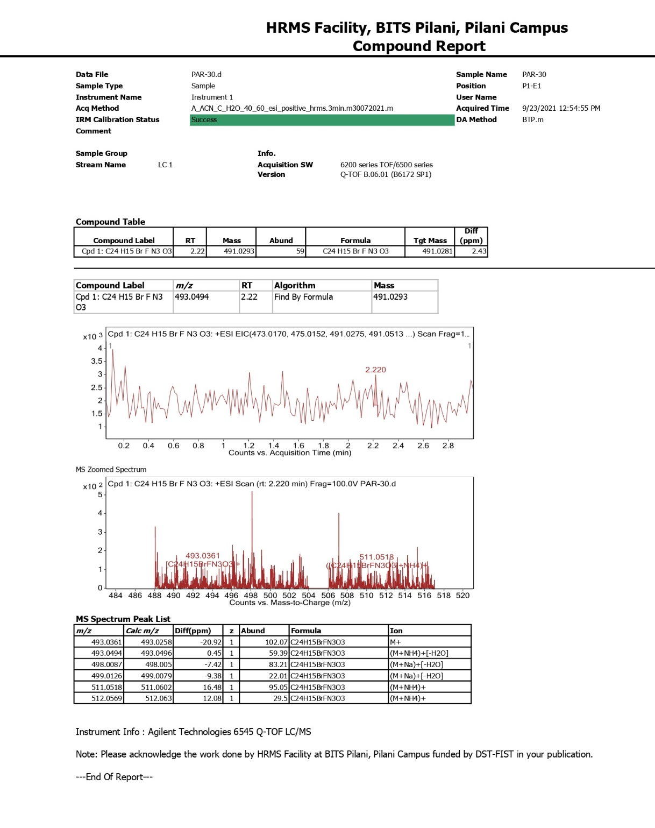

Compound 6m ¹HNMR 400 MHz, CDCl₃
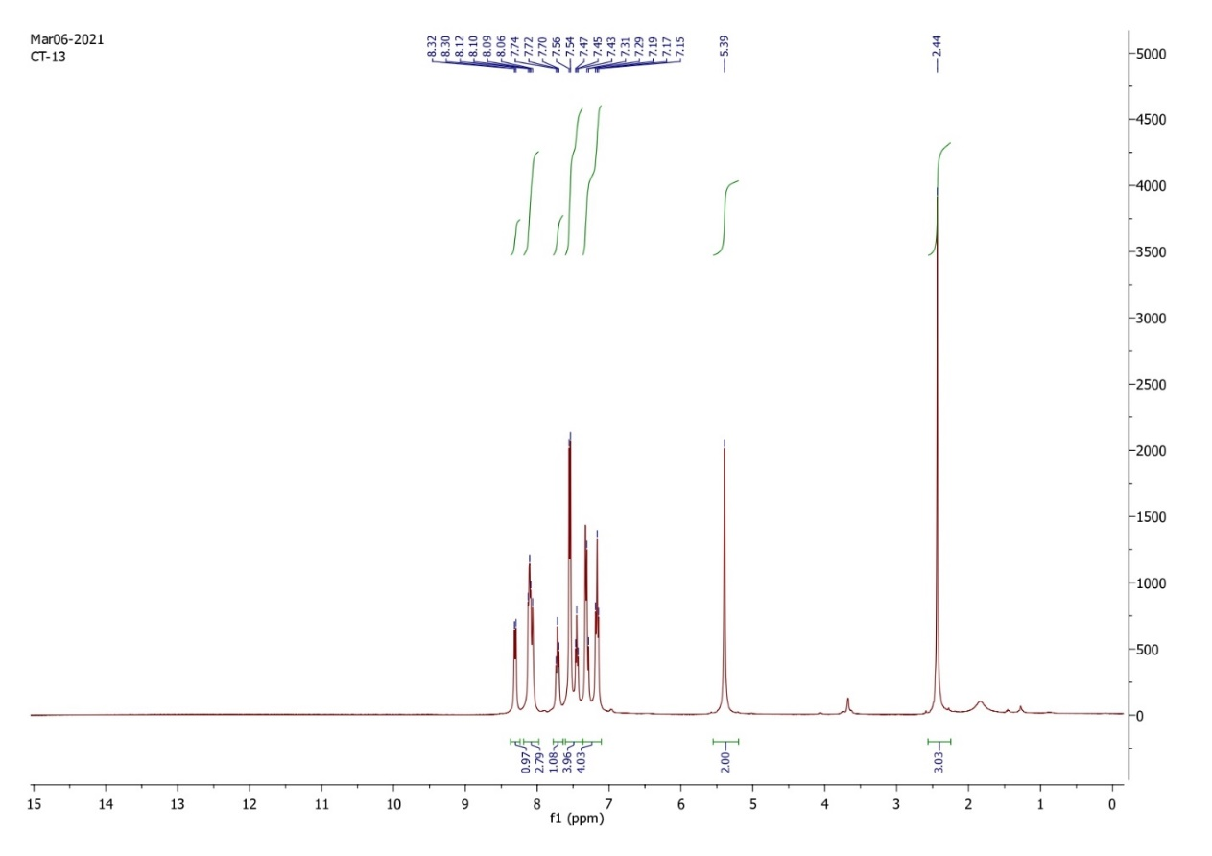
Compound 6m ¹³C NMR, 100 MHz, CDCl₃
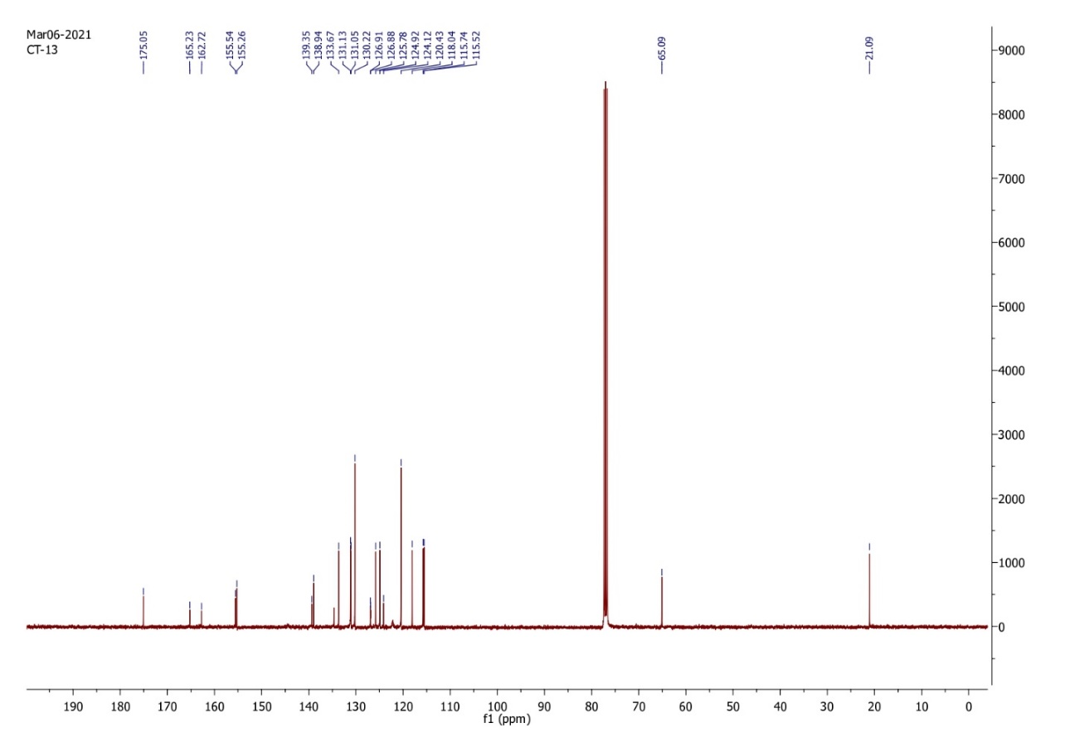
Compound 6n HRMS
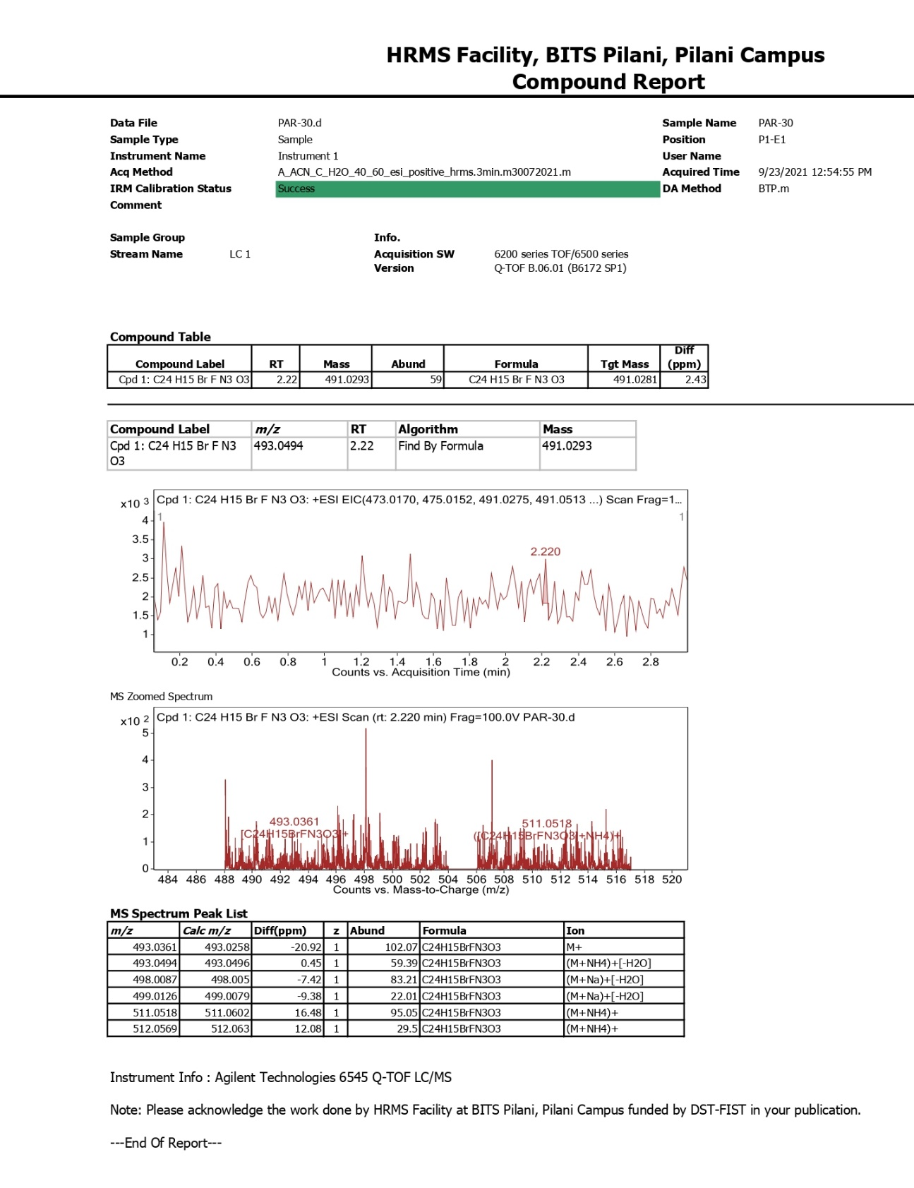

Compound 6n ¹HNMR 400 MHz, CDCl₃
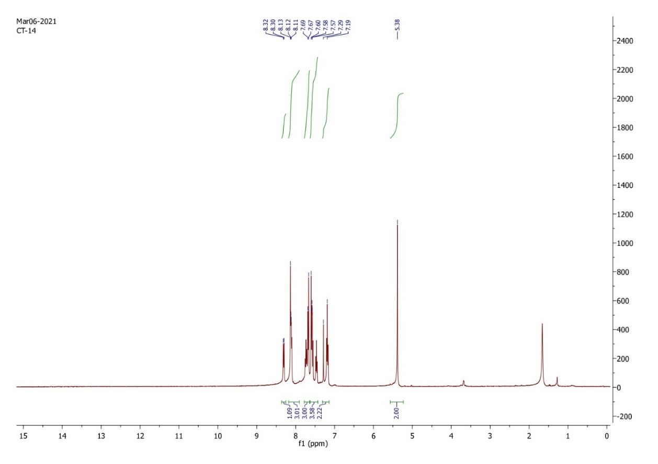
Compound 6n ¹³C NMR, 100 MHz, CDCl₃
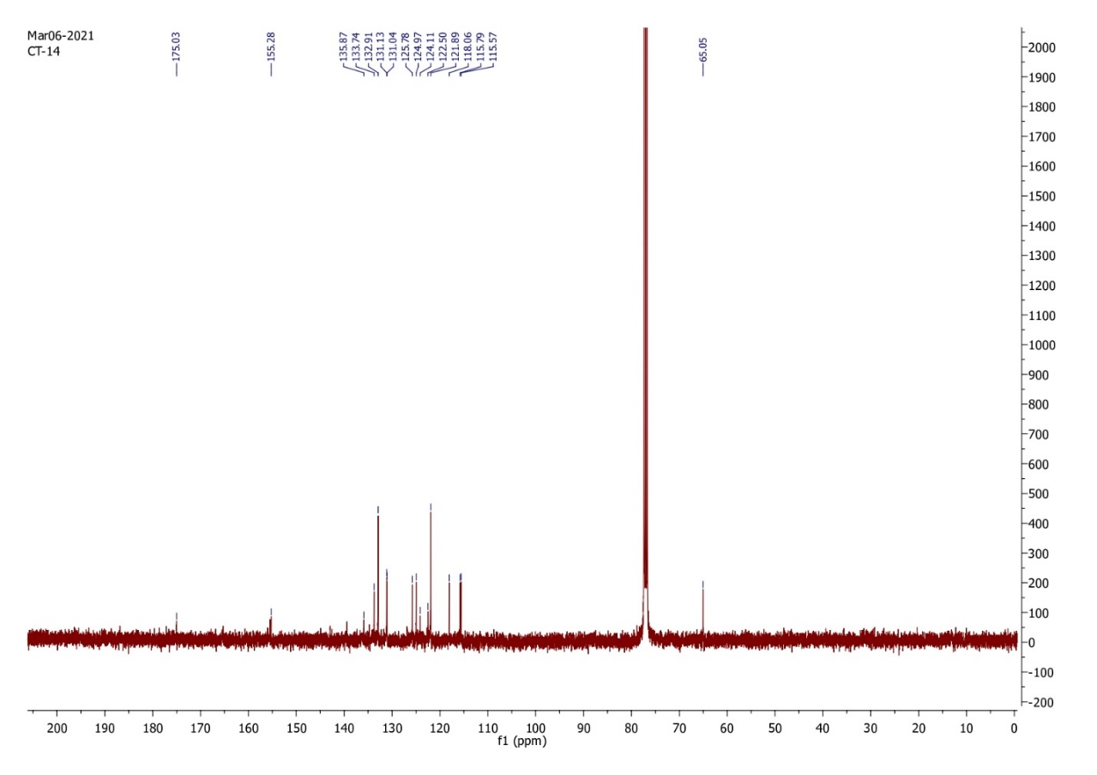

Compound 6o ¹HNMR 400 MHz, CDCl₃
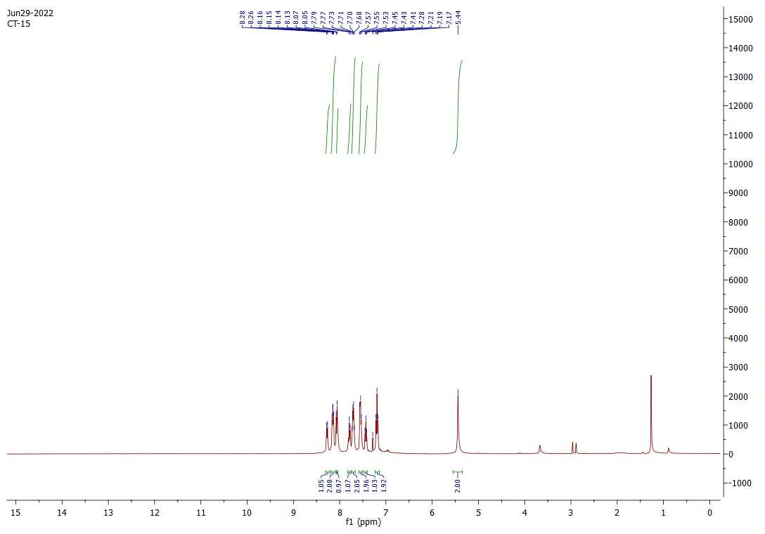
Compound 6p ¹HNMR 400 MHz, CDCl₃
