Supplementary TABLE 1. Generalized linear regession analysis for Length of PACU Duration in Patients after Thoracoscopic-assisted Surgery
Variable | Coefficient | 95%CI | P value
Age per year | 0.50 | 0.066 to 0.929 | 0.024
Female sex | 1.62 | -5.098 to 8.343 | 0.636
BMI | 0.24 | -0.923 to 1.395 | 0.690
Hypertension | 2.79 | -4.343 to 9.919 | 0.443
Chronic obstructive pulmonary disease | 0.03 | -14.941 to 15.004 | 0.997
Duration of surgery, min | -0.01 | -0.128 to 0.100 | 0.807
Total intravenous anesthesia | 3.24 | -8.875 to 15.361 | 0.600
Propofol, mg | -0.01 | -0.031 to 0.018 | 0.596
Midazolam, mg | 4.18 | -0.458 to 8.824 | 0.077
Rocuronium, mg | 0.04 | -0.233 to 0.308 | 0.787
Dexamethasone per mg | 0.21 | -0.501 to 0.920 | 0.563
Title of anesthesiologist
Registrar | Reference
Associate Consultant | 6.70 | -2.964 to 16.366 | 0.174
Consultant | 3.05 | -7.198 to 13.303 | 0.559
Type of regional block
GA | Reference
TEA | -7.71 | -18.403 to 2.977 | 0.157
TPVB | -14.71 | -23.175 to -6.251 | 0.001
SAPB | -9.75 | -19.687 to 0.186 | 0.054
Outcome: Length of PACU Stay (day); N = 140.
Abbreviations: PACU:Post-anesthesia care unit; GA: General anesthesia without regional block; TEA:Thoracic epidural analgesia combined with general anesthesia; TBVP: Thoracic paravertebral block combined with general anesthesia; SABP: Serratus anterior plane block combined with general anesthesia; OME: Oral Morphine Equivalents.

Supplementary TABLE 2. Generalized Linear Regession Analysis for Length of Postoperative Hospital Stay in Patients after Thoracoscopic-assisted Surgery
Variable | Coefficient | 95%CI | P value
Age per year increase | -0.03 | -0.091 to 0.027 | 0.288
Female sex | 0.30 | -0.532 to 1.122 | 0.485
BMI, per 1kg/m² increase | 0.06 | -0.020 to 0.137 | 0.142
Hypertension | 0.18 | -0.694 to 1.046 | 0.692
Chronic obstructive pulmonary disease | 0.86 | -0.103 to 1.818 | 0.080
ASA III to II | -0.16 | -0.993 to 0.671 | 0.705
Malignant tumor | -0.47 | -1.608 to 0.671 | 0.420
Wedge resection | -0.82 | -1.859 to 0.220 | 0.122
Duration of surgery per 1 h increase | 0.65 | 0.065 to 1.225 | 0.029
intraoperative OME | 0.00 | -0.003 to 0.005 | 0.997
Total intravenous anesthesia | 0.69 | -0.363 to 1.735 | 0.200
Title of anesthesiologist
Registrar | Reference
Associate Consultant | 0.96 | 0.009 to 1.902 | 0.048
Consultant | -0.19 | -1.207 to 0.821 | 0.709
Type of regional block
GA | Reference
TEA | -0.54 | -1.429 to 0.356 | 0.239
TPVB | -0.60 | -1.386 to 0.181 | 0.132
SAPB | -1.28 | -2.215 to -0.348 | 0.007
Postoperative complications | 9.87 | 5.562 to 14.167 | <0.001
Outcome: Length of Postoperative Hospital Stay (day); N = 168.
Abbreviations: GA:General anesthesia without regional block; TEA:Thoracic epidural block combined with general analgesia; TBVP: Thoracic paravertebral block combined with general anesthesia;SABP: Serratus anterior plane block combined with general anesthesia

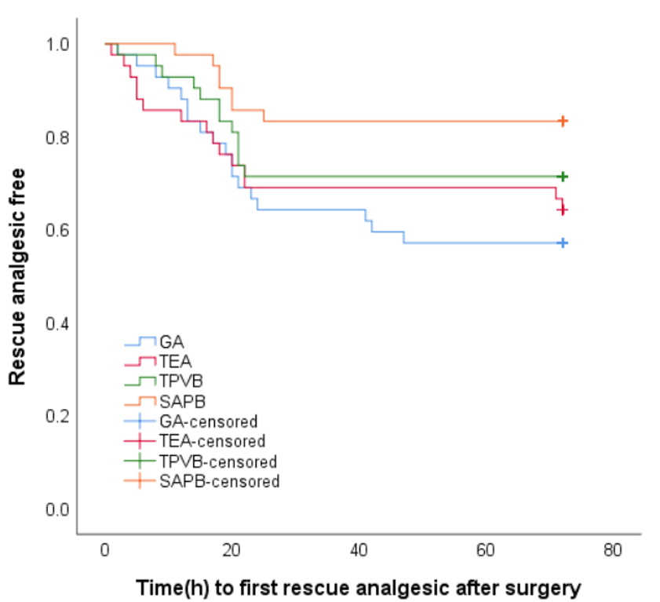
Supplementary Figure 1. The Kaplan-Meier curve of the first rescue analgesic in patients receiving different regional block within 72 hours after surgery.
GA= General anesthesia ; TEA= Thoracic epidural analgesia; TBVP= Thoracic paravertebral block ; SABP= Serratus anterior plane block;

