Outcomes measures | Pre- treatment | After 1 week | After 2 week | After 3 week
Pain on NPRS | 7 on NPRS | 6 on NPRS | 5 on NPRS | 3 on NPRS
Shoulder flexion | 135˚ | 135˚ | 145˚ | 150˚
Shoulder Abduction | 120˚ | 125˚ | 150˚ | 160˚
Shoulder Internal rotation | 40˚ | 45˚ | 50˚ | 60˚
Shoulder external rotation | 35˚ | 40˚ | 55˚ | 60˚
SPADI score | 65% | 60% | 55% | 43%
Results
According to our result we have found less effect on outcome after 1 week of intervention but there was considerable improvement in all the outcome parameters post 2 and 3 weeks of treatment
Table 1. Pre- post treatment result of outcome measures

Treatment Protocol

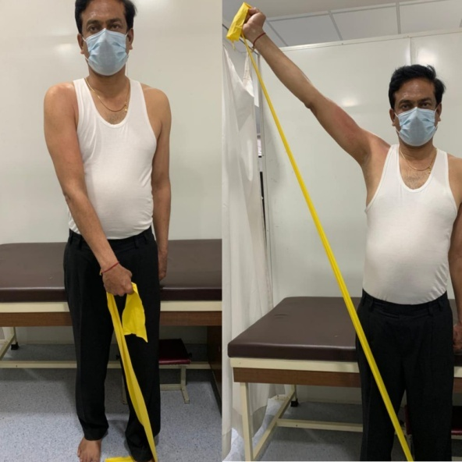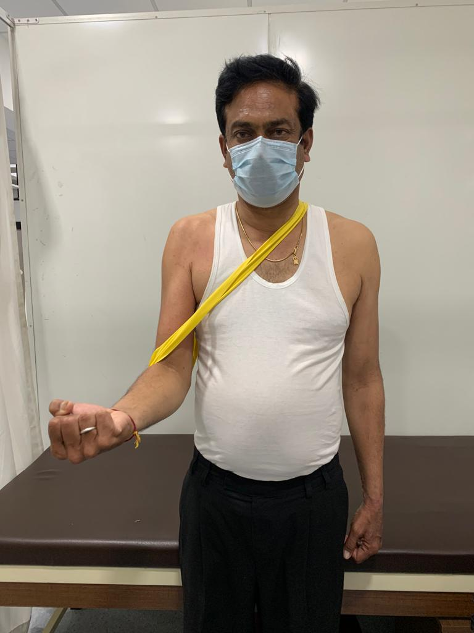
Fig 1 : D2 flexion PNF pattern Fig 2 : Shoulder sling exercise

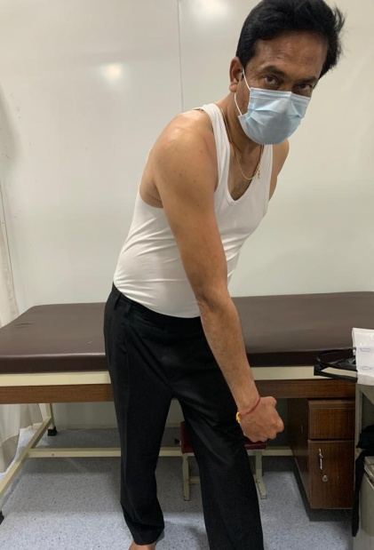
The patient pulls using a large amount of trunk rotation and lower extremity to guide shoulder motion
Fig 3: Lawnmower Exercise

