npj Climate and Atmospheric Science
Supporting Information for
An assessment of the ENSO-monsoon teleconnection in a warming climate
Bidyut Bikash Goswami¹, and Soon-Il An^{2,3}
¹Institute of Science and Technology Austria (ISTA), Klosterneuburg, Austria.
²Irreversible Climate Change Research Center (IRCC) and Department of Atmospheric Sciences, Yonsei University, Seoul, South Korea.
³Division of Environmental Science and Engineering, Pohang University of Science and Technology (POSTECH), Pohang, South Korea.

Contents of this file

Figures S1 to S4
Table S1

Introduction
This document contains Table S1 that depicts the NINO34 and corresponding DMI values for the first ensemble simulation for the first 70 years out of the total 140 years of ramp-up simulation.
This document also contains four supporting figures accompanied by individual captions. The context and relevance of these figures are mentioned in the main text where appropriate.

Table S1. List of years with El Nino and IOD for the first 70 years of the RU simulation of the ensemble number 01. The first column of the table indicates the top 20% years with high NINO34 values. The second and third columns indicate the corresponding NINO34 and DMI values, respectively. The years with top 20% of the DMI value are written in blue colored font.
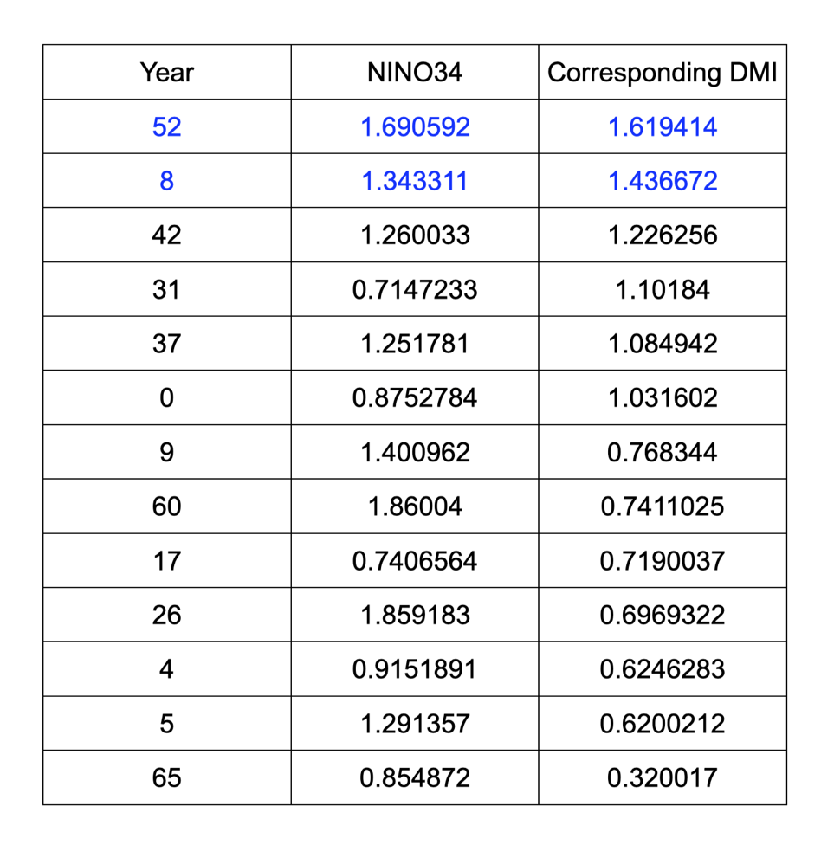

Figure S1. 200hPa velocity potential El Nino composite, (a) first 70 years, (b) last 70 years, of RU simulation.
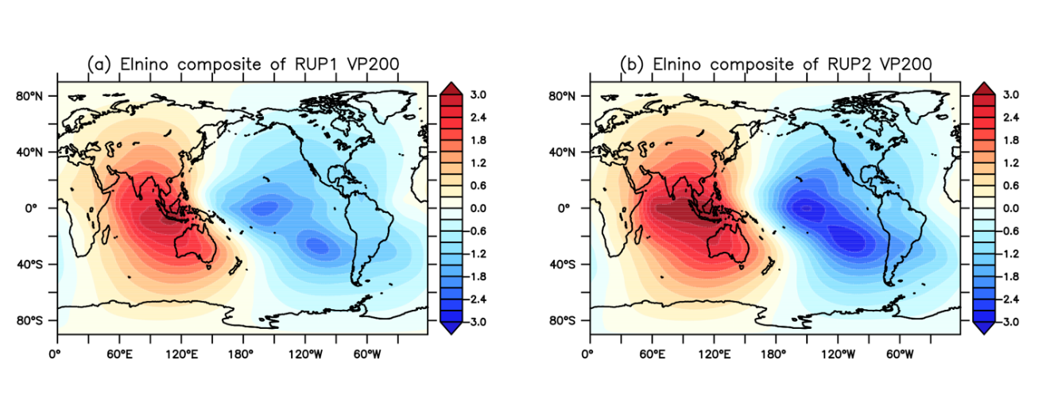

Figure S2. JJAS mean AZM and ISMR (over CI) 21-year running correlation. The blue color depicts the spread of ensembles (one standard deviation).

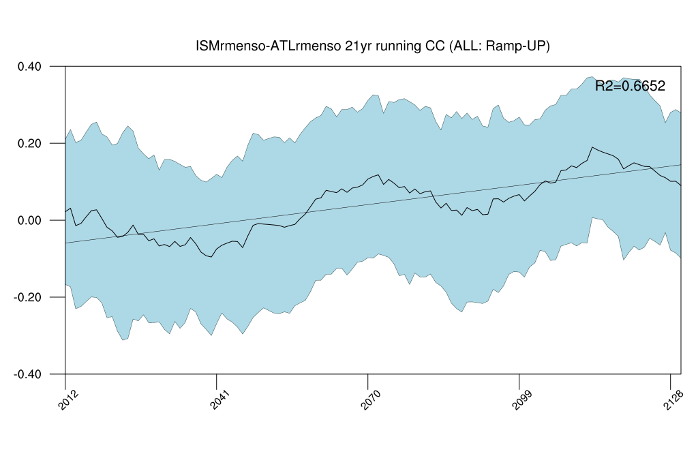

Figure S3. JJAS mean DMI and ISMR (over CI) 21-year running correlation. The blue color depicts the spread of ensembles (one standard deviation).

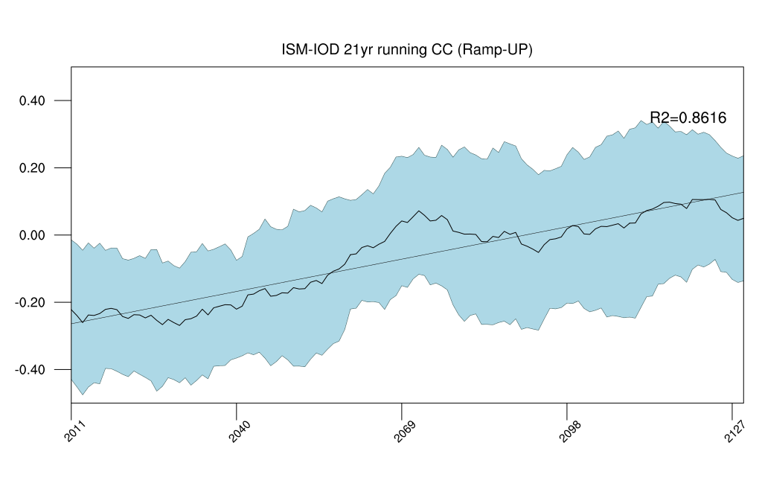

Figure S4. Same as Figure 3 but for RD simulation.

