Projection of Temperature Extremes of Egypt Using CMIP6 Shared Socioeconomic Pathways
Mohammed Magdy Hamed ^{1,2}, Obaidullah Salehie ^{2,3}, Mohamed Salem Nashwan ⁴ and Shamsuddin Shahid ^{2,}*

Table S-1. Global climate models (GCMs) used in this study.
No | Model name | Institution | Country | Resolution
1 | ACCESS-CM2 | Australian Community Climate and Earth-System Simulator coupled model | Australia | 1.2°×1.8°
2 | AWI-CM-1-1-MR | Alfred Wegener Institute Climate Model | Germany | 0.9°×0.9°
3 | BCC-CSM2-MR | Beijing Climate Center climate system model version 2 | China | 1.1°×1.1°
4 | MRI-ESM2-0 | Meteorological Research Institute Earth System Model Version 2.0 | Japan | 1.125°×1.125°

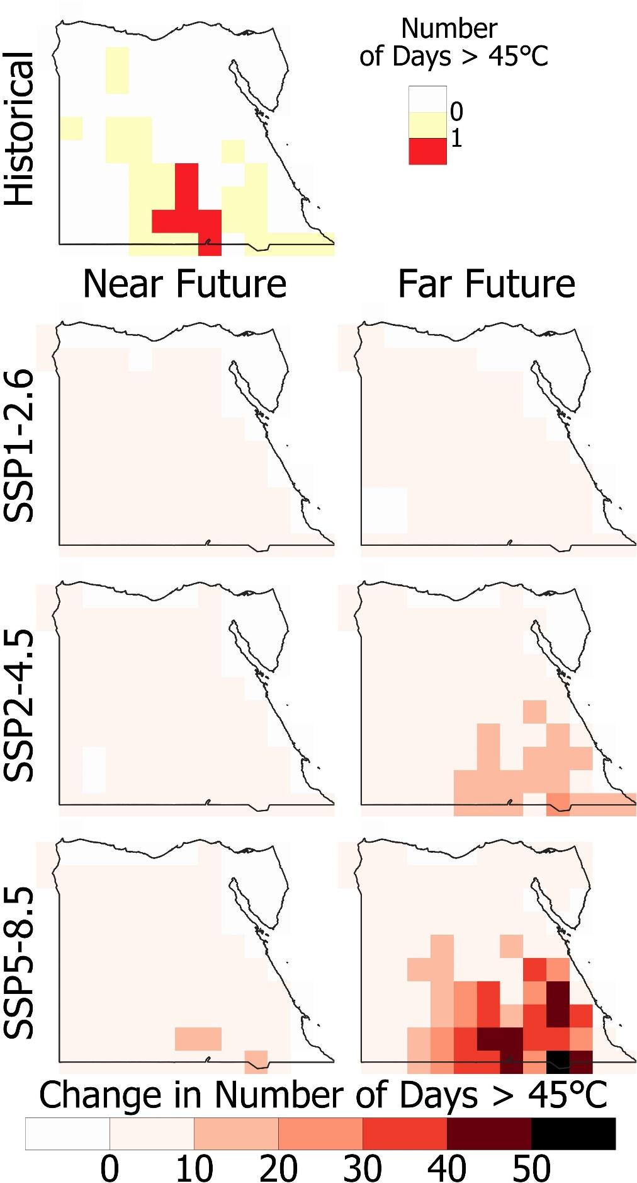
Figure S-1 Spatial distributions in the number of days with T_{max} above 45℃ for the historical era (1975-2014) and the changes (℃) in 2020-2059 and 2060-2099 for different SSPs.
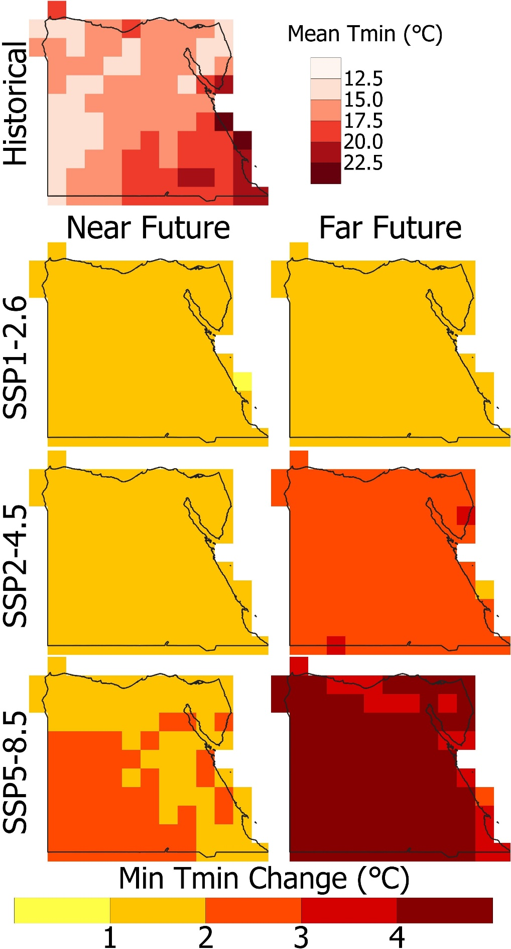
Figure S-2. The annual mean T_{min} spatial distributions for the historical era (1975-2014) and the changes (℃) in 2020-2059 and 2060-2099 for different SSPs.
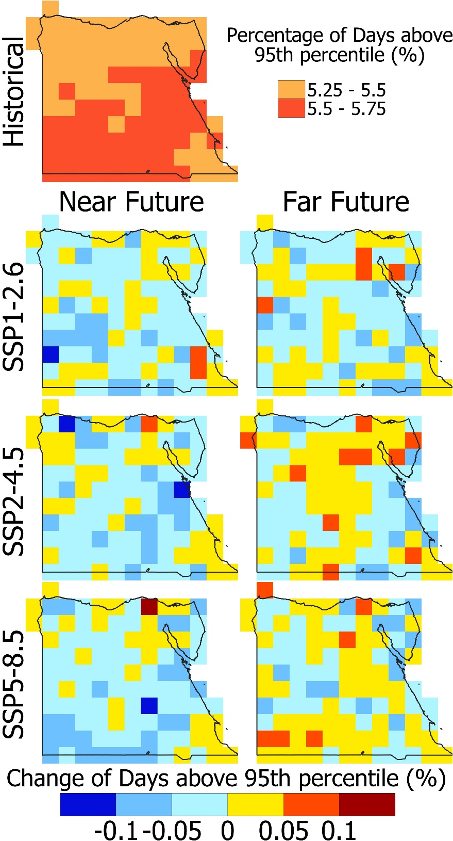
Figure S-3. Spatial distributions of the number of hot days in percentage (Tmax above 95th percentile) for the historical era (1975-2014) and the changes (%) in 2020-2059 and 2060-2099 for different SSPs

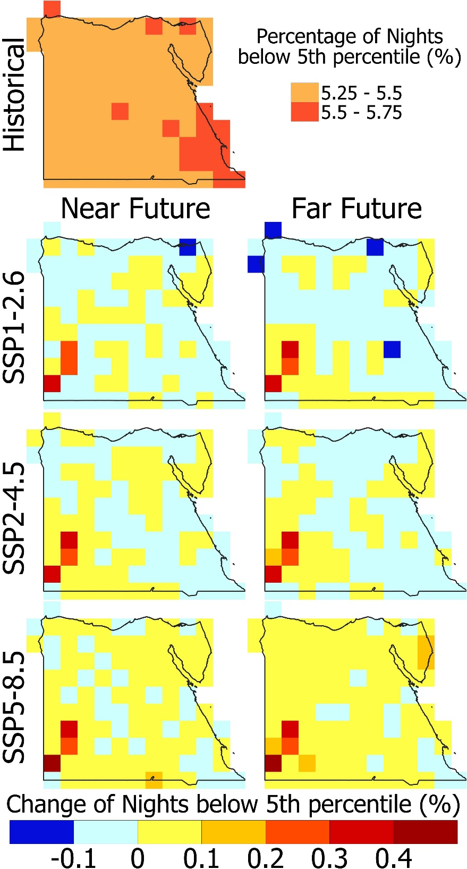
Figure S-4. Number of cold nights in percentage (Tmin below 5th percentile) spatial distributions for the historical era (1975-2014) and the changes (%) in 2020-2059 and 2060-2099 for different SSPs.

