Supplementary methods

HBV-ACLF diagnosis and COSSH grading
The diagnosis of HBV-ACLF was established based on the guidance of the Chinese Group on the Study of Severe Hepatitis B-ACLF, demonstrating that patients with an HBV etiology, single liver failure (TB ≥12 mg/dl) and an INR ≥1.5 should be diagnosed with ACLF, regardless of the presence of cirrhosis. The disease severity grading was based on the COSSH criteria and was assessed as follows: ACLF grade 1 was defined by (1) patients presenting with liver failure alone with an INR ≥1.5 and/or kidney dysfunction and/or hepatic encephalopathy grade I or II, (2) patients with kidney failure alone, (3) patients with failure of a single organ failure in the coagulation, circulatory or respiratory system and/or kidney dysfunction and/or HE grade I or II, and (4) patients with cerebral failure plus kidney dysfunction. ACLF-2 comprised patients with failure in two organ systems, while ACLF-3 comprised patients with failures in three or more organ systems.

Cellular sampling
Peripheral blood was collected before anesthesia from ACLF patients and healthy alive liver donor for the isolation of peripheral blood mononuclear cells (PBMCs). Blood was collected (14 mL) in heparinized tubes and diluted 1:1 in sterile phosphate buffered saline (PBS). The diluted blood was carefully transferred to a conic tube containing 6 mL of Ficoll (Sigma, Sigma, St. Louis, MO, USA). The mixture was centrifuged at 700 × g for 30 minutes at room temperature. The mononuclear cell layer was removed and centrifuged with 15 mL of sterile PBS at 700 × g for 30 minutes at room temperature, to remove contaminant platelets. Collected cells were dilluted into a final concentration of 5 × 105 cells/mL.
Liver resident CD45⁺ cells were sorted from resected livers. For ACLF patients, liver tissue was obtained abandonly from total liver of the recipients. As for negative control, liver tissue was also collected from alive liver transplantation donors. Liver tissue was fully perfused with the University of Wisconsin solution (UW solution) for removing residual neutrophile granulocytes and monocytes from microvasculature and was sequential processed with Multi Tissue Dissociation Kits, Dead Cell Removal Kit and CD45 MicroBeads (Miltenyi Biotec, Bergisch Gladbach, Germany) according to the manufacturer’s directions. MicroBeads-labeled cells were flushed through MS Column for further soring CD45⁺ cells. Collected cells were dilluted to a final concentration of 5 × 10⁵ cells/mL.
mRNA sequencing and identification of DEGs
For RNA sequencing, the RNA samples from the corresponding biological replicates of each grade (Natural Control, HBV-ACLF grade 1, 2, and 3) were separated into three independent pools, and each of them comprised two or three distinct samples, at equal amounts. Strand-specific libraries were constructed using the TruSeq RNA sample preparation kit (Illumina, San Diego, CA, USA), and sequencing was carried out using the Illumianovaseq 6000 instrument. TrimGalore v0.6.6 (github.com /FelixKrueger /TrimGalore) was subsequently used to trim the adaptor and primer sequences from raw data as well as filter outreads with average base quality score <30 and fragment length <40 bp. The clean data were aligned to the human reference genome (GRCh38) by Hisat v2.1.0 with default parameters. In order to gain the quantified information for subsequent analysis, StringTie v2.1.4 was applied to obtain the transcript-level and gene-level digital expression files^{[2]}. Gfold v1.1.4 was subsequently used to identify the differentially expressed genes (DEGs). In the current study, the bam files were transformed into read-count files by executing the built-in function ‘gfold count’of gfold^{[3]}. For each two-group comparison, function ‘gfold diff’ was used and the identified genes with GFOLD value < -0.58 or > 0.58 were presented as DEGs. In the present study, the GFOLD value could be considered as a reliable log2 fold-change indicator.
Hierarchical clustering
To characterize the heterogeneity among the different levels of disease, we used an unsupervised clustering method-hierarchical clustering analysis, to evaluate the similarity among individual samples. Firstly, the count expression data were centered for minimizing deflective influence by the library size. The marker genes were subsequently abstracted by ‘Seurat’^{[4]} and used as input for heatmap construction. The R package ‘pheatmap’ was used for analyzing and visualizing the hierarchical clustering results with ‘clustering_method = "average"’.
Functional analysis
Functional analysis was based on the KEGG pathways and Gene Ontology was performed using the R package ‘clusterProfiler’ with the DEG list used as input. Gene Ontology analysis was performed by focusing on the biological process terms. In the present study, the parameters were set as follows: ‘pvalue cutoff = 0.05, pAdjustMethod = “BH”, minGSSize = 10, maxGSSize = 500, qvalue cutoff = 0.2’.
Network analysis of the biological process
ClueGO is a plug-in of Cytoscape V3.8.2, which describes the relationship among biological terms. ClueGO was initiated by uploading a file containing the GO ids and the P values of the biological processes were generated by ‘clusterProfiler’^{[5]}. The relationship between the biological process terms was characterized according to their common genes. The network graph was created based on Kappa statistics. The kappa score was set as 0.3 in the present study. Each node in the graph represents a biological process. The connections between the nodes reflect the correlation between the biological functions, and the color of the node represents its functional group. The visualization part was also carried out in Cytoscape.

BTM
BTMs (Blood Transcriptional Modules) are molecular signatures derived from PBMC transcriptome sequencing based on different kinds of immunological stimuli^{[6]}. BTMs are regarded as an alternative to ‘conventional’ gene sets for Gene Set Enrichment Analysis (GSEA) analysis in this study, as well as paired t-test and the relative scaled mean expression analysis. To evaluate the immune level heterogeneity among patients at different disease stages, GSEA was used, which specified BTMs as the target database to explain whether a gene set was overrepresented in a specific stage based on the normalization expression data (normalizing methods: variance-stabilizing transformation methods in R packages ‘DESeq2’).
CIBERSORT
CIBERSORT is an analytical tool based on a devolution algorithm with the aim of achieving an evaluation of the proportion of various cell types in a mixed cell population^{[7]}. This software uses bulk gene expression files as input. We focused on 22 immune cells in the Immune Infiltration Analysis (Types: B cells naïve, B cells memory, Plasma cells,T cells , CD8 T cells,CD4 naïve T cells, CD4 memory resting T cells ,CD4 memory activated, T cells follicular helper, T cells regulatory, T cells gamma delta, NK cells resting, NK cells activated, Monocytes Macrophages M0, Macrophages M1, Macrophages M2, Dendritic cells resting, Dendritic cells activated, Mast cells resting, Mast cells activated, Eosinophils Neutrophils). The signature gene file of the immune cell expression profile and the gene expression data files were uploaded to the website, which would perform automated analysis and obtain the necessary results (website: https://cibersort.stanford.edu/).
qRT-PCR assays
Total RNA was extracted from cells and frozen samples by using Trizol reagent (Invitrogen, California, USA) and then reversely transcripted into cDNA. Real-time PCR was performed using SYBR Green PCR Master Mix (DBI® Bioscience, Ludwigshafen, Germany) and ABI PRISM 7900 Sequence Detection System (Applied Biosystems). Results were normalized to β-actin for mRNA measurement.
Clinical sample, immunohistochemistry and Immunofluorescence (IF)
Liver tissues were collected as mentioned above. Formalin-fixed and paraffin-embedded tissues were used to make sections. Immunohistochemical (IHC) staining was performed brieﬂy following deparaffinization rehydrating and antigen retrieval, primary antibodies were applied to slides, incubated at 4°C overnight, and followed with secondary antibody incubation (Dako Cytomation, Glostrup, Denmark) at 37°C for 30 minutes. Staining was carried out with DAB and counter-staining was performed with hematoxylin. The quantitive results of immunohistochemistry were evaluated and scored by two independent pathologists respectively. The intensity was scored as follow: 0, negative; 1, weak; 2, moderate; 3, positive; and 4, strongly positive. The frequency of positive cells was defined by percentage of stained cells in total cells within sights. The final score was reached by intensity multiplied by frequency.
Tissue sections were fixed by 4% paraformaldehyde at room temperature for 15 minutes, permeabilized in 0.5% Triton X-100 for 10 minutes, blocked with 1% BSA for 1h, and then stained using primary antibodies. The secondary antibodies used were anti-mouse Alexa Fluor 488 or 594 dye conjugate and/or anti-rabbit Alexa Fluor 488 or 594 dye conjugate (Life Technologies). Nuclei were stained with 4’, 6-diamidino-2-phenylindole (DAPI blue) (Life Technologies). Finally, the slides were mounted and imaged under Nikon A1 confocal microscope (Nikon; Minato-ku, Tokyo, Japan).
ACLF mice models
Male C57BL/6J mice were injected intraperitoneally (i.p.) with CCl₄ (0.2 ml/kg twice a week) for 8 weeks, before being given a double dose of CCl4 (0.4 ml/kg) and then an i.p. injection with K.P. strain. Mice were housed in polycarbonate cages (4 mice per cage) and maintained in a temperature and light controlled facility (12 h:12 h light-dark cycle) under standard food and water ad libitum. Mice were then randomly divided into 1 of the following 3 groups: (1) Mice accepting full procedure of ACLF induction (ACLF);(2) Mice given Rosuvastatin (1 mg/kg SC) once per 12 hours 3 days before administration of double dose of CCl4 (Statin-T); (3)Mice as negative control (NC). All animal experiments were approved by the Ethics Committee of Renji Hospital, Shanghai Jiaotong University School of Medicine.
Cholesterol measurements
Cholesterol content was measured using the Cholesterol Quantitation Kit (Sigma-Aldrich, MAK043-1KT). Cellular samples abstracted from patients were stained with 0.5 mg/ml filipin in 1% BSA/PBS for 1 h after fixation with 4% paraformaldehyde for 15 min and rinsed 3 × 5 min with PBS. Quantitive results of intracellular cholesterol is gained via fluorescence assay (λex = 535/λem = 587 nm).

Reference
1. Wu T, Li J, Shao L, Xin J, Jiang L, Zhou Q, et al. Development of diagnostic criteria and a prognostic score for hepatitis B virus-related acute-on-chronic liver failure. Gut 2018, 67(12): 2181-2191.
2. Pertea M, Pertea GM, Antonescu CM, Chang TC, Mendell JT, Salzberg SL. StringTie enables improved reconstruction of a transcriptome from RNA-seq reads. Nat Biotechnol 2015, 33(3): 290-295.
3. Feng J, Meyer CA, Wang Q, Liu JS, Shirley Liu X, Zhang Y. GFOLD: a generalized fold change for ranking differentially expressed genes from RNA-seq data. Bioinformatics 2012, 28(21): 2782-2788.
4. Hao Y, Hao S, Andersen-Nissen E, Mauck WM, 3rd, Zheng S, Butler A, et al. Integrated analysis of multimodal single-cell data. Cell 2021, 184(13): 3573-3587 e3529.
5. Bindea G, Mlecnik B, Hackl H, Charoentong P, Tosolini M, Kirilovsky A, et al. ClueGO: a Cytoscape plug-in to decipher functionally grouped gene ontology and pathway annotation networks. Bioinformatics 2009, 25(8): 1091-1093.
6. Li S, Rouphael N, Duraisingham S, Romero-Steiner S, Presnell S, Davis C, et al. Molecular signatures of antibody responses derived from a systems biology study of five human vaccines. Nat Immunol 2014, 15(2): 195-204.
7. Newman AM, Liu CL, Green MR, Gentles AJ, Feng W, Xu Y, et al. Robust enumeration of cell subsets from tissue expression profiles. Nat Methods 2015, 12(5): 453-457.

Supplementary Tables and Figures
Supplementary Table 1. Primer sequence used for qPCR in the study.
Name |  | Sequence | NCBI Gene ID
h-APOE | Forward | GTTGCTGGTCACATTCCTGG | 348
h-APOE | Reverse | GCAGGTAATCCCAAAAGCGAC | 348
h-APOC1 | Forward | TCCAGTGCCTTGGATAAGCTG | 341
h-APOC1 | Reverse | GGCTGATGAGTTCCCGAGC | 341
h-SPP1 | Forward | CTCCATTGACTCGAACGACTC | 6696
h-SPP1 | Reverse | CAGGTCTGCGAAACTTCTTAGAT | 6696
m-APOE | Forward | CTGACAGGATGCCTAGCCG | 11816
m-APOE | Reverse | CGCAGGTAATCCCAGAAGC | 11816
m-APOC1 | Forward | TCCTGTCCTGATTGTGGTCGT | 11812
m-APOC1 | Reverse | CCAAAGTGTTCCCAAACTCCTT | 11812
m-SPP1 | Forward | AGCAAGAAACTCTTCCAAGCAA | 20750
m-SPP1 | Reverse | GTGAGATTCGTCAGATTCATCCG | 20750

Supplementary Figure 1. Enriched Biologcial process of DEGs. The DEGs are obtained from the comparisions between liver-resident CD45⁺ cells from ACLF-grade 1 (C1) and NC.
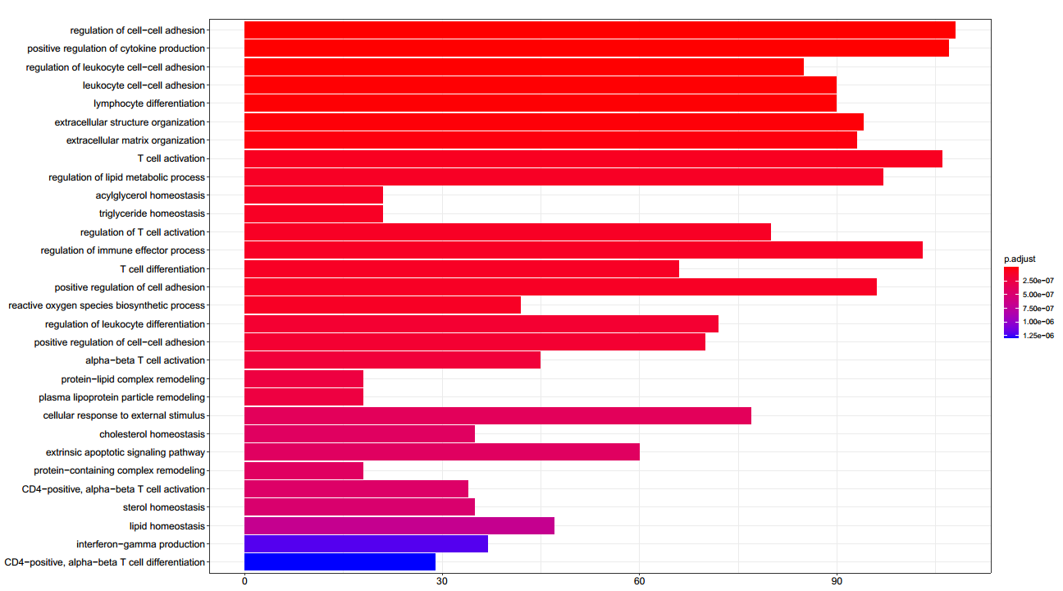

Supplementary Figure 2. Enriched Biologcial process of DEGs. The DEGs are obtained from the comparisions between liver-resident CD45⁺ cells from ACLF-grade 2 (C2) and NC.
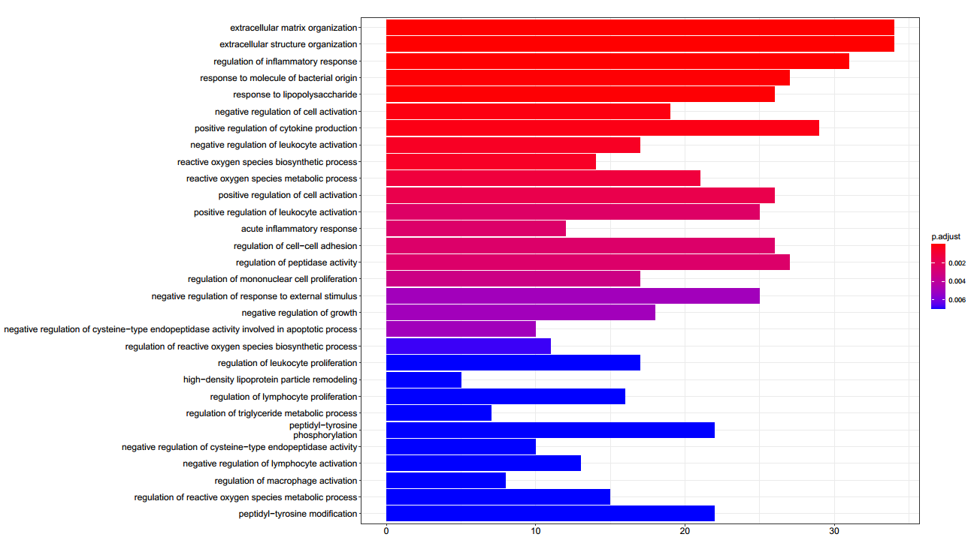

Supplementary Figure 3. Enriched Biologcial process of DEGs. The DEGs are obtained from the comparisions between liver-resident CD45⁺ cells from ACLF-grade 3 (C3) and NC.
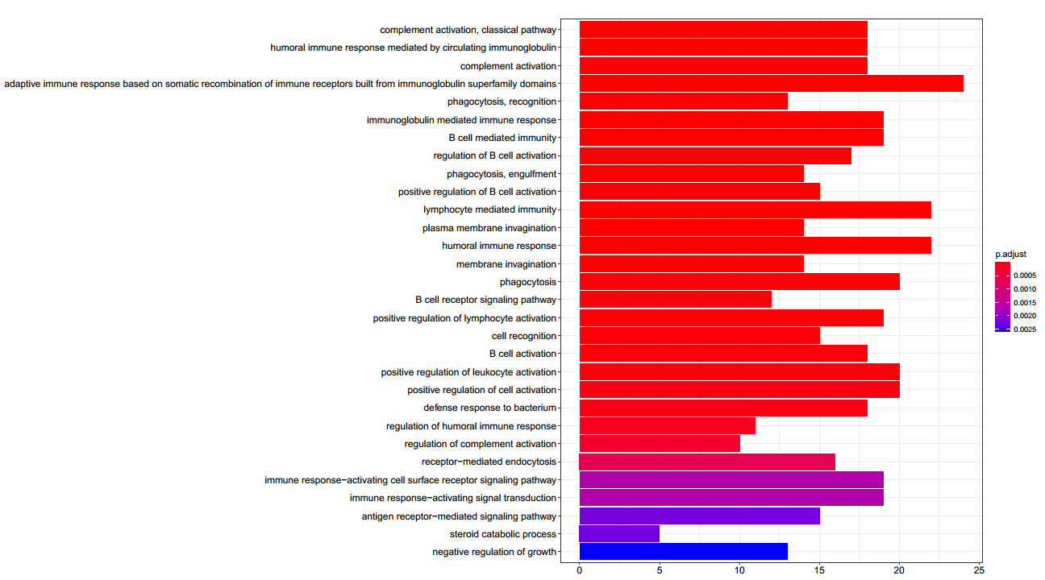
Supplementary Figure 4. Enriched Biologcial process of DEGs. The DEGs are obtained from the comparisions between PBMCs from ACLF-grade 1 (P1) and NC.
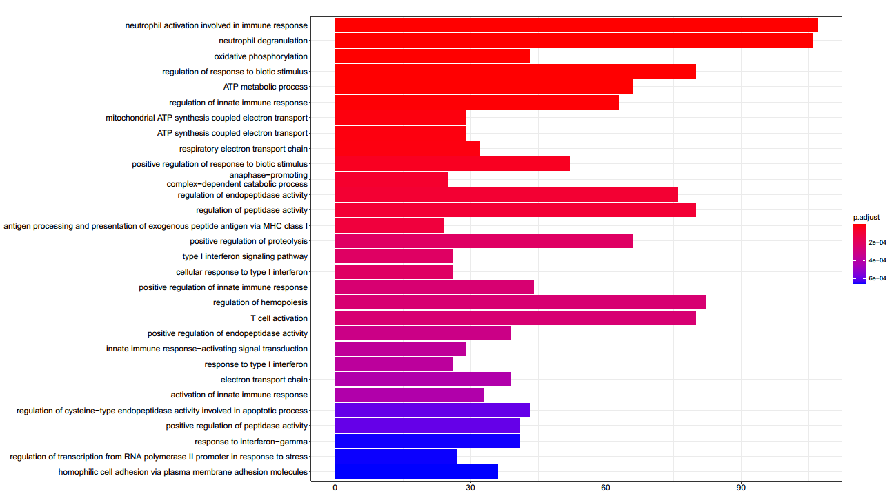
Supplementary Figure 5. Enriched Biologcial process of DEGs. The DEGs are obtained from the comparisions between PBMCs from ACLF-grade 2 (P2) and NC.
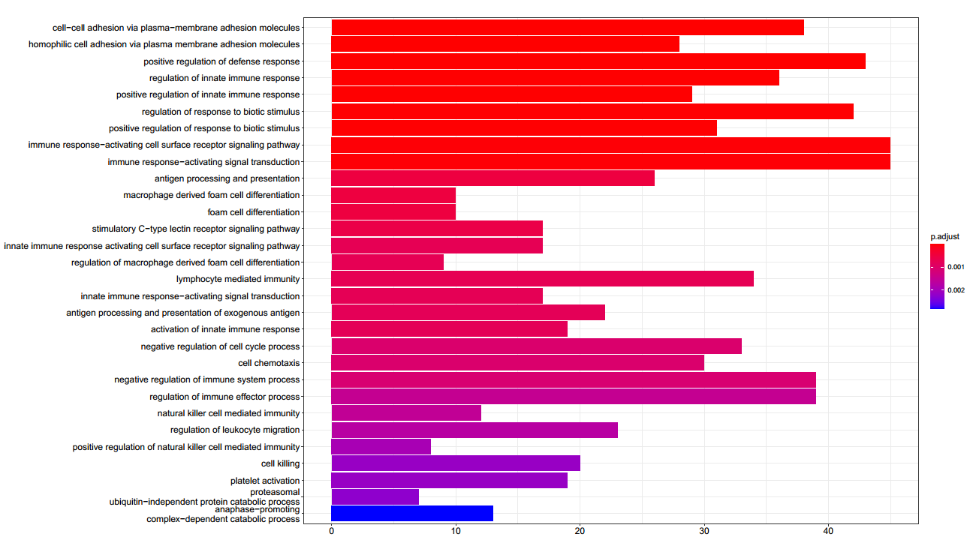

Supplementary Figure 6. Enriched Biologcial process of DEGs. The DEGs are obtained from the comparisions between PBMCs from ACLF-grade 3 (P3) and NC.
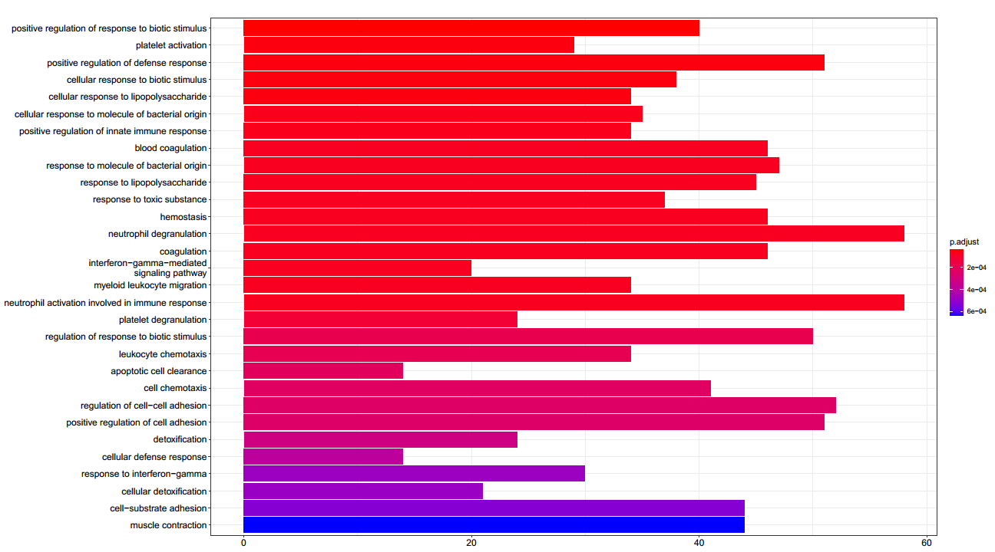

Supplementary Figure 7. Enrichment analysis on DEGs（separated in up-regulated and down-regulated）in pairwise comparison between HBV-ACLF and NC groups, both PBMC and liver infiltrated CD45+ immune cells.
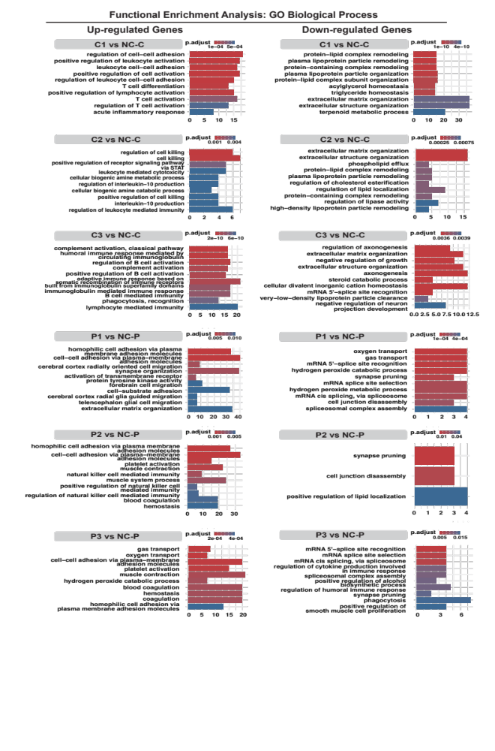

Supplementary Figure 8. Interaction network based on enriched BP modules of DEGs obtained from comparison between PBMCs of HBV-ACLF and NC.

Supplementary Figure 9. Interaction network based on enriched BP modules of DEGs obtained from comparison between liver resident CD45⁺ cells of HBV-ACLF and NC

Supplementary Figure 10. Interaction network based on 91 DEGs screened by cross match of expression comparison among liver resident CD45+ cells from three grades of HBV-ACLF and NC.

