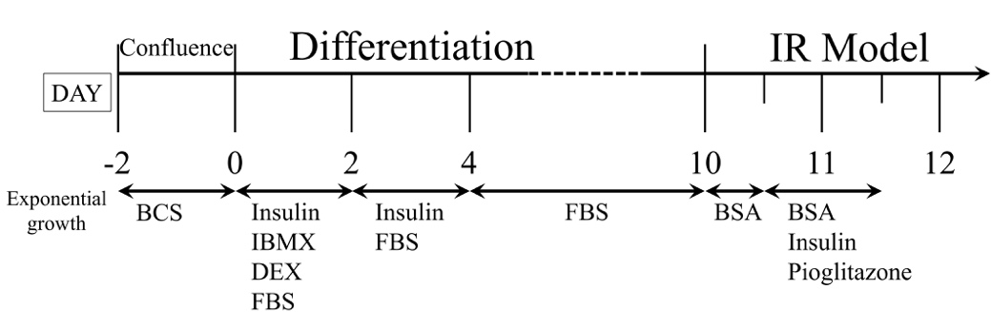
Figure S1. The protocol of 3T3-L1 differentiation and IR model. IR, insulin resistance; BCS, bovine calf serum; IBMX, 3-isobutylmethylxanthine; DEX, dexamethasone; FBS, fetal bovine serum; BSA, bovine serum albumin.

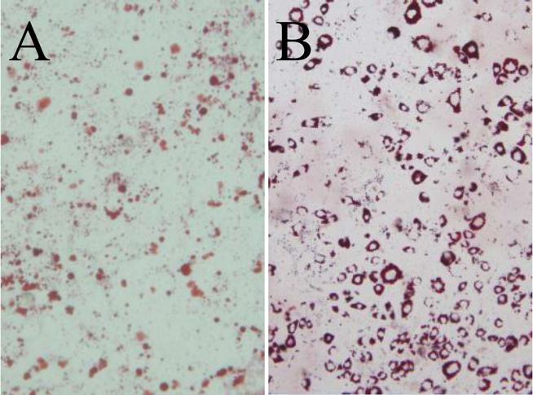

Figure S2. The picture of Red Oil of 3T3-L1 pre-adipocytes (a) and adipocytes (b). The degree of 3T3-L1 preadipocytes differentiation was assessed by Oil Red O staining of accumulated lipids.

Figure S3. Effect of FC on the main relative genes related to insulin signal pathway of 3T3-L1 adipocytes with IR. Data are expressed as mean ± SEM (n=6). * p <0.05, ** p <0.01 and *** p <0.005.

Figure S4. Effect of FC on the main relative genes expression of insulin signal pathway in C57BL/6 mice IR model. Data are expressed as mean ± SEM (n=6). * p <0.05, ** p <0.01 and *** p <0.005.

Figure S5. Effect of FC on genes expression of inflammatory cytokines in adipocytes. Data are expressed as mean ± SEM (n=6). * p <0.05, ** p <0.01 and *** p <0.005.

Figure S6. Effect of FC on genes expression of inflammatory cytokines in adipose tissue. Data are expressed as mean ± SEM (n=6). * p <0.05, ** p <0.01 and *** p <0.005.

