Supporting Information
Optimization of isoamyl acetate synthesis in the presence of ball-milled seashells by response surface methodology
Mohammad G. Dekamin*, Amir Hossein Fattahi
ªPharmaceutical and Heterocyclic Compounds Research Laboratory, Department of Chemistry, Iran University of Science and Technology, Tehran, 16846-13114, Iran.
*E-mail: mdekamin@iust.ac.ir
Page | Content
S1 | Title page
S2 | Experimental section (General)
S2 | General procedure for the synthesis of ball-milled seashells
S2 | General procedure for esterification of isoamyl alcohol with acetic acid
S3 | Chromatogram of the crude reaction mixture for the synthesis of isoamyl acetate under optimized conditions in GC-MS analysis (Fig. 1)
S4 | Mass spectrum of isoamyl acetate (Fig. 2)

Experimental section
General
Isoamyl alcohol, and acetic acid were purchased from Merck Chemical Company and were used without further purification. Yields were obtained by means of a FID-gas chromatography Shimadzu 2010 instrument equipped with BP5 (30 m , 0.25 mm) column. The oven temperature was maintained at 60 °C, elevated to 200 °C at a rate 10 °C/ min, and was held for 2 min. The injection volume was 1.0 mm³. Samples were prepared by adding 0.004 gr of n-dodekan, as an internal standard and 5 cm³ of toluene as solvent. FTIR spectrum of the catalyst was obtained using a Shimadzu-8400S spectrometer in the range of 400–4000 cm⁻¹ using KBr pellet. SEM images were prepared using a KYKY instrument (model EM-3200). The XRD pattern of the catalyst was obtained using TW 1800 diffractometer with Cu K_{ᵅ} radiation (k = 1.54 A ˚). Chemical analysis was performed using EDX model Philips XL-30. The tip radii were obtained from direct AFM measurements of the tip apex region in tapping mode. The shell surface was mounted on the AFM stage and the triboscope recording unit with transducers and leveling device was placed on the top of a NanoScope III E 164 | 164 mm² XY piezo scan base. Thermal gravimetric analysis (TGA) was performed by means of Bahr company STA 504 instrument. Statistical analysis and response surface graphs were generated using the Design-Expert 7 software (State Ease Inc., Minneapolis, MN, USA).

General procedure for the synthesis of ball-milled seashells
In first, 5 gr of seashells were washed thoroughly with water then dried at 70 °C, followed in refluxing ethanol for 8 h then washed with water and dried at 70 °C and finally were ball-milled for 3 min.

General procedure for esterification of isoamyl alcohol with acetic acid
The esterification of isoamyl alcohol with acetic acid was performed in a round-bottom flask equipped with a stirrer. Different molar ratios of isoamyl alcohol to acetic acid and catalyst loadings of ball-milled seashells were used at different reaction temperatures and times illustrated in Table 3. During the reaction, the water was eliminated from the reaction mixture by absorbent properties of seashells. After completion of the reaction, mixture was cooled to room temperature. The liquid phase was separated from the catalyst by filtration and analyzed by means of GC and GC–MS instruments. Furthermore, isoamyl acetate was characterized after purification was obtained IR data.

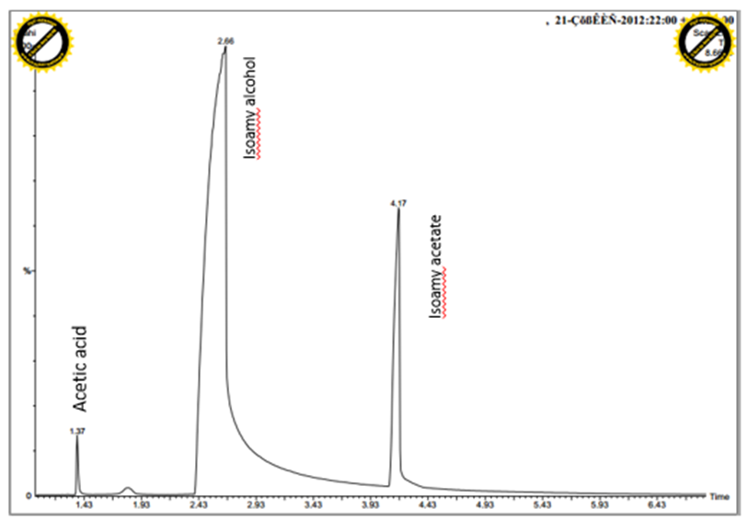

Fig. 1. Chromatogram of the crude reaction mixture for the synthesis of isoamyl acetate under optimized conditions in GC-MS analysis.

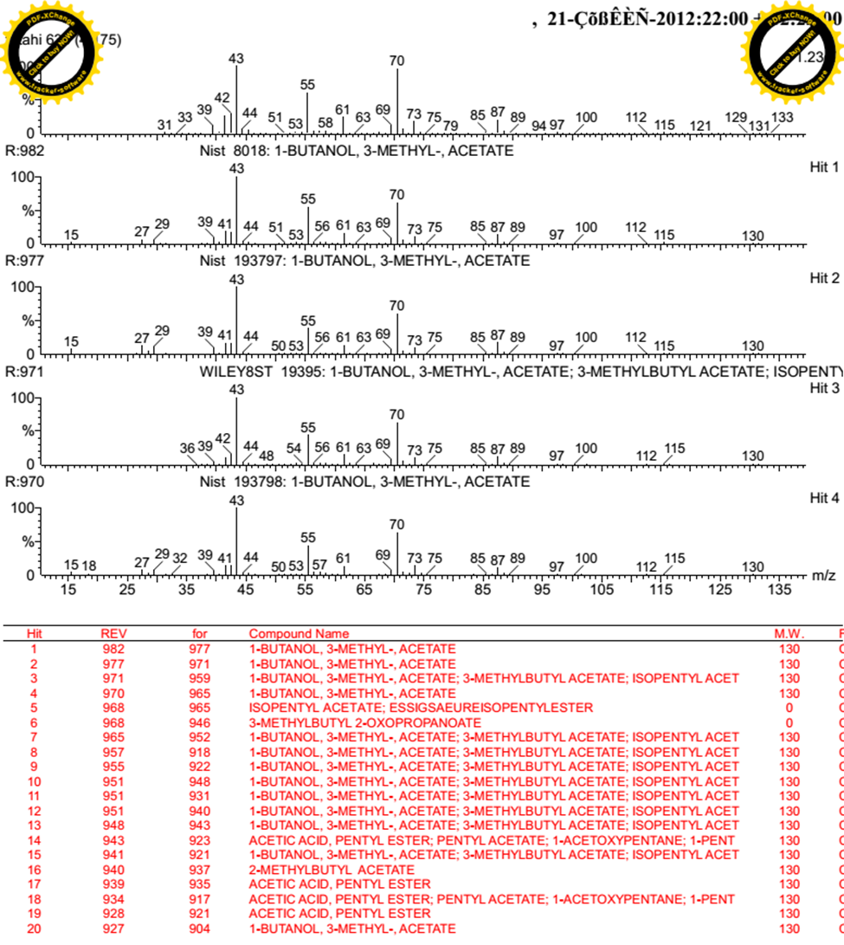
Fig. 2. Mass spectrum of the reaction mixture for synthesis isoamyl acetate catalyzed by ball-milled seashells.

