Supplementary Information for:

Spatial, temporal, and personal variation of metabolites along the human upper intestinal tract

Jacob Folz¹, Rebecca Neal Culver², Juan Montes Morales¹, Jessica Grembi³, George Triadafilopoulos⁴, David A. Relman^{3,5,6,7}, Kerwyn Casey Huang^{4,6,8}, Dari Shalon⁹, Oliver Fiehn^{1,*}

Affiliations:
¹West Coast Metabolomics Center, University of California, Davis, CA 95616, USA n
²Department of Genetics, Stanford University School of Medicine, Stanford, CA 94305, USA
³Department of Medicine, Stanford University School of Medicine, Stanford, CA 94305, USA
⁴Department of Microbiology and Immunology, Stanford University School of Medicine, Stanford, CA 94305, USA
⁵Silicon Valley Neurogastroenterology and Motility Center, Mountain View, CA 94040, USA
⁶Chan Zuckerberg Biohub, San Francisco, CA 94158, USA
⁷Infectious Diseases Section, Veterans Affairs Palo Alto Health Care System, Palo Alto, CA 94304, USA
⁸Department of Bioengineering, Stanford University, Stanford, CA 94305, USA
⁹Envivo Bio, Inc., San Carlos, CA 94070, USA
*corresponding author: Oliver Fiehn, 451 Health Sciences Drive, Davis, CA 95616; ofiehn@ucdavis.edu

SUPPLEMENTAL FIGURES

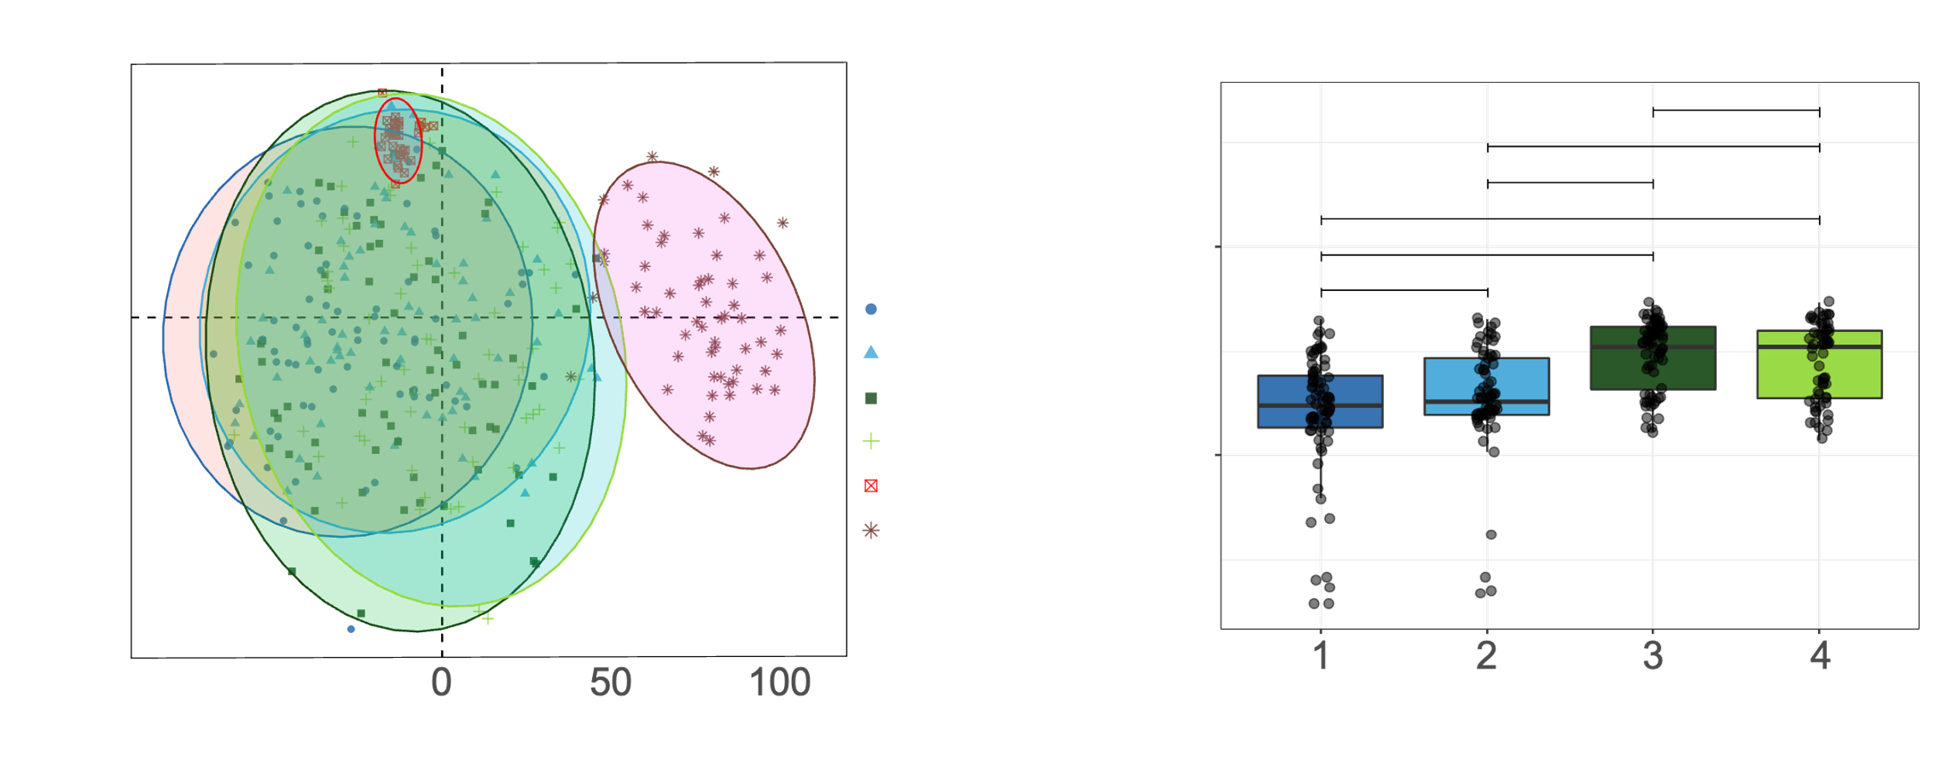
Figure S1. Summary visualizations. (A) Principal Component Analysis (PCA) score plot of normalized peak heights for metabolomics dataset. QC samples are pooled intestinal contents from previous human intestinal tract pilot studies. B) Sample pH for intestinal sampling device types. **** indicates significance p < 0.0001 (Kruskal-Wallis).
Figure S2. Heatmap of the top 80 metabolites most important to distinguish intestinal capsule samples from stool samples determined by partial least square discriminant analysis (PLS-DA). Samples organized on the x-axis by hierarchical clustering, and metabolites are organized on the y axis also according to hierarchical clustering. Each sample is labeled by subject number and sample type (device type or stool). Color of heatmap ranges from low (blue) to high (red) of metabolite abundance and the minimum and maximum values for color scale are set for each metabolite (row).

Figure S3. Heatmap of the top 80 metabolites most important to distinguish capsule samples by device type determined by partial least square discriminant analysis (PLS-DA). Samples organized on the x-axis by device type, and metabolites are organized on the y axis according to hierarchical clustering. Color of heatmap ranges from low (blue) to high (red) of metabolite abundance and the minimum and maximum values for color scale are set for each metabolite (row).

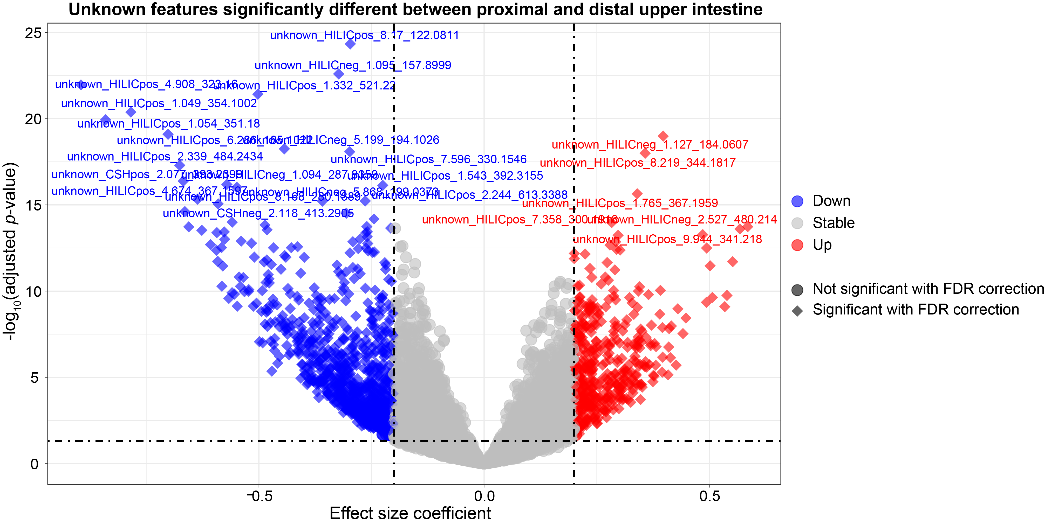
Figure S4. Comparison of proximal and distal upper intestinal non-annotated signal levels. Significance was calculated by linear mixed effect model (LMM). Significance of p < 0.05 is delimited by the lower dashed horizontal line. Circle shape for a metabolite indicates non-significant after FDR correction or an effect size coefficient less than ±0.2. Diamond shape indicates significant (p<0.05) after false discovery rate (FDR) correction (n=9,317) and effect size coefficient greater than ±0.2. Features detected in more than 50% of intestinal samples were included in this analysis (n=9,317). Effect size coefficient is the slope estimate calculated by LMM with positive coefficient meaning higher in the distal compared to proximal upper intestine, and negative coefficient meaning lower in the distal compared to proximal upper intestine. Vertical dashed lines are ±0.20 effect size coefficient.

Figure S5. Chemical classes significantly different between the proximal and distal upper intestine. Chemical enrichment statistics were performed by ChemRICH. Metabolites detected in more than 50% of intestinal samples were included in this analysis. These results are visualized by separating classes by chemical lipophilicity (logP) and chemical class significance level of -log10(p-value). Red circle indicates the chemical class was higher in the distal compared to proximal upper intestine, and blue indicates the chemical class was lower in the distal compared to the proximal upper intestine. The size of circles references the size of the chemical class.

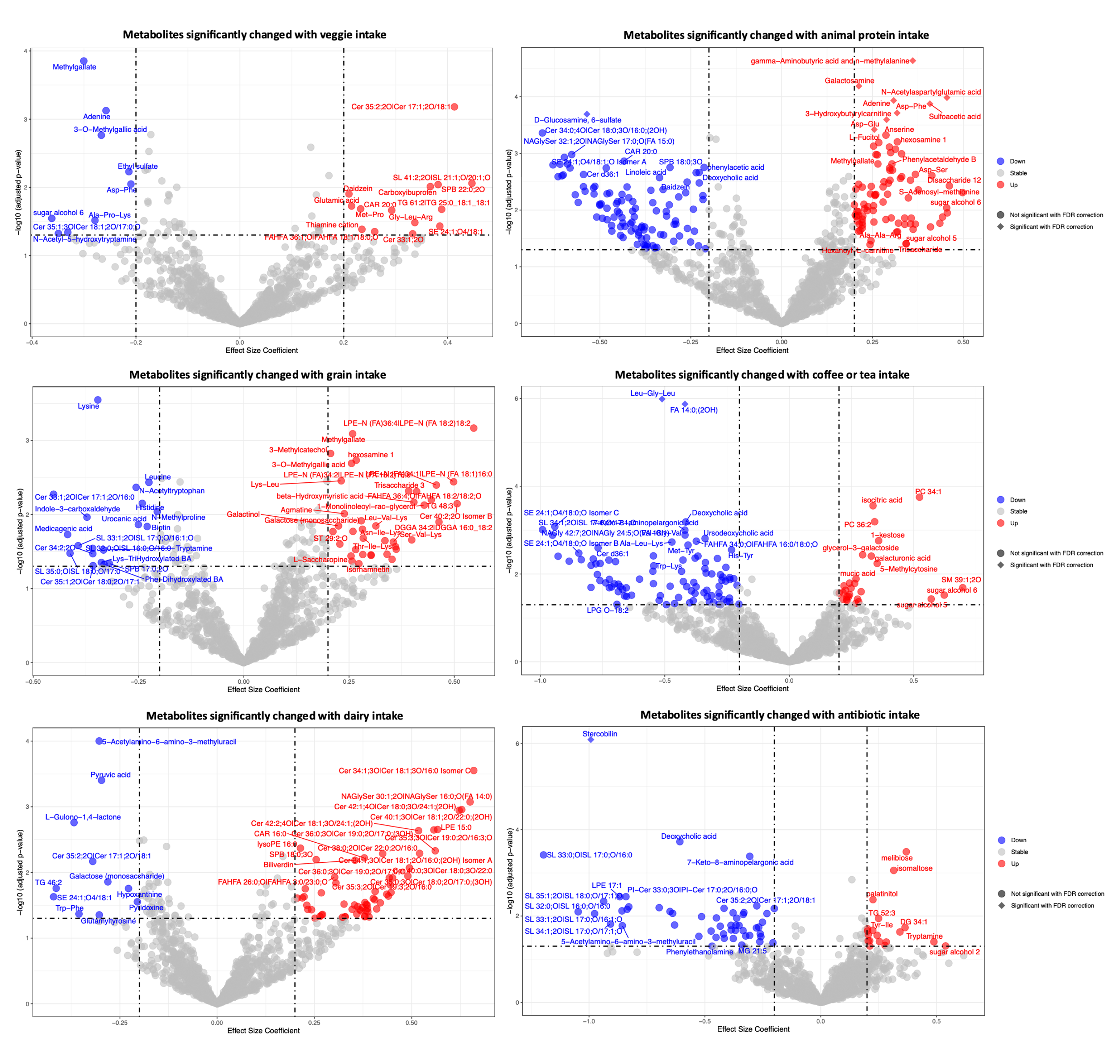
Figure S6. Intestinal metabolite association with food types. Volcano Plots show significance of each metabolite to food types of vegetable, animal protein, grain, coffee/ tea, dairy or antibiotics calculated by linear mixed effect model (LMM). Food consumption is considered for food eaten within 6 hours of swallowing sample devices (within 5 months for antibiotics). Significance of p < 0.05 is delimited by the lower dashed horizontal line. Circle shape for a metabolite indicates non-significant after false discovery rate (FDR) correction and diamond shape indicates significant (p<0.05) after FDR correction (n=1182). Metabolites detected in more than 50% of intestinal samples were included in this analysis. Effect size coefficient is the slope estimate calculated by LMM with positive coefficient meaning the metabolite was higher after food consumption, and negative coefficient meaning lower after food consumption. Vertical dashed lines are ±0.20 effect size coefficient.

Figure S7. Chemical classes significantly different after dietary intake of veggies, animal protein, grain, coffee/ tea, dessert, alcohol, dairy, antibiotics. Chemical enrichment statistics were performed by ChemRICH. Metabolites detected in more than 50% of intestinal samples were included in this analysis. These results are visualized by separating classes by chemical lipophilicity (logP) and chemical class significance level of -log10(p-value). Red circle indicates the chemical class was higher after food consumption, and blue indicates the chemical class was lower after food consumption. The size of circles references the size of the chemical class.

Figure S8. The number of metabolites that were significantly different between intestinal regions (device types) or between meals (sampling timepoints of 4 devices) were calculated for each subject by analysis of variance (ANOVA). Only metabolites detected in more than 50% of samples for each subject were used for this analysis. Non-FDR corrected p < 0.05 was used as significance value cutoff. (A) is the significant metabolites between different intestinal regions (device types) for each subject grouped by chemical class and the proportion of each chemical class is displayed for each subject. (B) is the significant metabolites between different sampling timepoints (group of four capsules swallowed after a meal) for each subject grouped by chemical class and the proportion of each chemical class is displayed for each subject.

Figure S9. Dendrograms of sample clustering separated by sample type (capsule type or stool). Dendrograms were calculated using correlation based hierarchical clustering of metabolites detected in more than 50% of capsule or stool samples for capsule type or stool dendrogram respectively.

Figure S10. Heatmap of metabolites with strong inter-subject differences. Data from all stool samples are shown. Metabolites include bile pigments, fatty acid esters of hydroxy fatty acids (FAHFAs and AAHFAs), short chain fatty acids, sulfonolipids (SLs), and secondary bile acids. Samples are organized by subject and antibiotic consumption is indicated for two subjects that consumed antibiotics 1 and 5 months prior to this study. Color of heatmap ranges from low (blue) to high (red) of metabolite abundance (peak height) or concentration (ng/mL) for bile acids. Minimum and maximum values are used to set color scale for each metabolite (each row).

Figure S11. Heatmap of FAHFAs, AAHFAs, and fatty acids with strong inter-subject differences in abundance. All capsule samples are shown. Metabolites are fatty acid esters of hydroxy fatty acids (FAHFAs and AAHFAs) and fatty acids detected in more than 50% of all capsule samples. Samples are organized by subject. Within the top (FAHFA) and lower (fatty acid) sections the metabolites are ordered based on hierarchical clustering. Color of heatmap ranges from low (blue) to high (red) of metabolite abundance (peak height) or concentration (ng/mL) for bile acids. Minimum and maximum values are used to set color scale for each metabolite (each row).

SUPPLEMENTAL METHODS

Ingestible capsule sampling device
The capsule sampling device (CapScan®, Envivo® Bio Inc, San Carlos, CA) consists of a one-way valve capping a hollow elastic collection bladder¹. The device is prepared for packaging by evacuating the collection bladder, folding it in half, and packaging the folded device inside a dissolvable capsule measuring 6.5 mm in diameter and 23 mm in length, onto which an enteric coating is applied. The capsule and the enteric coating prevent contamination of the collection bladder from oral-pharyngeal and gastric microbes during ingestion. When the device reaches the target pH, the enteric coating and capsule disintegrate. The target pH is pH 5.5 for type 1, pH 6 for type 2, and pH 7.5 for type 3 and type 4, with type 4 also having a time-delay coating to bias collection toward the ascending colon. After the enteric coating disintegrates, the collection bladder unfolds and expands into a tube 6 mm in diameter and 33 mm in length, thereby drawing in up to 400 µL of gut luminal contents through the one-way valve. The one-way valve maintains the integrity of the sample collected inside the collection bladder as the device moves through the colon and is exposed to stool.

In this study, subjects concurrently ingested sets of 4 capsules, each with distinct coatings to target the proximal to medial regions of the small intestine (coating types 1 and 2) and more distal regions (coating types 3 and 4). After sampling, the devices were passed in the stool into specimen-collection containers and immediately frozen. After completion of sampling, the stool was thawed, and the devices were retrieved by study staff. The elastic collection bladders were rinsed in 70% isopropyl alcohol and punctured with a sterile hypodermic needle attached to a 1-mL syringe for sample removal. Samples were transferred into microcentrifuge tubes and the pH was measured with an InLab Ultra Micro ISM pH probe (Mettler Toledo). A 40-µL aliquot was spun down for 3 min at 10,000 rcf, and its supernatant was used for metabolomics analysis. The rest of the sample was frozen until being thawed for DNA extraction.

Study design
The study was approved by the WIRB-Copernicus Group IRB (study #1186513) and informed consent was obtained from each subject. Healthy volunteers were selected to exclude participants suffering from clinically detectable gastrointestinal conditions or diseases that would potentially interfere with data acquisition and interpretation.

Subjects met all of the following criteria for study inclusion: (1) individuals between the ages of 18 and 70; (2) American Society of Anesthesiologists (ASA) physical status class risk of 1 or 2; (3) for women of childbearing potential, a negative urine pregnancy test within 7 days of screening visit, and willingness to use contraception during the entire study period; and (4) fluency in English, understands the study protocol, and is able to supply informed written consent, along with complying with study requirements.

Subjects with any of the following conditions or characteristics were excluded from the study: (1) history of any of the following: prior gastric or esophageal surgery, including lap banding or bariatric surgery, bowel obstruction, gastric outlet obstruction, diverticulitis, inflammatory bowel disease, ileostomy or colostomy, gastric or esophageal cancer, achalasia, esophageal diverticulum, active dysphagia or odynophagia, or active medication use for any gastrointestinal conditions; (2) pregnancy or planned pregnancy within 30 days from screening visit, or breast-feeding; (3) any form of active substance abuse or dependence (including drug or alcohol abuse), any unstable medical or psychiatric disorder, or any chronic condition that might, in the opinion of the investigator, interfere with conduct of the study; or (4) a clinical condition that, in the judgment of the investigator, could potentially pose a health risk to the subject while involved in the study.

Fifteen healthy subjects were enrolled in this study, and each swallowed at least 17 devices over the course of three days. Sample size was chosen to assess general variation across human intestinal tracts. Daily instructions included the following guidelines: record all foods and time they were consumed throughout the day; if you work out, do so in the morning; eat breakfast and lunch as usual; swallow a set of four devices three hours after lunch with up to 2/3 cup water; do not eat or drink anything for at least two hours after swallowing devices; if hungry after two hours, snack lightly (up to 200 calories); do not drink any caffeinated beverages after lunch until the next morning; collect all stool starting six hours after swallowing this set of devices until 48 hours after swallowing the next set of devices; eat dinner as usual at least six hours after lunch; swallow a set of four CapScan devices three hours after dinner with 2/3 cup water; after swallowing this set, do not eat or drink anything until the morning. Alcohol consumption and diet contents were not restricted. All ingested devices were recovered, and no adverse events were reported during the study. In total 274 capsule devices provided sufficient material for metabolomics analysis, and 225 provided sufficient volume or number of sequencing reads (>2500) for genomic analysis. Every bowel movement during the study was immediately frozen by the subject at -20 °C. Subject 1 provided additional samples for assessment of replicability and blooming. A total of 333 intestinal, and stool samples were analyzed with metabolomics methods.

Untargeted metabolomics sample preparation
Sample preparation was performed using a biphasic extraction² with water, methanol, and methyl tert-butyl ether to separate polar and non-polar metabolites. Capsule device supernatant and stool samples were prepared separately because device samples were liquid and stool samples were solid. For each supernatant sample, 10 µL were aliquoted into one well of a deep sample preparation 96-well plate in a pre-determined randomized order. Samples were extracted one 96-well plate at a time and all steps were carried out at 4 °C unless otherwise specified. Between every 10 experimental samples, a method blank and external QC sample were prepared. Blanks used 10 µL of LC-MS grade water instead of sample, and QC samples used 10 µL of a pooled sample of human gastrointestinal tract contents from unrelated studies. One hundred seventy microliters of methanol containing SPLASH LIPIDOMIX Mass Spec Standard (Avanti) were added to each well and the plate was heat-sealed with foil, shaken vigorously for 30 s at room temperature, unsealed, and 490 µL of methyl tert-butyl ether (MTBE) were added. The plate was then heat-sealed again, vortexed vigorously for 30 s at room temperature, and shaken for 5 min on an orbital shaker. The foil seal was removed and 150 µL of LC-MS grade water were added to each well. The plate was vortexed for 30 s at room temperature and centrifuged at 2400 rpm for 12 min. The foil was removed from the deep-well plate and two 180-µL aliquots of the top phase were transferred to two 96-well Vanquish LC plate using a 12-channel pipette. Two 50-µL aliquots of the aqueous phase were then transferred to two other 96-well Vanquish LC plates. All 96-well plates were dried completely under vacuum at room temperature, heat sealed with foil, and stored at -80 °C until further analysis. Each stool sample was prepared by mixing with spatula and 5±1 mg were transferred to a 2-mL microcentrifuge tube. Two hundred twenty-five microliters of methanol containing SPLASH LIPIDOMIX Mass Spec Standard (Avanti) were added to all microcentrifuge tubes and the tubes were vortexed for 10 s at room temperature. Seven hundred fifty microliters of MTBE and two 3-mm stainless steel balls were added to each tube and samples were homogenized in a Geno/Grinder (SPEX) at 1500 rpm for 1 min. One hundred eighty-eight microliters of water were added to each tube and each tube was vortexed for 30 s at room temperature. Tubes were centrifuged at 14,000 rcf for 2 min at room temperature. Two aliquots of 180 µL of the organic phase were transferred to two 96-well plates. Two 50-µL aliquots of the aqueous phase were transferred to two 96-well plates. All plates were dried completely in a rotary vacuum evaporator, heat-sealed with foil, and stored at -80 °C until further analysis.

HILIC LC-MS/MS analysis
Samples from the aqueous phase aliquots of sample preparation were removed from -80 °C and 35 µL of 8:2 acetonitrile/water containing 29 isotopically labeled and synthetic internal standards including CUDA³ were added to each well. The 96-well plates were then sealed with foil, vortexed vigorously for 30 s at room temperature, sonicated in a water bath for 5 min at room temperature, and centrifuged for 15 min at 2400 rpm. Plates were stored in an autosampler at 4 °C until analysis (maximum storage time in autosampler was 48 h). LC-MS/MS was performed with a Vanquish LC (Thermo Scientific) coupled to a QExactive HF⁺ orbital ion trap mass spectrometer (Thermo Scientific). Chromatographic separation was performed with a Waters Acquity UPLC BEH Amide column (150 mm length × 2.1 mm inner diameter (i.d.); 1.7-µm particle size) with a 5-mm pre-column (5 mm length × 2.1 mm i.d.; 1.7-µm particle size). Mobile phase A was 100% water and B was 95:5 acetonitrile/water. Both mobile phases were modified with 10 mM ammonium formate and 0.125% formic acid. Flow rate was 400 µL/min, column temperature was 45 °C and injection volume was 3 µL. The LC gradient was 100% mobile phase B from 0 to 2 min, 70% B by 7.7 min, 40% B by 9.5 min, 30% by 10.25 min, and returned to 100% B by 12.75 min to re-equilibrate until 17 min. All mobile phase gradient shifts were linear. Acetonitrile/water 1:1 was used as needle wash solvent before and after sample injection. Heated electrospray ionization (HESI) source conditions are as follows: sheath gas flow 50, auxiliary gas flow 13, sweep gas flow 3, capillary temperature 263 °C, S-lens RF level 50, auxiliary gas heater temperature 425 °C, and needle voltage 3500 V and -3500 V for positive and negative ionization mode, respectively. Spectra were collected with data-dependent MS/MS acquisition (DDA) for the top 4 ions. MS scans were collected with 60k resolving power from 60-900 m/z, AGC target of 10⁶ ions, and maximum accumulation time of 100 ms. MS/MS spectra were collected with 15k resolving power, 1 Da isolation window, 50 ms maximum accumulation time, a 3 s dynamic exclusion window, stepped (N)CE of 20, 30, 60 for fragmentation, and 8×10³ AGC target. All spectra were stored in centroid mode. Three rounds of iterative exclusion MS/MS were acquired for each pooled QC sample. Immediately after analysis the plates were dried under vacuum, sealed with foil, and stored at -80 °C.

Lipidomics LC-MS/MS analysis
Sample plates from the organic phase aliquots were removed from -80 °C and 50 µL of 9:1 acetonitrile/toluene were added to each well. The plates were then sealed with foil, vortexed vigorously for 30 s at room temperature, sonicated in a water bath for 5 min at room temperature, centrifuged for 15 min at 2400 rpm, and transferred to an autosampler kept at 4 °C until analysis (maximum storage time in autosampler prior to analysis was 48 h). Lipidomics LC-MS/MS analysis used a Thermo Scientific Vanquish LC system coupled to a Thermo Scientific QExactive HF⁺ orbital ion trap mass spectrometer. Chromatographic separation used a Waters Acquity UPLC CSH C18 column (100 mm length × 2.1 mm i.d.; 1.7-µm particle size) with a pre-column (5 mm length × 2.1 mm i.d.; 1.7-µm particle size). Mobile phase A was 9:1 acetonitrile/water and B was 8:2 IPA/acetonitrile. For positive-mode ESI, the mobile phases were modified with 10 mM ammonium formate and 0.1% formic acid. For negative-mode ESI, mobile phases were modified with 10 mM ammonium acetate. Flow rate was 600 µL/min, column temperature was 65 °C, and injection volume was 5 µL. The mobile phase gradient was 15% B from 0 to 0.6 min, 30% B by 2 min, 48% B by 2.5 min, 82% B by 11 min, 99% B from 11.5 to 12 min, and 15% B from 12.1 to 14.2 min. HESI source conditions are as follows: sheath gas flow 55, auxiliary gas flow 15, sweep gas flow 3, capillary temperature 275°C, S-lens RF level 50, auxiliary gas heater temperature 450 °C, and needle voltage 3500 V and -3500 V for positive and negative ionization mode, respectively. DDA MS/MS spectra were acquired for the top 4 ions. MS scans were collected with 60k resolving power from 120-1700 m/z, AGC target of 10⁶ ions, and maximum accumulation time of 100 ms. MS/MS spectra were collected with 15k resolving power, 1 Da isolation window, normalized collision energy of 20, 30, 60, 2 s dynamic exclusion window, 8×10³ AGC target, and 50 ms maximum accumulation time. Spectra were stored in centroid mode. Three rounds of iterative exclusion MS/MS were acquired for each pooled QC sample. Immediately after all samples were analyzed, the plates were dried under vacuum, sealed with foil, and stored at -80 °C.

Untargeted GC-MS analysis
Dried aqueous phase samples as described in the above section on untargeted HILIC ESI- analyses were removed from -80 °C and 10 µL of 40 mg/mL methoxyamine hydrocholoride in pyridine were added to each well. The plates were sealed and shaken at 30 °C for 90 min. Foil was removed and 90 µL of N-methyl-N-trimethylsilyl trifluoroacetamide (containing internal standards of C8-C30 fatty acid methyl esters (FAMEs)) were added to each well and plates were shaken for 30 min at 37 °C. The plate was then centrifuged at 2400 rcf for 15 min at room temperature. Foil was removed and 90 µL of supernatant were transferred to glass crimp-top vials with glass insert and crimped shut. Samples were analyzed within 48 h of derivatization. GC-MS analysis was carried out as previously described⁴. Briefly, 0.5 µL were analyzed in split-less mode through an Agilent 6890 GC equipped with a RTx-5Sil MS column (30 m × 0.25mm i.d., 0.25 µm 95:5 dimethyl/diphenyl polysiloxane film). Chromatography used helium at 1 mL/min and temperature gradient of 50 °C to 275 °C. MS analysis was performed using a Leco Pegasus III TOF MS. Spectra were collected at 17 spectra/s with 70 eV EI. Data files were pre-processed in Leco ChromaTOF software and further analyzed using the automated GC-MS data processing pipeline BinBase⁵ that used FiehnLib for spectra and retention time matching.

Bile acid quantification
Bile acids were targeted and quantified as previously reported¹. Briefly, dried aqueous-phase sample plates from HILIC ESI+ analysis were removed from a -80 °C freezer and dissolved in 60 µL of bile acid run solvent (1:1 ACN/MeOH containing 100 ng/mL of 5 isotopically labeled bile acid internal standards). Plates were vortexed for 30 s and sonicated in a water bath for 5 min. All samples were diluted 30-fold in bile acid run solvent. All plates were centrifuged at 2400 rpm for 15 min at 4 °C and stored in a Vanquish autosampler at 4 °C until analysis. A nine-point standard curve was prepared between 0 to 1500 ng/mL and analyzed with samples. A Vanquish UPLC and Altis QqQ mass spectrometer (ThermoFisher Scientific) were used for targeted LC-MS/MS analysis. An Acquity BEH C18 column (100 mm × 2.1 mm, 1.7 µm) (Waters) was used with mobile phase A of water and B of acetonitrile, both with 0.1% formic acid. Skyline software and custom R scripts were used to process and quantify bile acid analytes.

Short-chain fatty acid quantification
SCFA quantification was performed through derivatization with N-tert-Butyldimethylsilyl-N-methyltrifluoroacetamide (MTBSTFA) based on a previously reported protocol⁶. Briefly, 10 µL of intestinal supernatant were transferred to a 1.5-mL microcentrifuge tube on ice, pre-filled with 50 µL of LC-MS grade water containing deuterium-labeled SCFA internal standards and 10 µL of 37% hydrochloric acid. One hundred microliters of MTBE also containing deuterium-labeled SCFA internal standards were added to each tube and the tubes were shaken on rotary shaker plate for 30 min at room temperature. Tubes were centrifuged at 14,000 rcf for 2 min and 20 µL of MTBE (top layer) were transferred to a crimp-top GC-MS vial fitted with low recovery insert. Five microliters of MTBSTFA were added to each vial, which was then sealed. Vials were shaken on an orbital shaker plate for 30 min at 80 °C, cooled to room temperature, and analyzed by GC-MS. An Agilent 6890 GC coupled to a Leco Pegasus IV TOF MS was used with a DB5 duraguard (30 m × 0.25 mm × 0.25 µm) capillary column. One microliter was injected with 1:10 split mode enabled, helium flow rate of 1.2 mL/min, temperature ramped from 50 °C to 290 °C over 20.8 min, and scan rate of 17 spectra per min from 50-550 m/z. A 6-point standard curve between 1 and 100 µg/mL was analyzed for every 80 samples and blank samples were analyzed between every 10 experimental samples. Samples and standard curve mixes were prepared within 24 h of GC-MS analysis. Data was converted to .d format and processed using Agilent MassHunter Quant v. B.09.00. Linear 6-point standard curves using ratio of analyte to internal standard were used to quantify SCFAs in experimental samples.

Untargeted LC-MS/MS data processing
MS-DIAL v. 4.80⁷ was used to process untargeted LC-MS/MS data. HILIC LC-MS/MS (ESI+ and ESI-) and lipidomics (ESI+ and ESI-) datasets were processed with manually optimized parameters (Table S9). Peak height was reported for all untargeted analyses. Experimental MS/MS spectra were matched to MassBank of North America as well as NIST20 spectral libraries for HILIC analyses, and all lipid reference MS/MS spectra from MS-DIAL used for lipidomics analyses. Retention time information for HILIC and lipidomics from authentic standards run under identical chromatography conditions was used as another line of evidence for metabolite annotation. Metabolite annotations were based on accurate mass matching with retention time and/or an MS/MS match to a library spectrum. Blank subtraction was performed by retaining LC-MS features for which the maximum intensity from an experimental sample was ≥10 times as high as the average of the method blanks, along with further data reduction as described in Table S2. The final step of data processing was manual investigation of annotated features for MS/MS match quality, peak quality, peak alignment, and removal of in-source fragments using correlation between features with close retention time for in-source fragment identification. When multiple metabolites from spectral libraries matched one experimental MS/MS, the match was recorded as a non-unique MS/MS match (Table S1). Predicted retention times calculated using ReTip⁸ were used as an additional line of evidence to flag low quality annotations.

DNA extraction and 16S rRNA gene sequence analysis
DNA was extracted using a Microbial DNA extraction kit (Qiagen)⁹ and 50 µL from a capsule device, 200 µL of saliva, or 100 mg of stool. 16S rRNA amplicons were generated using Earth Microbiome Project-recommended 515F/806R primer pairs and 5PRIME HotMasterMix (Quantabio 2200410) with the following program in a thermocycler: 94 °C for 3 min, 35 cycles of [94 °C for 45 s, 50 °C for 60 s, and 72 °C for 90 s], followed by 72 °C for 10 min. PCR products were cleaned, quantified, and pooled using the UltraClean 96 PCR Cleanup kit (Qiagen 12596-4) and Quant-iT dsDNA High Sensitivity Assay kit (Invitrogen Q33120). Samples were sequenced with 300-bp reads on a MiSeq instrument (Illumina).

Sequence data were de-multiplexed using the Illumina bcl2fastq algorithm at the Chan Zuckerberg BioHub Sequencing facility. Subsequent processing was performed using the R statistical computing environment (v. 4.0.3)¹⁰ and DADA2 as previously described using pseudo-pooling¹¹. truncLenF and truncLenR parameters were set to 250 and 180, respectively. Taxonomy was assigned using the Silva rRNA database v. 132¹². Samples with >2500 reads were retained for analyses.

Statistics and data analysis
Statistical tests were performed using R¹⁰. Linear mixed effect models (LMMs) were performed using the lmerTest and lme4 R packages. To examine spatial differences across the intestine, we applied LMMs that accounted for sampling location (proximal (device types 1 and 2) or distal (device types 3 and 4)), 8 food types classified from food logs (vegetable, animal protein (meat, egg, fish), grain (rice, pasta, bread, other grain), coffee or tea, dessert, alcohol (beer, wine, alcoholic seltzer), dairy, and fruit), and antibiotic consumption within 6 months as fixed effect variables, and inter-subject variation as a random effect variable (Table S3, S4). Food types were manually assigned from subjects’ written food logs using customized assessment forms. Metabolite abundances were Log₁₀ transformed and missing values treated as zeros, followed by scaling from -1 and 1 prior to LMM analysis. Benjamini-Hochberg¹³ was used to account for multiple-hypothesis testing. Correlations between the microbiota and a subset of metabolites (both log₁₀-scaled) were calculated at the ASV-level using Pearson’s correlation with Benjamini-Hochberg corrected p-values. To calculate differentially abundant ASVs based on the presence or absence of a metabolite, Limma-Voom in R was used. Only taxa with an Benjamini-Hochberg corrected p < 0.05 and absolute differential abundance greater than 0.75 were considered. ChemRICH¹⁴ was used to calculate enrichment statistics. Clustering was performed using the hclust function with the metabolite Spearman rank correlation matrix calculated using the cor function in R and Euclidean distance calculated with the as.dist function in R. PLS-DA and PCA were performed with the ropls package in R. Untargeted LC-MS/MS (HILIC and RP ESI+/-) features were normalized to the summed intensity of internal standards for each platform. GC-MS data was normalized to the summed intensity of all annotated metabolites. Log₁₀ transformation and zero-value imputation using 1/10 of the minimum reported peak height for non-detected features was performed for each metabolite prior to PCA and PLS-DA.
Supplemental References

1 Shalon, D. et al. Profiling of the human intestinal microbiome and bile acids under physiologic conditions using an ingestible sampling device. bioRxiv (2022).
2 Matyash, V., Liebisch, G., Kurzchalia, T. V., Shevchenko, A. & Schwudke, D. Lipid extraction by methyl-tert-butyl ether for high-throughput lipidomics. J Lipid Res 49, 1137-1146, doi:10.1194/jlr.D700041-JLR200 (2008).
3 Barupal, D. K. et al. A Comprehensive Plasma Metabolomics Dataset for a Cohort of Mouse Knockouts within the International Mouse Phenotyping Consortium. Metabolites 9, doi:10.3390/metabo9050101 (2019).
4 Beaudoin, G. A. W. et al. Salvage of the 5-deoxyribose byproduct of radical SAM enzymes. Nat Commun 9, 3105, doi:10.1038/s41467-018-05589-4 (2018).
5 Skogerson, K., Wohlgemuth, G., Barupal, D. K. & Fiehn, O. The volatile compound BinBase mass spectral database. BMC Bioinformatics 12, 321, doi:10.1186/1471-2105-12-321 (2011).
6 Nusbaum, D. J. et al. Gut microbial and metabolomic profiles after fecal microbiota transplantation in pediatric ulcerative colitis patients. FEMS Microbiol Ecol 94, doi:10.1093/femsec/fiy133 (2018).
7 Tsugawa, H. et al. A lipidome atlas in MS-DIAL 4. Nat Biotechnol 38, 1159-1163, doi:10.1038/s41587-020-0531-2 (2020).
8 Bonini, P., Kind, T., Tsugawa, H., Barupal, D. K. & Fiehn, O. Retip: Retention Time Prediction for Compound Annotation in Untargeted Metabolomics. Anal Chem 92, 7515-7522, doi:10.1021/acs.analchem.9b05765 (2020).
9 Celis, A. I. et al. Optimization of the 16S rRNA sequencing analysis pipeline for studying in vitro communities of gut commensals. iScience 25, 103907, doi:10.1016/j.isci.2022.103907 (2022).
10 Team, R. C. R: A language and environment for statistical computing. R Foundation for Statistical Computing, Vienna, Austria. http://www. R-project. org/ (2013).
11 Callahan, B. J. et al. DADA2: High-resolution sample inference from Illumina amplicon data. Nat Methods 13, 581-583, doi:10.1038/nmeth.3869 (2016).
12 Quast, C. et al. The SILVA ribosomal RNA gene database project: improved data processing and web-based tools. Nucleic Acids Res 41, D590-596, doi:10.1093/nar/gks1219 (2013).
13 Benjamini, Y. & Hochberg, Y. Controlling the False Discovery Rate: A Practical and Powerful Approach to Multiple Testing. J. R. Stat. Soc. B 57, 289-300 (1995).
14 Barupal, D. K. & Fiehn, O. Chemical Similarity Enrichment Analysis (ChemRICH) as alternative to biochemical pathway mapping for metabolomic datasets. Sci Rep 7, 14567, doi:10.1038/s41598-017-15231-w (2017).

