Supplementary information

Vertical hydrologic exchange flows control methane emissions from riverbed sediments
Kewei Chen¹*, Xingyuan Chen², James Stegen², Jorge A. Villa³, Gil Bohrer⁴, Xuehang Song², Kuang-Yu Chang⁵, Matthew Kaufman², Xiuyu Liang¹, Zhiling Guo¹, Eric Roden⁶*, Chunmiao Zheng¹*

Affiliations:
¹ School of Environmental Science and Engineering, Southern University of Science and Technology, Shenzhen, China
² Pacific Northwest National Laboratory, Richland, WA, USA
³ School of Geosciences, University of Louisiana at Lafayette, Lafayette, LA, USA
⁴ Department of Civil, Environmental and Geodetic Engineering, Ohio State University, OH, USA
⁵ Climate and Ecosystem Sciences Division, Lawrence Berkeley National Laboratory, Berkeley, CA, USA
⁶ Department of Geoscience, University of Wisconsin, Madison, WI, USA

Correspondence to:
Kewei Chen: chenkw@ sustech.edu.cn
Eric Roden: eroden@geology.wisc.edu
Chunmiao Zheng: zhengcm@sustech.edu.cn
- Microorganism growth
The methodology of calculating the proportions of electrons in anabolic cell synthesis reaction and catabolic energy reaction follows Rittmann and McCarty (2001) and McCarty (2007). The energy balance of electron flow among electron donors (EDs), terminal electron acceptors (TEAs) and biomass can be expressed as,
$A=\frac{f_{e}}{f_{s}}=\frac{-ΔG_{s}}{εΔG_{r}},$ (S1)
where A is the relative distribution of electrons over energy reaction and synthesis reaction; $ΔG_{r}$ is the free energy released per equivalent of donor oxidized; $ΔG_{s}$ is the energy required to synthesize one equivalent of cells using ammonium as the nitrogen source and ε is the energy-transfer efficiency. $ΔG_{r}$ is,
$ΔG_{r}=ΔG_{a}^{0'}-ΔG_{d}^{0^{'}},$ (S2)
where $ΔG_{a}^{0'}$ and $ΔG_{d}^{0^{'}}$ are the free energy of half reaction for ED and TEA at standard condition (1 atm, pH=7), respectively. $ΔG_{s}$ consists of two parts, the energy of converting carbon source to organic intermediate, $ΔG_{p}$, and then to cellular carbon, $ΔG_{pc}$. Here we use pyruvate with free energy of 35.09 kJ/e⁻ eq as the representative intermediate. Thus $ΔG_{p}$ can be represented as the difference between the free energy of the pyruvate half-reaction and that of the carbon source, $ΔG_{c}^{0'}$,
$ΔG_{p}=35.09-ΔG_{c}^{0^{'}}.$ (S3)
For H2-related autotrophic reactions, no carbon source serves as ED and the half-reaction of water-oxygen in photosynthesis (-78.2 kJ/e⁻ eq at 298K) is used instead. $ΔG_{pc}$ is 18.8 kJ/e- eq when using ammonium as the nitrogen source. Thus,
$ΔG_{s}=\frac{ΔG_{p}}{ε^{n}}+\frac{ΔG_{pc}}{ε},$ (S4)
where n is an integer that accounts for the fact that formation of pyruvate may release energy for some electron donors (e.g., n=-1 for glucose) and consume energy for others (e.g., n=+1 for acetate). Once A is obtained, f_{s} and f_{e} can be calculated according to,
$f_{s}+f_{e}=1.$ (S5)

- Microbial functional group
Ten microbial functional groups are selected to represent the primary pathways occurring in hyporheic zone under dynamic redox condition. Methane production is induced by aceticlastic and hydrogenotrophic methanogen, and methane oxidation occurs due to the existence of methanotroph. Three aerobes that consume low molecular substrates are considered, corresponding to C₆H₁₂O₆, CH3COO- and H₂, respectively. These three microbial groups are assumed to be able to utilize NO₃⁻ as the TEA under anaerobic condition. Two microbial groups are considered for Fe(III)(s) and SO₄²⁻ reduction using CH₃COO- and H₂ as substrates, respectively. It is noteworthy that a particular species of bacterial/archaea is not tied to a certain reaction exclusively. For example, most methanogens can reduce CO₂ with H₂ as the electron donor. However, only two genera, ﻿Methanosarcina and Methanosaeta, are known to consume CH₃COO⁻. In particular, Methanosarcina also use H₂ as the alternative electron donor, but Methanosaeta can only use CH3COO- (Liu and Whitman, 2008). For iron reducer, all genera in the family Geobacteraceae except Pelobacter use CH₃COO⁻ as the primary substrate, and most of them can also use H₂ as the electron donor for iron reduction.
- Hydro-thermal-biogeochemical model built by PFLTORAN (Hammond et al., 2014)
3.1 Flow
Richards’ equation was applied to simulate groundwater flow beneath sediment-water interface. The governing equation is,
$\frac{∂}{∂t}\left(φsη\right)+∇∙\left(ηq\right)=Q_{w},$ (S6)
where φ is porosity; s is saturation of which 1 represents saturated condition; η is molar water density [kmol/m3], Q_{w} is source/sink [kmol/m3s] and q is Darcy’s flux [m/s]. q is calculated according to Darcy’s law,
$q=\frac{kρ_{w}g}{μ_{w}}\frac{dh}{dl},$ (S7)
where k is permeability [m²]; ρ_{w} is water density[kg/m3]; μ_{w} is water viscosity [kg/(ms)] and dh/dl is hydraulic gradient.

  - Heat transport
The governing equation of heat transport is,
$\frac{∂}{∂t}\left[φsηU+\left(1-φ\right)ρ_{r}c_{p}T\right]+∇∙\left(ηqH-κ∇T\right)=Q_{e},$ (S8)
where Q_{e} is source/sink term of energy [J/m³K]; U is fluid internal energy [J/kg]; ρ_{r} is rock density [kg/m3]; κ is thermal conductivity of sediments [J/(mKs)] and c_{p} is specific heat capacity [J/(kgK)].

  - Reactive transport
$\frac{∂}{∂t}\left(φsC_{j}\right)+∇∙Ω_{j}=-\sum_{n}{ν_{jn}M_{n}},$ (S9)
$\frac{∂S_{k}}{∂t}={β_{kn}M}_{n},$ (S10)
$Ω_{j}=\left(q-φsD∙∇\right)C_{j},$ (S11)
$D=τD_{m}+α_{L}v,$ (S12)
where C_{j} is the concentration of mobile species j [mol/L]; Ω_{j} is the flux of jth species [mol/L/s]; ν_{jn} is the stoichiometry of jth species with respect to the nth reaction; M_{n} is the reaction rate of the nth reaction [mol/L/s]; s_{k} is the concentration of immobile species k, including POC, sediment-associated Fe and biomass [mol/m³-bulk]; β_{kn} is the stoichiometry of kth species with respect to the nth reaction; $τ$ is tortuosity; D_{m} is molecular diffusion coefficient [m²/s]; $α_{L}$ is longitudinal dispersivity [m] and v is the value of Darcy velocity [m/s].

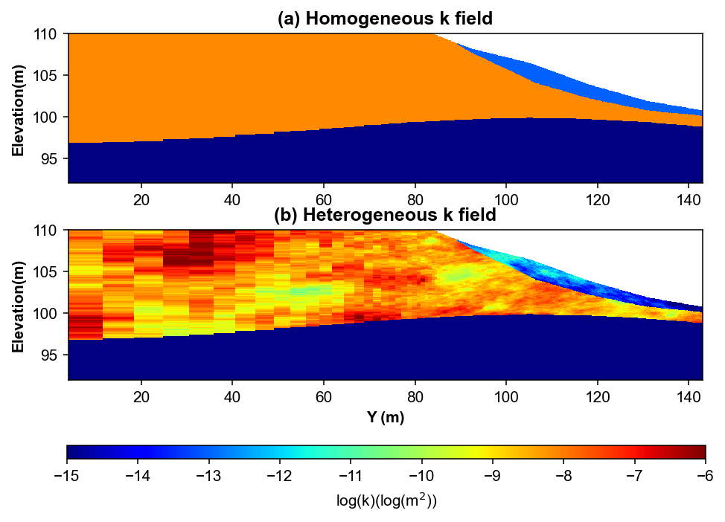
Supplementary Figure 1. Permeability field of the cross section between groundwater well and river gauge. (a) Homogeneous permeability field of Hanford formation, Ringold formation and the alluvial sediment with the value of 7.387×10⁻⁹, 1.0×10⁻¹⁵ and 1.0×10⁻¹³ m², respectively. (b) Heterogeneous permeability field of Hanford formation and the alluvial sediment generated by unconditional geostatistical simulation. The hydraulic, thermal, and geostatistical parameters are given in Supplementary Table S1.
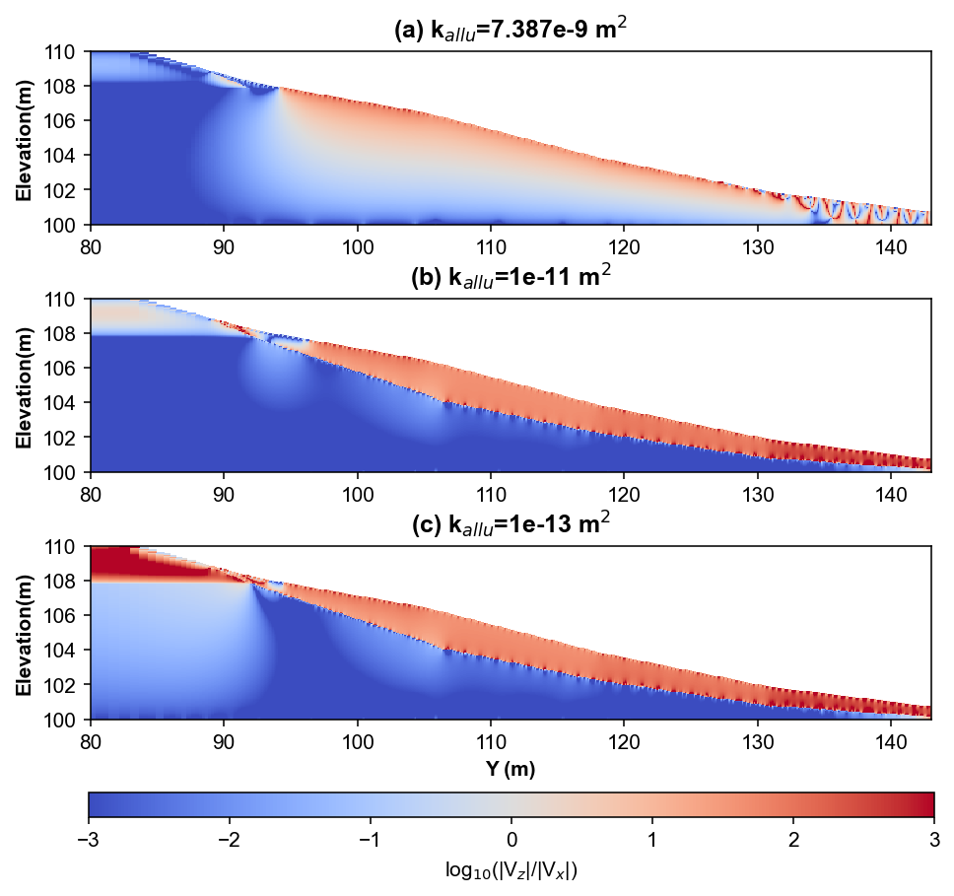
Supplementary Figure 2. Simulated spatial profiles of log(|V_{z}|/|V_{x}|) on 6/1/2018 assuming permeability field of the alluvial sediment is homogeneous. Three permeability values for the alluvium sediment, including 7.387×10⁻⁹ (a), 1.0×10⁻¹¹ (b) and 1.0×10⁻¹³ (c), are considered with permeability of Hanford and Ringold formation set to be 7.387×10⁻⁹, 1.0×10⁻¹⁵ m², respectively.

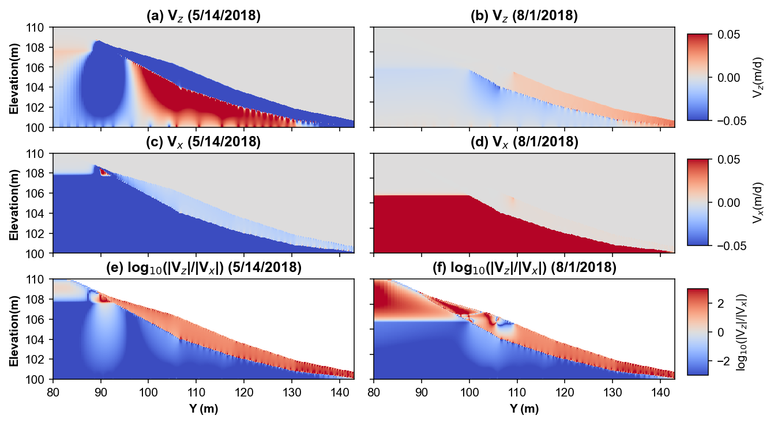
Supplementary Figure 3. Simulated spatial profiles of vertical flux (V_{z}), lateral flux (V_{x}) and log₁₀(|V_{z}|/|V_{x}|) under high (left, 5/14/2018) and low (right, 8/1/2018) river stage conditions. Positive V_{z} and V_{x} represent flow directions toward top and right, respectively. Permeability field of Hanford formation, Ringold formation and the alluvial sediment are assumed to be homogeneous as 7.387×10⁻⁹, 1.0×10⁻¹⁵ and 1.0×10⁻¹³ m², respectively.

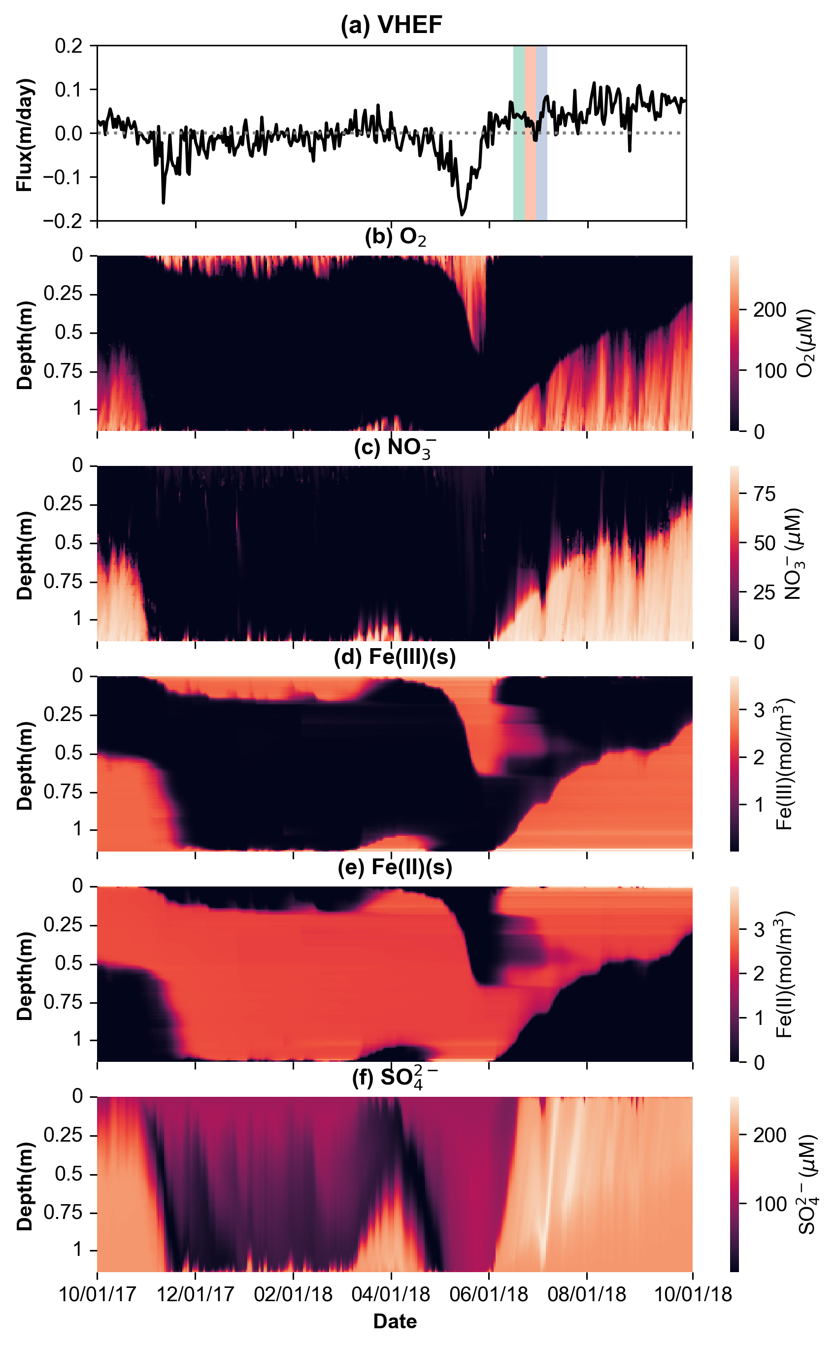
Supplementary Figure 4. Simulated spatiotemporal profiles of terminal electron acceptor concentration between 10/01/2017-10/01/2018 for the calibrated base case (deep-water depth). (a) Depth-averaged flux; the green, pink and purple zones correspond to the pre-falling, falling and post-falling stages in Figure 6, respectively; (b-e) the depth profile of O₂ concentration (b), NO₃⁻ concentration (c), Fe(III)(s) concentration (d), Fe(II)(s) concentration (e) and SO₄²⁻ concentration (f).
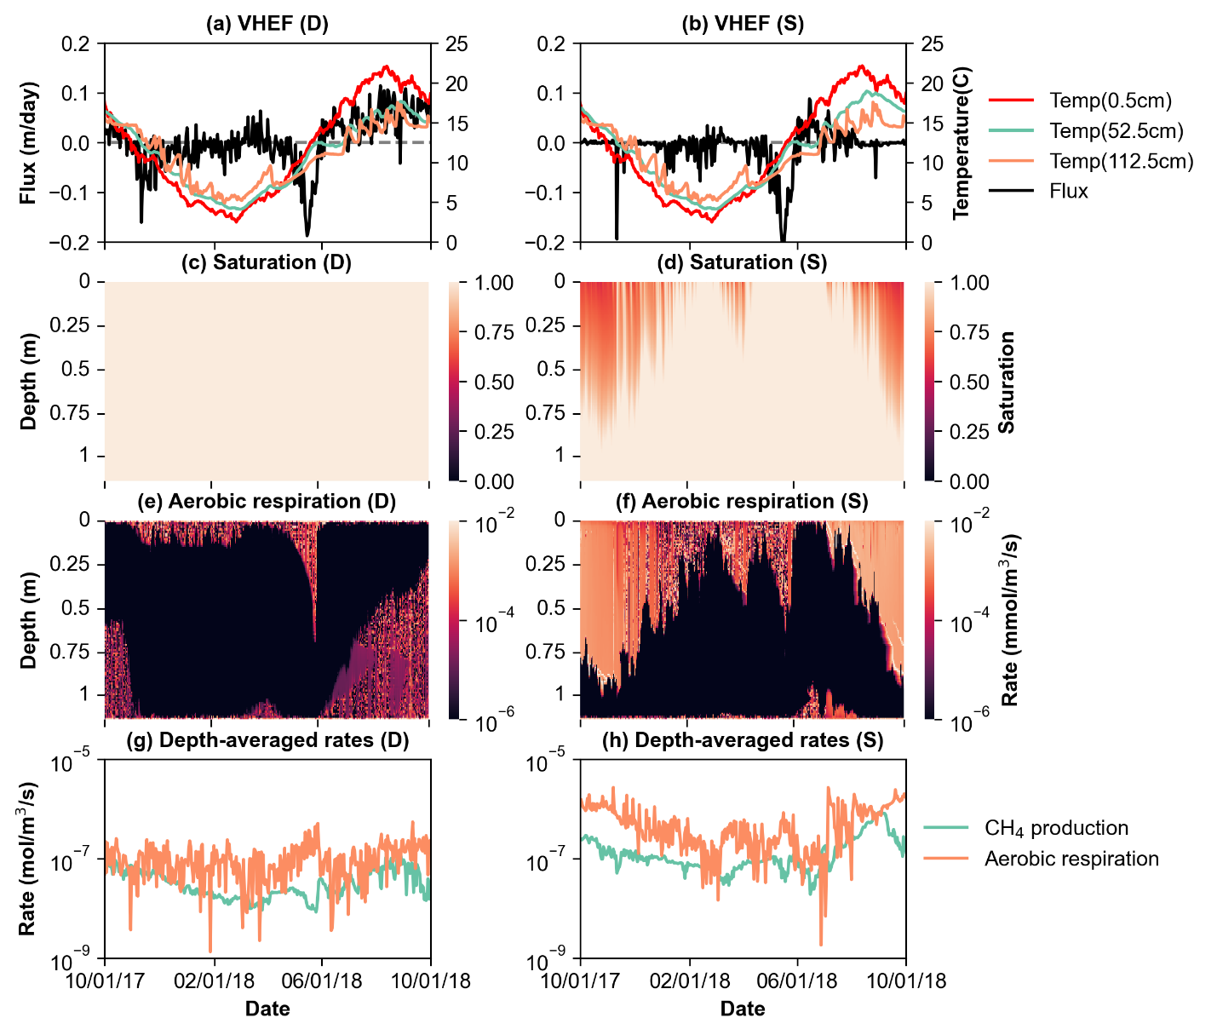
Supplementary Figure 5. Simulated spatiotemporal profiles of sediment saturation and aerobic respiration rate. The left and right panels are from the calibrated models at the deep (D) and shallow (S) locations, respectively. (a-b) Simulated depth-averaged fluid flux (positive: upwelling) and temperature at the depths of 0.5, 52.5 and 112.5 cm; (c-d) sediment saturation profile; (e-f) the depth profile of aerobic respiration rate; (g-h) the depth-averaged CH₄ production rate and aerobic respiration rate.
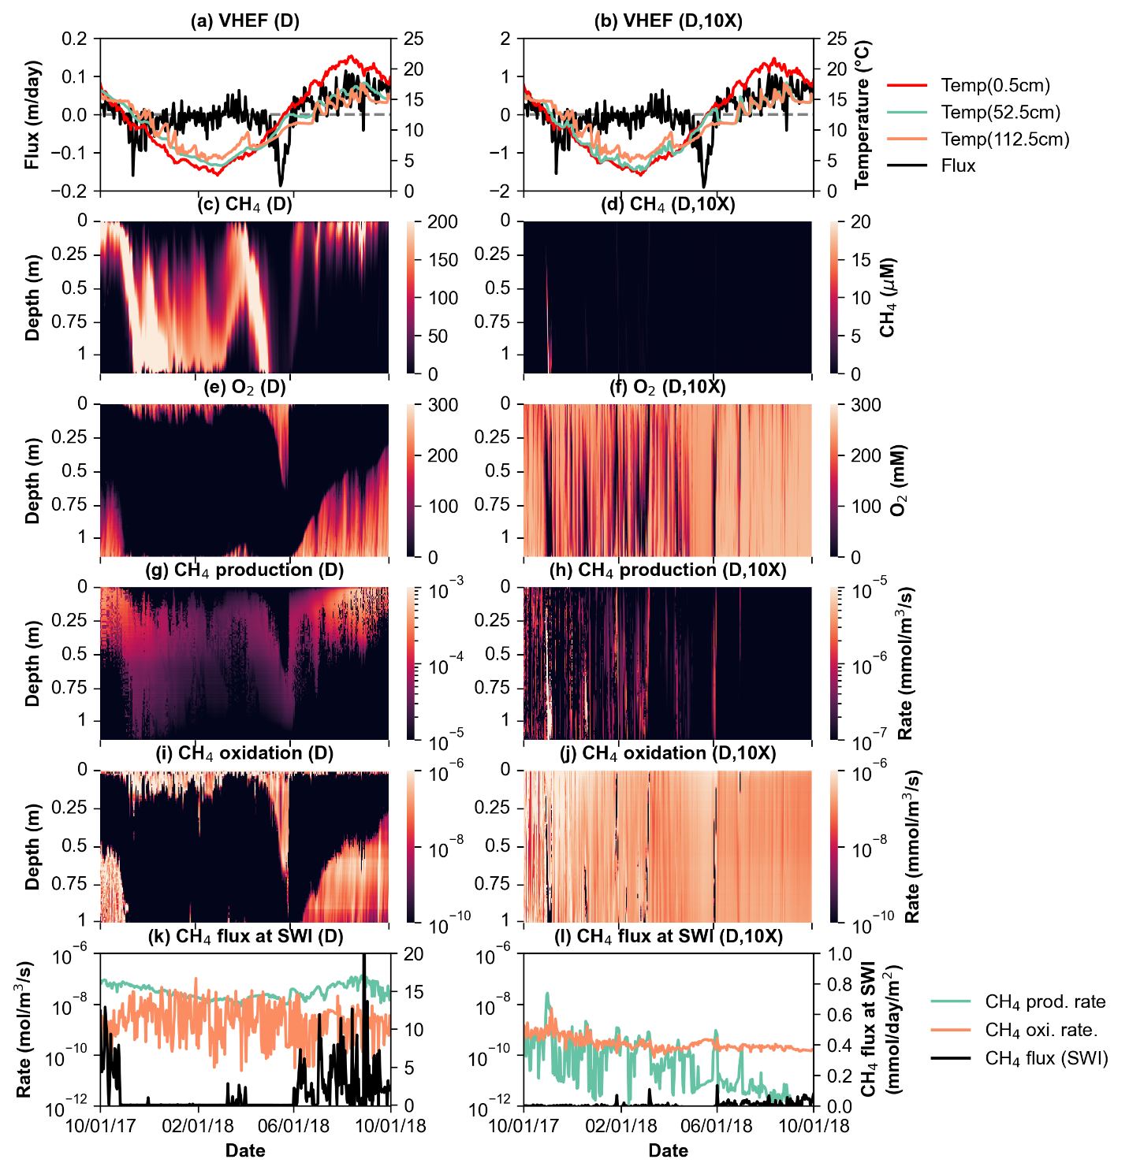
Supplementary Figure 6. Simulated spatiotemporal profiles related to CH₄ production, oxidation and emissions from the SWI between 10/1/2017 and 10/1/2018. The left (reproduced from Fig. 4) and right panels are from the base case (deep-water depth, D) and the base case with 10-fold higher permeability (D, 10X), respectively. (a-b) Simulated depth-averaged fluid flux (positive: upwelling) and temperature at the depths of 0.5, 52.5 and 112.5 cm; (c-d) the depth profile of CH₄ concentration; (e-f) the depth profile of O₂ concentration; (g-h) the depth profile of CH₄ production rate (acetoclastic methanogenesis and hydrogenotrophic methanogenesis); (i-j) the depth profile of CH₄ oxidation rate; (k-l) the depth-averaged CH₄ production rate (green), CH₄ oxidation rate (orange) and CH₄ flux at the SWI (black).

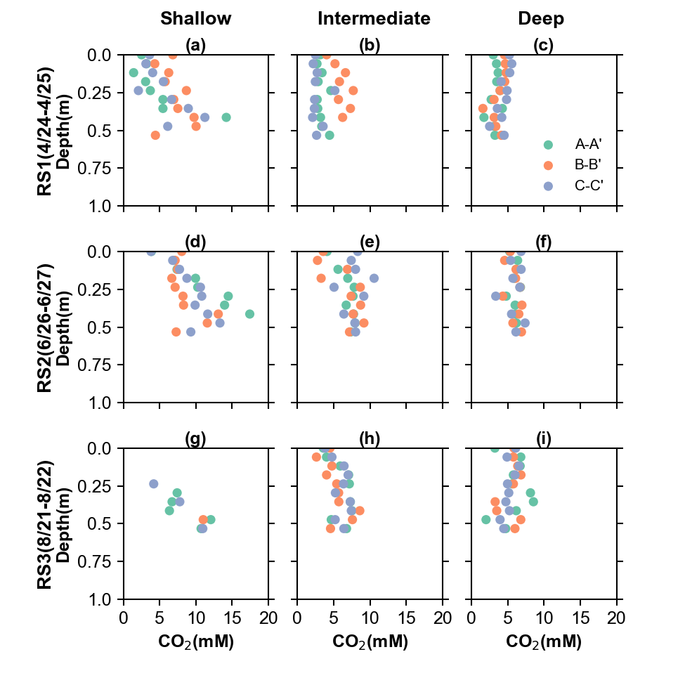
Supplementary Figure 7. Measured porewater CO₂ concentration at nine sampling locations during three field campaign. (a-c) Measured CO₂ pore concentration on 4/24/2018-4/25/2018 at shallow-, intermediate-, and deep-water depth, respectively. There are three replicates (A, B and C) for each case. (d-f) Measured CO₂ pore concentration on 6/26/2018-6/27/2018 at shallow-, intermediate-, and deep-water depth, respectively. (g-i) Measured CO₂ pore concentration on 8/21/2018-8/22/2018 at shallow-, intermediate- and deep-water depth, respectively. Note that sediments were exposed to air at shallow-water depth in (g).

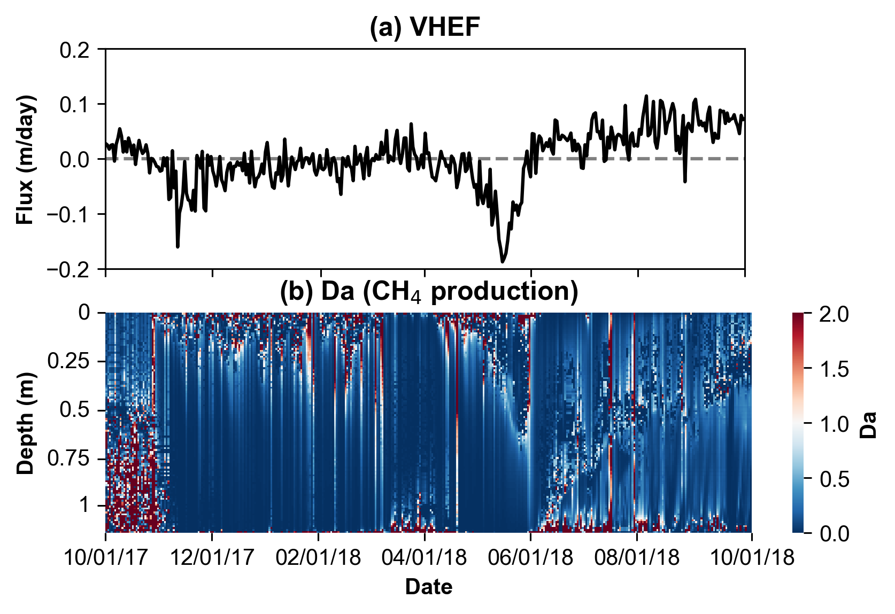
Supplementary Figure 8. Simulated spatiotemporal profile of Damköhler number (Da) between 10/01/2017-10/01/2018 for the base case (deep-water depth). (a) Depth-averaged flux; (b) Da for CH₄ production.

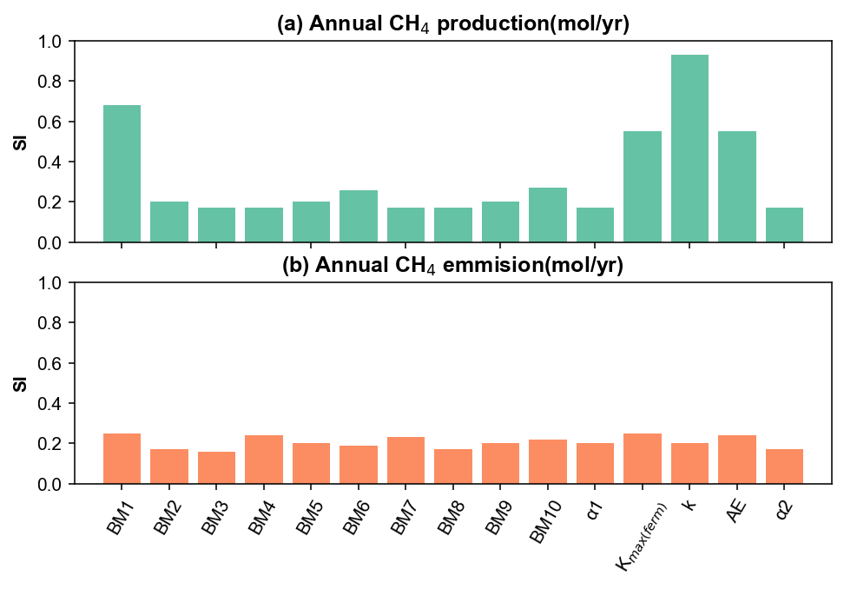
Supplementary Figure 9. Sensitivity index (SI) of 15 parameters with respect to annual CH₄ production (a) and annual CH₄ emission (b). BM1-10 correspond to acetoclastic methanogenesis (rxn 4), hydrogenotrophic methanogenesis (rxn 5), CH₄ oxidation (rxn 6), C₆H₁₂O₆ oxidation by O₂/NO₃⁻ (rxn 7 and 10), CH₃COO⁻ oxidation by O₂/NO₃⁻ (rxn 8 and 11), H₂ oxidation by O₂/NO₃⁻ (rxn 9 and 12), CH₃COO⁻ oxidation by Fe(III)(s) (rxn 14), H₂ oxidation by Fe(III)(s) (rxn 16), CH₃COO⁻ oxidation by SO₄²⁻ (rxn 17) and H₂ oxidation by SO₄²⁻ (rxn 18), respectively.α₁ is the rate constant from POC to DOC (rxn 1); α₂ is the rate constant from DOC to C₆H₁₂O₆ (rxn 2); K_{max(ferm)} is the fermentation rate constant (rxn 3); AE is the activation energy for CH₄ production (rxn 4 and 5) and k is permeability. Reaction number (rxn) is referred to supplementary Table 3.

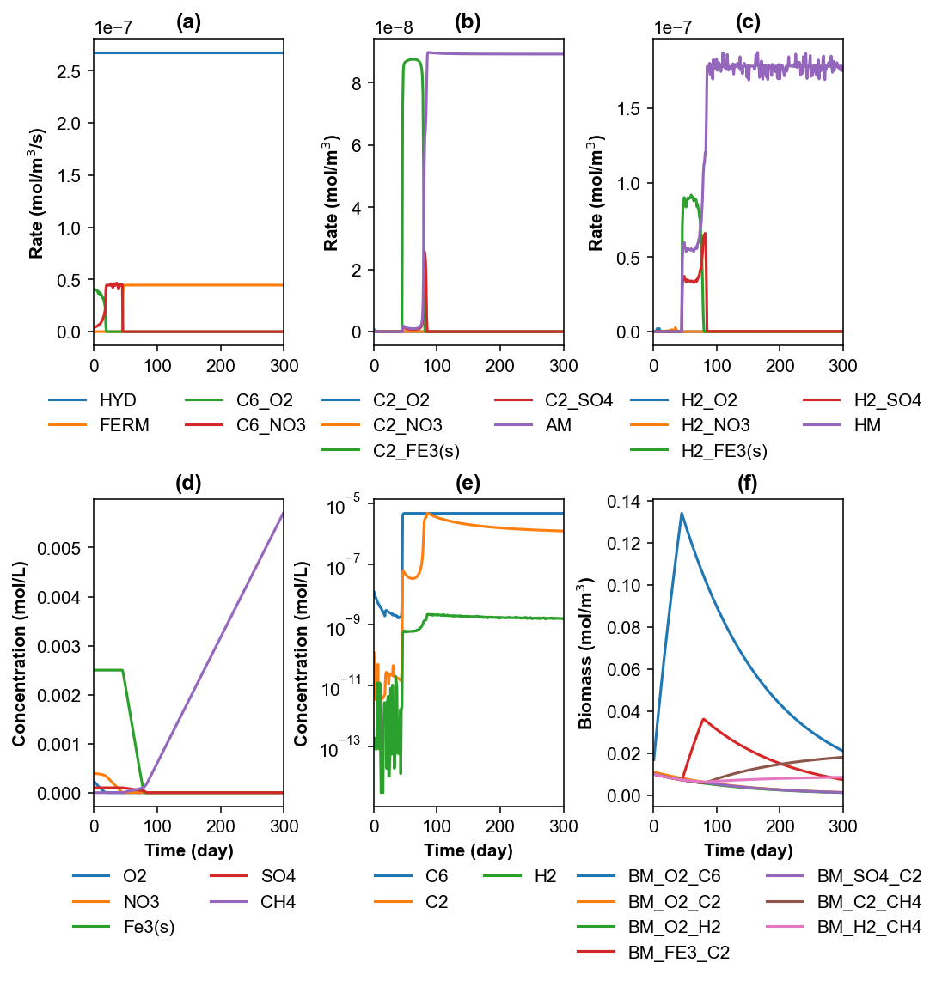
Supplementary Figure 10. Batch simulation of the biogeochemical reaction network to evaluate microbial competition for substrates. The initial POC concentration is assumed to be 0.1% (wt%) and the concentrations of other species are from the initial condition of the column model (supplementary Table 6). (a) Reaction rates of POC hydrolysis (HYD), fermentation (FERM), oxidation of C₆H₁₂O₆ under aerobic condition (C6_O2) and anerobic condition (C6_NO3). (b) Reaction rates of CH₃COO⁻ with O₂ (C2_O2), NO₃⁻ (C2_NO3), Fe(III) oxide (C2_Fe3(s)), SO₄²⁻ (C2_SO4) and acetoclastic methanogenesis (AM). (c) Reaction rates of H₂ with O₂ (H2_O2), NO₃⁻ (H2_NO3), Fe(III) oxide (H2_Fe3(s)), SO₄²⁻ (H2_SO4) and hydrogenotrophic methanogenesis (HM). (d) Concentration of O₂, NO₃⁻, Fe(III) oxide, SO₄²⁻ and CH₄. More thermodynamic favorable TEAs are depleted faster than less thermodynamic favorable TEAs. (e) Concentration of substrates C₆H₁₂O₆ (C6), CH₃COO⁻ (C2) and H2. Step increase of substrate concentration indicates that more thermodynamic favorable TEAs can maintain substrates at a lower level. (f) Biomass growth for reactions O₂-C₆H₁₂O₆ (BM_O2_C6), O₂-CH₃COO⁻ (BM_O2_C2), O₂-H₂ (BM_O2_H2), Fe(III)-CH₃COO⁻ (BM_FE3_C2), SO₄²⁻- CH₃COO⁻ (BM_SO4_C2), acetoclastic methanogenesis (BM_C2_CH4), and hydrogenotrophic methanogenesis (BM_H2_CH4).
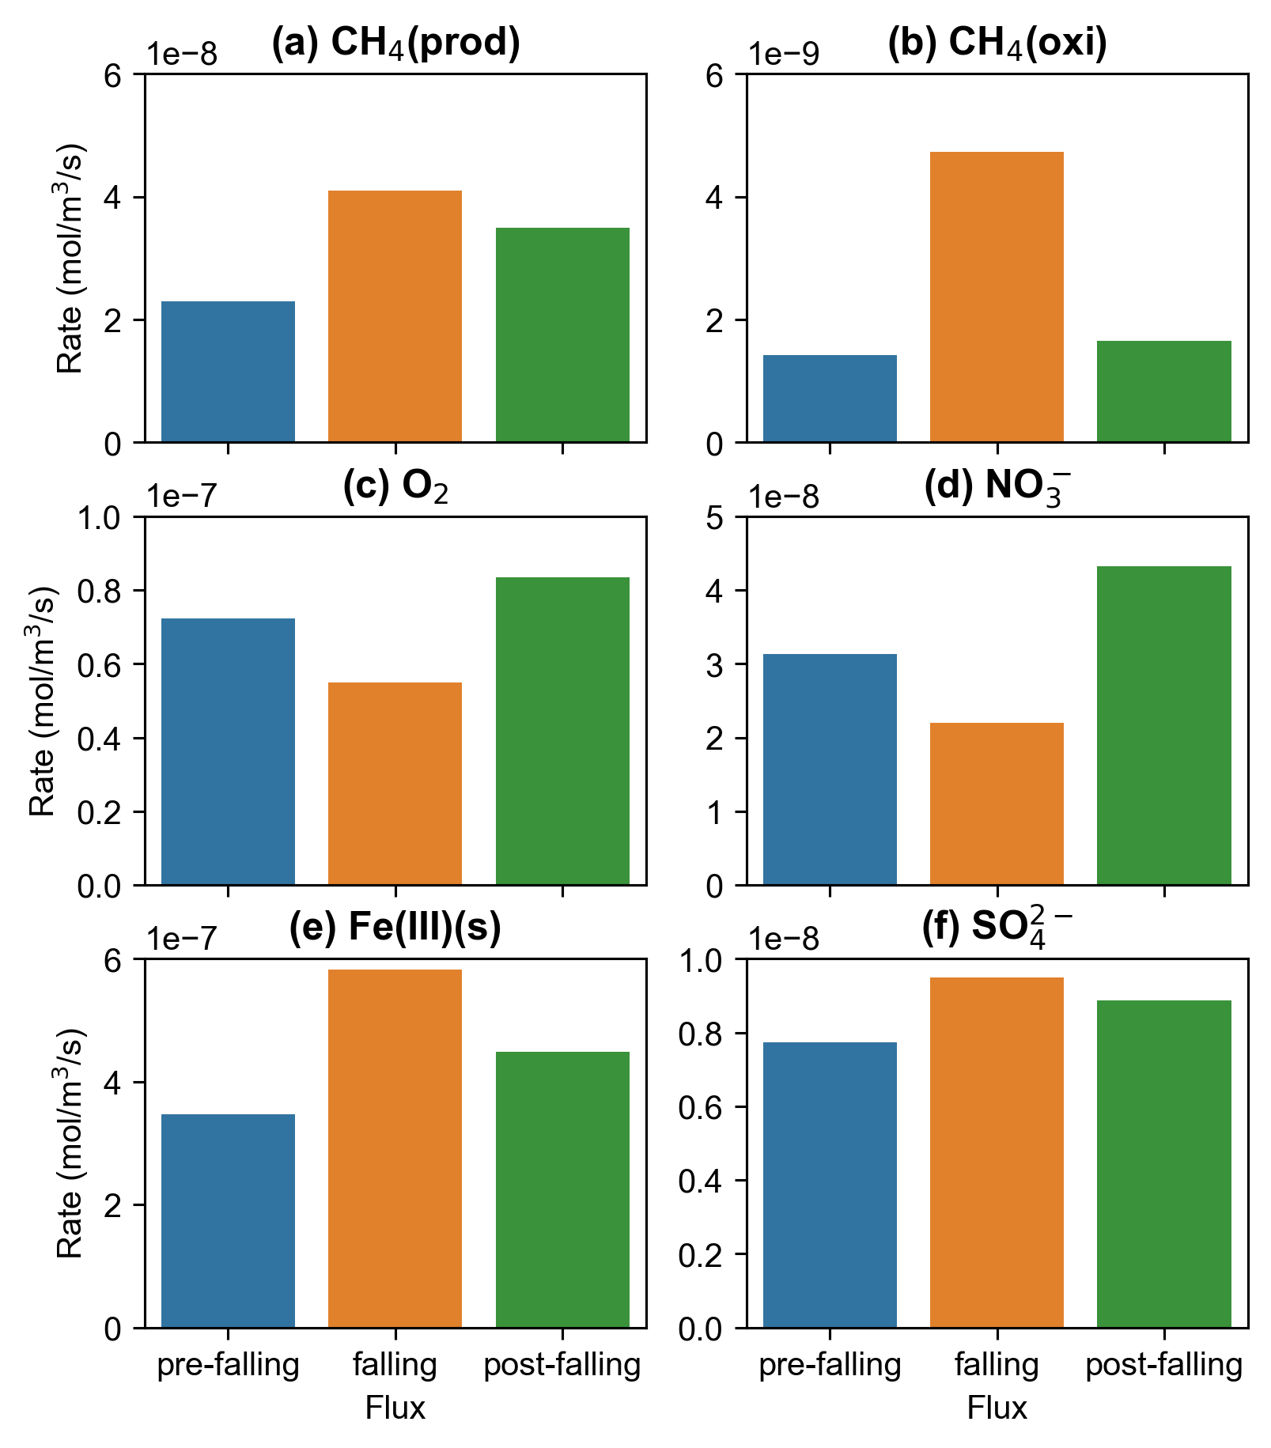
Supplementary Figure 11. Mean depth-average metabolism rates during pre-falling (6/17/2018-6/24/2018), falling (6/24/2018-7/1/2018) and post-falling (7/1/2018-7/8/2018) VHEF. (a) CH₄ production rates; (b) CH₄ oxidation rates; (c) aerobic respiration rates; (d) nitrate reduction rates; (e) Fe(III)(s) reduction rates; (f) sulfate reduction rates.

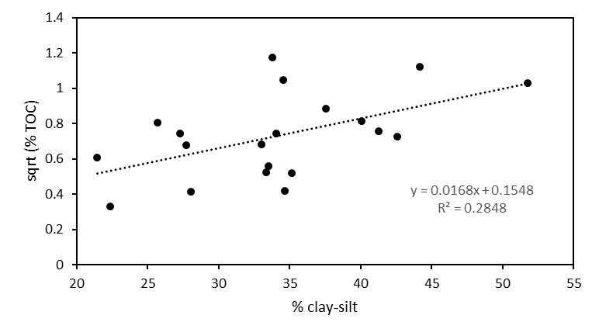
Supplementary Figure 12. The correlation between TOC and the content of clay and silt. The data is from Hou et al. (2017).

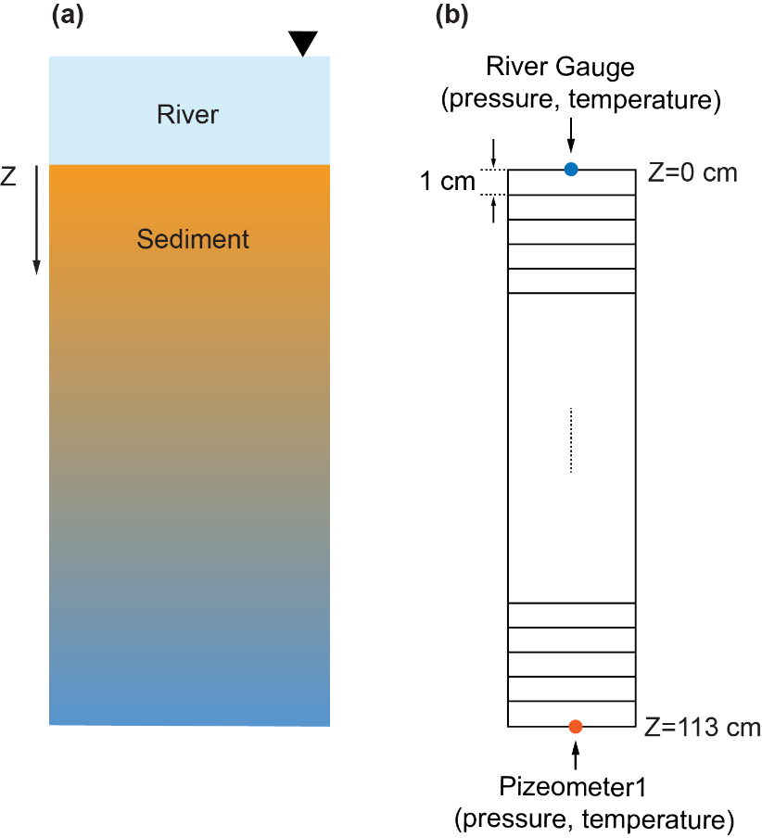
Supplementary Figure 13. 1D hydro-thermal-biogeochemical model. (a) Conceptual model of river and sediments with vertical flux. (b) Model setup. The model domain is 1.13 m in length, representing the sediments above piezometer P1 and below the sediment-water interface. The domain is discretized into 113 grids with grid dimension of 1 cm. Pressure and temperature measured by river gauge are used as the top boundary condition for flow and heat transport, respectively. And measured pressure and temperature by P1 are used as the bottom boundary conditions.

Supplementary Table 1. Physical parameters for 2D flow model and 1D hydro-thermal-biogeochemical model
 | Alluviumª | Hanford | Ringold^{b}
Hydraulic properties
porosity | 0.43 | 0.2 | 0.43
dispersivity(m) | 0.01 | / | /
residual saturation | 0.13 | 0.16 | 0.13
α(van Genuchten, Pa⁻¹) | 1.43e-4 | 7.27e-4 | 1.43e-4
m(van Genuchten) | 0.75 | 0.34 | 0.75
Thermal properties
rock density (kg/m³) | 2760 | 2760 | 2650
specific heat capacity (J/kg·K) | 920 | / | /
wet thermal conductivity (W/K·m) | 0.93 | / | /
dry thermal conductivity (W/K·m) | 0.68 | / | /
Geostatistical parameters for permeability field
mean (log, m2) | -8.13 | -13 | -15
standard deviation (log, m2) | 0.83 | 0.81 | /
integral scale (m) | 20 | 8 | /
anisotropy ratio | 0.1 | 0.1 | /
anisotropy angle (deg) | -3 | 9 | /
nugget | 0 | 0 | /
 |  |  | /
ª: The hydraulic and thermal properties of Alluvium are used by 1D hydro-thermal-biogeochemical model. And the hydraulic properties of all three formations are used by 2D flow model. Parameters are from Shuai et al. (2019) and Song et al. (2018).
^{b}: Permeability field of Ringold formation is homogeneous.

Supplementary Table 2. Half reactions related to methanogenesis, iron reduction and cell synthesis
 | Half reactionª | ΔG⁰ (kJ/e⁻ eq)^{b}
 | Organic half reaction
1 | 0.125CO₂(aq) + e⁻ + H⁺ = 0.125CH₄(aq) + 0.25H₂O | 23.53
2 | 0.125CO₂(aq) + 0.125HCO₃⁻ + e⁻ + H⁺ = 0.125CH₃COO⁻ + 0.375H₂O | 27.4
3 | 0.25CO₂(aq) + e⁻ + H⁺ = 1/24C₆H₁₂O₆ + 0.25H₂O | 41.35
 | Inorganic half reaction
4 | 0.25O₂(aq) + e⁻ + H⁺ = 0.5H₂O | -78.72
5 | 0.2NO₃⁻ + e⁻ + 1.2H+ = 0.1N₂(aq) + 0.6H₂O | -72.2
6 | Fe³⁺ + e⁻ = Fe²⁺ | -74.27
7 | 0.125SO₄²⁻ + e⁻ + 1.1875H⁺ = 0.0625HS⁻ + 0.0625H₂S +0.5H₂O | 20.85
8 | H⁺ + e⁻ = 0.5H₂(aq) | 39.87
 | Cell synthesis
9 | 0.2CO₂(aq) + 0.05HCO₃⁻ + 0.05NH₄⁺ + H⁺ + e⁻ = 0.05C₅H₇O₂N + 0.45H₂O | /
^{a:} Half reactions are from Rittman and McCarty (2012).
^{b}: Gibb’s standard free energy at pH=7

Supplementary Table 3. Thermodynamically-based biogeochemical reaction network
 | Primary Reactionsª | fs^{b} | Yield | Half reactions^{c}
1 | POC(s) -> DOC | \ |  | \
2 | DOC -> C₆H₁₂O₆
3 | C₆H₁₂O₆ + 4H₂O -> 2CH₃COO⁻ + 2HCO₃⁻ + 4H⁺ + 4H₂ | \ |  | \
 | Methane
4 | CH₃COO⁻ + 0.02NH₄⁺ +0.8904H₂O + 0.0304H⁺ -> 0.02C₅H₇O₂N +0.9504HCO₃⁻ + 0.9504CH₄(aq) | 0.05 | 0.02 | 1,2,9
5 | H₂(aq) + 0.2608HCO₃⁻ + 0.0042NH₄⁺ + 0.2566H⁺ -> 0.0042C₅H₇O₂N + 0.774H₂O + 0.2396CH₄(aq) | 0.0425 | 0.0043 | 1,8,9
6 | CH₄(aq) + 0.904O₂(aq) + 0.2192NH₄⁺ + 0.096HCO₃⁻ -> 0.2192C₅H₇O₂N + 0.1232H⁺ + 1.6576H₂O | 0.548 | 0.1096 | 1,4,9
 | Oxygen
7 | CH₃COO⁻ + 0.8184O₂(aq) + 0.236NH₄⁺-> 0.236C₅H₇O₂N + 0.8192HCO₃⁻ +0.0552H⁺ + 0.7088H₂O | 0.5905 | 0.2362 | 2,4,9
8 | H₂(aq) + 0.3782O₂(aq) + 0.0244NH₄⁺ + 0.0974H⁺ + 0.1218HCO₃⁻ -> 0.0244C₅H₇O₂N + 1.073H₂O | 0.2435 | 0.0244 | 4,8,9
9 | C₆H₁₂O₆ + 1.7266O₂(aq) + 0.8489NH₄⁺ -> 0.8489C₅H₇O₂N + 1.7482HCO₃⁻ + 2.5995H⁺ + 2.5468H₂O | 0.7082 | 0.8498 | 3,4,9
 | Nitrate
10 | CH₃COO⁻ + 0.68NO₃⁻ + 0.2288NH₄⁺ + 0.6H⁺ -> 0.2288C₅H₇O₂N + 0.34N₂ + 0.8496HCO₃⁻ + 1.0304H₂O | 0.5751 | 0.23 | 2,5,9
11 | H₂ + 0.3066NO₃⁻ + 0.0234NH₄⁺ + 0.4H⁺ + 0.1166HCO₃⁻ -> 0.0234C₅H₇O₂N + 0.1534N₂ + 1.2232H₂O | 0.2332 | 0.0233 | 5,8,9
12 | C₆H₁₂O₆ + 1.4556NO₃⁻ + 0.8345NH₄⁺ -> 0.8345C₅H₇O₂N + 0.7194N₂ + 1.8202HCO₃⁻ + 1.1991H⁺ + 3.2326H₂O | 0.6962 | 0.8354 | 3,5,9
 | Iron^{d}
13 | CH₃COO⁻ + 8Fe(III)OOH(s) + 15H⁺ -> 2HCO₃⁻ + 8Fe²⁺ + 12H₂O
14 | CH₃COO⁻ + 8Fe(III)OOH(s) + 8≡H(s) + 7H⁺ -> 2HCO₃⁻ + 8≡Fe(II)⁺(s) + 12H₂O |  | 0.1378e
15 | H₂ + 2Fe(III)OOH(s) + 4H⁺ -> 2Fe²⁺ + 6H₂O
16 | H₂ + 2Fe(III)OOH(s) + 2≡H(s) + 2H⁺ -> 2≡Fe(II)⁺(s)+ 6H₂O |  | 0.0217
 | Sulfate
17 | CH₃COO⁻ + 0.9176SO4²⁻ + 0.0328NH4⁺ + 0.0488H⁺ -> 0.9176HS⁻ + 1.836HCO3⁻ + 0.0328C₅H₇O₂N + 0.0984H2O | 0.0817 | 0.0324 | 2,7,9
18 | H₂ + 0.2378SO4²⁻ + 0.005NH4⁺ + 0.2574H⁺ + 0.0246HCO3⁻ -> 0.2378HS⁻ + 0.005C₅H₇O₂N + 1.015H₂O | 0.0491 | 0.0049 | 7,8,9
 | Secondary Reactions^{f}
19 | Fe²⁺(aq) + 0.25O₂ + H₂O -> Fe(III)OOH(s) + 2H⁺
20 | ≡Fe(II)⁺(s) + 0.25O₂ + 1.0H₂O -> Fe(III)OOH(s) + H⁺
21 | HS⁻ + 2O₂ -> H⁺ + SO₄²⁻
22 | S⁰(s) + 1.5O₂ + H₂O -> SO₄²⁻ + 2H⁺
23 | FeS(s) + 2.25O₂ -> Fe(III)OOH(s) + SO4²⁻ + 2H⁺
24 | Fe²⁺(aq) + 0.2NO₃⁻ + 1.4H₂O -> Fe(III)OOH(s) + 0.1N₂ + 1.8H⁺
25 | ≡Fe(II)⁺(s) + 0.2NO₃⁻ + 1.4H₂O -> Fe(III)OOH(s) + 0.1N₂ + 0.8H⁺
26 | HS⁻ + 1.6NO₃⁻ + 0.6H⁺ -> SO₄²⁻ + 0.8N₂ + 0.8H₂O
27 | S⁰(s) + 1.2NO₃⁻ + 0.4H₂O → SO₄²⁻ + 0.6N₂ + 0.8H⁺
28 | FeS(s) + 1.8NO₃⁻ + 0.6H₂O -> Fe(III)OOH(s) + SO₄²⁻ + 0.9N₂ + 0.2H⁺
29 | HS⁻ + 2Fe(III)OOH(s) + 5H⁺ -> 2Fe²⁺(aq) + S⁰(s) + 4H₂O
30 | HS⁻ + 2Fe(III)OOH(s) + 2≡H(s) + 3H⁺ -> 2≡Fe(II)⁺(s) + S⁰(s) + 4H₂O
31 | HS⁻ + ≡Fe(II)⁺(s) -> FeS(s) + ≡H
32 | 3S⁰(s) + 2Fe(III)OOH -> SO₄²⁻ + 2FeS(s) + 2H⁺
33 | 4S⁰(s) + 3H₂O + 3≡Fe(II)⁺(s) -> SO₄²⁻ + 3FeS(s) + 5H⁺ + 3≡H(s)

ª: NH₄⁺ is assumed to be the only nitrate source and C₅H₇O₂N represents biomass.
^{b}: fraction of electrons for cell synthesis.
^{c}: The number of half reactions correspond to Table S2.
^{d}: Assuming solid phase ≡Fe(II)⁺(s) is produced at a constant ratio, faq=0.01, with aqueous Fe²⁺ (Roden, 2008).
e: Thermodynamically-based method is not suitable for solid-phase Fe(III). Yield coefficient is from Jin and Roden (2011).
^{f}: Adapted from Van Cappellen and Wang (1996) and Dwivedi et al. (2018).

Supplementary Table 4. Kinetics formulation for primary and secondary reactions
1 | $$R_{1}={}_{1}C_{POC}$$
2 | $$R_{2}={}_{2}C_{DOC}$$
3 | $$R_{3}=k_{3, max}C_{C6H12O6}(\frac{1}{1+I_{3,O2}C_{O2}})$$
4 | $$R_{4}=k_{4,max}X_{4}(\frac{C_{CH3COO-}}{K_{4,CH3COO-}+C_{CH3COO-}})(\frac{1}{1+I_{4,O2}C_{O2}})(\frac{1}{1+I_{4,NO3-}C_{NO3-}})$$
5 | $R_{5}=k_{5,max}X_{5}(\frac{C_{H2}}{K_{5,H2}+C_{H2}})(\frac{1}{1+I_{5,O2}C_{O2}})(\frac{1}{1+I_{5,NO3-}C_{NO3-}})$
6 | $$R_{6}=k_{6,max}X_{6}(\frac{C_{CH4}}{K_{6,CH4}+C_{CH4}})(\frac{C_{O2}}{K_{6,O2}+C_{O2}})$$
7 | $$R_{7}=k_{7,max}X_{7}(\frac{C_{CH3COO-}}{K_{7,CH3COO-}+C_{CH3COO-}})(\frac{C_{O2}}{K_{7,O2}+C_{O2}})$$
8 | $$R_{8}=k_{8,max}X_{8}(\frac{C_{H2}}{K_{8,H2}+C_{H2}})(\frac{C_{O2}}{K_{8,O2}+C_{O2}})$$
9 | $$R_{9}=k_{9,max}X_{9}(\frac{C_{C6H12O6}}{K_{9,C6H12O6}+C_{C6H12O6}})(\frac{C_{O2}}{K_{9,O2}+C_{O2}})$$
10 | $$R_{10}=k_{10,max}X_{10}(\frac{C_{CH3COO-}}{K_{10,CH3COO-}+C_{CH3COO-}})(\frac{C_{NO3-}}{K_{10,NO3-}+C_{NO3-}})(\frac{1}{1+I_{10,O2}C_{O2}})$$
11 | $$R_{11}=k_{11,max}X_{11}(\frac{C_{H2}}{K_{11,H2}+C_{H2}})(\frac{C_{NO3-}}{K_{11,NO3-}+C_{NO3-}})(\frac{1}{1+I_{11,O2}C_{O2}})$$
12 | $$R_{12}=k_{12,max}X_{12}(\frac{C_{C6H12O6}}{K_{12,C6H12O6}+C_{C6H12O6}})(\frac{C_{NO3-}}{K_{12,NO3-}+C_{NO3-}})(\frac{1}{1+I_{12,O2}C_{O2}})$$
13ª | $$R_{13}={f_{aq}k}_{13,max}X_{13}(\frac{C_{CH3COO-}}{K_{13,CH3COO-}+C_{CH3COO-}})(\frac{C_{Fe(III)(s)}}{K_{13,Fe(III)(s)}+C_{Fe(III)(s)}})(\frac{1}{1+I_{13,O2}C_{O2}})(\frac{1}{1+I_{13,NO3-}C_{NO3-}})$$
14 | $$R_{14}={{(1-f}_{aq})/f_{aq}R}_{13}$$
15 | $$R_{15}={f_{aq}k}_{15,max}X_{15}(\frac{C_{H2}}{K_{15,H2}+C_{H2}})(\frac{C_{Fe(II)(s)}}{K_{15,Fe(II)(s)}+C_{Fe(II)(s)}})(\frac{1}{1+I_{15,O2}C_{O2}})(\frac{1}{1+I_{15,NO3-}C_{NO3-}})$$
16 | $$R_{16}={{(1-f}_{aq})/f_{aq}R}_{15}$$
17 | $$R_{17}=k_{17,max}X_{17}(\frac{C_{CH3COO-}}{K_{17,CH3COO-}+C_{CH3COO-}})(\frac{C_{SO4-}}{K_{17,SO4-}+C_{SO4-}})(\frac{1}{1+I_{17,O2}C_{O2}})(\frac{1}{1+I_{17,NO3-}C_{NO3-}})$$
18 | $$R_{18}=k_{18,max}X_{18}(\frac{C_{H2}}{K_{18,H2}+C_{H2}})(\frac{C_{SO4-}}{K_{18,SO4-}+C_{SO4-}})(\frac{1}{1+I_{18,O2}C_{O2}})(\frac{1}{1+I_{18,NO3-}C_{NO3-}})$$
19^{b} | $$R_{19}=k_{19,max}C_{Fe2+}C_{O2}$$
20 | $R_{20}=k_{20,max}C_{Fe(II)+(s)}C_{O2}$-
21 | $$R_{21}=k_{21,max}C_{HS-}C_{O2}$$
22 | $R_{22}=k_{22,max}C_{S0(s)}C_{O2}$-
23 | $$R_{23}=k_{23,max}C_{FeS}C_{O2}$$
24 | $$R_{24}=k_{24,max}C_{Fe2+}C_{NO3-}$$
25 | $$R_{25}=k_{25,max}C_{Fe(II)+(s)}C_{NO3-}$$
26 | $$R_{26}=k_{26,max}C_{HS-}C_{NO3-}$$
27 | $$R_{27}=k_{27,max}C_{S0(s)}C_{NO3-}$$
28 | $$R_{28}=k_{28,max}C_{FeS}C_{NO3-}$$
29 | $$R_{29}={f_{aq}k}_{29,max}C_{Fe(III)OOH }C_{HS-}$$
30 | $$R_{30}={{(1-f}_{aq})/f_{aq}R}_{29}$$
31 | $$R_{31}=k_{31,max}C_{Fe(II)+(s)}C_{HS-}$$
32 | $$R_{32}=k_{32,max}C_{Fe(III)OOH }C_{S0(s)}$$
33 | $$R_{33}=k_{33,max}C_{Fe(II)+(s)}C_{S0(s)}$$
ª: Assuming solid phase ≡Fe(II)⁺(s) is produced at a constant ratio, faq=0.01, with aqueous Fe²⁺ (Roden, 2008).
^{b}: Secondary reactions are assumed to follow second-order reactions according to Van Cappellen and Wang (1996).

Supplementary Table 5. Reaction-specific model parameters
Parameter | Unit | Value^{i}
α₁ª | 1/s | 5×10⁻⁹
α₂ ª | 1/s | 8×10⁻⁶
k_{3,max}^{b} | 1/s | 2e-5
I_{3,O2} | L/mol | 4e4
k_{4,max} | 1/s | 1.96e-5
k_{4,CH3COO-} | mol/L | 1e-5
I_{4,O2}^{c} | L/mol | 4e4
I_{4,NO3-} | L/mol | 4e4
k_{5,max} | 1/s | 2.07e-4
k_{5,H2} | mol/L | 3.5e-8
I_{5,O2} | L/mol | 4e4
I_{5,NO3-} | L/mol | 4e4
k_{6,max}^{d} | 1/s | 2.61e-4
k_{6,CH4} | mol/L | 5e-6
k_{6,O2} | mol/L | 2e-5
k_{7,max}^{e} | 1/s | 5.47e-4
k_{7,O2} | mol/L | 1e-6
k_{7,CH3COO-} | mol/L | 1e-6
k_{8,max}^{f} | 1/s | 2.07e-4
k_{8,H2} | mol/L | 1e-8
k_{8,O2} | mol/L | 1e-6
k_{9,max}^{g} | 1/s | 2.46e-4
k_{9,O2} | mol/L | 1e-6
k_{9,C6H12O6} | mol/L | 1e-6
k_{10,max} | 1/s | 2.46e-4
k_{10,NO3-} | mol/L | 1e-6
k_{10,CH3COO-} | mol/L | 1e-6
I_{10,O2} | L/mol | 4e4
k_{11,max} | 1/s | 2.07e-4
k_{11,H2} | mol/L | 1e-8
k_{11,NO3-} | mol/L | 1e-6
I_{11,O2} | L/mol | 4e4
k_{12,max} | 1/s | 2.46e-4
k_{12,NO3-} | mol/L | 1e-6
k_{12,C6H12O6} | mol/L | 1e-6
I_{12,O2} | L/mol | 4e4
k_{13,max} | 1/s | 1.57e-4
k_{13,CH3COO-} | mol/L | 1e-6
k_{13,Fe(III)} | mol/m³ | 2.5
I_{13,O2} | L/mol | 4e4
I_{13,NO3-} | L/mol | 4e4
k_{15,max} | 1/s | 2.07e-4
k_{15,H2} | mol/L | 2e-8
k_{15,Fe(III)} | mol/m³ | 0.5
I_{15,O2} | L/mol | 4e4
I_{15,NO3-} | L/mol | 4e4
k_{17,max} | 1/s | 1.3e-5
k_{17, CH3COO-} | mol/L | 3e-6
k_{17, SO4--} | mol/L | 5e-6
I_{17,O2} | L/mol | 4e4
I_{17,NO3-} | L/mol | 4e4
k_{18,max} | 1/s | 2.07e-4
k_{18, H2} | mol/L | 2e-8
k_{18, SO4--} | mol/L | 1e-6
I_{18,O2} | L/mol | 4e4
I_{18,NO3-} | L/mol | 4e4
k_fe2aq_o2^{h} | L/mol/s | 3.17e-1
k_fe2s_o2 | L/mol/s | 3.17e-1
k_hs_o2 | L/mol/s | 4.76e-3
k_s_o2 | L/mol/s | 1.9e-3
k_fes_o2 | L/mol/s | 1.9e-3
k_fe2aq_no3 | L/mol/s | 6.34e-3
k_fe2s_no3 | L/mol/s | 6.34e-3
k_hs_no3 | L/mol/s | 5.07e-3
k_s_no3 | L/mol/s | 1.9e-3
k_fes_no3 | L/mol/s | 1.9e-3
k_hs_fe3s | L/mol/s | 2.55e-4
k_hs_fe2s | L/mol/s | 2.55e-4
k_s_fe3s | L/mol/s | 9.51e-7
k_s_fe2s | L/mol/s | 9.51e-7
ª: Calibrated.
^{b}: Calibrated based on Tang et al.(2016).
^{c}: inhibition constant for O₂ and NO₃⁻ are assumed to be the same and the value is from Arah and Stephen (1998).
^{d}: Chan et al.(2019).
^{e}: Zarnetske et al. (2012).
^{f}: Maximum uptake rate for H₂ is assumed to be the same as 158 mmol/g/d for biomasses using O₂, NO₃⁻, Fe(III), SO₄²⁻ as terminal electron acceptors.
^{g}: Maximum uptake rates for CH₃COO- are 188, 188, 121, 10 and 15 mmol/g/d for biomasses using O₂, NO₃⁻, Fe(III), SO₄²⁻ as terminal electron acceptors, respectively (Roden, 2008).
h: Rate constants for secondary reactions are from Van Cappellen and Wang (1996).
i: Parameters for most TEAs are from Roden (2008).

Supplementary Table 6. Initial and boundary conditions for reactive transport
Speciesª | Initial | Top (river) | Bottom | Unit
DOC | 1×10⁻⁴ | 2.58×10⁻⁴ | 4.16×10⁻⁵ | mol/L
O₂(aq)^{b} | 1×10⁻⁵ | 0.2p_{o2} | 0.2p_{o2} | mol/L
C₆H₁₂O₆ | 1×10⁻⁵ | 1×10⁻⁵ | 1×10⁻⁵ | mol/L
CH₃COO⁻ | 1×10⁻⁵ | 1×10⁻⁵ | 1×10⁻⁵ | mol/L
H₂(aq) | 1×10⁻⁸ | 1×10⁻⁹ | 1×10⁻⁸ | mol/L
CH₄(aq) | 2×10⁻⁶ | 1×10⁻⁷ | 1×10⁻⁷ | mol/L
NO₃⁻ | 8.87×10⁻⁵ | 8.87×10⁻⁶ | 8.87×10⁻⁵ | mol/L
Fe(II)(aq) | 1×10⁻²⁰ | 1×10⁻²⁰ | 1×10⁻²⁰ | mol/L
SO₄²⁻ | 1×10⁻⁴ | 1×10⁻⁴ | 2×10⁻⁴ | mol/L
HS⁻ | 1×10⁻¹² | 1×10⁻¹² | 1×10⁻¹² | mol/L
X^{c} | 0.01 |  |  | mol/m³
Fe(II)(s) | 1×10⁻²⁰ |  |  | mol/m³
Fe(III)(s) | 2.5 |  |  | mol/m³
FeS | 1×10⁻²⁰ |  |  | mol/m³
S | 1×10⁻²⁰ |  |  | mol/m³
ª: Mobile species can move in or out of the domain through top and bottom boundaries, but immobile species (biomass, Fe(II)(s), Fe(III)(s), FeS, S) can only be consumed or produced within the domain.
^{b}: Top (river) water and bottom (deep hyporheic zone) boundaries are assumed to be saturated with O₂ (0.2P_{O2}) according to Kaufman et al. (2022).
^{c}: Initial biomass are assumed to be the same and subject to calibration.

Reference:
Arah, J. R. M., & Stephen, K. D. (1998). A model of the processes leading to methane emission from peatland. Atmospheric Environment. https://doi.org/10.1016/S1352-2310(98)00052-1
Chan, E. W., Shiller, A. M., Joung, D. J., Arrington, E. C., Valentine, D. L., Redmond, M. C., Breier, J. A., Socolofsky, S. A., & Kessler, J. D. (2019). Investigations of Aerobic Methane Oxidation in Two Marine Seep Environments: Part 1—Chemical Kinetics. Journal of Geophysical Research: Oceans, 124(12), 8852–8868. https://doi.org/https://doi.org/10.1029/2019JC015594
Dwivedi, D., Steefel, C. I., Arora, B., Newcomer, M., Moulton, J. D., Dafflon, B., Faybishenko, B., Fox, P., Nico, P., Spycher, N., Carroll, R., & Williams, K. H. (2018). Geochemical Exports to River From the Intrameander Hyporheic Zone Under Transient Hydrologic Conditions: East River Mountainous Watershed, Colorado. Water Resources Research. https://doi.org/10.1029/2018WR023377
Hammond, G. E., Lichtner, P. C., and Mills, R. T. (2014), Evaluating the performance of parallel subsurface simulators: An illustrative example with PFLOTRAN, Water Resour. Res., 50, 208– 228, doi:10.1002/2012WR013483.
Hou, Z., Nelson, W.C., Stegen, J.C. et al. Geochemical and Microbial Community Attributes in Relation to Hyporheic Zone Geological Facies. Sci Rep 7, 12006 (2017). https://doi.org/10.1038/s41598-017-12275-w
Jin, Q., & Roden, E. E. (2011). Microbial physiology-based model of ethanol metabolism in subsurface sediments. Journal of Contaminant Hydrology, 125(1), 1–12. https://doi.org/https://doi.org/10.1016/j.jconhyd.2011.04.002
Kaufman MH, Ghosh RN, Grate J, Shooltz DD, Freeman MJ, Ball TM, et al. (2022) Dissolved oxygen sensor in an automated hyporheic sampling system reveals biogeochemical dynamics. PLOS Water 1(4): e0000014. https://doi.org/10.1371/journal.pwat.0000014
Liu, Y., & Whitman, W. B. (2008). Metabolic, phylogenetic, and ecological diversity of the methanogenic archaea. Annals of the New York Academy of Sciences. https://doi.org/10.1196/annals.1419.019
McCarty, P. L. (2007). Thermodynamic electron equivalents model for bacterial yield prediction: Modifications and comparative evaluations. Biotechnology and Bioengineering. https://doi.org/10.1002/bit.21250
Rittmann BE, McCarty PL. Environmental Biotechnology: Principles and Applications. Tata McGraw Hill Education Private Limited (2012).
Roden, E. E. (2008). Microbiological Controls on Geochemical Kinetics 1: Fundamentals and Case Study on Microbial Fe(III) Oxide Reduction. In S. L. Brantley, J. D. Kubicki, & A. F. White (Eds.), Kinetics of Water-Rock Interaction (pp. 335–415). Springer New York. https://doi.org/10.1007/978-0-387-73563-4_8
Shuai, P., Chen, X., Song, X., Hammond, G. E., Zachara, J., Royer, P., et al. (2019). Dam operations and subsurface hydrogeology control dynamics of hydrologic exchange flows in a Regulated River reach. Water Resources Research, 55, 2593– 2612. https://doi.org/10.1029/2018WR024193
Song, X., Chen, X., Stegen, J., Hammond, G., Song, H.-S., Dai, H., et al. (2018). Drought conditions maximize the impact of high-frequency flow variations on thermal regimes and biogeochemical function in the hyporheic zone. Water Resources Research, 54, 7361– 7382. https://doi.org/10.1029/2018WR022586
Tang, G., Zheng, J., Xu, X., Yang, Z., Graham, D. E., Gu, B., Painter, S. L., & Thornton, P. E. (2016). Biogeochemical modeling of CO2 and CH4 production in anoxic Arctic soil microcosms. Biogeosciences. https://doi.org/10.5194/bg-13-5021-2016
Van Cappellen, P., & Wang, Y. (1996). Cycling of iron and manganese in surface sediments: A general theory for the coupled transport and reaction of carbon, oxygen, nitrogen, sulfur, iron, and manganese. American Journal of Science. https://doi.org/10.2475/ajs.296.3.197
Zarnetske, J. P., Haggerty, R., Wondzell, S. M., Bokil, V. A., & González-Pinzón, R. (2012). Coupled transport and reaction kinetics control the nitrate source-sink function of hyporheic zones. Water Resources Research. https://doi.org/10.1029/2012WR011894

