Supplementary Material

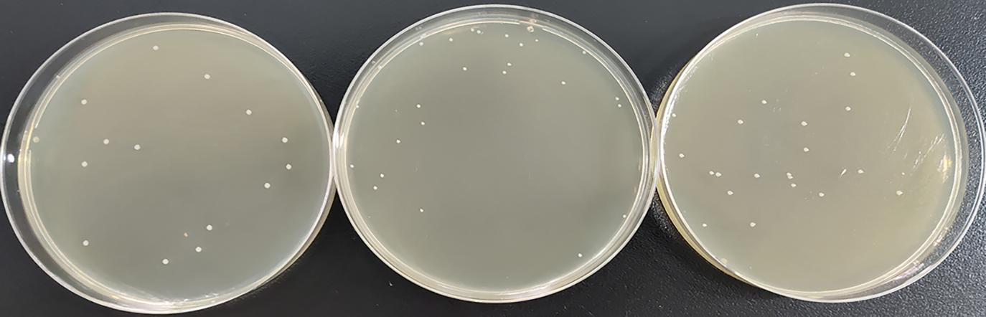
LM928
CΔLIPI-4
ΔLIPI-4

Supplementary Fig. 1 Growth of LM928, ΔLIPI-4 and CΔLIPI-4 on BHI solid medium

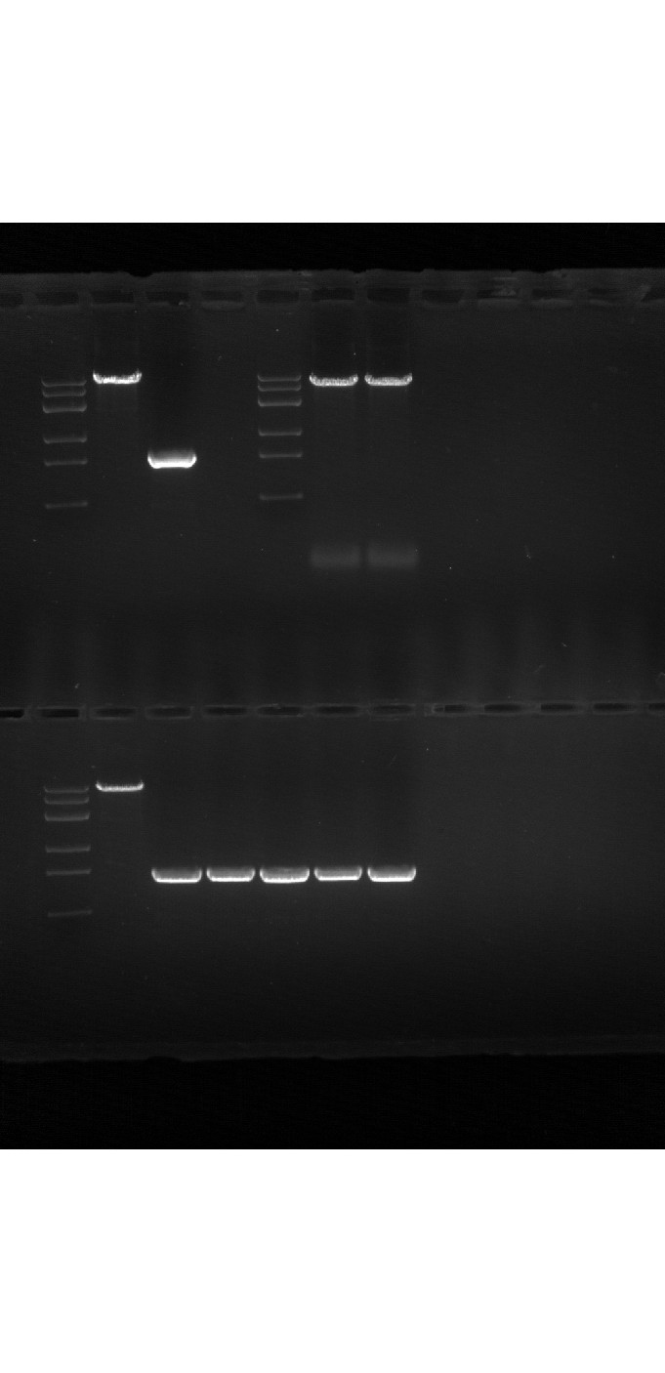

Supplementary Fig. 2 Gene replacement of LIPI-4

