Supplementary materials

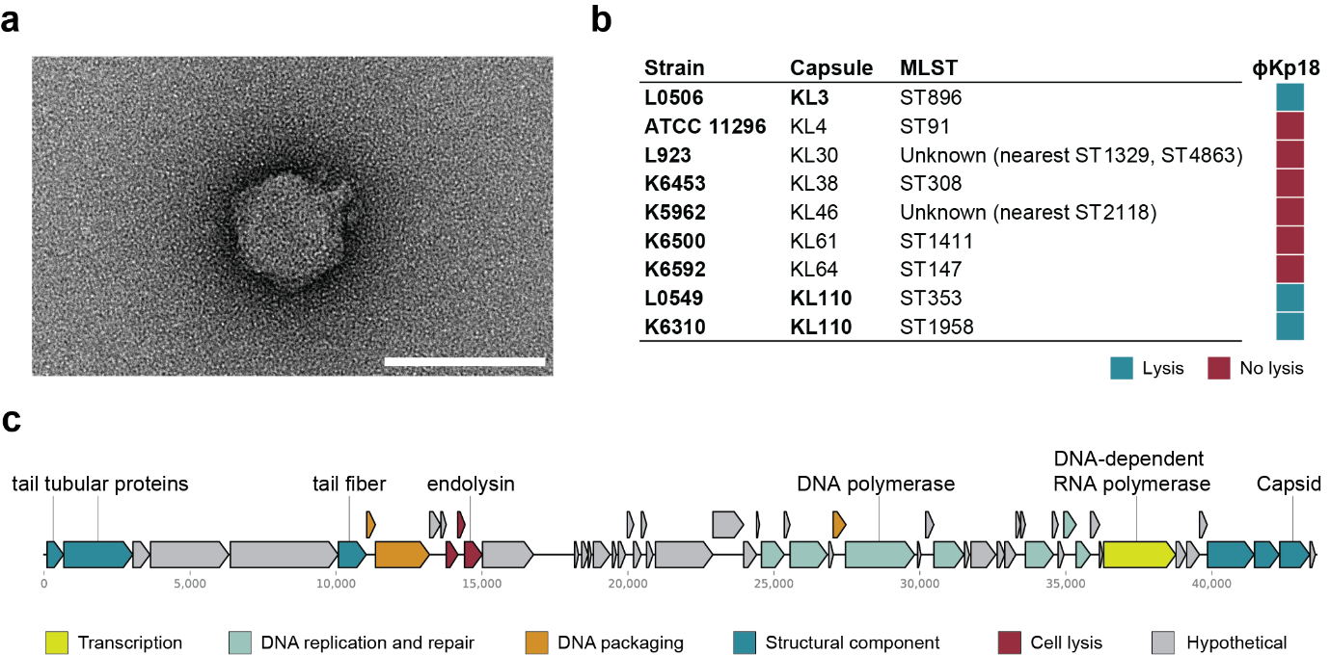

Figure S1. Characteristics of Klebsiella phage vB_KpP_FBKp18. a) Transmission electron microscopy image of φKp18 negatively stained with 2% uranyl acetate. Scale bar, 80 nm. Micrograph taken at 200,000x magnification. b) Infectivity of phage φKp18 against K. pneumoniae strains of different capsular (KL) and multiple sequence locus (MLST) types. c) Linear genome map of φKp18. ORFs are colored according to predicted function as shown in the key.

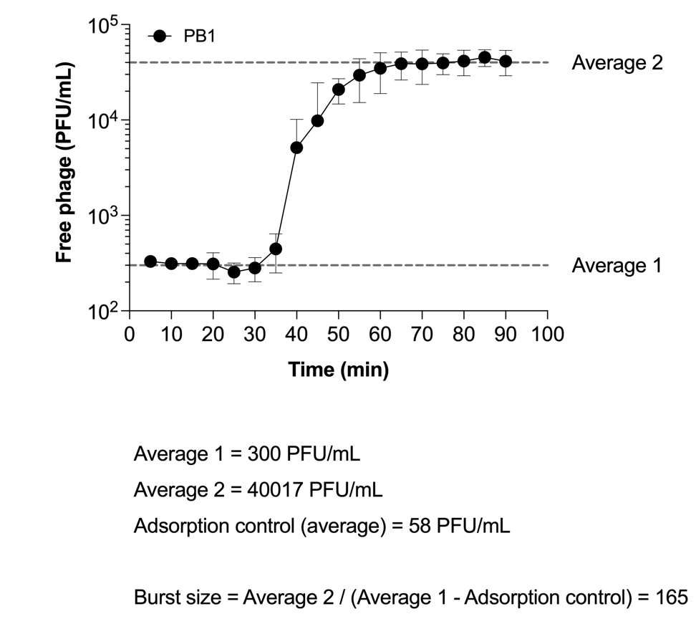

Figure S2. One-step growth curve of phage PB1 and calculation of its burst size, as described by Kropinski (2018)[14].

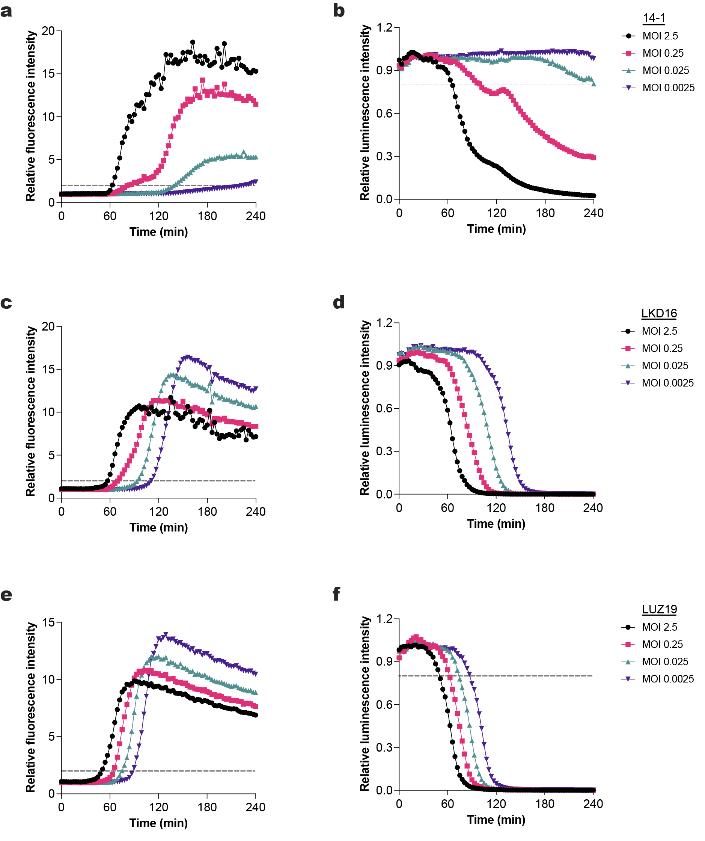

Figure S3. The fluorescent DNA dye signal correlates with a loss of bacterial metabolic activity. PAO1 expressing a luciferase reporter system was incubated with phages at different MOIs at 37ºC in the presence of Sytox green. a,c,e) Sytox green fluorescence intensity for phages 14-1 (a), LKD16 (c) and LUZ19 (e) was measured using a fluorometer. Values were divided by control signal to obtain relative fluorescence intensity. Black dotted line represents threshold for phage-mediated damage (relative fluorescence = 2). b,d,f) Luminescence intensity for phages 14-1 (b), LKD16 (d) and LUZ19 (f) was measured and divided by signal of the control. Black dotted line represents threshold for phage-mediated damage (relative luminescence = 0.8). a-f) A representative graph of at least three independent experiments is shown.

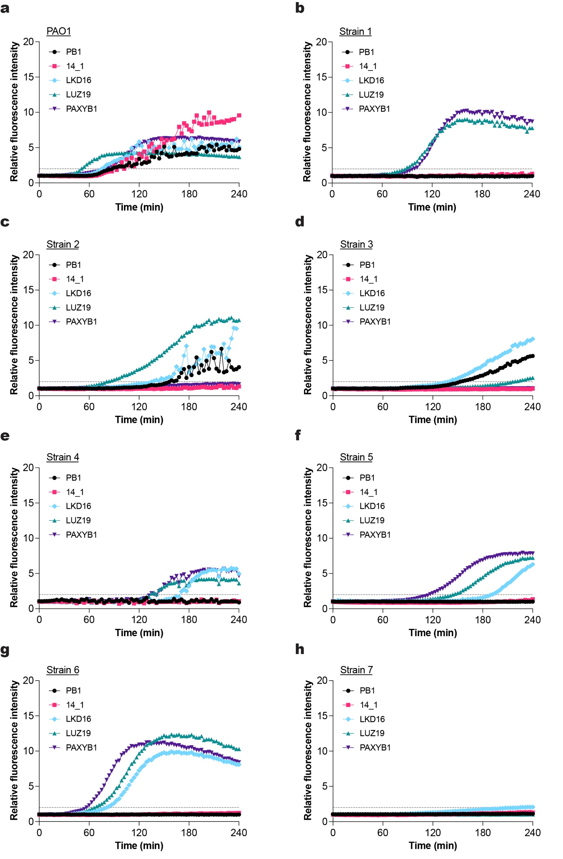
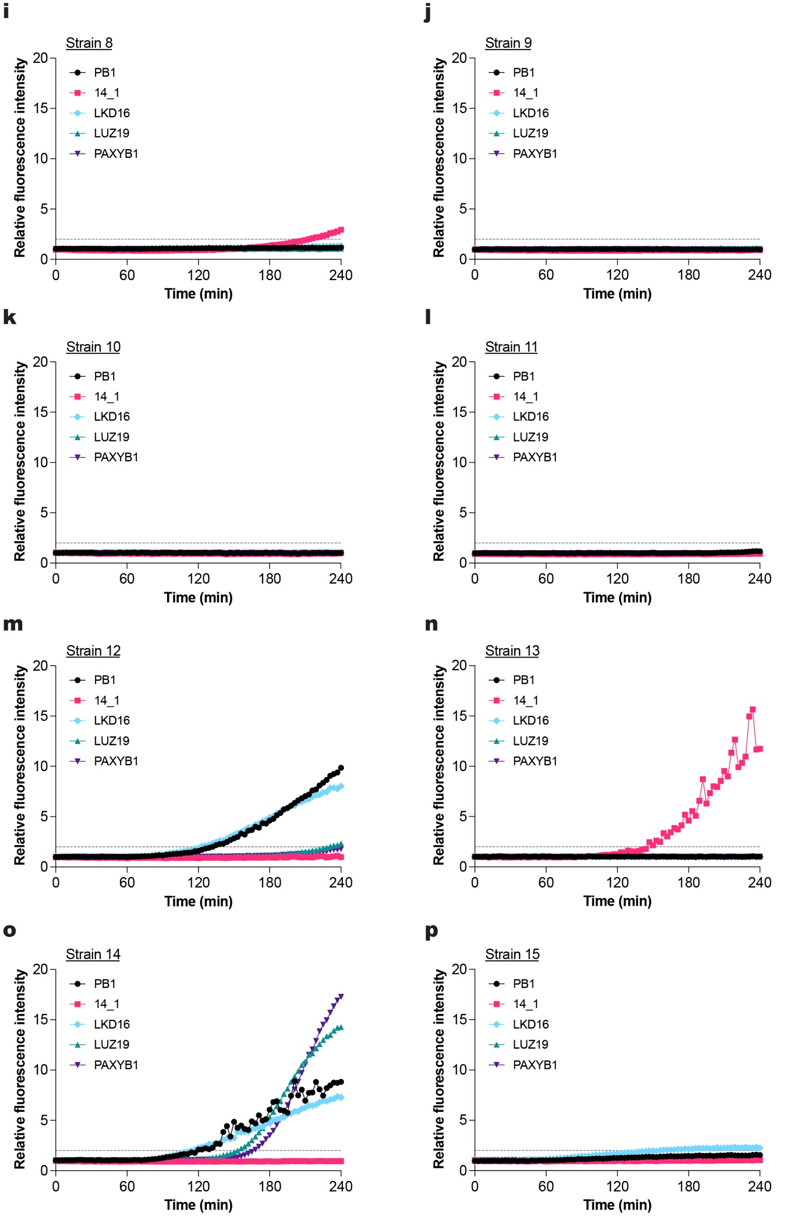
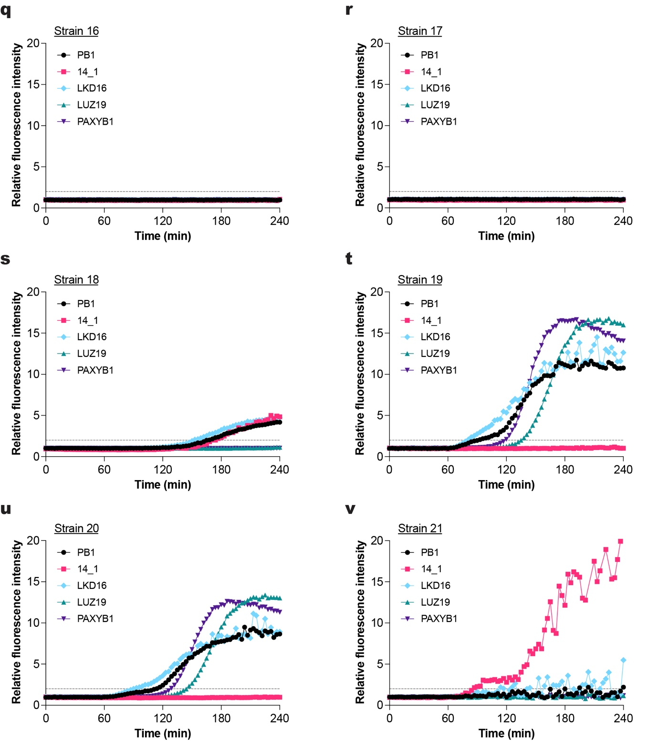

Figure S4: Phage susceptibility profiling of several P. aeruginosa clinical strains obtained from patients at the UMC Utrecht, as determined by fluorescent DNA dye assay. a-v) Strains were incubated with phages PB1, 14-1, LKD16, LUZ19 or PAXYB1 at an MOI of 1 at 37ºC in the presence of Sytox green. Fluorescence intensity was measured using a fluorometer, and values were divided by control signal to obtain relative fluorescence intensity. Black dotted line represents threshold for phage-mediated damage (relative fluorescence = 2). A representative graph of at least three independent experiments is shown.
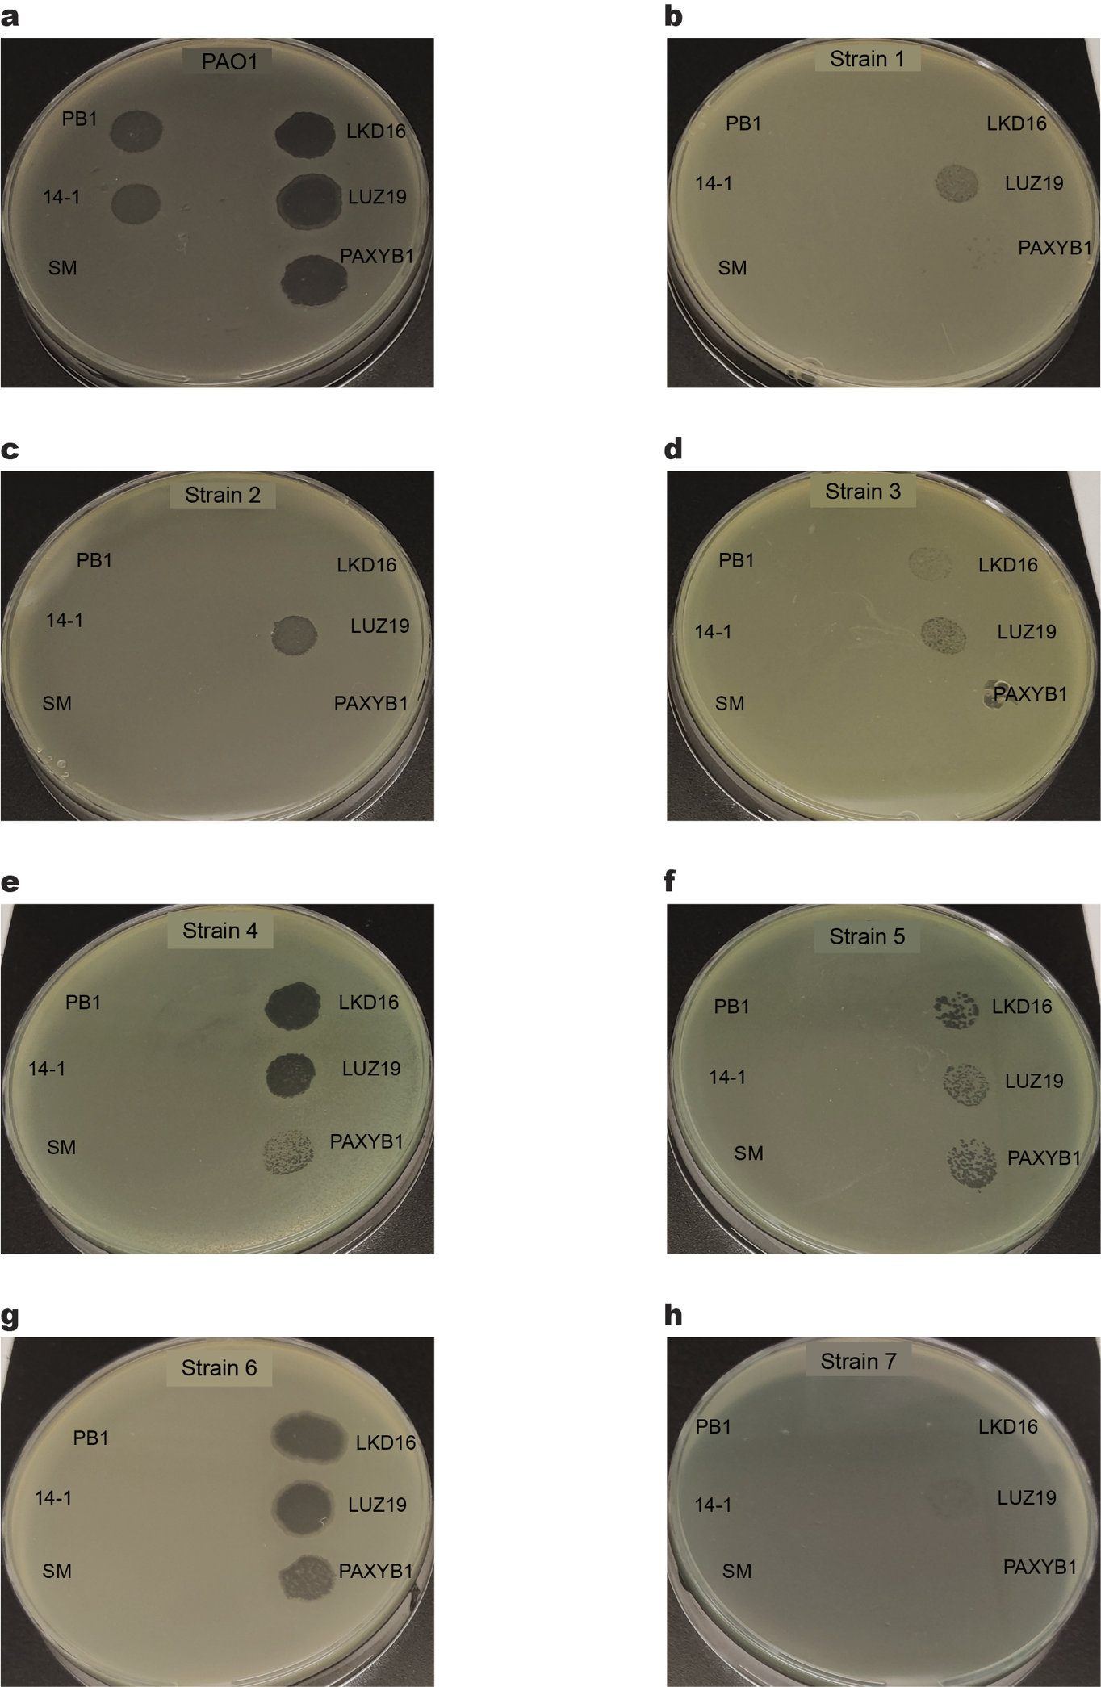
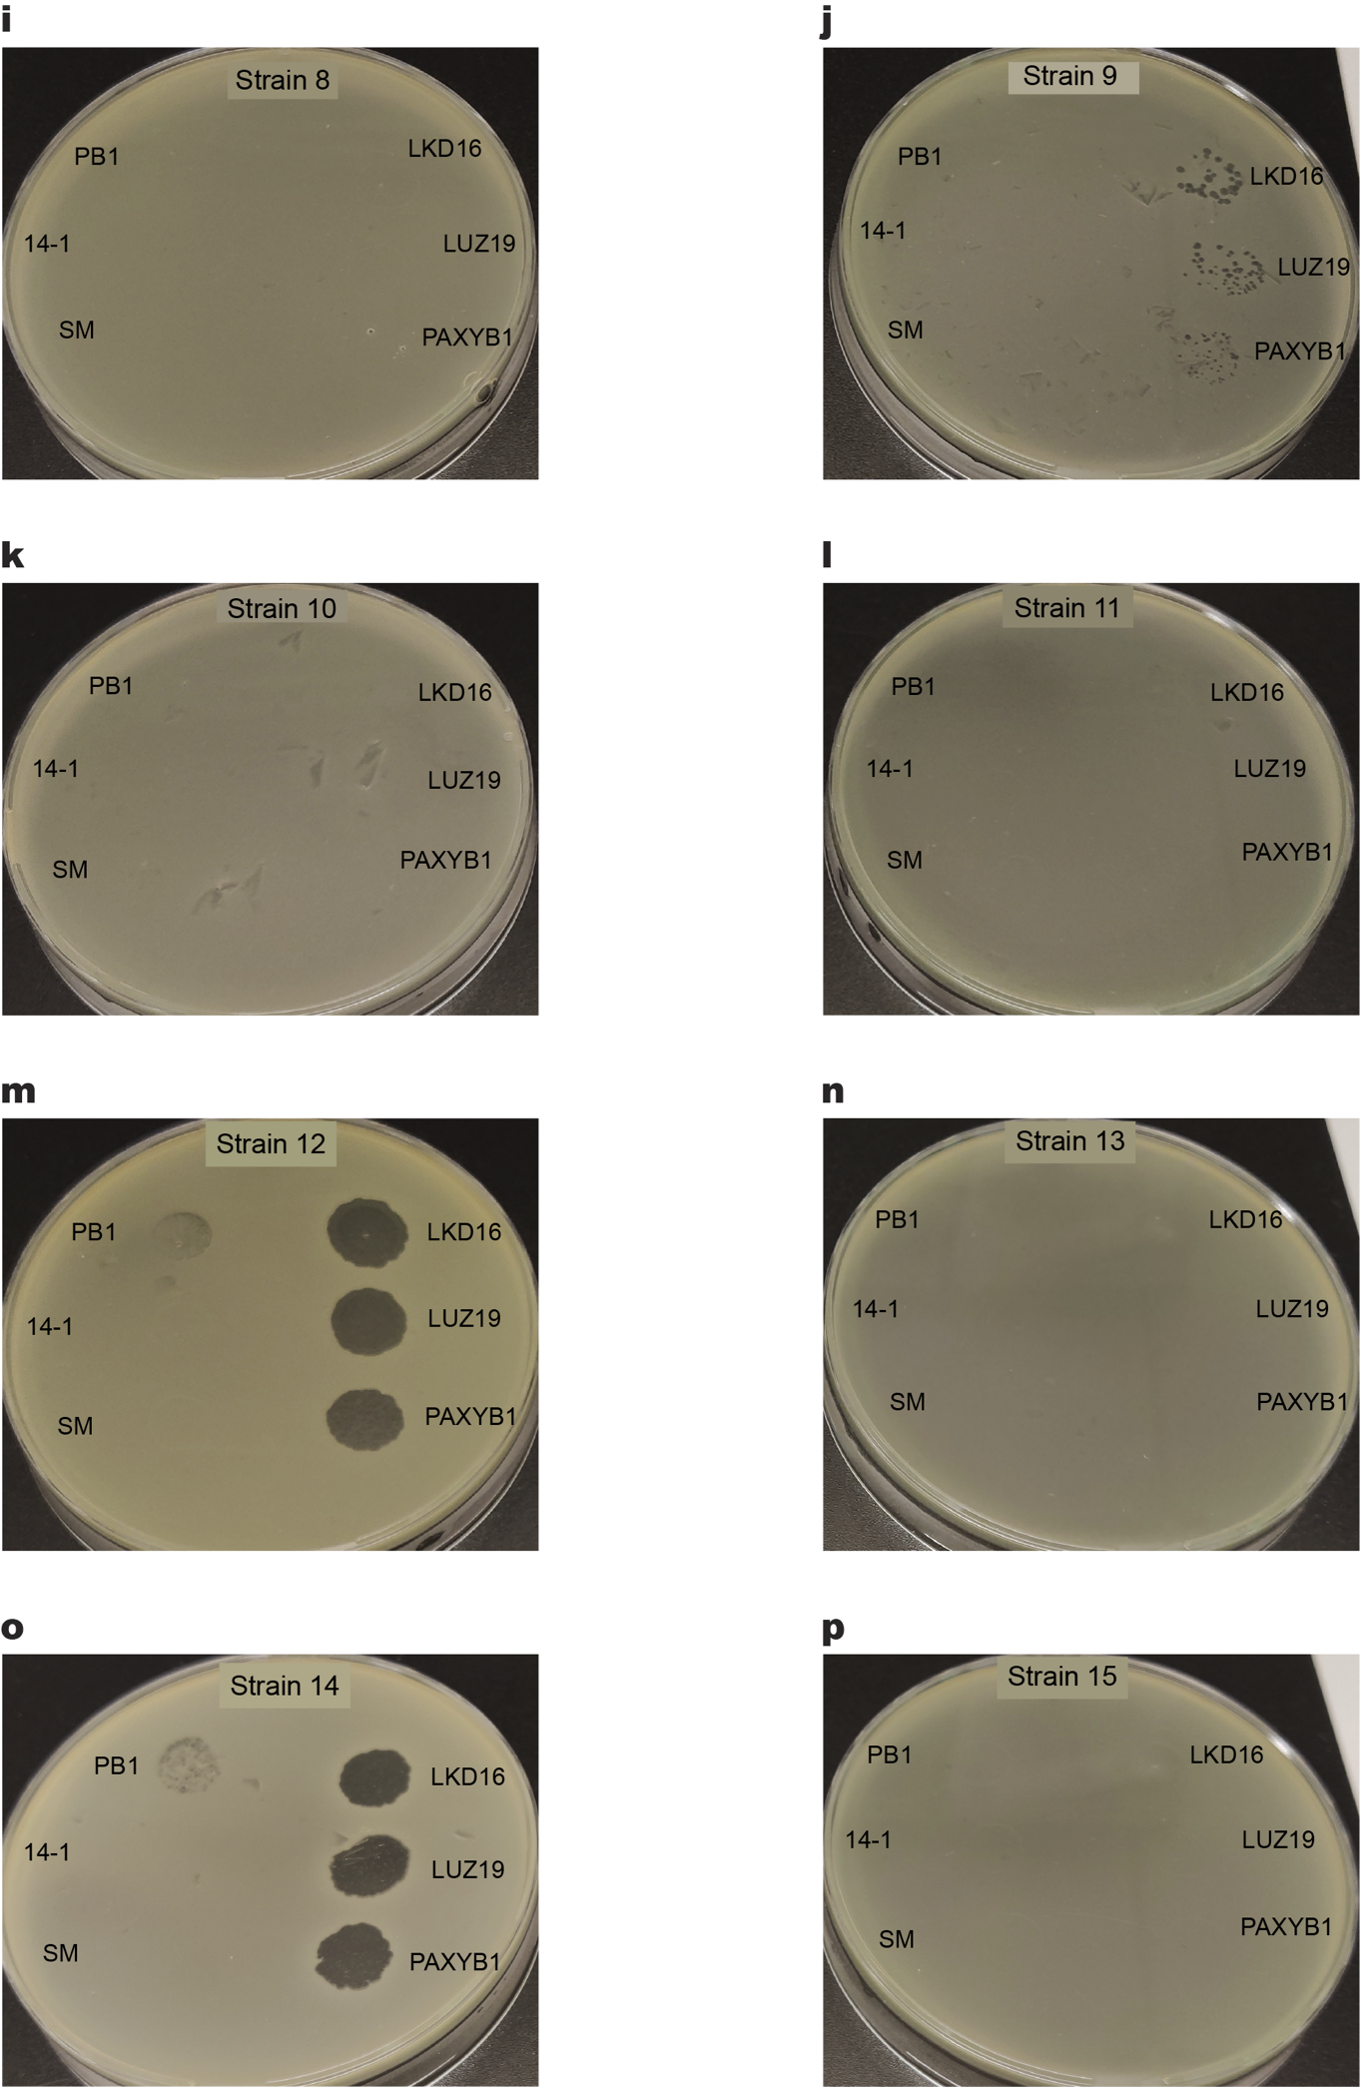
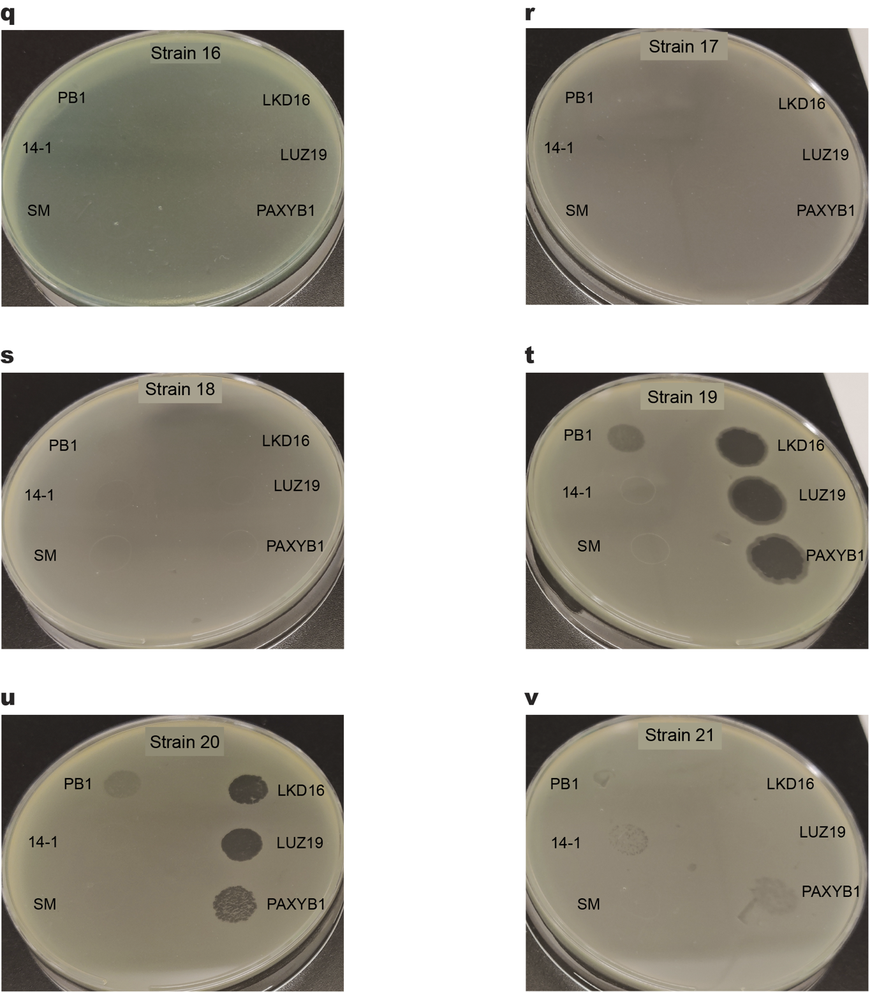

Figure S5: Phage susceptibility profiling of several P. aeruginosa clinical strains obtained from patients at the UMC Utrecht, as determined by plaque assays. a-v) Strains were inoculated into top agar and overlayed on a plate. Phages PB1, 14-1, LKD16, LUZ19 and PAXYB1 (10⁶ pfu/mL, 5 μL) and SM buffer (5 μL) were spotted to detect plaque formation after overnight incubation at 37ºC.

