Development and validation of asthma risk prediction models using co-expression gene modules and machine learning methods

Eskezeia Y. Dessie¹, Yadu Gautam¹, Lili Ding¹, Mekibib Altaye¹, Joseph Beyene², Tesfaye B. Mersha¹
¹Department of Pediatrics, Cincinnati Children’s Hospital Medical Center, University of Cincinnati College of Medicine, Cincinnati, OH, USA, ²Department of Health Research Methods, Evidence, and Impact, McMaster University, Hamilton, Canada

List of supplementary Figures

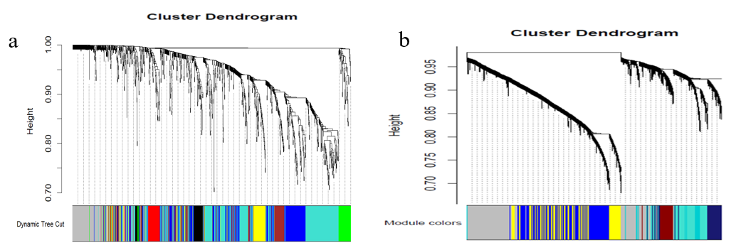

Figure S1. Weighted gene co-expression network analysis of gene dendrogram and module colors for a) NECs data b) AECs data. Clustering dendrograms of genes, with dissimilarity based on topological overlap, are bracketed together with assigned module colors.

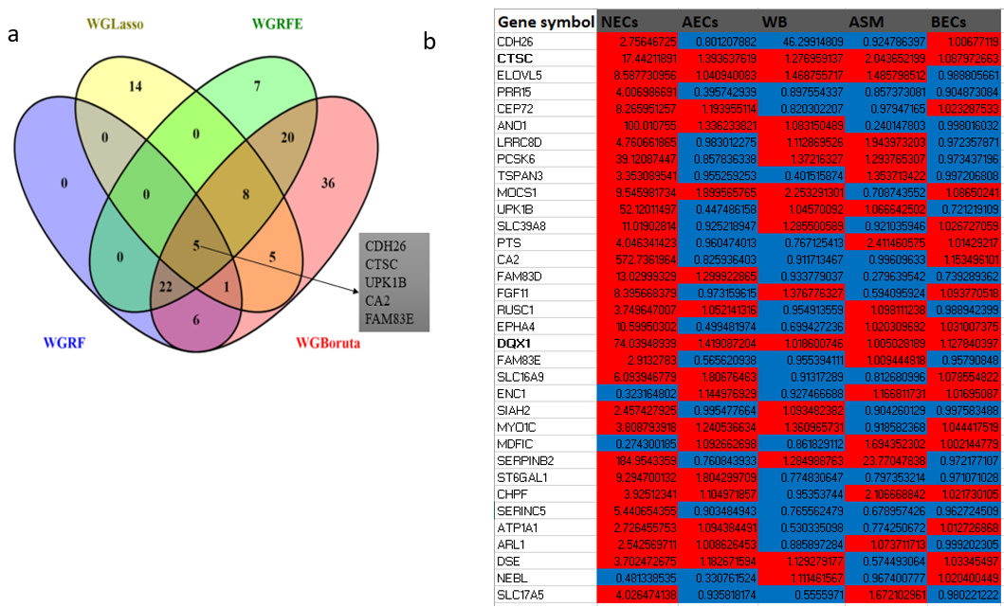
Figure S2. Persistently differentially co-expressed genes in asthmatic compared with control subjects in multiple cells/ tissue dataset. a). List common potential differentially co-expressed genes identified by four machine learning methods. b). Differential expression direction of 34-NECs-derived gene signature and their validation in multiple tissue/cell including GSE152004 (NECs: nasal epithelial cells), GSE172367 (AECs: airway epithelial cells), GSE69683 (WB: whole blood cells), GSE146532 (BECs: bronchial epithelial cells) and GSE58434 (ASM: airway smooth Muscle). Colors denote fold change value of gene signature in various tissue/cell types. Red denote upregulated, blue denote downregulated in asthmatic compared with control subjects.

