Supporting Information
for
Development of an on-line two-dimensional normal phase liquid chromatography system for analysis of weakly polar samples
by
Li-Wen Zhu ª, Bao-Ying Xie ^{c}, Shun-Zhi Liu ^{b},Yi-Hong Wu ^{b},Guo-Gang Zhang ^{a,*}, Ying-Kun Qiu^{b,*}
ª College of Traditional Chinese Medicine, Shenyang Pharmaceutical University, Xihu District, Benxi 117004, Liaoning, China
^{b} Fujian Provincial Key Laboratory of Innovative Drug Target Research, School of Pharmaceutical Sciences, Xiamen University, South Xiang-An Road, Xiamen, 361102, China;
^{c} Shool of Medicine, Xiamen University, South Xiang-An Road, Xiamen, 361102, China;

Submitted to
Chromatographia

Content

Figure S1. NPLC chromatograms of reference compound solutions enriched at different temperatures under vacuum, at different flow rates .................................................... ...................................................... 1
Figure S2. NPLC chromatograms of reference compound solutions enriched at 90°C under different vacuums, at different flow rates ........................................................................................................... 2
Figure S3. NPLC chromatograms of reference compound solutions enriched at 90°C under vacuum for different mobile phases, at different flow rates ............................................................................ 3

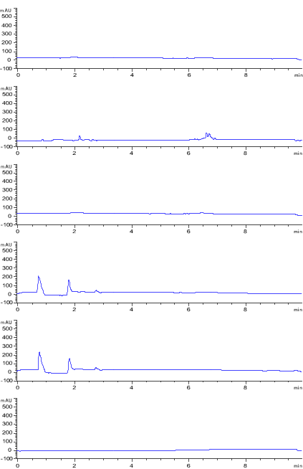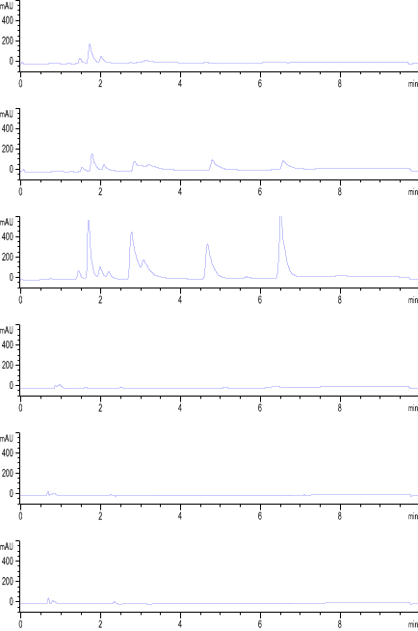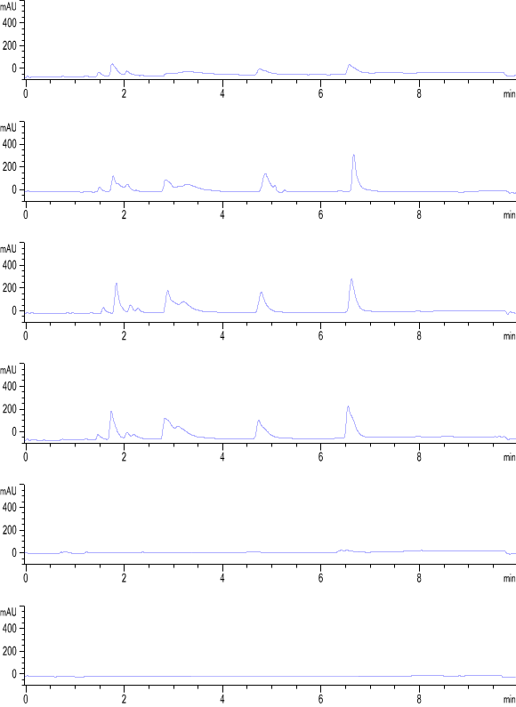
a)
b)
c)
0.01
0.02
0.05
0.10
0.15
0.20
0.01
0.02
0.05
0.10
0.15
0.20
0.05
0.10
0.15
0.20
0.25
0.30
Figure S1. NPLC chromatograms of reference compound solutions enriched at different temperatures under vacuum, (a) 30°C; (b) 60°C; (c) 90°C, at different flow rates (mL/min).

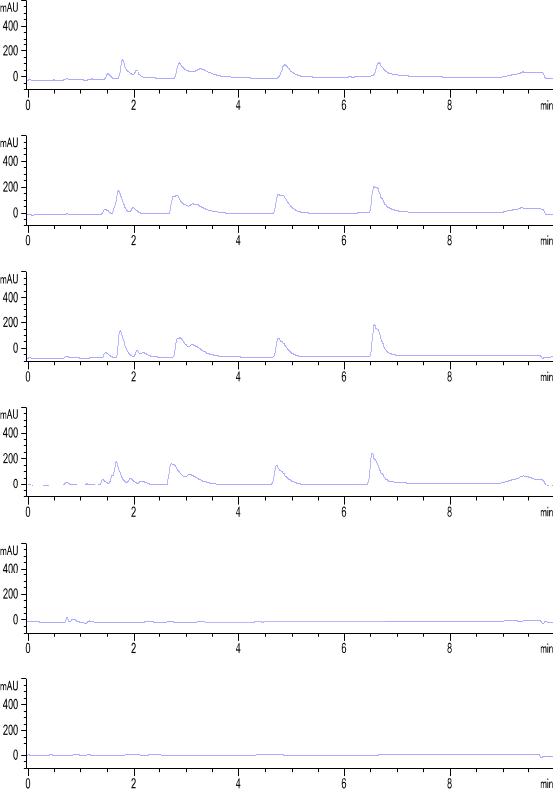
a)
0.05
0.10
0.15
0.20
0.25
0.30
b)
0.05
0.10
0.15
0.20
0.25
0.30
Figure S2. NPLC chromatograms of reference compound solutions enriched at 90°C under different vacuums: (a) without vacuum and (b) vacuum, at different flow rates (mL/min).

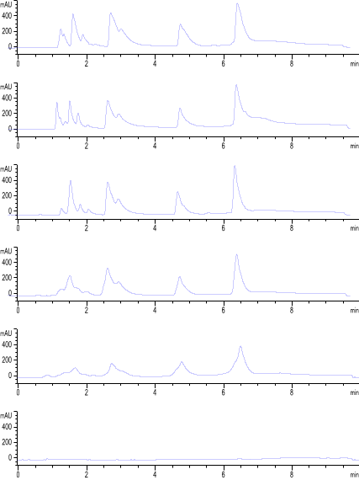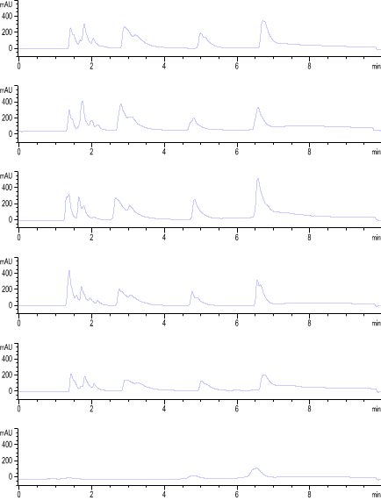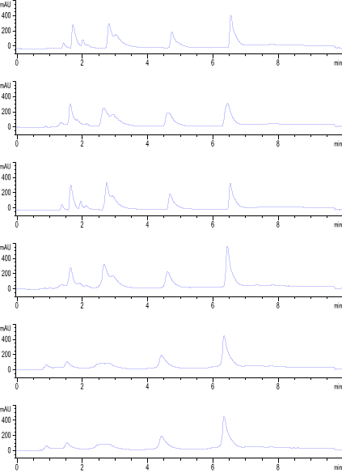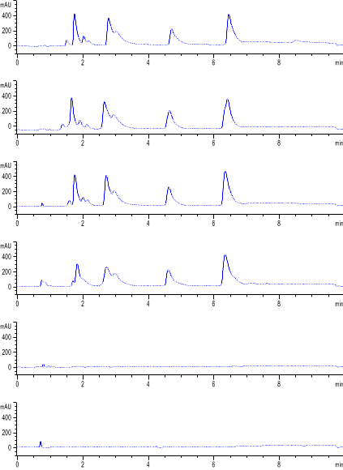
a)
0.05
0.10
0.15
0.20
0.25
0.30
b)
0.05
0.10
0.15
0.20
0.25
0.30
c)
0.05
0.10
0.15
0.20
0.25
0.30
d)
0.05
0.10
0.15
0.20
0.25
0.30
e)
0.05
0.10
0.15
0.20
0.25
0.30
Figure S3. NPLC chromatograms of reference compound solutions enriched at 90°C under vacuum for different mobile phases: a). chloroform-methanol, b) chloroform-acetone, c) n-hexane-acetone, d) n-hexane-anhydrous ethanol, and e) n-hexane-ethyl acetate, at different flow rates (mL/min).

