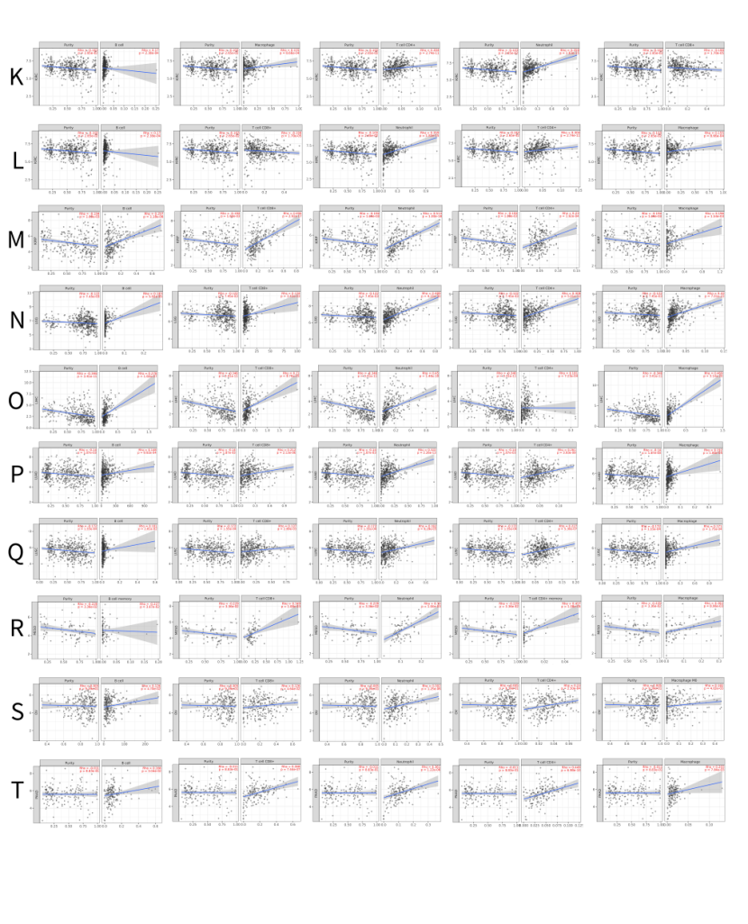

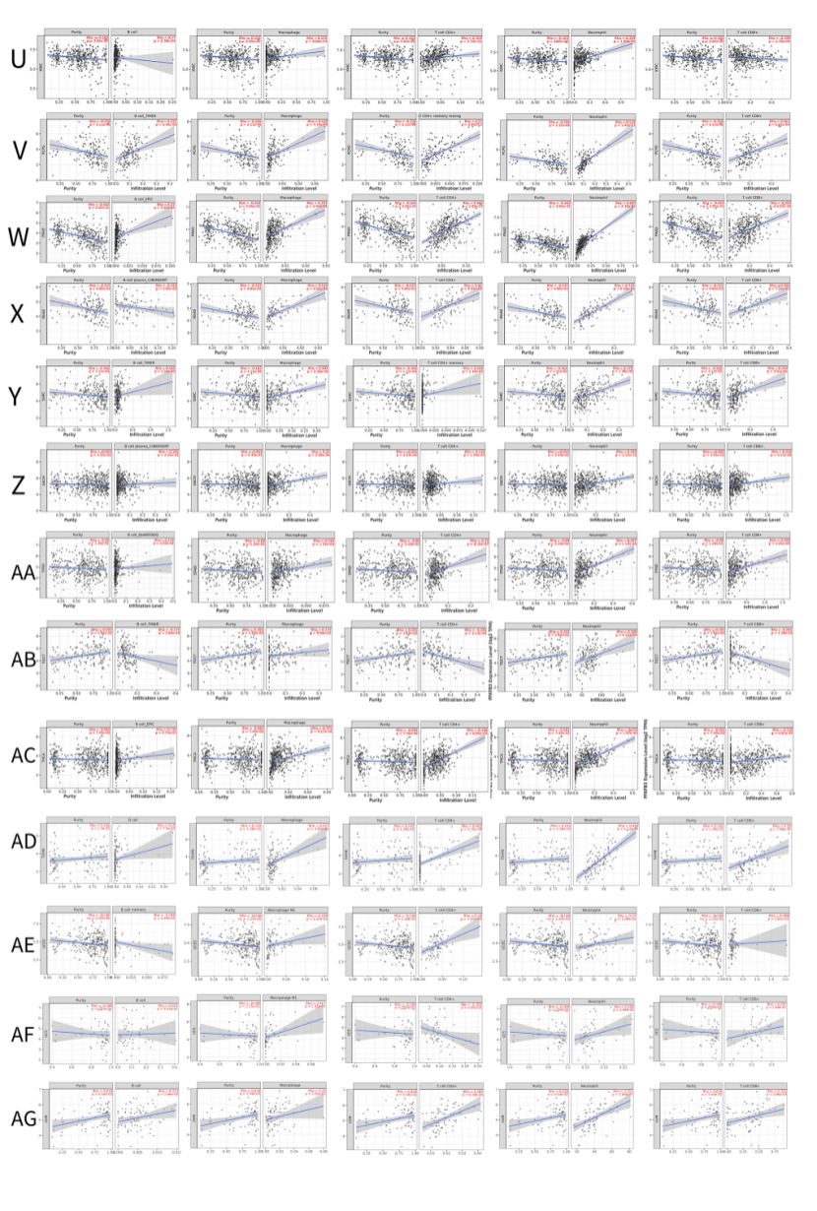

Supplementary Figure 2. Correlation of PFKFB3 expression with immune infiltration level in diverse type cancers via TIMER2.0 database.Correlation of PFKFB3 expression with immune infiltration levels in Adrenocortical carcinoma(ACC) (A) , Bladder Urothelial Carcinoma (BLCA) (B), Breast invasive carcinoma (BRCA) (C), Cervical squamous cell carcinoma and endocervical adenocarcinoma(CESC) (D), Cholangio carcinoma(CHOL) (E), Lymphoid Neoplasm Diffuse, Colon Adenocarcinoma(COAD)(F),Large B-cell Lymphoma(DLBC) (G), Esophageal carcinoma(ESCA) (H), Glioblastoma multiforme(GBM) (I) ,Head and Neck squamous cell carcinoma(HNSC) (J), Head and Neck squamous cell carcinoma HPVpos(HNSC-HPVpos) (K) , Kidney Chromophobe(KICH) (K), Kidney renal clear cell carcinoma(KIRC) (L), Kidney renal papillary cell carcinoma(KIRP) (M), Brain Lower Grade Glioma(LGG) (N), Liver hepatocellular carcinoma(LIHC) (O), Lung adenocarcinoma(LUAD) (P), Lung Squamous Cell Carcinoma(LUSC)(Q),Mesothelioma(MESO) (R), Ovarian serous cystadenocarcinoma(OV) (S), Pancreatic adenocarcinoma(PAAD) (T), KIRC(U) Pheochromocytoma and Paraganglioma(PCPG) (V), Prostate adenocarcinoma(PRAD) (W), Rectum adenocarcinoma(READ) (X), Sarcoma(SARC) (Y), Skin Cutaneous Melanoma(SKCM) (Z), Gastric adenocarcinoma(STAD)(AA),Testicular Germ Cell Tumors(TGCT) (AB), Thyroid carcinoma(THCA) (AC), Thymoma(THYM) (AD), Uterine Corpus Endometrial Carcinoma(UCEC) (AE), Uterine Carcinosarcoma(UCS) (AF), Uveal Melanoma(UVM) (AG).

