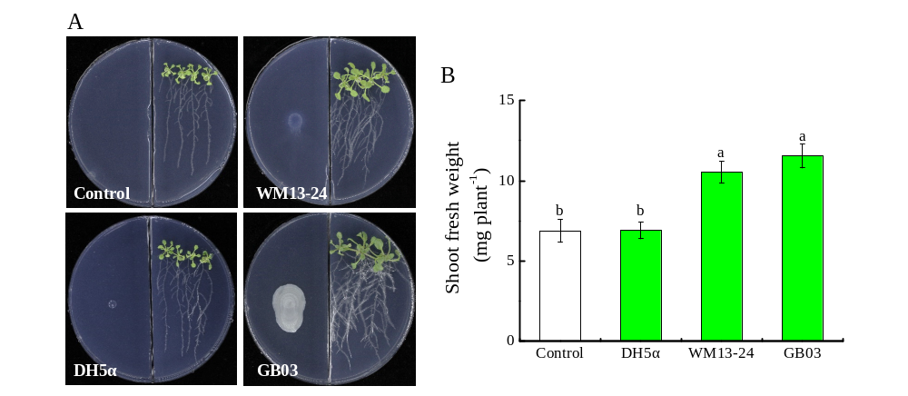
Fig. S1 Effects of VCs released from strains Bacillus subtilis WM13-24 and Bacillus amyloliquefaciens GB03 on the growth of Arabidopsis. Plant growth performance (A). Shoot fresh weight (B) was measured 14 days after inoculation of Bacillus subtilis WM13-24 and Bacillus amyloliquefaciens GB03 and sowing of the seeds of Arabidopsis. Values are means and bars indicated standard errors (SEs) (n = 20). Same colored columns with different letters indicated significant difference at P < 0.05 (Duncan’s multiple comparison test).

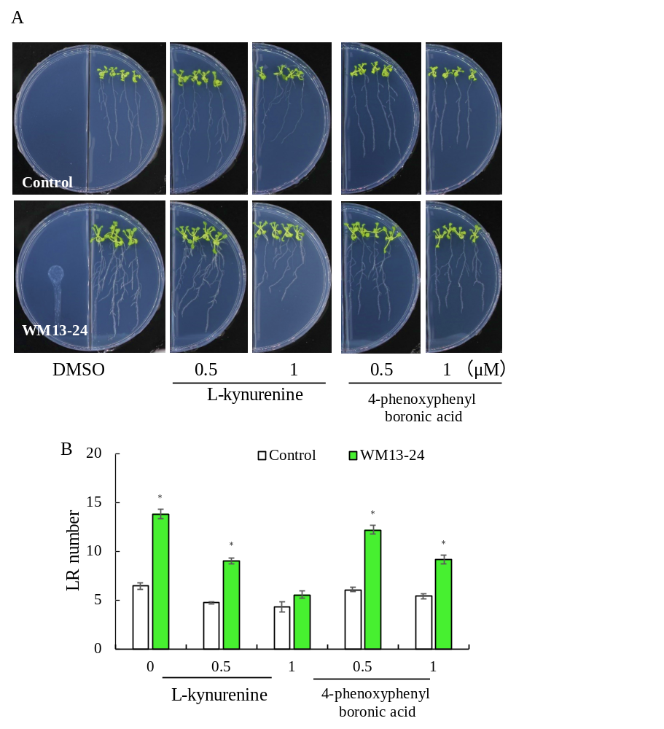
Fig. S2 Effects of TAA1/TARs- and YUCs-mediated auxin biosynthesis on Bacillus subtilis WM13-24 VCs-mediated LR formation in the Arabidopsis. Plant growth performance (A), LR number (B). Values are means and bars indicated standard errors (SEs) (n = 20). “*” indicated significant differences between WM13-24 treatment and control (P < 0.05).

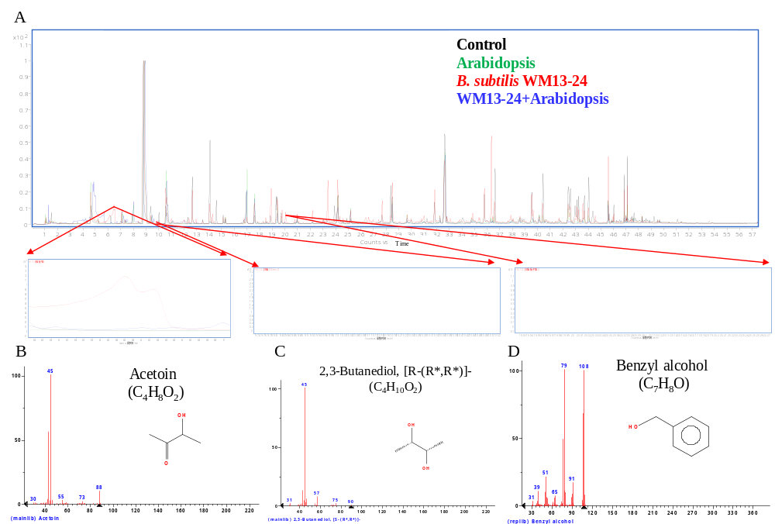
Fig. S3 Chromatograms of VCs detected in the headspace of plates from control (1/2 MS medium, black), Arabidopsis alone (green), Bacillus subtilis WM13-24 alone (red), and WM13-24 in the interaction with Arabidopsis seedlings (WM13-24 + Arabidopsis, blue) (A). Acetoin (B) 2,3-butanediol (C) and benzyl alcohol (D) were detected in the plates with WM13-24 alone.

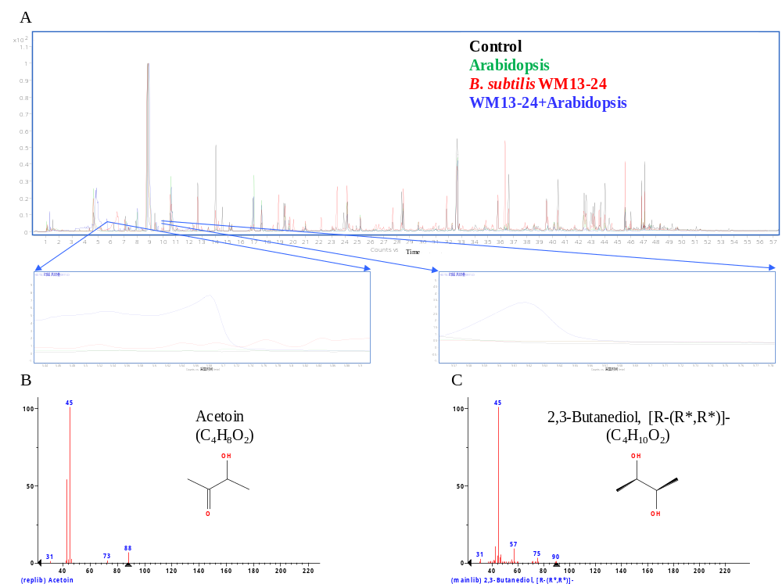

Fig. S4 Chromatograms of VCs detected in the headspace of plates from control (1/2 MS medium, black), Arabidopsis alone (green), Bacillus subtilis WM13-24 alone (red), and WM13-24 in the interaction with Arabidopsis seedlings (WM13-24 + Arabidopsis, blue) (A). Acetoin (B) and 2,3-butanediol (C) were detected in the plates with WM13-24 in the interaction with Arabidopsis seedlings.

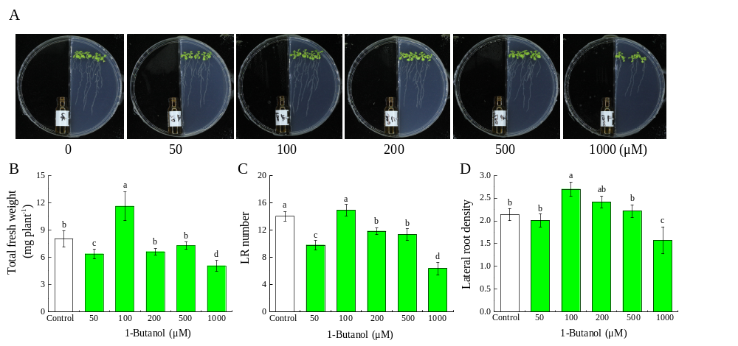
Fig. S5 Effects of 1-butanol on the growth of Arabidopsis. Plant growth performance (A). Total fresh weight (B), LR number (C) and Lateral root density (D) were measured 14 days after exposed to 1-Butanol at various concentrations. Values are means and bars indicated standard errors (SEs) (n = 20); Different letters indicated significant differences between WM13-24 treatment and control (P < 0.05).

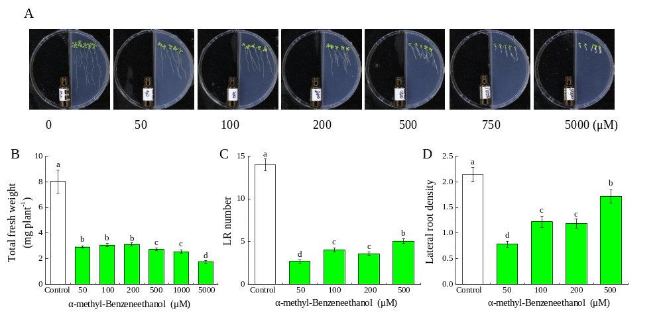
Fig. S6 Effects of α-methyl-benzeneethanol on the growth of Arabidopsis. Plant growth performance (A). Total fresh weight (B), LR number (C), Lateral root density (D) were measured 14 days after exposed to α-methyl-Benzeneethanol at various concentrations. Values are means and bars indicated standard errors (SEs) (n = 20); Different letters indicated significant differences between WM13-24 treatment and control (P < 0.05).

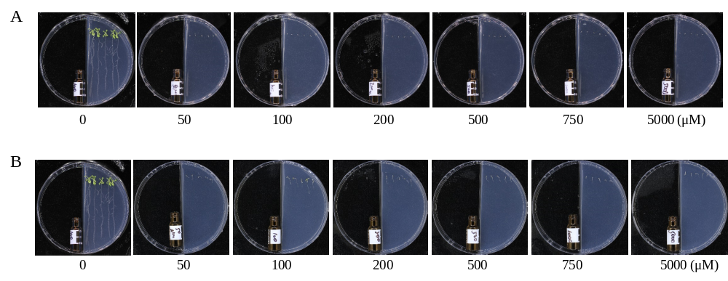
Fig. S7 Effects of 1-nonanol (A) and 4-(1,1-dimethylpropyl)-cyclohexanone (B)on the growth of Arabidopsis.

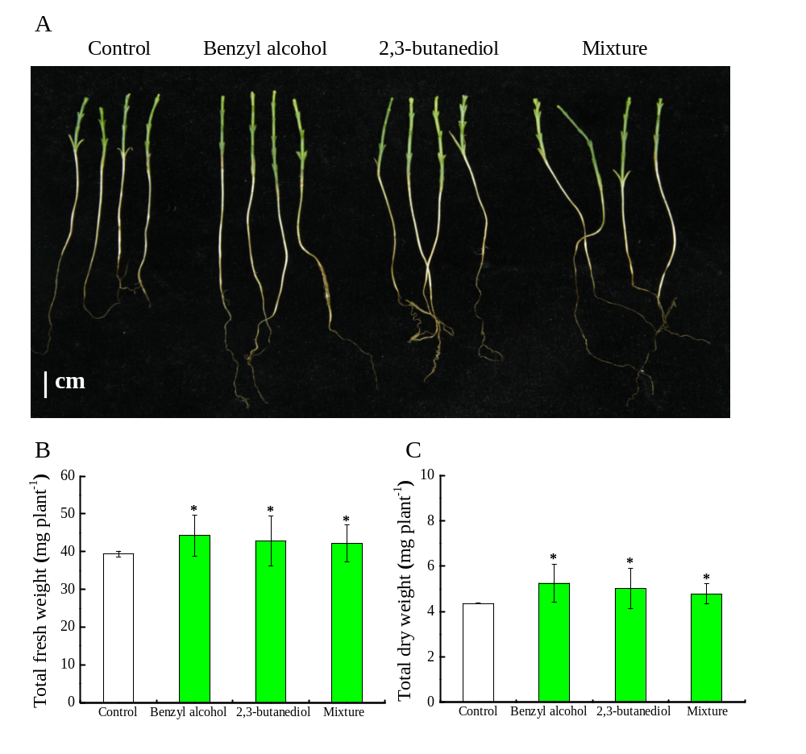
Fig. S8 Effects of the benzyl alcohol, 2, 3-butanediol and their mixture on the growth of Haloxylon ammodendron in the sealed containers. Plant growth performance (A). Total fresh weight (B) and total dry weight (C) were measured 14 days after exposed to benzyl alcohol, 2, 3-butanediol and their mixture, respectively. Values are means and bars indicated standard errors (SEs) (n = 20). Asterisks indicated significant differences between WM13-24 and control treatments (P < 0.05).

Table S1 Primers sequences used in quantitative qRT-PCR expression analysis.
Genes | Forwards primer | Reverse primer
PIN1 | GTCTTGGGTTGTTCATGGCG | GGCAGGTCCAACGACAAATC
PIN2 | TCTTTCTTTGGCAGGCGTTT | ACCAACGTGTTAGGCAGTGT
PIN3 | CCCTCTCCACACTTCCCAAC | TGGAGGACGACGATTTGGAC
PIN4 | ATGCTAGAGGTGGTGGTGAT | GCCCTGCTGTAGCTTTCTCT
PIN7 | TGGAGCCAATGAACAAGTCG | AGCTTTGTTTTCACCATTTTGAGT
ARF7 | GCATGCACATCGGAGTTCTT | ACCTCGGGTTGTAGAAAATGGT
ARF19 | TGTAGCCGCTGGAAGATCAC | CGTGTTATTGGCGGAAGGTG
LBD16 | CGCCGGAGATCTAAGACACA | CACTACCGATCGGAGAGACAC
LBD18 | ACAGTCATGACCTCCAAGCA | ATAGTTCGAGACGGCGAGTG
LBD29 | CTAGCTCTGGCTCTCCTTGTG | TGTGAATGGCTGCAAAGTGTG
AUX1 | CTCGTCAGAATGCGGCG | CCAAACCACCACGAAAGCAT
LAX1 | ACGGGGGCAATGGATTTAGT | GAATACGGCAGCGTCAACAG
LAX3 | CTGGCATGGTGGTTCTGTCT | TTCCCGACATCATCCCAAGT
ASA1 | GTTTTGAGCGGCGAACATTTG | GCATCCTCTAGCCTGCAAATAAC
NIT1 | CACCGTAAACTCATGCCCAC | TAGCAGCACCGAGTTTTCCA
NIT2 | CTACCATTGTCCAAGCCTCCA | AGCTCCGATCCCTTGCTTG
GH3.1 | TCAACGCATTGCTGATGGAG | CCTCTCTCCGGCTGATGTTC
GH3.5 | TGGAAACACACCGATCCCTC | GGGCCTATGGACTTGTCACT
GH3.6 | CGCGGTAACACACCTTGTTC | ACATAGTGGCCCGGGATAGA
TAA1 | CAAGTGGGAAGGAGACGCAT | GGTTCACCACCGTCTCTCTG
YUC5 | ACCGTAGCAACGTCCCATC | GAATCCAGCCGCGTAAAGTC
YUC8 | AAATGCCCTTCCCTGAGGAC | TTGATCTCGAACCGGGTAGC
YUC9 | CAACGTCCCTTCTTGGCTTC | GAATCCGGCCGCGTATAATC
LAX2 | TCGGTGGTTGGGCTAGTATG | ATGGCTGATTGGAGGAGGTG
AtActin2 | TCAGATGCCCAGAAGTGTTGTTCC | CCGTACAGATCCTTCCTGATATCC

