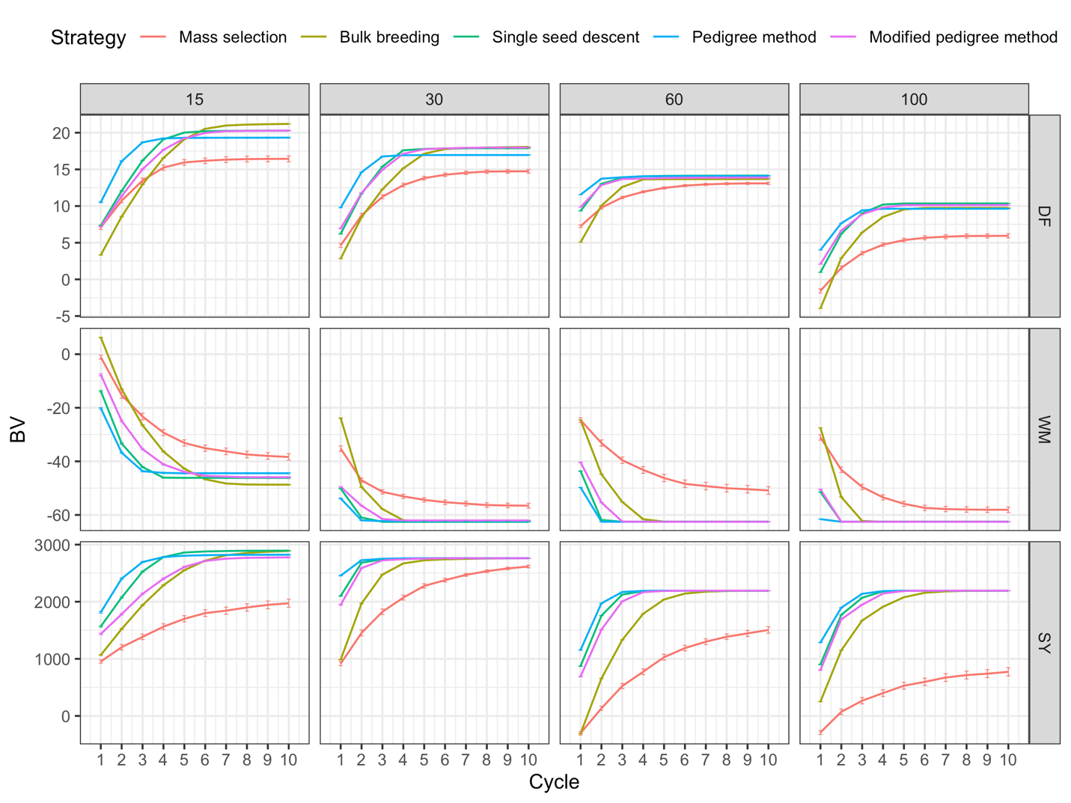
Supplementary Figure 1: True breeding values provided by QU-GENE plotted over 10 cycles for increasing parental population sizes and three traits. Traits include days to flowering (DF), white mold tolerance (WM), seed yield (SY).

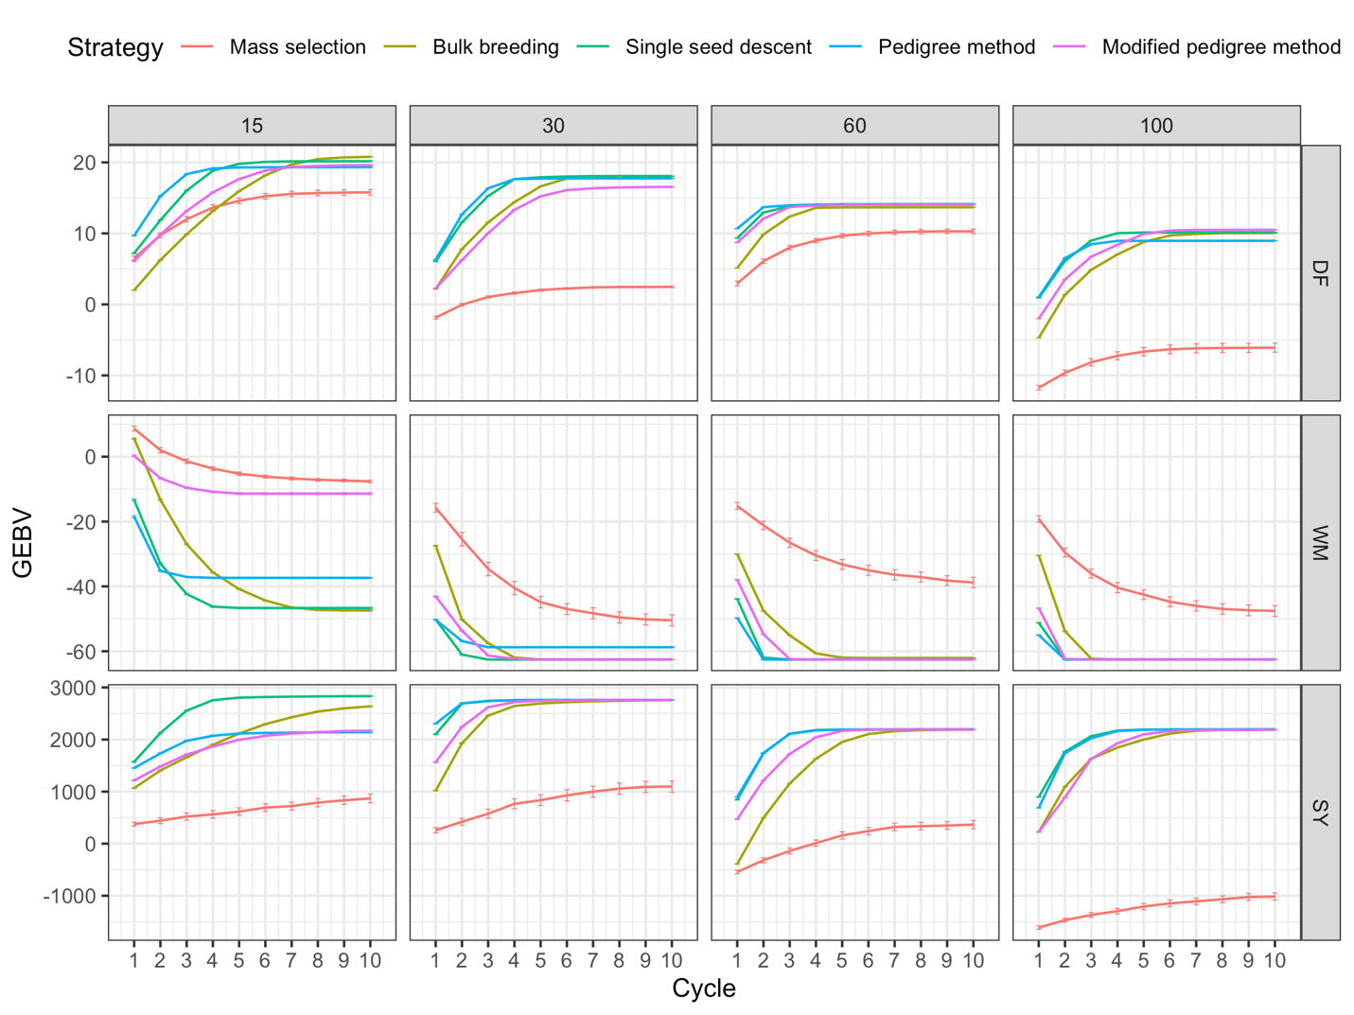
Supplementary Figure 2: Genomic estimated breeding values plotted over 10 cycles for increasing parental population sizes and three traits. Traits include days to flowering (DF), white mold tolerance (WM), seed yield (SY).

