Identification of sequence mutations in Phytophthora cactorum genome associated with mefenoxam resistance and development of a molecular assay for the mutant detection in strawberry (F. ×ananassa)

Marcus V. Marin^{1,2}, Juliana S. Baggio², Youngjae Oh², Hyeondae Han², Saket Chandra², Nan-Yi Wang², Seonghee Lee^{*3}, and Natalia A. Peres^{*1,2}.
¹ Department of Plant Pathology, University of Florida, ²Gulf Coast Research and Education Center, Wimauma FL 33598, U.S.A.
³ Horticultural Science Department, University of Florida, IFAS Gulf Coast Research and Education Center, Wimauma, FL, 33598, USA
*Corresponding authors: Natalia A. Peres (nperes@ufl.edu) and Seonghee Lee (seonghee105@ufl.edu)
Supplementary Table 1. List of primers developed for this study
Primer | Sequences 5’->3’ | Amplicon (bp)* | Assay
RPA190-F1 | TCAGACAGGATGCCAGTGC | 145 | RNA polymerase (RPA190)
RPA190-R1 | TTGTCGCCCATGAAAACAGG | 145 | RNA polymerase (RPA190)
RPA190-F2 | TTCCTGAACGTGATTCCCGT | 115 | RNA polymerase (RPA190)
RPA190-R2 | GTACGGATCAGGAGAGATAACC | 115 | RNA polymerase (RPA190)
RPA190-F3 | GCGAGGCTATCAGTAAGACG | 102 | RNA polymerase (RPA190)
RPA190-R3 | TTGTAAGCCTCCGAACGC | 102 | RNA polymerase (RPA190)
RPA190-F4 | GAGGCTTACGCTGAGTTTGC | 170 | RNA polymerase (RPA190)
RPA190-R4 | ACAAGACCTTCACGACCAGCCATA | 170 | RNA polymerase (RPA190)
RPA190-F5 | GAGCAGCGTCTGAACCAGGT | 141 | RNA polymerase (RPA190)
RPA190-R5 | GAATCTTCTCGTCCTCCTCATC | 141 | RNA polymerase (RPA190)
RPA1-F1 | CGTCCAATGACAACCAGTACA | 1119 | RNA polymerase (RPA I)
RPA1-R1 | CTTCACGACCAGCCATACAA | 1119 | RNA polymerase (RPA I)
RPA1-F2 | CCACAGACCAGACCATTCTT | 1170 | RNA polymerase (RPA I)
RPA1-R2 | GCTTGTAGTAGTCTCCCTGAAC | 1170 | RNA polymerase (RPA I)
RPA1-F3 | ACGGATCCAACAGTGACATTAT | 1188 | RNA polymerase (RPA I)
RPA1-R3 | AGTAGTTCACCCACACAAGAAG | 1188 | RNA polymerase (RPA I)
RPA1-F4 | GGTTTGATTTCGGAGCGTATTC | 1017 | RNA polymerase (RPA I)
RPA1-R4 | AGATTTCGTTTGCTGCTTCTTC | 1017 | RNA polymerase (RPA I)
RPA1-F5 | AGTTCTTCCTGAACGTGATTCC | 1076 | RNA polymerase (RPA I)
RPA1-R5 | CACACCAGCATCTTCCATACT | 1076 | RNA polymerase (RPA I)
RPA1-F6 | CAGATCCGCCTGACTTTCTT | 1016 | RNA polymerase (RPA I)
RPA1-R6 | ATGGACGTCTCGAACGTAATC | 1016 | RNA polymerase (RPA I)
RPA2-F1 | CGAAGAAGAAGGTCAGCAAGA | 1024 | RNA polymerase (RPA II)
RPA2-R1 | GTACACATAAGGCATGGCAAAC | 1024 | RNA polymerase (RPA II)
RPA2-F2 | GGACGCTATGATCCTCAACAA | 1189 | RNA polymerase (RPA II)
RPA2-R2 | GCATCCCTTCAGAGTCAAAGA | 1189 | RNA polymerase (RPA II)
RPA2-F3 | GGTGTCAAGAAGCAGGAGTT | 1011 | RNA polymerase (RPA II)
RPA2-R3 | CATAACAGGCAGATACGAGTACG | 1011 | RNA polymerase (RPA II)
RPA2-F4 | TGGAATGTGAACTGGTGTGT | 1135 | RNA polymerase (RPA II)
RPA2-R4 | CAGAACCGGAGCTTGATACTC | 1135 | RNA polymerase (RPA II)
Rdmyl1 F | ACCAGCGGAAATCACTGC | 202 | Sequencing regions identified in the whole genome analysis
Rdmyl1 R | GACAGGCAACCGCTCAA | 202 | Sequencing regions identified in the whole genome analysis
Rdmyl2 F | GGACTTGACGCCTAGCTT | 201 | Sequencing regions identified in the whole genome analysis
Rdmyl2 R | TTGAGCACATACACTGTTGTTT | 201 | Sequencing regions identified in the whole genome analysis
Rdmyl3 F | CCAGCAACGTGGCAATTT | 167 | Sequencing regions identified in the whole genome analysis
Rdmyl3 R | GTTCCTGACCCGTCCTTT | 167 | Sequencing regions identified in the whole genome analysis
Rdmyl4 F | GCGTATACATCTCACTGTGGTTC | 182 | Sequencing regions identified in the whole genome analysis
Rdmyl4 R | GTGGTAACGCATTCTGACTATGT | 182 | Sequencing regions identified in the whole genome analysis
Rdmyl5 F | CGAGGAACTATCAGTGGATCTT | 162 | Sequencing regions identified in the whole genome analysis
Rdmyl5 R | GCGTAAGCTTCCAGCTC | 162 | Sequencing regions identified in the whole genome analysis
Rdmyl6 F | GCTCCGCAATTCGAAACAG | 192 | Sequencing regions identified in the whole genome analysis
Rdmyl6 R | GATTTCTCCATAGTCCGAGTACAA | 192 | Sequencing regions identified in the whole genome analysis
HRM 1F | CACCTCCTGCACTTTGGTAT | 127 | HRM – Region 1
HRM 1R | CCGCTCAACTGGATGAATGA | 127 | HRM – Region 1
HRM 3F | GTGGGCCTTGATCTTGTTCT | 96 | HRM – Region 2
HRM 3R | AAATGAGTAAGCCCAGCCTAAG | 96 | HRM – Region 2
HRM 5F | CCGTGATCTTCTTGTTGGGATT | 112 | HRM – Region 3
HRM 5R | GCAAGAAGAAGGACCCGAAC | 112 | HRM – Region 3
S1F | TGCCACCTTCAACGACAA | 99 | HRM – Region 4
S1R | ATCACGTCTGGACTGATCAAAT | 99 | HRM – Region 4
R4F | CAAGATGATTGCCGAGCAAATG | 71 | HRM – Region 5
R4R | CGCGCAAGTTCTCCCTTT | 71 | HRM – Region 5
R6F | TTGTCGAAACCTCCCTGAC | 84 | HRM – Region 6
R6R | CGGACTTGCAAAGGTGTTG | 84 | HRM – Region 6
R3-1F | ATTCTCGTCGCGCACCT | 57 | HRM – Region 3
R3-1R | CTGTCGGCCTACTTCTTCTTCT | 57 | HRM – Region 3
R2-1F | CTAAGCGTTACCGACTAGC | 83 | HRM – Region 2
R2-1R | GTCAGGTGGGCCTTGAT | 83 | HRM – Region 2

Supplementary Table 2. A list of Phytopththora cactorum isolates collected from strawberry in Florida, used for marker development and validation. [R indicates mefenoxam-resistant and S indicates mefenoxam-sensitive isolates for genetic regions targeted by primers set R3-1 and R2-1]
Isolate | Year of collection | Phenotype | R3-1 | R2-1 | DNA condition
16-88 | 2016 | Resistant | R | R | Clean
16-90 | 2016 | Resistant | R | R | Clean
16-91 | 2016 | Resistant | R | R | Clean
16-353 | 2016 | Resistant | R | R | Clean
16-363 | 2016 | Resistant | R | R | Clean
16-364 | 2016 | Resistant | S | S | Clean
16-365 | 2016 | Resistant | R | R | Clean
18-27 | 2018 | Resistant | R | R | Clean
18-39 | 2018 | Resistant | R | R | Clean
18-62 | 2018 | Resistant | R | R | Clean
18-627 | 2018 | Resistant | R | R | Clean
18-638 | 2018 | Resistant | R | R | Clean
18-639 | 2018 | Resistant | R | R | Clean
18-640 | 2018 | Resistant | R | R | Clean
18-641 | 2018 | Resistant | R | R | Clean
18-651 | 2018 | Resistant | R | R | Clean
18-656 | 2018 | Resistant | R | R | Clean
18-691 | 2018 | Resistant | R | R | Clean
8425 | 2019 | Resistant | R | R | Clean
8477B | 2019 | Resistant | R | R | Clean
8732 18 | 2019 | Resistant | R | R | Clean
8732A | 2019 | Resistant | R | R | Clean
8816 | 2019 | Resistant | R | R | Clean
8925 | 2019 | Resistant | R | R | Clean
Sample 13 | 2020 | Resistant | R | R | Clean
Sample 19 | 2020 | Resistant | R | R | Clean
Sample 23 | 2020 | Resistant | R | R | Clean
Sample21B | 2020 | Resistant | R | R | Clean
11-03 | 2011 | Sensitivity | S | S | Clean
13-434 | 2013 | Sensitivity | S | S | Clean
16-345 | 2016 | Sensitivity | S | S | Clean
18-31 | 2018 | Sensitivity | S | S | Clean
8475 | 2019 | Sensitivity | S | S | Clean
8729_S | 2019 | Sensitivity | S | S | Clean
8865_S | 2020 | Sensitivity | S | S | Clean
8880_S | 2020 | Sensitivity | S | S | Clean
8904_S | 2020 | Sensitivity | S | S | Clean
8912_S | 2020 | Sensitivity | S | S | Clean
8917_S | 2020 | Sensitivity | S | S | Clean
8947_S | 2020 | Sensitivity | S | S | Clean
8425-1 | 2020 | Resistant | R | R | Crude
8425-2 | 2020 | Resistant | R | R | Crude
8425-3 | 2020 | Resistant | R | R | Crude
8425-4 | 2020 | Resistant | R | R | Crude
8472-1 | 2020 | Resistant | R | R | Crude
8472-2 | 2019 | Resistant | R | R | Crude
8477-3 | 2019 | Resistant | R | R | Crude
8477-4 | 2019 | Resistant | R | R | Crude
8816 | 2020 | Resistant | R | R | Crude
8925 | 2020 | Resistant | R | R | Crude
9067-1 | 2020 | Resistant | S | S | Crude
8887 | 2020 | Sensitivity | S | S | Crude
8889 | 2020 | Sensitivity | S | S | Crude
8912 | 2020 | Sensitivity | S | S | Crude
8920 | 2020 | Sensitivity | S | S | Crude
8949 | 2020 | Sensitivity | S | S | Crude

Supplementary Table 3. Sequencing results of PCR products from mefenoxam-sensitive and -resistant P. cactorum isolates.
Profile | Region | Genomic sequence
Sensitive | 1 | TTATGCAGGAGAAACGCAAGC
Resistant | 1 | TTATGCAGGATAAACGCAAGC
Sensitive | 2 | ACAGGATCTTCTTGCCGTGAA
Resistant | 2 | ACAGGATCTTATTGCCGTGAA
Sensitive | 3 | GATGTCATTGCAGAAGAAGAA
Resistant | 3 | GATGTCATTGTAGAAGAAGAA
Sensitive | 4 | GGTGCTACCGTCGTCCTCGCT
Resistant | 4 | GGTGCTACCGACGTCCTCGCT
Sensitive | 5 | CACCAACACGAGAGTCTAGAA
Resistant | 5 | CACCAACACGGGAGTCTAGAA
Sensitive | 6 | ACTCTGAAAGTCTAAACACCA
Resistant | 6 | ACTCTGAAAGCCTAAACACCA

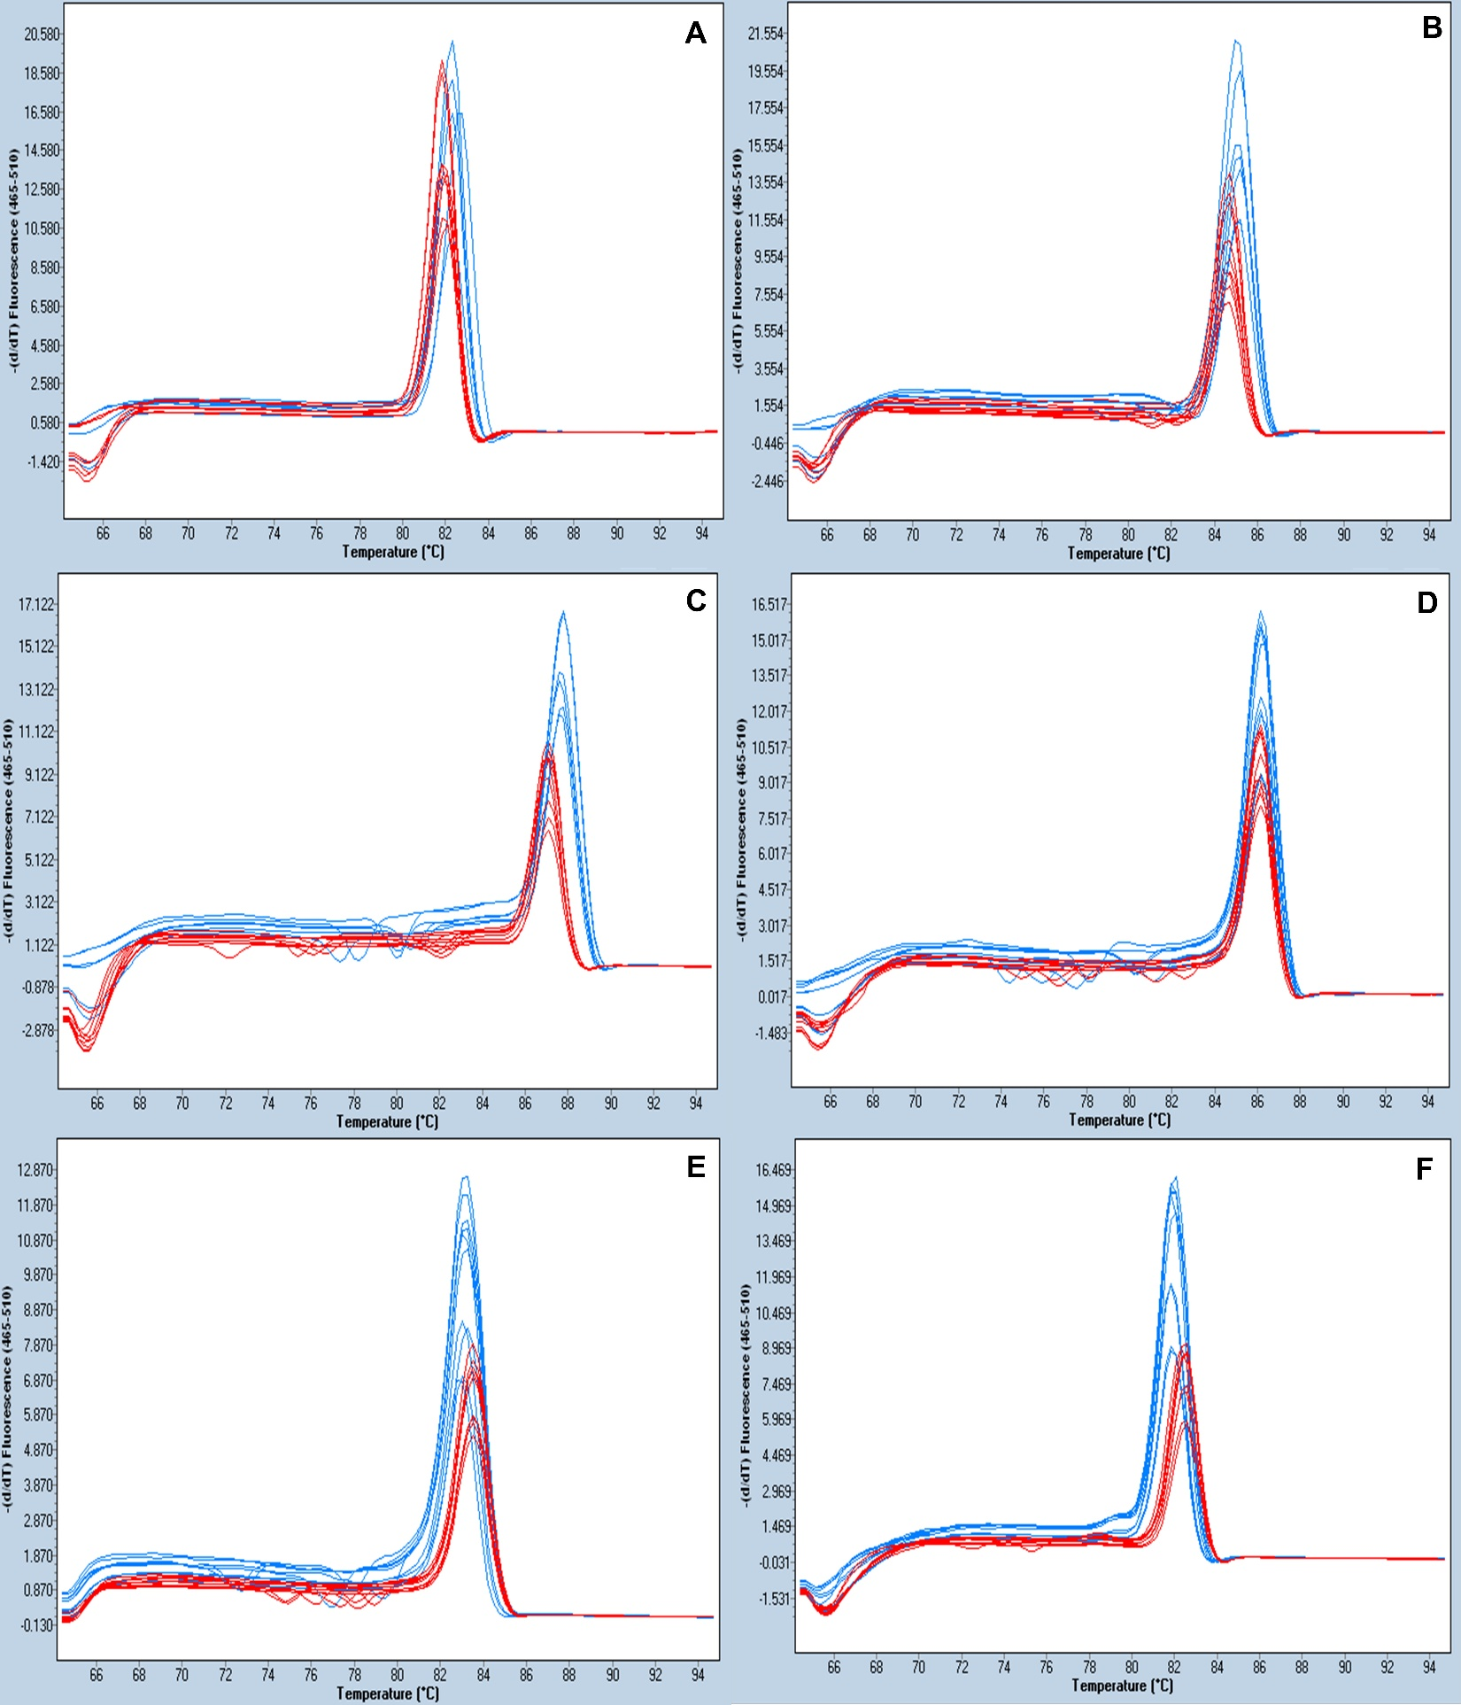
Supplementary Figure 1. High-resolution melting (HRM) analysis of regions 1 (A), 2 (B), 3 (C), 4 (D), 5 (E), and 6 (F) for the identification and differentiation of mefenoxam-sensitive (red) and -resistant (blue) isolates of P. cactorum of strawberry based on derivative plot analyses.

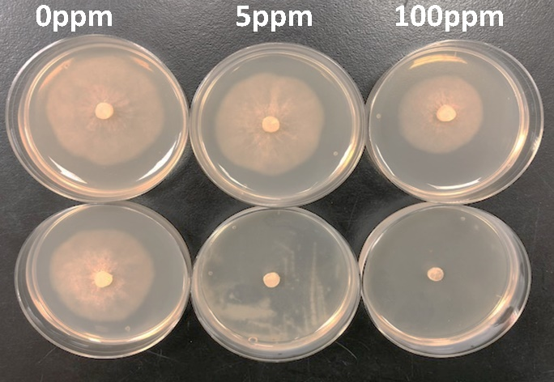
Supplementary Figure 2. Mycelial growth of a representative Phytophthora cactorum mefenoxam-resistant (top) and -sensitive isolate (bottom) after 4 days of plating on clarified 20% V8 medium.

